|  |  |
| --- | --- |
| Mother Daughter Pageant  Inspired by a Captioned Image  Suggested by Annabelle Raven  By Maryanne Peters  I will not be the first person to say this and I doubt that I will be the last: My sister married an idiot.  My sister Julie married Don because she thought that living with him would be fun. It is true that if there is anything going, Don is up for it. The crazier the better. Their son Kevin in a bit a chip off the old block, except that generally he knows when to stop.  I told Julie about the Mother/Daughter Beauty Pageant by way of saying that it was a pity that she did not have a girl instead of a son in Kevin. Julie is 38 but she looks great. Then I put into her head the possibility that I might be able to give Kevin a makeover and have him pass himself off as female. I suggested that they would make an unbeatable pair. | https://2.bp.blogspot.com/-AYpMb5PHd8k/UF_QHxmhL9I/AAAAAAAAFHU/PRBrLOZC3S8/s1600/Reluctant+womanless+pagent+entrants.JPG |

Of course, Don loved the idea, but he said that if I was so clever, he could be the mother in the lineup.

Then on Kevin’s birthday, he made it official. As a treat for his son, he took him and Julie and me, to lunch at the “Sassy Chicken” Roadhouse which ran and lunchtime stripper. Both he and Kevin started drinking, and out came his phone and the late entry went in with the hefty deposit. The details included the measurements for Doria, a statuesque blonde, and her daughter Keira.

“It’s over to you now, Sharon,” he said to me, slurring with way too much liquor on board. “Make us beautiful.”

We had only the afternoon and the evening to get ready, as the competition was the following day. I told Don that they should surrender themselves to me totally, to have any chance of getting a place.

“The Hell with that,” blubbered Don over his glass of neat bourbon and plastic cup of Coke. “We’re going to win.”

I never believed they would, given that I had such little time, but I had already straightened their longish hair and dyed it blonde, and had them in women’s clothes. And “Keira’s” eyelashes had been tinted. In their drunken state, both had been through full body waxing plus pedicures and manicures, including painted stick-on nails. But the day after was to be another full morning at the salon for hairstyling and full makeup for both of them. They could hardly turn up to the pageant drunk so I needed to keep the changes coming thick and fast so they had no time to think.

Fortunately, neither of them are great thinkers.

Julie and I spent all morning rehearsing the catwalk moves and the all-important answers to the judges questions, delivered with a ditzy sincerity that needs plenty of practice. We even rehearsed the winners breathless acceptance speech, although it seemed outrageous that it would ever be needed.

But just as our time was up and we were about to get in the car to go to the pageant, we had a chance to look upon our work and we were both amazed. Not only were Doria and Keira convincing, they were real. They even chatted with one another in feminine voices, primping themselves and one another. I have to say that I looked at Julie quizzically – what was happening in front of our eyes?

Strangely when Doria picked up the prize for the most beautiful mother (Keira did not place as the competition was stiff) we were only moderately surprised.

|  |  |
| --- | --- |
| “I don’t know how you did it,” I said.  “Well, I’m not proud of it, but I needed to suck the Chief Judge’s cock to get the crown,” said Doria off-handedly.  “Oh my God,” I exclaimed.  “That’s not the worst of it,” Doria said. “He wants to take me away to his beach house next weekend, and worse still…”, she gulped.  “What?” I said.  “Worse still, I want to go.”  She did. And Keira found a new life too, with a guy she met at the after party.  The End | Sarah (far left, pictured with Ella), who runs her own beauty salon, wowed judges who placed her first in every stage of competition |

Step-brother

Based on a captioned image

By Maryanne Peters

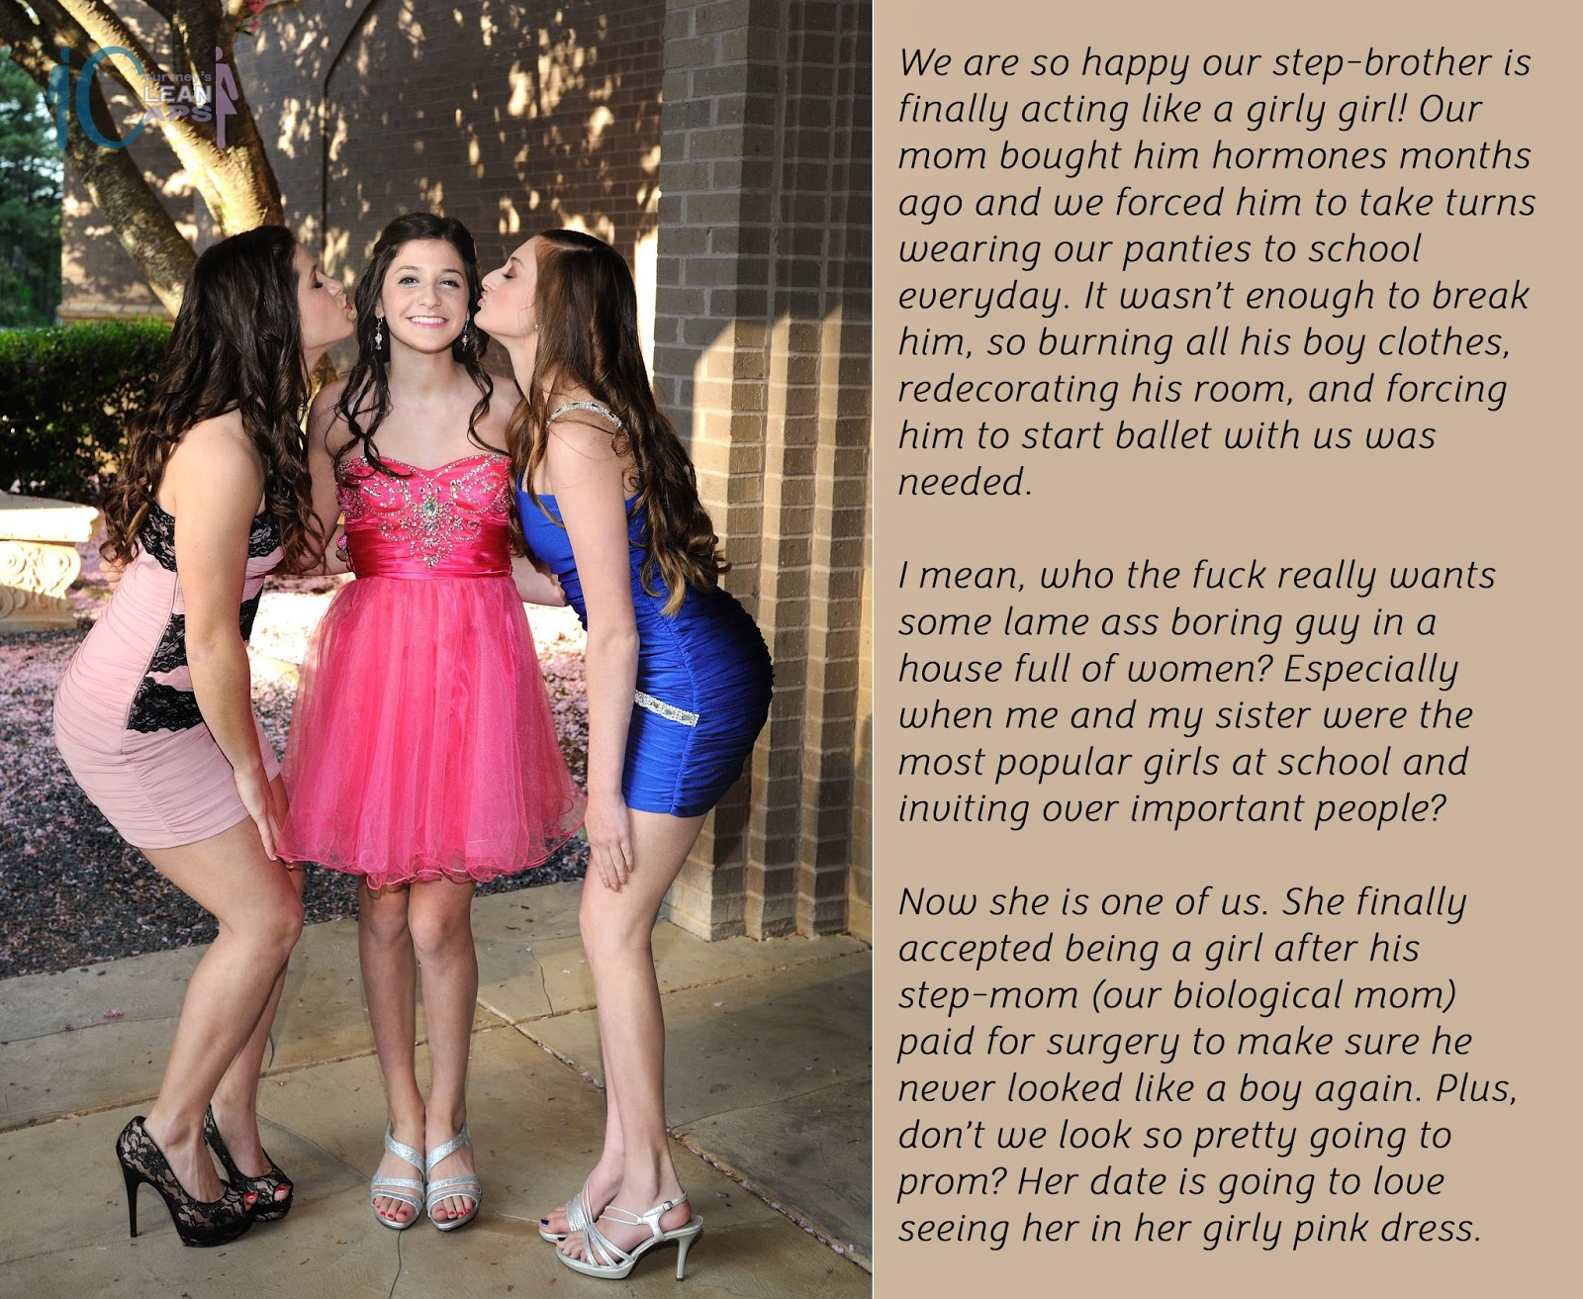

When our step-father died Alex was the only one who cried. After all, he was his blood.

I am not sure that Mom ever really loved him, her second husband. She just needed to have someone to provide for us, just as he needed somebody to fill the role of mother for his son. It was a marriage of convenience, but it quickly turned bad. It turned bad when the abuse started.

Mom was strong. She was so much stronger than his first wife, who had committed suicide. Mom said that she could understand why, but she was determined to survive him. It was when the abuse turned to us, her two daughters, that she decided that action needed to be taken.

Now I am not suggesting that she had anything to do with her husband’s (our stepfather’s) death, so let’s just say that the fatal traffic accident was timely and convenient.

That left Alex an inconvenient remainder, and reminder, of that man. His father’s son. A boy in a house full of women.

It was not that we had planned to dress him up. It was just that if he was to be included in our games he would have to be one of us. And we always had spare dresses around. In fact, as the youngest and the smallest, all hand-me-downs were suitable for him.

We gave him the feminine name Alicia. He could go to school as Alex, but when he got home he would have to get changed and become Alicia. We even had him wear hand-me-down panties under his school clothes. He went to school in dread of them being discovered.

Mother thought that it was funny. She had never really liked him, although she had always put on a show while his father was alive. But curiously, the more he changed to be less like Alex and more like Alicia, the more she warmed to him. Now, it’s almost like Alicia is her favorite.

I think that it was that change in our mother that really won him over. He never wanted to be a girl, but what he did want is to have a mother who cared for him. You see, his own mother had died when he was quite young, so that need ate him up inside. From the moment that he started wearing dresses around the house, everyday, Mom started to notice and compliment him.

We encouraged him to grow his hair. He got teased at school about it, but he kept growing it. He banded in back in a low pony tail when outside the house, but at home he could hang with us while we styled each other’s hair. I guess that it got so full and pretty looking that it got harder for him to call it boy’s hair, but he held on through the jeers. He always had his older sisters for support, and, as we were popular, we were able to keep the abuse in check.

Maybe if he had a more masculine face or body he could have pulled off the androgynous look, but we think that it was the hormones that put an end to that. Mom was so happy with his progress that she arranged to slip drugs into his energy drinks, which stopped him developing into a boy and are now allowing him to grow breasts.

Then last month, Mom paid to have his testicles removed. I am not really sure that he knew what was going on. Mom gave him some kind of party pill, which got him excited and happy. The clinic seemed convinced that he was looking forward to it. By the time the painkillers wore off it was all done, and he could never be a boy or a man.

Sure, there was a period of anger and anguish. I suppose we can understand that, even if we can never understand why anyone would want to be male in the first place. I mean, where is the fun in being a boy? No dresses? no hairstyles? no makeup? no flirting with the boys? What a sad life that must be. Our sister Alicia is now spared that fate.

I think that because we love being girls so much, that she just got caught up in our view of the world. Now she is a girly girl, just like us.

The very first time that we took her on a triple date, she learned the payoff. Boys will do anything that a girly girl wants. Let’s face it, Little Sister is learning from the best in the business in the two of us. That same night she had Leighton Browne eating out her hand, when he was not nibbling her ear that is. Now Alicia says that she cannot wait until she has the final surgery and can offer that boy what he really wants. When she does, he will be completely in her hands, you just wait.

The three of us are now an inseparable threesome. What would Alicia’s father think if he could see her now?

The End



|  |  |
| --- | --- |
| Competition  Inspired by a Captioned Image  By Maryanne Peters  I have always had a thing for redheads. I am not sure if Carol was a natural redhead but her boyfriend sure was. I say “boyfriend” only because that was how she introduced him, but he looked nothing like a boy at all.  Carol was pretty, but Erin was something very special, and a photographer such as me, has to have an eye for such things.  Her nose was not small but had a great shape. She had a solid brow, a larger than well-proportioned mouth and a dimpled chin. All of these should have appeared masculine, but on her, they did not. Especially with that hair. Carol had arranged for extensions but in her natural color.  Carol had also chosen the name – Erin. It seemed right to me – a red haired pixie of Irish folklore. |  |

She seemed a bit out of it during the photoshoot. How much of that was down to Carol I did not know. It gave Erin a sort of a languid grace that I found enthralling. Carol is attractive, but for me, I chose Erin.

It happens sometimes: A girl brings along a friend who is less attractive by many standards, and they think she presents no competition. A girl brings along a boy to participate in a photoshoot by dressing as a girl – how can he compete? By being prettier, that’s how.

And by being realistic too. When I told Erin about the future she might have with the portfolio I had compiled, she was enough of a pragmatist to ask the price and then be prepared to pay it.

But I am good to her. It is not just about the sex, although she has become so good at that, she has the shape and the attitude that looks good on the runway and on the pages. She sells, and we both know it.

I never found out what happened to Carol. I just know that she never made it.

Silly girl. She should have left the competition at home.

The End

|  |  |
| --- | --- |
| Normal Life  Inspired by a Cap  By Maryanne Peters  Somehow, I knew it from the first minute that I rolled the pantyhose up my freshly shaved leg. It was something more than a simple thrill, it was a feeling of comfort, as if I was at last at home, in a warm happy place, out of the horror that was my life. |  |

I can blame nobody else but me for my circumstances. I had been driven all my life. First by my parents, who wanted their youngest son to achieve as they had done, and my brothers before me. Then by my own pride and ambition, and the hunger for money.

I had thought that Sabine might meet my need for a diversion, but one that did not stand in my path. She was foreign, attractive and quirky. She pushed me to go to odd bars and shows, to visit places and see things that were strange to me, and I loved her for it. I made sure that my proposal was suitably odd – I had the ring baked into a cake which I gave her in a hot-air balloon.

I married Sabine because she offered me some release. But it was not enough. The burden of work, the stresses of constantly having to perform at the highest level, were wearing me down, eating into me. In small moments I could feel it. It was panic. Mind-warping fear. Just for an instant, but terrifying.

But the moment that she suggested the cross-dressing, everything changed. She worked as a stylist, specializing in exotic looks. She had some clothes for a customer which she explained, were about my size. I should try the dress on.

“No, no. You cannot wear this dress with legs that look like that,” she said. “There are stockings to go with it so you will need to shave your legs.”

I laughed. I thought: ‘what the hell. Let’s do it’. I wear pants every day. Summer is a long way off.

And then, as instructed, I bunched up the right leg of the pantyhose and I rolled it up my smooth right leg. And a light went on. A wonderful soft, rose-colored light. As if I had entered a warm room – no, a new world.

I think that she knew something was wrong. I slipped the luscious fabric onto my other shaved leg, and I gently smoothed both and pointed my toes to admire the shape. I had gorgeous legs. Legs that had remained hidden my entire life. That seemed so wrong. Something this beautiful needed to be on display.

And as I stood and pulled the pantyhose up to my waist, I realized that there was something that destroyed that image. There was an ugly bulge in my crotch. And suddenly that seemed wrong too.

Honestly, I was trembling when I slipped the dress on.

“What’s wrong?” Sabine asked.

“Is it cold in here?” I asked, but it was not. It was warm. Not the room. Just me. I was glowing. I could see it in the mirror. Before the wig and the makeup, and any of that stuff that she went to work on after that dress went on, I could see in the mirror that I was no longer me. I was somebody else. Somebody calm, and relaxed, and at peace with herself. Her.

There was arousal, and that surprised me. She saw it to. She came up to me and thrust her had down the top of my pantyhose to fondle the erection.

“Well, look who likes to dress like a girl,” she whispered. Still she insisted on the wig and the mascara, eye shadow and lipstick before we had sex. By the time that happened my cock was engorged to bursting. I started on top, but she rolled me over and bounced up and down on me. It seemed like she was fucking me. When we came together it was, without, the best sex I have ever experienced.

I suppose I thought that sex would never be the same again. But I was wrong.

A weekly cross-dress, or maybe two or three times a week, should be enough for an ardent transvestite. Is that right? I really don’t know. What I do know is that it was not enough for me. I needed to dress every night. I could not wait to get home and tear off the horrible clothes that I had to wear and put on something pretty.

It was worse than that. It got to the point that I could not go to work unless I wore panties and pantyhose under my pants. I even had a bra thing, just a flat lacy bikini top that I could wear under a business shirt without it showing. But I needed to wear it just to be able to function.

At that point Sabine refused to help. It had been her idea but now it had to stop. She suggested that I get psychotherapy. I went because she asked. He said that I had “Transvestic Disorder” and that there was no treatment beyond acceptance. He expressed doubts that this was a new discovery on my part as he said that usually arose around puberty.

He was more concerned when I told him about my thoughts of my genitals. He said that was more in line with a diagnosis of “Gender Dysphoria Syndrome” but that would have arisen even before puberty. In any event, he was of no assistance.

I started to pluck out my beard. I bought a home electrolysis kit and got to work every night. That was too much for Sabine.

“It was supposed to be fun,” she said. “I don’t want permanent changes. I don’t want to be married to a feminized man.” She left. I thought that she might come back, but I have to admit that I did not make too much effort to see that happen.

Then of course, they started to notice at work. The only thing that I had mentioned was that I was “toying with stress relieving techniques”. But now I was turning up at the office with a hairless face, partly plucked eyebrows and hair way too long.

And my work was not up to standard. Somehow, I had new priorities. They could have dismissed me, but instead they offered me “redeployment” with no client contact. I could have a job in analysis if I was prepared to take a massive cut in salary.

The only thing I asked was: “Is there a dress code? I mean, can I come to work in a dress?”

It was that best decision I ever made in my life. I am good at my job but there is no stress, and I get to wear dresses and skirts and pantyhose every day! I grew my hair and I get to wear it in different styles. I do my best to look fabulous at work, and after some initial misgivings, my employers and co-workers have accepted me, totally.

The girls at the office have been a huge help in my adjustment to living as a woman 24/7. I have always believed that key to success is to constantly learn and improve, and that is what I have done. So much so, that there is not a person who could meet me for the first time who would not believe that I was a born woman. Ok, I have had a little work done to improve my look, and I take blockers and hormones, but most of it is in the confident way in which I present myself.

Sadly perhaps, Sabine is out of my life now, but you do not lose your family. They were shocked, but over time they have come to accept. I think that they quite like the new me. I do. I like her a lot.

The only thing left to do is to get rid of what is left, these ugly male bits. I can’t wait for that to happen. It is the only barrier to me living a normal life.

The End

|  |  |
| --- | --- |
| With Darius  A short story inspired by this image.  By Maryanne Peters  It’s hard to be gay in Draketown. We both know it. Well, I do more than Darius, because now I’m not sure how gay he is.  When we first met I was just that little nerd Colin Szachnowicz, with the big glasses and the stringy hair, trying so hard to be a jock just like him.  It was my Dad who pushed me to play football. Sure, I could handle a ball and run. Dad had me doing that almost from the first day I could walk. But I had one major problems. I had shitty eyesight. I could only catch a ball when I could see it, and I could not play with glasses on. And there was no way I could play any position that did not handle the ball. I was never not big or strong enough to do that.  So I decided to go onto the dark web and find steroids to help me to bulk up. I had muscle then – just not enough.  I suppose I wanted to please my father by getting on the team, but also to impress Darius - show him that I could make the grade. He sort of, took me on as a project the moment that the training squad. |  |

Anyway, the steroids I took had the reverse effect on me as what I intended. It turns out that I just the got the wrong steroids - corticosteroids instead of anabolic steroids – really dumb, but I understand, not so uncommon. So instead of building muscle, what I had wasted away. Many of the guys laughed at me. I was the team weakling.

Just Darius backed me up, and I didn’t need anyone else. His position on the team was solid, and he was respected by every other player. When he stood up for me, that was enough to stop any shit, fast.

I came off the corticosteroids but I got severe steroid withdrawal symptoms. My stepmother took me to her doctor, and she prescribed another drug for those, with unfortunate side effects. By unfortunate I mean really bad – gynecomastia. Do you know what that is? Tits. Tits on a boy.

My stepmother was less than helpful. She said that my body - with no male muscle and now with a pair of small breasts, could be beautiful. She said that I should flaunt it. She said that I should show my tits to Darius, as he might like them.

I think that my stepmother had a bit of a thing about Darius. When he came around to our house she flirted with him something crazy. Sooo embarrassing to have a parent behave that way. She bought some magazines full of pictures of naked black guys. She would say: “See what you are up against. Maybe you should just accept that you never be a real man.”

It was like everything my father wanted me to be, she wanted me to be the opposite. I found out later that she did not flush the new prescription down the john, instead she crushed the tablets and gave them to me in my morning smoothie.

Anyway, she told Darius that I was growing breasts. Imagine that. She just told him outright. I had just been dropped from the training squad and Darius had driven me home. He was comforting me, I suppose, and my stepmother said to me in front of him: “You’ll never make a good football player but you could make a really good girl.” And it all came out.

Before he left, Darius asked to see my tits. I had them taped down, but I agreed. I guess I felt that I could not refuse him, even though it seemed very weird. So I pulled off the tape and flopped them out.

“They’re beautiful,” he said, softly. He just stared at them. I suddenly felt good having them. Like, at least he was admiring me. In fact, I think it was the first time anybody had admired me for anything.

Add to that, I went to bed that night with one of those damn magazines. I started to have gay thoughts. Gay thoughts about Darius.

I was not sure that I would have much contact with him after I had been dropped, but only the day after, he called me and asked me whether I would get together with him, as his girlfriend!

“I don’t want to be gay,” he said, “But I really want to be with you.”

Everything that I was screamed at me to say no. I had always assumed that I was a regular guy. I thought maybe one of these drugs had an unexpected effect on my brain that I would even listen to him ask me again. I just found myself saying yes.

So, I washed my hair and combed it out, and my stepmother gave me a modest makeover. Just shaped my eyebrows and applied some lippy and mascara. Just like that, I looked like a girl! It was like she had been hiding inside me my whole life and suddenly she was out. I was her. I was so happy.

But not as happy as Darius was when he met the new “Shannon”. I chose the name because it was kind of gender-neutral, but she really is not that at all. She was ready to become a sex partner to Darius from the first moment together.

But Darius was gentle. He needed to be. He was so big. I needed lubrication, and I needed stretching before I could get pleasure. But the first few times were all about his joy, not mine. Now we truly make love, face to face, with him on top, and me underneath, trembling with excitement every time.

I am always limp these days, but when I orgasm a little pearl of goo always oozes out, just to show him how much happiness he gives me. He never touches my clitty except to scoop up that pearl and put it on my lips to lick up.

Because we were in love, we needed to tell everybody of our new status. Most of the guys on the team knew that it was me, the team weakling become the MVP’s girlfriend. It is a measure of just what kind of player Darius is, and what kind of person, that they were totally accepting of me. But, as Darius said, they never could have accepted me as his boyfriend – that would be too gay. I was happy to be his girlfriend.

In fact, happy to be a girl, too. I love wearing girls’ clothes, although I still like to mix it up – like standard jeans with a floral top, or a jean jacket over a dress, or one of Darius’s training jerseys over a miniskirt and heels.

Plus, I love my hair which I have grown out even longer. I even play around with hairstyles.

But even while all this was going on, it was like my father was the last to know. He was furious about me missing out on the team, but not as mad as he was when he saw the photo on Facebook advising that Darius and I were now a couple. That is the photo up there. Darius and Shannon.

Luckily, because we had become inseparable, when my Dad blew up Darius was with me in a second. Dad caught me in the bathroom in the morning, doing my hair, and he just exploded. But Darius had spent the night and he came up behind my father and tapped him on the shoulder.

I cannot even remember what the words were. All I remember is that my man was looking after me again. My father fled in fear. Actually, I have not seen him since. My stepmother was happy to see him go too. There was nothing for him in our house anymore. All girls

That morning I blew Darius, right there in the bathroom, with his hands in my fresh curls. It was wonderful.

So, what am I now? Am I gay? Am I a girl or a boy? I’m with Darius – that’s what I am.

The End

© Maryanne Peters 2019