ROLES ABROAD
COMMISSION STORY
BY CHALDEACHANGE
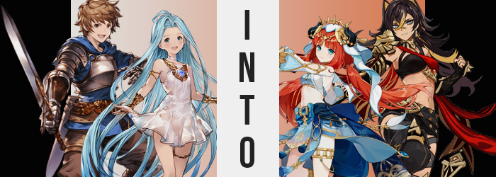

“This island is so huge! Way bigger than we thought!”

Lyria was in very good spirits, which in turn left the captain of the Grandcypher, Gran, feeling happy as well. It had been a few days now since they had landed on this island within the depths of the sky. Not an island that was uncharted, but one that wasn’t often visited by outsiders because it was too far out of the way for most travels. The island of Sumeru. But Lyria’s comments were well founded. Despite being a sky island, it was almost as large as a continent. There were jungles, a desert, hidden ruins…

And it was only natural that an island of this size, at least one where people lived, had a large population. A large population in need of help, and a large population that paid well for that help. Not that Gran and his crew took this as a chance to exploit others for money, that wasn’t their attention. Helping people was primary and if that helped them fill the ship’s coffers for future travels then that killed two birds with a single stone.

The two had actually come to the island’s capital, Sumeru, on one of these jobs. The Grandcypher needed a few more days of repairs to be ship shape thanks to storms they had encountered on the way in, and so the trip itself looked to have become at least a week long endeavor. “So this is the Bazaar? It’s so busy…” Gran couldn’t help but note how hectic things were. Lyria and himself had been asked to help bodyguard a theater troupe known locally as the Zubayr Theater.

It had been an easy job so far, with the two simply accompanying the performers and a group of local mercenaries that had likewise been hired to help protect them as they moved around the city. But the two had found themselves strangely distracted throughout the job; not that Gran and Lyria themselves had really noticed all that much. For Gran specifically, he’d been unusually interested in the part of the theatre troupe that appeared to be supporting the performers.
The prop and costume designers had been hard at work ever since they had settled in at the Bazaar. That made sense though. The stage was there, and there seemed to be a show happening later that evening. The way their hands moved as they concocted and sewed, it was quite captivating. A little too captivating for someone who didn’t really know much about the craft, nor didn’t care about it typically.

“Hey, can you come over here for a second?”

“Huh? Oh, sure!” While he’d been staring at him, one of the women in the troupe had suddenly called out to Gran. He hadn’t been sure as to why, maybe they’d caught him staring? But she was clearly pointing at him. So after getting telling Lyria where he was going, he went over hoping he wasn’t about to get into trouble. “What’s up?”

The woman answered Gran’s question while moving behind him and pushing him forward to a small changing booth that had been erected beside the tables they were working on. “Could you help me model something? You’re always such a big help!” She wasn’t really giving him a choice was she? After all, he was already in the booth with her closing the door behind him.

“Uh… Sure! Is it a decoration, or…?” He was pretty sure he’d seen the woman who had beckoned him over working on what looked like a costume meant for a woman? But being unfamiliar with Sumeru’s fashion perhaps he was wrong? Strangely, there was no response. “Hello? Should I come out?” Still no reply. In fact, why was it so quiet outside? The hustle and bustle of the Bazaar had become dead still.

And he couldn’t seem to open the door?

Gran arched an eyebrow. “Uh…?” This was a temporary changing room, a shabby looking structure they had thrown together with materials on their carriage. A medium strength wind likely would have blown it over, and yet he couldn’t even shake the structure much less wiggle the door free. Almost like it was frozen in place. “Hello? I think I’m stuck?” There was no response again, which led Gran to one conclusion. “I guess I can just climb out…”

He was tall enough to do that. The walls weren’t very tall, so with a bit of a jump he should have been able to grab the edge. It meant taking off his armor pieces and laying down his blade first though. Which he did. Yet when he sized up his jump after the fact? “What…? Did the walls get higher?” It seemed like they were a few inches taller than he remembered – which was enough of a gap that he was less confident he could reach the ledge with a jump. Well he wouldn’t know until he tried, right?

And so he did.

The young man immediately understood that it wasn’t just the walls that were bigger the moment he jumped. How? Well, his pants, boxers, and even his socks and shoes slid off his body, pooling on the floor beneath him. “HUH!?” By the time his now bare feet landed down on that pile, at least his blue, hooded sweater covered his crotch and butt, but… “Did I get smaller?” He had obviously missed the top of the changing stall, too. There was no way he’d be able to reach it at this height.

It was only a few inches, but it was enough. Examining his hands, though? Was it just a matter of his height regressing a little bit? His hands looked and felt smaller and daintier. Where were the thick callouses their adventuring had accumulated? And as a chronic nail trimmer, why did his nails now extend an inch past his fingertips? This was all mirrored in daintier feet too, for they were fairer in size and while not without callouses, those that existed were much less prominent.

“I… What was I…?” An opportune wave of amnesia rendered Gran incapable of questioning the bizarre situation he found himself in. His movements had become more delicate against his notice, and his body itself was being remolded into a trimmer shape in the meantime. Muscles that clad his body diminished largely, but it was more prominent in his arms than anywhere else. Muscle in his legs, chest, and even tummy remained, but they were certainly leaner. Suggesting he would remain someone who was physically active, but not one who had trained his arms as tirelessly as he had in the past.

There was a dip in his waistline too. One that almost seemed to better highlight the width of his hips, or at least that would have been the case if those hips in question hadn’t ultimately highlighted themselves. Gran stumbled a bit inside the booth before finding his footing again, widened hips prompting smoother knees to point in towards one another slightly. “Is… something wrong? I feel like something is… off…?” Even the sound of his own voice struck the captain’s ears wrong, and yet nothing came of that concern. It was simply swept up in the acceptance that reassured him that there was nothing abnormal whatsoever.

Lips pursed a moment before closing into a resting pout that hadn’t be present before. An effect made possible because his lips were slightly plumper in design than they had been before, and even then this was just a small part of what had been happening to Gran’s face. Eyelids fluttered anew with lengthened lashes around an eye shape that was notably rounder, and these took up more of a face that seemed a little smaller, a little more circular in shape. It was notably feminine like a young woman in their early twenties, complete with a button nose and irises that soon shone with turquoise. At the very least? This face was a better match for his new voice.

Tufts of brown locks that had once been styled into spikes softened and fell; not from his scalp, but in length as they fanned out towards his rear end. A bright red shone midst the brunette, eventually overcoming it while bangs framed his gaze like a pair of proper curtains. Eyebrows received this red as well, as did a trimmed bush around his dick. Which, come to mention it…

“Mmn… A-Ah!? This isn’t the time or place to get so uppity!” Gran had idly moaned, nibbling at his lower lip in the process. At least before he had caught himself. Or, well, she had caught herself. The high of arousal had been the doing of a change in her biological sex, and so after growing erect so suddenly? Her dick had instead gone flaccid, shrinking to the point that it mended with her pelvis and a slit that led to reorganized organs took shape beneath her crimson bush. A proper woman’s pussy.

Thighs rubbed together from the temporary feelings of need, and with her hips widened? That probably shouldn’t have been possible. Her thighs had been parted farther by those hips, and so it would have only been possible if there was more to her thighs. Which there, in fact, was. Skin was pulled so tautly around them that they bore a shine, excess weight prompting her ass to bloat up with bubbled cheeks that lifted the back of her hoodie.

Said hoodie likewise disguised a related change, but only because it was oversized and baggy, and the change in question wasn’t too excessive. Where her chest had once been completely flat with nigh a scrap of excess, fatty tissue had begun to accumulate beneath her nipples, prompting those nipples to swell all their own in the meantime. What took shape beneath stretched skin was a mere B-cup bosom, yet that seemed like plenty upon her delicate shape. It remained hidden by her sweater, with sensitive nipples rubbing against the underside.

Yet in a blink that issue was alleviated. A cropped top with woven blue and white clad this chest, leaving her tummy exposed while a matching headdress with faux, black horns upon it decorated her head of hair, now styled into twintails. Detached sleeves with golden clasps had found her arms, and a short skirt with a sash tied in the back left her legs almost entirely exposed. Aside from golden jewelry and heels. This was in every way the outfit of a performer. Of a dancer.

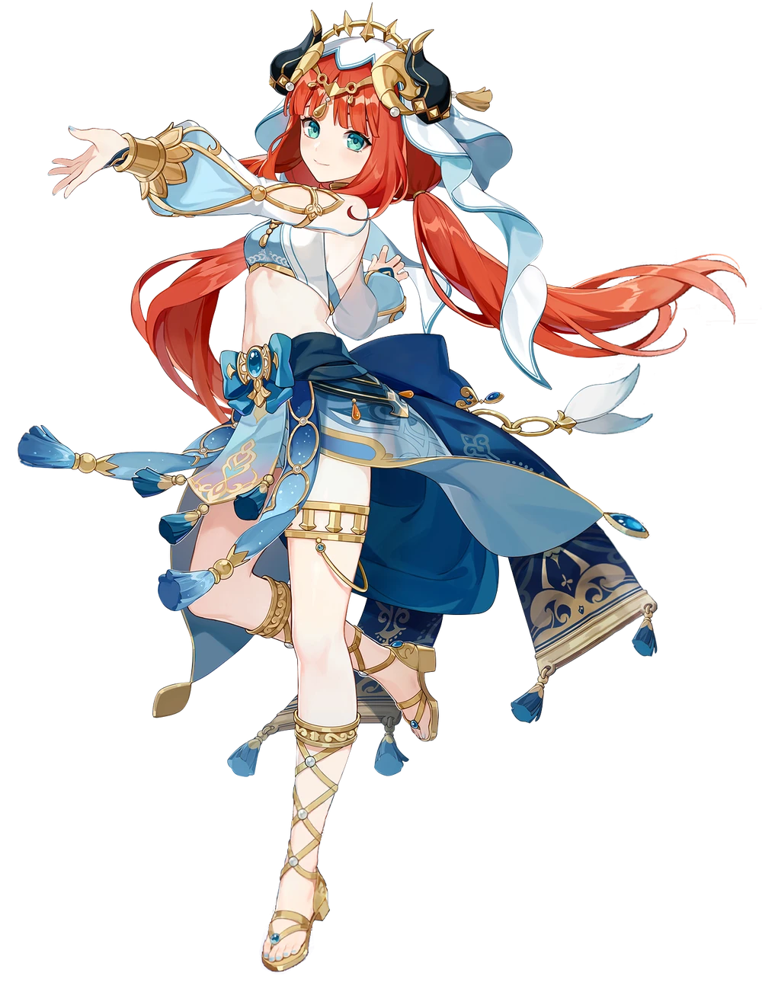
“So! Lady Nilou, what do you think? Is the fit alright?” The sound of a familiar voice set to the backdrop of a busy Bazaar was what ultimately stirred the red-headed young woman from her own confusion. In fact, hearing that voice seemed to provide a great deal of clarity as the final doubts as to her own identity were dismissed just from hearing her name. Nilou. She was undoubtedly Nilou, a dancer of Zubayr Theatre that was well loved by her fans.

Now that her mind didn’t feel so heavy she did a little twirl so that she could answer the questions that had been asked of her. Nothing in the outfit came loose, not did anything feel too tight. “It’s perfect, Najia! I’m sorry you had to work on it, but the costume designers are busy with other things!” Najia was typically assigned to props, but their show that night was going to be a big one and some new aspiring dancers were joining her on stage.

The redhead opened the changing stall door and stepped out delicately, smiling at the props engineer as she gave a slight bow of thanks. “It’s fine, Nilou. Happy I could be of help. After all, you do so much to keep the troupe going.” She really was the heart. Everyone in Zubayr loved Nilou, and she loved them. As Najia left her alone, Nilou gave a little wave.

“Of course! There’s nowhere else I’d rather be after all!”

After Gran had been beckoned over by the theater troupe staff, Lyria had been left to her own devices. Without anything to help protect the staff from, there wasn’t much use for a bodyguard. She was just left standing around. “They’re all so strong, aren’t they?” But her blue gaze kept wandering over to certain individuals that had been working alongside them. The mercenaries that had been hired from the desert region of the island.

The men and women alike were big and visibly strong, carrying out physical tasks as they secured the area and set up seats and props given to them by the theater with ease. Lyria wondered, idly, what it might feel like to be someone that strong. “Hey! You’re not doing anything, right? Can you check behind the stage? Heard some kids were running around.”

“Y-Yes!?” She was taken completely off guard when one of the mercenaries had spoken to her, giving her a job to do. That was strange, though? Lyria clearly wasn’t one of them. Maybe he had just noticed that she was bored and had given her a job? If it was just some kids, that was definitely something she could take care of.

And so she went behind the stage. It was dimly lit, but there were clearly props and performance supplies stashed there. It was probably a dangerous place for kids to me. “Hello? Is someone here?” Not only did she receive no reply, but it had gotten eerily quiet outside too. Had something happened? She certainly hoped not.

Something had happened, though. In fact it was in the process of happening. But not to anyone else. Just to her. The beautiful shade of blue that Lyria’s hair had always been her constant companion was the first real victim of this process. From the roots to the tips it was all darkening, first towards a navy blue and then to black, before lightening a touch towards a very dark brown. But this was on the surface. Some of the hair beneath was a golden copper color.

You could make out streaks midst it, but this become more obvious when the style changed. A layer atop her head rose to almost resemble cat ears, and not only could you see the copper inside, but the bangs that crossed between her eyes took it on too. In terms of style it wasn’t only her bangs and the top of her head had changed. It had all shortened in length to the middle of her back, but rather than being perfectly straight it was wild and free.

“I guess no one is around… Well, less work for me! …Huh? I didn’t… mean that…?” Lyria didn’t typically bemoan work, nor did she look for ways to cut corners. That wasn’t quite the vibe those words had been going for anyways, but it was still much more casual than anything she would typically say about work. She shook her head, coarser hair bouncing about from the gesture.

Much like she hadn’t noticed her hair, the Girl in Slightly Less Blue didn’t notice the remnants of that blue dwindling in kind either. Her eyes. Their blue luster was stolen, a piercing silver laid bare instead within eyes that bore a sharper design. Her eyes had narrowed in the corner and her lashes had grown longer. It made her appear racially different, something that was emphasized not only by continued changes to her face, but a creeping darkness to her skin tone. Little by little her usual pinkish tone was erased, instead replaced by a copper that was only a little lighter than the highlights of her hair.

When it came to Lyria’s face though? It wasn’t merely a case of taking on a different racial profile. She appeared increasingly unlike herself, and increasingly unlike her usual perceived age. Lips inflated wonderfully, almost beestung in their swollenness while her nose grew and her face seemed ‘fuller’ on the whole. There was a maturity to it that gave off the impression she was likely in her mid-twenties, even if her body didn’t give off that impression otherwise. Yet.

“Don’t get paid if you don’t work though. A sad part of… life…?” What was she saying? Why was she saying it? Since when had her voice been so deep? It almost sounded like something Lyria had overheard those mercenaries saying, and she was speaking like it personally affected her. But… didn’t it though? Did she not work with the same lifestyle? “No, I… Uh…?” Something was wrong and yet she had no means of identifying what that was.

It was a lifestyle that she was now destined to grow into, and literally at that. Like a plant that had somehow been watered with some sort of miracle solution? Her body began to sprout upwards at an alarming rate, inches applied not only to her height but to the broadness of her body as well. “Wah!?” Such a dramatic change in body mass not only lifted her dress, but her body soon outgrew it to the point that she was rendered naked as tanned flesh tore through the cloth and gold jewelry fell to the floor with a clang.

She had been rendered completely naked in a matter of moments, height having ascended to about 5’6” while her hips and shoulders had widened to give her a broader, more hourglass-shaped silhouette. But while initially smooth? The terrain of her flesh quickly grew more rugged. Muscles tightened and swelled from her arms to her legs, raw strength rippling while beads of sweat traced their grooves. She was rightfully muscular now, with a strength that matched the image of a mercenary that she increasingly had in mind for herself.

Scars and cuts etched themselves into her skin, callouses forming around her hands and feet to suggest having lived a more physical lifestyle. Yet while there was a rugged femininity to her overall appearance, some softness did bleed in. And in the places you would most certainly expect it to, seeing as her womanly figure had yet to mature beyond her height.

Her breasts were first, the flesh of her bosom rippling as more and more was siphoned into their pockets. Copper skin tightened around them as the rippling turned to jiggling, then to straight up bouncing. What were once practically non-existent had ascended into a pair of perky D-cups upon an otherwise muscular chest. Not that her new personality thought much of them; they were simply there.

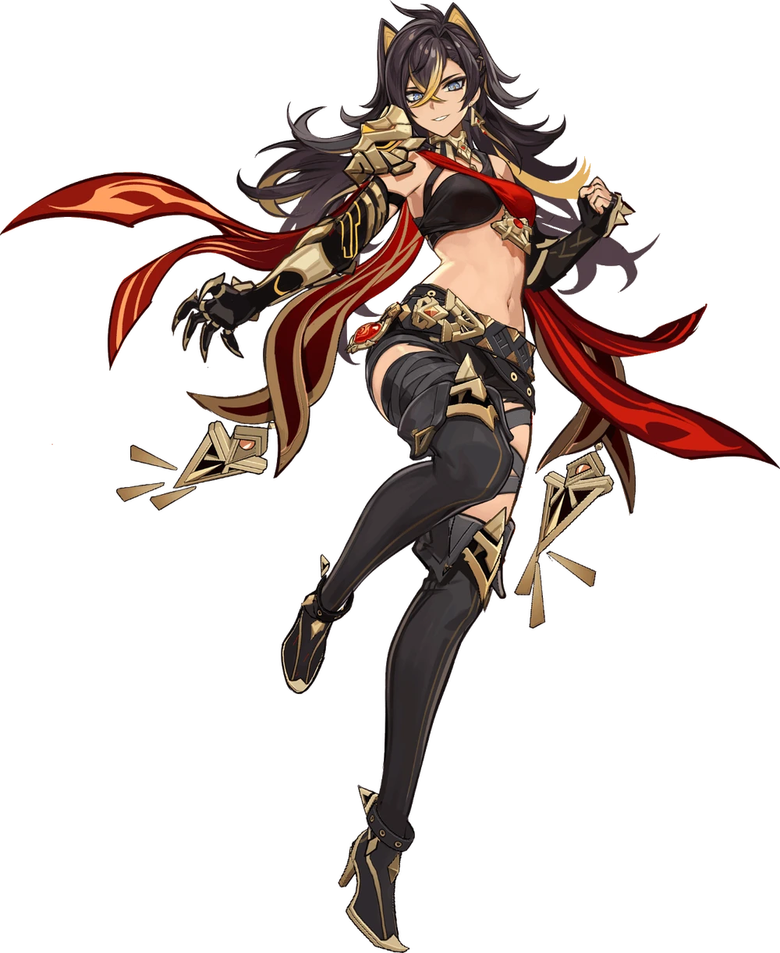
Her sentiments were applied similarly to the curvature below. Her muscular ass lost a touch of its tightness because her cheeks ballooned, an enticing heart shape curving down into equally swollen hips that surrounded a bush of long, dark-colored pubes. But black shorts and a thick, black and gold belt quickly hid this along with a black thong. It was part of a greater outfit change that saw black and red wrap cross across her breasts almost like a bikini top, black fingerless gloves and golden gauntlets across her hands, and thigh-highed black boots with golden decorations. She certainly looked the part of a mercenary, and the big broadsword now fastened to her back certainly contributed.

Noise returned to the woman’s surroundings as time began to flow once more, and all at once the tall, muscular, tanned woman snapped back to attention. “Woah! Huh…? What was I doing again?” Rubbing at the back of her head boyishly, Dehya felt like she had just forgotten something important. This was behind the stage in Sumeru City’s Bazaar, right? After a second her mind managed to make sense of the situation.

“Right… Nilou hired us again. That girl pays well, but maybe she’s a little too cautious hiring mercenaries to guard a show?” Not that the mercenary would complain about the money. She just knew that some of her fellow Blazing Beasts Ermites tended to get bored when things were quiet, but they take the paycheck anyways. “And there were kids back here? I don’t see any… That’s probably for the best.” The Ermite woman wasn’t bad with children, she just didn’t want to give them trouble.

Dehya was both strong and kind. It made her popular, and it was no wonder that she paired well with Nilou of the Zubayr Theater. She had become something of a common hire for the Theater as a result. Dehya gave a little smirk to herself while wandering back to the front of the stage. “Speaking of, I should make sure everyone’s favorite dancer is doing okay!”

She knew she was, though. Nilou was always in high spirits.

But what of the Grandcypher? Well, it was only a matter of time before the other crew members were swallowed up. Not only by Sumeru but the neighboring Teyvat islands as well. There was a reason people didn’t generally venture out this far into the sky. It was because those that did seldom returned.

