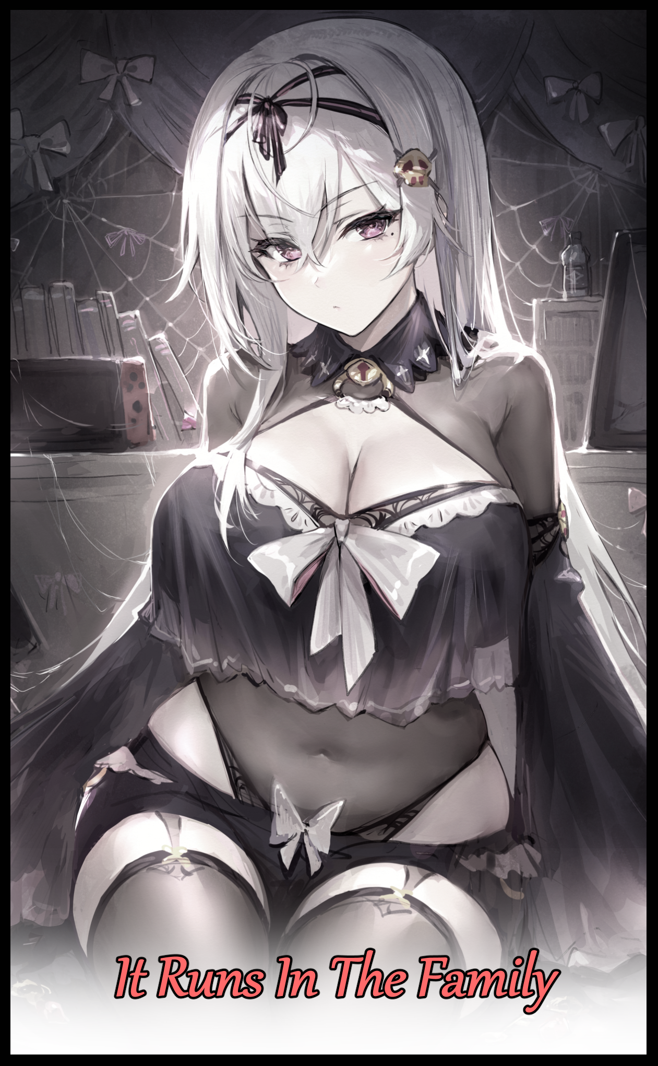

Gregory Rosemont had thought himself a strange individual, born into a family boasting an immense roster of eccentric women besides him and his dad who was almost never home thanks to his job flying him to all corners of the world, the boy understandably felt alienated from his mother and sibling ever since he was a kid. Playing alone, eating in his corner of the dinner table without much talk, spending his days cooped up in his room or playing games by the telly. It was a distant life that made him feel like the odd one out, like there was something wrong with him.

If that wasn't enough, the schools he enrolled in were all different from the ones his sisters attended. According to his mother, it was to 'facilitate a better environment' for them to learn in, but to Gregory, it was just an excuse to hide something behind his back…until a curious incident before the start of his highschool life would turn Gregory's world upside down forever.

It was on the night of his sixteenth birthday, the sixteenth celebrated yet again with just his mother in attendance when he would awaken within him an ability once thought exclusive to the women of the Rosemont family; the channeling of mana through his body.

In other words; Gregory could cast spells and achieve a whole assortment of magical feats through the use of the mana flowing within him. A rarity amongst men, and although it was weak, Gregory's mother had been quick to notice the flow of magical energy flowing within her son the moment he had put his hands together as he usually would when the time came for wish making, although he wasn't usually the type to dream, his lack of training in the field of witchcraft meant his body was instinctively burning through the mana in an effort to fulfill his desire to no avail. For as fickle as magic was, not even skilled wielders of the otherworldly power could grant their wishes with a simple thought for there existed no well of power great enough to accomplish such a task. But that's besides the point.

Because with his ability to channel mana made clear, Gregory's mother was more than eager to break the news of his magical inheritance and the detailed history behind the Rosemont's well kept secret. And all she needed to do to convince him of the truth in her words was to simply ignite a globule of blue fire in the palm of her hands with a quiet incantation. Promising he could soon do the same if he simply agreed to quit life as an ordinary boy going to school and embrace that of a magic practitioner. And of course, Gregory being the juvenile youngster he was, readily accepted his mother's offer.

To him, this was the moment where he would earn his place in life, figuring the reason why he'd spent so long being 'out of touch' with the world was because of this one true calling he had been born to fulfill. And it didn't help that the tales his mother, now known to him as a prolific witch thanks to said stories, was feeding him further led Gregory down that line of thought, unaware of any potential negatives the title of a rarity might hold when applied to the world of magic. Something he was completely unaware of until now.

For one, his mother never mentioned the fact that there was no such thing as men who could channel mana. While there were wizards who held mastery over the art of shortening and enhancing incantations, they all required a staff or a suitable medium with which to channel mana through in order to cast spells. And the second, arguably most damning one of all Gregory's not so truthful mother was more than aware of;

What would happen to a man born with the rare genetic defect that enabled his body to act as a suitable vessel for mana channeling….more specifically; the effects of continued spell casting using said technique.

Over the next few weeks, Gregory's mother would go about setting up the groundwork for her son's 'disappearance' from the world at large, going through paperwork and a little bit of magic on the side to ensure everyone he had met, every school he studied in, every clinic or hospital housing medical records, was stripped clean of anything to do with the fledgling wizard.

And while she set about doing that, Gregory would be introduced to the hidden study he never knew existed just out of sight beneath the staircase. A typical entrance for a witch's treasure trove of knowledge as far as magical tropes were considered.

Within that centralized repository of Rosemont knowledge, the excited young boy would begin the arduous path of a wizard in training, pouring over books, scrolls and thick leather bound tomes, some written in fanciful English while others were scribed in a strange language comprising symbols Gregory had never seen before. But thanks to a conveniently provided monocle his mother had given him, all he had to do was put the nifty thing on and it would begin siphoning the mana stored within him, acting as a real time translator of sorts tuned to that specific language, allowing Gregory to read just fine. It was strange not being forced to leave the house on weekdays to go to school but it was a lifestyle Gregory would soon grow attached to; waking up in the morning, making hot cocoa to take with him into the study before burning through another hefty pile of books focused on a bevy of content ranging from spells, alchemical recipes to fantastical creatures. A mere peek into the world he could not yet enter.

Once his mother was finished with her cleanup operation however, the smile she wore on her face was one of satisfaction more than sincere affection to see her boy so focused on his new line of study. Poking fun at him while removing the monocle that had aided him in deciphering the alien text all.

"It's a joy to see you taking this all with great stride but...you will need to learn the individual alphabets some day, you can't keep depending on a crutch after all if you hope to be a proficient spell caster just like mommy! Not to worry, even though you're a bit late to enroll, I'm sure you'll learn plenty with me by your side!"

Through his eyes, Gregory's heart was bubbling with excitement, eager to begin learning spells and fling fire. But through his mother's calculating crimson slits, she simply couldn't help but adore the brilliant shade of platinum silver her son's drab brown hair had taken on during her absence, ruffling Gregory's head with just as much excitement as her son had…and an eagerness to rekindle the warped image her boy no doubt must've harbored against them for years now.

For indeed, she wasn't oblivious to the way Gregory was being treated around the house, nor did she mean to subject him to said life. But with the need to mentor, care for and ensure her daughters were all set to become independent witches coupled with the duties entrusted to her as one of the most famous witches alive bearing the Rosemont name, there was just no time to spend with Roderick, even his birthday parties were last minute affairs for her, and behind the smile she wore on her face, her heart broke every time she saw the light of youthful vigor dwindle and fade in her son's eyes. Despairing over what to do while her hubby was unable to help, stuck in a similar limbo of endless work.

That is of course, until she saw the unmistakable flow of mana coursing through her son on his sixteenth birthday when he would perform the annual ritual of wish making he always did ever since he learned it. Never in her life had she thought herself to be the one to bear a son with the fabled ability to wield mana, but it also had her casting an oblivification spell the moment she had calmed herself enough to deliver the good news to her son. And despite his incredulity, the look of awe on his face once she spawned an orb of chilling flame in the palm of her hand was a memory she still took immense pride in whenever she thought back to that moment in time. But why was there a need for her to cast a spell meant to mask the victims senses with a falsifying veil cast over their reality?

Firstly, to prevent unnecessary panic. And secondly, she wanted to keep what was happening to Gregory a secret, planning to reveal it at a later time when he least expected it as a surprise of sorts, a reward for whenever he would graduate from her private educational institute of which he was its newest and only student in attendance. The white hair was simply the start, a sign that she hadn't been seeing things that night thanks to the monocle she had deposited back inside her pockets, serving the dual purpose of allowing Gregory to read the ancient tongue of her people and to test if he really could channel mana in the first place, since if he couldn't, then he wouldn't have been able to read most of anything stored within her family's archives.

Now that she was free of work thanks to official leave granted to her by her handlers in taking care of her son's 'unique' quirks and ensuring he became an upstanding member of their society, Gregory's mother couldn't wait to get to tutor her son, teach him everything she knew just like she had her daughters before him.

Although when the time came for him to graduate, the wizened witch was more than aware of the fact that she needed to think of a good name to christen her student once Gregory's body had fully adapted to the non stop use of mana she was about to subject him to. But more importantly, all the fun and familial bonding they could ever want along the road to get to that point.
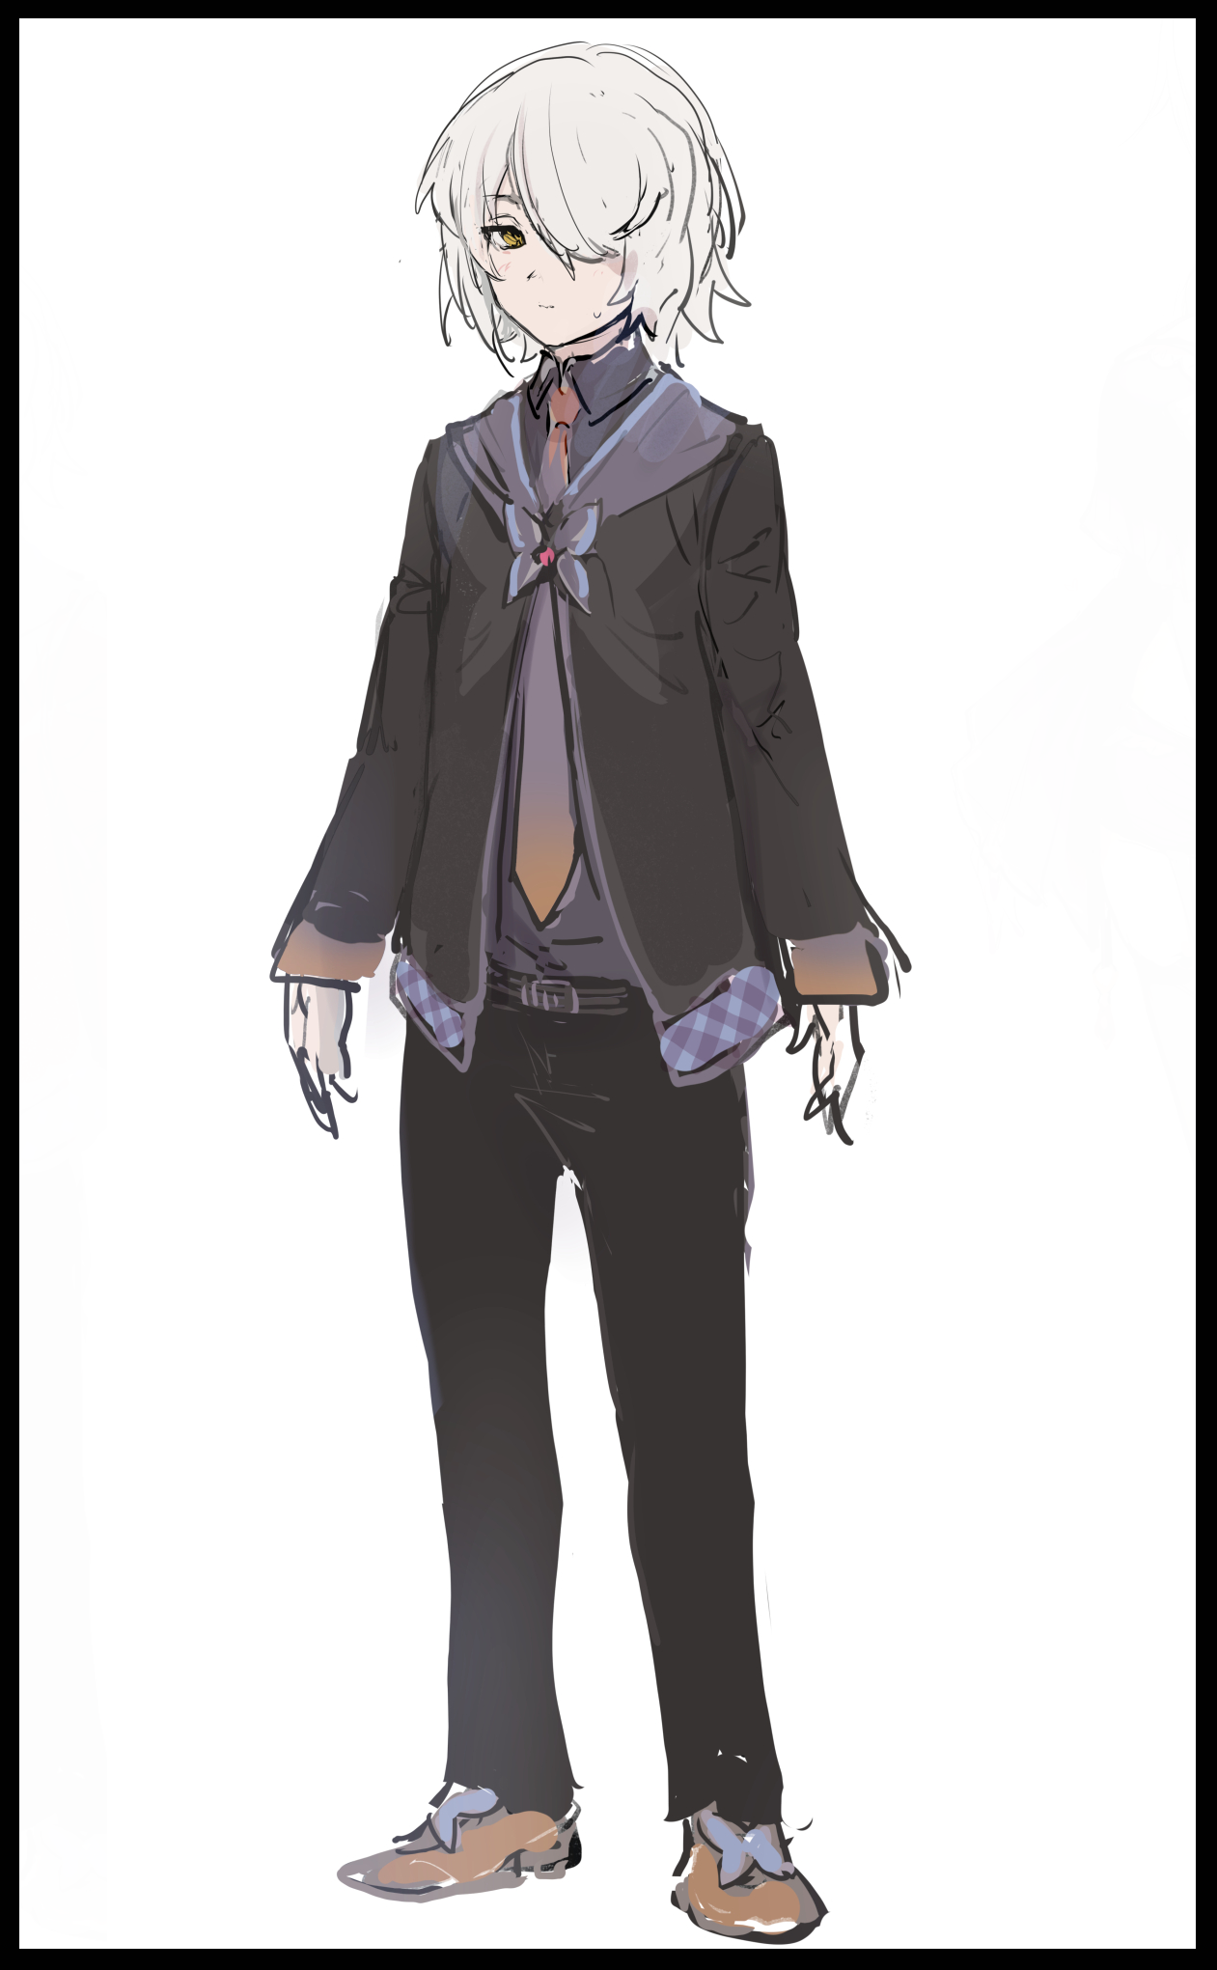
Over the next few weeks, Gregory, now adorned in his new mages uniform (actually composed of hand me downs from his older sisters and a mix of men's wear tossed in for some assurance), would begin actual hands-on lessons that were surprisingly demanding in the physical department.

If it could be described in simple terms, it would be like running increasing distances each day, except he was training his ability to channel more and more mana into his body, teaching it to hold more and release less based on instinct alone. And the fact that his mother couldn't help him here made that process all the more harder to master. Oftentimes he would either take in too little or release too much, both of which would instantly make him feel lethargic and out of breath. Needing constant breaks in between each try to freshen up and recharge, and despite the strict nature in which she conducted these sessions, not once did Gregory's mother seem to scold him. Coaxing him with bits of wisdom every time it seemed like he would lose faith.

"A mage can't hope to cast if they're overwhelmed by panic and fear, breathe in Gregory, close your eyes if you must. Feel the words, focus the mana within your chest…then let it out through the tips of your fingers…you can do this!"

Each time he would take his mother's words to heart, and slowly but surely, Gregory would soon begin to get into a steady rhythm once he found a suitable output and input he was comfortable with. Leaving a satisfactory smile on his mother's face by the time he had managed to contain a blue ball of cold flame, leaving it dancing in the palm of his hands just like his mother had on his sixteenth birthday a few months ago, albeit at a smaller scale.

By then, Gregory's physical appearance was beginning to change, losing that bit of manly edge around a face that was starting to nurture in the final stages of puberty while his hair seemed to continue growing well past the ordinary length for a boy his age. And the consistency they took on was far too silky and fair, as if he was slowly taking on girlier traits the more weeks sped the mother-son duo by.

With each incantation memorized, every second spent playing with the spells that could be conjured forth by reciting them, every time he channeled mana in greater and greater portions through his body, it was undeniable at this point that there was indeed a metamorphic affliction that had taken ahold of the growing boy. And by the time he reached the ripe age of seventeen, Gregory had changed dramatically despite him not knowing about it much to his mother's chagrin.

While she went through lesson after lesson with her son, her eyes were never far from his body, scanning through his bodily makeup with enhanced eyes that gave her front row seats to the biological changes going on unnoticed beneath the skin. And through the marvelous use of mental replays and memory editing, her evenings were spent piecing together clips of bones slowly growing outward in certain places while receding in others, masses of organic tissue coming together to form new organs, filling up the open space left in the wake of Gregory's altered skeletal structure. While on the surface, minute changes were ongoing, blessing the boy with porcelain smooth skin of unparalleled quality, bereft of the fine hair follicles he was beginning to grow in abundance while what little musculature his frail form possessed was being repurposed, softened into pliable layers of supple fat aligned with perfectly sculpted flesh that served to improve the growing boys gaunt figure with curves and dips especially prominent around a toned midriff that was gaining a rosy red tint with each week being checked off the list on what his studious mother predicted to be a three year course for her son to become an intermediate mage in addition to his body finally completing it's transition from a pupae brimming with potential into a gorgeous butterfly bobbing with vigor.

By the time he was two and a half years into his education, Gregory's once lean silhouette was permanently chiseled into the beginnings of an hourglass figure, gaining a cute bob cut head of white grown from his unruly mop while the seeds of a woman's pride took shape from atop his chest, budding mounds of soft, sensitive flesh and fat riddled with reactivated nerves and glands set to produce the sweet nectar vital for a newborn's sustenance in the near future. Tipped with swollen pink nipples and dull areolae his mother had a hard time getting used to seeing poking out like tents on a uniform that was gradually conforming to its wearer's increasingly feminine proportions.

Besides a dull ache emanating from somewhere below his flat tummy however, Gregory remained ignorant to all that had happened to him ever since starting his magical studies under the continued supervision of his mother. Never wasting a day to improve himself even when she needed to leave the house to see to his sister's, who he couldn't wait to show off his prowess to once he could finally join them on the other side of the etched maple door his mother had shown him on his most recent birthday as a reminder of the whole new world awaited him in just one year's time.

Every morning since his mother had cast the oblivification spell without his knowing, Gregory simply saw himself as a normal teenage boy, growing up and getting ready to transition into life as a young adult. Brushing the teeth on a face he'd known since forever, washing his lean bony body etcetera etcetera. Never once realizing he was applying lipstick over increasingly plump lips to go in the morning while lifting tender breasts to ensure every nook and cranny was thoroughly washed while he showered, lathering soap down between smooth, meaty thighs with dainty hands, connected to firm calves that were a vast improvement over the frail sticks they once were.

Thanks to his mother's intervention, Gregory was spared the horror of knowing his pecker was slowly wasting away every day, receding back inside his body with the wrinkled sacs containing his testicles long since having vanished altogether, replaced by the beginnings of a smooth opening into what would soon be a tight, virgin slit of the fairer sex. While he could still see it clearly, the magic clouded his mind from the fact that he couldn't even grasp ahold of it any longer, needing to wash it by gently lathering his nethers with gentle strokes that elicited the flames of arousal within him, strong enough to penetrate the haze that kept him oblivious to the changes. Although he thought nothing of it, keeping his mind off such distractions through continued study and practice, none the wiser to the fact that it only served to hasten the loss of his manhood as the tip of it shrinks away into a blanket of damp, pink flesh atop a puckered snatch contained by plump, untouched lips crowned by a pale lane of silver pubes beginning to grow out in a neat strip. All while his mother happily kept track of her son's progress, smiling giddily to herself as she watched her newest daughter take shape from the withering form of Gregory, which by now had already been entirely replaced.

With the lack of a penis and the presence of a fully functioning vagina connected to a womb that lay dormant for now and prominent C cup teats tenting the now inadequate clothes he had been instructed to wear since year one, it was clear that Gregory was no longer fit to be called a man. And to her mother, that meant she was ready to be gifted the new clothes she had weaved especially for her; the magically imbued garments of a witch. Unique ones that were tailor made for Gregory's form alone.

Gifting her with the new clothes as a present for her eighteenth birthday, it was clear to see that the newborn girl's mother was more than happy to see her child don such 'mature' clothes despite doing so without realizing how revealing the suit and trousers she was seeing really were, as was expected of the maidens sired forth from the Rosemont family. In Gregory’s case, her outfit consisted of billowing sleeves, semi transparent silks and a one piece leotard lined with frills that showed off every single curve her voluptuous figure sported.

To Gregory, it was nothing more than an expensive tuxedo set embroidered with golden thread and more of the Victorian styled fluff he had grown familiar with over the past few years. But to his mother, she was watching a gothic phantom flourish before her, spinning on heels with a long curtain of white adorned in cute yet brooding accessories, trailing behind her long enough to tickle the extended curves of a heart shaped ass straining against the garter straps and hot shorts that held it down. Barely conceiving the length of a lace thong built into the leotard rubbing up between immaculate legs pumped full of blubber and muscle. Fidgeting as a wry smile crosses her face after inspecting her reflection in the mirror.

'Oh I can't wait to see the look on her face once she realizes what she truly looks like!'

And so Gregory's last year as her mother's protege would commence, taking her to new locales once hidden to her like a sizable indoor training room of sorts capable of simulating a variety of scenarios for her to fight through, solve or simply to meander in as she pleased. Now that almost all of the basic to intermediate tier incantations were known to Gregory, the study they had been using up till now was no longer an adequate place to safely practice, not when there were advanced incantations capable of summoning forth incinerating firestorms and rending swirls of hailstone. They'd wreck the study for sure!

But just like she had aced the last two years, Gregory would do the same for her take on the advanced tier incantations her mother had expected her to take all year long to get down. Shortening the phrases for the aforementioned firestorm spell and combining it with her strange penchant for ice magic, turning the simple whirlwind of fire into a neon blue craze of dancing flame sprites scattering razor sharp fragments of ice at blistering speeds all around the circumference of the storm. Surprising her expectant mother but also opening herself up for further critique like controlling the amount of mana she poured into the spell. If she kept up like this, she'd be sapped dry after just two to three casts.

"What will you do if your opponent has a nullification spell capable of erasing your offense? Or if they move fast enough to dodge all you throw at them? Defense my dear! You might want to put some consideration into that if possible…although If you were to refine your offense…make it so that no one can bypass it…you might very well be a powerhouse all on your own!"

Unsure of which path to take, Gregory would assume the role of an all rounded, jack of all trades. Raising an equal proficiency in both sides her mother had taught her to consider. But behind her back, the up and coming witch was beginning to grow aware of what had become of her body.

Since the spell had been cast almost three years ago now, it's effects on an increasingly powerful witch was beginning to wane, granting Gregory brief glimpses of her new appearance and gender when her focus was at its highest, particularly during moments of lucid dreaming where she would awaken in a fit of cold sweat, glimpsing heaving breasts clad in women's nightwear for just a fraction of a second before her vision would ‘correct’ itself to the male body wrapped up in plain white pajamas as if she was simply hallucinating. Initially, she had chalked it up to some side effect of casting spells that demanded a great deal from her, but the more times they happened, the less the troubled witch would think they were a simple coincidence.

After crossing a hallway and catching sight of a silver haired woman dressed like a harlot reflected in a hanging mirror instead of her well kept self, that was the last straw that urged Gregory to seek out advice from her mother, asking if she knew what was going on with her strange visions, lucid dreams and hallucinations. And from the look of mild surprise that crossed the woman's face, it seemed she really did have an idea as to what was afflicting her, sighing heavily as if she was…disappointed?

"Come with me dear…my, my, you never cease to amaze do you?"

Crossing her room over towards a full body glass mirror built into the walls of her private study, Gregory seats herself down on the chair her mother directs her toward, sidling over behind her before placing both hands on either side of her head as if bracing her for something to come, making her shoulders tense up in anticipation and dread as if she had done something wrong.

"Look forward now dear…and please, be calm okay? What you're about to see…I understand it could be abit of a shock but I assure you, it's not malignant in nature…ready? When I count to three, I want you to blink, okay? One…Two…Three!"

Shutting her eyelids on the final count with an unnatural wind blowing through the room, Gregory's eyes widen in shock as a whole bevy of new sensations rock her body, feeling her chest sag forth while the rod between her leg vanishes, feeling the warmth of her exposed thighs pressed together while a silk curtain tickles the nape of her frail neck. In a split moment, the young man she had always known herself to be was replaced by a stunning gothic beauty sitting in her place. Gasping in a hushed voice that made her body tingling.

"Sorry dear…I was planning to save this moment for until you graduated but…I never expected the spell's hold over you to weaken so quickly…in truth, you've always looked like this. Ever since I gave you those clothes during your eighteenth birthday? You peaked sooner than I expected…so I guess you being able to break free of my magic wasn't too much of a surprise…do you like it?"

"B-But how…how long has this…oh gosh…is that my voice? I sound so…"

"Wonderful? Hahh…while what I told you about men who can channel mana through their bodies being a rarity wasn't a lie…I might have omitted a few details…like how it's more of a genetic defect than a-"

"D-Defect?! So this wasn't a gift like you said it was?!"

"C-Calm yourself dear…this was what I hoped to avoid when I cast the oblivification spell the moment I noticed you were channeling mana! It might sound negative, I know…but it's more of a…process of rebirth."

"Rebirth?"

"Hmhm! The reason why you became female was because the act of channeling mana within an organic vessel requires…well, the consumption of an essence only found within men…by casting spells or doing anything that would take from the vast stores contained within your body…well, it's sort of like burning your manhood for fuel to power your spells with! It's why normal mages need stuff like wands or other vessels filled with an artificial reproduction of that essence to cast spells with…and umm…while we witches can channel mana effectively on our own through our own way, taking in that essence…helps improve our abilities greatly!"

"B-But you said that essence comes from…men…right? I-If I run out…what will happen?"

"Oh dear, you've already run out a long time ago! You're one hundred percent female now! See? You've even got a bosom that's as big as mine! The reason why I had you prepare was to maintain a high level of magical aptitude so by the time your body adjusted to being that of a woman, you wouldn't need a refuel anytime soon to pull off the feats you're capable of now."

Blushing upon her mother's shrewd remark, Gregory's attention falls back down to her body, realizing just how provocative her appearance was…yet…she couldn't help but feel right at home despite remembering clearly how it was like to be a male, in her original form not too long ago. Her gorgeous face, pale white hair, attractive figure, she couldn't see it as anything but hers and hers alone…and it sort of made her feel a small sense of pride despite how a small side of her brain knew it was 'wrong'.

But the bit her mischievous mother mentioned about 'refueling' had her a bit concerned…

"W-What's that 'refuel' thing about? Is it something I have to learn in the future?”

"Ohh…well…that can come at a later time~ For as beautiful as you are my dear…I'm afraid it's still too early for you to be privy to such things…anyway! I've come up with an excellent new name for you considering your new appearance and all."

"A new…name? But M-Mother…I…this is all just so much to take in…"

"I know dear…again, I'm so sorry. I was too excited, too wrapped in what-ifs to think about how you'd react to it all…if you'd like, we can take a break from your studies and…well…get you acquainted with your new form? I assure you, being a girl isn't as hard as it sounds…in fact, you've been acting the part just fine ever since you started going to the toilet like a proper lady!"

"T-Toilet?! Mother! You can’t just-"

"But it's true! I can share some recollections if you’d like? Contrary to what you’ve been seeing all this time thanks to the oblivification spell, you were actually acting quite appropriately to your new gender when your hormones balanced out and all your new organs became fully functional. I was suppressing the more drastic changes but from here on out, you’ll be menstruating and maybe…just maybe…lactation might be a common occurrence…in my experience at least. Your sisters have had little trouble in that department but…you take after me surprisingly well my dear Gretchen~ Your hair! Your face! It all reminds me so much of my younger days! Dare I say you might even have the prowess to catch up and surpass me someday!”

“Gretchen…but Mother…do I really…can you truly say I have what it takes to-oh?”

Embracing her daughter in a warm hug, the newly named Gretchen falls silent as particles of light begin to trickle into her vision from somewhere behind her, gazing into the mirror in shock as her mother transforms, shifting into what she could only assumed to be her witches attire, gaining a lustrous sheen of white that paints itself over her chestnut brown hair. Shifting from an ordinary housewife into an otherworldly mistress that didn't look that far off from Gretchen in terms of appearance. All while the room around them began to unveil it's true form just like its mistress had; peeling apart the early Victorian architecture and furniture designs to reveal dark, shimmering metals, cobwebs lined with cute spider based decor and pale sheets draped over almost every surface..even the chair she'd been sitting on turned out to be a satin bench of sorts, lined with mahogany and inlaid with gold.

It really was true; she looked alot like her mother did…instilling within her a pang of joy and a soothing wave of calm as her parent and guiding figure traced a warm hand over her cheeks, pinching and squeezing them playfully.

“You’ve mastered the ancient script…learned almost every single incantation there is to know up to the advanced tier while adapting some in ways not even I could think of at your age…dear…you are amazing! Even before you showed the potential to become a witch, I always cursed my inability to help you…to give you the normal life you deserved, but never once did you take it out on me or your siblings even though every day was a another in a wasted childhood…now look where you are; how far you've come since then! Take pride in the fact that you, my child; are special in your own way…but, we still have quite a ways to go~ After all, there's still alchemical theory I have yet to teach you!"

“Y-You noticed all this time? I thought…I thought no one knew…cared about what I did…"

"Oh baby…I am your mother after all…boy, girl, it doesn't change the fact you're my son. Witchcraft aside…you being a special case has finally allowed me to spend some much needed time with you…but are you displeased? Like I said, I didn't mean to deceive…but if you're offended, I understand…"

"Offended? Hardly…I was just…shocked is all…and about that break…I think I'd very much like to continue our lessons together. Like you said; relax too early, and I might just lose my edge right?"

"You really do take after me Gretchen…but…as hard as you want to work yourself. I'm afraid we must both sate our hunger if you hope for me to supervise you at my best! So…I'll be headed downstairs to cook us up a storm…and once we've eaten, we'll be right back in the thick of it, deal?"

"Deal…oh, and…Mother? Thank you…for everything!"

"Think nothing of it dear~ In the meantime, feel free to take a look in your room. I think you'll want to see what the oblivification spell has been hiding from you all this time~ I'll see you later then!"

Waving her daughter a temporary farewell, Gretchen's mother takes her leave from her room, leaving her to sit alone in front of her own reflection, curiosity growing stronger within her heart as she shifts in her seat, warm blush returning to her deathly pale cheeks as she fidgets to and fro, magenta hued eyes narrowing into mischievous slits before whispering something in that cool, yet husky new voice of hers that had Gretchen growing more and more conscious of her bodacious figure and the growing need to…’explore’ every single inch of it.

Before shaking her head in frustration, rising to her feet before storming out of her mother’s room in flustered shock at the audacity of her hormonal instincts baring itself so soon after sharing an endearing moment with her mother, painting a slim smile on her face.

The past two or so years had been the best years of her life, thanking whatever this ‘defect’ was if it meant her mother now had the time to devote to her after spending fifteen or so years barely making contact with her family. Feeling her heart skip a beat upon the realization that she would have to face her father whenever he came back from work, wondering how he would react to the news that his quiet boy was now a young woman. And besides showing her skills off to her fellow siblings, maybe she could flaunt her looks whenever the time came to join them wherever they were now. Leaving Gretchen Rosemont’s heart burning with a renewed vigor for the future and what it held for her…

THE END

