Complex Numbers – Formula Sheet:
Complex Numbers in Rectangular Form:  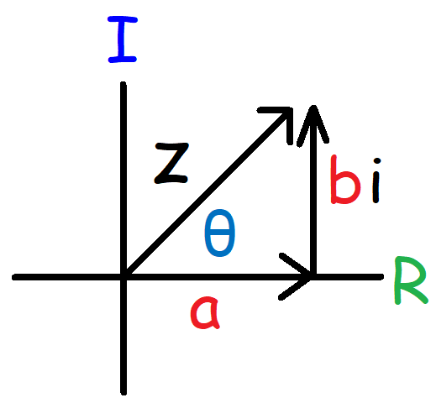 | Imaginary Numbers:  $$i=\sqrt{-1} i^{2}=-1 i^{3}=-i i^{4}=1$$  Complex Number in Rectangular Form:  $$z=a+bi$$  $$a=r\cos{θ} b=r\sin{θ}$$  Absolute Value:  $$\left|z\right|=\sqrt{a^{2}+b^{2}}$$
Complex Numbers in Polar Form:  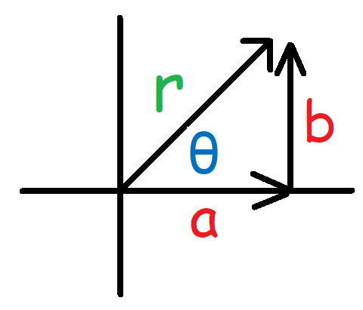 | Complex Numbers in Polar Form:  $$z_{1}=r_{1}[\cos{θ_{1}+i\sin{θ_{1}}]}$$  $$z_{2}=r_{2}[\cos{θ_{2}+i\sin{θ_{2}}]}$$  Modulus $(r)$ and Argument $\left(θ\right)$:  $$r=\sqrt{a^{2}+b^{2}}$$  $$θ=\tan^{-1}\left(\frac{b}{a}\right)$$
Product of Two Complex Numbers:  $$z_{1}∙z_{2}=r_{1}r_{2}\left[\cos\left(θ_{1}+θ_{2}\right)+i\sin\left(θ_{1}+θ_{2}\right)\right]$$ | Quotient of Two Complex Numbers:  $$\frac{z_{1}}{z_{2}}=\frac{r_{1}}{r_{2}}\left[\cos\left(θ_{1}-θ_{2}\right)+i\sin\left(θ_{1}-θ_{2}\right)\right]$$
De Moivre’s Theorem – Power of Complex Number:  $$z^{n}=r^{n}\left[\cos\left(nθ\right)+i\sin\left(nθ\right)\right]$$  Exponential to Polar Form:  $$e^{iθ}=\cos{θ}+i\sin{θ}$$  $$e^{i(0°)}=1 e^{i(90°)}=i$$  $$e^{i(180°)}=-1 e^{i\left(270°\right)}=-i$$ | De Moivre’s Theorem – Roots of Complex Number:  $$z_{k}=\sqrt[n]{r}\left[\cos\left(\frac{θ+2πk}{n}\right)+i\sin\left(\frac{θ+2πk}{n}\right)\right]$$  $$z_{k}=\sqrt[n]{r}\left[\cos\left(\frac{θ+360°k}{n}\right)+i\sin\left(\frac{θ+360°k}{n}\right)\right]$$  $$k=0, 1, 2, 3, 4, …n-1$$  Shortcut Notation:  $$r cis θ=r[\cos{θ}+i\sin{θ}]$$

