*Tempering Her Flame*

*Siggy Commission for TheQuelch*

Sarah Wellington, a rather inconspicuous name you could apply to a great number of girls without much trouble. You'd think that such a pleasant sounding name would fit a beautiful maiden with a bubbly personality or maybe a soft spoken girl that could be so much more once you got to know her.

But the Sarah Wellington that lived just a few streets down in a rather backwoods suburban area in a certain city was anything but beautiful.

Born and raised as the eldest daughter in a well off family, Sarah had been living the high life from the moment she could learn to speak her first words; coddled by her mother and sent to prestigious schools where like minded folk were aplenty, Sarah's mind set had been warped into that of a jaded noble girl, looking down on 'commoners' and anyone that she disliked, running her own clique back in her high school days. Treating her siblings the same way she did those she picked on in school, breaking their toys or ignoring them all together.

While her parents were initially skeptical of her behavior, they still entertained her requests for pocket money whenever it came up seeing how deep their pockets were with Sarah's dad being the CEO of some banking firm while her mother was a well sought after interior designer.

But when the time came for college, Sarah had to face the real world as it was without her funkiest backing her up. And with how stuck up and snotty she was, it didn't take long to decide on the de facto outcast in class for the rest of the students.

With her ego so badly bruised, Sarah had descended into an inescapable pit of rage and spite, hating the people she saw as inferior who dared gang up on her and even growing to become a recluse who spent most of the day playing games and venting her frustrations through the microphone in very audible and very frightening bouts of furious yelling.

But with her parents, especially her mother, beginning to grow fed up with her behavior, it was only a matter of time until they took things into their own hands on how to handle their wayward daughter. Sending her for consultation, or worse; exile from the family to some backwater farm as suggested by her strict father, who was rarely home at all because of the work demanded of him.

Refusing to change and still stuck up to her neck in her ways, it seemed the road Sarah was taking had no further chances for course correcting…

That is, until a nameless hacker with a fetish for MILF's (or as he liked to call it; an exquisite taste for women) would chance upon the Wellington family. Browsing disciplinary records, private messages and calls between regretful parents and finally; to a blog run by the family's oldest daughter, where post after hateful post ranting about how tiresome life was could be bundled together to form a digital tome that could be used to tutor any wannabe edgelord.

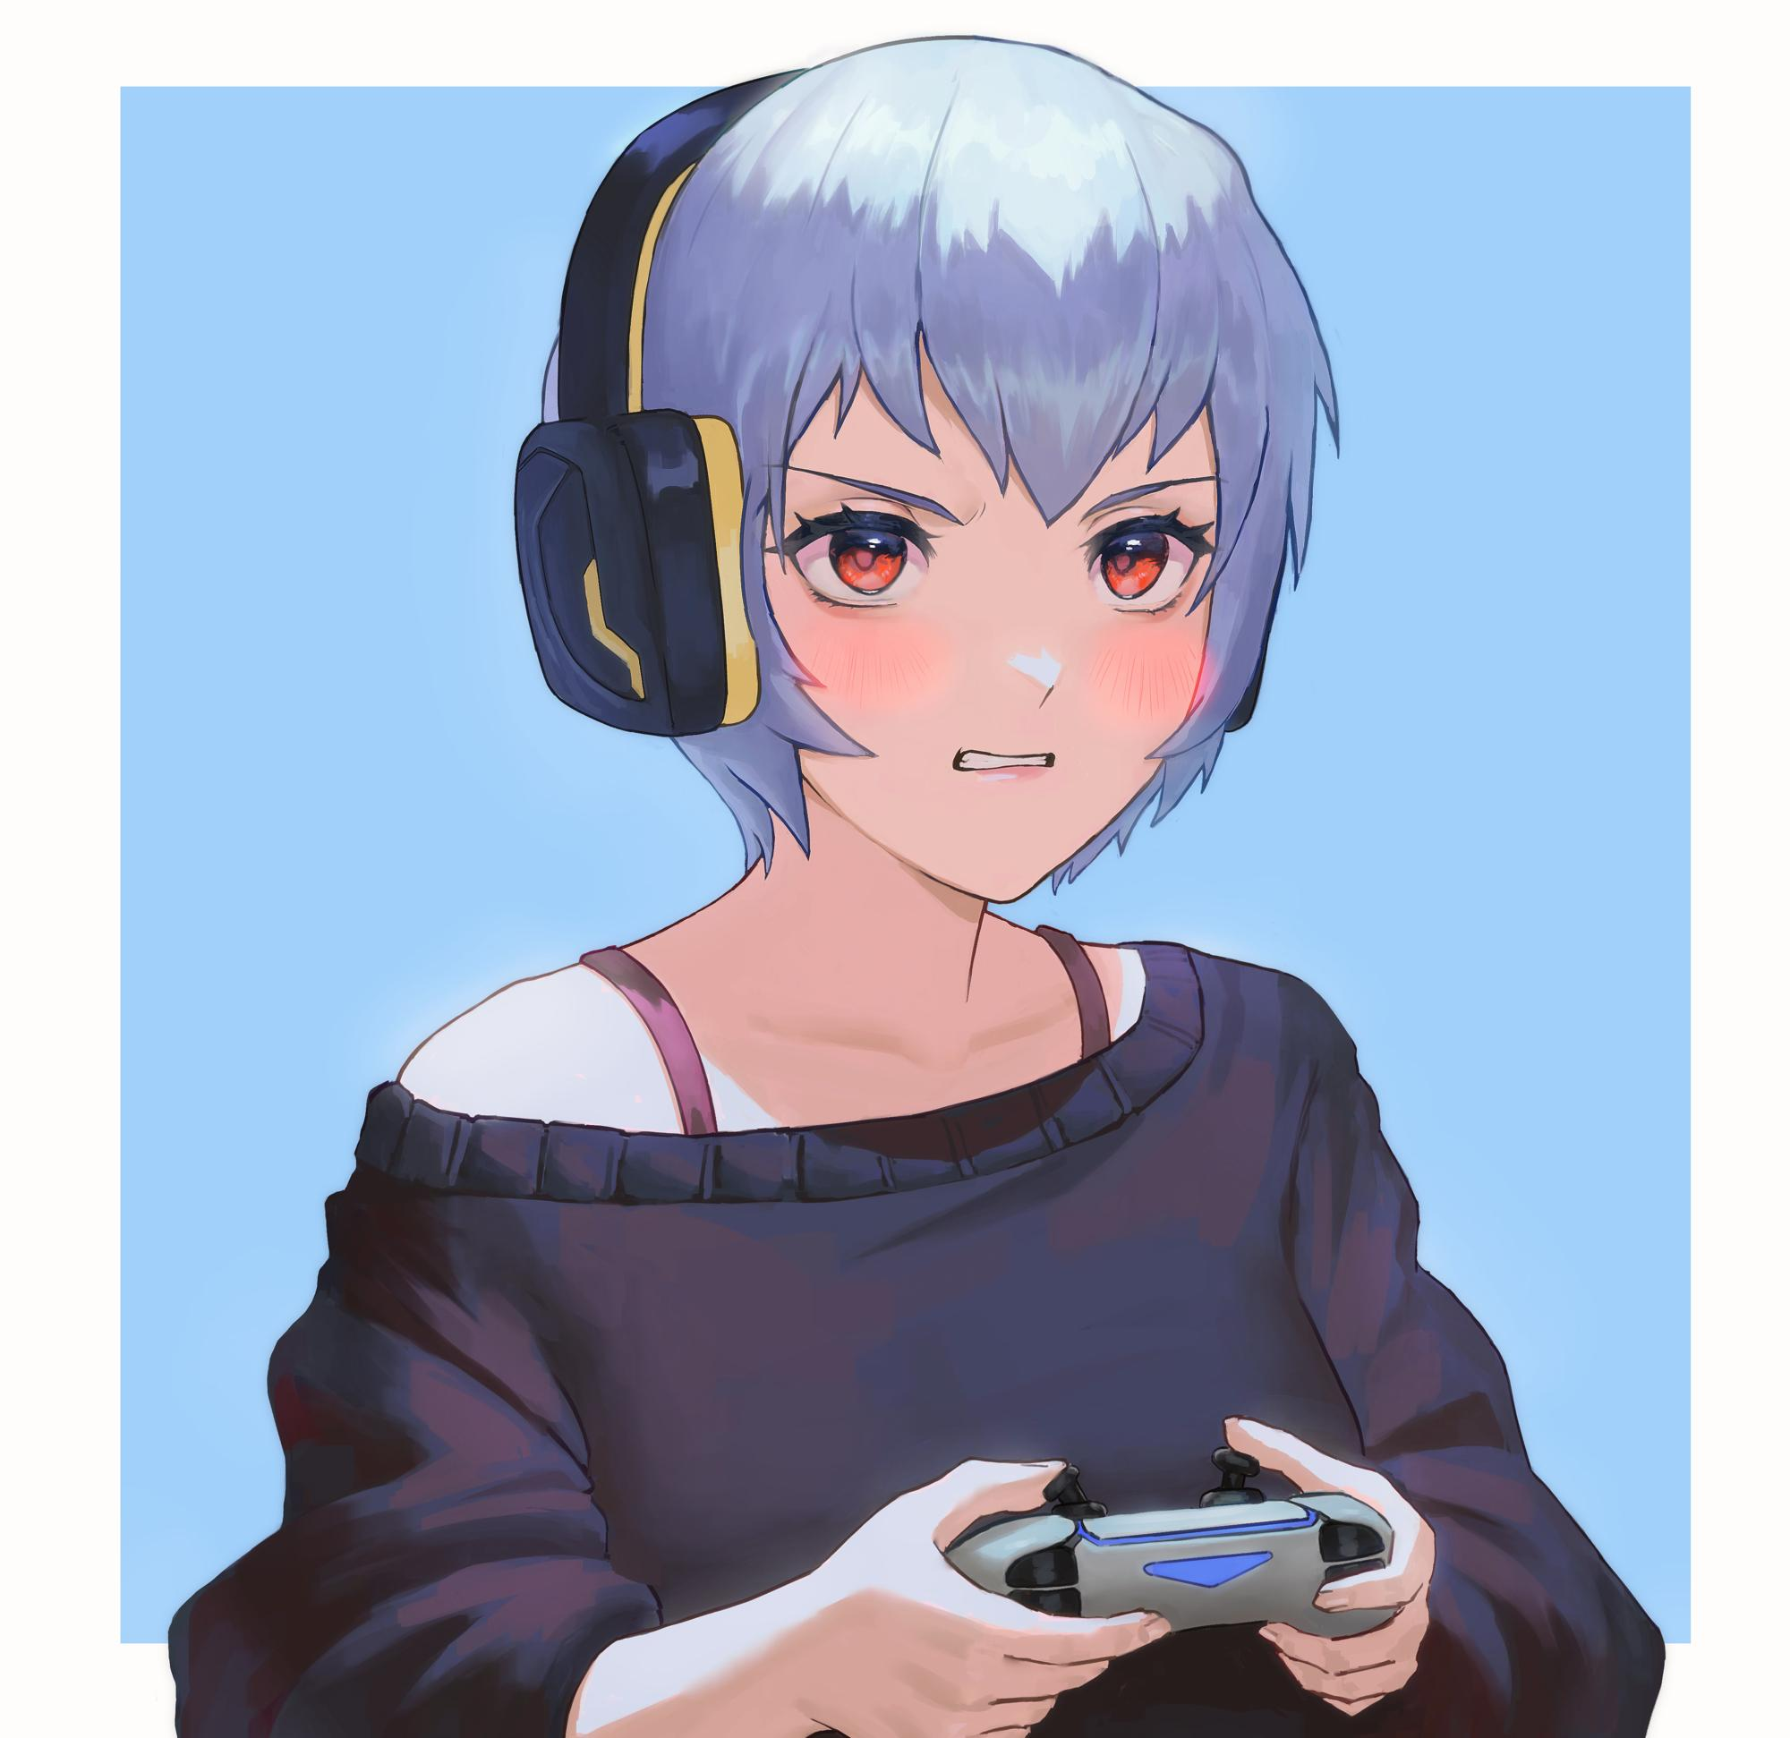

But viewing the face of the young woman with the beginning of eye bag under her eyes and her once auburn head of hair now dyed a gaudy platinum silver, the hacker sighs deeply at the flower she could've become if her parents had raised her right…not like the fault lay entirely with them, but still, it was a regretful sight to see.

**"Jesus…how far gone is this girl…"**

Not being one to leave a struggling family hanging, the man prepares a file just for her, taking on the name of one of her more 'devout' followers that were really just nutjobs feeding her ego and sending her a message on the site before logging off. Whatever happened next, would be entirely on her hands. Whether she accepted his help or simply deleted it, he didn't quite care.

For a deep web hacker implicated in many crime rings and dubious deeds, the man still had a soft spot…

**“God fucking damnit Troy! You had one fuckin’ job and you fucked it!”**

Behind the thick mahogany doors with a sign hanging off it with the simple message of 'DO NOT DISTURB' scrawled in full capitalization and very angry strokes, thunderous banging could be heard reverberating down the halls of the empty household. Not surprising considering it was a bright Saturday morning right outside. The perfect day for a family outing downtown, or maybe at the beachfront for a relaxing weekend on the sands.

But that didn't sound appealing to the irate young woman hunched over on the floor in barely anything but her jacket and underwear, with a pair of headphones clamped over her mottled head of hair and her eyes stuck fast to the television monitor installed in the wall, furiously moving her fingers across a controller in her hands as she focused all her attention on the game, cursing and shouting for every perceived failure on her teammates part.

By the time the game was over, very angry replies could be heard pouring into Sarah's headphones, gritting her teeth as she exits the lobby, throwing the controller to the side and removing the headphones as she groans in annoyance, sidling over to the desktop similar moved to the floor to check on any messages in her very active online forum. Raising her brow in surprise to find a newly sent message from one of her more familiar internet friends, someone called **Nickian778**.

**"What the hell is he on about? This some mod pack for that Sim game?"**

Opening his message, Sarah's eyes poured over the senseless drivel about improving her life before finally coming to rest on the attached file simply labeled *'Maturity Leave'*...maybe it was some sort of pun on the name for when pregnant women took days off from work or something.

Misinterpreting the intention of the message, the oblivious Sarah drags the attached zip file out of the email and onto her desktop, opening the installation folder for the game she had assumed it to be for, since she didn't read it as if it were addressed directly to her. Thinking instead of that one life sim game she was proving terrible at.

And so, without even checking for viruses and going all in, Sarah opens the zip file…

**"Seriously Nick, what the…hell? It's…pretty~"**

The moment her cursor finger had slammed down for a double click, the still screen of Sarah's computer exploded into an array of multicolored lights that instantly enraptured the witless mind of the young lady caught in its otherworldly glow.

But just as soon as it starts, the screen fills with static before dying just as suddenly, snapping Sarah back to reality as she blinks for a few moments, wiping away the drool leaking down her chin before realizing her desktop was dead, groaning as she moves over to the desktop in the hopes of a simple reset being able to fix things right up.

Unbeknownst to Sarah however, the ass scraping across the floor was a lot firmer than it had been before, filling with toned flesh that had begun to grow across her body soon after snapping out of her hypnotic trance. Slowly pumping her frail, skeletal physique with supple layers of pudgy fat and muscle where there were none before with the oblivious Sarah continuing to fiddle with the desktop all while her arms become slender branches ending off in dainty twigs tipped with clean, pink shells.

**"Cmon, don't die on me…"**

With her lean shoulders rounding out to match her widened neckline, Sarah readjusts her posture, letting loose on the strain pressing down around her belly as a thick layer of baby fat weighs down on her navel where a gaunt stomach once was, nicely accentuating her hips as it slowly widens out into porcelain smooth handlebars that was just as soft as it looked, spreading her widening legs apart before wincing at the sudden sting of her now ill fitting underwear as it cinces into the sensitive skin coating her larger, heavier frame.

Making a mental note to order herself some new set of underwear, Sarah slides the string of her panties a little lower down her now plump thighs, exposing the beginnings of a hairy bush of blonde pubes beginning to sprouted atop her snatch, squirming a little as her hair likewise follows suit, lengthening down her shoulders in long silky smooth waves that were beginning to take on the same golden yellow coloration from the roots, brushing a rogue fringe and tucking it behind her ears before slouching to get a better look at the components, no longer squinting with her eyesight recovering as years of reckless gaming and overnight binges begin to leave her entirely, in both body and mind.

**"Aw shucks…the CPU's looking a little cooked…"**

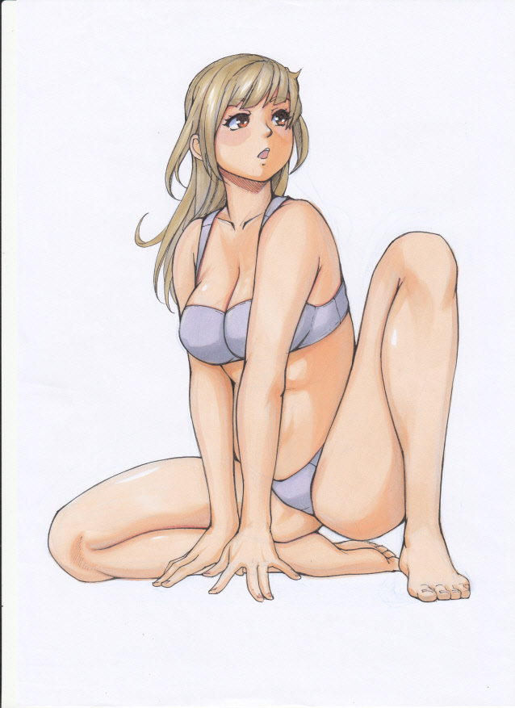

Not even caring a lick about the kinder words that now punctuated her crude vocabulary, Sarah pulls the desktop closer, beginning to take it apart in the hopes of replacing the damaged component, but just like her memories of gaming and being an overall toxic individual leaving her, Sarah's previous familiarity with technology would soon follow suit, frowning at the thingamabob in her hand she should've known was a graphics card while her once flat chest begins to inflate, bloating with fat, nerves and milk with her sky blue bra soon struggling to hold back the naturally firm and perky D cups, rubbing up against the warm desktop until she finally sighs in defeat, carefully depositing the GPU back where she had found it. Without the proper knowledge in computer repairs, Sarah couldn't do much but bring it in for a repair.

**"Geez…maybe Ma would know something about this…"**

But just as she grabs the phone off her bed with the intent to drop a message, the poor bra holding on for all this time finally gives up the fight, snapping off its clasps before taking off like a rocket all the way onto the other side of the room, leaving Sarah topless as she lets out a surprised **"oh!"**.

**"Dear me…I'm getting a little too old to be wearing these things…"**

With her sore breasts hanging free as they begin to throb and bloat with a little bit more girth, Sarah scoots over towards the wardrobe, with her unsteady gait normalizing into a familiar trot with her bubble butt jiggling behind a hypnotic sway to her child birthing hips with her brain shorting out for a second as fabricated memories of a jovial time at highschool, a successful college timeline and even new ones involving work at a law firm fly by in an instant, leaving no doubt in her tingling mind to the 40 year old lady she now was as the cheeks on her face sag a little to match up right with the accelerated aging taking effect across her body; loosening her skin with previously firm layers of buoyant fat now hanging slightly off her frame.

But just like the mother she was beginning to think of as someone else entirely, Sarah's body was still a delight to look at if not a little bit of a pain to handle with a dull ache now present in her joints and a heavy pull on her shoulders as her breasts finish growing one size up into double D tits as firm and full as she remembered them being in high school. Biting her plump lower lips at the memory of her exciting youth in high school; popular with everyone and just as much of a tease with the boys, the scenes of horrid bullying and skipping lessons with the girls she once cherished were warped over with new flicks of her first time being taken from her by a lovely young man by the name of Ben, smiling validly as she withdraws a skimpy pink bra that was thin enough for her erect nipples to peer through as her body begins to heat up at the suddenly vivid recollection of the stunning jock pressing her into the cold hard surface of the bench in the locker rooms as he made her a woman. Rubbing her thighs together as her hymen vanishes to match the new history of the many men who were lucky enough to bed her afterward, vaginal muscles and lubricated walls loosening up as both the memories and sensations of having raunchy sex perforate the new timeline she inhabited.

But it wasn't as if she did it for the sake of it, sure; the sex was great, but she wanted a man to love her for who she was, a man who didn't mind her age that would make most people lose interest entirely. Someone that loved Sarah; the spunky romantic MILF.

With her mind newly reformatted and her angsty young self all but locked away in the back of her mind, Sarah walks over to retrieve her old undergarments, looking upon them lovingly as she stores the old keepsakes away after getting the urge to try them on again after so many years after growing out of them. Hefting her milk filled teats with a giggle before doing a spin in front of the full body mirror that had replaced the case full of games and manga previously leaning against the wall. Not that she seemed to mind as she tossed her lengthy mane of blonde to the side, looking far more vibrant than it had been only minutes ago.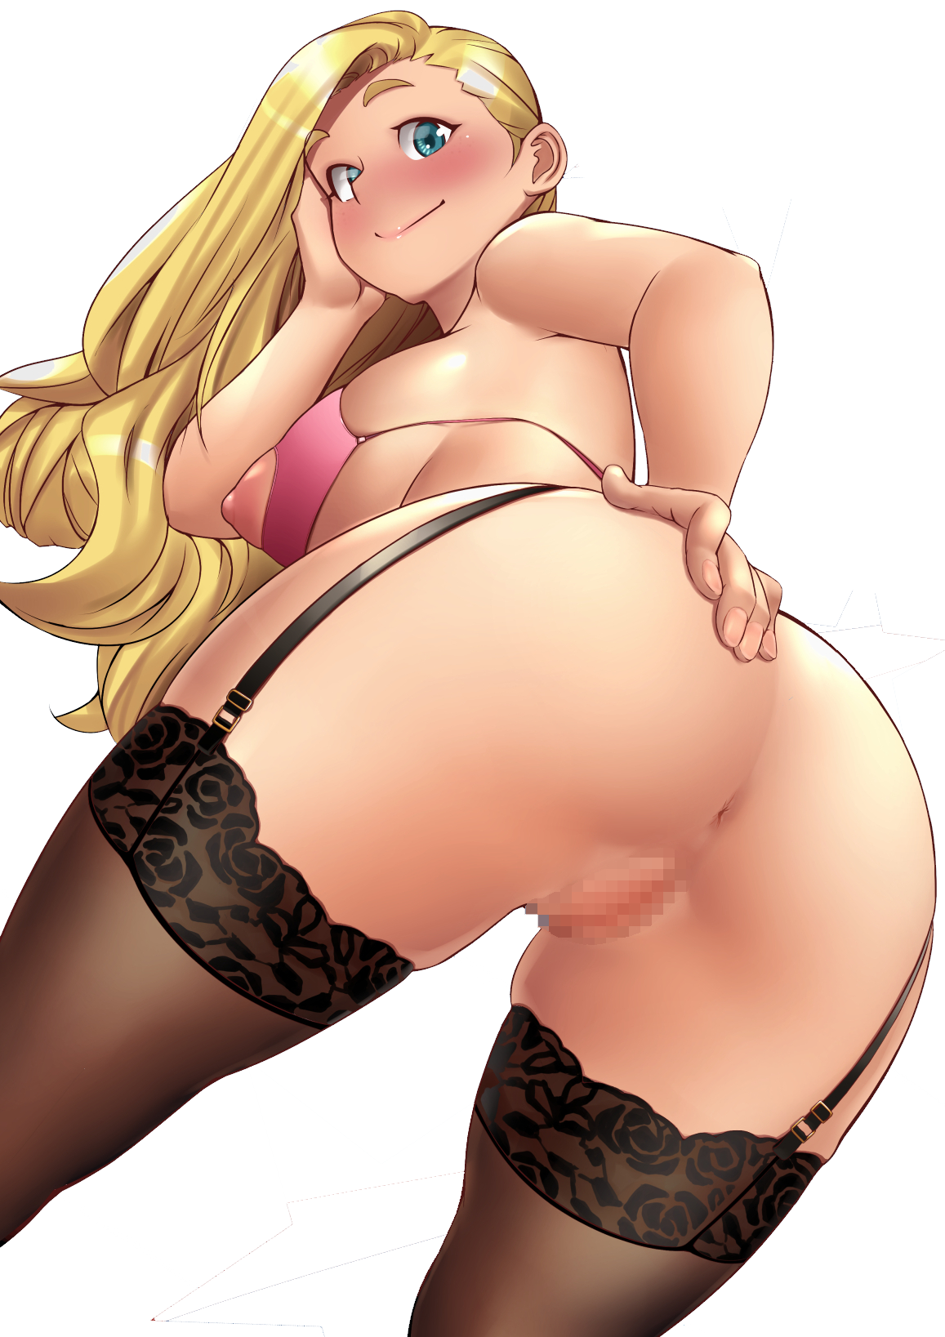

**"These babies have grown a little too big for you I'm afraid…ahh, almost forgot my panties, silly me!"**

Unsurprisingly, Sarah's once modest wardrobe of dresses and normal underwear had changed to fit her salacious habit of bar hopping whenever the night fell on weekends, dressing in her best dress with a very exciting package beneath…the very same package she now wore in the form of a string bikini top with stunning heart shaped cutouts to provide easy access to her bright pink nips and a sexy set of lingerie connected to translucent leggings…also with a suspicious gap where you'd expect cloth to be to cover up her aching snatch. For where she was going, that spot was going to be filled with something else entirely, smacking her rump in the mirror as she ogled the reflection of her loose mature pussy while shaking her ass in the air.

For as innocent as her intentions were, her body and her actions most certainly weren't.

But before Sarah could proceed to prep the desktop for the short trip down to a mechanic she knew, the sounds of a baby bawling from the next room over grabs her attention. Dashing right outside without wasting a breath when her old self would've just screamed at her baby sister to shut up.

Pushing open the door to her mother's room, Sarah scoots over to the crib by the window, gently bringing the bawling baby within up to her bosom, cradling her with gentle bobs that soon bring her to relative calm.

**"There, there Rachel~ You're alright now~ Oh? H-Hey now, if you're hungry there's-mmppf?!"**

Before she could do anything, a sudden pang of pleasure from small teeth gnawing on her swollen teats silences Sarah, forcing her to take a seat by the bed to steady herself with her baby sister's efforts to fill her belly coming to fruition as a trickle of warm mothers milk begins to flow forth from her nipples, dribbling down her smooth skin and onto her underwear…just as her blue eyes widen for a moment.

For just that one split second, the last vestiges of the spoiled brat that Sarah once was had broken free of the trance, coming to a realization that she never had breasts that big before and that her irritating sibling was now nibbling on them and making her feel good.

*'Wait just a fuckin’ second that…that's not right? Is it? This shit isn't what I do!'*

But the more she gazed upon Rachel's happy face as she suckled on her nipples, the more she felt that wholesome warmth spread in her heart, overpowering the sudden spout of anger her old self had been infamous for. She didn't know what this intense feeling was, but she knew she couldn't fight it for long.

With the desire to be a mother realized no matter how artificial it was, the old Sarah finally gives in to the dull ache that had been imposed upon her to ease her back into the mentality of the spunky cougar she now was, longing for a child of her own as she smiles warmly down at Rachel, stroking her head and cleaning up after she was done drinking her fill. Only to be interrupted mid way through as the door to the room opens.

**"Dear God Sarah, how many times have I told you not to dress up like that in the house?!”**

Giggling at the sight of her sister walking into the room after a day outside with her son, Sarah walks over to gently pass Rachel over to her mother before leaving her with a simple retort.

**"Don't be jealous Susie! Besides, the menfolk love it when I put these on~ And dear Rachel seemed absolutely famished…I’ll have you know these babies are good for more than just prettying me up!"**

Sighing as she moves back over to the crib, Susan deposits her baby back into the crib before landing one final peck on her forehead, turning her attention back to her older sister with a pout on her face, dismissing her tease and hugging her warmly around the shoulders in a surprise hug.

**“Hahah! Miss me all of a sudden?”**

**“I dunno…it feels like I haven't seen your face in such a long time…everything going alright?”**

**“Hmmhm! I’m a-okay! Just going down to the mechanic for a quick repair job and I’ll be right back in time for dinner.”**

Taking one look down at her sister’s gorgeous body wrapped up in that salacious getup however, and Susan knew Sarah wouldn’t be back so soon like she claimed she would with the mention of the mechanic she knew her sister had been seeing for awhile now since the two had met a few months ago when she’d first went downtown to get her phone repaired.

**“Take your time sis…I’m sure Kevin will be delighted to see you…just confess already alright?”**

**“That’s the plan~”**

Bidding her sister farewell and waltzing back to her room, Sarah thinks twice on her lewd getup before swapping it out for a rather ordinary set of spats and a tight sports bra before putting on a heavy jacket while doing up her hair with a sizeable mane hanging off the rear before hefting the heavy desktop in her arms, bringing it outside to her car before catching sight of a few kids from the surrounding houses picking on a small boy probably no older than 10.

Sighing in disappointment, Sarah slowly makes her way over to the group, unaware of her approaching presence until her shadow falls over them, glaring down at the bullies and cracking her knuckles in a threatening display.

**“You best scram before I teach you punks what it means to pick a fight with someone you don’t wanna mess with…this kid’s with me, so…and there they go~”**

Watching as they all part and run off in random directions, Sarah yells after them all in her deepest voice with a satisfied smile on her face, before turning her attention back to the bruised youngster lying on the grass.

**“What’s your name, boy? You alright?”**

**“B-Ben…I-It’s Ben ma’am…t-thanks for helping…”**

Slapping him on the back and lifting him up onto his feet, Sarah takes a knee as she cups the boy's dirty cheeks in her hands, playfully squishing them as he stares bashfully at the motherly lady before him, trying not to stare at her more inappropriate parts.

**“Grow up big and strong, and don't be afraid to look for help when you need it alright? I’ve gotta go and do my thing so run along now, and stay safe!”**

Trotting back over to her car and waving Ben goodbye, Sarah takes off down the road with a smile on her face. Doing the right thing felt good, but finally bagging herself a man who seemed to be just as interested in her as she was in him was something indescribably better…

*‘Just you wait Kevin~ Momma’s coming for you!’*

With her car parked outside the mechanic’s store, Sarah had been pleased to know that she seemed to be the only customer in the store, and with closing hours already close at hand, the horny woman had taken the initiative to turn the sign hanging over the door from open to closed, much to Kevin’s surprise.

**“W-What’re you up to Sarah? Closing hours are still a good forty or so minutes a-woah!”**

Ignoring him, Susan pushes the man into the backroom, giggling mischievously at his stunted words with her breasts pressing up against him before shutting the door behind her and clasping the lock shut, eyeing her target up with lust before undoing the buttons on her jacket and letting her pillowy breasts push free, plating her ass on the floor before him and spreading her legs…

**“S-Sarah…you’re…”**

**“Very fucking horny right now Kev~ Don’t think I haven’t noticed you eyeing me up…I’ve always wanted to show you…to tell you that…”**

**“Y-Yeah?**

**“...That i’ve been in love with you for awhile now…you look at me sometimes in no way anyone ever has before!”**

**“So you mean to say you’ve been watching me all this time? Even when I thought you didn’t care one lick about me?”**

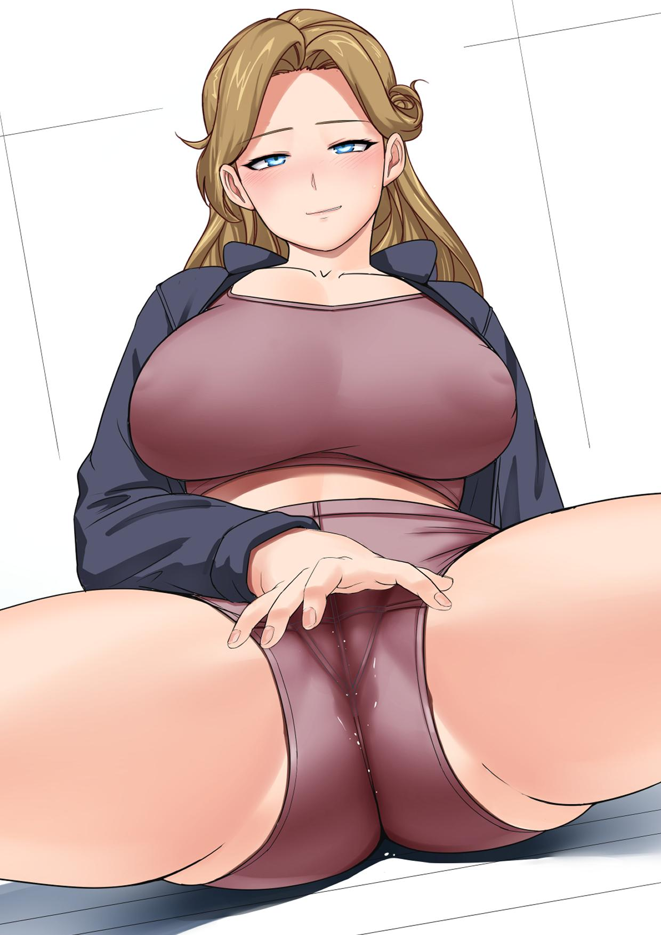

**“Nonsense dear…I’ve had my eyes on you since you spoke to me while repairing my phone back then!”**

**“About why you seemed so gloomy when I saw you down the street?”**

**“I thought no one would notice, but when you spoke about how dull my eyes were…and the creases brow…I had my doubts…”**

Stepping closer towards her and taking a knee before cradling Sarah’s chin hesitantly in his hand only for her free arm to gently caress his own, Kevin leans closer toward his lover’s lovestruck face, staring right into her crystal blue eyes.

**“And now? What do you think about me now?”**

Giggling madly before leaning forward, Sarah locks lips with Kevin, allowing his tongue to probe hers, madly tweaking her aching clitoris through her pants as the wet spot emanating from her puckered pussy only grows larger. Grabbing Kevin’s free hand before redirecting it over to her heaving breasts, letting him press down to feel her rapid heart beats and bask in the comforting warmth of her body as the two part lips, sighing deeply as they gaze longingly with renewed lust into each other's eyes.

**“Do I really need to spell it out for you?”**

From that day on, Sarah’s nightlife as a lusty cougar would soon come to an end with her successful confession to Kevin, now her loyal husband and the man who would be in charge of satisfying her very needy body every night with a hearty serving of baby batter straight into the womb in the hopes of finally being impregnated with child despite her inability to bear a child after being creampied by so many other men in her life.

But in the near future, the Wellington household and in turn, the surrounding suburban street would soon become a much livelier place than it had been a few years ago with the introduction of another happy family into the mix…

*THE END*