FRESH PERSPECTIVES
COMMISSION STORY
BY CHALDEACHANGE
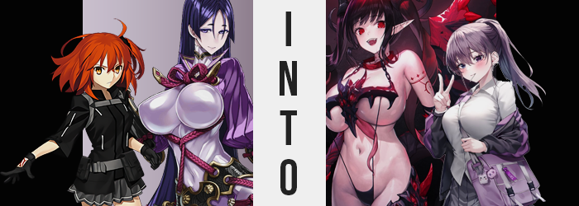

In Chaldea it was only natural that there’d be many different dynamics.

Even among the staff there were levels of respect due, roles to be fulfilled. Toss in the presence of Servants in the community, and things got even more chaotic in that regard. Some of them wanted nothing to do with Servants that weren’t their Master, while others curiously interacted with the other humans and even befriended them. But these still weren’t all that complicated.

At least not compared to the dynamics between Servants and their singular Master, Ritsuka Fujimaru. The young woman was often thrown into a tizzy trying to keep track of each of her relationships with each and every one of her Servants. Some treated her kindly, some treated her with venom – in the end, these were normal relationships to have, right? But unfortunately that wasn’t the full extent of just how varied they actually were.

There were some, like Jack the Ripper, that treated her like their parent. Some treated her with clear romantic affection that she really didn’t know how to reciprocate. Some treated her like the scum of the Earth. And others? Well, like Minamoto no Raikou? They had a tendency to treat her like a child. Not that the Berserker could really help it, since it was a biproduct of the Mad Enhancement skill that had been forced upon her due to the class she had been summoned into.

It was this dynamic that had ultimately lead to this particular conundrum. A Holy Grail had gone missing from Chaldea’s storage and there were no leads as to where it had gone. But one of the Servants in particular knew exactly where it was. After all, Minamoto no Raikou was caressing it between her own fingers. “Should I? Shouldn’t I? But wouldn’t my child be mad? But then how can I get her to realize?”

Sitting on her bed in the darkness, she clearly wasn’t in her right mind. But the reality of the situation was that she was just downtrodden. Ritsuka had always been evasive when it came to the motherly affections that the Berserker attempted to push onto her, but in Raikou’s mind she couldn’t perceive her efforts as coming across this way. She was merely offering her child her love, so why weren’t they receptive to it?

It seemed that in a fit of anger, Ritsuka had told Raikou to stop doting on her so much. Clearly it wasn’t Raikou’s fault and Ritsuka had just lashed out because something was already eating at her. Everyone else present had realized that. But the Berserker hadn’t, and the incident had by eating at her sensitive heart ever since. Cradling the Grail close to her big breasts, a single wish passed her lips. “I wish that Master could understand my perspective, so that I can better understand her in kind.”

At the very least, she still recognized that understanding was a two way street.

“Where am I?” After making her wish, the room had changed around the Servant. No, that wasn’t quite right. It was more like she had been teleported, hadn’t she? This wasn’t Chaldea. With the modern day knowledge she had been given by the Throne of Heroes, she could identify that it was a gymnasium. One in a high school. Based on the moonlight filtering in through the windows it was most certainly the dead of night.

But Raikou didn’t understand. How did this fulfill her wish? Should it not have only affected her Master’s understanding of motherly love? So why send her to a school? She squinted down at the floor of the gym. It had gone unnoticed at first, but there was something there. It looked like a magic circle drawn in powder, or perhaps chalk. Was it used for summoning something? “I need to return to Chaldea. To where my child is.”

Staying here served no purpose. At least at first.

All it took was a single step on Raikou’s part for the woman to sense that something was amiss. No one knew her body better than herself, after all, and so even something as discreet as the length of her leg’s gait was immediately recognized. She didn’t immediately process the reason, though, stopping and wordlessly raising an eyebrow as she looked down at herself. Not that she could really see all that well past her huge breasts.

Now fixated downward, she took another step forward. Did her skin tight bodysuit feel a little bunched up? This was just another sensation she noted before it finally struck her. “Am I shorter?” She didn’t sound panicked by the idea. It was more like she was uncertain about the idea? But she honestly wasn’t wrong. The Berserker was a tall individual at 5’7”, which was quite large compared to most of Chaldea’s other women Servants.

But no longer. Her lankier limbs were prompt in becoming more compressed in length along with her torso, the shortening procedure ultimately rendering the fit of that light purple bodysuit she wore a little too ample. This left the rubbery material to bunch against her limbs and tummy, particularly around her knees and hips; generally wherever any joints were. “I am…” The long term outcome was that Raikou had shrunk down to around 5’2”. Five inches of loss didn’t sound like all that much, but in the grand scheme of things it was pretty significant.

Especially when you factored in the fact that, at least initially, the curvature of the woman’s body had not compressed along with her height. Her enormous breasts and ass remained untouched thus far, which almost seemed comical with her new proportions otherwise. There was something about it that similarly felt unnatural, but only because Raikou’s face had experiences some notable changes as she had shrunk.

Initially they didn’t seem that significant. Her beestung lips were drained of some of their weight, instead leaving them puffy but nowhere near as abundantly so. Her cheeks were a touch fuller and eyes a touch wider as well. There was a roundness about her features that came across as youthful, and that was why her figure seemed even more out of place. Not only did Raikou seem to be younger and looking more like a teenager? Structurally, her face didn’t even seem to have all that much resemblance to what she had looked like moments before.

“I… What was I…? I’m supposed to be here to… My child?” While speaking in a softer voice, the Berserker winced due to some mental feedback that left her feeling disoriented. Was something wrong with her height? She was pretty average sized for a girl her age, wasn’t she? And was she not supposed to be at her school? No, hadn’t she come here for a reason? But at the same time, what were these thoughts about a child!? She was only eighteen, and she didn’t even have a boyfriend!

The stronger she felt that her old memories were wrong, the more abundant changes to Raikou’s hair became. When these new memories were only first seeded, the roots of her dark purple hair had lightened to a steelier colored shade of violet. But as those memories became clearer and clearer, the color not only crept out towards the tips of her locks, but they also saw each strand soften, smooth, and shorten until her hair only fell halfway down her back.

She took another step, this time towards the magic circle on the ground. Was that why she was here? Deep down, she certainly felt like it. That circle was calling to her, and yet… She felt sluggish and heavy as she slowly moved in that direction. This was of no surprise, seeing as her breasts were K-cups, her hips, ass, and thighs were beyond abundant, and she was only 5’2”.

But while Raikou felt bogged down, the burden was gradually lifted while she continued to walk. The weight of her ass and thighs regressed with each jiggle until they hardly juggled at all, her rump still full and tight, but nowhere as dramatically excessive. Her hips were allowed to narrow slightly because of this, and her bodysuit bunched up even further to look more like an empty balloon.

That empty balloon comparison was certainly more apt for her breasts, though. They lost their K-cup bounce, and yet even despite her nipples shrinking a touch, and the immense weight of her bosom lessening? She still retained a pair of breasts that were just a little too big. That is to say they were still E-cups, which meant they looked huge against her shortened form even so. “Right, I’m here for that circle.”

Without realizing why, the girl was tugging at her outfit. Subconsciously its ill fit was annoying her, and this was ultimately remedied by a change in the outfit itself. A flash saw her momentarily stripped, her late teens body exposed to the elements, perky and hefty bosom and all, before a Japanese school uniform consisting of a button-up white dress shirt and pleated grey skirt clad her. A purple hoodie rested on her shoulders, socks and loafers on her feet, and her hair? It was pulled up into a ponytail now.

“I think that’s everything… All that’s left is the blood, right?” Wiping the sweat from her brow, what she now perceived as a strange hitch that had temporarily stunned the eighteen year old girl finally gave way, providing the clarity she had been lacking thus far. Ruri Minamoto was a teenaged girl like any other, really. She was cool and attractive, if not a little quiet. But her family was… complicated. Her father was a magus and her mother a normal person. It had led to plenty of infighting not only between her parents, but between the related families as well.

Ruri was tired of it. They were fighting because there was supposed to be this weird Holy Grail War thing soon, and there was the risk of her father dying in it so lines had been drawn on whether or not he should participate. But Ruri? She didn’t want them to fight anymore. And she definitely didn’t want her father to die. That was why she had stolen a book on summoning one of those Servant thingies and had erected the summoning circle in her high school gym.

She walked up to the circle’s edge and pulled out a knife, bringing it’s blade to her palm. And then?

Pain.

Ritsuka didn’t have the foggiest idea about what had just happened. She’d been relaxing in the cafeteria, trying to take her mind off of things, when everything had just turned black. It wasn’t like she was unconscious though, and despite the void that surrounded her? Not only were her feet planted on the ground, but she could still see her own body clearly. Almost like she alone was illuminated in the dark. “I don’t understand...”

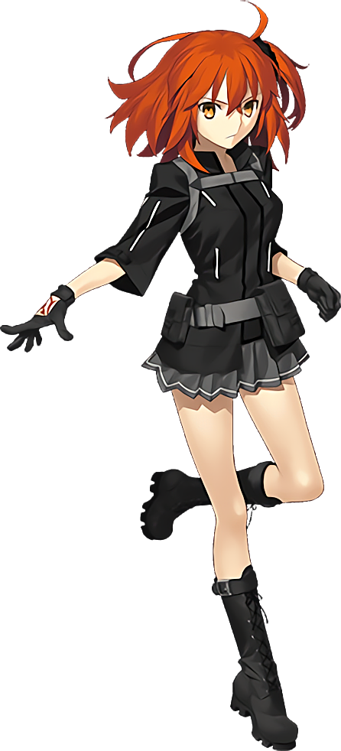
She wasn’t a stranger to being suddenly displaced, but regardless of how far she walked, she didn’t seem to get anywhere. It was honestly the worst possible ending of a very terrible day. Not only had it been very stressful, but she had regretfully shouted at one of her Servants because of it and had been planning to apologize. But now there was no way she could get to Raikou to tell her sorry. Not as long as she remained in this unfamiliar space.

After wandering for a while, though, Ritsuka finally realized something.

She felt strange.

At first the feeling was hard to place properly. It began with a warmth that spread throughout her flesh, but very quickly became focused in places that some might consider to be embarrassing. “Wh-Why am I getting horny?” She was aroused and didn’t have the foggiest idea why. She’d been walking through a dark void, not looking at or even thinking about something stimulating! Yet her loins ached and her chest throbbed.

“Put it aside! This isn’t the time!” The best that the Master could do was push the feeling away for the time being. It wasn’t that intense, and it wasn’t like she was going to just drop onto the floor and start masturbating in a dark void, right? Yet what was manageable at first became increasingly less so, and as desires built? Visible change became apparent in Ritsuka’s body.

Like? Well, her ears for one. The tips were stretching, pulling longer into almost elven points. Yet they didn’t stop with that growth alone, stretching inch after inch until both ears were about six inches long, pointing behind her. They didn’t quite appear monstrous, but they did appear demonic. As if to match how her teeth were lengthening and sharpening within her mouth, or how the orange in her eyes was deepening to a dark crimson.

She pushed forward, her cheeks burning redder with each step, breaths becoming more and more labored as her horny level was only increased further. “Ngh…” What was making her body feel so uppity? She slouched in an attempt to try and ease the feeling, each step slower than the last. Though the slowness of her body wasn’t completely attributed to her own free will.

Her flesh was becoming heavier, legitimately. Being Chaldea’s Master, over time her thin body had naturally become muscular. She’d also earned plenty of scars that were hidden beneath her uniform. But not only did those scars fade away to leave her skin free of blemishes entirely, but that wasn’t even the main takeaway. Her muscles were shrinking, and in their place? A gentle layer of fat emerged, making her limbs and tummy seem soft. And regarding the latter? While some muscle remained upon her gut, it bulged oh so slightly.

Not from over nourishment. It looked more like the side effect of natural aging. As if Ritsuka’s build was more befitting now of a woman in her late thirties rather than a young adult. It could be perceived in her face, too. Her skin was slightly worn, lashes lengthened, and her perceived age greater than it had been. But at least in regards to her crimson gaze? Those eyes rounded in shape, giving her a more Caucasian look. A new fullness to her lips that hid sharpened teeth certainly helped with that.

“Mmn… So horny…” Despite her attempts to resist, she practically purred and moaned the next time she had spoken, her voice significantly deeper than it had been before. This transpired while the woman’s auburn hair began to darken due to the corruption that had taken root inside of her, a Saint Graph forming in the core of her soul. Black locks lengthened and curled into waves, falling down as far as her ass.

Which actually became farther away as her hair grew. The Master was understandably distracted by how she felt, and it was becoming harder and harder to deny the corruption’s call. This meant that she wasn’t as aware of what was happening to her body, not even as her overall jumped from 5’2” to 5’8”. This pulled up her jacket and undershirt so her tummy was somewhat bare, and her skirt didn’t cover as much of her thighs as they had before.

And honesty? That was probably for the best. “Would a little touch be so bad?” Her feelings of need had met critical mass, and now ‘critical mass’ was being applied to her taller form as fingers began to rub at her chest through her top. Her tits ached, but so did her thighs and ass – all for similar but easily recognizable reasons.

Her thighs being barer meant that an increase in their girth didn’t affect the fit of her outfit too much otherwise. And they certainly did expand stupendously, skin pulled taut and shiny around them with time. Ritsuka’s ass, though? It became ampler still, with panties forced into the crevice that was her ass crack, the back of her skirt pushed up by a rump so abundant that it even forced her hips wider and the band of her panties to eventually snap.

“Ara ara…” The sound she made was somewhat representative of how much older she looked, but it was one she made as she brought her hand down to yank broken underwear from her ass – fingers playing soon with a pussy that was bigger and more sensitive beneath a black bush. She didn’t buckle onto the floor, but only because… she was floating in the air. Thanks to powers that had finally been bestowed upon her by her new Saint Graph, because fundamentally? She was a Servant now.

And clearly not a human one, because above all of that new cake she had developed something began to grow. Long and coated with black scales, it crept out from her tailbone and began to swish to and fro behind her. A long, reptilian tail – though she wasn’t becoming a lizard. The heavy and sharp black, red tipped horns that crept out of her skull, or the matching wings that tore through the back of her jacket still looked a touch reptilian though.

Ritsuka panted. Partially because she was on the cusp of climaxing, but these new body parts that had erupted from her body had certainly disoriented her. Hands were still at work on her tits and pussy even despite these changes, or the changes to those hands themselves. Flesh beneath her elbows all the way down to her fingertips both darkened to purple and hardened, red lines glowing atop claws that fingertips were shaped into.

Those claws didn’t bother her as she continued to please herself, though. Her skin seemed to be too tough for them to pierce her, not even as claws dug into the heft of a once average bosom that was no longer average at all. With the back of her top blown out by her wings, the front had peeled off and left her bosom bare. This had made it easier for pound after pound of fleshy growth to settle into place, tits bouncing and heaving as they grew to the size of her and beyond. Greater than Raikou’s K-cups even, M-cups full, round, and exceptionally heavy.

The perfect size for a demonic woman who had birthed and raised hundreds of her own kind.

Memories of such a life had been pulled to the forefront, and by the time she finally climaxed, fluid dripping down the insides of her thighs, there was no longer any memories of her past life. She had been remolded by corruption, she embraced it. And to make her appearance even more befitting of such an existence, what little remained of her old uniform was replaced. “Fufufu…”

A dark purple bikini was essentially all that clad her ample flesh, the ‘top’ little more than a dark purple, bone piece that connected from nipple to nipple, a demonic skull in the center. This was chained to her neck, while spaghetti straps stretched down to a bikini bottom that barely hugged her loins and ass. It seemed that with the change of costume, the mess between her legs had been cleaned up too, and red tattoos were wrapped around her bare forearms.

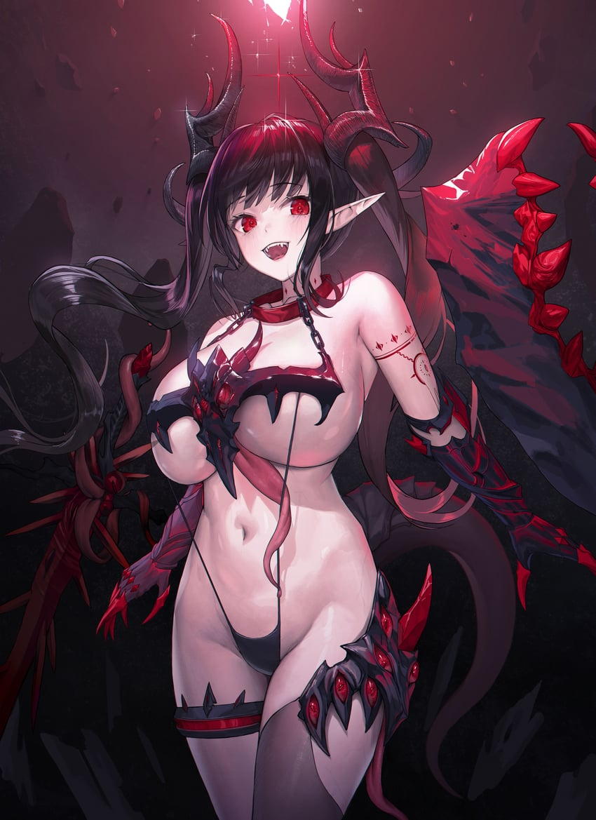
“Ara ara! What’s this? A light at the end of the tunnel~?” It wasn’t a tunnel at all. The demonic woman was engulfed by a bright light that consumed the darkness the moment that her transformation had completed. She felt an intrinsic pull on her body, on her very soul. And the next thing she knew? She was standing in the middle of a gymnasium lit only by the light of the moon filtering in through large windows, and the red light of a summoning circle at her feet. “Servant. Berserker… Mhmhm~! Risnore is my name! Art thou my child?” She hovered several feet off the ground, her largely naked body bare as wings flapping behind her kept her airborne.

Her gaze settled upon a human. One with Command Seals clearly on the back of her right hand – clearly the girl who had summoned her. She could only assume this girl was a teenager. She reminded her of one of the many children she had given birth to over her long life. Perhaps she reminded her a little too much of them. A side effect of the Mad Enhancement that had been embedded in her as a Berserker.

Similar to Minamoto no Raikou’s. Fulfilling the ex-Berserker’s wish.

Risnore was every part of the obsessive mother that Raikou had been. Perhaps worse, in fact, because as a succubus her mannerisms were much lewder, and her interest in her Master much carnal. “My, you’re so adorable! Sexy, too! What big breasts you have, my dear~!” The Master in question was taken aback.

Ruri really didn’t know what to make of this. “Risnore…? Child? A-And what do you mean?” Wasn’t she supposed to summon someone famous or something? She’d never heard that name before. Not to mention this woman, this demon… What was with her sexy body!? It was so ample, and she was barely wearing a thing! It didn’t help that the succubus answered her with gestures before words.

She embraced Ruri, pulling in against her big, basically bare tits before whispering the answer sensually into her ear. “It means mother is here to take care of you~! I’ll shape you into a fine succubus while we work together, my dear child~!” The human didn’t really understand still, but she was blushing like mad.

Risnore didn’t mean she’d literally shape her into a succubus, right?

Right?

