Jessica route patch 2.1

* After starting the game and doing the first events of the game where you get bullied by tricia you go to summer.(Find her using the app you got from the Devil) 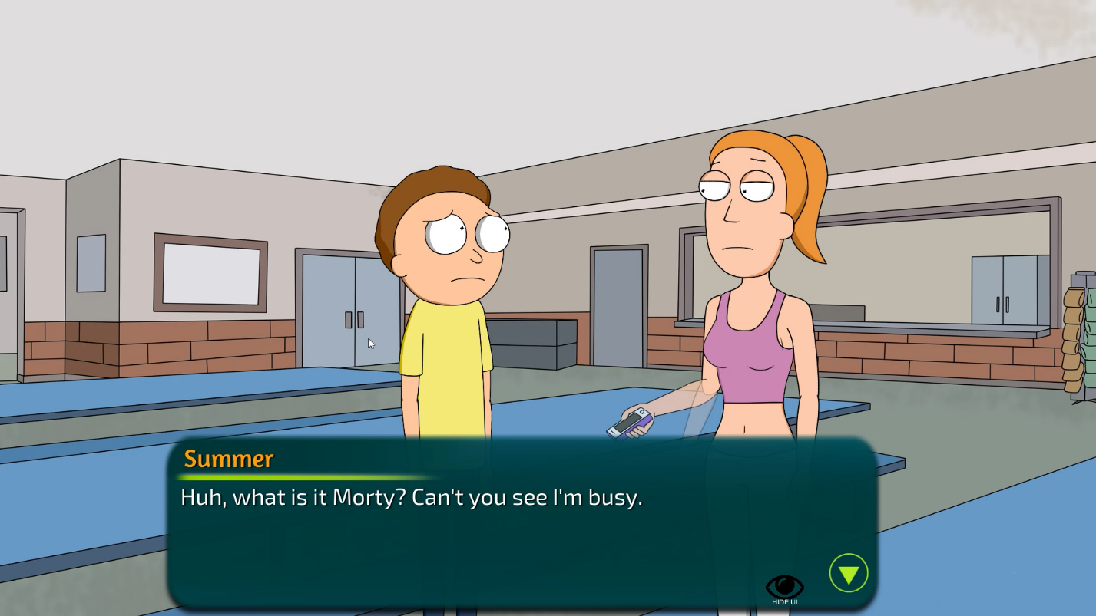
* For the next event you have to continue the missions with Tricia. After the bathroom scene Summer will talk to you.
* After showing the video of Tricia you have to ask her about Jessica. This will activate the mission to sneak into her room and search her phone
* At midnight you have to go to summer’s room. She is sleeping you have to click on her. Then click on her phone – Its locked. Click her diary on the shelf to get the password. After that click on her phone again. 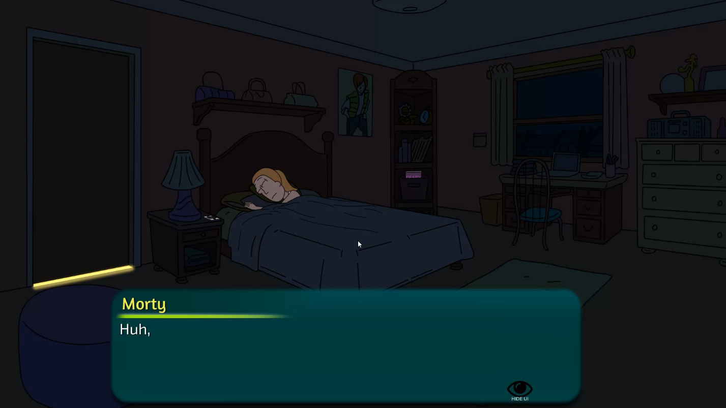
* On the next day go to school and talk to Tricia. After that the next mission is to ask for advice for Jessica. Go to Summer
* After finding crying Summer she will ask you to make Tricia give you a blowjob.
* After going to the church and receiving the blowjob. Wait a second day to trigger the next event at the church.
* After the church You and Tricia will go to Morticia and trigger the Pickle Morty event.
* Visit Jessica’s house right after the scene with Tricia and Morticia.



* On the next day ask Beth for advice for dating Jessica.
* Go to the school and talk with Tricia to help you get closer to Jessica.
* After that go to the classroom and that will trigger the science class scene.