MMO SUMMER
JULY 2021 REQUEST STORY
BY CHALDEACHANGE
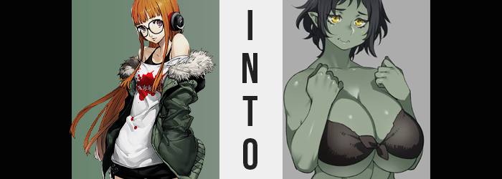

“ALRIGHT! I’ve got my chips, I’ve got my soda – it’s time to party!” Futaba Sakura appeared quite content as she spun around in her computer chair as the SSD booted up, items previously mentioned sprawled out on the desk beside her. It was no surprise that she was this excited, really. She’d been waiting for this day all year! For it was the day of the annual summer event that her favorite MMO ran!

It wasn’t the most popular MMO on the market, simply called ‘Fantasy Quest’ in English, but it had a dedicated player base that almost rose to cultish levels at times. And Futaba? She was absolutely the sort of girl that fell hook, line, and sinker for any underdog projects in the gaming market. She’d been burned more than a few times by bad games as a result, but Fantasy Quest? It was different.

The events they ran were always exciting, and the summer ones? They were the most coveted of all. Always releasing cute beach outfits and fun minigames to go alongside the festive offerings – it was the time of year that the game was busiest during. And Futaba? She really needed this reprieve after having a stressful interaction with a fellow player earlier in the week.

It had definitely been wrong of her to say, but she’d called orc women ‘big, smelly, and stupid’ in front of them after they’d told her that her elf’s costume looked funny. That had led to an argument, and since Futaba was so brazenly stubborn while hidden behind a computer screen, it had certainly escalated. Even now they hadn’t made up. “Ah well, I should just try to have fun today…” Evidently it was still eating at her in some capacity.

Having fun had been the intention, but no sooner than the girl logged into Fantasy Quest on the beach where the event was being held did she realize that something was strangely amiss. “HEY!? WHERE’S MY CHARACTER!?” Its model hadn’t loaded in, and even after waiting half a minute it showed no signs of doing so. A glitch? But remembering she’d installed a computer update the night before, the girl reached to hit the power button on her tower.

ZAP!

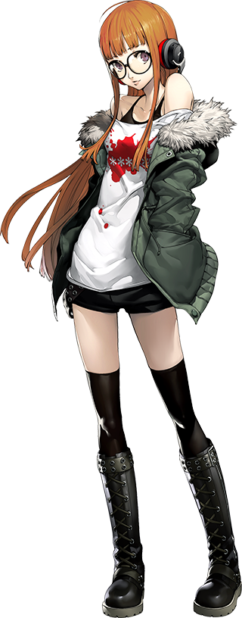
“Ow!? What was that!? Static electricity!?” The very moment her fingernail had contacted the power button on her computer, a jolt of what she presumed to be electricity had jumped from the plastic to her body. Futaba flew back in her chair with surprise, but as if said chair had been yanked out from beneath her, she plummeted towards her floor. Thankfully, there was sand beneath her to cushion her fall somewhat.

Huh? Sand? She should have landed on carpet, right? Almost all at once, an awareness struck her. The awareness that she was no longer in her own bedroom. Between the cool breeze and the summer sun – she was now sitting on a beach. “HUH!?” Resting on her bottom, the girl looked around in wide-eyed bewilderment. “Isn’t this… Isn’t this FANTASY QUEST!?” More specifically: the new beach zone they’d added for the summer event.

“Is this an isekai? Did I get isekai’d?” Even though this looked like the concept art for the summer zone, it all looked and felt real. She could smell the ocean’s water, feel the breeze upon her face – the idea that she had been transported to a world based on the game was rather compelling for a dork like her. Or she’d been caught up in someone’s Palace, but that was a less exciting possibility.

Inspired with energy by the fact that her fondest wish might have just come true, Futaba wriggled until she jumped up and onto her feet. Though, the moment she was upright? Something had struck her as funny feeling. She felt the breeze all over her body, and she could feel the sand beneath her feet. None of which should have been possible were she wearing her usual outfit.

“HUH!?” It didn’t take much more than a glance to understand the case of this. Gone was her regular outfit (aside from her glasses) and in its place was what looked like a black bikini. Except it was made of worn cloth that was tied in the front, and it was hardly hanging onto her tiny frame. “Why am I wearing this? I’m fairly sure normal swimsuits aren’t quite so…” Raggedy? It looked like a makeshift swimsuit you might find in simpler times. Maybe this was just starter gear? Because she’d been isekai’d and all!

The fact that she had more to worry about than her outfit was not something that had quite occurred to Futaba yet. The tips of her ears had been stretching so that they poked out from the sides of her hair almost like an elf’s – or at least that was the initial impression before their color began to change. Beginning at the pointed ends, a forest green soon swept through them in their entirety.

It was a phenomenon that soon slid into her facial features, and would progress throughout her body like wildfire after the girl turned her attention away from herself and back at her surroundings. The green coloration was even aside from the darkness of her nipples and genitals, and when she blushed now the affected skin would undoubtedly turn a darker shade of emerald. The quality of her skin was different too, though. It was a little rougher, a little more durable, and its cleanliness? There were patches of dirt here and there, with a wry body odor on the horizon.

Almost as if it wasn’t to be outdone, the girl’s hair suffered a pigmentation shift all its own – though not towards the realm of green in any capacity. Instead, the orange dye that she meticulously applied monthly was washed out, leaving a natural black in place. Strange still, once her hair was affected by this color change, it appeared oilier with frayed ends… almost like it hadn’t been washed in a while. Things certainly weren’t helped once the excess past her neckline was suddenly chopped away and stollen from the breeze, leaving her with a messy, black bob.

Sniff, sniff. “Something smells a little rank. Was a skunk killed nearby or something?” Futaba was hardly in a place to realize that she was the source of this scent. She was just as ignorant to the fact that her two, lower canine teeth had begun to passively stick out from her lips. Instead, something provoked her to reach for her glasses. Her vision was blurry? It would have been difficult for her to realize that the eyes through which she perceived the world were now glowing gold. These vision problems were because her eyes had actually improved.

“W-Wait a sec! Why are my fingers all green?” In the process of removing her glasses, it was impossible for the teen not to notice her changed skin pigmentation. She held her hand away from her eyes with her glasses between her fingers for a few moments from sheer shock, noting how her fingernails were frayed and dirty was wedged inside of them. With a hand so close to her nose, she now understood the source of the smell, too. “It’s me!? W-Wait, am I turning into a Fantasy Quest race!?”

That kind of thing happened in isekais now and again, right? Wasn’t there that one where the girl became a spider, or the one where a man became a slime? But there were only two races in Fantasy Quest with green skin, and neither of them were to her liking. It was either goblin, or orc! Lore wise, both races were considered to be the filthier of them all – being the most monstrous, of course. Goblins were seen as crafty gremlins, while orcs were seen as stupid oafs.

“This no be happening!” For some reason, her sentence had struck her as odd. What was with that broken sentence? “What? Me am talking funny? Again!? What’s happening!?” At times it almost sounded like she had suffered a concussion, but there was no injury to speak of. In fact, what was happening mentally could best be described as complete rewrite of how she processed words and information. In a way, her mind was slowing. More complicated words were falling out of her head – Futaba was getting dumber. And, as a result, her manner of speech was degrading as if she hailed from a time when language was still developing.

As she’d learn, what she lacked in intelligence now would gradually be made up for with instinct.

“Nn… Thinking hard. But me feeling weird in body too…?” It was best described as a feeling of bloating, except she hadn’t had anything to eat, and the direct result wasn’t any immediate weight gain… at least not in her belly. But the teen did gain mass, and plenty of it, in a less conventional manner.

She groaned and hugged her own torso as her body began to swell. In terms of height, in terms of mass, in every way imaginable. “Me… getting… bigger…!?” Her voice deepened dramatically as her height came to surpass six feet over only a few seconds, arms and legs alike lengthening to meet the moment. The girl didn’t simply grow up though, and her bones thickened and widened at the same time.

This left her frame to become just as broad as she was tall, and by the time she peaked at almost seven feet, Futaba’s body looked almost three times as thick as it had once been. Her bones were more durable than ever, with hands and feet several sizes larger than they’d once been. As she’d still been holding onto her glasses, they’d ended up crushed as her hands had swollen with big, sausage fingers. The growth had forced the changing woman (as her facial features now sported a more advanced age, likely in her twenties) to perspire, and so her hairier armpits were damp as well. “No… This wrong! But hard to think of why! Head feel… heavy?”

Everything felt heavy though. Her body was big and burly, and that only worsened as all of the muscles across her body began to swell and tighten. Her arms and legs soon rippled with unbelievable, raw strength, while her abs firmed up around a green belly that protruded just the slightest bit with fat otherwise. “Me… orc!?” There was no way she could be a goblin. Not with her current height and build. In fact, it was a miracle the cloth bikini she’d been wearing had stayed on. A testament to how oversized it had been initially.

“Mmn… But feel good. Me feel so…” Horny? Her loins were aching, undoubtedly stimulated by the transformation. In fact, her void had deepened to meet her new build, while the hair above her pussy had grown so long and bushy that it began to peer up over the bikini as it was pulled tighter thanks to widening hips.

They parted a handful of inches, yanking the bikini string tight while her ass pushed out the back. With the explosion of muscles, her butt had already grown several sizes – but this additional growth was from sensual fat that slid in between her skin and strength. It allowed her ass, and her thighs by succession, to bloom with promiscuity, giving her cheeks that found the bikini wedged between them.

A dirty, oversized orc hand reached behind her to rub the cheek in surprise, only for Futaba to end up groping it. “Mm… good…” But this didn’t last for long, as her second hand made its way to her breasts. An immense pressure had built above her pectorals, and before long the bikini top was stretched to capacity as a once A-cup bosom flourished with great abundance. Cup size after cup size was poured on, forcing the woman to pant as her posture dipped forward.

Each swelled to the size of her big head, then grew even larger still; this weight far too much for most to accommodate, but her strong orc muscles gave her the means. “Bouncy…” Both hands had been brought to her chest to fasted the cloth bikini, but now she was cupping both teats and giving them a shake to watch them jump up and down. Even through the bikini top, she could see her immense nipples trying to escape their cloth confines.

No! Futaba! You need to focus! You need to… Wait, what did I just think my name was? Deep down, Futaba’s voice was doing its best to cling to the last bit of herself she could. But her body felt so big and strong, and sensual, and…!? She’d already forgotten about her orc’s odor, now accepting it subconsciously as a scent her people considered to be pleasant.

“Oh… Remember who am. Me Skarsnaga… NO! Me… Skarsnaga!? Nn…” The hefty orc woman had retained all of her memories of her past life, and yet she could not recite any of them, not even her old name. Instead, her deep-voiced grumblings recited a different name, in a manner that spoke to a less civilized background than she was supposed to have. Skarsnaga. Despite attempting to restate her old name again and again, this was what blurted out.

Skarsnaga had been so excited! She had been isekai’d into one of her favorite games of all time. Yet now? Her body was so big and burly (especially around the chest) and she reeked of body odor. Almost like she had come to personify the insults she’d lauded towards her orc friend days prior. Which made sense because this was karma paying its dues.

“What is Skarsnaga supposed to do? Can me even go home?” How was she supposed to explain her circumstances to anyone else at the beach? Even now, there were other orcs leering at her with lustful eyes, as if they hadn’t just watched a Japanese girl turn into a well-endowed orc woman. But maybe that was the case. Maybe they hadn’t noticed at all? Actually, a part of her felt like this beach had been empty just a moment ago…?

A hand touching her ass from behind caused Skarsnaga to cry out and turn around, and when she did? “Buzum!?” Even in person, she recognized the orc avatar standing in front of her. It was the avatar of the friend she had insulted, an orc woman with assets likely only half of Skarsnaga’s own in size. “You do this to Skarsnaga!?”

“Huh?” The voice spoken was the very same as the avatar’s player. Was she just logged in? Was that an avatar? “Are you roleplaying? I just didn’t know orc avatars could get this… juicy.”

“No! Skarsnaga is Skarsnaga! Not game! Real!” Of course this didn’t help her case any, and Buzum merely laughed.

“Okay, got it! Dedicated roleplayer! But hey…” Without any hesitation, the other orc woman’s hand reached out to grope Skarsnaga’s left breast in broad daylight. “Why don’t we find a private spot alongside the beach, and we could, uh… ERP. With emotes? You know, they’ve added some pretty weird stuff for this event, if you’re into it?”

That should have been a hard no, particularly because Skarsnaga wouldn’t just be emoting. This body was her flesh and blood. Anything done to her would feel real, and yet…! Smelling the musk of her fellow woman, catching a glimpse of her strong muscles… instincts took hold, and they were more powerful than common sense. “Sure… Skarsnaga like.”

And thus she fell down a very slippery slope, one that would inevitably overpower any desire for her to return to the real world.

Meanwhile, in the real world…

“Futaba-chan? Where’d you go?” Ann Takamaki had entered Futaba’s room, surprised to find it vacant but with the computer on. That girl was so fussy with her privacy that it was a surprising sight to see. She knew she shouldn’t, but the teen strolled over to the computer to see what was on the screen. “Is this a game? Character Creator?” It looked like where you made your character for a fantasy game? The character on it was short and green though. “A goblin? They’re kinda gross!”

The computer screen flickered.

TO BE CONTINUED?

