OUTER LOVE
COMMISSION STORY
BY CHALDEACHANGE
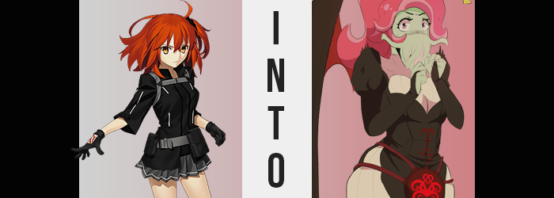

It was time again for Chaldea’s weekly game night, and as always many of the Servants and staff had split up into groups as to best enjoy the evening. Whether it was video games, board games, or even games like charades – there was a plethora of activities to enjoy provided no emergency interrupted their evening. And Chaldea, being Chaldea? Well, there wasn’t exactly any guarantee that this would not be the case.

Among the Servants, however, there was one that was more excited than most. Abigail Williams had been trying for what felt like years to try and get the coveted Master slot, where she could have Ritsuka Fujimaru in her group for the game of her choice. Through a little bit of mischief she had even gotten said Master all to herself, and she was excited to be doted upon for an entire evening!

But the issue was that she had yet to figure out a game for them to play. Coming from Salem as she did, she wasn’t all that well versed in modern games. Forget video games, she didn’t even understand the regular games of today. She knew things like hopscotch! …But she had a feeling that her Master wouldn’t enjoy an evening of simply playing that. And so, with nowhere else to go, she had confided in Katsushika Hokusai. The father, not the daughter.

He had given her a computer game that apparently would ‘work well to ease the gap between them’, whatever that meant. Apparently it had something to do with the Outer Gods? So it was certainly a topical game for Abigail Williams of the Foreigner class, at least! Sucker For Love was the name, and she really wondered what that was all about? It didn’t really sound like a game for a child.

Not that it would really matter all that much in the end, because they would never quite get around to playing it.

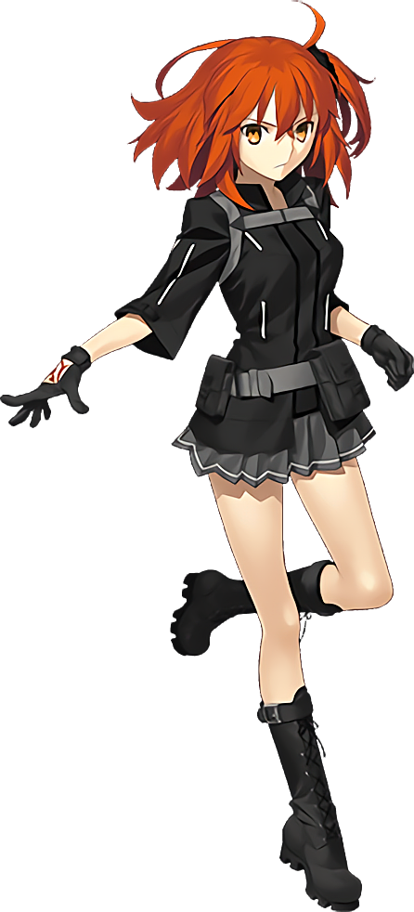
“Abigail? Are you in here?” Ritsuka Fujimaru arrived at the room Abi had reserved at the scheduled time that evening, none the wiser that Hokusai had placed something in the child’s hands that would ultimately redefine her life. Admittedly she was surprised that the girl had requested one of the computer rooms, since she was always struggling with modern technology thanks to her past in the, well, past.

But the Foreigner was a child, and it also would not have been all that surprising had she had seen footage of a game that had caught her eye. After getting acquainted with Tomoe Gozen during the summer camp incident, she had definitely been hovering around the gaming oni a little more in recent months, for better or for worse.

Because Abigail was always projecting the idea that she was a ‘good girl’, she was surprised to find that the rented room was empty. If anyone were to arrive on time, it certainly would have been her. But again, she was just a kid. There was nothing wrong with being late once in a while. “Oh? One of the computers is on. Maybe she was setting up and had to go get something?”

It appeared as if the title screen for a game was on the monitor, and so Ritsuka slid over to see what Abi had in store for the two of them. If anything, maybe the person who had been using the room before them had just left their game on? In which case it would be best to turn it off in case any of the content was too unsavory for a child’s eyes.

“Sucker For Love? This doesn’t exactly sound like a child friendly game…” Upon examination, there was a bright and colorful title screen that was reminiscent of those you might see in a dating sim. Yet at the same time? There was something Western about the art style, and she assumed this wasn’t your traditional dating sim as a result. Seeing what she did, she couldn’t exactly gleam the nature of the game’s content, but she could at least identify that Abigail was not old enough to play a dating game. Someone must have just left it on from before them.

Although that wasn’t true, not at all. As soon as Abigail had installed and started up the game from the disc she had been given, an unsettling energy had poured out of the computer and spooked her. So she had run to try and find the one who had given her the disc to help her fix whatever was wrong. But her Master was there now, and she was unaware of the energy pouring out because she wasn’t attuned to an Outer being.

At least it was largely harmless so long as Ritsuka didn’t click on the— Well. Had she left well enough along, nothing would have come from it and things could have carried on as normal, but Ritsuka just had to close the game. Instead of bringing things back to the desktop, the image distorted and a bright light poured out, the Master becoming consumed by the raw energy that had just been released. “I don’t think this is a normal video game!”

A little late on that one, chief.

Its influence was already quick to get to work, rapidly pouring an unholy energy from beyond space and time itself not freely into the room, but directly into Ritsuka’s body. It felt strange. It felt powerful. It felt… “This is weird!” Yeah, it most certainly felt weird. The energy made every hair on her body stand on end, or at least it did so long as they remained. Because before long? Any hair upon her body that wasn’t attached to her head was practically obliterated into nonexistence, and that included her pubed.

Ritsuka felt both cold and clammy, and she couldn’t really figure out why that was the case. Well, whatever energy was pouring out of the computer monitor was the direct cause, but she didn’t really know more than that. Taking a look at the girl’s skin, on the other hand, certainly painted a rather convincing picture as to why she was feeling off when it came to her flesh and skin.

Splotches of a color that was foreign to the Master’s body, and that would have been foreign to any human’s body, had begun to splatter against skin that was otherwise a very natural pink. How off was this color exactly? Well, most humans would not fancy the color of their skin to be a pale green unless they were seriously ill, which this human was not. Nonetheless, the state of her health proved to be irrelevant once more and more of these splotches appeared to pop up against her flesh, and those that existed swelled to meet with the others. Before long she was covered in green from head to toe.

“Wait! My Command— What’s… happened to my skin?” The young woman in question hadn’t even noticed what was happening until she looked down at the back of her right hand to see her Command Seals disappearing. She noted the green hand in the window cut from the glove, and how it also covered her forearm. Not only was her skin green though, but it also bore a rather rubbery sheen that was suggestive of how it felt to the touch. “I’m green!?”

Well, not all of her was green at least. Her orange hair hadn’t succumbed to the same color, but that didn’t mean it had remained orange, either. In fact her hair appeared to be growing longer and thicker. Perhaps a little too thick, almost? It seemed like the strands were binding together into something just as rubbery as her skin – which it was – all while brightening to both a darker and lighter shade of pink.

As more and more of this hair bound together and grow rubbery, it began to wriggle in a rather uncomfortable way. Pointed at the ends, the ‘strands’ looked more and more like— “Why do I have TENTACLES!?” Ritsuka herself had naturally taken notice after feeling something long and rubbery flop against the back of her neck. It was all designed in a way to remember a hairstyle with a high ponytail and left-swept bangs, but it was all made of pink, elongated organs.

Ritsuka wanted to scream. “Thisth ithn’t… pfft… thhtpt!?” And yet for some reason, she just couldn’t manage to squeak the words out from between her lips. The lips in question felt strangely heavy, and they were clearly smacking against each other. She couldn’t tell if her mouth was even opening properly, and yet to her horror? By bringing a gloved finger up to check, she found the hole that should have functioned as her mouth was not there.

Instead, her hand pressed up against something. A number of things, in fact. The space beneath her nose had pushed forward, and her upper lips had turned just as green as the rest of her skin. As this lip had grown thicker and heavier, it had begun to sag not only past her lower lip but past her chin as well, and little by little? This rubbery flesh parted into eight little tentacles that dangled over her mouth.

“Whath happenth thoo my mouth?” Something more horrific than she even realized, actually. Because her original mouth had contorted into something inhuman and disgusting. A gaping orifice with a sharp beak hidden within was disguised by the tentacles that overlapped it, and while it most certainly did not look like a mouth that should have been able to communicate in human tongues, she suddenly had no issues communicating whatsoever. “I’m some kind of tentacle monster? What is this?”

And yet, what had felt weird before now felt somewhat… nice. Ritsuka had been given every chance to make a run for it, but the call of something bigger than herself had kept her rooted in place. And now that she had come so far? She almost felt as if she wanted to see it to completion. The stronger this desire grew, the pinker her irises became and the bigger her eyes became.

Really, she looked like someone had stuck an octopus on a human’s head though.

Her voice had even changed to something higher and more cheerful – becoming more-so the farther along her transformation become. “But this body just won’t do, right? I need something… fuller!” Fuller? For what purpose? She didn’t really understand herself, but something was instinctively suggesting she should become more alluring. For something. Or someone? Was there someone she wanted to seduce?

Regardless of the reason she desired this, her prayers were answered, nonetheless. The young woman’s height promptly expanded, her point of view rising up to 5’10” over a few seconds, testing the fit of her Chaldea uniform. “Hey, that’s better! But not exactly what I meant, though.” She’d been thinking more about her womanly bits while her mouth tentacles wriggled about.

It didn’t take long for her to receive just that, though. “Oh!?” An aroused coo escaped her ‘mouth’ as pressure built beneath her bosom. Dark green nipples swelled bigger and thicker, and before long the rubbery masses beneath them did the same. Like water balloons full of fat, the pair exploded forward and forced the front of her jacket open, ripping the neckline of her undershirt at the same time. Pale green tits spilled out, beautifully perky despite their E-cup sizing. In the process it had also yanked her shirt up a bit to reveal that she had no bellybutton upon her long, fit tummy.

Well, it wasn’t like she was a mammal.

She peeled the gloves from her hands, feeling them grow just slightly too big to accommodate the cloth. But as soon as that was done, green fingertips grazed the sides of her hips, for they too were growing. They jumped into childbearing sizes – and then even further beyond before ample meat decorated both her ass and her thighs. A generous helping saw her lower half swell incredibly thicc, with her skirt lifted by the growth and her panties digging well into the jiggling cheeks of an ass that was bigger than her rack. Her thighs were so ample that each one was thicker than her torso. The kind of lap anyone would be lucky to rest their head upon.

“What was I… doing again? Who am I?” A fog inevitable beset the monster woman’s mind, clouding her memories just long enough for them to be tweaked along with her personality. She was beginning to see herself as a being just as powerful as she felt, and in doing so? A pair of batlike wings then ripped through the back of her coat, allowing what remained to flutter to the floor in tatters.

Not that her clothing was an issue for long. As the light of the monitor waned, a sudden blast of light repurposed her ensemble into a black dress over a tanned, skintight bodysuit that hugged her large breasts and ample thighs to the point that they looked like they might burst out. A piece was draped around her hips, with a very tentacle-y emblem in the front, adding to her already otherworldly appeal.

“Huh!? Huh!? HUUUUH!? How was I summoned into this world? I mean, clearly I was… someone else? And my powers aren’t what they’re supposed to be… but who even has the ability to do that!?” The green tentacles that functioned as her ‘mouth’ wriggling about, the Cthulu-like entity named Ln’eta girlishly had her hands up to her ample bosom as she surveyed the room with no shortage of shock plastered upon her face.

As far as she was aware, she was one of the ancient beings whose dreams sustained humanity. Were she to wake up, the world would be destroyed – and it was the same when it came to her peers, of course. But this was not her world. Was it a world that another Outer God was dreaming of? Even then, she should have been able to project some influence here, but she couldn’t at all!

“This isn’t good! If I’m not in that world, my darling is just going to end up dating my sister!” Ln’eta was sure of this, but there was also a voice deep down reminding her that this wasn’t truly her existence. She was occupying someone else’s place in this world. Or was it better to say that they were now sharing it? Ritsuka wasn’t gone so much as the two had blended into an Eldritch monster woman where the monster was in control. And alien or not, there was no denying that her body was smoking hot.

You know, in a tentacle-y horror sort of way.

Leads? She had to find leads to figure out what to do next. With a disgruntled sigh (From what orifice? Who knew?), she started towards the door with her long, thick legs. But before she could even step outside it opened, revealing a small girl with an aura that was strikingly familiar. She was a human, but there was a power like her own that was radiating from within. “Abigail? Are you the one who…? Wait, how do I know your name? But I definitely know it, right?”

It was because Ritsuka was still part of her of course, and Abigail could sense it in Ln’eta. “Master? Are you a Foreigner now?” She almost sounded excited, and why wouldn’t she be? She’d always wanted a mom or big sister that completely understood her, and another Outer God definitely would! “Can I call you mama?”

“M-Mama!?” Ln’eta got immediately bashful, cradling her own chest. She had never been called that before, but it sounded kind of nice! Oh, if she could get back to her world and bring this child, she could totally tell her Darling that Abigail was their child born from the kiss they’d shared! Then he’d have no choice but to stay with her!

That was how kissing worked, right?

Meanwhile, the game continued to play in the background…

