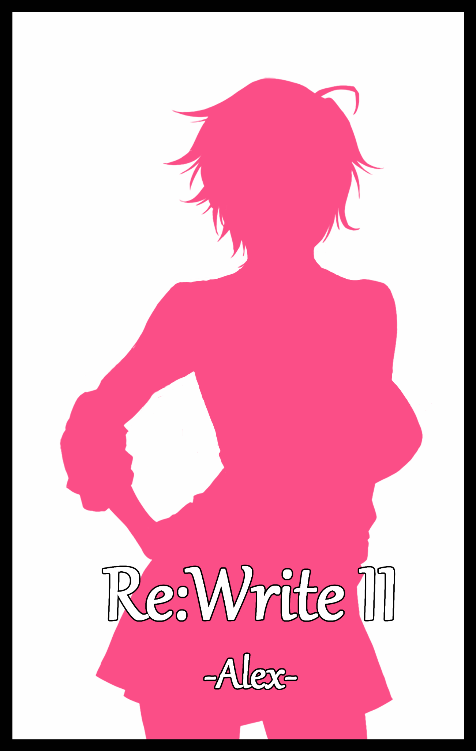

Chapter 1
-Evil Never Sleeps-

Down a narrow corridor few students and faculty frequented near the core of Pendleton University, faint shouting and thuds could be heard echoing down the walls alongside harsh grunts and warbling laughter that made it sound as if a small group were engaged in a round of fisticuffs.

But calling it a fight was a bit of a stretch, not when one side was being bodied by the other. In terms of skill, the only fighter amongst their number was more than a match for their adversaries. But morals and justice would prove a burden against foes who knew no such thing.

Everytime the swift young man was about to land a hit against his lumbering opponent, the audaciously dressed gal who served as his number two would butt in, making him flinch and redirect his swing, leaving him exposed for brutal backhands and upper cuts that were more than enough to lay him flat out on the ground. All while a shivering girl watches in fright like a mouse backed up against the cold wall of the dead end corridor.

And as if that wasn't enough, the woman would partake in her own share of physical abuse, kicking to her heart's content until the brave fighter couldn't stand any longer, showcasing her lack of empathy when she intercepts the girl as she tries to flee, grabbing her wrist with a wicked sneer on her face, leaning in close before shouting expletives right into the poor blonde's ears before swinging her around like a sack of potatoes, tossing her back against the wall for her defeated friend to place his shivering hand over in a futile attempt to ward off any more attempts to harm her.

Such a sight would've made any other offender hesitate, or at least feel a smidge of guilt. But Dani Willow was an exception. Heartless, cold and apathetic towards anyone that wasn't her boyfriend, the debauched woman delighted in picking on the weak whenever she wasn't busy satiating her bodily needs, a habit she shared with the aforementioned man she had seemingly been destined to be with.

Despite her provocative looks, salacious fashion sense and oftentimes ditzy mannerism, Dani was in truth, a highly intelligent individual who had managed to work her way into earning a spot in the hallowed halls of the prestigious university many students across the world could only dream of attending. The only one amongst them who could even stand up to her in a debate was probably the slim young man her stud had put down in one hit, rubbing said arm suggestively while they were sandwiched between her firm melons.

Reciprocating Dani's advances with a rough hand sliding up beneath her skirt to give her pert buttocks a good squeeze was Kevin Pendleton, an infamous thug everyone, both in and out of campus steered clear of. Renowned for his herculean strength and little else, Kevin's shared surname with the esteemed place of learning they all stood in was no mere coincidence, for he was none other than the son of Regis Pendleton, current Rector of the university and the one responsible for sending him here in the first place in a last ditch effort to get his wayward son to learn his lesson.

Instead, the attempt at fixing him straight only seemed to worsen his behavior when reports of bullying the student body and even getting confrontational with the staff started flooding his inboxes. Even more troubling was the fact that he had gotten together again with an old fling of his who saw something in Kevin no one else could, leaving his father stumped as to how someone so…'special', could also be smart enough to earn her place in Pendleton University, frowning as he scans through paperwork containing Dani's colorful history, oblivious of his son's angst against a certain group of students whose only crime was standing up for themselves.

Irritated by the sight of the nerdy fellow glaring daggers at them from where he laid on the floor, Dani crooks her neck up toward Kevin, looking to take their steamy fun time elsewhere upon the reminder of their undeserving audience.

"C'mon babe, we're done here. We've got totes better things to do elsewhere, not in front of these clowns~"

"Anything you say Dani…you got off lucky this time dweebs. Next time I catch you looking at me the wrong way, you're in for it big time!"

Joining her boyfriend's booming baritone with her own shrill laughter, Dani wastes no time in sticking to Kevin's pace, matching each step with perfect synchronization as they made their way toward the opposite side of the lesser used storage wing; one out of many places on campus they had claimed for whenever either of the pair felt the need to vent their 'frustrations' on each other. And after relishing in the pummelling of that speedy wimp and the look of sheer terror plastered over the girls face as she interfered in her attempts to escape clear in mind, Dani was more than eager to quench the throbbing ache in her loins.

Wasting little time once Kevin had wrenched the door to the storage room open, Dani immediately falls to her knees before her stud, tracing lengthy fingers down the man's solid pecs before undoing the zipper between his legs to free the rousing beast from within its fabric prison, cooing in delight with her meaty prize in hand.

It was a systematic process the two had grown used to, so much so that by the time they passed the tenth session, Kevin had found his favorite spot in every love nest while Dani knew what her boyfriend wanted her to do just from body language alone. In this case, his posture suggested relaxation, so that meant she got to enjoy his nice throbbing member filling every inch of her throat. And that was precisely what she set her mind to as gurgling and choking sounds begin to fill the silent air, accompanied by Kevin's grunts as his boisterous front begins to crack and give way under the heavenly warmth encompassing his groin, peaking whenever the overzealous slut kneeling before him took it too deep, bumping the sensitive head against the back of her throat with only a minor reaction in the form of a muffled groan exiting the dripping lips of the experienced woman as her seductive eyes narrow in glee and amusement at the sight of her usually overbearing boyfriend melting in her arms.
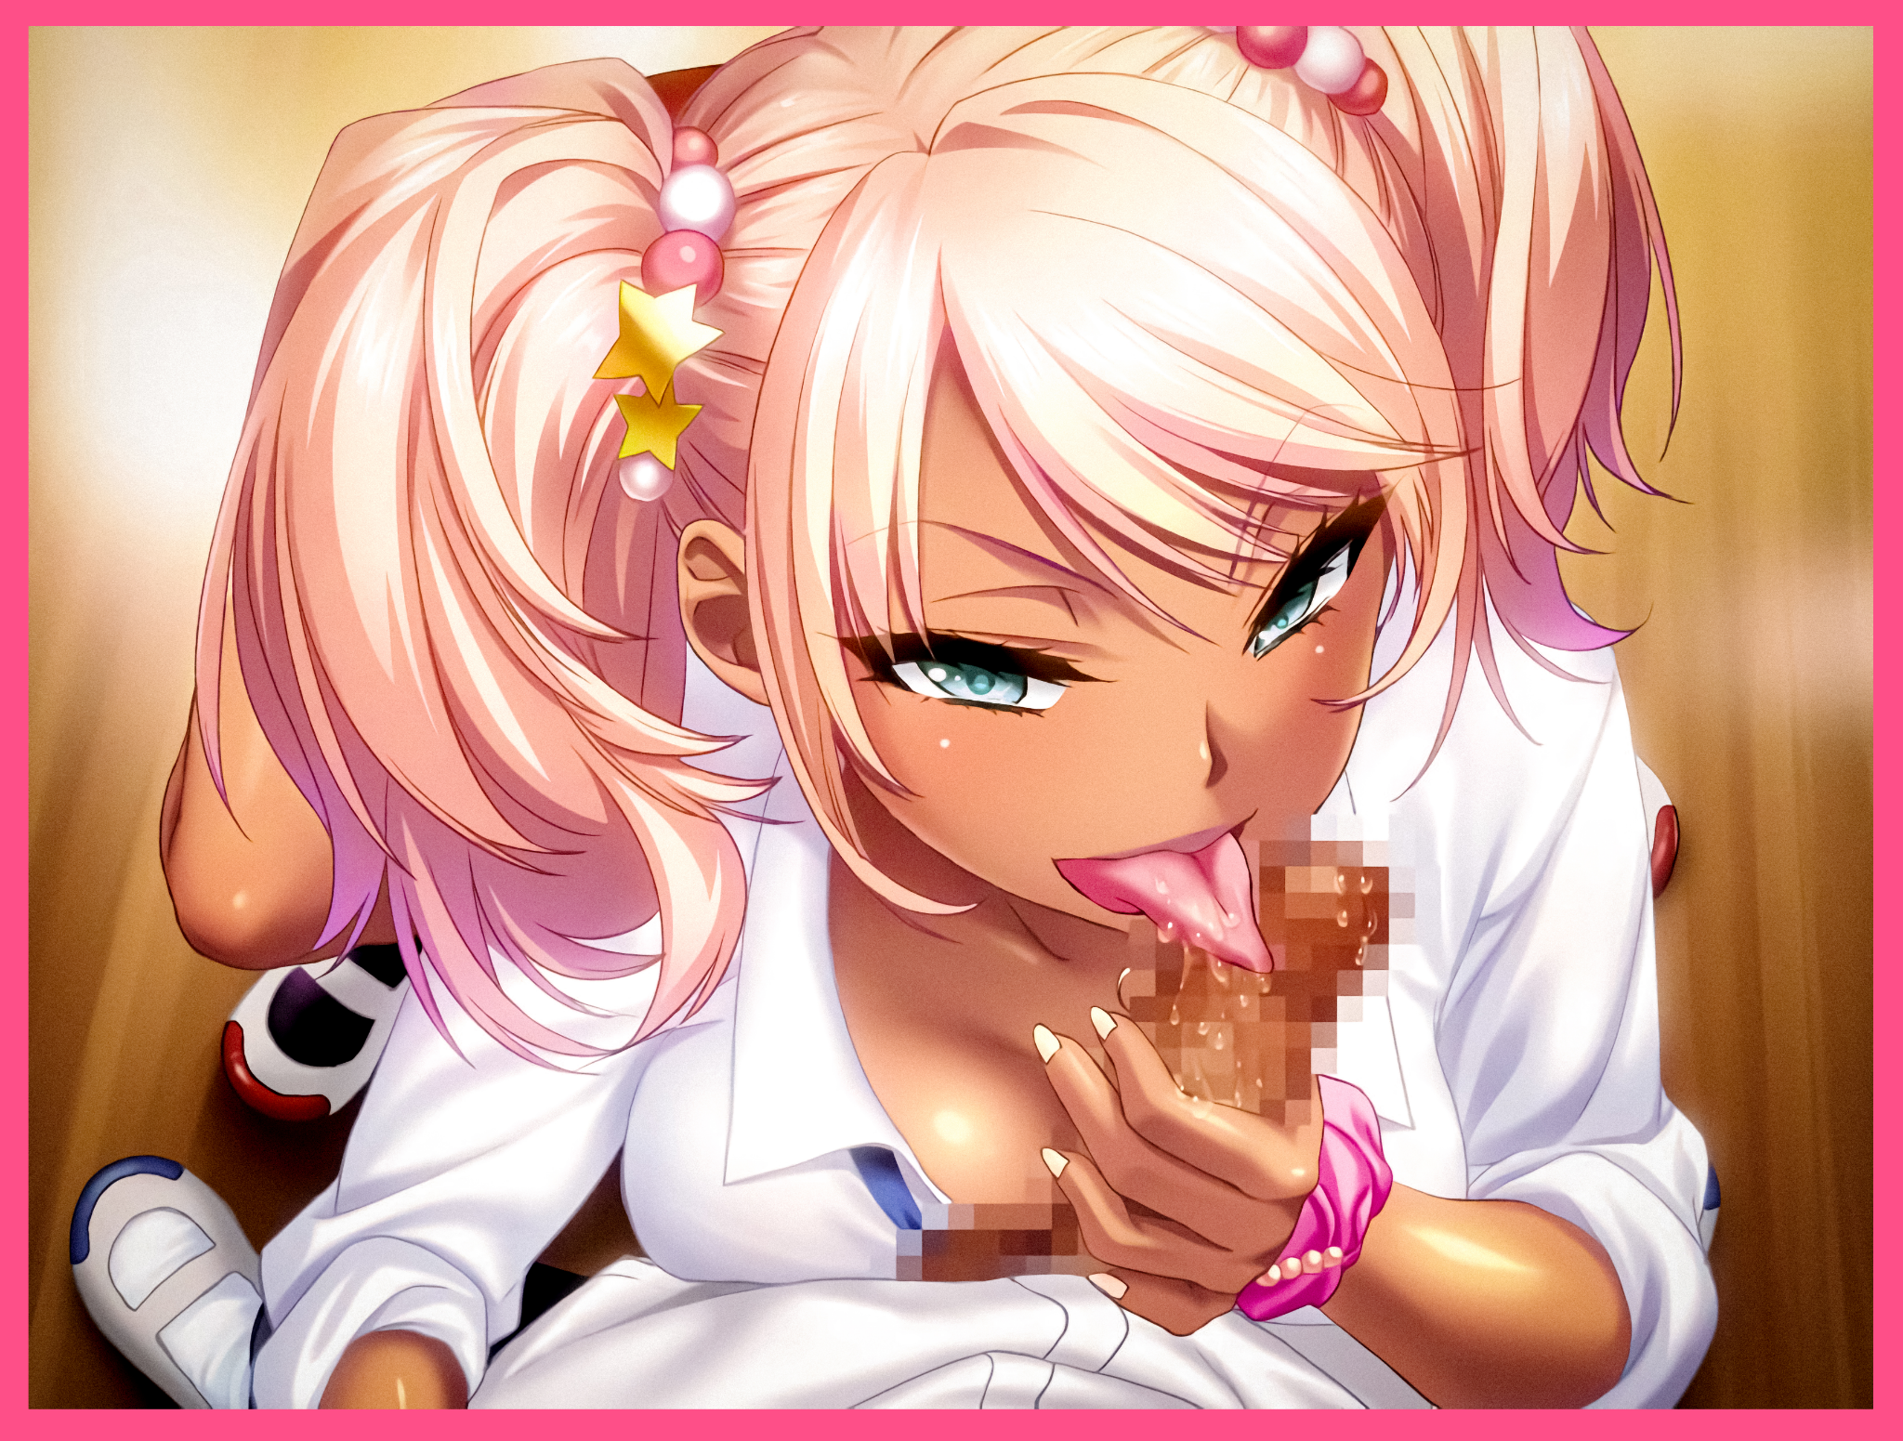
Unbeknownst to her however, it wasn't how good the inside of her throat felt or the way she used her tongue that got Kevin going. In his mind, the man was relishing something quite different, related to what he had done to a certain someone a few days ago, and that someone was currently kneeling before him, pressing her nubile body against him in complete submission while she slurped on his pecker with gusto after getting turned on from bullying her former companions. Initially, worry had plagued Kevin's mind that what he had done might reverse itself, but after watching how Dani willingly used herself as a shield to prey on their target's weakness before abusing them without hesitation, Kevin knew she had completely fallen into place as his ideal gal; a woman tailor built to his every need, who knew him as well as she knew the back of her manicured hand.

Which was why she had stopped her fellatio all of a sudden, frowning a little as she stared up at a confused Kevin with an accusing look.

"It's that girl isn't it? You're totes thinking of her boobs aren't you?"

"Girl? What girl? You know I've only got eyes for-woah!"

Clearly unamused by her boyfriend's protestations, the flexible gal spins on her heel, landing a calculated sweep kick that sends the giant tumbling onto his back, giving Kevin no time to even process his skyward vision and aching back as Dani slides a damp, leopard print thong down her long curvy legs before kicking them away and coming down on top of him in one swift motion, straddling the man like a horse with her exposed pussy nudging up against the base of Kevin's still throbbing member on the peak of climax.

Normally, he would've immediately gotten up to his feet with fire in his eyes to exact vengeance on whoever tripped him up like that. But the warmth exuding from Dani's pillowy ass resting on his exposed thighs and her gorgeous face staring down at him tempered his impulses, keeping him down while she continued her monologue.

"Tut tut tut~ Hiding things? From me? Baby baby baby~ Whether you're distracted or angry, I can totes read you like an open book…and right now? Your eyes tell me you're not focusing on me at all~"

"Oh really? Remind me again…what girl are you talking about?"

"You know who; that…Alex girl or whatever her name is. Boring, quiet bitch but has tits the size of watermelons…don't even think about lying to me, I saw you checking them out…"

That had Kevin thinking as he laid there rubbing his girlfriend's creamy thighs. Although Dani hadn't been completely wrong about him not being focused, her words only served to bring attention to Alex, a girl he would've otherwise ignored if it weren't for the vapid gal's worries that her boyfriend was thinking of someone else.

And with this realization, the seeds of an insidious plan would begin to take root within Kevin's mind as his devious thoughts drifted back towards what Dani had said about Alex being boring and quiet…and wondering what he could do to fix that, just like he had done to the plain old nerd that had become the loyal sexpet grinding her privates against him, although she didn't need to know that part, nor did he think she would even care even if he told her.

With his mind made up and the rejuvenated flames of excitement burning away in his chest, Kevin hoists Dani up with firm hands clenched tight around her hips, lifting her comparatively smaller frame up without much trouble until she hovered a few inches above his erect javelin, looking mildly excited despite the dissatisfaction she had expressed earlier.

"D-Don't think this is enough to tell me you're not interested in another girl!"

"Nah…like you said Dani; no one knows me better than you…and I'd like to prove myself through…action!"
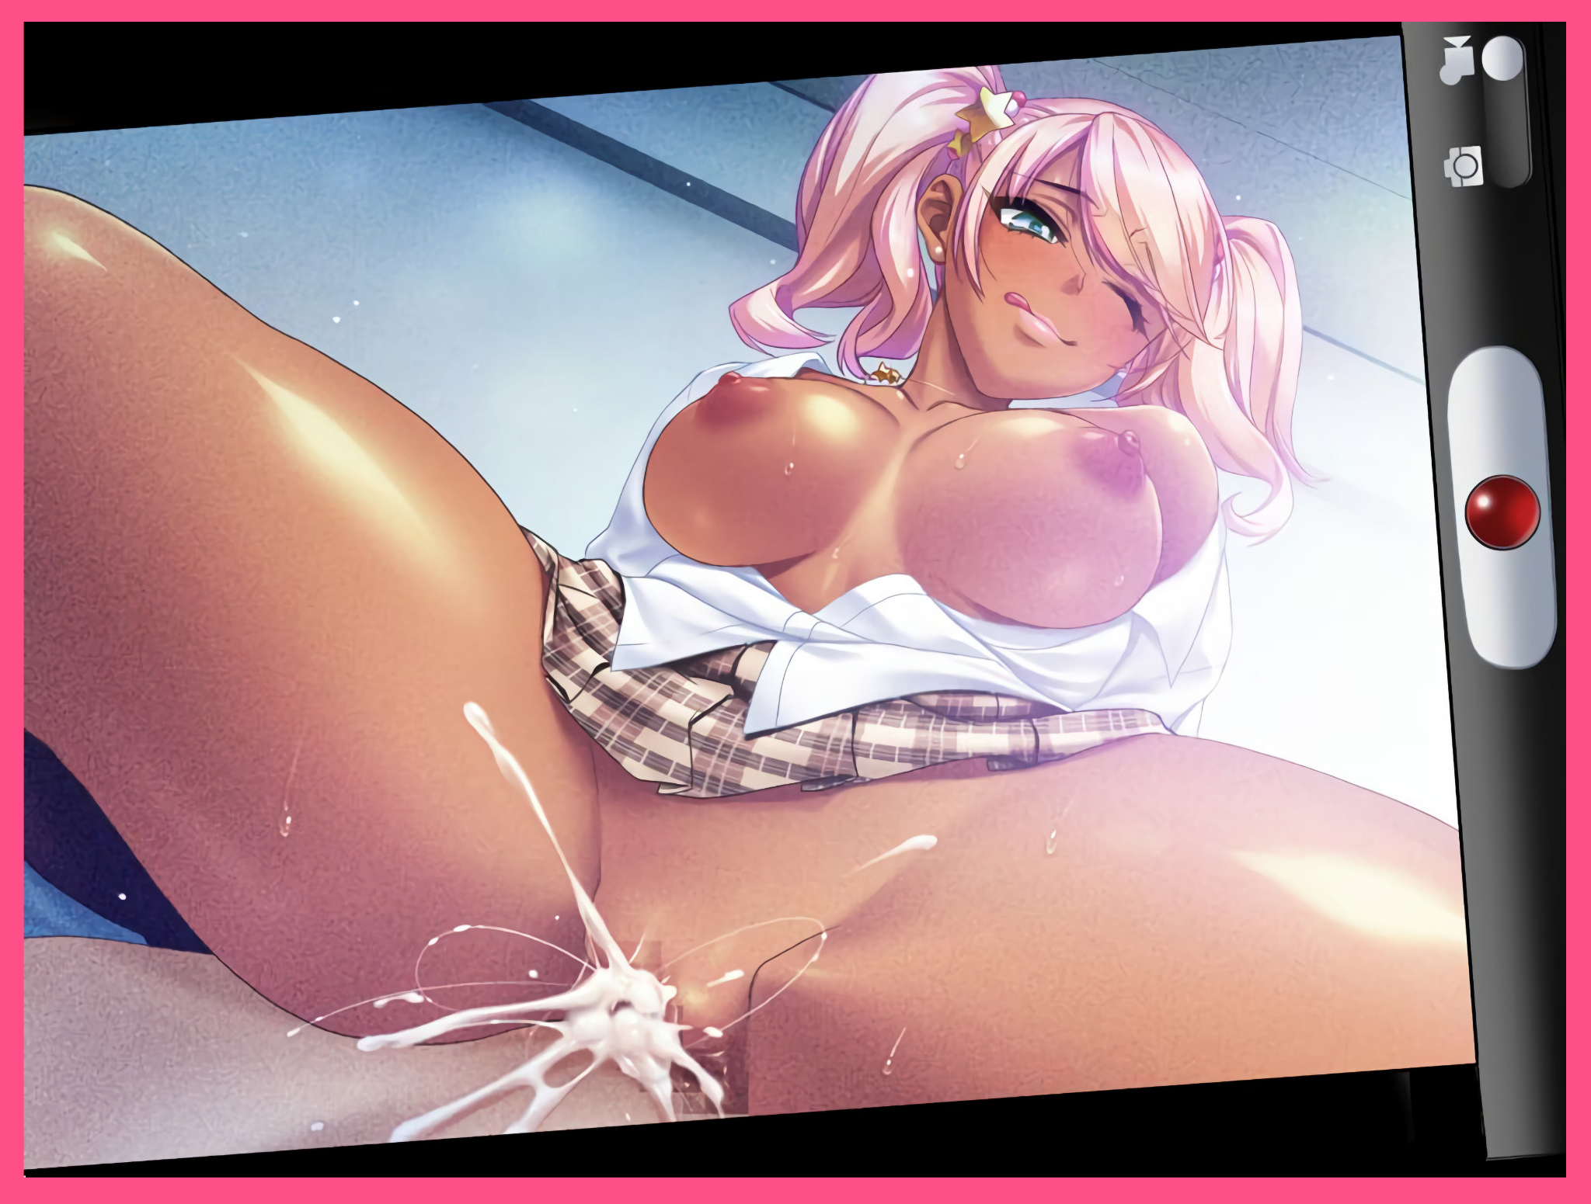
Dropping Dani while thrusting his hips upward at the same time silences the woman midway through whatever she was about to say, turning the table in Kevin's favor as the one in command, bouncing his girlfriend off of him, her former commanding tone all but annihilated as a goofy smile spreads across her face, eyes struggling to stay locked with Kevin's as the two made love in the comfort of a dinghy storage room. Grunting and moaning as they joined their bodies together, steadily unrobing each other simply from the rough movement alone as Dani’s loose top pops open, letting her breasts bounce freely while Kevin’s already opened shirt splays out to the side, leaving his chest and navel bare for Dani to blush at.

But after he'd been left hanging with no chance to let loose the load that had already been loaded inside his organic gun, the sudden stimulation from Dani's piping hot vaginal walls clamping tight around the barrel like a hungry starfish was enough to prime another round, melting together with the first into a creamy payload, firing it off deep inside the spasming woman as she braces her arms against the floor, arching her back in an effort to drive Kevin deeper, all while thick spurts of cum spray forth from the small gaps between her sputtering lips and her boyfriends veiny rod. No stranger to sex and all it entails, the experienced gal twists her body in ecstasy, shivering in frightful glee until she could no longer feel any more spunk flooding into her belly, looking down at the camera lens of her boyfriend’s phone to give Kevin a mischievous wink of approval right before he snaps a picture of her half naked self.

"God dayum babe…we really should try this more often…if you can keep holding in your load of course, wouldn't wanna look like a quick shot after all~"

"Next time Dani…cuz after what you told me earlier? I think I might’ve found something we could toy around with…say, what would you look for in a girlfriend?”

Chapter 2
-The Second Fall-

'Why are those monsters even doing this? Why us…why me?'

It hadn't been long since Caleb had been admitted to the medical bay after the two bullies had grown bored of tormenting them for what the man had done to Kevin. Preying on his morals and code by using herself as a meatshield, that accursed Dani had prevented her friend from landing the quick, clean strikes that would normally have dissuaded the thug from pushing himself onto others. And because of that, he'd been made easy pickings for Kevin to beat down on. Letting his wicked girlfriend in on the fun with a few kicks the nurse said were very close to breaking his ribs.
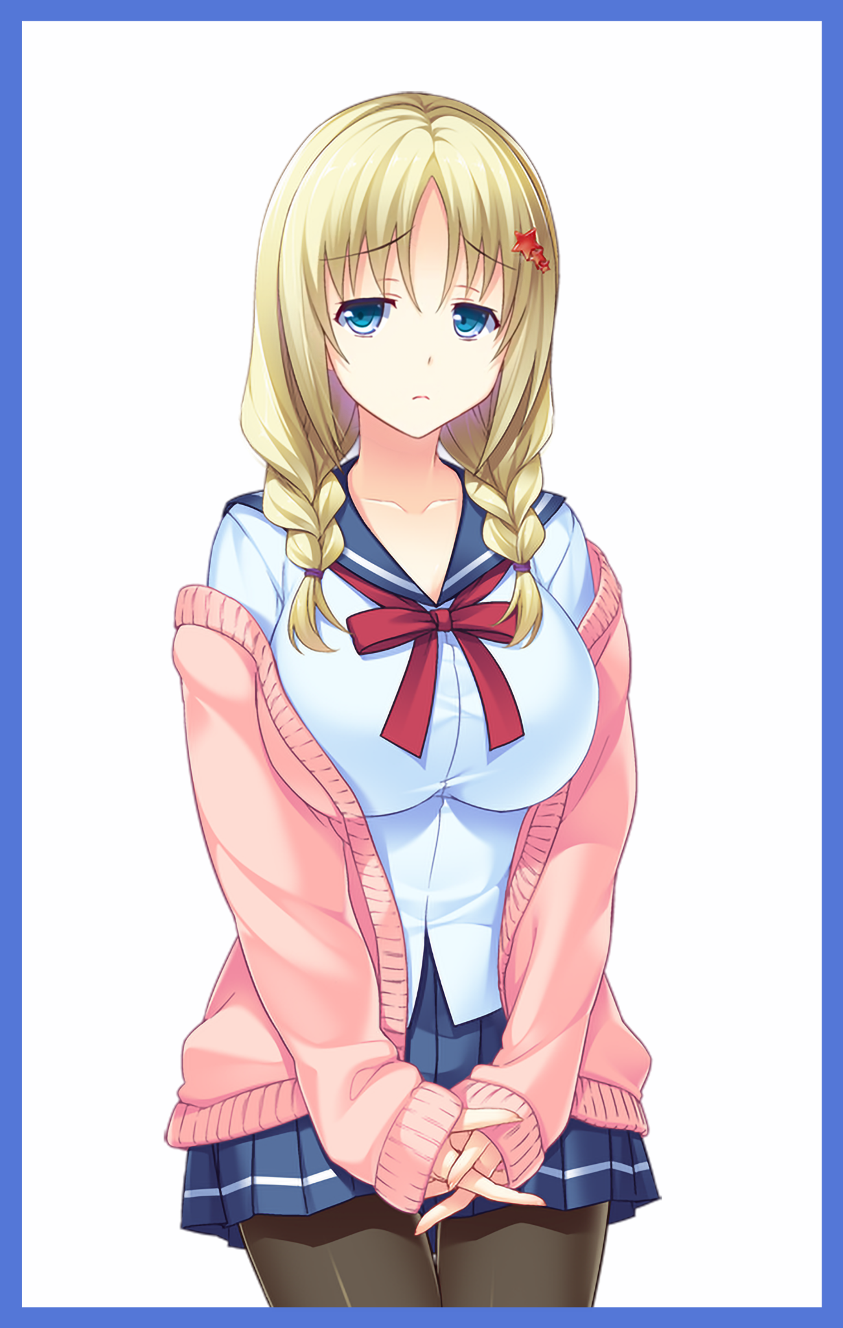
With Caleb out of the picture, she was left alone and afraid, wondering what the next day would hold for her now that the only one capable of reigning Kevin in wasn't there to protect them.

Not one for conversation outside the Internet, Alex Bradford wasn't an outgoing individual. With a penchant for all things related to BL, or yaoi in Japanese media, the quiet maiden preferred to spend her time reading and watching her favorite shows while engaging in gushing discussions with people online talking about their favorite characters.

People knew her to be a quiet mouse who rarely spoke an octave louder than her peers, even during presentations and the like. But behind closed doors and out of sight from everyone else, Alex was free to be herself without a care in the world. Enjoying the comforts of home and a loving family to go back to after yet another stressful day as a university student studying under the nation's best.

Sighing despondently after one last look back at the cot a sleeping Caleb was now confined to, Alex turns to make her exit now that she had done all she could for her friend, ignorant to the fact that this would be the last time she saw her friends and family in the same positive light once her phone buzzes with an incoming message, extracting it from her pocket before freezing at the sight of the sender and what they had to say;

DanDan

[Hiya fucko! If you don't want everyone to know you're some sorta shut in perv who likes watching men screw with each other, come to the roof alone. ;) FYI don't even think of telling anyone, if you do, can't say Kevy baby will be too pleased. I warned ya~]

Too many questions were entering Alex's head for her to even begin to process the alarming pain she felt in her chest as her breathing began to quicken. If the crude nickname and vulgar manner of speech wasn't enough, the presence of Kevin's name shortened into a sickening title was more than enough to point towards Dani as the one who had sent the message.

"B-But how does she k-know my contact number? M-My…no…this can't be happening…it's a lie!"

But another notification would shake the trembling girl from her attempts at denying the reality she faced before her, gnashing her molars at the hopelessness she felt upon reading the second mocking message flung her way as if that bitch had eyes everywhere, watching her every move;

[Better come quick or we'll start spreading the word~ No time for tears dear XD Don't forget; no funny ideas once you're there whenever, ciao~]

Making a beeline for the nearest stairwell connected to the roof, Alex paws through her bag for a scissors, tucking it inside the baggy sleeves of her pink cotton jacket in preparation for the tremendous odds she was about to face, trying to steady her breathing while keeping what Caleb had told her about self defense tactics clear in mind as her feet carried her up through flight after flight of cold blue stairs illuminated by dim LED lamps, acting like guiding flares for the heroine as she made her way up the steps leading to the demon king's throne. The climax to a tale of heroism from one bold enough to face evil alone.

Except this tale was of the grimdark variety, there would be no happy ending for all except the 'demon king' and his loyal followers, and the heroine would meet a fate most foul as she slowly pushes open the cold iron doors that barred her way forward, sweat trickling down her forehead, wincing once the full strength of the mid-day sun shines down upon Alex's face as she emerges from the dark, only to come face to face with Kevin, leaning against the protective fence with what looked like a thick leathery book held open in the palm of his hand.

"Heh…can't believe you actually came alone…gotta say, didn't think you had what it takes to play along…Alex, was it? Nah, not like that's going t-"

"Why are you doing this to us?! Why can't you just…stop bullying other people?!"

Interrupted by Alex's sudden shout, Kevin's broad shoulders shudder before the man breaks out into a fit of laughter, chortling as if the frightened girl had told a bad joke. And the look he shot her way was more than enough to force Alex a step back as her adamant front soon shattered in the face of the unreasonable tyrant before her.

"Why do you think? Because it's fun, that's why! The fact you even have to ask…ahh Alex, Alex…too innocent for this world…Welp, once I'm done with you, that won't be the case any longer…say, one thing I gotta ask before we begin. Daniel Weller; name ring any bells with you?"

"I-I don't…know who that is…w-what are you planning you creep?! Stay away from me."

Rising up from his roost, Kevin begins to close the distance between himself and Alex, eyeing up her body in a manner that sends the panicking girl skittering backwards, holding her ground once the man's gaze returns to lock with her eyes, reminding him of what Dani's message mentioned about getting cold feet or trying anything 'funny'. The fact that they somehow knew about her secret hobby was more than enough to convince her to stay, getting ready to extend the makeshift razor still hidden under her clothes if Kevin tried anything with her.

But the man didn't seem the least bit interested in her, even when he was close enough to dwarf her in size, he was utterly focused with the book in his possession, scribbling something inside it's weathered yellow pages, leaving Alex trembling in place for a few seconds while her eyes lock on to the cover concealed behind the man's broad hands, reading the title silently in her mind; Re:Write…

Although she wouldn't have long to wonder what exactly Kevin had in store for her as he turns the book over so that the pages faced her, and on it, Alex was shocked to see full name written on it in Kevin's ugly handwriting, followed up by a neatly written sentence in cursive that came after as if someone else had stepped in to write it down;

The Following Individual Shall Be Rewritten As Follows :

"You were wondering how Dani and I knew about your…kinks? Well, it's all thanks to this nifty little thing right here. All I have to do is write down someone's name in it, and bang! It's like I know everything there is to know about them…like how you're a complete sucker for mommy and daddy…or how you have a thing for that dweeb Cal-"

"D-Don't just say those things out loud! Y-You're disgusting! You and Dani both!"

"See? You can be loud when you want to, che! Believe me or don't, but I'll have you know peeping in on other people's memories isn't all it can do…it can change them, add new ones too…hell, I can even change someone without them or anyone else knowing~"

"C-Change?"

"Yeap….just like I did with Dani…and you know what lovers do for each other right? Seeing as you're all gung ho about that romance shit…see, Dani's been a good girl…and I'm thinking; I can't just let her go without a reward…so how about becoming her best friend hm? Someone she can share a bed with?"

"W-What…are…you're totally insane! I won't be f-friends with someone like that!"

"Sorry dear, I wasn't asking, the only reason I even let you know what's gonna happen is because it's the least I can do before you, y'know? Stop being yourself? Now if you'll just hold still…"

"Wait! What're you-"

A strange feeling washes over Alex, silencing her midway through her protestations while the flow of time itself slows to an agonizing crawl, leaving the poor girl trapped with a look of terror on her face while her spine shivered in disgust at the creeping sensation of something…perverse…crawling all over her. She couldn't see what it was, not when her eyes remained locked with a smug Kevin, but she could feel it's cold, inhuman touch swarming over her skin, piercing her very being as if she were a jigsaw puzzle, prying her apart before her vision blanks for a moment like a TV channel being switched.

And before she knew it, Alex scrambles forward with a start until her shaky vision registered the fact that she was surrounded by the familiar walls of her room back at home, struggling to catch her breath while wiping away beads of sweat pouring down from her forehead.

"A-A dream…it was all…just a dream..haha…of course it was…"

Looking down, Alex pats herself down, musing to herself for falling asleep in her uniform and sweater. No wonder she had a bad dream, it wouldn't matter how well she slept if she did so in uncomfortable conditions after all.

"Really should take better care of myself…can't just go around falling asleep in-"

Thunk! Ka-KLACK!

The sudden sound of something metallic falling onto the floor catches Alex's attention, turning her gaze downward before her eyes widen in horror at the sight of the pink, plastic handle adorning the twin razors catching the warm orange glow of the sunlight peering in through her windows. The scissors she had slipped away earlier…

Alex's breathing begins to worsen while her vision grows hazy, feeling like she'd just been punched in the gut while backing away from the abandoned scissors as if it were a bomb, shaking her head slowly from side to side while the twin braided length of her hair begins to fray and shrink away, losing the silken edge she had maintained as the well cared for tufts turn into jagged, spiky threads that darken near the roots, turning Alex's eye catching natural blonde mane into an artificial dirty yellow mop of spikes that looked sorely out of place atop her head, losing the cute floral accessories that once adorned them as they crack and shatter, finally drawing the girls attention upward once the disintegrating particles enter her vision, feeling up her degraded head of hair in a fit of panic.

"M-My hair?! W-Why's it so rough?!"

While the frightened girl continued to tussle with the loss of her luscious hair, Alex would be rendered blind to how her room was beginning to change alongside her as her precious collection of novels, manga and figurines begin to fade, melting away into dust much like her hair ties and accessories had while what little remained were altered, swapped out for far more perverse material devoid of the charm and romance she loved in yaoi and anime. Novels were swapped out for Playgirl magazines, collector figurines were reshaped into studded dildos while her collection of notebooks and papers she kept aside for revision were all reduced to dust, leaving her table empty save for a few bottles of half used makeup and lipstick of the gaudy variety she would never buy in the first place. And to reflect the degrading room, so too was its startled tenant beginning to lose her innocent appearance once the physical changes started to affect her body as a whole.

Starting with her face, the wide eyed doe look once synonymous with Alex begins to ebb and wane, gaining a sultry edge alongside a hefty dosage of masculinity as her rounded cheeks harden, losing most of its baby fat while huge, almond shaped eyes begin to shrink and contort, gaining cold, sleek edges especially prominent around the sides to contain smaller irises shaded a darker hue of aquamarine. All while soft spoken lips plump up, inflating into fat pink cushions that just couldn't close properly, laced in a generous amount of lipstick that accentuates their glossy texture, drawing further attention to the face of a mature vixen twisted in terror that had completely subsumed Alex's naive one.

"This can't be happening! H-How…stop this! Let me go!"

Attempting to run, Alex fails to ignore the presence of something bulky rolling around where she had last dropped the scissors, wincing at the sight of yet another rolling dildo that hadn't been there before. Realizing then that the changes had been progressing further and further without her notice as her fearful eyes turn just in time to catch her alien reflection staring back at her now that she had landed perfectly before a full body mirror, leaning against a wall plastered in heavy metal posters and other horrific imagery she felt nauseated excited just by looking as they invaded the periphery of her vision.


Instead of her usual self, she saw a big breasted tomboy staring back at her, dressed in ill fitting clothes that were probably oversized, leaving her top looking crumpled while the last of her fluffy pink jacket tears itself off her shoulders as it too fades away, revealing toned shoulders she could only dream of having before a guttural groan escapes her mouth involuntarily, feeling a sudden weight pressing against her chest while rising occasionally to tickle the depths of her esophagus, altering vocal chords while her already impressive D cup breasts surge forward in tune with a strained gasp of air, inflating into burgeoning E's topped with bright pink areola and swollen nipples tenting the button up shirt that had replaced her Pendleton University uniform sporting a popped collar that leaves a generous amount of cleavage exposed.

But the kicker and what freaked Alex out was the moment her prim blue skirt, the last remnant of her former self, instantly changes into a ridiculously short, checkered skirt that left little to the imagination considering how it could only reach down long enough to conceal her upper thighs, thighs that had already fallen to the metamorphic affliction that plagued her and the surroundings, altering all she knew, even her body, into foreign concepts she despised. Even more so when she realized why the skirt looked so familiar to her, half lidded eyes growing dim before the light of intelligence in Alex's eyes faded away as if something had crept into her at that very moment.

"Isn't that…D-Dani's skirt? The fuck? Why'm I…why can't…ah, screw it, gotta find something to wear before he gets here~"

Alex's grammar had been dumbed down into an atrocious trawl accompanied by vulgarity and her husky voice was complemented by an artificial accent that made her sound even more vapid and simple minded than she already looked as her pale skin darkens just a little, gaining a faint beige coloration as time spent under the sun ingrains itself into Alex’s toned body, hefting massive milkers strained against beefier shoulders that supported them without aid from a bra while her formerly pudgy navel had become a lot more solid and exercised, bulging with sexy lines and indents formed from her pelvis bones, enhanced musculature and the undulating waves of flesh formed from her belly button and broad hips that were the core of her killer hourglass figure.

Grasping at her throat in mild discomfort while failing to notice the blushing in joy from the breeze wafting up between her legs once the cotton panties that had kept her privates concealed turn to dust, Alex rises slowly to her feet, moving shakily fast on longer legs bulging with muscle indentation while trying to push back the disgusting reveling in the way her engorged breasts jiggled with her every move, hoping to find some sort of reprieve in her wardrobe that thankfully looked untouched with a worrisome hungry look on her face.

"Let's see here…ahh, this should do the trick, Kev's totally gonna freak when I…when I…huh?"

Staring at the salacious nightwear she held in her hands, the voracious light in the woman's eyes dim as Alex's waning persona attempts to claw her way back into the light, throwing the disgusting thing far away from her face with a pained grunt once control fully passed back into her hands…no matter how foreign they now were.

By then, the room she once used to live in had completed its transition into a debauched den she wanted to get out of. Sex toys, porn magazines, unwashed clothes piled up on the floor that radiated the rancid smell of something bad sex. Not even a single piece of paper remained from her original belongings, and that fact had her frowning in sorrow as she shook her head, trying to convince herself that all this was just in her head.

'Whatever that asshole is trying…he won't…win…he can't!'

"Che! Nice try, but do you even hear yourself right now? You just cussed without even skipping a beat! I'm sorry dear, but face it; no matter what you try to use to convince yourself otherwise, you can't win Alex…or should I say, Lexi?"

Turning swiftly to face her tormentor who had suddenly appeared on her bed without making the slightest sound, Alex grits her teeth in response to a sudden bout of anger coursing through her veins. Ignorant to Kevin's claims of her waning sense of self as a result of her already dwindling IQ and situational awareness bleeding into the mental hellscape she was trapped in. Especially after that extended period of time spent behaving like the slut her body had been transformed into once her mind had temporarily fallen into its new abrasive mindset far removed from the old.

In truth, the Kevin Alex thought she was talking to wasn't the real one who had brought this on her in the first place. Instead, it was the embodiment of the malignant entity she felt right before being transported into the depths of her mind. Here to personally finish up off the last bits of Alex's impressively resilient soul, even though she might not be aware of the state her actual body was in right now alongside the highly negative light everyone she knew now saw her in.

"Fuck you! The name's Alex Lexi! Not Lexi Alex! Turn me back now!"

"Oh no need to be so hasty Lexi…I'll have you know I'm not as heartless as I seem so…let's play a game shall we? If you can answer my questions truthfully and correctly, I'll let you go and change you right back to the boring old raisin you were, deal?"

"Deal!"

"So quick to agree hm? Well then, first question; what were you doing before our little meeting?"

"D'you really have ta ask? You trapped me here I was jackin' it since you took your sweet ass time gettin' here…that…was what I was doin' right?"

With a keen eye and a gleeful smirk taking note of the trickle of love juices now leaking down her thighs, the Kevin lookalike turns his attention back to Alex, whose uncertain stance had become more relaxed, one arm hanging lazily down her side while the other rested on her handlebar hips, staring at him with heavy lidded eyes that were gradually beginning to narrow, losing that resentful look as the new and last memory she had unwittingly given rise to starts to bounce around inside her mind, stimulating her libido while minute changes occur outside her notice, vocalizing an impatient harrumph as a tingle of electric arousal shoots up from somewhere within her miraculously intact vagina that had managed to weather the changes until now as years worth of use assault's Alex's folds, erasing her hymen in an instant while loosening the moist canal greatly, fattening labia lips to finalize the perfect pussy molded to take the one cock her new body had been designed for. Leaving her one step closer towards the point of no return…

…a point Alex would eventually cross once her thoroughly drained mind opened itself to further suggestion and assimilation from the other her that had already consumed most of Alex's soul, appropriating it so nothing but the new her would remain once this mental escapade was over.

"Correcto! For this next one, how many men have you slept with?"

" Is that the sort of question you should be asking an unmarried woman I lost track after my first time back in highschool. And for the record? Whether ya got a dick or a vag, I don't mind much. As long as ya got the dough, my body's all yours~"

"Does that openness apply to your past times? Hobbies etcetera?"

"Look, all I do is fuck and suck now. That ya…y…gay shit is in the past. Old me, don't wanna talk about it."

"Hoo~ Sensitive topic I see…which leads into my third question; do you have anyone in particular you like?

Furrowing her brow while her mind tussled with the question, Alex's thoughts drift toward her parents, scowling at the image of them looking down upon her. She hated them to the core for not lifting a finger to help her during her tumultuous life in highschool where people bullied her because of her masculine name. Leading to another familiar face making his appearance from the dark recesses of her mind; Caleb. If it were the old her who still wore her hair in cutesy twin braids, she would've easily said yes if asked whether or not she held feelings for him. But now? Now all she could feel was cold nothingness whenever she looked upon her old friend. He too had done nothing, telling her to take the pain she felt ‘in stride’ while the bullies had their way. It made her frustrated to no end whenever she thought about that pacifistic dweeb and his limp dick approach, totally unlike the man her body ached for whenever the simplest mention of his name reached her ears, unable to help the wry smile that crept up her face upon the vivid memory of when they first had sex after she did all in her power to become a woman most fitting to be by his side. Basing her getup on the advice given to her by the girl who’d been by his side at the time.

"K-Kevin…the man I love…is Kevin…"

"My, my, even a tomboy has her soft spots I see…why the shyness my dear?"

"W-Well…he was…the only one who really…got me y'see? Everyone else…it was like they just didn't want anythin' t'do with me…but Kevin…he beat up those who bullied me, helped me grow outta that pathetic shell…if anyone deserves my love…it's Kevin. And I don't give a shit about what anyone else has to say about him."

"Well spoken my dear, one step closer to freedom…lastly…do you remember this place? When did you last see it?"

Looking around with narrowed eyes, Lexi's emotionless visage breaks into a warm smile upon the sight of her toys and the bed she used to sleep on a few years ago. Caring more about the final act of defiance she pulled on her parents instead of all the times she spent cooped up in there reading books.

"Sure I do…was my ol fuck nest when I was still a senior back in high. Took almost all the boys in school here by the time 'Cember rolled around, freaked Ma and Pa whenever they found it…so me and Kevin gave em the finger, screwed like rabbits all day while they tried so hard to break in…ahh that shit still makes me laugh so hard…so? How’d I do? Free t’go now? I really need to get goin’, promised t’meet Kev at the roof today if ya catch my drift?"

“Come on now, I’m the spitting image aren’t I?”

“Sorry to bust yer balls, but Kev ain’t so…big brained, especially when it comes to the things he says sometimes…as much as I love him, I think he and I share t’same brain cell sometimes…even then, I bet I could do some math stuff better than him~”

"Spoken like a true rebel; no remorse for all the misdeeds you’ve wrought…but that is to be expected of someone like you after all, isn't that right, Lexi Bradford? Well, I won’t keep you any longer, go on, you’ve got a date don’t you?"

With a dismissive wave of the hand, a blinding light surges forward from the open hand of the Kevin lookalike, blinding Lexi while an invisible force sends her flying backward, freeing the changed woman from the suffocating darkness of her old home until the warmth of sunlight and a host of other sensations assaults all her senses, shaking her head as she comes to before none other than Kevin, just the two of them, alone on the rooftops of Pendleton University.

To Kevin, the changes had been instantaneous, watching as the innocent young maiden before him transformed into yet another perverted slut in the span of a few seconds with each word etched into the yellow page beneath Alex's name. Clothes unwound, flesh gurgled while strands of silken hair wore themselves out, all while Alex finally loses in a hopeless mental battle after what felt like a few agonizingly drawn out minutes.

Outgoing, Abrasive, Whore, these defining qualities and more were what helped shape Lexi Bradford into existence, forcing Alex's stalwart mind to endure until it could no longer remember what it was even holding out for. Without a single shred of love left for who she once was, all that remained for her soul was to conform to the new debauched mold Kevin had made for her to be cast in. Reborn as Lexi Bradford, Kevin’s second girlfriend, besties with Dani and an 'illegal tenant' on campus, sharing rooms with either one of her legitimate friends whenever she wasn't out working the horny student body and faculty for cash, oblivious to the fact that the entire university now saw as her as the resident ‘bicycle’ instead of the quiet doe she once was; the easiest, and cheapest lay for those looking to either lose their virginities or have a good time with.

But the man before her wasn't a customer, sure, seeing him with a book was probably a first, but the sight of his handsome face looking all smug had Lexi raring to go as her hands moved to undo the buttons holding her baggy clothes shut, giving her puppies some room to breathe as they flop freely out of their confines, tipped with angry looking nipples shimmering with sweat.

Slapping the book out of Kevin's hand, the overbearing blonde shoves her man hard in a move she had learned from Dani, except instead of her legs, the brash woman preferred the use of her hands considering how she admittedly wasn't as flexible as her senior was. Everything she knew, Dani had taught her, repurposing them so they fit her straightforward way of doing things. Plus she probably had more stamina than the pink haired ditz so that was something she could proudly flaunt in place of the brains she lacked. And now that Kevin was all ready and waiting on the floor, all Lexi had to do was to extract the scissors she had been keeping under her sleeve to make him pay vibrating dildo she had lodged up her uncovered pussy.

"What the…hnng…shit!"

"Everything okay Lexi?"

Blocking out the overwhelming nausea racking her mind, Lexi paws at her snatch, grunting once her hands grab ahold of the cold rubber base jutting out of her dripping folds before her silent whining devolves into a guttural moan that turns Kevin's concerned frown into a victorious grin, half reclined against the floor of the sun baked roof while taking in the sight of Lexi panting in ecstasy, holding the monster pecker slick with her juices in hand, seductive face flushed red with a gorgeous smile plastered over it. The heat must've been getting to her head but a little dose of her favorite medicine had clearly been enough to silence the pesky headache that was about to take root in her mind.

"It’s nothin’...just a head dookie is all…now…where were we, Stud?”

"You were gonna fuck me?"

"Right~ Where's Dani by the by?"

"Storeroom, waiting for us…make sure to save some for her alright?"

Snorting in disbelief while tossing the dildo aside in a dismissive manner, Lexi strides over toward Kevin before crouching low over his groin, keeping herself aloft with the aid of powerful quads and a familiarity with the term 'down and dirty' while she undid the zipper over his throbbing member before turning to look the man in the eye, resting her full weight down on his rod all while her devilish look intensifies once Kevin sneakily pretends to be out of breath, reaching his hands out to grope and squeeze her pillowy tits beneath the facade of a protest.

"Seriously? Ya tellin' me t'save seconds when you two already a go with each other? Didn’t think I’d know how ta sniff ya out huh?"

"C'mon Lexi, I was just…looking out for ya…can't tell whether you'd be able to take us both y'know? Considering how hard you work all the-hnghh!"

"Hah! I'm not the same old girl who’d scream just cuz she took one dick up the ass! Save the shit talk till after we fuck, hm? Then we'll see who needs 't'save some'...love ya Stud~"

"L-love you too…Lex…"

For the rest of the afternoon, Kevin would spend it splayed out under the complete mercy of Lexi's relentless assault as used him like a stationary sex toy, fueling the sadistic tendencies he had imbued her with as per the mini story he had ended up writing for her thanks to inspiration provided by Dani in what she would want in a BFF that wasn't him, simply rewriting Alex's past so that at some point or another during her unsurprisingly harsh highschool life, she ended up meeting the two of them, sowing the seeds for Lexi's eventual birth and forever twisting the quiet girl with a burning passion for boys love into Kevin's cock hungry bisexual second girlfriend who wouldn't hesitate to get physical with someone if they had the money to afford her, lending credence to the skills she was currently using to whittle Kevin down. No matter what he tried, Lexi would power through it, at most, she would moan, but that was it. For most of their time on the roof, the seasoned street walker was in charge, and she loved every second of it.

By the time she called it quits with a belly full of cum and sweat soaking her through, her boyfriend was completely drained, panting as if he'd just run a marathon, muscles throbbing while visible spouts of steam rose from his boiling skin. But this was far from over, not when Lexi still remembered what Kevin had said about Dani waiting for them in the lesser known storeroom situated all the way on the other side of the campus. With his fate sealed and Lexi still raring to go, the tomboy hoists her boyfriend on her shoulders like a sack of potatoes, but not before gathering up his belongings as they leave the roof with the evidence of their fun time slowly burning away under the unrelenting heat of the sun…

Chapter 3
-Twofer-

“How long are those two gonna…finally…what took you so…woah…what the heck happened? D-Did you walk here like that? That's totes hardcore…"

Hoisting a half conscious Kevin off of Lexi's shoulders, Dani carefully lowers him to the floor with a raised brow, aware of what had happened between them but confused as to how her boyfriend could've been drained till he looked like a mummy, turning back toward Lexi who had already tossed aside her sweaty drenched top without a care in the world save for her still intact necktie, Dani couldn't help but smile at the sight of the girl she'd helped raise once the memory of the boring girl she once was crosses her mind.

"I was starting to think the neckbeards had caught you two or something. Good to know you were just fuckin' like rabbits on the roof. Here…y'know Lexi dear? If you got a tan…"

"Thanks…but nah, tan's yer style, I'm good just the way I am…after all, ain't that what you two taught me?"

"Awww~ Our lil baby girls all grown up~ You're totes right tho, if you got tanned, we'd both have something else to fight over!"

Sharing a little heart to heart before falling silent, the women turn toward the unmoving figure of Kevin still lying still by their side, halting Lexi's attempts at cleaning up the cum oozing out of her still steaming loins with the handkerchief her friend had given her once Dani begins to strip, taking off her clothes before sliding over toward Kevin, planting her bosom over the pecker that had suddenly risen to full mast once again at some point during his chance to rest, still dripping with a combination of juices consisting of Lexi's ejaculate and Kevin's semen.

"Well? Wanna join in? I think he's up for another round~"

"Hah! Should'a heard what he told me earlier! Sure, I'm in!"

Not being one to say no to a duet despite intending for her friend to enjoy her own time with their shared love, Lexi takes up her position directly opposite of Dani, pressing her far larger bosom against hers until an overwhelmingly warm, pillowy prison was formed between them, rousing Kevin from his slumber while wet sounds begin to fill the air.

"P-Please…can't go another…"

“Come now babe, Lexi here’s worked really hard…you love her like you love me right? So give her this moment, hm?”

“Y’hear that Stud? Hope ya prepared more than seconds cuz we ain’t lettin ya off so easily!”
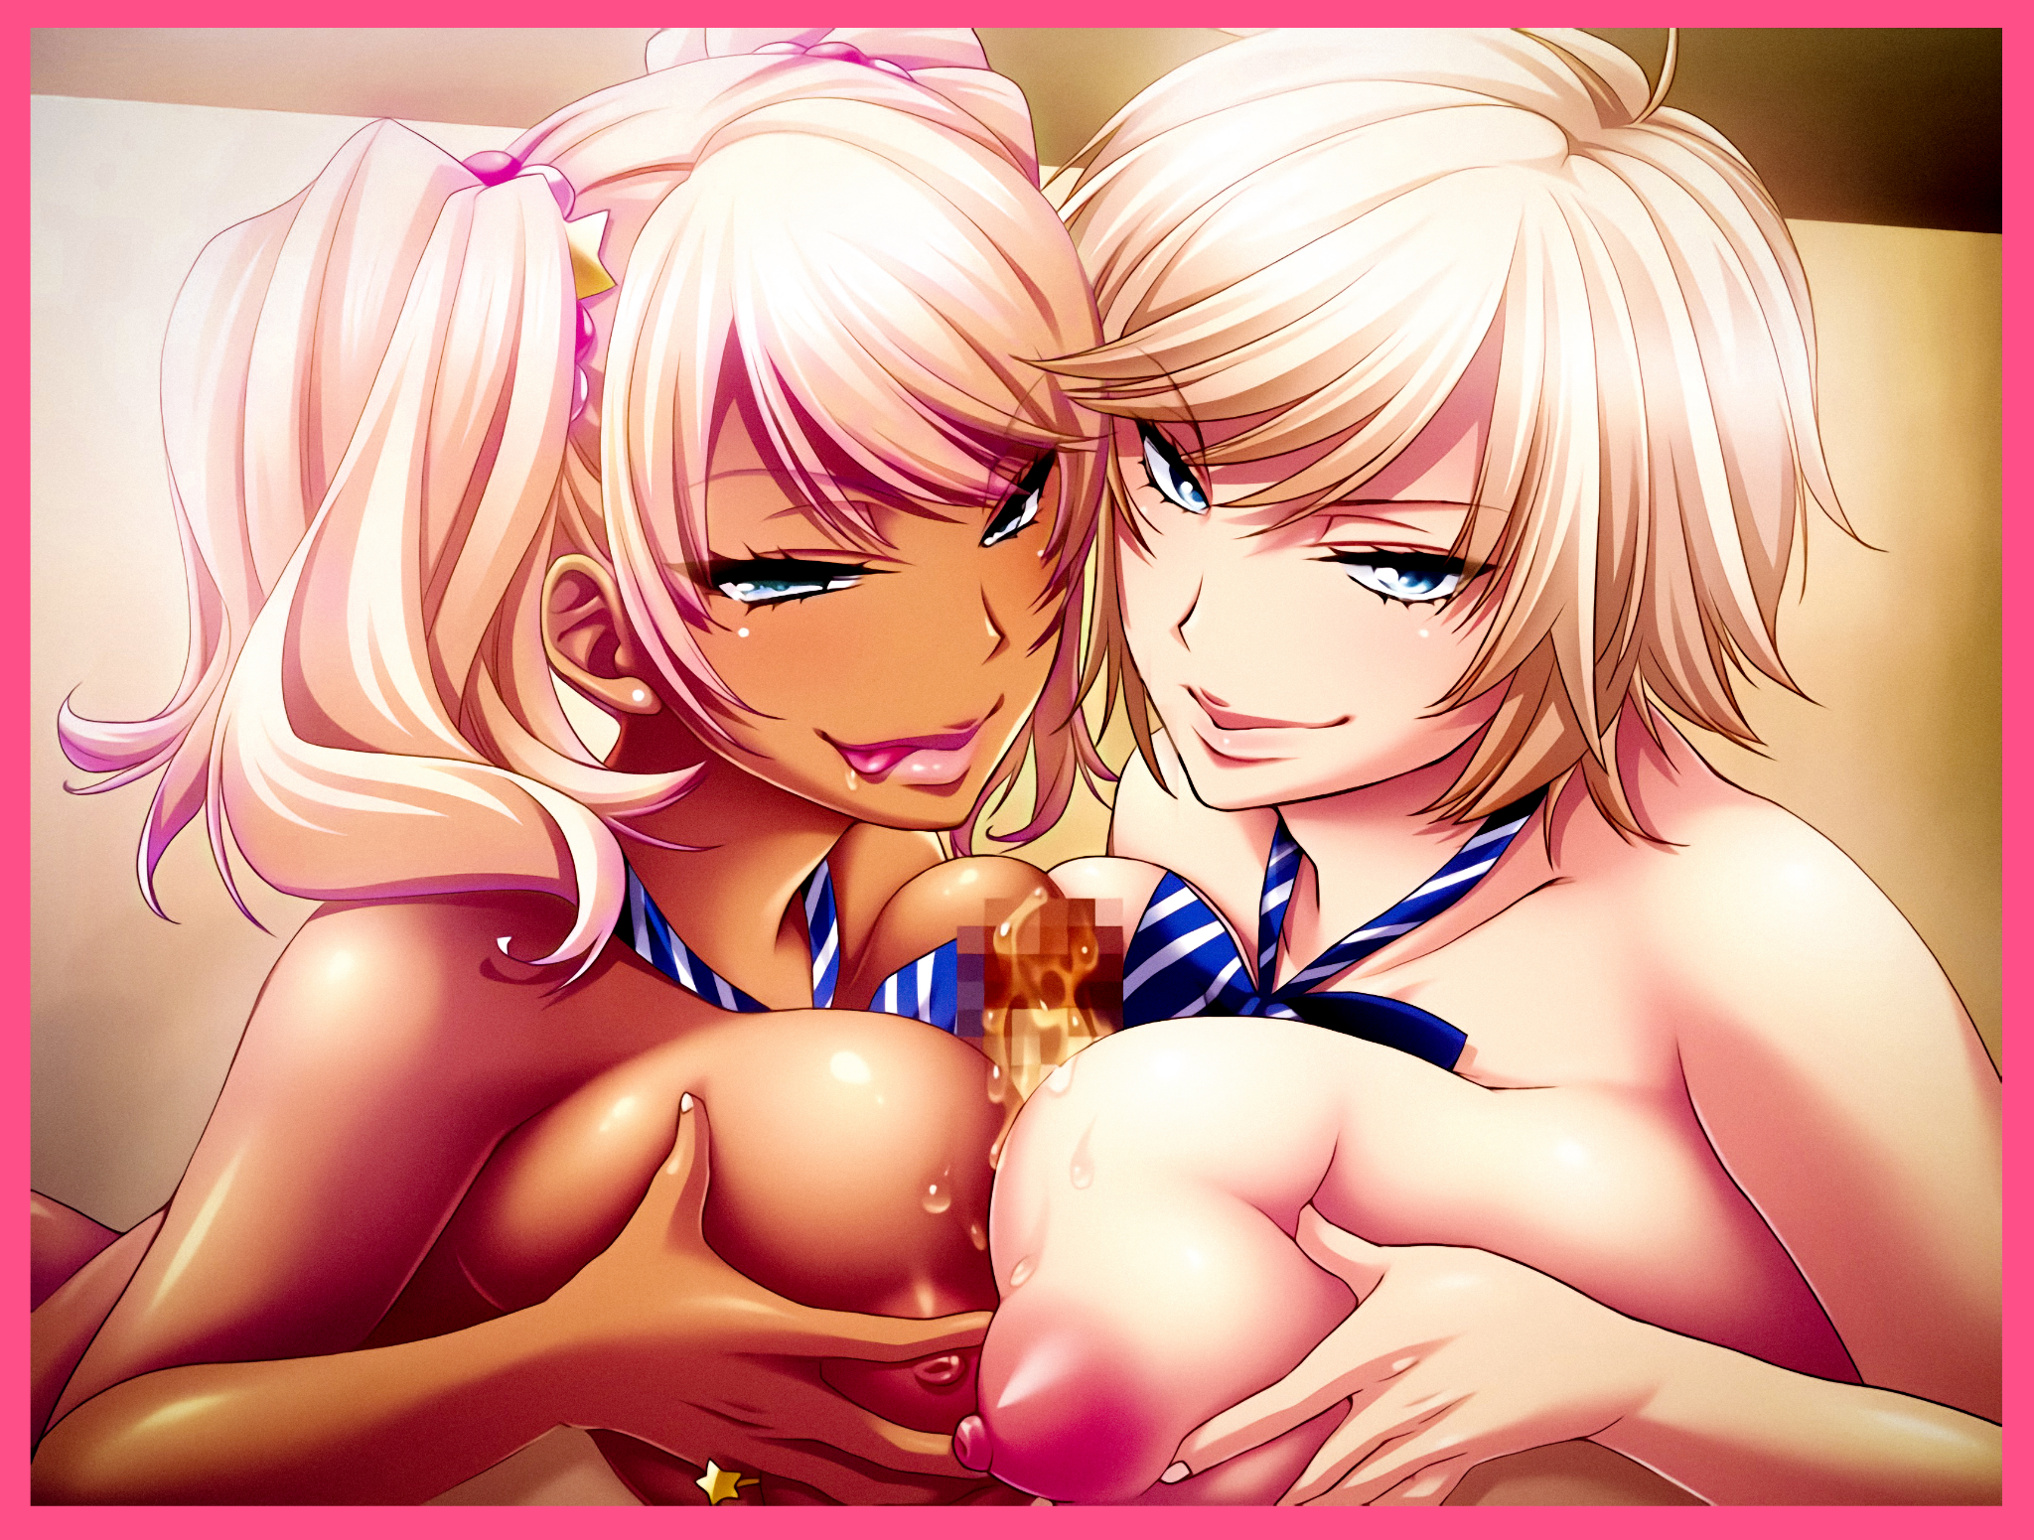
Uttering a drawn out groan in response, Kevin relents to his girlfriend's demands, making revenge plans to pay Lexi back in the future once he knew what made her tick. But with the new addition to what would become a growing harem, so too would Kevin's place in Pendleton University begin to worsen once new reports of an unregistered student soliciting sexual favours from both students and faculty members materialized on his father's desk, eliciting a frustrated grumble from Regis as he moves to make a call on the phone. His son had gone too far this time, harboring an unauthorized person was bad enough, but tarnishing the goodwill of the Pendleton name by encouraging promiscuous activity on school grounds?! Preposterous!

“Miss Valery…we need to talk…”

To Be Continued

