BAD RELATIONS
MARCH 2022 REQUEST STORY
BY CHALDEACHANGE
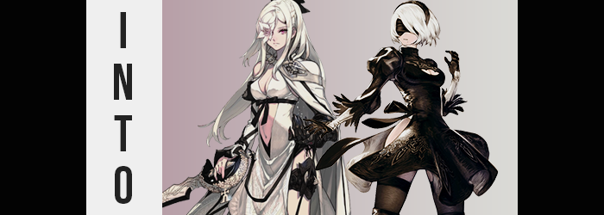

The turn of one’s birthday was usually a happy occasion.

It went without saying that, whether they were rare or not, there were still some people who did not enjoy turning a year older and as such did not wish to celebrate their growth. It was a celebration that was typically up to the receiver when it came to whether it should be celebrated or not, but at the same time you could have cases where someone hated their birthday and their friends would be insistent on celebrating it.

Fortunately, in this case? The latter possibility wasn’t what was true. The young man by the name of Urban truly appreciated his birthday. Being surrounded by friends, getting presents, eating cake… There weren’t exactly a ton of days in the year where you could enjoy an experience like that one. Well, not without petitioning all of your friends to buy you presents and get you cake for literally no reason whatsoever. If it was that easy, you would probably hear a lot more about incidents like that.

Not that this birthday was particularly bombastic at the moment. It started off humble with one of his friends coming over for a simple meet and hang for a few hours, with a party planned for much later in the day when more people were home from work and whatever else they had going on at the time. Urban didn’t really mind and appreciated her visiting. After all, a few hours of video games and snacks was still a good way to start off your day.

But she had strangely disappeared for longer than he had initially assumed she would after claiming she had to use the bathroom. They had been in the middle of a shared Nier Automata run and had spent a good time reminiscing about not only the characters in the game, but those present in related media as well. Like the Drakengard games, for example. These games were pretty exceptional in how they usually presented their main characters as strong women leads. It wasn’t something that was done enough in modern stories, really.

“Ha~ppy Birth~day!” It wasn’t quite a song, but there was melodic intent in the young woman’s words as she finally came back into the bedroom while holding a little cheesecake with a candle stuck firmly inside of it. Lit, of course! The woman and friend in question, Ori, was wearing a smile as she presented the cake to the young man, who stood up just as quickly as she had stepped in. He’d been on the verge of telling her that she hadn’t had to go to all the trouble, but she was quick to cut him off with a mischievous smirk and comment. “Make sure you make a wish!”

Urban felt a little taken aback by the comment, even though he knew he probably shouldn’t have. It wasn’t exactly an unusual request to make that the one celebrating their birthday make a wish of some fashion on a cake’s candle. In fact he would probably be asked to make another with dinner later that night. But he hadn’t really had anything prepared and so he just blurted out the first topical thing that he could think of. “I… wish we were Drakenier characters!” He felt a little embarrassed that he had blurted out that of all potential wishes, but too late now.

“Oh yeah? Which one would you be?” Unsurprisingly, the conversation carried on normally from that point on. It wasn’t like this was the first time that the two of them had talked about things like these at the end of the day. And so their little party waged on, the two of them ignorant to the fact that they were actually being watched by something magical. A nekomata that just liked to have a little fun at the expense of others, for no real reason in particular!

…Or so she would always claim.

About half an hour had passed from the moment Urban had made his wish, and after feeling a little off after eating his slice of cake, it had quickly become his turn to head to the bathroom. He didn’t really need to use the toilet or anything, but he was certainly under the impression that maybe he was sick? He had felt so weak and jittery all of a sudden, and it had happened so inexplicably quickly that he was a little worried about it.

So worried, in fact, that he even removed his infamous hat to get a better look at his face in the mirror. “I hope I’m not sick. That would probably make for a really crappy birthday.” And the last thing he wanted to do was not only ruin the day for himself, but also for all of the people who had come out to visit him when all was said and done. Undoubtedly at least some of them were excited to come over for the big party later.

Staring at his own reflection in the mirror though? He didn’t really look sick? Maybe his room had just been too cold and he’d been plagued by the chills? That was certainly a plausible possibility that couldn’t really be ignored. Sometimes shit just happened and it wasn’t really all that serious. Although in this case? There was something just a little serious happening. Perhaps even incredibly serious, depending on your definition.

“Huh? Am I seeing things?” Still staring at the mirror to make sure he wasn’t unwell, after blinking several times he became unsure of what he was looking at. It wasn’t a sign that he was sick, at least he didn’t think so, but among his brown irises there were some strange speckles that were of a different color than what was natural. He squinted, and when he did? Those speckles multiplied… and multiplied… until his eyes were a bright, silvery blue. “What the hell!?”

He had heard stories of people who had eyes that could change color, but that had never been a trait of his. In fact, even if it was something that did happen, he couldn’t imagine that it ever happened that quickly. Urban continued to glare at his own reflection, or at least his eyes. Up until a brighter color pulled that gaze higher up, that is. “MY HAIR!?”

With his hat off, it really was easy to see that the color of his hair wasn’t quite… right. Its dark roots had lightened, and not even to a lighter brown or even a blonde. They were a stark, snowy white – and that white moved up all of the way into the tips of a hair that looked softer than ever somehow, even though its length nor volume had really changed.

“This is impossible, right?” Was he dreaming? Had he not really woken up that morning? Hair and eye colors didn’t just change, and not so dramatically. Strangely enough though, he felt like he had seen this hair and eye color combination somewhere else, very recently in fact. It wasn’t even just his hair color that had paled, for a lightening swept through the melanin of his skin, rendering him several shades lighter than he had been from birth.

Should he go find Ori? Would she be just as alarmed as he was? Thoughts of actions he should take wracked his mind, but he just couldn’t seem to pull his gaze away from his reflection whatsoever. It was like every time Urban blinked, there was something notably different about his own self.

Now? It was the emergency of a beauty mark. A dark spot beneath the left side of his lip. And come to think of it, had his lips always been quite that swollen? No, they were definitely plumper than he recalled – and were continuing to grow plumper before his very eyes. “Whath…?” The way those lips interacted felt foreign, and the slapped together a little awkwardly at first.

Their growth certainly served as an ample distraction for a brief moment though, because bloating lips came about with an overall distortion of his facial features. Paled cheeks narrowed and smoothed, his nose grew daintier, and his eyes? Well, they became much bigger and earned sets of lashes that were exceptionally long. “This is… my face?” No sooner than he’d notice did he speak with a voice that was somehow sterner and womanlier. It was familiar, just as his face was.

After all, it was the face of the main character from the game he had just been playing with Ori.

The face of 2B.

A hand reached up to cup his own cheek, but even then there were some notable differences in that hand. His fingers appeared a little longer and had become smaller along with his palms. They were blatantly effeminate, and it was likewise a trend that saw his feet collapse in the same way. He almost fell forward, but had the counter of the sink to keep him up. “Woah.” Evidently, it was getting harder for him to express surprise at the situation. Or express much of anything, really.

“This cannot be possible. I cannot be becoming a character of fiction? And why am I… speaking like this?” Try as he might, Urban couldn’t revert back to the casual manner of speech that he was used to speaking with. It was like something was preventing him from doing so, stifling even his emotional response. That was demonstrated no more plainly than when his height suddenly undertook a drop, and his pants fell from his hips to reveal legs that were now entirely hairless.

That said, speaking of hair? The white locks atop his head had begun to lengthen some. They curled in towards the young man’s head before reaching the peak of his neck, leaving him with a bob that was just as familiar as the face it framed. In fact, if you were to only show Urban by his bust, you wouldn’t recognize him at all as who he had once been aesthetically.

No longer capable of expressing the same alarm he had prior, he shuffled in place rather uncomfortably as the shirt that was now just a tad too big for him began to loosen even more. Not because he was becoming even shorter, but because the weight of his gullet was fading away. His tummy was not only flattening until it was tight as could be, but his waistline pulled in at the sides so that his hips looked far more pronounced than they would have under normal circumstances.

But, then again, that phenomenon did have a little help. His hips were pulled wider around the same timeframe. Not just a little wide, but significantly so. They eventually usurped his shoulders in girth, and left a gratuitous gap between his legs that almost shredded his boxers down the sides. Well, if Urban could even be seen as a man still with, well… “It’s gone?”

All there had been was a sharp tug, but it was still enough for her to realize. Her sex had been changed, leaving a pussy where a dick had once been. If there had been any doubt that she had been becoming a woman before, then it was certainly undeniably by this point in time. And building upon that? The rest of the woman’s body began to fill in to the correct proportions.

Most prominently of these fillings involved her ass and thighs. There was significant space left with her hips now parted, and whatever was happening seemed keen to make good use of them. Her thighs bloated without any disregard for her boxers whatsoever, with new tears rippling through them thanks to tender meat that pulled skin so tight that it bore an enticing sheen. When all was said and done, each thigh almost seemed to be as thick as her waistline.

“Oh…” The tightness of her undergarments could not be denied, especially not with her ass filling in behind her. Cheeks rose to the occasion, their plumpness yanking the waistband of the boxers down so that ample ass cleavage was left on display. But it all eventually became far too much to bear, and with a loud ripping sound her gratuitous cheeks completely blew out the backs of the boxers altogether, leaving her big bum bare short of the oversized shirt lipping over it ever so slightly.

Even then, that shirt was hoisted up thanks to what grew beneath it. Now with the ass and legs of the game character, Urban inherited her breasts as well. They swelled to notable C-cups, pushing out the inside of her tee, until….

Until…
Until…
DARKNESS.

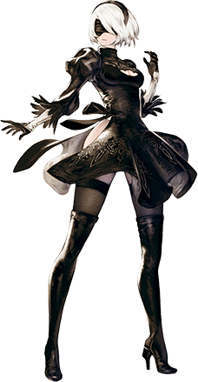
It was brief, but Urban’s consciousness had flickered out – as had her heartbeat. It was so brief that she hadn’t managed to fall before catching himself, but when her consciousness returned? Not only was she clad in 2B’s outfit, but his body felt incredibly heavy. That was because, internally, his flesh and blood and bone had all been replaced by the inner workings of an android. And that had multiplied her weight several times over.

“I… am Yorha No 2 Type-B? 2B…?” Where Urban had once retreated to check on his physical wellbeing was now a woman dumbfounded by her own appearance. With fair skin, white hair, and ample flesh when it came to her upper legs and rear end, it was all highlighted by a black gown and thigh-highed boots that left all of the sensual things exposed. Most surprising of all was the perceived blindfold that was now over her eyes. But this wasn’t a blindfold at all. She could see through it.

For how different she looked, when it came to her memories, 2B could still remember her past as Urban. In fact, she couldn’t exactly remember 2B’s life as her own more than she could just recall what she had seen while playing the game. “Wait… Does this mean that I have become… an android?” That had to be the case, didn’t it? After all, 2B was an android, and during her transformation… Well, it had felt like she had ‘gone offline’ and then ‘come online’ again near the end, had it not?

What was she supposed to do? How was she supposed to face her family? Would they even believe her? It had affected her mentally too, after all. While she had her memories, she was still acting like 2B. From her stiff posture to her serious tone of voice, it would be hard to recognize her as someone who was even remotely like Urban. “Oh. Would…?” But then she remembered her friend in her room. Ori had been there when she had made that wish, and that must have somehow been the cause of all… this. So would she believe her? Probably!

And so she headed towards the bedroom, the floor creaking loudly beneath her. Just how heavy had her body become?

When Urban had gone off to use the bathroom suddenly, Ori had been left in his room all by her lonesome. Something of an anxious person, she wasn’t really the sort of individual that could just sit still when left alone in a place that wasn’t her own, and so she quickly devolved into pacing back and forth without looking too much into her surroundings. This wasn’t her room so it wouldn’t be very nice of her to go snooping around aimlessly.

“…Am I not feeling well, too?” The young man had mentioned how he was feeling when he had run off, and now after a few moments had passed? Ori couldn’t help but feel similarly. Her body kept shivering, and she felt a little physically weaker than she normally did – not that she put a whole lot of stock in her physical condition in the first place.

But if she really was sick, then wasn’t that a little strange? The two of them hadn’t met in person for a long while now, and it took a lot longer for a disease to incubate than only a couple of hours. The chance that they had both gotten sick with the exact same illness so quickly was practically zero. Well… unless something was wrong with the cake? But Ori had endured food poisoning before, and this didn’t really feel like it whatsoever.

Unbeknownst to the woman in question, something strange had begun to happen with her hair. As she continued to pace about the bedroom, it appeared to be creeping longer and longer behind her. Not significantly so, because it typically already reached halfway down her back – but it did stretch to reach just past the bottom of her rear end. What’s more, it was much more voluminous now. Naturally soft and silky, lengthened bangs found themselves naturally parted to the right.

“I hope I’m not fucking sick… Huh?” Wait, had she just swore in there? Not that Ori never swore or anything, but she wasn’t the type to just throw in a curse word unnecessarily. There typically had to be some kind of reason for it, which wasn’t really the case there. “The fuck?” Wait! She had gone and done it again! Maybe she needed to make sure she was getting enough sleep these days…?

Of course it actually had no relation to her sleeping habits. Another personality had begun to seep in over her own. One that was cruder and more fixated on violence and experiences of a sexual nature. It was far different than the meekness she exhibited naturally, and it would only grow stronger as she continued to succumb to her physical changes. And speaking of...

Some generous adjustments had begun to be made to the young woman’s figure. Among the most noticeable was one that saw the front of her hoodie push a little forward and lift up a little from beneath, because the size of her chest had begun to swell. Beginning with her nipples, they had become quite engorged and had grown several coin sizes before things took a more serious turn, their pinks undeniable. But from that point on, it was the mass of the chest itself that became more ample. “Huh? Are my tits getting…?” It was, of course, something that couldn’t be ignored, and before long her right hand was fondling one of the D-cup breasts that now rested perky above her chest. “Something fucked is happening here.” But it didn’t feel bad. It felt warm, and she felt… good. More confident, somehow.

Was it all that surprising that she would feel more confident, however? Her enhanced bosom aside, her tummy had also flattened and was now rippling with a strength she hadn’t possessed before. With the sides of her waist pinching in, she almost looked to be gaining something akin to an hourglass figure.

Which was, with time, delivered upon. Ori’s hips widened ever so slightly, and with that width provided it allowed her thighs to bulge beneath her jeans. Now, these jeans were already pretty tightly fit, so the fact that her thighs were swelling did them no favors. Blue material frayed and split at parts, allowing some of the bulging flesh to poke up and out of these tiny holes. It was uncomfortable, but something about that discomfort prompted her to lick her lips.

Even as it intensified thanks to a ballooning of her rear. Her bottom had been relatively flat prior, but was now being exacerbated in size so that it was comparatively as big and perky as the bigger breasts that sat upon her chest. The line going down the center of her jeans, as well as her underwear, dug straight into her crack, and the waistline was tugged down a little so that it sat on her thighs.

“This feels so damn good! I feel so fucking powerful! And the hell’s wrong with my voice? I almost sound like goddamned…” The woman had been on the verge of completing that sentence, of making mention of the main character of a video game that she had played plenty of times in the past. When Urban had made that wish of his with the cake, that was actually the character that she’d had in mind. But back then she couldn’t believe such a wish might be granted. And yet…?

She hadn’t gotten that name out thanks to an overwhelming pain stemming from her right eye. “FUUUUUUCK!”, she screamed in agony as while that eye turned blood red, the iris of her left eye inherited a soft pink. Both eyes turned in shape so that they were narrower, and her face overall grew longer with thick, luscious lips. But the right eye was most certainly the area of concern. Because after a moment of sheer agony? A white, five-petalled flower erupted from it, concealing the eye entirely and leaving the crude-talking woman panting with her left hand covering the eye in question. “Hah… Hah… Guess I was fucking right.” Only one character had a flower in her eye like that.

THUD!

Ori wasn’t able to react in time, but the hand that had been covering her flowered eye suddenly fell out of her sleeve and onto the floor in front of her. No, not just the hand, but her whole damn arm! “Yeah, there was that too.” But the woman herself wasn’t shocked nor alarmed. She just gazed down at her severed appendage, watching as its skin darkened and hardened, the fingers gaining sharp points and rough edges. Until it was very clearly a black, prosthetic arm.

With an inconvenienced sigh, she reached down with her good hand and picked it up, before painfully shoving the arm back up the sleeve and into its socket. “Agh!” Upon doing do, however, her entire outfit promptly changed into that of the character she had become. Into that of Zero from Drakengard 3.

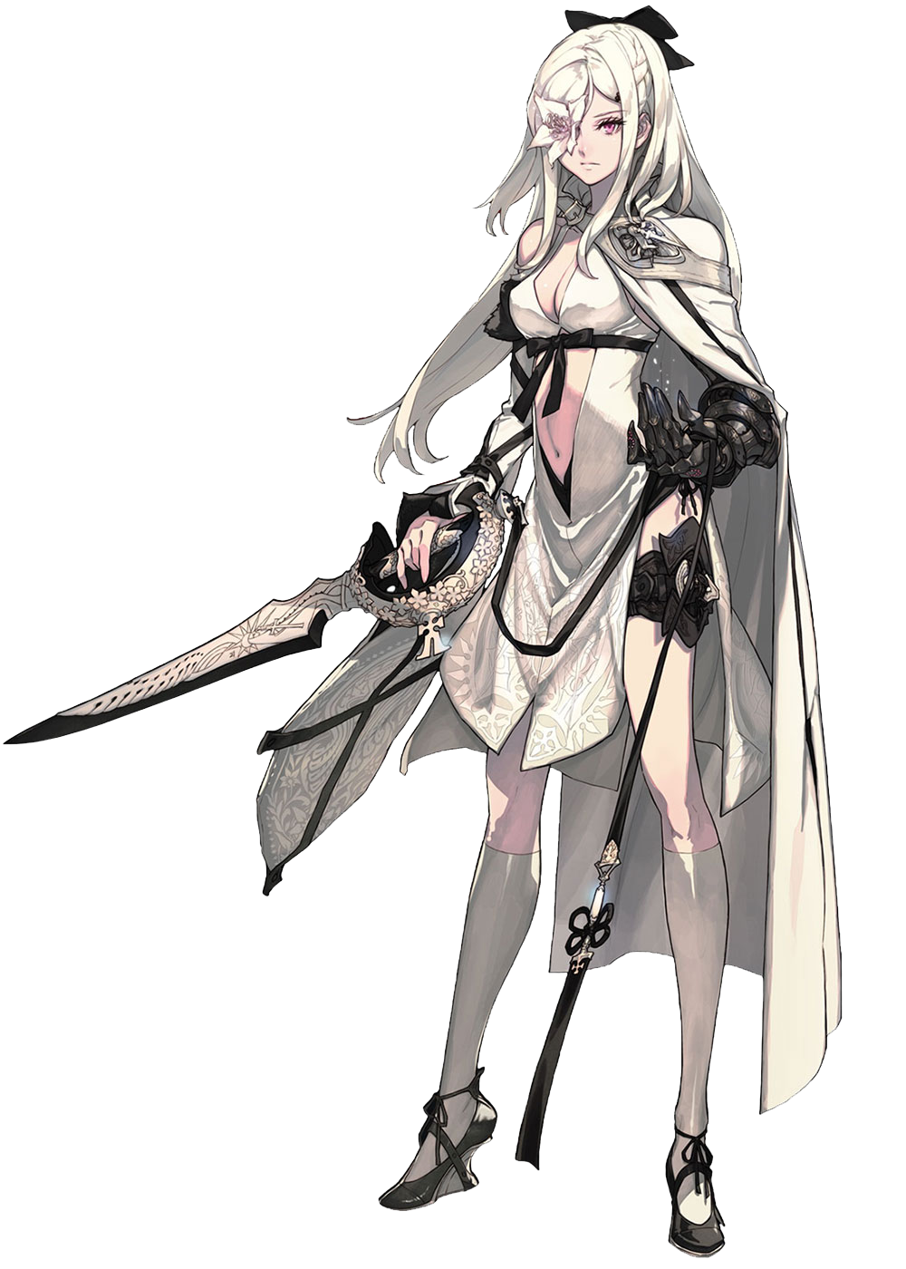
“Holy shit!? I can’t fucking believe it! I’m Zero!?” For the once meek and polite Ori to shout so crudely aloud with such consistency was certainly a testament to just how much her personality had gone awash along with her physical form. Not only did she feel hot as hell, but like a total fucking badass to boot. The confidence that boiled up from within felt overwhelming, but in a way that was very, very good.

Something that had also changed about her personality was her willingness to be indecent, it seemed, because hands had gotten to work touching herself all over. Whether it was grabbing a breast or smacking her own ass, she was beyond curious about her own body now. This made sense, seeing as she had a much more sexual and dominant personality than 2B did.

“Huh? Who the fuck are— 2B!?” She immediately dropped her hands to the sides when someone else came through the bedroom door, though. It wasn’t Urban, but it was another Drakenier character. 2B, from Automata. Zero could remember all this, because her memories were still Ori’s despite the very obvious shift in her personality and body. Wait, did that mean this was Urban? But she couldn’t say that. Like, literally.

And 2B was quick to realize that the opposite was true as well. “And you are… Zero?” She had meant to say ‘Ori’, because that was the only person the woman with the flower in her right eye could be. But she just couldn’t say it. Her mind auto-filtered it into the name she had now. “No… Something is wrong here.”

“No shit.” The contrast between their two personalities might as well have been night and day. “I guess your dumbass wish actually worked, huh? No fucking clue how, though.” At least the two of them were on the same page, but that didn’t give them any answers regarding what to do now. Perhaps they could become professional cosplayers? It would be easy to do considering they were literally the characters in question.

“How should we proceed, then?” It was a sensical question posed by the android, but Zero didn’t really seem to be thinking all that hard about it. Instead? She kept staring at 2B. Or, at least, the gaping thigh window on the side of her dress. The way those huge thighs were bulging… It was really appealing to her sensibilities, so to speak.

“Why don’t we get familiar with these bodies?”

“Huh?”

“Strip, dumbass.”

“…Huh?”

