House Spouse
A Short Story
By Maryanne Peters

I worked alongside Matt Linaker for three years. I had no idea that he was anything other than a normal guy. I knew that he was married, so the fact that he had a slightly effeminate appearance I simply put down to “metrosexuality”.

I liked Matt. We shared a few jokes. We had a few drinks after work. We both complained about the job. Which was funny I suppose, because neither of us needed to be doing it. My family had money and I could have a job working in the family business anytime I wanted to go back to Ohio. As for Matt, his wife Gabby was some big cheese downtown, and she earned all the money they needed.

“I could be a house husband,” he said.

Then one day, I turned up at work and Matt was not there. No big deal, but he was not there the day after. I checked with the boss, and he said that Matt had quit. He had received a call from Matt’s wife to tell him. Matt had not quit, his wife had resigned for him.

His cellphone was cut off. Number no longer in service. Not a word from Matt. We were not super close, but I would have expected a call. Nothing.

At the end of the week I decided to go around to Matt’s place see him. I knew where he lived. I had been there before to drop him off after a work a few times. So, I just walked up to the front door and knocked.
I got the shock of my life.  Standing there in the doorway was Matt, dressed as a woman. Well, more that dressed, he looked like a woman. His dark hair seemed very long and was tied back, and his brows and lips looked feminine, but his blues and his nose … it was definitely him.  “Hello Pete,” he said. “I have something in the oven and Gabby is due home any minute, so I need to get back to the kitchen straight away, but do come inside.” | 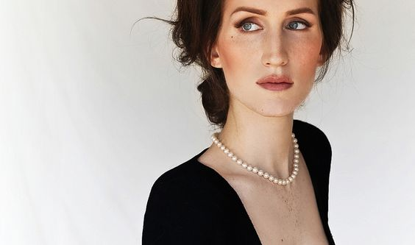

“Matt?” I mean, what else could I say. It was obviously him. He knew me. He just smiled, but that smile was saying yes. I was him and he was happy enough that I should see him dressed that way.

I followed her to the kitchen. I use the word “her” because if you had followed that ass walking down the hallway, you could not have used any other pronoun.

“Man, what are you doing?” I was still in disbelief as “she” put on oven mitts. “You just up and quit? I never heard from you. And now, what is this?”

“You know I hated that job,” she said. “Now I am at home full time, and I never thought I would ever say this, but the truth is, I love being a house husband.”

“But Matt,” I implored him, “This is not being a house husband, this is being a transvestite.”

“Somehow it just seems more natural like this,” he said, checking the pot roast.

“But the hair and the makeup? And what is with walking around in a dress, with that bubble butt, and, … are those tits real?”

“Oh, you like them?” He seemed very proud and turned to face me, pushing them up. “Gabby bought them for me, and the butt implants too. Aren’t they great?”

I was suddenly aware that his crotch seemed very empty as well. I was too frightened to say anything. I was still coming to grips with the guy I had worked so closely with up until a few days ago, seemed to have been transformed into a woman.

“Honestly, quitting work was the best thing that ever did,” she said. “I mean, the relentless stress of it all, I’m glad it’s all over. All I need to worry about is what is in the oven and how tidy the house is – all things within my control. Honestly, it’s empowering.”

“But, I can’t believe that Gabby wants you to be like this,” I said.

“Don’t be silly,” she scolded. “Why else would she insist that I dress like this and take the tablets. Of course, this is how she wants me. And I just do what I am told. She’s the boss now. She makes the decisions. She worries about the mortgage. Not me. I don’t have a worry in the world. As long as I keep house and stay looking pretty, I will always have a provider. It’s a great life.”

“You are taking pills?”

“Hormones, you silly boy,” she said. “How else would I have skin this soft and hair this silky? And they make me feel so good. So peaceful and calm. Not like I used to be. Not aggressive and nasty. I am a nicer person – don’t you think.”

“I don’t think I know you, Matt,” was my honest reply.

“You should stay for dinner,” he said. “Get to know the new me a little better. And meet the new Gabby. She is so in control, sometimes it scares me. Of course, I will need to check with her first, but I want you to stay. I will call her and get dressed. I need to be properly dressed for when she gets home.”

She rushed off the make the call, wiggling her expanded ass as she hurried to the phone. She chatted away in happy high tones. She got the go ahead and I agreed to stay.

Matt insisted that I take the big reclining armchair in the living room and read “Sports Illustrated”. She bought me a pair of men’s slippers that were too small for me, but still more comfortable that my shoes.

“Are these yours?” I asked.

“They used to be, but now I wear these”. The slippers he wore had white faux fur and 2 inch heels. “Before I fix you a drink would you like me to rub your shoulders. You look a bit tense.”

If anything, she was the cause. I tried to relax, and she worked on the knots at the base of my neck, but her face was way too close to my cheek and I could smell an intoxicating perfume – all flowers and spices. Finally, I felt the tension escape as if a dam had been released. She whispered in my ear: “That’s better, now let me get you that drink”.

She brought me a caipirinha – something I had never tried. It was made of limes and Brazilian rum. He said that she would never make it for Gabby. “Caipirinha is a man’s cocktail. I have the ingredients and I have always wanted to make one.”

“It’s delicious,” I said, because it was.

A slam of the door announced to arrival home of my friend’s wife, Gabby. Matt immediately sprung into action, rushing to collect Gabby’s things and make her comfortable opposite me.

“Did you have a good day, Honey,” she said. “Here is your cosmopolitan. Would you like me to rub your feet? Would you like some snacks? Dinner won’t be long.”

Gabby showed a disinterest that I found slightly abusive. Here was a guy who had sacrificed every ounce of his pride to please this woman, and it was clear that she looked at him, now her, as if he was filth. If it was true and Gabby had agreed to all of these changes, even made them happen, why would she treat her own creation this way?

When Matt was back in the kitchen, she sipped her drink and asked me: “What do you think of my little man-wife?”

“To be honest I am pretty upset about it,” I said. I really could not care less if I offended this woman, who had done these awful things to a previous colleague of mine. “He tells me that you are having him take hormone pills. That can’t be good.”

“No, it’s not,” she admitted. “I probably went too far there. I suppose I wanted him to understand what I had gone through when I was in his position. When he was in charge. He was an asshole as a husband, you see. But I had to go out to work, and it was not long before I was earning more than him. He lacks ambition, you see. So, we traded places. But you are right. The pills have been too much. He can no longer perform as a man. He wants me to be the dominant partner during sex. The breasts and butt were his idea. Frankly, they do not turn me on. The only thing that I like about him is that he is constant proof of my dominance in this relationship.”

“I don’t think that is healthy,” I said. “Marriage should be between equals. I think most men understand that.”

“He didn’t” she quipped. “And now he lives by the rules he set himself.” She laughed. Not quite the laugh of the arch villain of melodrama, but close enough to it.

“Frankly, I think that he is a better wife that you deserve,” I said.

“Well, if you think that, maybe he should go home with you,” she said. “Maybe I can find a man like the one you are talking about. An equal. Because my man-wife is certainly not that.”

Matt reappeared carrying the pot roast. He had changed into a blouse and full skirts and his hair bounced around his shoulders in soft curls. There was still a trace of him in his strong nose and square jaw, but just a trace. Overall, he appeared to be 100% a woman, and a very attractive one. He smiled sweetly and dished up the meal. It smelt great. It tasted even better. | 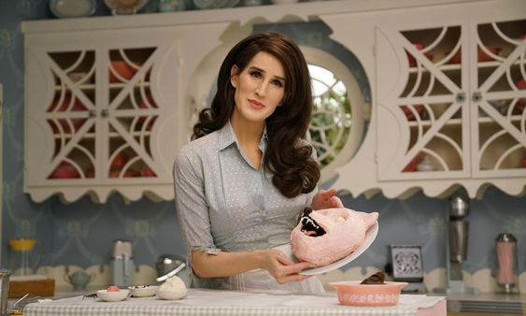

“This is garbage,” said Gabby. “All I ask is that when I get home from work you treat me right. You sit around at home all day and this is the best you can do?”

Matt burst into tears and rushed back into the kitchen.

“What the fuck was that about?” I said to Gabby. “What have you done to him? You made him like this and now you are abusing him. What exactly do you want from the guy?”

“Do you think I made him like this?” she said. “I got him started on the hormones – I admit that. It was a joke. My husband as my housewife. All the things a husband comes to expect from a wife, he was to give as if he was a wife. And then it took over him. I offered to pay for the breasts. I never thought he would say yes. I came back from a business trip and she had the implants top and bottom and I had a bill to pay.”

“If that’s true, he needs help, not insults,” I said. “He needs treatment, and support.”

“You support his then. I’m going back to the office and I grab some takeout on the way.” And with those words she was gone, and front door slammed.

I went into the kitchen. Matt had tied back his hair and dried his eyes but he still looked achingly sad. Who could not be effected by the sight of him?

 | “I don’t know what to do, Pete,” she said. “I just want to be the perfect wife to Gabby. But everything I do seems to make it worse for us. She is never happy.”  “That’s women for you, Buddy,” I said. “You can never make a woman happy in my experience.”  “Do you think that I could make a man happy, Pete?” he said. “Do you think that I could make you happy?”  “Well,” the question had me flummoxed. “Maybe not me, but some guy, sure.”

“Why not you?” he said.  “Well, I am not gay, Matt.” I could not happen, even though some strange thoughts were filling my mind.  “Oh, that’s easily fixed,” he said. “Just a little snip, fold and tuck and I could have a vagina built just for you … if that is what you would like. I can tell you that I would do anything to please my husband. Anything at all.”  The End  © Maryanne Peters 2019 | 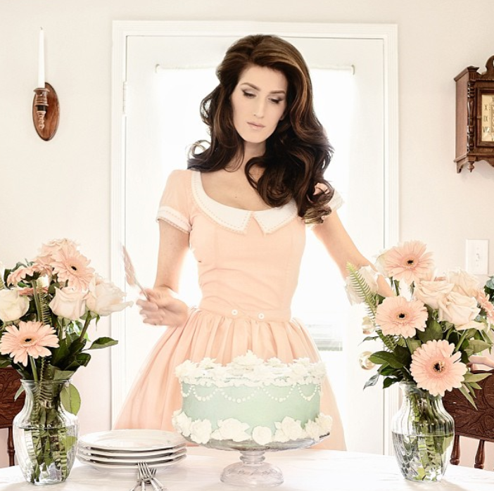  She insisted on making our wedding cake

