REDOMINANCE
MARCH 2022 REQUEST STORY
BY CHALDEACHANGE
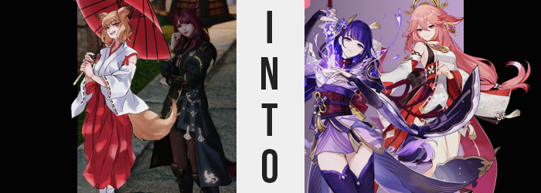

“Oh, do not be that way, Silvia. ‘Tis but a bit of light teasing.”

“A bit of light teasing that I don’t appreciate while I’m working, Ranka.”

The exchange made between the two passing through the night streets of Kugane might have come across similarly to the bickering of an old married couple to the ears of someone who did not know better, and yet their relationship could not exactly be described as such. The were old friends at best, but their closeness was often pushed by the antics of the older woman.

That said, to call her ‘older’ was something that was true of number only. The woman with light blonde hair and fur, as well as a pair of piercing crimson eyes, could be reasoned to be an extremely old lady as far as numerical age went. After all, kitsune had a habit of living for hundreds and thousands of years and Ranka was no exception.

The fact that she wasn’t being given strange looks from passersby because of her fox features? Well, it really came down to ignorance. Most assumed that she was a Miqo’te within reasonable doubt, even though her furred features were slightly different.

On the other hand, her present company very much was a Miqo’te woman. Silvia Kuroi was a ruby-haired beauty that had an interest in the archaic and valuable, and was a scholar by study and trade. Her background with Ranka was a complicated one, but every now and then they met up with one another when the moon was at its fullest. …Or whenever the fox was in the mood to bother the more serious feline, but tonight was a night with a full moon!

Silvia led with Ranka practically skipping along behind her. It was so late that the street was largely empty, which left ample room for a spat that had come about because Ranka had sensually stroked Silvia’s tail ‘as a joke’ while Silvia had been exploring the wares of a local’s booth. There had been some valuable things there, and yet when her tail had been touched she had let out such an indecent sound! She’d been forced to flee out of embarrassment!

“You can keep harumphing all you like, but wouldst you really sour our evening because of that prank?” The fox was doing her best to bring the tensions down, but the cat still kept her nose upturned and silent. She had no doubt that things would eventually reach a simmer, but for the time being it was a waste of their time for her to fixate on a problem that would otherwise blow over. Should she pamper the feline with some manner of gift? The thought had struck her.

Before she could propose such a boon though, the two of them passed an exceptionally dark alleyway. At first it seemed unsuspecting, but from it’s shadows a very old woman stepped out, provoking the two of them into pausing as the woman opened her mouth. Yet, neither the fox nor the cat could hear her words. They had immediately been caught up in some manner of ancient sorcery.

“Shall I fix your little spat for you, girls?”

“…HAH!?” The next Ranka awoke, it was within a chamber she did not recognize. The walls and floor were styled similarly to typical Kugane building pieces, yet a large emblem was raised on the back wall, just above the futon she had awoken laying upon. It consisted of three purple fragments that appeared to swirl together – and she had seen enough over the course of her long life that she could tell it surely meant something significant. “What… That woman! Did she use a sleeping spell upon us!? Nay… The air here. It is different, somehow.”

Different enough to reason that this wasn’t Kugane, nor perhaps even Hydaelyn. A different world altogether? Few magics should have possessed the power to launch targets that were not oneself into different planes of existence. A snap of her fingers after standing once more revealed something else of alarm. She could not conjure any of her own powers, which prompted her to bite her lip. “Something is most certainly afoul here.”

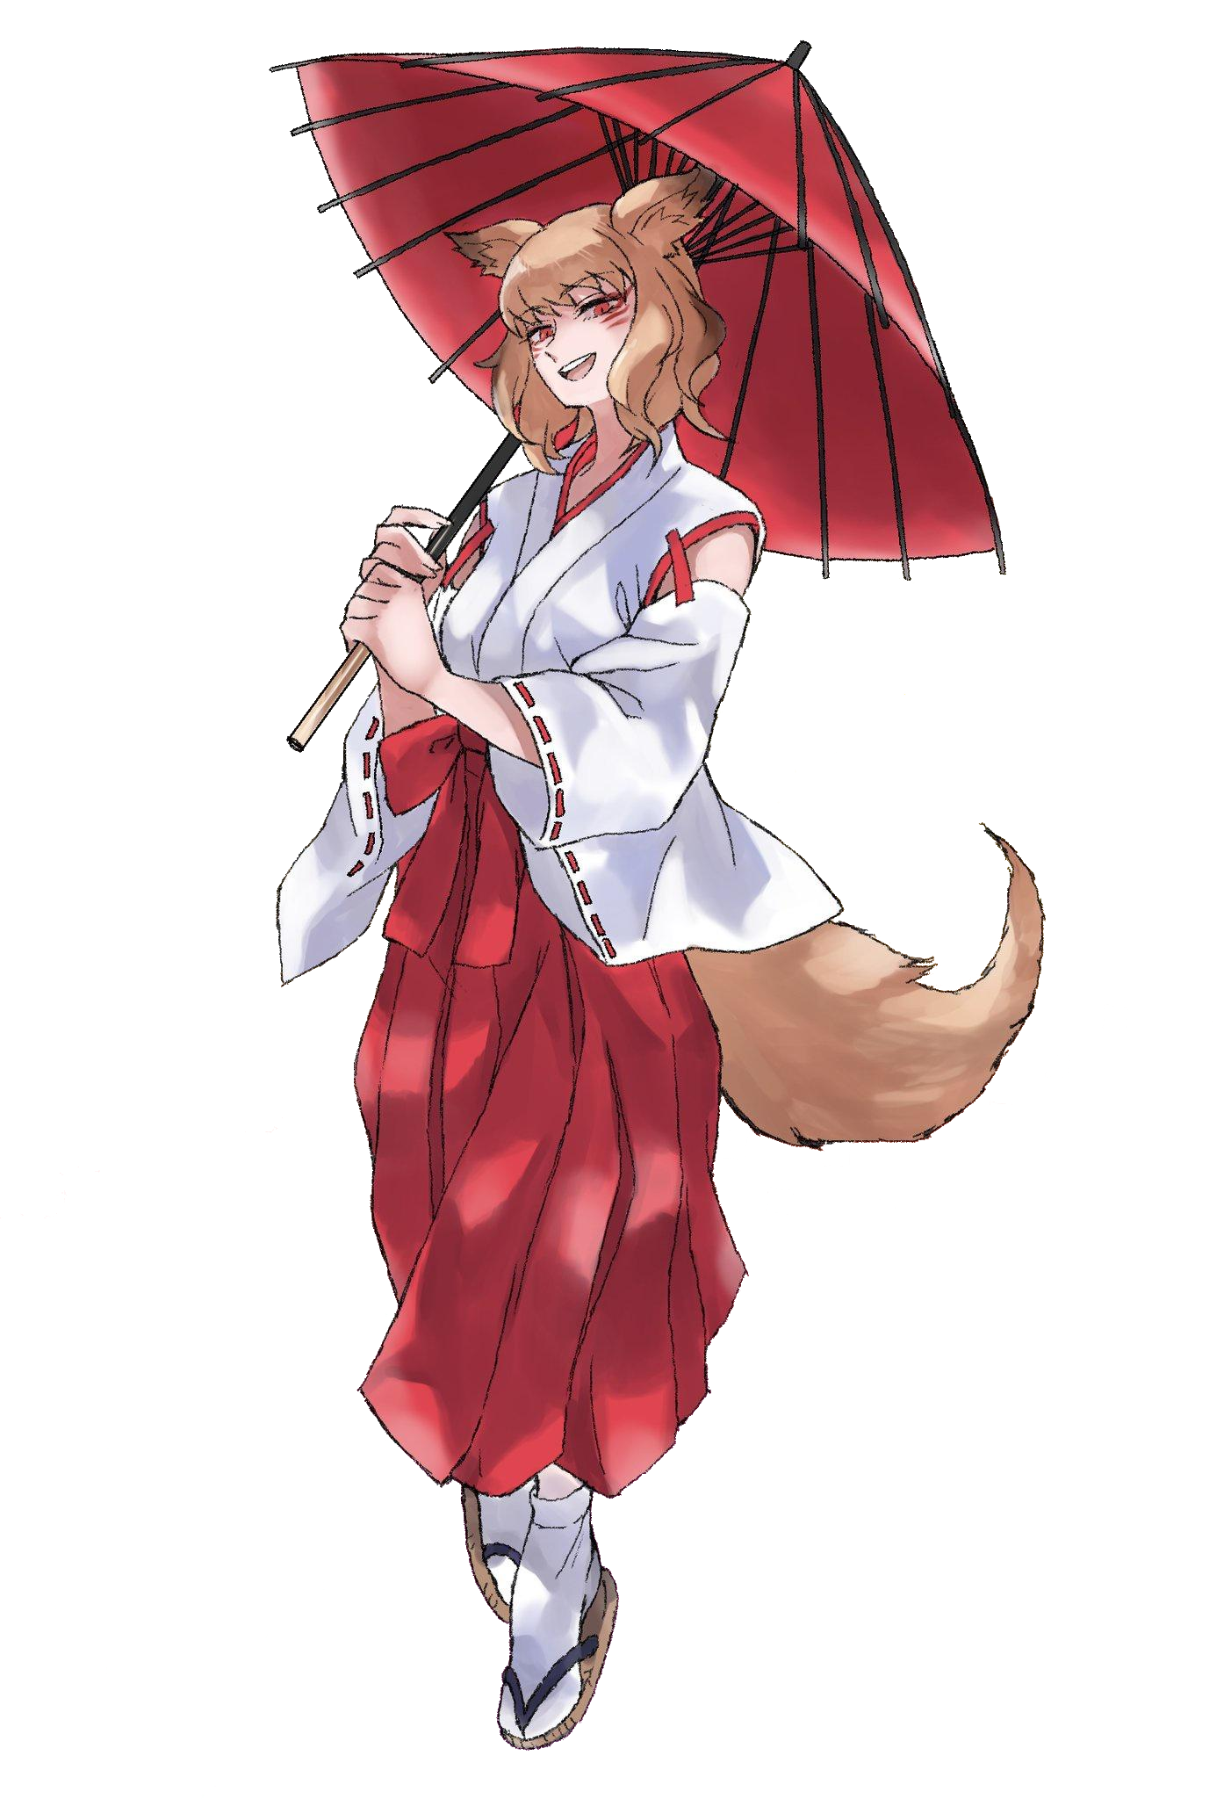
More afoul than she even realized, for her presence in this space had provoked a response from the world itself. She was presently standing in a room that was meant to be occupied by another, and that other individual had been sent to Ranka’s home world in the process. This meant that to maintain any sense of balance to the known multiverse, the original existences had to be preserved while using whatever was available.

In this case, Ranka’s own flesh and blood would do quite nicely. There were already warning signs in play, albeit ones that were not immediately recognizable to the kitsune. After all, she did not have a mirror to witness the crimson markings beneath her eyes fading away into obscurity, nor that the pinkish hue of her skin was gradually growing skewed.

It didn’t at all darken, and in fact? It did quite the opposite, lightening to a pale that almost seemed supernatural, if not sickly. So too did her skin ultimately inherit a strange sheen. It was difficult to describe, but her skin, while soft, almost bore a glossier quality that somehow seemed vaguely artificial. This sheen even seemed to rob her body of all beauty marks and scars… at the cost of creating a fresh beauty mark beneath her right eye.

“My first order of business should be to… Hm?” Strange. What had happened with her voice just there? It felt as if it had cracked somehow, but it hadn’t grown higher. It had deepened. Had there been something in her throat? As the fox woman pondered this strange phenomenon, her expression grew into an unintended pout not based on her emotions, but because her lips had swelled rather keenly to almost double their original thickness.

This was simply part of a greater wave of change that sought to reconstruct Ranka’s face. Her cheeks seemed to widen and her nose hooked a little longer – yet despite making her head almost appear bigger overall, there was something far more elegant about it. Her features, with her new skin tone, bore resemblance to the porcelain of a doll. Fair and beautiful, it most certainly wasn’t Ranka’s face. But it was an appealing face, nonetheless.

“No, this world is rejecting me…? I am…? My voice!” She could hear it now. What had once been a crack in her voice was now her voice’s true sound. It almost sounded passively monotonous in its deepness, not helped at all by panic besetting Ranka and leaving her slightly flustered. While this happened, her eyes began to shine with a pale purple colours, corners pinching in to grant her an even greater beauty in an aesthetic comparable to Kugane natives.

A hand cupped her face. Not only did that face not feel right, but she could observe the fingers on that hand lengthening in slight. As did her fingernails, but their also took on a purple polish that added to her alarm. “I’m succumbing to some kind of curse?” Now that she was aware, every little change became expressly apparent to her. Abandoning her face, she reached a hand back to grab hair that was cascading far longer than the shoulder-length cut she normally sported, and in doing so she could observe that a rich, thunderous purple had begun to weave through her blonde hairs. “By the gods!”

It made sense that she had become incapable of wielding her powers, because she now realized another being entirely was being applied upon her. Almost as if she had been fit into an invisible mold meant to give her a completely different appearance and body altogether. Her hair continued to lengthen, falling as far as her ankles as the purple became the dominant color. When it came to her bangs, they were minutely parted on the rightmost side, but cut squarely just above her eyes, there was some strands at the side that framed her new face.

“No, no! Leave my ears alone!” Hands darted back up to the top of her head, for she could feel her hairs readjusting as her vulpine ears slid down the sides of her head. They became increasing less vulpine as they did so, though. Tips shortening and rounding, blonde fur disappearing, before long they were the fleshy sort of rounded cartilage that were typical of humans – or Hyur as they had been called in Hydaelyn. “Tsk!” Her words, unsurprisingly, had made little effect on their transformation.

A wave of her fair fingers reminded Ranka that she could not wield her powers, and instead? Sparks of electricity shot from within, taking her by surprise. “That ability is of no use to me here!” She could certainly feel it though – an electrical current flowing within her, deep down. It was steadily growing stronger, and as the current became more potent?

Her body became fuller. “Ack!?” The kitsune almost fell over thanks to a sudden imbalance that sent her akilter. She managed to prevent a fall by throwing arms out to the sides, yet that position also perfectly demonstrated the cause. Her arms were steadily sticking out a little farther from within her shrine maiden-like outfit. But so were her legs. Her body was growing, and before long she was roughly 5’7” in total stature. It was a height that had pulled the white of her top loose from the red of her bottom.

“I am taller now, am I?” There was no better way to describe it, though this wasn’t the only growth to ultimately bless her. “Oh!?” Despite finally regaining her balance, a tug in her chest almost sent her falling forward just as soon as she had stabilized. The cause was obvious, because it seemed to be dead set on unfurling her robes to expose itself. Plainly put? Her breasts were growing. Without thinking, Ranka reached out to ‘catch’ them as they ballooned into a greater cup size, realizing her folly soon after that they wouldn’t exactly ‘fall out’. They bloated to DDs, and the subtly perverse fox couldn’t help but lick her lips at how sensitive they seemed to be. Almost like they hadn’t been touched in weeks.

But there was more going on than just a bloating of bosom. Her hips had slid wider as well, allowing fresh meat to see her thighs inflate and round, taking on enticing shapes that would just barely meet between her legs even with more space allotted from those hips. Of course, the cheeks of her ass weren’t ignored, and with due diligence they ballooned as well – while her pubes in the front took on the same purple hue as the hair atop her head. “Perhaps it is not all bad?” From what she could tell, she had become quite the looker.

The little bit of acceptance she had taken quickly eroded thanks to a THUD behind her, mind you. “GYAAA!?” The sound in question had been accompanied by a floatier feeling behind her. …Because her tail had fallen off! What rested on the floor where it had landed was not her tail, mind you, but a spear. Her beautiful tail had become a spear.

It was a lot to process, and she wasn’t even able to. Because the electricity that had been building within her suddenly exploded outwards, eviscerating her clothing. Fortunately she wasn’t left naked, however. Because in its place was life an ornate, purple kimono with sensual thigh highs, long ornate sleeves, and fingerless full-arm gloves. It was an outfit befitting of a ruler, and even sported the emblem above on the sleeves. Her hair had even been tied into a very long braid.

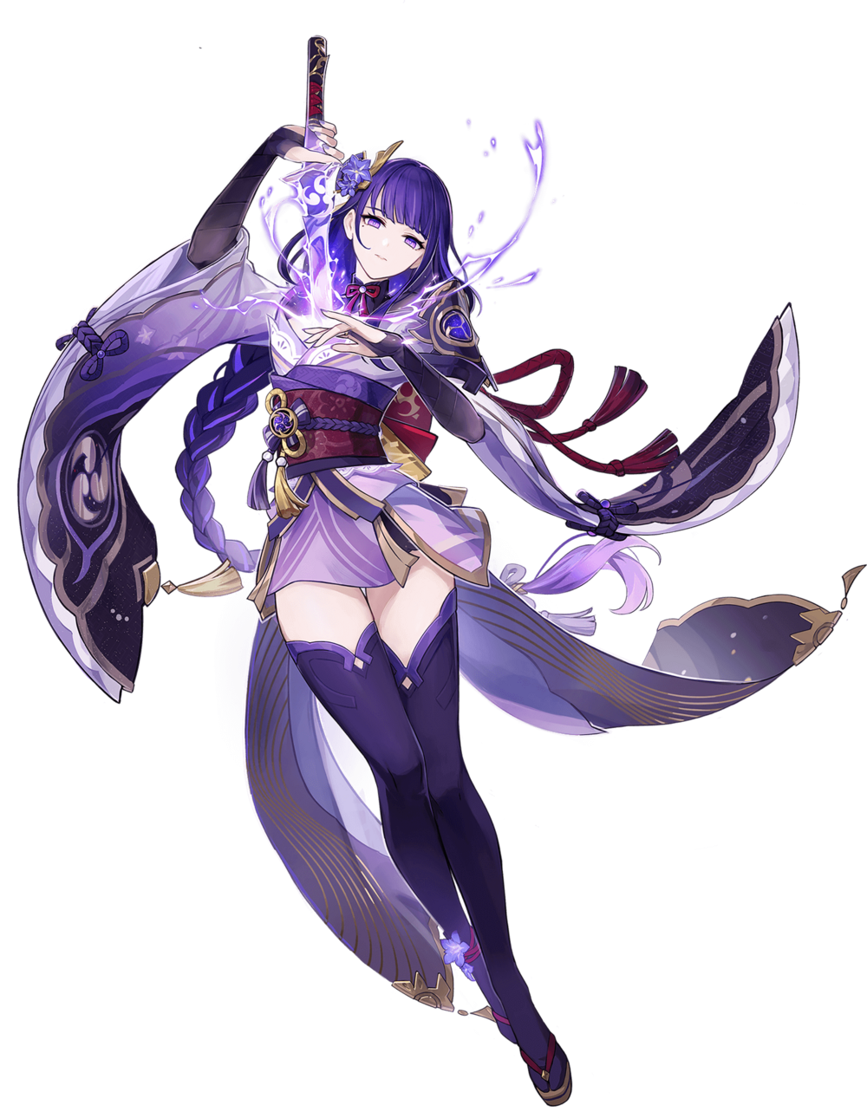
“Why can I not take a step towards the exit!?” Ranka’s new fingers, long and painted with a light purple polish, folded into her fists as she found herself incapable of making a beeline for the room’s exit as she had been planning since her transformation had begun. It was almost as if something deep down was instinctually keeping her pinned in place, like she was meant to meet someone or something here. But what? Whom?

She had plenty of questions about her own, current state as well. Her body had been refashioned into that of another woman altogether. A woman who was far more beautiful than she had ever been, with ample bosom and long, purple hair. But she still was not mortal. This body… there was something off about it. Disgruntled, the woman who now occupied the body of the Raiden Shogun finally sat back upon her futon with thick thighs crossed. “Fine then. I suppose I will wait for whatever it is I am expected to wait for.”

The anticipation, somehow, was nice.

Silvia, in fact, had woken up in the same building – in the very same wing, several sliding doors down from where Ranka had appeared. Her awakening had transpired in a very similar fashion, waking upon a futon that was not her own and ultimately drawing similarities between the architecture that held her and the city of Kugane that she had been in before passing out. But she didn’t exactly have the power to reason that she was no longer on Hydaelyn, either.

“Is this a palace beneath the seas, perhaps? But if that’s the case, I can’t imagine how or why I’ve ended up here.” Inquisitive and without a single iota of concern, the young scholar had begun closely examining the wares within a room that was far humbler than the one Ranka was in. After all, it was a room made up for guests, and the full moon could still be seen outside of a nearby window. “Wait… Is it the same night?” The full moon was still where it had been in the sky. The only other alternative was that she had been asleep for an entire month.

She had plenty of questions, but those questions would only multiply tenfold by the time she noticed what was happening with her body.

Idly, a hand reached up to touch one of her feline ears without thinking much of it. They felt a little heavy – droopy, almost? – and something deep down expected her to investigate even if she hadn’t remotely realized what was going on by herself. The reality of the situation, on the other hand, was that her crimson ears had been growing taller, and as a result their new weight had set them to pun downwards towards her skull. It took lifting one and feeling it fall several times for the Miqo’te to finally realize. “Wait… That’s not right?”

Not only was it not, but the woman was ignorant to what had become of her tail as well. It had disappeared. Not because she had lost it, but because a passive magic from the back of her subconsciousness had sought to disguise it. In the process, that tail had become thicker and fluffier – and like her ears had, came to resemble Ranka’s more than those of a Miqo’te. That is to say: they looked far more like a fox’s than a cat’s.

“They’re too long, and too…?” The more the scholar thought about it, the more she was reminded of her companion’s ears. While they pointed upward, they were about this perceived length, weren’t they? But that couldn’t be! If only she’d had the awareness of the situation that Ranka had possessed in the other room, she might have frantically looked for signs that could have tipped her off about what was actually happening.

And so, for the most part, it all transpired unimpeded initially. A pale purple glazed over her eyes, and the eyes themselves? Well, while Ranka had possessed a pair of eyes that were of similar shape to those of an Inazuman woman, Silvia’s were not. But that was quickly changing, for the corners of her eyes pinched in much more tightly so that their once rounder shapes were shaped closer to almonds than anything. They had the same look as Ranka’s once had. All things considered by this point, you might assume she was becoming her friend, but… that wasn’t quite the case, and the purple of those eyes confirmed as much.

So too did the color of her hair. The ruby locks of her hair appeared to lighten some, a pastel pink ultimately settling not only in the place of this red, but seeing the volume of her mane amplify as well. Softer and softer it all became, but it also began to grow longer. And that? It wasn’t a change that Silvia could plausibly ignore. “Huh? My hair!?” Not just her hair, it seemed. Her voice sounded deeper and sultrier too, strangely enough. But it was a handful of her hair that she was holding, for it was falling far down her back – to the base of her thighs, more or less. “It’s long and… pink?” For consistency’s sake, all of the hair on her body had turned this color. This included a now shaved pussy and her ears and disguised tail.

“What’s happening to me?” The scholar wasn’t exactly unfamiliar with being cursed. It kind of came with the territory of investigating artifacts, and even Ranka had gotten her into trouble that involved the changing of her flesh in the past. Her brow furrowed while attempting her best to rationalize the cause, finding herself not panicking overly so about the transformation in question. “It doesn’t seem to be harmful, at least?”

This silver lining was communicated by lips that appeared just a little plumper than they normally did – part of a facial shift that saw cheeks narrow and that face become slightly longer overall. “Ah…?” It was strange that Silvia was the more measured of the two when it came to her transformation, but she also didn’t see herself as an all-powerful being that should have been immune to the influences of others.

Her gasp there had been because she felt her body growing. Her point of view was ultimately elevated slightly up to 5’6”, and an unfortunate result of that was that her tunic seemed to fit a little strangely upon her. Her thigh highs now slid slightly more down her thighs than normal, and the tunic was raised just a teeny bit.

More clothing malfunction was on the horizon for her, though. “Nn…?” It took the ex-Miqo’te a second to realize, but her thighs had begun to rub together. Namely because there was more thigh to speak of in the first place. They were swelling more amply, and that pushed the peaks of her thigh highs down even farther – inevitably forcing her hips to widen slightly to even accommodate their girth. It was a boon that was likewise spread to her rump, for cheeks blew up into a perfect peach shape that protruded a number of inches out more behind her than normal.

That big rump was meant to make up for her chest, because while Silvia’s tits did grow, it wasn’t to the same heights that Ranka’s had. They bloated to a heavier set of C-cups, pushing the tunic’s front out somewhat. It was enough for her to marvel at them, at least. “My figure just… I must be much fuller now?” Not that she could grasp just how much fuller she was with how she was dressed.

It wasn’t an issue for long, though. Because a burst of electricity from within mirrored one that occurred in the Shogun’s room at the exact same time. It effectively replaced her outfit with a shrine maiden outfit that was much more ornate than Ranka’s. It still had the same red and white, but it was more stylized – and seemed to be fashioned to highlight her sideboob and all of her long legs, including her thighs. A gold head piece in the back of her hair also indicated she held a post of some importance.


“How in the world did this happen!? I must be a kitsune, right? Like Ranka!?” Actually, now that she put it this way… had this been Ranka’s doing? From her pink hair and fur to her folded fox ears and a tail that was actually made invisible, she resembled the type of woman she assumed Ranka might be interested in. Was this just another one of her pranks? If so, she had most certainly taken it a little too far this time. One’s flesh was not something meant to be molded! Especially without the permission of the owner! “I’m going to give her a piece of my mind!”

It felt strange to be speaking with a voice that wasn’t her own, yet convinced of this fictional plot, she easily charged out of the guest room through the sliding door and into the hall, towards where Ranka was waiting. The thought had not even occurred to her that she shouldn’t have known Ranka was even in the same building, much less the specific room. But the spirit of Yae Miko, whom she had become in flesh, had been inadvertently guiding her.

“Ranka, you…!?” The door of the imperial chambers flew upon, casting the light of the hall’s lamps on the woman resting in a cross-legged position on a futon in the room’s corner. Silvia stopped mid-sentence, of course, because that woman was not Ranka. Or, looking at her, she shouldn’t have been. “What did you do to us!?” She didn’t know how she knew, but she did! She had changed herself as well, and the pink-furred kitsune stomped towards her quickly.

Ranka didn’t take well to these accusations from whom she assumed to be Silvia. “What did I do? Nothing! How dare you accuse me of… Well, whatever this is!” There was something observably strange, however. Of the two women, Ranka was typically the most vocal and confident. She never wavered, and so overly confident it was rare that she would ever display a bashful side. But seeing Silv as she was now, so fair and fluffy… Well, a tinge of pink tickled her cheeks, and her voice grew softer.

The fox noticed this. Had she ever seen a side like this from Ranka? With porcelain cheeks so fair, she almost looked downright adorable. It brought a strange stir to her chest, and before long her strut slowed and her mind began to wander. Would it not be delectable to see even more of this side of the other woman? She came this close to licking her lips, but reasoned it would ultimately give her intentions away. Her thoughts were slowly becoming more archaic in vernacular, almost mirroring Ranka’s but not quite reaching their fullness – no, she sounded older, but like she understood the current youths as well.

“What’s with that look, Ei? There’s no one that could do this to us other than you, is there!?” Silvia’s voice was uncharacteristically playful and almost mocking, but she paid this no mind just as neither of them paid any mind that Ranka had just been referred to by a different name. Ei. No sooner than it had been said, the two of them believed it to be her factual name without a single question. But she wasn’t there yet. Shades of her old self were still shining through. She was still holding back.

“What makes you think you can act so defiant, Miko!? Do nt forget that I’m the strongest of us!” Evidently, Ei wasn’t a fan of Miko talking down to her. She stood up and practically bared her teeth, knowing in her heart that even now she was still stronger than the kitsune before her. Stronger in power, mind you, but strength could manifest in many different ways. A part of her realized that there was a power imbalance that she would lose, and she grew more bashful still despite the airs of strength she was putting up.

Yae Miko’s smirk widened as she came within striking distance. Had she seen this woman as a mere friend just moments ago? No, that wasn’t quite right, was it? The recollections of it were vague, but the two of them were much, much closer, and it wasn’t unlike them to have spats like these over… Hm, what had she been mad about again? Oh well, to see Ei’s flustered face was prize enough!

The kitsune reached out and grabbed the Raiden Shogun by the collar, pulling her in so that their faces were only inches apart. “What’s the problem~? You needn’t play the part of a vicious warrior when its just the two of us, you know?” More mocking. It made Ei’s blood boil, but it was simmering. Because she felt used to this behavior from the fox. Ranka’s arrogance had melted, perhaps crying out one final time before her new demeanor forced a harder blush despite her angry expression.

“Miko, you— MMPH!?” But it all melted in the end. Miko stuck out her tongue as a joke before pushing in to steal Ei’s lips, and there was nothing but silence for the two or so minutes that followed as, while both of their cheeks were stained crimson, Ei submitted to the moment. Hands ran across each other’s bodies, readily stripping each other as passions and a need for touch that built from weeks apart finally culminated in the pair collapsing upon the futon. Their roles kept them apart much of the time, and so on the nights they could meet up privately?

Well, the sex was certainly quite passionate.

