BUNNY BOOTIES
COMMISSION STORY
BY CHALDEACHANGE
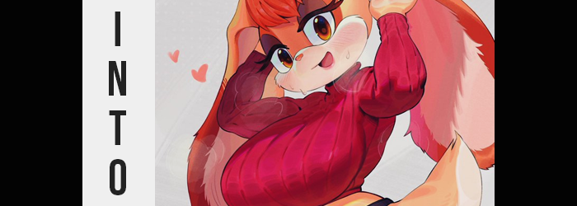

“This feels… more than a little bit suspicious.”

On its head that might not have seemed like the case, mind you. I was simply in my office with an office in hand. I had just picked up my mail from the mailbox outside so there realistically wasn’t anything suspicious about that. As always, most of it had been spam and unfortunately bills as well. But after I had meticulously sorted 99% of the mail that had come in? One small box had remained within my clutches and only because the return address had caught my eye.

Universal Studios. Why had I received a package from Universal Studios of all places? The box wasn’t even a small one, similar to a shoe box in its design but a little larger. “This must have come to the wrong address, right? Does someone working at Universal have the same name as me and they mixed it up?” That had to be it, right? Because I hadn’t ordered anything from the movie studio and even if I had ordered merchandise of some kind, I doubted that the studio itself would have sent it.

“I guess I should check what it is at least…” I supposed that it wasn’t impossible that a friend or family member had ordered me a gift, right? And it was addressed to me in the end. After a moment of deliberation I tore the tap around the sides of the box so I could lift up the top, finding a note inside. “Try them on? We’ll need you to wear them on set?” I’d read the note to myself before putting the piece of paper aside. The note had borne the mark of the Sonic the Hedgehog movie logo. I was a big fan of the live action movies…

But it sounded like the kind of note you’d send an actor.

And what I found inside the box… “Boots?” A pair of tanned Timberlands, in fact. Certainly not cheap boots, but they were sized for a woman. “No, that’s not even the strangest part, right?” It was hard for me not to notice their designs. They were much wider than regular boots and had the shapes of three big toes in the front. Almost shaped like a pair of cartoonish rabbit feet. “I mean I guess if this was a prop for the Sonic movie then it makes sense…”

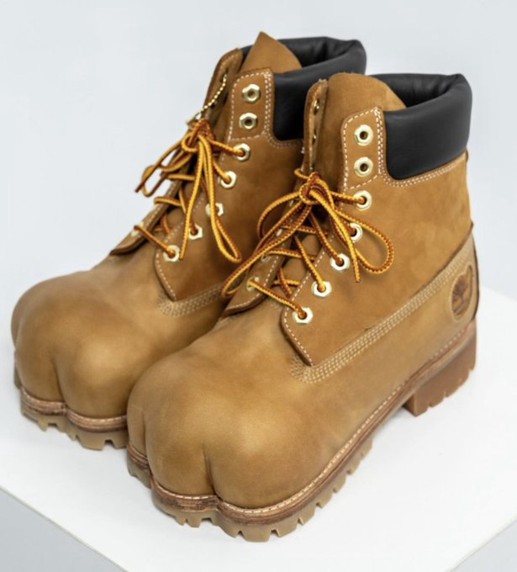
Even though they used CG for the anthropomorphic animal characters, right? I supposed it wasn’t impossible that they used real models and props for some things, however. “Well these obviously weren’t meant for me.” Despite the fact that they probably would have fit since they were so big. Satisfied with this assertion I ended up closing the box with the note inside again. I’d just figure out how to send them back later and hoped that they didn’t need them right away. There were probably spare boots made, right?

The box was left out of sight and out of mind for the rest of the day. Or well, the former had been true for much of the day, but the latter? Not so much. While working my mind had begun to wander. At first it had only been a little bit. An idle thought about the bunny boots here and there that I often redirected to wondering about how I’d best return them. But as the hours ticked by? It became harder and harder to concentrate on my work.

It had become harder and harder to think of anything but the boots.

I’d even missed a DM from my friend Joseph about receiving a smaller pair because of that growing obsession.

“Ugh! What is going on with me?” In the end I’d cleared off my desk and placed the box back on it. I really wanted to see them again. To touch them. And once I removed the lid and note once more I was doing just that. “They’re just boots and they’re not even mind, so why do I care?” I did have a point, mind you. I wasn’t the sort of guy that really cared about fashion; especially as far as footwear was concerned. So long as it was comfortable then I’d wear it. Well, that and not bright yellow or something.

Reiterating this aspect of myself in my mind didn’t do me any favors though. “Speaking of comfort…” I turned the boot I was holding to look down its top. Since they were expensive boots from a movie studio then they had to be comfortable, right? But just how comfortable were they? It wasn’t like I had a lot of opportunities to try on such a premium pair of boots, right? And even though I knew that it was wrong to do so…

I ended up sliding on one and then the other and stood up. “…Eh?” But the moment my heels sunk into the plush, albeit oversized interior of the shoes? I had a sudden moment of clarity. It was like my mind had been under an increasingly thick fog for the past few hours and now that I had put the boots on I was ‘myself’ again. “Why did I put the boots on!? Am I an idiot!? What if they charge me for any wear on them!?” They could definitely figure out where I lived once they realized their mistakes. And then they could charge me if anything happened to them. I could not afford that.

But what if I made a killing on a movie deal?

“A movie deal? Am I high right now or something?” I had absolutely no acting skills and crippling social anxiety, so there was absolutely no way I could ever stand in front of a camera and perform. In that moment I had the right sense of things: I was just going to kick the shoes off since they were too big for me. And yet when I went to do that? They didn’t even budge a little bit. “…Huh?”

I tried wiggling my toes within the boots and it felt… strange to do so. Why were they pressing up against the ends of the boots now? Why did it feel like my nails were sharply digging into the tips? No, why was I not…? “Am I missing toes?” Somehow I could only feel four of them per side, with two cramming into the same ‘toe’ of the boot on either foot.

Concerned, I sat my ass back down immediately and lifted one foot over the opposing knee so I could take the boot off manually. I was working under the assumption that maybe the unfelt toes had just fallen asleep, but when I went to reach for the boot I paused. There was something fluffy peeking out from above the boot’s top. It was a soft brown color. Was that part of the boot? “What the…?” Seeing no other choice I touched it gingerly and then gave it a little pull. “OW!?” A yank that I felt on my skin.

My left eye twitched. The implication was that this thin, fluffy brown was attached to my skin, right? That would make it fur, right? “There’s no way.” This realization prompted me to speed up the boot’s removal and I practically tore it off. But what awaited me beneath? It wasn’t a normal human foot. It was covered in the same brown softness that was seemingly sprouting up my legs, for in that time it has traveled to just beneath my knees. But the sole of this foot had a cream-colored fur, and the foot only had four toes… each with a little claw on the end.

It looked like the foot of a rabbit, and I could only assume the other foot was the same.

“I… What? What am I even supposed to say about this!?” I wiggled my furry toes several times to make sure I wasn’t seeing things, touching them with my hands simultaneously out of disbelief. But much to my dismay? Perhaps it was unrelated, or perhaps it was because I was touching them with my hands, but the hands in question were quick to inherit traits similar to those of the foot they had been exploring. Namely the brown fur on the backs of them and the white fur on my palms. Although, watching my pinkie fingers merge into the fingers beside them and claws become fashioned from my human fingernails was certainly unsettling.

The fur then began to creep up my arms just as it did my legs, but I was unaware of it sprouting beneath my shirt for the time being. I was made acutely aware within time, mind you, because of a different change that affected my belly. It crunched inward. “EEP!?” A strange, feminine squeak left my lips as the sensation forced my posture to straighten suddenly. I looked down immediately, confused because I didn’t see a protruding belly that I was accustomed to.

But upon moving a rabbit-shaped hand beneath my now huge shirt? It rubbed against an equally furry surface that felt impossibly thin to me despite there still being a bit of chub to it. My waistline was also much thinner than my hips now. If I grabbed it with both of my hands I might have been able to meet them together on either side.

“I’m so thin!” I gasped in a voice that alarmed me all the same after unintentionally putting the boot back on and standing with surprise once again. That earlier squeak hadn’t been a voice crack nor a mistake, it was now just my voice? I could only imagine how out of place it sounded with my masculine face, but… There was a fundamental mistake with that line of thinking. It assumed that my face had remained unchanged itself, which was very far from the truth.

My face had gained a feminine slant to its design, but more than that its weight was strange. My stomach and chest had thinned, but my face seemed to be heavier as far crept into it. Heavier in size and rounder in shape as fur began to attack it net. A white and fluffier fur possessed my cheeks and the areas around my lips and nose, forming a pattern while lips swelled up a little and my nose collapsed into a small, wet, pink triangle.

And then my nose and mouth pushed forward, which obviously wasn’t something I couldn’t ignore. “Oh my!?” Nor were those words I would usually use to express my surprise. Hands reached up, nonetheless, feeling how fuzzy my vaguely extended maw had become. But my vision also blurred for a second and I ended up poking myself in the eye where I probably shouldn’t have before. “That’s… strange.”

But it wasn’t that strange if you could see why. My eyes had tripled in their size until they were cartoonish in shape, complete with big, brown irises and dark eyeshadow above long lashes. There was a pure brown band of fur around these eyes, but the remainder of my forehead found the same pale brown as much of the rest of my fur. And these didn’t even mark the end of the changes to my cranium.

“Wah!?” I was temporarily deafened and that naturally surprised me, but what was just as surprising was how my sense of hearing returned. Pressure had built immensely at a rapid pace on the upper sides of my head before soon exploding, flesh and fur growing from these spots and flopping down around the sides of my head as a pair of fuzzy rabbit ears, parting and moving my hair so that it was merely a tuft of reddish brown sitting between them. I couldn’t even be surprised considering my feet and hands!

That said, it wasn’t the only reason I wasn’t surprised. Something deep down was affirming these changes as ‘correct’. Was it strange for me to have the features of a rabbit if I was a rabbit? Memories of my childhood and teens now all reflected the traits that I had now and, while much of my life was similar? There were plenty of divergencies relevant to my changed race… and sex.

“Mmn!?” The shocking sensation of my dick and balls folding inside a pair of fur-surrounded lips prompted me to moan and bite my lower lip all of a sudden. I was undeniably a woman now, but that felt right. Rather, I was confused about why I’d briefly been so horny. “That was ooooodd?” Was it as odd as how that final word had lingered with a hint of surprise to it? Perhaps not, but it had sounded that way because my subconscious had recognized a new change that my conscious self appeared to be willfully ignoring.

My nearly six foot tall stature was slowly compressing. The inches were peeling off my height little by little, lowering my perspective and giving the vague impression that I was falling – which was what my subconscious had reacted to. In a case like this you might expect the excess weight my body required at that taller height to disappear so that my build remained consistent despite the dip, and yet that wasn’t what happened.

As I shrunk, the unneeded weight simply moved. It pooled within my chest, thighs, and ass, provoking what had previously thinned to plump out again in a way that was much more attractive. But that weight wasn’t just weight that had move. New weight formed in kind, seeing my thighs explode within loosening and shortening pants until the cloth was pulled neatly around them. Either thigh was three times as thick as my waist, but there also seemed to be a great deal of strong muscle concealed beneath the fat. It was befitting of a rabbit to have powerful legs, of course.

It was around this point that my clothing began to change too. “It’s a shame I don’t have anything that fits me…” My already tight pants tightened further, colors darkening to black as rather than cotton the material shifted into a skintight latex that reached the tops of my shins. You could make out the shapeliness of my thighs, and the perky ass that flourished behind them with ease, but there was a slit in the material just above my ass…
Through which a fluffy rabbit tail suddenly popped out above a pair of red lace panties.

My oversized shirt’s darker colors actually brightened to a pinkish red as sleeves lengthened to my wrists, vertical stripes etching into what was clearly becoming a turtleneck. Theis thicker cloth tightened around a pair of breasts that had begun small as I dipped below the 5’ mark in terms of my height, but it was forced to stretch again as those tits exploded with the additional weight needed to give me a pair of G-cup tits completely with full, erect nipples concealed by the white fur that surrounded them. For some reason this outfit did not have a bra.

But I knew the reason.

“Oh dear. I believe I’m running late, aren’t I?” It hadn’t even occurred to me. While I had once been standing in an office, I was now standing in the ‘living room’ of a relatively expensive looking trailer. The type that movie stars tended to use. But wasn’t that what I was? I was Vanilla the Rabbit, and I would be playing the role of myself in the third Sonic the Hedgehog movie. Of course, I wasn’t alone either.

I may have been only twenty six years old but I was a single mother. My daughter, Cream, was also acting in the movie and was in the trailer beside mine. Of course I had no way of knowing that my new child had actually been Joseph in the end. I didn’t even know who that was now! “I hope she managed to get changed on her own. We’re having lunch with the director after all! We need to look our best!”

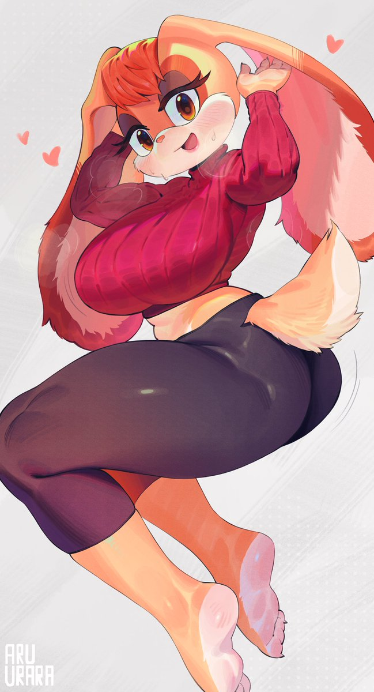
Now you might have been wondering: if I was going to such an important meeting then why was I wearing such a revealing outfit? It was unfortunate, but Cream had accidentally knocked my bag off of vehicle before we had come out to the set. So aside from the costume I had to wear during recording, the yoga pants and tight, red top were all I had to wear. It was a little embarrassing, of course.

But it also seemed like plenty of the staff stared at me under normal circumstances. I was well aware of how curvy my body was despite being under five feet in height. It was a body that my daughter would likely have when she grew up as well. None of that was here or there, though! I’m terribly sorry for getting off topic!

I straightened my posture after making sure my Timberlands were fitted comfortably. Just doing that much made my big tits bounce. I sighed. “I wish they had a bra that had fit me among the costumes…” Or pants that weren’t that tight for that matter. You could even make out my panties beneath my tail! If I was feeling insecure about my clothes already though, that insecurity only worsened as the door to my trailer opened and my daughter skipped in. Her expression immediately soured.

“M-Mom!? Are you meeting a special someone!?”

“N-No…!”

But there was that cute lady who did my hair, I supposed…

