IN THE NAME OF THE MOONCANCER
COMMISSION STORY
BY CHALDEACHANGE
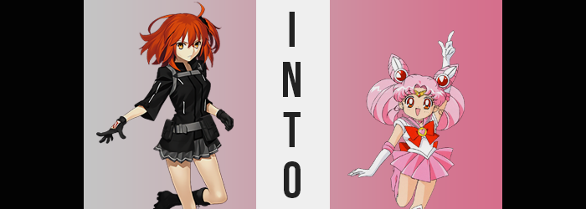

What was happening with Chaldea as of late had been interesting from BB’s perspective.

The Ordeal Calls. A series of tests that were designed to help Chaldea’s Master, Ritsuka Fujimaru, better understand the Extra classes. As of this point in time the Master had apparently conquered two of these tests: Alter Ego and Avenger. The second of which had resulted in a number of the organization’s Avenger class Servants mysteriously disappearing. BB didn’t really have all of the context about what had happened during either of these tests, however.

“This is so stupid! Mooncancer is an Extra class too, right? So, if there would be some sort of test or learning opportunity, I would be hearing about it, right?” BB was the original, OG Mooncancer. The class card had her image on it! If it made sense for anyone to teach everyone about the class, then it was her! “Hmm… But what if it isn’t something you’re just chosen to do? What if it’s something I’m just supposed to do on my own? I bet I could come up with a fun theme for it!”

If she recalled, a lot of the child Servants had been gathering to watch anime in the recreation room as of late. Anime… Anime with moon themes? Could she work with that? And if she wanted to teach the children too, then it would probably have to be child friendly, right? “I wonder if I could make it more hands on somehow. Hmm… Oh! What about…?”

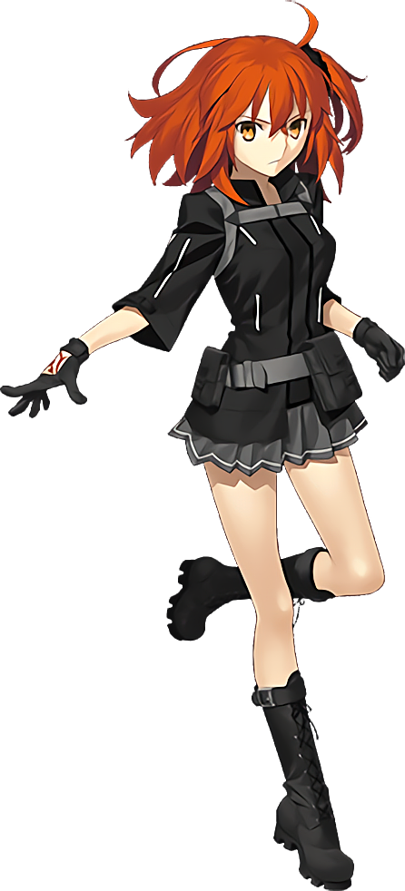
“Master~! I’m so glad you could make it! You’re cooperation will be extremely helpful!” Or so BB had greeted Ritsuka as she stepped into the Mooncancer’s quarters, but in actuality? The ginger-haired woman didn’t really know what she was helping with. She was still worn down after suffering through the most recent Ordeal Call, and the tonal whiplash of BB’s actions had left her even more exhausted; albeit unintentionally.

So, what had BB done? It definitely wasn’t difficult to see, really. You could hardly take five steps through Chaldea’s halls without seeing one: a mass-printed poster advertising a ‘Sailor Moon Marathon’. More curiously was the tag line underneath the title. ‘Come learn all about the Mooncancer class!’. And so Ritsuka had a sense of the kouhai’s intentions, but she didn’t really understand the rationale behind it.

What had confused her even more was the invitation she had received asking her to meet BB in her room before the marathon so that she could ‘help out’. If this was her idea of replicating an Ordeal Call, then that probably wasn’t the type of role that Chaldea’s Master was supposed to have within it. She was supposed to be tested somehow. “Uh… Yeah. Listen BB, what exactly is it that you’re expecting me to do? Like, change the episodes when they end?”

The fatigue in Ritsuka’s voice was very apparent to BB. Poor Thing! The second Ordeal Call really took a toll on her… But maybe this will work out for the better in that regard too! Her thoughts on the matter were optimistic, but only because in a typical BB fashion, she was actually up to no good. A little prank of sorts that was harmless on its face. Then again, she thought that about every prank that she pulled.

“Well, senpai… I was thinking that considering you’re the one who needs to understand the class better than anyone, that you could take a more hands on role in the event!” Something about BB putting emphasis on ‘hands on’ gave Ritsuka a bad feeling. “You’d be better off examining the class on a much more personal level, right? So, I played around with this authority of mine and… Voila!”

Ritsuka’s intuition had unsurprisingly been on the mark. BB had pulled out her wand and poked her Master’s forehead with it before she could even react, and from it a pink light erupted and flowed into her body. The victim’s body froze up briefly as a strange energy coursed throughout her flesh, gathering together in a place that felt like her heart. But it wasn’t. It was something much more spiritual. Within a newly formed Saint Graph, like a Servant would possess.

“What did you just do?” …Was naturally the first question that came out of Ritsuka’s mouth one she regained control. And much to her annoyance BB only really shrugged in response. “BB!” Really, she wasn’t all that surprised by the Mooncancer’s actions nor her response to being called out for them. But that certainly didn’t make it any easier to deal with.

BB just did a little twirl. “Don’t worry so much, senpai! I wouldn’t do anything to hurt you! You should know that by now! But I was just thinking that this little event could benefit from a guest appearance too, so why not kill two birds with one stone?” Of course, before Ritsuka could inquire any further, BB turned into Spirit Form to indicate that she wouldn’t give any further information on the matter. Typical.

The Master simply sighed and looked herself over to make sure that nothing was out of sorts still. As far as she could see, it didn’t really seem like the Mooncancer had harmed her. Although realistically that thought had never crossed her mind. BB might have been free willed and extraordinarily difficult to tame, but under no circumstance would she do something to Ritsuka that would hurt her. That said, this didn’t mean that she wouldn’t do anything that would get under her Master’s skin. Those were entirely different things.

And she could still feel something spreading warmth throughout her body from within an invisible ‘core’ of sorts. From the Saint Graph she still didn’t realize had been forged.

“…Wait a second.” In the end, it seemed as if she had given up on looking for signs of foul play too soon. “I guess there was no way that BB just injected some sort of magecraft into me for no reason, huh?” What had prompted her to change her opinion on the matter was something she could plainly see because it was dangling between her eyes. The orange bangs that traditionally hung between her gaze of lighter orange weren’t, well, orange!

They were pink. Pinker than bubblegum itself, actually. The woman had seen fit to grab at what she could see in front of her, but by the time she had reached her hand up? Her bangs had both shortened and moved, parting to either side in fluffier forms while leaving something akin to a heart shape in the dead center with how those bangs had been lifted. But that wasn’t all that had happened; she could feel the weight of her locks shifting behind her. “What’s the damage?”

Ritsuka’s groan was audible after reaching back and grabbing two thick, long curls that had been fashioned from lengthened, denser hair. “And that explains why it’s so heavy…” What was even tying it into two tails? Small ribbons, it felt like, but she dared not remove them and risk her thickened mane spilling out behind her. She’d completely missed the two rabbit-ear shaped odongo that shot up just before the tails. “BB… This isn’t funny! Just turn my hair back!” No response came, of course, nor did her hair change back.

Was it isolated only to her hair, though? Truthfully it wasn’t, but you had to cut the woman some slack seeing as, well, she couldn’t really see what else had happened. Noticing her hair had even only really come down to an initial fluke. But the eyes through which she gazed upon the already noted changes were definitely different. Oranges were enriched with a vibrant red that were certainly easier to see as her eyes grew several inches bigger in size. The blacks of her pupils remained, but they were pushed away from the center of her gaze by big white circles that likewise seemed to give her eyes some shine.

“What am I supposed to do here? Just embrace my now pink hair?” Was this part of the Sailor Moon thing that BB had wanted help with? Ritsuka was unfortunately not well versed with the show, so her running idea was that she had needed pink hair to… cosplay, maybe? But changes soon unfolded that tested that growing assumption of hers. With things that, er, weren’t growing. Kind of the opposite, actually.

The woman first noticed this because she felt the underwear beneath her skirt begin to slip a little. “Huh?” And then it slipped a little more, and then it almost fell off, but fortunately she had caught it by the strap and pulled it back up. This meant lifting her skirt, but there wasn’t anyone else in the room unless BB had been lurking. But she was immediately taken aback by the realization of why they’d slipped in the first place – as well as why they would no longer fit again. “Where… did it all go?”

In the end she allowed her panties to fall down her legs and onto the floor, having realized that trying to put them back into place had become a fruitless effort. What was missing was mass, namely around her butt and thighs. Ritsuka had never considered herself to have a big butt or anything like that, and in fact it had been pretty average, but the weight that it had possessed had been entirely sapped away along with the meat on her thighs. Her legs were left stripped of their perceived femininity, and it certainly didn’t help that her hips had been forced closer together in kind.

“Okay, so definitely not a cosplay gig…” There had been a strange chirp to her voice for a second there that would come back with the vengeance later, but for now? She was left contemplating what to do without panties, much less the concern that her skirt was beginning to slip now that her hips were narrower. Unfortunately, she wasn’t given much time to dwell on these things before she had to consider a related issue.

Her top and jacket began to feel emptier. “Oh shoot…” The Master had wanted to use a much more profane word there, but her mind had autocorrected it to something a little more PG. Regardless, hands reached up to now paw at a chest that was melting away beneath her grasp. The cups of her brassiere emptied before her very eyes until she hardly even had A-cups. “Am I becoming a boy? With pink hair though…?”

No, something about that just didn’t feel right.

And she was once again immediately corrected when it came to the assumption she had made. Because everything about her just dropped. Her height, that is. “WHAAAAAAAAAAA!?” For some reason, she couldn’t stop herself from crying out the second she realized what was happening and until the process had completed, her voice growing higher and higher to match that chirp from earlier. Arms and legs shortened and her hands and feet shrunk and thinned until she had the cutest little toes and fingers. Of course, clothing also fell from her person… but fortunately her top remained overtop of her tiny form like a really big dress.

Seeing as she’d shrunk all of the way done to 3’6”, that wasn’t really too surprising. But becoming the size of a child had come with an added side effect. “I’M A KID!?” Ritsuka had literally become a child. She couldn’t be any older than seven or eight and the way she reacted to it felt like an appropriate response for a girl of her (new) age. This was partially the fault of a new personality rooting itself within her soul, but fundamentally she still remained herself, even if her cheeks were so chubby and round now!

“Wh-What’s happening to my clothes now!?” She stood in the pile of clothing that remained, flailing frantically as it all began to glow with a rainbow of colors. Her Command Seals had long since disappeared, but the hand they had rested upon was soon hidden as the glowing rainbows disappeared and were pulled against her small body. Piece by piece the rainbows exploding, giving her an all new outfit that looked to be directly out of the show that BB had planned on marathoning.

A sailor fuku with a frilled, pink skirt, knee-length boots, elbow-length white gloves, and big red bows on the front and back of the uniform. You couldn’t leave out the golden tiara on her forehead or the ruby hair ornaments overlapping her odongo either. “Seriously! Why am… Huh?” The girl almost comically turned her head to a source of new light in the room. A CRT television that had been nestled in the room’s corner had begun to glow and, well…

It sucked her inside.

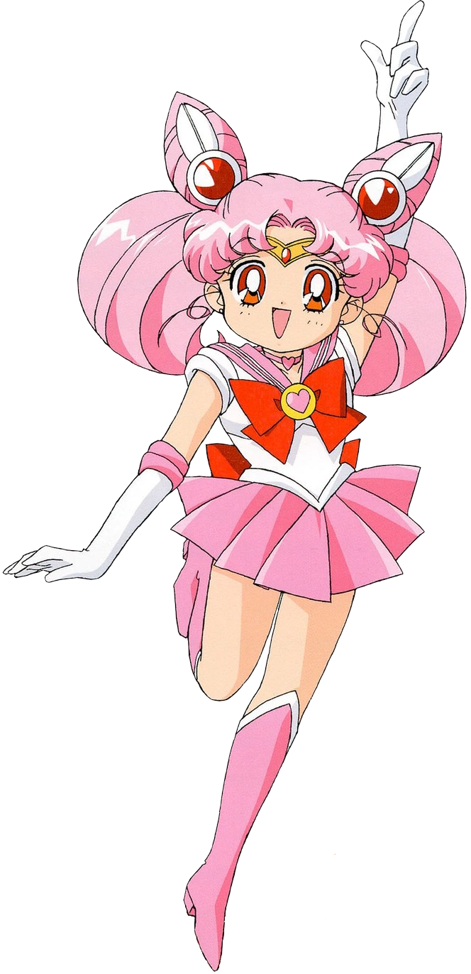
The panic that the child had felt when the television had whirred to life and sucked her in led to a strange moment of comfort on her part, as Chibiusa Tsukino found herself standing in a familiar bedroom in her Sailor Form. “What the— EHHHHH!?” There really was something comforting about her surroundings. Subconsciously she recognized it as home, but the child’s internal identity was a little more complex than you might imagine.

She was very much Chibiusa Tsukino now. As the events of Sailor Moon unfolded, the pink haired girl would be given no choice but to play the role she had been given. But at her core, and when the child was off-screen or not being carried by the whims of the narrative? She could still think and function as Ritsuka Fujimaru. It was simply that her personality and mannerisms mirrored those of the rambunctious 90s anime girl that she had become.

“This is so weird! I’m a little kid again, and I’m Chibiusa!? I didn’t even watch the anime!” And so Chibiusa had no idea what was in store for her future. She did, however, have all of the princess of 30th Century Earth’s memories. “What did that… that… purple haired lady do!?” BB? Another side effect of what had happened was that while she could recall aspects of her old life, she wasn’t able to communicate them with any sort of clarity. It was like things got a little blurry the moment any recollections left her mouth.

A disembodied giggling caused Chibiusa’s posture to perk up. “Don’t worry about it too much, Chibi-chan! Just play your role perfectly and I’m sure you’ll understand what it means to be a Mooncancer! Because at your core that’s what you are! I just figured that some firsthand experience in the show might cheer you up first!” The magical girl knew what this voice was saying, but she also didn’t. Perhaps because she’d regressed in age, some of the more complicated terms were going over her head? “When the show is over and you’re all finished, I’ll pull you back out and you can function as a Servant until you understand the true meaning of being a Mooncancer!”

“You should pull me out right now! I don’t belong in heeeeeeere!” But that sentiment on her part caved way when the door to her room swung open a blonde haired teen stormed in with an angry, 90s-styled anime expression.

“WHY ARE YOU YELLING FIRST THING IN THE MORNING!?”

So scary!

“No, wait! I’m not Chibiusa! I’m Chibiusa! …Eh!?”

She couldn’t say her old name!?

