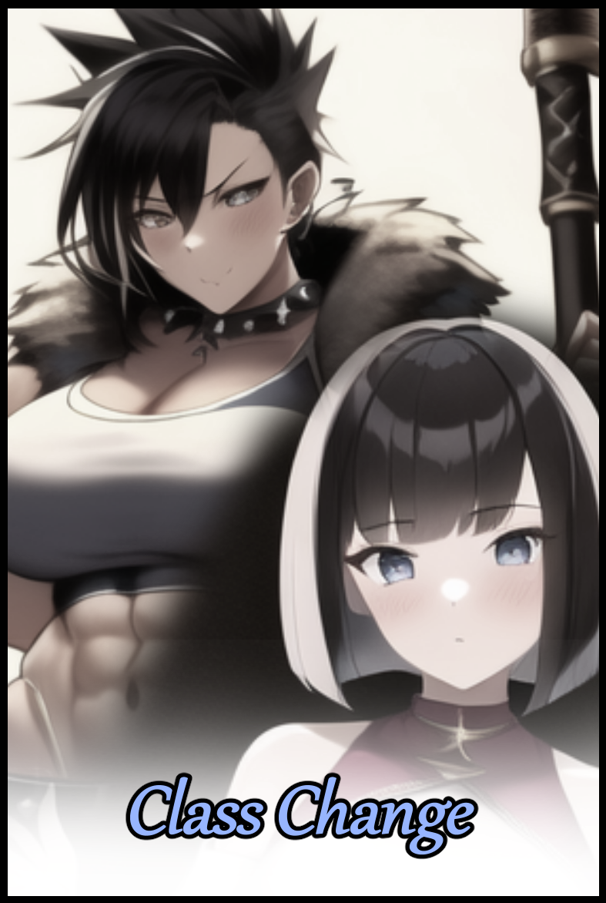

Jeremy and Hank, two faces on the same coin that was the Bully Dynamic; where a ruthless side, brimming with the urge to assert their influence and dominate, would come into conflict with its docile but not necessarily weaker counterpart. Starting a conflict that could only end in one of two ways; through outside intervention, or when the usually dominant side finally overtakes the other, shattering the metaphorical coin before moving on to find another weak 'face' it could latch on to, renewing the cycle once more.

And in this case, Hank had the honor of playing the role of Domineer as resident bully in the town's local highschool where the blonde jerk wasn't exactly a foreign sight to the student body and faculty. When he wasn't leering at the girls, skipping class or hanging out with his gang of cronies who parroted his every word like a portable echo chamber, Hank could usually be found partaking in his favorite pastime activity; picking on Jeremy. Who, by all appearances, seemed to be your average nerdy kid who minded his own business and buried his face in books. But as the saying went; looks can be deceiving.

Hank had left many 'coins' shattered or at least shaken to a brittle mess. But it had been months since he'd added another notch to his list of victories. All thanks to the stubbornness his current target presented against his best efforts to break and force him to submit. Prodding at weaknesses, verbal jabs and even some minor physical roughing up did little to move the iron willed mountain that was the diminutive Jeremy. And Hank, instead of seeing sense enough to cut his losses then and there, doubled down, persisting in his efforts to make the defiant nerd submit.

Not like the rest of the student body did much to complain of course. With the bully's sights set on one unfortunate soul, they were free from any sort of harassment. Better one than all of them, right?

Jeremy however, didn't align himself with them despite his nature as just an average student amongst many others. Even before he had the misfortune of catching Hank's attention, Jeremy had already been considered an outcast by his classmates. The Silent Kid With A Creepy Look, Loner Boy, Lonely Jeremy, these on the nose titles had been repeated so often the young man had been desensitized to it all, partially building up an immunity of sorts to the bully that would come for him not long after.

As for the reason behind why a highschooler like Jeremy didn't seem too keen on mixing around with others during what was arguably the peak of his youth…it was something that would come into play much further down the line, for both he and Hank had much in common. Even though they didn't know it just yet as they got into another one of their usual bouts, with Hank cornering Jeremy right outside the school gates in a convenient spot right along the busy road.

For years now, that particular stretch of asphalt had been left to dwindle away in neglect, lined with cracks ranging from minute lines that could barely be seen to concerning streaks large enough for a person to stick their fingers in, and over time, the once level surface had become bumpy and uneven. The perfect ingredients for a traffic accident to occur so close to a populated area. And as it just so happened, a truck of considerable mass was about to head right down that road, turning the corner without much trouble before its rear wheels snag in a particularly large crag, sending the truck careening off course and straight toward Hank and Jeremy…

The two boys barely had enough time to turn their necks toward the ear piercing blare of the truck's horns as it came charging toward them in a bumbling mess of steel intent on flattening them into the ground while smearing a pulpy mess across the outer walls of the school.

A loud boom combined with the wincing screams of tortured metal fill the air, followed by a dying crescendo of shattered brick bouncing off a ruined chassis and onto the dusty ground. The relatively slow burning and uneventful Friday afternoon had been broken within a second as passersby ran up to help the driver out of his seat while checking for any other potential victims that might've been caught up in the accident.

But besides the shell shocked driver, no one else seemed to have been involved. No ruined mess caught in the shattered radiator grille, no arm sticking out from beneath the ruined pile of concrete and rebar…

…until someone, a student from the looks of it, pipes up with a question that had many of the crowd confused and wondering if she'd been seeing things;

**"Where'd those two boys go? Hank and the nerd?"**

While the rest of the people outside the school tended to the incident, Hank and Jeremy would find themselves in a completely different place altogether, both of them displaying completely different reactions to their current predicament with Hank falling backwards onto his bum against solid rock in his startled bid to escape the incoming truck that had vanished as fast as it appeared in his face while Jeremy simply sits and stares, half lidded eyes examining the damp, slick walls of the cave they'd been transported into, lined with barely lit scones that struggled to illuminate the darkness.

He didn't have much to go on besides what were clearly tribal markings of a sort Jeremy had never seen before in all his time reading through history books and texts concerning the tribes of man. And with a slow graze of his hand across the smooth limestone floor, the intuitive student could feel what felt like rough, man made grooves carved into the stone face, ignoring Hank's panicked shouting and yelling in favor of getting a better look at the massive spherical pattern.

But before he could do so, a hard kick to his side sends Jeremy sprawling, hacking up a cough while an irate Hank turns his anger and confusion on the one person in the room who seemed unusually calm about the whole 'trapped in a dark cave' situation they were in, growling threats in his face, shaking him silly with his comparatively enormous stature allowing him to suspend Jeremy with his feet barely touching the ground.

Right as things were about to get ugly, a reverberant shout in a commanding tone forces Hank to drop Jeremy, choking on saliva that had built up in his gullet while he watches the bully immediately collapse onto all fours, knees huddled under him, hands laid over his head, palms pressed down on the cold floor in a posture of supplication forcibly imposed upon Hank judging from his incessant cursing and demands to be set free, words that were incoherent gibberish to the middle aged woman draped in dark khaki tinged robes that blended perfectly into the subterranean backdrop. If it weren't for the ball of light glowing in her palms, Jeremy would most likely have missed her entirely.

Stepping forward, the mystical woman reaches out with her other hand, fingers spread wide as she waves it over the duo, causing everything they had on their person to disintegrate entirely, leaving them naked and shivering once the natural chill of the damp chamber bites into their exposed skin.

***"Nayarla vi! Clohastu…diel vei…"***

Freeing Hank from his magical restraints with a fierce bark dripping with mild annoyance while gesturing with a sharp flick of her robes toward a small lump of raised stone by her feet, upon which rests two sets of brand new clothes in the style of medieval tunics and braies. The basic necessity for clothes equivalent to wearing a simple t-shirt and boxers in the modern age. But before either one could protest or press questions, the stranger had already turned her back to them, lifting a heavy boulder out of the way with the curious light that seemed capable of doing anything.

And like an angry drill sergeant who didn't quite like what she saw, the lady hollers at the two highschoolers still staring at her, spurring them to their feet as they scrambled for the clothes on the floor. Doing their damnedest to get dressed as fast as possible. And once they were done, all they would get for their efforts was a mocking scoff from their inspector whose cursory glance over the ragged boys seemed satisfactory enough for her to walk down the newly opened passageway, beckoning for them to follow with a simple crook of her finger. With Jeremy following after her without another word, Hank was left with no other choice but to fall in line begrudgingly, his outrage somewhat quelled by the knowledge that Jeremy wasn't the one who had somehow pulled strings and trapped him here as some form of revenge.

Boring corridor after boring corridor, cold, featureless passageways that quickly left Hank bored, irritated and confused beyond all belief while Jeremy was having the time of his life, spindly neck spinning to and fro as he takes in the sights, spotting faded markings and paintings barely visible in the low light conditions of the underground tunnel network, glimpsing faint grooves and indents that might indicate more hidden pathways locked behind the use of whatever that light had been…and the intuitive man was starting to believe it was none other than magic.

Before the silent tour could go on however, the woman in the lead barks another word in her alien tongue, signaling for them to approach what looked to be an altar of sorts positioned in the center of this new room, this time decorated with high hanging banners painted over with humanoid figures wielding the unmistakable silhouettes of ancient weaponry, dressed in a myriad of outfits ranging from heavy plate armor to simple robes. If anything, it looked like a typical hall where one could lay respects to heroes of legend in many online games familiar to the nerd.

There was no doubt left in Jeremy's mind that wherever he had been taken to alongside Hank, it had to have been one of fantasy, where sword and magic was commonplace. The thought excited him to no end, making him wonder whether they were summoned here to aid the people of this world.

Hank's interest on the other hand, lasted only for about five seconds before dwindling away. Leaving his eyes to wander back over towards their mysterious tour guide, lecherous gaze immediately taking note of the surprisingly bodacious figure hidden beneath the thick robes and that husky voice of hers, wondering if all the women in this place were as gorgeous as she was.

And for the umpteenth time that day, the two unfortunate souls couldn't seem to have a moment to themselves when the woman turned from whatever she was doing while calling out to the boys in a sharp whip that immediately had their eyes focused straight as she strides forward, holding what looked like flowers made out glowing minerals pulsing with a hypnotic rhythm of constantly changing colors in both hands.

***"Shahum…"***

It was a simple gesture that didn't take much for the two to understand, reaching out in turn to grab ahold of the crystalline flowers with their bare hands. It felt like…nothing, as if they were balancing a ball of cotton, which made it hard to judge whether they were holding it right as the two curious youngsters bring it up close to their faces, inspecting the flowers that, to Jeremy, looked a little close in appearance to the multi layered bloom of the lotus. Except this one sported a curious halo in its center, hovering above a spiky core that lay nestled in the center of the assembly like a core, within which bubbles the ethereal energy leaking out in that enchanting ever changing flow of color.

Until the crystals suddenly shatter without build up, causing both to jolt in fright while Hank lets loose an involuntary curse, earning him a scowl from the woman, who had fallen silent ever since she passed the strange objects to the foreigners, watching as the splintered fragments change color while hanging in midair, solidifying into a scarlet red for Jeremy and a pale, winter blue for Hank before fading away entirely, leaving no trace of their existence behind, a sight that paints a smile over the face of their guide as she unfurls the hood concealing her entire face this whole time, opening her mouth to speak once again, except this time their ears were able to understand her clearly despite the movement of her mouth not matching up with the words.

**"You understand me now, yes? Wipe those looks off your faces…it’s just magic. To be honest, I'd rather do with you two being unable to understand me but…circumstances demand I help you acclimate…so here we are…do you have any questions?"**

The moment she had allowed them the opportunity to ask questions however, Hank would be the first to take advantage of it, demanding to know where he'd been taken to, demanding that he be returned back home, speaking as if Jeremy wasn't there at all. And the moment she told him there was no way back, the characteristically violent brute launched himself at her, swinging wildly in an effort to catch her in the head before she could whip out that blue light of hers, feeling his fist connect with something hard

Something *too* hard to be a human skull, yelling out in pain from the torture Hank's knuckles had to endure from bashing the invisible force field surrounding the unimpressed woman, taking a few steps back from where he stood now that the difference in their power was made clear. All while Jeremy stands silently by, watching through half lidded eyes that hadn't changed in the slightest despite how excited and on edge he was feeling.

**"If you're done fooling around, I can explain to you both what it is you're to do here before I set you loose…and you can bring that violence elsewhere…"**

Put in his place once more, all Hank could do was begrudgingly listen in alongside Jeremy as the lady goes over the basics behind their sudden arrival here, the impossibility of returning and what this meant for them. Alongside a curious tutorial of sorts that had the boys, Jeremy more so than Hank, reeling from the menu like overlay that appears over their vision after doing what the bored lady tells them to; a flick of the wrist, thumbs depressing their palm.

**"These are your stats…name, class, weapons proficiency, etcetera etcetera…you'll find them all here if you ever need to check…you…your class has been changed to *Barbarian*…"**

With a razor sharp finger pointed at Jeremy swiftly slicing the air toward Hank, who had laughed at the mention of the scrawny whelp being given a title usually reserved to hulking men of muscle and brawn.

**"And you…amusingly…have been reassigned to a *Mage* by the powers that be…congratulations…"**

Shrugging it off as a better thing than Jeremy's ill-fitting assignment, the two were presented with an assortment of gear that seemed spec'd towards their 'class' and not the individual that was to wield it.

In Jeremy's case, his side of the table contained thick hide armor that could go perfectly over his current innerwear, coupled with a two handed ax that at first glance, looked a wee bit too big for him to handle, tipped with a biting, two sided head that certainly looked capable of dealing good damage despite the subtle hints of corrosion and battle damage speckled across its gun gray surface.

Meanwhile, Hank's pile didn't look as protective as Jeremy's; Containing a neatly folded robe dotted with ornate patterns and gold embroidery sewn into the hem. The fabric looked so soft and flimsy in comparison to the sturdy pauldrons and fur gloves Jeremy had already attached to his body after some exploratory attempts to do so. And when he caught sight of the red sphere stuck on the end of a long wooden stick, suffice to say pissed was a word that could barely describe the emotions roiling within Hank as he reaches a hand out towards Jeremy's stuff, looking to steal it for himself.

But the lady did not interfere, watching from the sidelines with earnest glee for what was about to happen once Jeremy's leather wrapped hands intercepts the bully, easily slapping it away when he couldn't even hope to move a finger on Hank not too long ago, inciting the brash thug's rage after having failed to learn his lesson for what must've been the third or fourth time now, throwing a basic punch that does nothing, bouncing off of Jeremy's flat nose without leaving a mark. All while the chortling laugh of the lady rings out in the air, throwing Hank off kilter while he wondered where all his strength had disappeared to.

**"A Mage going up against a Barbarian in a fist fight is like a slime trying to wallop a dragon…you're much better off with spells but I'll let you handle that…your friend over there looks like he's got his own handle on things so I'll let him do the leading…"**

True enough and much to Hank's dismay as he turns to look, Jeremy was already done slipping on the fur boots, easily hefting the immense ax to sling behind his back, looking like a comically small dwarf who could easily do him in thanks to the accursed magic jargon of this otherworld he'd been sucked into, grumbling under his breath while putting on the robe, slipping his arms through the sleeves, ears barely pricked to listen in on what the lady was saying. Stuff about being chosen from souls whose time on their respective planes of existence were at their end, earning experience, gaining attributes, easing themselves into the world, protecting the populace when the time comes…it was all so gamified Hank couldn't help but roll his eyes.

Unbeknownst to the two new arrivals however, the magic that governed this fantasy realm had much more in store for them than just simple alterations to their physical strength once the doors leading out of the underground chambers were opened by their unnamed guide, happily tossing them out the opening before closing it behind them, leaving the two stranded in the middle of a vast open field and no sign of a cave entrance as far as the eye could see.

From there, the two would strike it out on their own, seeing no problems with going their separate ways. Not when Hank had immediately stormed off after gazing silently into the distance without even saying farewell or announcing a smidge of his plan, if he even had one, to Jeremy. Who could only be bothered enough to give his former bully a sideward gaze that remained locked on his back until the man was too far away to remain visible, a forgettable speck on the horizon that finally spurs Jeremy to take his first steps into this strange world he'd been dumped into instead of the afterlife…or was *this* it? He didn't want to think about it, nor could he even begin to fathom such a concept. There were other important things to worry about, like food, shelter and whether this new stat system would render all of those worries null.

Over the following weeks since the two parted ways with barely a word exchanged besides insults and grunts, the two fledgling 'adventurers', as the lady had so eloquently called them with the most unenthused voice known to man, would gradually acclimate themselves to the new world through their own individual experiences as they thread separate paths that would converge at some point down the line.

For Hank, the hard-headed mule had to adjust himself to his new role of a background player. Whatever strength he had before back on Earth mattered little when it had been converted into numbers. Numbers that were a little on the low side when his class had been changed from whatever it had been before to the support oriented Mage, meant to stay away from the fight altogether while supporting the front line. So for a lone caster fresh out the gates like Hank? That meant he couldn't be careless while on the road, as he would soon learn after being pounced on by a small pack of slimes. Seeing the translucent blobs of jelly up close was a surprise to be sure, but the loss of his strength after bonking one over the head with his staff was cemented firmly when it didn't seem to do anything, forcing him to retreat when its four other buddies started to swarm.

Left with no other choice of he wanted to strike out on his own and live since he had no intention of seeing whether this world had a revive system for game overs, Hank was forced to read and memorize, viewing what skills and attributes he had in his arsenal, memorizing incantations, keeping track of his mana levels. It was all so taxing for the formerly uneducated goon that by the end of the first day, fireworks were going off inside his head from how stressful and demanding it was. A part of him had considered turning back to join up with Jeremy but his pride wouldn't allow it. He was supposed to be the alpha, not the other way around. He'd been his target for bullying for so long and even now, after they'd been sent into god knows where, he still hadn't conceded, not even giving him the satisfaction of a fight…*and now he was stronger than him?*

Absolutely unacceptable…thinking back on what the lady had said and from the experience of the first day he had successfully endured, Hank knew his winning cards now lay within spells, and if what she said was true, then as he leveled up and gained experience, more spells would become available to him…and once he had really destructive ones…he'd track Jeremy down and make him pay again, just like the old days…

But as Hank went to sleep beneath the withered old tree under the cover of night, he wouldn't realize the experience points he'd earned during the day being collated. Slimes, Wildebeests, Garms, all the kills he'd netted with a seemingly endless stream of fireball spam thanks to a hefty mana pool converted from his former strength aided in boosting the Mage class up by over ten levels, contributing towards skills, spells and attributes being unlocked…including some very strange ones that didn't seem quite right.

And as they slotted themselves into his very being, the Mage's chiseled form would slowly begin to wax and wane, shrinking down inside the robes for each level gained. Accompanied by subtle hair growth as blonde streaks loosened themselves, gaining a natural shade of chestnut bleeding from the root itself. Hardened muscle became fat, soft and tender. A rugged visage softens up around the edges while sharp eyes grew gentle and slant. And down below, between softened thighs bereft of hair laid a pathetic weiner that was a shadow of its former self. A direct parallel to what was happening to Jeremey as he rests under the shelter of rock and stone, hidden from the ravenous monsters prowling the particularly nasty region he'd wandered into by accident.

Much like Hank but with a greater degree of success at the beginning, Jeremy immediately began familiarizing himself with what he had on hand; skills, equipment, talents. The nerd inside of him was free to do as it pleased in the comforts of privacy, swinging his battle-ax with reckless abandon, marveling at the ease with which he could swing the hefty weapon without pause. Starting off with a strong start in comparison to Hank's unsteady beginning as a Mage.

But unlike Hank, who had the misfortune of running into powerful monsters he could easily dispatch once he'd mastered the talent of fireball spamming under stressful conditions. Jeremy had slipped completely over the edge once he had managed to pummel monsters far larger than him into the ground without effort. Even slimes that normally had resistance to physical attacks were smashed into a paste so fine they no longer had any life in them at all. Monsters were laid low as Jeremy cuts a bloody path across the verdant plains, leaving a trail of untouched corpses ripe for plunder by scavengers all the way into the misty bogs that lay beyond the hills. A dangerous place teeming with monsters above what the fledgling Barbarian could handle once his ax swings began to bounce off thick carapaces while barely leaving a scratch whenever the bladed edge managed to connect with callused flesh.

Driven into a corner and forced to flee, Jeremy had spent most of the day running to and fro, only managing to score kills on some of the weaker inhabitants of the bog like the many gigantic bugs that hid in the smelly water. They were quick, but the exoskeleton and slimy flesh did little to defend in comparison to the layered scales of Razorhide Crocs and the bulwarks that were Caravan Turtles.

By the time he'd managed to get away and lose his pursuers, night was beginning to fall. And in his little hidey hole caked in mud, none of the bog residents could see or smell Jeremy as he quickly loses consciousness leaned up against the rock wall once the adrenaline and excitement resides, leaving the pain that wracked his body from the numerous cuts and bruises earned from the many narrow scrapes with the denizens of the bog as nothing more than a dull throb he could barely feel amidst the haze of exhaustion that had claimed his mind.

And just like the slow burning changes that were affecting Hank in his relatively peaceful sleep, Jeremy would undergo his own set of physical changes once the accumulated experience from his afternoon tromp converts itself into levels that stack higher and higher, barely catching up to Hank thanks only to the sheer quantity of kills Jeremy had notched while enjoying the euphoria of his newfound strength, something the bonuses he was gaining seemed to supplement as bulging layers of toned muscle begins to build up all across the once skeletal boy's frame, becoming especially abundant in his biceps, abdominals and calves. Transforming the weakling into an oddly comedic caricature of what a bodybuilder should be in the mind of someone who had no idea what they were supposed to look like.

Although there was also a subtle…*charm*…to the way Jeremy's jacked up body looked. For instance, the natural glazed hue his hairless hide sported alongside a noticeable curvature beginning to take shape from broadened hips that were far too wide for a normal male of his age. And although his hair was starting to become frazzled and wild, the quality of it was anything but; luscious, soft and incredibly smooth to the touch….less than subtle signs for what awaited the two should they continue adding levels to their classes.

Surprise was the least that could be said about the boys' individual reactions to their bodily changes once the morning came.

Hank's reaction was unsurprising; irate yelling, constant cussing, a refusal to adhere to reality and a lot of fondling as he ran his dainty hands over his petite new form, tracing sleek indents and curves that weren't there before while pressing down on soft flab that had replaced the familiar solidity of his muscles. Hank didn't feel the least bit different, in fact, he was feeling... rejuvenated. And that irked him greatly, flicking his wrist to summon the status menu, hoping that something had gone wrong, an ailment maybe, or even a curse he could cure…oblivious to how he was now considering a course of action, showing initiative he was never known for in the past.

Jeremy on the other hand, didn't have much time to inspect himself, not when he was awoken by the low growl of a Razorhide that had caught his scent. Except the Barbarian would see no retreat that day, not when he was now able to sink his ax into the snout of the leathery reptile instead of the blade glancing off its armored scales. Only when the beast had been disabled would Jeremy realize a lot had changed both physically and mentally after passing out last night as his gaze goes from his knobbly knuckles up to his pulsing forearms and raging biceps, clad in skin that looked slightly more 'cooked' than the deathly pallor he once knew it for. It was as if the effects of a month-long workout regime were instantly pumped into his body. Although his height has barely changed at all, increasing at a barely noticeable amount in comparison to Hank's drastic loss of height that had put him within inches of Jeremy. Although the immediate benefits could not be denied.

Take Hank for instance, whose arsenal of spells now leaned heavily towards flame considering how often he had used the basic fireball incantation. Except instead of fireballs, he could summon founts of magma, whirlwinds of searing flame and launch spikes of superheated stone. That, and a bevy of traits that aided him in matters of the mind and magic…while doing away with the peskier ones that had tagged along with him from his original class, making Hank less of a muscle brained fool and more of a calm tactician.

But the same couldn't be said for Jeremy, who had also suffered as much as he gained from the alterations to his skillset; gaining a focus on the traits that…in a nutshell, would make a Barbarian out of him. Focusing on building up his offense and defense while eating away at the traits that made him the level headed boy everyone formerly knew him as. Feeding compulsion and a love for bloodshed that soon overpowers any rational thought…at a massive penalty to his overall IQ as if that wasn't enough, not like he minded much when his Blood Rage trait only served to fuel an urge for battle far greater than the ordinary power trip he'd experienced yesterday. With each spray of reptilian blood on his face, the mashed up guts of insects splattering his armor from the swift swings that obliterated them in an instant, the tiny Barbarian only seemed to bulk up and grow stronger as all the physical stimuli and experience points began to add more and more traits to his arsenal while Hank, on the other hand, had taken a more subtle approach, practicing the new spells he'd learned in addition to combining them with ones from the other elements, an urge to experiment and document new things stemming from the Inquisitive Elementor trait that had supplanted Low Attention Span at some point or another…

Over the days that followed, the pair would find themselves settling into the same loop unsettlingly fast: gaining experience doing whatever it was the Mage and Barbarian had on hand before turning in for the night, collating that bounty into levels that would in turn, boost them up with new skills, traits and changes to their physical and mental states. Although the process would eventually slow at a certain point where the region they were in could no longer support them in terms of experience gain, the damage, if any, had already been done, leaving the two irrevocably altered for the foreseeable future in their time wandering this strange world where the sights ranged from boringly mundane plains and mountains to exciting fantasy scapes dotted with extreme geography the likes of which could not be found anywhere on Earth.

Once the first week was up, Hank's height of six feet two had stabilized at an average four feet nine, supplementing his new, girlish frame with rosy flesh and tubby fat that further emphasizes his growing femininity. Gaining the pleasant face of a young lady in exchange for his grumpy mask…with the exception of it being forever stuck in an emotionless gaze after he'd stepped into a trap while exploring a small ruin that left him unable to convey any sense of emotion in both vocal tics and facial expressions. Initially, he'd been relieved to find out it was relatively harmless, but that calmness would soon fade in the coming days when he would stumble across a town. First contact with the locals of this foreign land.

Communication was easy enough thanks to whatever the lady in the caves had done to enable both him and others to understand what they were saying, but when combined by the fact that his face seemed to be frozen in a mile long stare while his voice made it sound like he was bored to high heaven, no one wanted to be near him despite the impressive skill set he boasted in fear of the curse that held sway over him like a plague. With no one being as strong as the fabled Adventurers sent here from the other world that was Earth, wandering the wilderness willy-nilly like Hank did was an impossibility, leaving many in fear of whatever it is he had brought into their town.

For as much as they were adored by the populace, there was also plenty to fear, especially after he'd been told of many past takes where Adventurers had fallen drunk on their powers.

Rather than risk a witch hunt, Hank was forced to reduce his time in town to only the bare minimum. Taking jobs, resupplying, selling materials and treasures gleaned from his previous excursions, searching for anyone who could help diagnose what this curse actually was…it was the hardest hurdle for Hank to get by, even more so than facing down monsters on his first day here.

At this point, it wasn't too far-fetched to claim Hank's experience was like a slap on the face by the invisible hand of karma. Because in comparison to the former bully who had lost almost everything that made him the over assertive grump he once was, Jeremy, or Rana to the people *she* had gotten to know, was having the time of her life running a gig as the uncontested champion in a gladiatorial arena where no holds were barred and everything was allowed. An environment where only the strongest who were willing to do anything outlived the weak and spineless.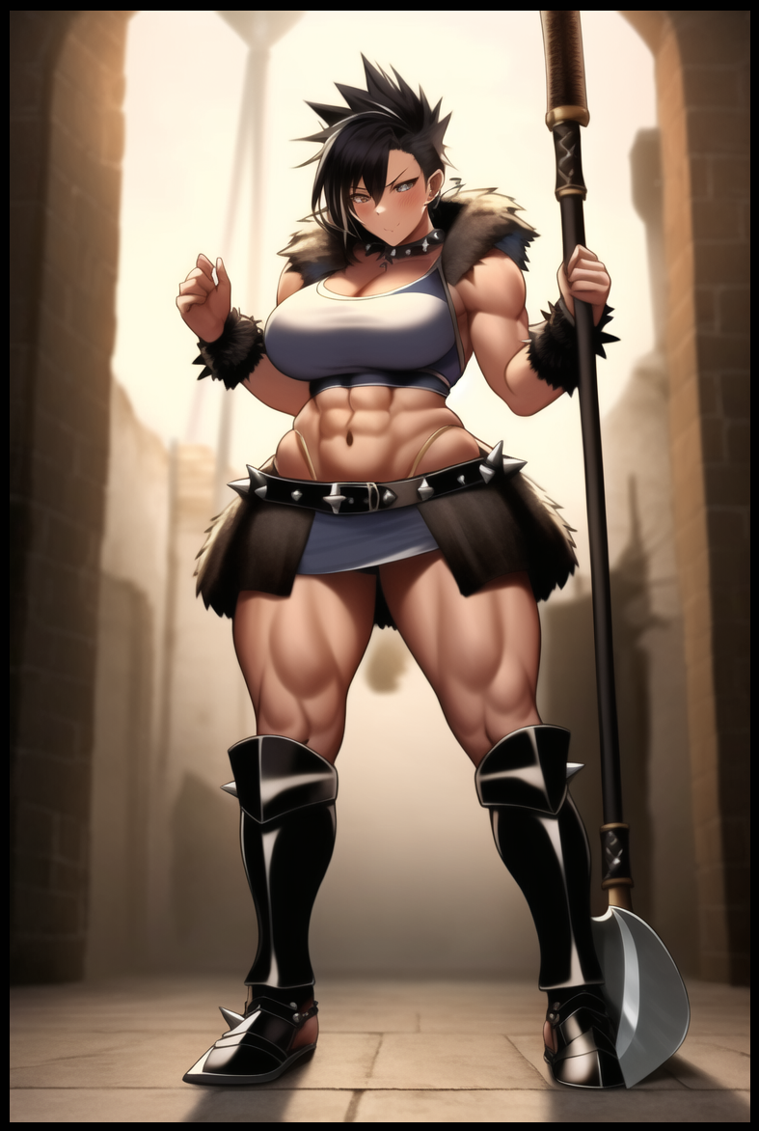

Ever since she had emptied out the bog of most of its inhabitants, the bloodthirsty Barbarian had accrued countless kills under her belt, stopping only to rest and refuel, sustaining herself off the edible kills while fashioning new armor and clothes from the hide of the monsters unlucky enough to catch her eye.

By the time Jeremy had crossed into the arid deserts in search for more challenges to test herself against. Her transformation into the ultimate Barbarian was complete, as was her transition from silent boy to boisterous amazoness. Clad in beast skin while her steaming body sported tribal markings she had instinctively painted over her bare skin in lieu of underwear. A sight that had the local people reeling in shock and awe at the muscular woman walking into their town, speaking in a smooth, husky baritone far removed from the soft lisp the Jeremy of old once spoke with. None of them privy to the fact that the new Adventurer before them had once been a brooding Caucasian highschooler who could barely lift a stack of books without falling over.

Throbbing abdominals that instantly had most men in the desert village beat, powerful muscles that packed the power of a small bomb powering each limb. One would think no trace of a woman could be left in that ensemble, but to the surprise and delight of the silent crowd, the body of the Barbarian still retained the features of what made a perfect women in the simplistic minds of men from all over; A spiked head of luscious hair with a draping fringe over a sleek right eye, wide set hips that could serve as suitable handlebars. A compact waistline that emphasized the curvature of her otherwise solid form. Pert breasts that jutted out like rolling sand dunes atop her chest. And even though she didn't quite have the charm, her rugged face had struck a chord with the menfolk in the village, a village that just so happened to practice an eat or be eaten lifestyle that she'd be perfect for. Especially the implications it had for women who fumbled even a single step in such a harsh environment.

Jeremy's intelligence had been whittled away, his morals and forethought desiccated. So much so that the woman he had become didn't hesitate in the slightest to take on the new name of Rana, a masculine take on a common name used throughout the town for girls, so common in fact, that it had begun to decline over the last few years before her arrival. If it weren't for her immense strength and unique talents derived from her status as an otherworld adventurer, the newly dubbed Rana might well be regretting her decision without the strength to subdue the entire population of the village capable of wielding a weapon. From the opportunistic oafs looking to take her as a trophy wife to those who wanted a genuine challenge, all were laid low, and it didn't take long for Rana to become the de facto owner of the arena and all its earnings…and in a way, it's centerpiece as the grand prize a lucky challenger could stand to win if they managed to best her in combat. The one and only fight where dirty tactics were not allowed. A true test to see who could be best suited to take Rana as their warrior bride.

With the money she earned and the fame she drew in an environment tailor made for her to prosper in, the Barbarian was quick to adorn herself in the finest armor based on her original set, forged from the village's best smiths and tailors, trading her worn out battle ax for an ornate, high quality war hammer tipped with a bladed club on its main head alongside a retractable spearhead on its base, serving to crush and maim her enemies depending on the situation or her mood. So great was her reputation that word would eventually make its way across the borders through gossiping bards and bored merchants looking to make merry with a tale or two; speaking of a barbarous woman who didn't know defeat, and that the prize for surmounting her rage was her hand in marriage…

Even more time would pass since Rana had staked her claim in the world. Long enough for someone like Hank to have found his place in life…albeit with a mild longing for the past she couldn't express with her face and voice still locked in monotonous stasis, long enough for her to forget what it felt like to smile or frown. Basking in her lifelessness as the days went by and people from the town she had settled in came to her for a variety of reasons, ranging from medical examinations to cross referencing her research on the arcane, knowledge the reputable Doctor Hana was more than willing to part with for she saw no use in them if it wasn't related to a cure for the curse that plagued her till now, even as her body continued to mature into that of a voluptuous young maiden on the opposing end of the kid she had forgotten in her bid to free herself of an unfeeling life.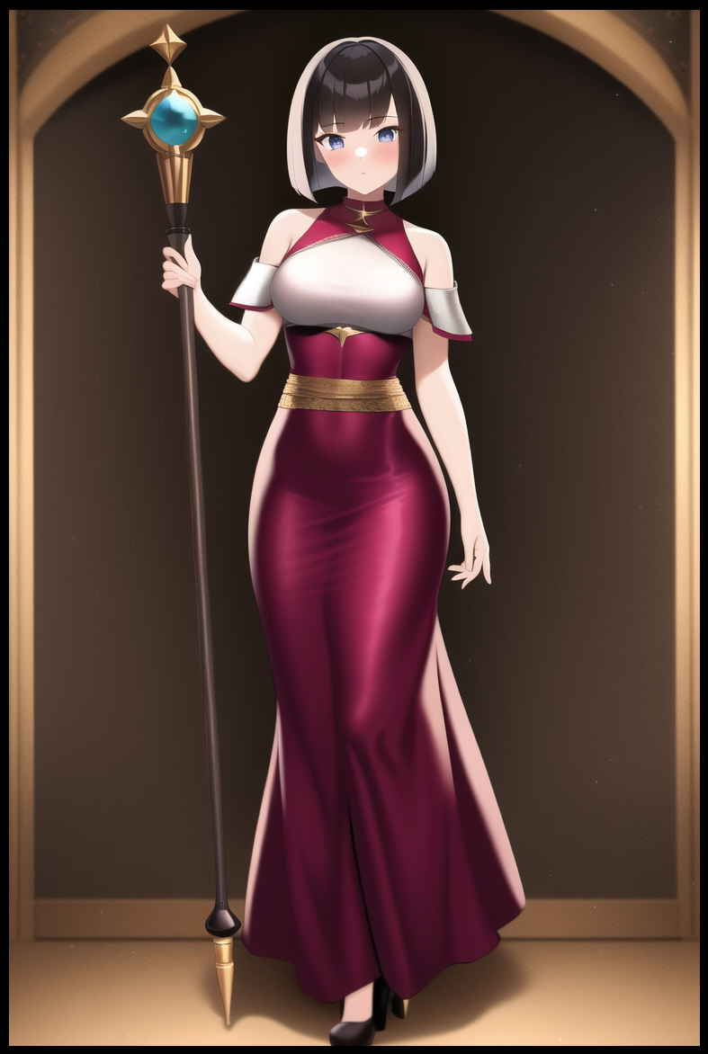

For indeed, her inability to make known how she was feeling had begun to take its toll on her heart and mind. Day by day, week after week, Hana was starting to feel cold and bitter, losing the drive to continue looking for a cure after everything she had done to get to where she was; living a comfortable life in a posh house she had bought on the edge of town. Her days of scouring dangerous ruins, toppling demons and looting the treasure laden dens of dragons was over, draped in the same undergarments and dress she had stocked in her drawers, keeping her hair in the same bob cut length she had maintained ever since finding safe refuge and becoming desensitized to her new existence as a local bred woman in a world that wasn't her own…and she couldn't even feel a lick of remorse about it. Heck, she still didn't know why that cursed lady had sent her here in the first place…sure, she'd slain potential world ending threats and stifled regicidal plots before they could begin…but was any of it intentional? She was just looking for something to cure a curse no one seemed to know about thanks to how strong and unique her talents were as an existence with the ability to hoard skills, talents and levels that made her leagues stronger than the average person…And it was at that very moment when Hana would eventually think back to the person she had come into this world with, the one she formerly bullied.

Whatever had become of Jeremy? If she could get to where she was now based on her magic alone, surely a Barbarian like him would ascend to far greater heights? Was he even a man at this point? The Mage's inquisitive mind ran wild with questions she didn't have the answers to, and as much as she wanted to deny the rumors as mere fantasy, the portrait of this Rana character hung up on the bulletin board the other day bore a striking resemblance to the scrawny boy she once knew. More specifically, the armor she wore. It had been modified to fit her enormous frame and feminine aspects, but it was definitely the same one her photogenic memory reminded her of. What would visiting her even do at this point if Rana really was Jeremy? Would it make her feel something when she couldn't even remember the thrill and anger derived from her bullying days? She doubted it…but maybe it would help freshen things up a bit despite how she knew it wouldn't do much to up her dour mood.

And so Hana would leave the town she had no attachments to for the last time, making sure her shop cum home was locked up tight with a message to the state that they could have whatever she left inside if she didn't come back within a year's time, setting off on foot for the long road towards the desert her old 'friend' now dominated with an iron fist.

Both sides of the coin were pressed into each other before coming out as an unrecognizable piece for they had lost sight of one another. One more than the other, the face that once dominated had lost its fire, wandering slowly, but surely, back toward its missing counterpart. And it wouldn't be until a few months later when Hana would eventually arrive in the same sandy dunes, crossing the same wastes until making herself known in the village that had expanded into a lovely town filled with merchants and folk from all over drawn towards the tale of Rana, warrior goddess of the arena. And as it just so happens, the legendary figure herself was out and about, wandering the streets whenever she wasn't busy facing challengers in the arena or beating down on Sandworms out there in the wastes.

Being stopped by a Mage was one thing, but one who didn't seem afraid of her presence even within the radius of her Overwhelming Might aura was certainly enough to pique Rana's interest in the silent spellcaster who stood a good two heads or so smaller, but something about the way she spoke irked her.

Unlike everyone else, her emotionless voice lined up perfectly with the way her lips were moving, mouthing each word in perfect sync instead of the disjointed translation she had grown accustomed to. The woman was speaking English…introducing herself as Hana and that she was a well known scholar and solo adventurer from some fancy town abroad…before leaning in close to whisper a question that had her ears twitching beneath her messy mop of hair.

**"You're Jeremy aren't you?"**

**"That's an old name…somethin' only one person in this world's s'pposed ta know…ya can't seriously be…Hank?"**

**"Hana…it's Hana now…though I must say, I never thought I'd hear you talk and behave like a complete Neanderthal…what happened to you?"**

**"Heh…well *Hana,* things change…c'mon, let's go fer a walk while I tell ya all about it!"**

**"You aren't…mad?"**

**"About wut? That shit ya pulled in t'past? Yer seriously still hung up on that? Craps old, time t'ferget…now let's go already, 'fore any goons show up."**

Left to look on silently through half lidded eyes, the only thing Hana could muster was a disappointed sigh from how lackluster this meeting had been. She was expecting Rana to launch an assault or something upon knowing her true identity, giving her a rush of adrenaline at the close range fight she would have to face. To feel anger and jealousy upon knowing for sure that the quiet nerd she once knew had basically turned into who she always wanted to be. But alas, nothing, pressing a hand against her left breast where her heart pulsed without a change in rhythm, as smooth as it had always been ever since being afflicted by the Coldheart Curse as she dubbed it to be in honor of being the first one to suffer its effects.

Catching up with Rana, the bully turned scholarly mage would listen intently to the Barbarian's tale; of her initial harrowing experience in the bogs to the path of carnage she had unleashed upon the native wildlife population in her mindless travels, unknowingly saving many nearby settlements from dangerous beasts and aggressive monsters until finally setting down roots in the desert village she had helped boost into the up and coming town it now was with her fame alone.

A rather anticlimactic tale considering how she herself had been facing down demons, robbing dragons and clearing labyrinthine dungeons all on her lonesome self…

**"So? What's the story with ya? Must be better than mine if yer lookin' so bored…"**

**"It's not…really…and I'm not trying to be rude Rana…I'm suffering from a curse…"**

**"Oi…that shit ain't somethin' to joke about if yer bringin' it up this late…what curse is this even anyways? A-And how long have ye got it for?"**

**"A week or so since I left you after the cave lady sent us here…it's something called the Coldheart Curse, courtesy of yours truly being the first recorded case…"**

**"Damn…Coldheart huh…so…what? Ya can't…*feel* or somethin' like that?"**

**"I can feel perfectly fine…pain, warmth, cold…it's emotions that I can't project…but it's been years now, and I think…slowly, I'll be unable to actually feel for real…I haven't experienced joy in nine months now…I stopped feeling sad two years ago…and our past…even that doesn't-"**

**"Yer kiddin'...right? Ya said ya been lookin' for a cure…that's possible right?"**

**"In theory…but like I said…I've turned the countryside upside down…I've faced down demons, snuck under the noses of titanic dragons, cleared dungeons the likes of which no man alive will ever see…and nothing…I don't even know *why* I look for a cure anymore. It's like I'm losing sense of myself…how long till Doctor Hana ceases to be…how long till I become a doll who can't even remember…Rana? Stop…you're hurting me…"**

The Barbarian had taken hold of Hana's dainty wrist, holding it tightly in her slightly callused grip, gazing down at the Mage with a stern frown on her face meeting the lifeless stare Hana was shooting back at her. Her eyes were dead and her lips were unmoving despite her claims of being hurt. It was infuriating to Rana, who had no idea what to do or say.

A chance encounter with her former bully had initially filled her with the hope of showing her just how much she'd changed, that she couldn't be pushed around any longer…and it also meant the chance to confront her about the fact she knew about her old life, the life of Hank that had turned him into the bully who tormented her former self…because she too, knew what it was like, simply taking a different path than the one he had taken that had led to them being at that exact spot outside the school.

But to think her former bully would just go and lose sight of herself over god knows how long it's been since they last saw each other before anything could be done was just…devastating.

**"There…y'still feel pain right? That means ya ain't some toy…yer human damn it!"**

**"Rana…Jeremy…it's not like-"**

**"But it's exactly like that! Just shaddup and listen…"**

There was a subtle snap before the two women fell silent, and although her arm had been bent at an awkward angle, Hana's face remained frozen, her body stiff as a rock. Head craned up toward Rana's soured visage. She clearly hadn't meant to do that…but she wasn't totally saddened by the harm she had inflicted upon her, instead, she seemed to be bracing herself for the words she was about to say, sighing in anger before bending over to hoist Hana up into her arms, carrying her easily like a sack of potatoes cradled carefully between her biceps while walking towards a street side tavern that didn't look busy at this time of the day.

**"What are you-"**

**"Ya parents…they were real shitheads weren't they? Don't play with me Hana…now answer…"**

**"You mean…Hank's parents…yes…they were terrible caretakers…"**

**"And that's why ya picked on others yeah? Well tough luck princess, but ah got it real rough too…ring any bells?"**

**"So…the reason why you never gave me the satisfaction of a response…"**

**"Was cuz I had enough of it…more than enough to know that shit's what bullies get high off of…and I've smoked enough in this world to know it feels good…real good…heya! Room fer two please!"**

Tossing the barkeep a coin satchel from her hip with a strong buck, Rana's words had Hana thinking about what she meant…wondering how she even knew she had a terrible upbringing and what it meant when she said she had chosen a different path…

But by the time she had tossed her onto a comfy straw bed, she still couldn't find the answer, taking the moment to mend her broken bones while she laid lifelessly on the sheets to emphasize her earlier point…instead, it only made the wry smile on Rana's face widen.

**"What are you planning Rana…why the theatrics?"**

**"I'm gonna make ya remember…right now yer hidin' away like a lil bitch…kinda rings a bell doesn't it?"**

**"Rana…I might not be able to get angry…but your verbiage is-"**

**"-offendin'? Tell me somethin' ah don't know…but…bein' vulgar…it's taught me a thin' or two…made me reconsider life a lil…and datin' a man just ain't it…women however~"**

Licking her lips with a foxy look, Rana didn't give Hana a chance to protest, lunging forward before grabbing ahold of the Mage's dusty dress, not caring about the expensive silk that composed the luxurious piece as she shreds it apart in one swift motion, leaving Hana bare and naked on the bed before her lustful eyes, pale skin glistening in the dim orange flames dancing on reused lanterns hanging above, long waifish limbs reminiscent of a doll's, a surprisingly voluptuous figure with a well endowed bosom and a face that could not shine in its full glory thanks to the emotionless thousand yard stare permanently painted over it.

**"You're insane Rana…"**

**"That's like uhhh…the kettle callin' the pot black ain't it? From what ya said…ya haven't actually gotten used to yer uhh…girly bits yeah?"**

**"I never thought I'd hear you get something wrong but I'll let it slide…and like I said, I can't feel remember? Why would masturbation be on my priority list if there isn't a release at the end?"**

**"Great! Then that means ya haven't had ya flower popped yet…me too by the way…all the girls I bedded weren't up to snuff…"**

**"Too much information there Rana…but…what you said…you can't possibly be thinking of taking my virginity?"**

**"Why not? Gettin' back at my bully by fuckin' her sounds like a good deal…and seriously? I doubt you'll truly be immune to what my fingers can make ya body feel…plus I ain't the one doin' all the work…you can have mine as well…on one condition…"**

**"But I'm not interested in sleeping with you…"**

**"You let me help ya…"**

**"With what…"**

**"A cure…ya said ya turned the countryside around…but the countryside ain't the whole world…and to be honest, I was about ready to ditch this joint altogether."**

**"Money's run dry? Fight's getting boring?"**

**"And I've finally found ya…I had a feelin' that I'd see you again some day ever since you left like a grump…somethin' like intuition!"**

**"Surprising…intuition surviving in this monkey of a woman that was once the smartest boy I hated?"**

Laughing while armor piece after armor piece lands on the floor with a heavy thud, Rana disrobes herself, not a hard thing to do considering how little she had on to cover her powerful body with. And by the time she was done and crawling over the bed to join her motionless partner, she was as naked as Hana was, shivering in excitement as her khaki tinted hide rubs up against the Mage's pearly white porcelain smooth skin.

**"By the gods…your skin's so…smooth…"**

**"Hey…focus…what's gotten into you all of a su-amph…hngh…mmn!"**

Locking lips with Hana before she could finish her sentence, Rana lifts the waifish woman up in her arms, greedily smacking her lips against those plump pink cushions of hers while curling her tongue around inside the woman's mouth, forcefully intruding deep inside her throat, relishing in the guttural sounds the cursed maiden was making, holding her frail body tight in an effort to keep her jerking still, feeling her legs kick and twitch beneath her. The reaction of a first timer to the heated fires of a romantic tryst, acclimating the virgin's body to the methodology of sex as she grinds herself against Hana, supporting her neck with one arm while her other roams across her curvaceous form, tracing the contours of her hips, kneading a breast before pinching the unmistakable firmness of a swollen nipple.

And down below, the unmistakable dampness of a soaking snatch hits her in the knee, pulling free just in time to see a fresh squirt of transparent juices shooting free from Hana's puckered urethra before turning her attention back toward the supposedly emotionless Mage, glimpsing a slight frown over her brow, rosy cheeks flushed red in embarrassment and arousal. Which, judging from the way her breathing came out flustered and ragged, Hana was more than aware of, balling the hand held over her chest into a fist before landing a magic reinforced punch clean on Rana's right cheek.

**"Y-You…that was uncalled for…"**

**"Cheh! Is that what ya say for repayin' a good deed? So? How was it? I saw yer face there…ya *must've* felt somethin' right?"**

**"I admit…for a moment there…I felt something…but it wasn't pleasure…I couldn't feel…control…my bodily reaction to your stimuli…it was something else…"**

**"But…it was *somethin'* right? See? Yer not a lost cause…so…about my help…woah!"**

Rising off the bed like a shaky mannequin, Hana grapples Rana, pulling her in closer, hands over her shoulders to brace her neck, keeping it facing her so she could take a good long look…and in her purple eyes, there was a level of confidence burning within them. Enough for Hana to exhale in defeat, pushing Rana down over onto her back before unceremoniously reaching down with a hand glowing in a manner not too dissimilar to the lady who had sent them here for a reason she could no longer remember…

**"Hana…what're you-hngh?! Agyahhh~!"**

One moment things had been calm, but in the next, a searing white pain has engulfed the Barbarian's mind, forcing her body to buck uncontrollably against the sudden penetration she had suffered down below from the double sided dildo firmly lodged inside of her snatch, staining the sheets with an incredible splurt of precum far larger in intensity and quantity than Hana's.

True to her unfeeling nature, Hana had no trouble with maneuvering despite having a magically fabricated dildo suddenly pierce her folds as deep as it was currently buried within her partner. The tables had been turned, and now, she was the one in charge…just like the old days in a simpler yet strenuous time. She would've been furious if someone had given her the whole 'understanding how you feel' speech, but coming from Jeremy/Rana and with a mind free from irrational thought…she knew the woman wasn't lying, that the other path she'd taken was the one she was currently walking on; neglect.

But both roads led to the same, self destructive end. And that realization only served to make the Mage contemplate the true reasoning behind why the lady had plucked them from an inescapable brush with certain death and strangely enough, why this class leveling system had turned them both into women with completely opposite dynamics of who they once were. Before a grunt snaps her out of her thoughts, turning her attention back towards the struggling Barbarian, harkening back to the face that young boy would make whenever he had to suffer her cheek, unable to cherish the excitement she felt at the prospect of sharing the road ahead with someone else…someone totally unexpected.

**"I accept Rana…on the condition I take your virginity and vice versa, yes? So we go after-"**

**"A-After…I have my t-turn…you asshole…"**

**"Pot calling the kettle black? Tut tut tut…you only have yourself to blame…now sit back and enjoy…mphh~"**

Rejoining her lips with hers, Hana falls over Rana, pressing her bosom into the Barbarians stiff melons while doing her best to entertain her despite not being able to feel a thing. Maybe one day she would, but for now, the thankful Mage was more than comfortable with playing the role of entertainer for the only soul she could connect with even after all these years. Coupled with the pain she no doubt had heaped upon her in their past lives, completely ignorant to her own suffering…maybe they were two sides of the same coin, same at their core but with minute differences to call their own…

THE END