SECELIA’S GIRLS
BIG STORY #27
BY CHALDEACHANGE
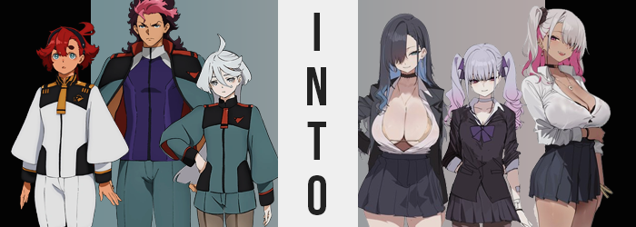

It had become very noisy at Asticassia as of late.

For a piloting and technology school, essentially a military academy on the space front, perhaps that was to be expected. Even more so when said school’s politics revolved around the selection of a groom through Mobile Suit duels for the daughter of the Beneritt Group’s president – essentially the most powerful position possible. But things had gotten even noisier once she had shown up.

Suletta Mercury. A mysterious yet sheltered girl from the planet she shared a namesake with. On her very first day of school she had won the position of Holder from the ex-Holder Guel, making her the next groom of Miorine Rembran. Chaos had ensued ever since, with Guel both challenging her again and then losing a duel in an attempt to protect Suletta’s honor.

“Oh here you are. Camping alone? You know things have been quite busy for me lately.” In the wake of that duel with Elan Ceres, the ex-Holder, Guel Jeturk, had been cast away by his father and wasn’t even allowed to stay in the dorms anymore. He’d just finished watching the follow-up duel between Suletta and Elan when he had been approached by her.

A tan-skinned young woman with silver hair, her uniform modified to intentionally show off her thick thighs. Or at least that was the assumption Guel himself had always made. “So what? If you’re here to mock me then just keep walking. My mistakes are my own and I’ll live with the consequences.” The young man still had his pride, and nothing would change that in his own opinion. “So push off, Secelia.”

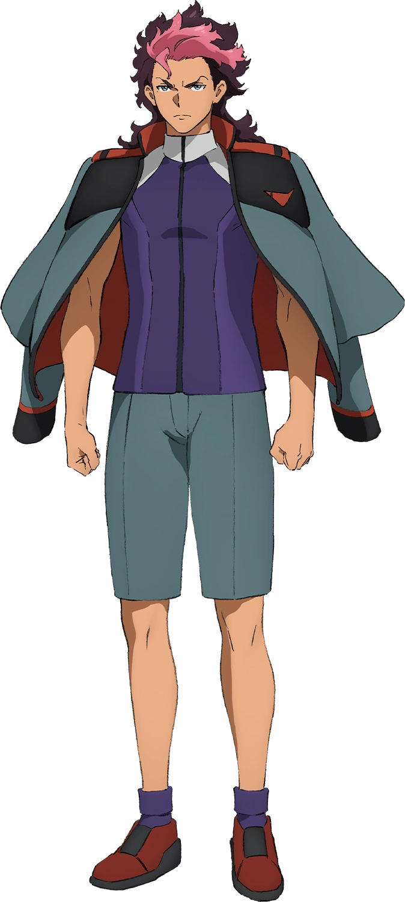
He never could get a good read on Secelia Dote. She was always lounging around on the couch of the Dueling Committee and, while she did have responsibilities, she always seemed to shirk them to the best of her ability. She merely smirked at Guel’s assumption and poor attempted at intimidation. “Oh I’m so scared! What are you going to do from me from this tent? Besides I’ve come here with an offer. I need some extra hands and you seem like your family has let you go, so…”

The woman reached out to touch him and in doing so managed to grab his skin with a hand carrying a certain perfume. One that had been developed through some nefarious means that carried over to Guel’s skin where it was absorbed. “Hands off.” But Guel gently shoved her away, which prompted a smirk from Secelia.

“Alright, but you’ll come find me on your own soon!”

Guel scoffed. He didn’t really understand what Secelia had meant by that and, honestly? How could he. It probably didn’t matter anyways. Not when he was fully expected to be reprimanded more by his father soon; perhaps even ejected from the school itself. Needless to say he had far more on his mind at the time than whatever games that girl was up to. At least that was what he had thought.

The boy stood up and went to put some of his belongings back in his tent but was immediately met with a sudden onset of wooziness that left him struggling to stand up with any semblance of balance. He merely grunted at it at first, but as he managed to stabilize his vision? Guel became acutely aware that something was very much amiss. “HUH!?” It had been doable enough to dismiss it as a side effect of his disorientation initially, but now that things had settled a little bit? He couldn’t really deny it.

He was shorter. No, he wasn’t just shorter – he was continuing to become shorter, experiencing this unusual phenomenon in the moment. “What the hell!? How is this even happenING!?” The heir had to put aside that crack in his voice for the time being. He had been roughly 5’10” initially, but with how his clothes were hanging off of him and how much closer his eyes were to his tent now… was he 5’4”? No, he dropped all the way down to an even five feet before long. His boxers and shorts had slipped from his waist, but his purple top fortunately covering his crotch.

Even Guel’s jacket had slipped off his shoulders because he hadn’t merely shrunk downward. His shoulders had slimmed down and all of her muscle mass had softened away. In the end his body was shorter and narrower, with even hands and feet collapsed so that they were small, delicate, and unusually feminine. “Like, what in—” What in… what? What was she so confused about again? She… She…? “URK!?”

She lurched forward again, this time because of an uncomfortable yank between her legs. She had perceived it that way in terms of sensation, but realistically the action itself had involved her male genitalia folding up and inside of her body to create a girl’s counterpart – and one that showed signs of having some experience. This should have been incredibly alarming for Guel, but the seed had already been planted in her mind.

“Right, I’m totes a girl. Why the fuck would I be a dude?” Not only could the teen not remember being male but she couldn’t imagine it. After all, what kind of dude had a voice as high as hers? Or a face as cute? This didn’t feel all that true initially, but her facial structure soon compounded and softened. Guel’s skin had been doing so for a short while now, but her natural tan had been paling away while her skin simultaneously became smoother to the touch.

Her nose shortened yet became slightly more upturned while lips pursed a little. She wasn’t wrong that she was cute, and while her age hadn’t changed she certainly did look a touch younger as a result. But what was equally striking was how her eyes began to burn with a reddish brown while narrowing, in terms of shape taking on a more Asian appearance. A more Japanese appearance. This coincided with a second language appearing in the back of her mind.

She clicked her tongue and stomped her foot. “I feel so out of it, the hell?” Because her memories and personality were still in the process of changing. The stronger this new persona become the more her hair of all things changed, possibly because the roots were the closest part of her body to her brain? Little by little her hair extended and took on a sheen only feminine hair products could present her with. But the color lightened too, with brown and pink dye both evening out into a soft lilac that had pink highlights upon twirled tips that fell just past her shoulder blades.

Memories of being part of a bitchy, dominant clique of girls took root within. She loved the rush of being rude and mean to other chicks, which was funny because out of this group? Guel was the smallest of them. Her thighs and ass thickened to live up to this internal idealization, gaining an average plumpness that was enticing but not particularly meaningful in size. And similarly? The B-cup breasts that pushed forth underneath her shirt continued this trend.

That was why she had to use fucking pads!

“Ugh, ew? What the hell am I wearing?” From Michi Endo’s point of view, well… What had happened to her? The Japanese JK girl was a student of Asticassia but she wasn’t sure why the hell she was out in the forest. She also didn’t have a clue why she was wearing the top of a men’s uniform by a tent and nothing else. “Did I sleep with some dude out here last night or what?” That somehow sounded like something she would do if the guy was hot enough.

Tearing some cloth, she created makeshift ties so that she could pull her hair into twirling twintails. “That or some bitch played a prank on me. It’s hard being one of the popular girls I guess?” She could think of a few skanks that might have played a prank like this on her. It would have been here fault for being part of a clique of rude girls though. “But whatever, the dorm isn’t that far from here so I can grab some clothes. Plus I told Secelia I’d help her out with some shit, didn’t I?”

“Fuck, I’m way too tired for this shit.”

Suletta Mercury watched Michi with confusion. Not only had she never seen this girl before, but she wasn’t dressed in the standard Asticassia uniform. A black blouse, a black skirt, black tights… “E-Excuse me? Does that outfit follow the school’s dress code?” She had bumped into her in the bathroom of all places, and since they were alone she didn’t see any harm in asking. Michi seemed to take issue with it though.

“Huh!? The fuck is it to you, string bean? Secelia-onee-san gave it to me and said I could wear it. Push off.” Well, Secelia had given her the clothes and had asked her to go make a delivery – which she had already done. But she had borrowed some of Secelia’s perfume behind her back too. Not knowing it was the source of the transformation she had no recollection of triggering. But she had put more on in the bathroom and some of it had fallen onto Suletta.

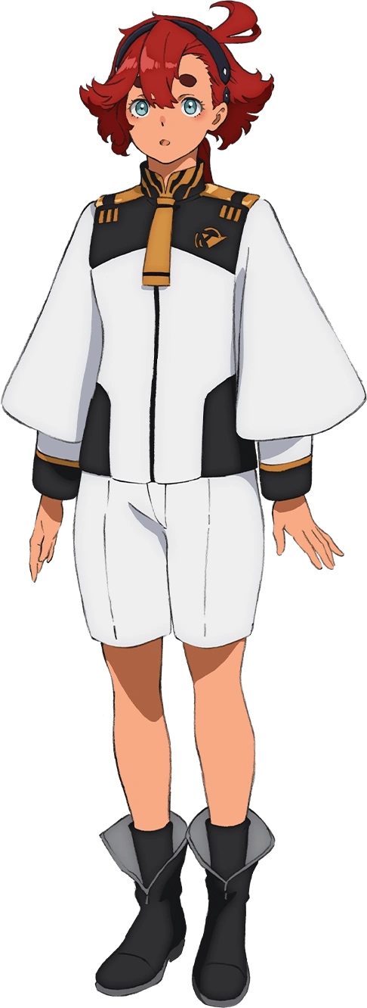
The bitchy JK stormed out of the bathroom before Suletta could formulate a reply though. “String bean? I don’t even know what that is…” The strength of the perfume was so much that she almost sneezed too. She was pretty sure wearing scents that strong went against the school’s code too.

I bet I could make myself look waaaay hotter!

“…EH!?” The tall girl’s cheeks burned red. She had never cared too much about her appearance in general much less looking ‘hot’. She just wanted to wear what was comfortable – not that she had much of a choice at the school. Her gold and white Holder uniform overtop of an orange leotard-like pilot suit were all she was realistically permitted to wear. It was the school’s policy! Fuck the policies! “Um… No? Why am I thinking about the rules like tha-AAAAAAAAAT!?”

That trail off at the end certainly sounded panicked and it was. It sounded that way for a good reason too, or at least a pair of good reasons. Her top was getting tight, and her latex leotard was stretching tightly around her… chest? As Suletta gazed down at herself – helped by a pull that tilted her forward – she came face to boob with the sight of her own breasts practically ballooning upon her body. “M-M-M-My chest!? What IS happening!?”

The Holder’s voice deepened for a split second as part of what was happening to her; and a lot was happening to her. Her breasts engorging was certainly part of it, expanding larger and larger until it became clear her leotard was holding on for dear life while the top’s base was lifted a little bit. They burgeoned past D-cups and stretched the latex more. Suletta was certainly lucky that the pilot leotard was industrial strength and stretchy enough to contain a pair of breasts that rivaled her head in size.

But simultaneously? The girl’s shorts had been filling as well. Her ass had bloated first, cheeks bubbling out behind her while the lower portion of the leotard was pulled tight between her tanned cheeks. The wedgie was twofold – first in her ass but then in her loins as well as nylon was yanked into crevices it wasn’t supposed to reach into, while simultaneously any loose space in her white shorts was erased by the swell. This bloated ass pushed her hips wider, and in turn? The weight that her ass couldn’t contain bled into her thighs instead. Before long the shorts were gripping her flesh tightly.

Flesh that somehow seemed paler than it had moment before.

“It’s not just my tits! It’s my sexy ass too!?” …What was she saying? Those weren’t terms she’d ever use. She was much too polite and sheepish for that! But Suletta couldn’t stop herself. It felt natural and when it came to her curvier body? She felt proud of it. A confidence was bubbling up from within, and that confidence would soon breed arrogance and something of a mean streak too. “Mm… I suppose this isn’t so bad. In fact… Huh? I’ve always been so big, haven’t I?”

As her mind adjusted to the life her changes sought for her, the pilot’s voice had deepened too. There was something about her face that appeared a touch older, namely because she had grown an additional year so that she was eighteen. But that said? Her paler complexion also highlighted that this face of hers had been changing in different ways as well. She poked at it with a lengthened fingernail idly, unaware that it was even happening.

It was a phenomenon similar to what Guel had experienced. Her eyes narrowed into Japanese almond shapes first while their blues deepened, and from there? This new racial profile saw to it that the rest of her face’s shape complied with what became of her eyes. As it shifted in its shape though? One area in particular gained some abundance. Suletta’s lips swelled into a fuller, poutier design that felt just as ample as the rest of her body.

“Mm… What the fuck was I even doin’?” The teen just couldn’t remember. Her head felt heavy because her memories were, of course, shifting. She was becoming more and more familiar with this new body of hers – and that included the pleasures such big, pillowy tits could provide. There was a reason her loins showed signs of use, but her growing affections for Miorine persisted in a twisted way that had yet to show itself.

She licked her plump lips as the last of the changes settled in. Changes that she didn’t even register even after looking in the mirror. Her red hair was growing, bangs thickening over her right eye while it cascaded almost the entire way down her back. It darkened in color in kind, with much of it black. Yet it simultaneously seemed as if an extremely talented individual had managed to dye the under-layer with an ocean blue.

Part of a JK aesthetic that wasn’t as clear dressed as she was.
“The Holder’s uniform? I ain’t the fuckin’ Holder! I’d never wear something so ugly even if I was!” But it seemed that Yumi Edamura didn’t have a choice in wearing at least part of it if she wanted to escape the bathroom. The bathroom that she was in because… “Hold on. Why the fuck am I even in here?” She couldn’t remember why. She had crossed paths with Michi, one of her fellow JK bitches, but before and after that?

The busty bombshell looked at her reflection and rolled her eyes. “Whatevs. If I’m gonna walk back lookin’ ridic then I’m gonna do it in the hawtest way possible.” The elastic, orange leotard beneath the exterior of her outfit was soon revealed as she stripped off what she could of the Holder uniform and tossed it into the trash. She was basically wearing a one piece swimsuit, one through which her tits were bulging out of the sides. But Yumi didn’t give a shit as she walked out the door.

I’m hot as fuck!

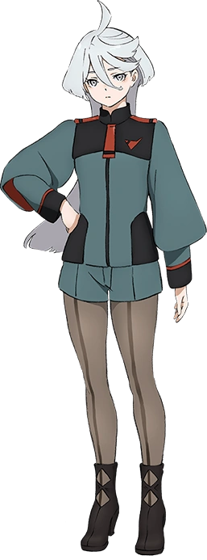
“Do you mind?” Miorine Rembran was annoyed. She had given Suletta specific directions to meet her in a private study room in Asticassia’s library, but she hadn’t shown up. Instead some big-breasted chick in a completely different uniform had shown up. She reeked of a strange perfume and the small room had filled up with the scent immediately. “I should report you for dressing lack that, you know? Besides, I reserved this room for my Groom and I.”

Yumi clicked her tongue. “Hah? But I was told I’d find my girlfriend here if I showed up. Guess that’s not you, you short, flat-chested bitch.” She knew full well that she was speaking to the Beneritt Group’s heiress, but she could have cared less. She’d shown up at Secelia’s place earlier and, while confused, her bestie had given her this outfit. A uniform like Michi’s with the top worn open to show off her big tits. She could remember having a girlfriend and Secelia had guided her to the place where she’d find her. But it was just Miorine Rembran.

She flipped Miorine off as she stormed out of the study room.

“What the fuck was that about? Rude bitch…” Now Miorine wasn’t exactly the nicest person to people that annoyed her, but not even she resorted to such foul language. It took her a moment for it to even register as she went to walk back to her desk after that altercation. “…What did I just say? I know I’m pissed off, but that wasn’t like me.” It wasn’t her time of the month already, was it? No, that couldn’t have been it.

Before she even got back to her desk something gave her pause, though. “Wait a second…” Why was her tummy showing? Why were her tights beginning to yank down her shorts? The heiress squinted downward at her own body pensively for a moment as she attempted to figure out what the problem was. And she eventually realized once more of her tummy was exposed. “I’m… taller!?” Not just a little bit taller but a lot taller. She’d jumped up from only five feet in height to a height that rivaled Suletta’s.

But peering at her now exposed tummy, even bringing a hand to poke at it, Miorine became acutely aware that more was wrong than she had first realized. Her exposed tummy not only seemed wider, but the skin was darker? Little by little it took on a rich tan, but as she was still largely clothed she couldn’t tell that it didn’t cover her full body. Her bikini line and much of her breasts were pale, with thin strap lines suggesting she had entered a tanning booth in a bikini.

“Something is totes not right here and stuff! Ugh, why do I sound so stupid and sexy!?” She reached up to cover her mouth, but upon seeing tanned fingers with lengthened nails upon them she stopped before she could reach lips that had swelled. Isn’t this like how I always look? I’m being so silly! After all, hadn’t her sexy girlfriend just visited? There was no way she could bag someone as hot as her if she wasn’t equally as hot!

Confused, she shook her head. But as she did so? Her usually silver hair was tussled. What usually reached her ass was now pulling up so that it only reached just past her shoulders. The coloring shifted too, giving it a platinum blonde coloration on the outer layer, but like Yumi she had a different colored layer underneath. A darkish pink that came to match the color of her changing eyes. All of that hair flattened on top and became wavier in the back. A much more stylish hairdo.

A more stylish hairdo to suit a young woman who had a much more stylish sense of fashion now. Like Suletta, Miorine had been aged up to eighteen – shown in her height, by likewise shown in a warping face. Fuller, bee stung lips beneath a bigger nose. A nose that was nestled between two pink eyes that narrowed into Japanese counterparts like the other two. Raised cheekbones helped sell the reality that she was older, but…

There were better areas to demonstrate as much.

Because Miorine’s new figure would be one to rival Yumi’s. “Hmm~?” She raised a manicured finger to her chin. A pressure was building around her pelvis, and the reason for that made itself quite clear as tanned flesh exploded in the surrounding area. Lowered shorts made it easier for plush cheeks to push those shorts down further, just barely continuing to hide her loins while soft and bulbous skin rested overtop their waistline in the rear. All the while? Tears formed in already ill-fit tights as tanned skin pushed through. Each thigh was nearly as thick as her waistline, and all together it had pushed her hips wider.

That said, while staggering? Her ass was nowhere near as impressive as the tits that exploded into view. “Like, guess I should free ‘em…” The teen herself didn’t seem to think it was odd and in fact reached up to unzip her top so that mounds of jiggling flesh could spill out, swollen nipples and all. The bikini lines were even narrower around breasts that rivaled her own head in size – and actually edged out Yumi’s in overall mass and roundness. Something that made the time in the bedroom for the two of them all the bouncier.

And speaking of…

“Eh? Yumicchi was just here, wasn’t she or something? Why’d I not go with her?” Putting the matter of her terrible outfit aside for the moment, Rio Fujishima lamented her circumstances. Why the fuck was she in the library? Why had she not gone off with her girlfriend? They probably could have fucked in the study room and finished long before anyone else managed to find them. “Ugh, and now I need to get to the dorms dressed in this boring ass outfit. It doesn’t even fit! Maybe Yumicchi can help me dress and stuff! Then we can push around some juniors. He-he!”

Not that she minded having an excuse to show off some skin on her way back.

Along with Michi, Yumi and Rio were all part of the same clique of girls. They all had extremely wealthy Spacian parents and that allowed them to get away with doing whatever the hell they wanted to on Asticassia. But in order to preserve that freedom they had to help Secelia out here and there. …Even though Secelia herself had only intended on creating Michi. When Yumi had come to her door she figured she might as well have tied up any loose ends.

“Hey! Could you three do something useful?” Secelia barked several days later as she returned to the Duel Committee office. Michi, Yumi, and Rio were the only three there. Michi was taking selfies while making cute poses off in the corner, meanwhile Yumi and Rio? They were making out passionately on the couch. It had been a pain in the ass to find Rio clothes, but much like her girlfriend it seemed that she loved having her tits out. Seemed the two liked groping each other too.

Of course none of them seemed to listen to her.

“…Maybe this was a bad idea.”

