Calculus 1 Final Exam Review
Worksheet

Organic Chemistry Tutor

1. Evaluate the limit shown below:

$$\lim_{X→3}{\frac{X^{2}+2X-15}{X^{2}-9}}$$

A. 4/3 C. 7/5
B. -2 D. 1
E. -5

2. Evaluate the expression shown below:

$$\frac{d}{dx} [X^{6}+ \frac{3}{X}- \sqrt{X} ]$$

3. Find the value of c that makes f(x) continuous.

$$f\left(x\right)=\left\{\begin{aligned}2cx-6, &x<3 \\ x^{2}+cx, &x≥3\end{aligned}\right.$$

A. 1 C. 3
B. 2 D. 4
E. 5

4. Find the derivative of the expression shown below:

$$\frac{d}{dx} [e^{4x}\ln\left(2x+5\right)]$$

5. Evaluate the following integral:

$$\int{\frac{4X^{5}+X^{4}-3X^{2}}{X^{2}} dx}$$

6. Find the equation of the tangent line to the curve x³ + 4xy² + y³ = 107 at the point (2, 3) using implicit differentiation.

A. 16x – 25y = 107 C. 25y – 16x = -107
B. 16x + 25y = -107 D. 16x + 25y = 107

7. Which of the following answer choices is equivalent to the expression shown below?

$$\lim_{h→0}{\frac{sin\left(x+h\right)-sin(x)}{h}}$$

A. cos (x) C. tan (x)
B. ln (x) D. sin (x) – h
E. cos (x + h)

8. Evaluate the integral shown below:

$$\int{2X}\sqrt{3X^{2}+5} dx$$

9. Water is flowing into a cylinder with a diameter of 6 ft and a height of 10 ft. If the height of the water in the cylinder is increasing at 3 ft/min, at what rate is the volume of the water in the cylinder changing?

10. Identify all intervals where f(x) is increasing given f(x) = x³ + 3/2 x² – 36x – 9.

11. Identify the location and maximum value of the function f(x) = 16x – x² + 5.

A. (7, 68) C. (11, 125)
B. (8, 69) D. (-9, 84)
E. (10, 65)

12. Calculate the average value of the function
f(x) = x³ + 8x – 4 over the interval [1, 5].

A. 32 C. 59
B. 47 D. 83
E. 105

13. Evaluate the expression shown below:

$$\frac{d}{dx} {[ 2X^{3}-7X^{2} ]}^{8}$$

14. Evaluate the limit expression shown below:

$$\lim_{x→4}{ \frac{ \frac{1}{x}-\frac{1}{4} }{x-4}}$$

A. +1/4 C. -8
B. -2/3 D. 12
E. -1/16

15. Identify all intervals where the function
f(x) = x³ – 6x² + 5x + 1 is concave downward.

16. Perform the operation shown below:

$$\frac{dy}{dx} [x^{sinx}]$$

17. Calculate the average rate of change of the function f(x) = x² – 5x + 2 over the interval [1, 5].

A. +1 C. +2
B. -3 D. -5
E. +8

18. Evaluate the limit shown below:

$$\lim_{x→9}{\frac{x^{2}-81}{\sqrt{x}-3}}$$

A. -18 C. -63
B. +27 D. +81
E. +108

19. Evaluate the expression shown below:

$$\frac{d}{dx} \int_{x^{2}}^{4}{\sqrt{5+t^{4}} dt}$$

20. Find the area of the region bounded by y = x/2 and y = $\sqrt{x}$.

A. 5/6 C. 12
B. 4 D. 4/3
E. 16/3

21. Calculate the value of the solid formed by revolving the region bounded by y = $\sqrt{x}$, y = 0, and x = 3 about the line x = 6.

22. Calculate the volume generated by rotating the region bounded by y = x², y = 0, x = 1, and x = 2 about the line x = 4.

23. Evaluate the limit shown below:

$$\lim_{x→0}{\frac{\tan{(3x)}}{5x}}$$

24. Perform the indicated operation shown below:

$$\frac{d}{dx} [e^{8x} ln(x)\sin\left(x\right)]$$

25. Which of the following answer choices is equivalent to the expression shown below?

$$\lim_{x→0}{{[1-2x]}^{1/x}}$$

A. e⁻³ C. 1/e
B. e⁻² D. e
E. e²

26. Perform the indicated operation shown below:

$$\frac{d}{dx} \left(\frac{x^{2}+3}{x^{3}-4}\right)$$

27. Find the value of c guaranteed by Rolle’s Theorem in the function f(x) = x² – 8x + 12 on the interval [2, 6].

A. c = 1 C. c = 3
B. c = 2 D. c = 4
E. c = 5

28. Use linear approximation to estimate (3.99)³.

29. Find the value of c guaranteed by the mean value theorem in the function f(x) = x³ – 4x on the interval [-2, 4].

A. c = -2 C. c = 1
B. c = -1 D. c = 2
E. c = 3

30. Evaluate the limit shown below:

$$\lim_{x→0}{\frac{|x|}{x}}$$

31. A ball is thrown upward at 96 ft/s from a height of 256 ft. The height of the ball with respect to time is given by the equation h(t) = -16t² + 96t + 256. (a) How long will it take the ball to hit the ground? (b) What will the velocity of the ball be 4 seconds after it is thrown? (c) Calculate the velocity of the ball just before it hits the ground. (d) Calculate the maximum height of the ball.

32. The acceleration of a particle is given by
a(t) = 2t – 6. The initial velocity of the particle is 8 ft/s and is located 5 ft east of the origin along the x-axis at t = 1. (a) Write a function for the velocity of the particle v(t). (b) When is the particle moving to the right? (c) What is the position of the particle at t = 5? (d) Calculate the displacement and total distance traveled by the particle in the first 6 seconds.

33. Perform the indicated operation shown below:

$$\int{x^{2} lnx dx}$$

34. Using the table shown below, what is the value of (f o g)’(2)?

x | 1 | 2 | 3 | 4
f(x) | 1 | 3 | 8 | -3
g(x) | 0 | 4 | 5 | 9
f’(x) | -6 | 1 | -2 | 7
g’(x) | -4 | -5 | 11 | 6

35. The rate of water flowing into an empty tank can be modeled by the equation R(t) = 0.1t² + 0.4t + 12 where R(t) is in gal/min and t > 0. Calculate the total volume of water accumulated in the tank after 10 minutes.

36. If $\int_{1}^{8}{f\left(x\right)dx}$ = -7, and $\int_{1}^{5}{f\left(x\right)dx}$ = -12, then
$\int_{8}^{5}{f\left(x\right)dx }$= ?

37. Which of the following statements about f(x) is false?
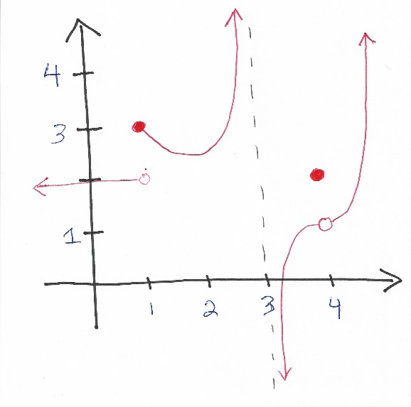
A. The limit as x approaches 4 exists in f(x).
B. f(x) has an infinite discontinuity at x = 3.
C. f(x) has a jump discontinuity at x = 1.
D. f(4) = 2.
E. The limit as x approaches 1 equals 3 in f(x).

38. Evaluate the definite integral shown below:

$$\int_{0}^{5}{\sqrt{25-x^{2}} dx}$$

A. 25π C. 25π/4
B. 5π/2 D. 25

39. The table below shows the velocity of an object where v(t) is in m/s and t is in seconds. Use the midpoint rule (n = 5) to estimate the total distance traveled by the object.

t | v(t)
0 | 12
5 | 13
10 | 14
15 | 13
20 | 15
25 | 14
30 | 16
35 | 17
40 | 16
45 | 18
50 | 19

40. A farmer wants to set up a rectangular fence adjacent to a river as shown below. The area of the field is 16,200 ft². (a) What dimensions will require the least amount of fencing if no fencing is needed along the river?

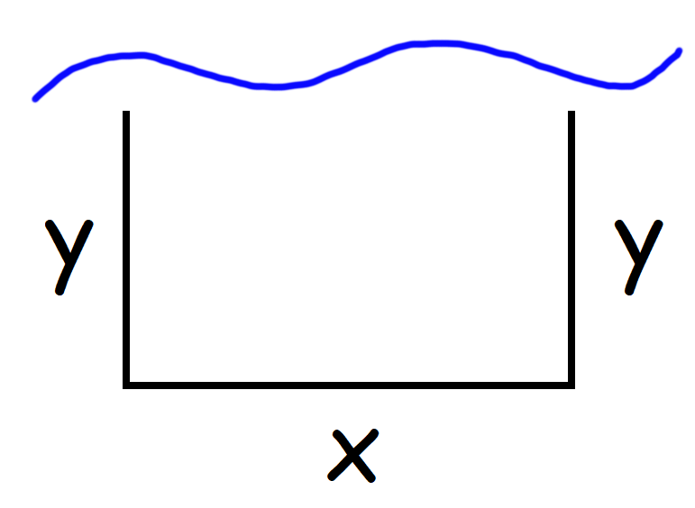

Answers:
1. A

2. $6X^{5}-\frac{3}{X^{2}}-\frac{1}{2\sqrt{X}}$

3. E

4. $4e^{4x}\ln\left(2x+5\right)+\frac{2e^{4x}}{2x+5}$

5. $X^{4}+\frac{1}{3}X^{3}-3X+C$

6. D

7. A

8. $\frac{2}{9}{ [ 3X^{2}+5 ]}^{3/2}+C$

9. +27π ft³ / min

10. (-$∞$, -4)U(3, $+∞$)

11. B

12. C

13. 16X (3X – 7) [2X³ – 7X²]⁷

14. E

15. (-$∞$, 2)

16. $\frac{dy}{dx}= x^{sinx}[cosx lnx+ \frac{sinx}{x}]$

17. A

18. 108

19. $-2x \sqrt{5+x^{8}}$

20. D

21. $\frac{84π \sqrt{3}}{5}$

22. 67π/6

23. 3/5

24. $e^{8x}[8\ln\left(x\right)\sin\left(x\right)+ \frac{sin⁡(x)}{x}+\ln\left(x\right)\cos\left(x\right)]$

25. B

26. $\frac{-x[x^{3}+9x+8]}{{\left(x^{3}-4\right)}^{2}}$

27. D

28. (3.99)³ ~ 63.52, (3.99)³ = 63.521199

29. D

30. The limit does not exist (DNE)

31. (a) t = 8s. (b) -32 ft/s (c) -160 ft/s (d) 400 ft

32. (a) v(t) = t² – 6t + 8. (b) Right [0, 2)U(4, +$∞$)
(c) s(t) = +19/3 ft
(d) displacement = 12 ft, total distance = 44/3ft

33. $\frac{1}{3}x^{3} lnx-\frac{1}{9} x^{3}+C$

34. -35

35. 520/3 gallons

36. -5

37. E

38. C

39. total distance ~ 750 m

40. x = 180 ft, y = 90 ft

