Unreal Punishment  Told in real time  By Maryanne Peters  Hey, you can talk?  What the fuck are you?  I have no idea. I am just here. One minute I was around at Bonnie’s place looking for a second dive in, and now I am here.  Wait a minute. You were at Bonnie’s place. So was I.  Who are you? No, what are you? This whole place cannot be real.  No way this is real. We are like in some kind of virtual reality. I mean, look at my hand. Look at these pink fingernails. This is not me.  So you are not really a chick?  Hell no. Are you? You look like one. | 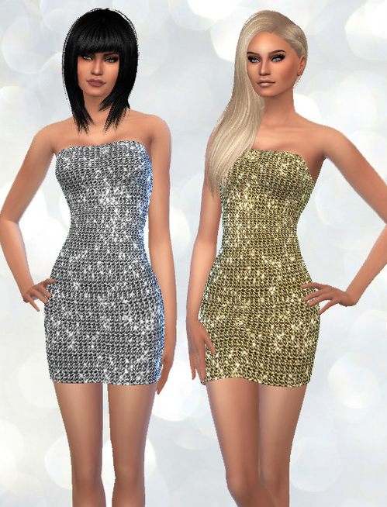

No. I’m Steve.

Steve! No way! Hey bro! It’s me, Kev.

Kev. You look like a girl. Like a really sexy girl. Like bright red hair, like yours, but long. And wow – what a body.

Shit. Yeah. Look. I’ve got tits. And … fuck bro, I’ve got not junk in those tights.
What the fuck!

We need to exit out somehow. How do we find the menu?

But I am not controlling anything. I mean, my hands are not … they are not my own. They are … hers.

This is VR. It must be like the holo-deck on “Star Trek”. So what do we say? I know: “END SIMULATION”

That didn’t work. So what next?

We will have to find a panel somewhere. It must work like that.

Okay. So we are in a simulation of a big mansion of some kind. It looks so real.

Inside maybe but look out the window. That looks fuzzy. Pixillated.

Yeah. So the exit is not there, it must be somewhere in this house. Maybe we look for a switchboard?

It won’t be here. This is the living room. And there is the kitchen and dining area over there. Maybe the entrance? Or near the back door or laundry.

Good thinking Kev. Man, it seems weird calling you that. Do you have a girl name.

Fuck you. Do you have one?

I could be Steffi. You could be Keira.

Get serious, man. We have to find a way out of this.

This will be her brother. You remember? That girl. What was her name? Was it Jill or Joanne? Anyway, she said she had a brother who was working on advanced VR. Remember?

Maybe you remember because you got the first fuck. By the time I got in for the sloppy seconds she was already fully whacked from the GHB we gave her.

We could be in trouble here.

It is not real man.

There is nothing back here. There was a study off the entrance hall. Let’s go back there. Maybe there is a computer screen.

It’s like one of those puzzle games – right? We need to find a way out. Get back to reality.

Hey look. The mirrors work. Get a load of this. I’m a knock out. Check out the hair! Look at my tits. Wow! And my butt. I am a dream girl. Stunning Steffi. That’s me.

Hey. Let’s concentrate on … yeah. You’re right. I’m a babe too. With the red hair and look at my eyes! Is this makeup … does it come off. Nope. These eyelashes are real. Even these shoes are stuck on. Just as well we seem to be able to walk in them.

I thought you said nothing was real. Not even these tits. Turn you on.

No. They don’t. They should but … maybe we just need to check out that PC on the desk in there.

Okay. Power up. But seriously, the detail here is incredible. Like I can feel my hand on my skin, and I can feel the smooth hairlessness. Hey, that hurt.

It did? Let me see. You’re right. We can pinch ourselves and feel pain. How is that possible. We have to be in some king of sensory deprivation thing. Like suspended in water and with electrodes on our skin of something. This is way beyond a game. This is serious technological shit that could allow this.

We have a screen. Here it comes. Fuck. Access denied. You try something. You are into this stuff more than I am.

Move that pretty ass of your Steffi, and let me settle mine into that chair.

Try something else.

I’ll reboot and try to open in another mode, but this does not look good. How do we even know that these virtual computers will follow cyber principles? They don’t have too. They are mirages. They are invented and so have no rules.

So what next?

Nothing here. I get the same screen. The mouse and keyboard are nothing. I can feel them, but they might as well be smoke.

Maybe upstairs?

Sure. Let’s go up there. You lead.

Hey, are you looking at my booty? You’re not a lesbian are you Keira?

No, of course I’m not. But hang on, why am I not? I should be right?

There are just bedrooms up here. This looks like the master bedroom. Hey, there’s a cool master bedroom in here … full of clothes. Wow! Look at this stuff.

We are looking for a menu’ or some trigger for a drop-down box.

Do you think I could try something on?

You’re nuts. This top and tights thing is probably what these characters come with.

What kind of VR doesn’t allow you to customize the character? See – now the shoes come off. And so do the tights. Wow – sexy panties underneath. Top comes off. Matching bra. Nice. Step out of the way of that full-length mirror. Check this out. Fuck, I am gorgeous. Take your clothes off too. You would look great in this dress.

I am not finding what we are looking for here, but … actually I would like to try that on.

Just a minute, is there somebody out there?

Shh. There are two guys backs turned looking out the window.

Hey, you guys. Are you … Keira. Fuck. It’s us.

What do you mean … Oh my God. It is us. It is the avatars of us. Hey, you two. Who is behind this? Is one of you … the brother of … the brother?

They are not talking.

Take your hands off me. That hurts. I mean, it really does hurt.

Do you have to be like this? We don’t have anything like your strength factor. We are just weak and powerless. Why don’t you talk? Either of you.

Now you’ve torn my panties, you brute. Stop it. Stop!

Keira! Keira! He’s going to rape me. They are going to rape both of us.

No, please. What have we done to deserve this? Please don’t. Oh my God, no.

This is not real! This is not real! Why does it hurt? Why do I feel so dirty and ashamed?

The End

© Maryanne Peters 2020

Author’s Note:
Thanks to Ftygrl who suggested in her review of my “The Huntress”: Maybe … men or boys, who like harassing and assaulting girls and women … have them picked up and plugged into a Virtual Reality machine that allows them to experience the fear, terror and horrors their victims went through! Optionally you can leave them permanently jacked into their VR world or unplug them into total insanity and institutional commitment. Just an idea, play with it if you will.”
I don’t do magic and the old “rapist turned into a woman” thing, but VR being used for punishment could be a thing. This is just riffing on that great idea.

