MY DAILY SOLDIER LIFE AS A MONSTER GIRL
CHAPTER 1: BUZZ WORDS
BY CHALDEACHANGE
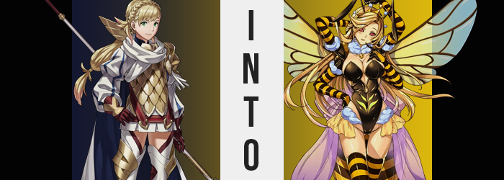

Accidents happen.

It was a saying that transcended both time and space, one common from world to world, even if they were incredibly displaced from one another. The meaning behind this phrase was simple: people make mistakes, and so those mistakes should be forgiven. And yet, as a sorceress with inhuman features brought her claws down upon the Summoner after he had inadvertently summoned her through the gate, he wasn’t sure if this mistake were one that could be swatted away with such a simple philosophy.

“Thank you for bringing me here, o talented one. I’ll surely make use of this gift, but for the time being I require a vassal. You…? You shall do just nicely.” From the claws around his throat he could feel it pouring into him, dark magics that tore both his body and mind asunder. In the beginning he had been a man, but at the end?

She was a monster. One loyal to the Delva the Succubus Witch.

Later on that day, Sharena was busy doing her rounds within Askr’s capital. When everyone was on standby, they were free to do whatever it is they please, and the princess was keen on helping the people of her kingdom whenever she could. All day she had been helping with busywork the people had amassed since her last departure, and with the evening now upon her and a good sweat built up, she was finally ready to call it quits.
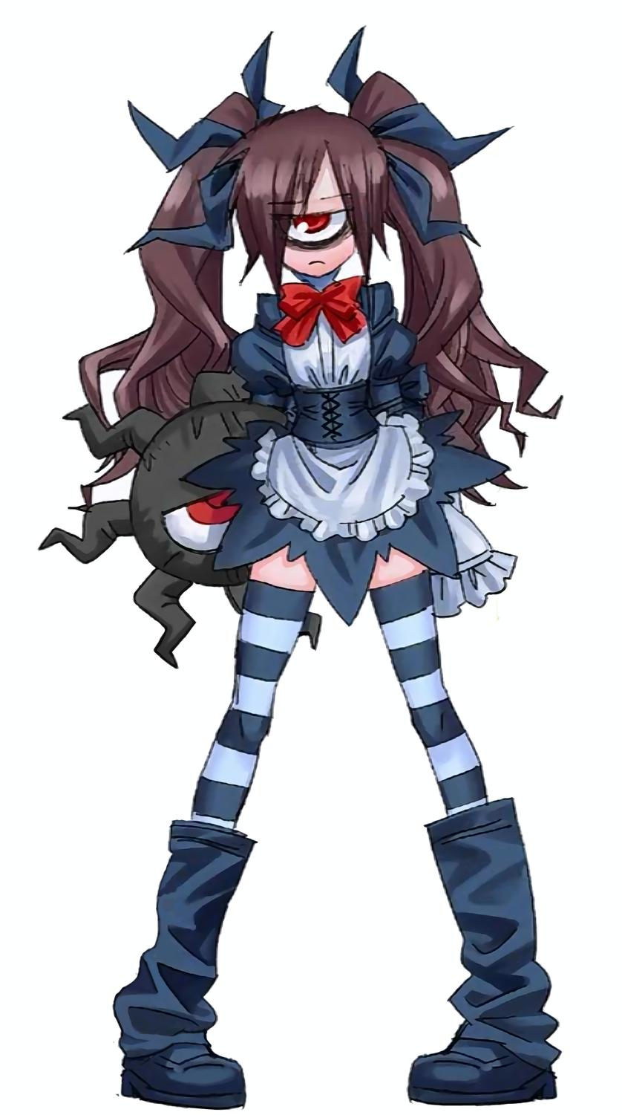
She’d been on her way back to the castle, following an unconventional path that led up and through the garden, when she’d encountered a strange individual. The fact that there was anyone here in the first place was strange enough – she wasn’t aware of anyone else than knew of this path short of the Summoner.

But stranger still, this individual, who looked like a young girl with hair pulled into a pair of twintails… she had a single eye, like some sort of monster. “Um… Hello…?” A single eye or no, that wasn’t grounds to assume she meant her any harm. Perhaps it was a birth defect of sorts? “Are you lost, little girl? Do you need help getting h—”

“SILENCE!”

Evidently, the girl was not here for passing conversation, for her voice boomed and her single, crimson eye began to glow. Sharena froze in place immediately. Hypnosis, a special talent of the Backbeard monster girl. She found herself waiting for the girl to speak, hanging off any word she was to speak. “Take this and eat it.” The girl held out her hand, revealing an amber colored candy within. Sharena had no choice but to accept the gift and popped it into her mouth. It was sweet like honey, but the taste did not linger as she’d swallowed it whole. “Do not move for three minutes. When that time is up, you will forget anything that just happened.”

“Huh!? Why am I standing here?” After the three minutes had passed and the hypnosis wore off, Sharena found herself staring blankly at the garden path. Had she dozed off, standing up? Little by little she became aware of her surroundings, and of herself. And regarding the latter? Why was the pit of her stomach burning so intensely? Had she eaten something strange?

There was a subtle sweetness lingering in her mouth – honey? Had she even eaten anytime recently? She’d had lunch, but there wasn’t any honey involved. But some honey sounded good, actually. She really wanted some. That was only natural, for honey was her treasure.

“…Huh?” That had been a strange thought to have! Sharena had plenty of things she considered to be treasures, but never had she considered honey to be one of those things. She was unaware of the fact that her eyes had begun to glow red in the meantime – or, rather, were becoming completely red. From irises, to pupils, to the whites of her eyes; they became red entire, evidently inhuman, almost monstrous.

But that was merely the beginning.

A pair of nubs had appeared to protrude from the top of her skull all the meanwhile. At first, they might have been mistaken for couple of bumps earned from hitting her head (and Sharena was certainly prone to such accidents), but they quickly became dark in color and grew long, stretching up several inches atop her head before dipping as it became jointed, the latter half dangling there. They were antennae, and the moment they were fully formed they activated.

Sharena was overwhelmed sensually, the scents of the garden hitting her with a new intensity unlike anything she’d ever experienced before. A bee’s antennae allowed them to smell the world around them more or less, and this was far more powerful of an ability than her human nose had ever allowed. “EEP!? WHAT ARE THESE!?” Mind you, the moment she sent a hand up to investigate the source of a new weight upon her skull, she was immediately freaked out by these new appendages and just how sensitive they were to the touch.

Panic and anxiety set in quickly, and as it did there was an evident shift in the girl’s hair tone. She remained a blonde, that much was consistent – but while her natural tone was a little lighter, the color that seeped in was far richer and golden, almost like honey. The tails it was tied to in the rear unravelled as it grew towards her butt, and in the front? Her bangs were swept to a lick on the right.

“They’re gross, they’re like… Those things on bugs…” Sharena was too distracted by her antennae to notice any changed to her hair though. Distress clouded one’s judgment, and it was a pretty drastic clouding in this case. The heat in her belly had grown even stronger, and her ignorance was very much portrayed in how she hadn’t realized all of her clothing and accessories had burned away, leaving her completely naked.

Admittedly? Touching her antennae felt extremely good. They were really sensitive and fondling them with her four hands made her shudder. She’d honestly never really felt anything quite like this before, and so— “W-Wait!?” It took her a minute to realize, and she wasn’t sure how she hadn’t noticed sooner. “One… Two……. Three… Four!?” Counting the arms reaching up to grasp her new sensors, she lingered after the second… because there were two more.

Antennae fondling time was over.

She had four arms. All looked like her regular arms, but once she dropped them and looked to her armpits… “I’m naked!? Wait, no, that’s not as important!” What was important was that a second pair had sprouted from her armpits. They rested eerily in an X shape between both sets, and while she could fold them against one another, it was uncomfortable to do so. “This can’t be happening… Between the things on my head and… Ah!?”

Things were moving quickly now, and Sharena noticed that the tips of her fingertips – all of her fingertips – had suddenly been coated in a black fuzz. While this continued down to coat even her hands, on the tips of these fingers a set of black claws were formed from her fingernails. In fact, the black fuzz spread like wildfire, coating her arms in their entirety right up until where they conjoined beneath her shoulder.

“Am I becoming some kind of monster…? I look kind of like a bug… And what’s wrong with that?” Fearful at first, out of nowhere she questioned her own anxiety. Something deep within was crying out with pride, perceiving her new features of nothing less than an absolute boon. It felt like the kind of pride one might expect of royalty, of a queen. “Ngh!? Now what!?”

Sharena craned her neck over her shoulder to the best of her ability. She could feel it. Pressure building both beneath her shoulders and above her butt, and from what she could see? Something was grossly trying to bulge out of her flesh in all three areas, for the looked swollen and tender.

This pressure built more prominently at the lower spot first, and with a single, sweeping expulsion that turned her stomach with how it felt, an entirely new section of her body exploded. It was painful at first, but sensory wise it soon felt pleasurable in its tenderness, as this segmented ball of flesh found itself coated in gold and black fur – much like the abdomen of a bee. The weight was unusual at first, but her muscles quickly accommodated it. And at the very end? Well, naturally there was a stinger.

The girl was hardly given much of a chance to reach before the second set of pressure points blew out too. “UGH!?” It was uncomfortable again, but what slid out of these slots was far less off-putting than a whole new body segment, but still… a pair of giant, translucent insect wings were still gross. “I really am becoming a monster… a proud bee!” The princess hadn’t meant to say ‘proud’, but it had been blurted out regardless.

Instinctually those wings began to buzz. The vibrations felt strange, but surprisingly calming. Sharena didn’t even panic as her body lifted a few feet off the ground before! She’d never flown with wings before of course, but this just felt right.

Her skin crawled, but only because while she’d earned all of the monster traits required of her, the girl’s figure did not match her own expectations. Surely a beautiful, proud bee needed a body suitable to find a king? And her figure at present? It was quite lacking.

Feet suddenly hung closer to the ground, several inches of height seeing her bones creak and crack as they extended. Excluded from any walking difficulties now that she had wings as well, one could only watch her legs pop and resettle into wider hips, the process uncomfortable to look at even as her waistline receded to provide a much sexier build.

But sexiness was more than just being tall, or having long legs, and something in Sharena’s head buzzed. Her face had already begun to reflect an advanced age, plump and needy lips accompanying higher cheek bones and a generally more mature appeal, but now her four hands? They set to work treating the other areas that mattered. Two of them massaged her tiny breasts, while the lower pair reaching back to massage her ass around the thorax connecting to her bee’s abdomen. Both areas benefited greatly – or perhaps it was inevitable that this would happen, and the bee was simply aroused?

Nipples tweaked by her black, clawed hands, her flying posture was forced to lean forward slight as a beautiful bounty found its way into her bosom. The bloating was almost excessive, seeing her tits nearly quadruple in size over the course of a single minute, an undeniable bounciness applied despite their F-cup size that undermined the fact that they were both natural and firm. Anyone would be lucky to get to bury their face in these, and Sharena’s personality? It was corrupting so that she would be happy to oblige such a fantasy. In fact, her mind was growing lewder and lewder, memories of being an innocent princess being sacrificed in exchange for a Queen Bee’s lustful, prideful nature.

While massaging her ass did not bring the exact same abundance as doing the same to her breasts had, there was no denying that significant volume was brought to her rump. Skin tensed around the swelling fat of her cheeks, the kneading of that flesh by her lower hands more stimulating than she might have expected. On the whole, her ass doubled in size, but it seemed some of the volume made its way into her thighs. With hips widened there’d been a grossly large gap between each leg, but now? Jiggle and round, her thighs closed that gap with a sensual gusto. They were the types of thighs that might make someone think ‘boy, I’d love those wrapped around my head’.

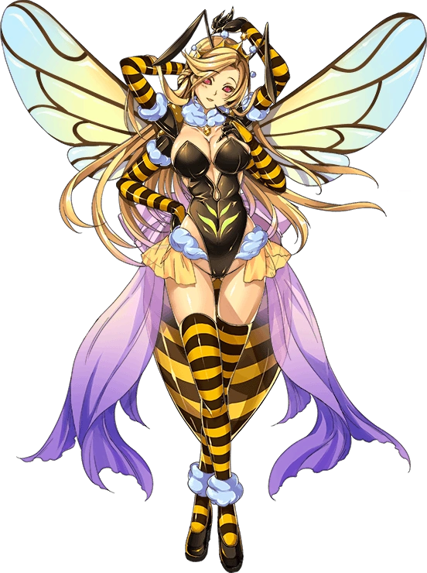
And again, she’d oblige.

She was Queen, after all. Queen the Queen Bee.

Her thirst was unsatiable, her desire to find a king prominent.

Otherwise, she did not give a damn about humans. They could buzz off.

The heat in her belly had begun to wane, but something told her to remove her hands from her body momentarily. There was little need to question the reason, for within a moment’s notice, clothing formed against her bare skin. Black and yellow thigh highs wrapped around her legs, while matching gloves extended up her arms to culminate in a fluffy trim that likewise matched a collar around her neck.

Otherwise, she was adorned with a black leotard that left much of her breasts exposed hips completely bare short of a frilly, yellow throw, and a fitting pronged tiara upon her head. She looked every bit the part of the provocative noble she now believed herself to be.

The Queen Bee’s wings buzzed rapidly behind her as she hovered in place, her surroundings foreign yet familiar at the same time. ‘Sharena’ still existed within her, but only enough to grant her a limited understanding of this land, and kingdom. “How are you feeling, princess?” A voice suddenly accompanied a rustling from the nearby bushes, and a Backbeard stepped free of them.

“Princess?” The flying woman’s voice was teeming with pride, the back of her hand raised to the side of her mouth in a typical ojou fashion. She could recall enough to know that was the title she had once had, and yet… “I am a Queen Bee. My name is Queen. I will not settle for any title but. If I need to make this kingdom bow to me so that this comes true, I will not hesitate.”

The Backbeard simply smiled at this arrogant declaration. Ah, this was too easy, just as her mistress had told her it would be.

“Well then, would you like to join the Witch’s army?”

