DOWN BAD ADRESTIAN
COMMISSION STORY
BY CHALDEACHANGE
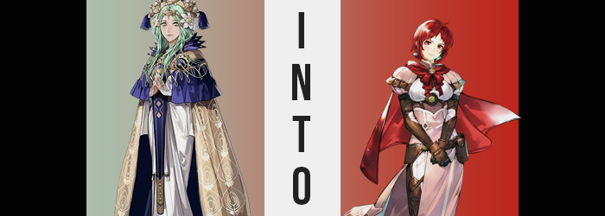

The Archbishop of the Church of Seiros, Rhea, was fuming.

Garreg Mach Academy had been forced to close two years prior as a result of unforeseen circumstances related to Those Who Slither in the Dark. A great deal of intelligence had been unearthed after a girl from the academy that the Slithers had captured, and as a result most of the students had left. Rhea had truly had little choice in the matter with her own campus compromised for the time being. But she had planned on reopening the academy once the dust had settled and she could assure the nations that such an incident would not be repeated.

But one of those students had inserted a major problem into those plans. Almost two years to the day of the school’s closing, the Adrestian Empire had declared war on the Church of Seiros under the leadership of one of the school’s previous students, Edelgard von Hresvelg. The news had only reached the Archbishop’s ears earlier that day, still huddled up in Garreg Mach herself.

It had angered her to no avail. “To think she would raise her empire’s banner against the church! Death as a punishment would hardly be enough!” If she could take any solace in the implications of Edelgard’s declaration, it was that the young woman would surely meet such an end upon the battlefield. Adrestia was sorely underestimating the Church’s forces, both their own and of their allies, if they believed declaring war against them was a good idea.

The day had come and gone, and Rhea had retreated to her personal quarters to ‘relax’ and ‘calm down’. But because she was constantly being interrupted by Seteth and military personnel that were scrambling for her opinions. It certainly didn’t help improve her mood, but she also understood that as Archbishop she had certain responsibilities to attend to.

“I wish I could just take care of her myself.” It was a comment born of vitriol that the woman had begrudgingly murmured under her breath. The kind of comment that anyone might make if they were understandably upset about something. But she couldn’t have known that something had been listening. Something that had entirely misunderstood her intentions behind the sentence.

“Ngh…”

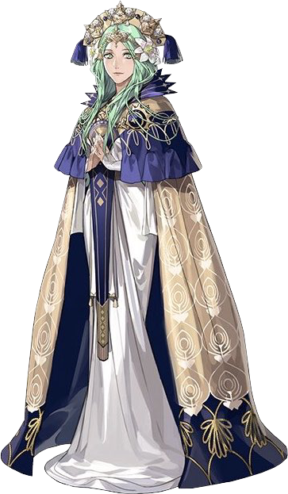
It took Rhea a few moments to piece together her thoughts after opening her eyes. What had just happened? She had been lambasted by guests after Edelgard had declared war on her church, but had been struck by a dizzy spell of sorts? In that moment she reacted like any person would and had decided to sit down until that feeling passed. But she had nodded off? No. “Did I black out?” Had she been in poorer health from the news than she had realized?

“No, that’s hardly a concern now. This red…” The primary issue was that the Archbishop absolutely had not awakened in the room she had fallen asleep in. She was surrounded by the thin walls of a tent – a war tent meant for long term encampments based on the quality of the bed and sprinklings of light furniture that it offered. But what stuck out to her most of all was the coloring of the tents walls. A crimson red. The same color hoisted on the flags of the Adrestian Empire.

How long had she been out to warrant such a stark change in location? She must have been captured, right? All signs pointed to the possibility that she had become Edelgard’s political prisoner. “But then why hold me in a tent?” The only lighting outside was from torches, indicating that it was sometime late at night. She couldn’t hear any footsteps nor make out the silhouettes of any guards. Why take her, Rhea, prisoner with such little security?

But didn’t this work to her advantage?

She was in an Adrestian camp late at night. The possibility that Edelgard was present was high. This was the perfect opportunity to take care of that girl by infiltrating her tent and slitting her throat! All she had to do was escape the tent and slink into the shadows. With a little bit of investigation, she could figure out where the woman was… and strike!

But first? She had to scope out the tent’s exit. Rhea moved towards it, thinking about the best way to take Edelgard’s life. She’d have to find a blade to slit her throat, but in the worst case she could just choke her out, couldn’t she? It was truly alarming that such an important religious figure could have such dark thoughts, but this was her true nature. Or, at least, it was supposed to be.

Why in the world would I think about killing Edelgard!?

“…Hm?” The contents of Rhea’s own mind pushed her to pause her adventure out of the tent. It wasn’t just a thought but came with a number of complicated feelings as well. “Of course I’d kill her? Why wouldn’t I? She’s a threat to everything I’ve built thus far!” And yet, while she knew this, something deep down felt deeply saddened at the idea. Something that she couldn’t quite place whatsoever.

The Archbishop shuddered suddenly. Was she cold? Perhaps a little bit as it was likely some point late at night, but the cause was much more closely related to how she had ended up within the Adrestian camp in the first place. “Something isn’t right. I feel strange somehow.” In a way that she couldn’t really put a finger on for some reason. She was biting the nail on her thumb now, a bad habit she had when something was making her nervous. Because she wasn’t enough of a fool not to realize. It had to be related to her sudden aversion to the concept of bringing Edelgard harm.

Even though Rhea had hit the nail on the head with that assessment, she really didn’t have enough context about the circumstances to paint a more vivid picture than that. Her skin felt a little tight, but couldn’t that have merely been a side effect of now being in a drier climate? It certainly could have, but it wasn’t. The truth of the matter was plain in Rhea’s face, even though similar signs had appeared all across her body. Any signs of her age had softened away, from stretch marks, to dimples, to Crow’s feet. Her skin didn’t sag even the slightest bit, either.

Archbishop Rhea had been rejuvenated. She was younger. She looked like she had when her physical age had been around the mortal standard of twenty or so. Old enough that her figure didn’t really suffer any consequences of the regression aside from becoming perkier around her breasts and ass. She’d always had that attractive body of hers after all, human or not. But that was also a point of contention that hadn’t even occurred to her.

What if Rhea was no longer Nabatean and instead a mere human? It wasn’t really a change that could be shown visibly aside from the pointed tips of her ears rounding beneath her hair, but the woman who suffered that change could feel it. “…Wh-What!? I feel so… weak.” As if all of the energy had been sapped out of her body all of a sudden. She recovered after a moment, but her strength certainly wasn’t what it had been a moment ago. “Where did my power go!? How can I hope to defeat… Edelgard?” No! I don’t want to hurt Edelgard! It happened again, but this time? A disturbingly affectionate feeling bubbled up along with it.

Directed at Edelgard of all people!?

The feeling overwhelmed her. She felt dizzy for a moment and had to grab onto the nearby bed to stop herself from falling. All the while a bright crimson began to weave itself vividly throughout some of her physical features. It was the woman’s eyes who shone with this color before anything else, but simultaneously it was just a smaller change that could only go unnoticed because she didn’t have a means of peering at her reflection. But this change of eye color was also a small part of a bigger shift in structure when it came to her face. Such as thinning lips, a rounding eye shape, a shrinking nose, and being given an overall softer curve to her face’s design.

She looked like an entirely different person altogether facially, and the fact that the very same crimson that had stained her eyes began to seep into her emerald mane as well. It appeared to be intent of robbing the woman of her very last tie to her Nabatean heritage, for green eyes and hair were defining physical features that accompanied their pointed ears. Yet red consumed that green as if it was flames burning down a lush, green forest. That analogy seemingly worked in more ways than one, too, because anything dyed red was ‘burned’ away, shortening until the woman possessed only a shoulder length bob cut.

“No, I’m not supposed to want to kill her… B-But she declared war on my church! …My church? But Rhea is… BUT I’M RHEA!” This back and form that she seemed to be having with herself, and in a much more youthful and flowery voice at that, almost sounded comical – and might have been if not for the implications. It was plain to see that the woman’s memories had were presently wedged between two different lives. One where she was the Archbishop Rhea as her unchanged body had dictated, and one where she wasn’t as her changing flesh proved.

It was just a matter of who those new memories belonged to.

Her face would have been enough to tell if Rhea could see herself, but she couldn’t. Besides, a new name was on the tip of her tongue. She was on the cusp of remembering it, but her old self was clearly fighting against the flow. Growing affections for Edelgard churned her stomach more than anything, with her will to destroy her becoming consumed by the opposite desire. The desire to protect her.

The aspect of the phenomenon that was affecting her physical body hadn’t ceased in the meantime, either. She had been distracted by the mental aspect of what she was undergoing, pulling her attention away from more obvious physical changes and sensations. Such as? Well, her dress feeling much larger upon her body was a good one. Her height had slowly been shrinking until six inches were shaved off her overall height, dropping her to a mere 5’2” from 5’8”.

“How could I be Rhea though? Didn’t we just go to war… with her?” Rhea, or at least the young woman she was becoming, was already at the point of doubting her previous identity more than her new one. Her dress continued to enlarge around her person at this point to finally finalize her physical shift. Unfortunately, it was once again because parts of her were diminishing, with her breasts, ass, and thighs alike all regressing in size until they were still respectable but nowhere near as enticing as they had once been. Yet considering her shorter stature? They were still enough to do plenty to make her seem sexy.

A change of outfit certainly helped too. Another moment of dizziness plagued the twenty year old, not as intense as the first one but still enough to prompt her to shake her head to clear it. In this time? The regal archbishop’s dress that she had been wearing tightened against a body that was smaller and, having become so in its final moments, fitter.

This new outfit of hers consisted of a long, soft pink tunic with a brown corset. It snugly fit the shapes of her DD-cup bosom, and a red cape was wrapped around puffy, pink sleeves. Nothing decorated the woman’s hair even after the clothing shift, but she did have long, brown leather gloves and matching boots that ran over the tunic’s base to almost make it seem like she was wearing pants.

With the dizzy spell cleared, her heart overflowed with positive emotions for one person in particular. She had fought so hard against it while changing, but now? She couldn’t imagine ever being angry with her, much less thinking of killing Edelgard somehow. “It almost feels like I just awoke from a nightmare. How strange.”

Monica von Ochs smoothed out her tunic as if she had realized that final change. For but a brief moment it had felt like her clothing had been riding upon her body in a way that it normally did, and yet she couldn’t at all figure out why now that her mind had completely adjusted to this new life of hers. “It must have been a trick of my imagination… Or perhaps it’s simply fatigue? We were preparing for it for so long, but the beginning of a war truly can be the most exhausting, can’t it?” She did feel a little tired.

But the redhead knew well enough that it was all worth the energy and effort. It was Monica herself who had been captured by Those Who Slither in the Dark two years ago. She knew how terrifying they could be, and as the empire had gathered more and more intelligence over the course of the two years that had followed, more and more darkness within the Church of Seiros itself had been unearthed that had painted it in just as evil of a light.

Did this mean that Rhea no longer existed, however? No. Rhea may have taken Monica’s place in the Adrestian Empire’s camp, but the opposite was true as well. The original Monica had filled her shoes, destined to lead the Church of Seiros in its own war while carrying the Archbishop’s many, many sins. All because of Rhea’s desire to ‘take care of Edelgard’. It had been meant in the sense of killing her, but what had granted her wish had taken it in the other sense. In the sense that she wished to care for Edelgard. And there was no better woman for the job!

“Oh! I told Edelgard that I would meet her at the hot springs, did I not?” It was fortunate for them that they had set up their main camp near a set of hot springs. They would be advancing towards Garreg Mach the next morning, and so they wished to make the best of them while they could. The idea of seeing Edelgard mostly naked, helping her bathe… Well, this truly was a cursed fate for Rhea of all people. Because Monica truly loved Edelgard. That affection she had felt over her transformation’s course had been genuine.

And so, she grabbed a towel off the foot of her bed. She remembered putting it there prior. “It would very well be a shame if I was late!” Because opportunities like these were few and far between! And because she didn’t want Dorothea Arnault pulling a fast one on her and hogging Edelgard all to herself again!

