REPRESENTED DEFENSE
COMMISSION STORY
BY CHALDEACHANGE
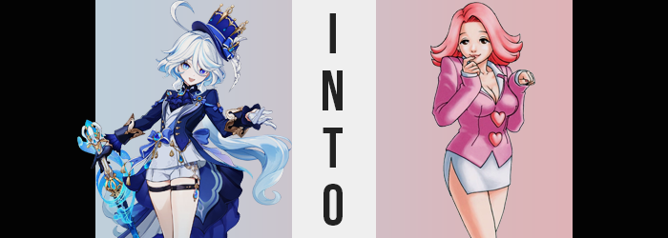

It was a day like any other through the eyes of Furina de Fontaine.

This wasn’t an observation made lightly. How many days had it been now? How many years? She had been acting as the Archon of the Fontaine region for so long that she wasn’t even sure if she knew the correct number of years anymore. Each day bled into the next and, after you had lived for such a long time, it was only natural that the motions would become mundane. Almost torturously so.

Not that these were concerns that Furina had shared with anyone else. She was honestly suffering a great deal. She held a secret that she could not share with anyone for the benefit of everyone. In the end it didn’t really matter how much she suffered so long as she could accomplish that goal. Because if she gave up at this point? What would all of that time have been for? Everything she had endured would become moot and she would have failed. All she could do was hope, every day, that the end of her suffering was near.

And it was in a sense. The woman didn’t know this, but in a year’s time the Traveler would appear in Fontaine and she would be freed from her curse shortly after. She didn’t have the precognitive ability to know that though; she could only assume it could be hundreds of more years until she was freed. And honestly, every day that she spent living in the shoes of an Archon was another day closer to ultimate despair.

“Hmm~! I suppose I’m here a tad early? Not even Neuvillette has arrived…” For all of her suffering, Fontaine’s Archon never allowed anyone else to know, not even her closest companion in Neuvillette. Regardless of how much she hurt inside? She presented herself as a carefree, albeit pompous personality; what she believed to be the idealized leader in the eyes of her people. It wasn’t odd of her to show up to the Opera Epiclese well before a trial began – and while it was an opera house, it was very much a courtroom as well.
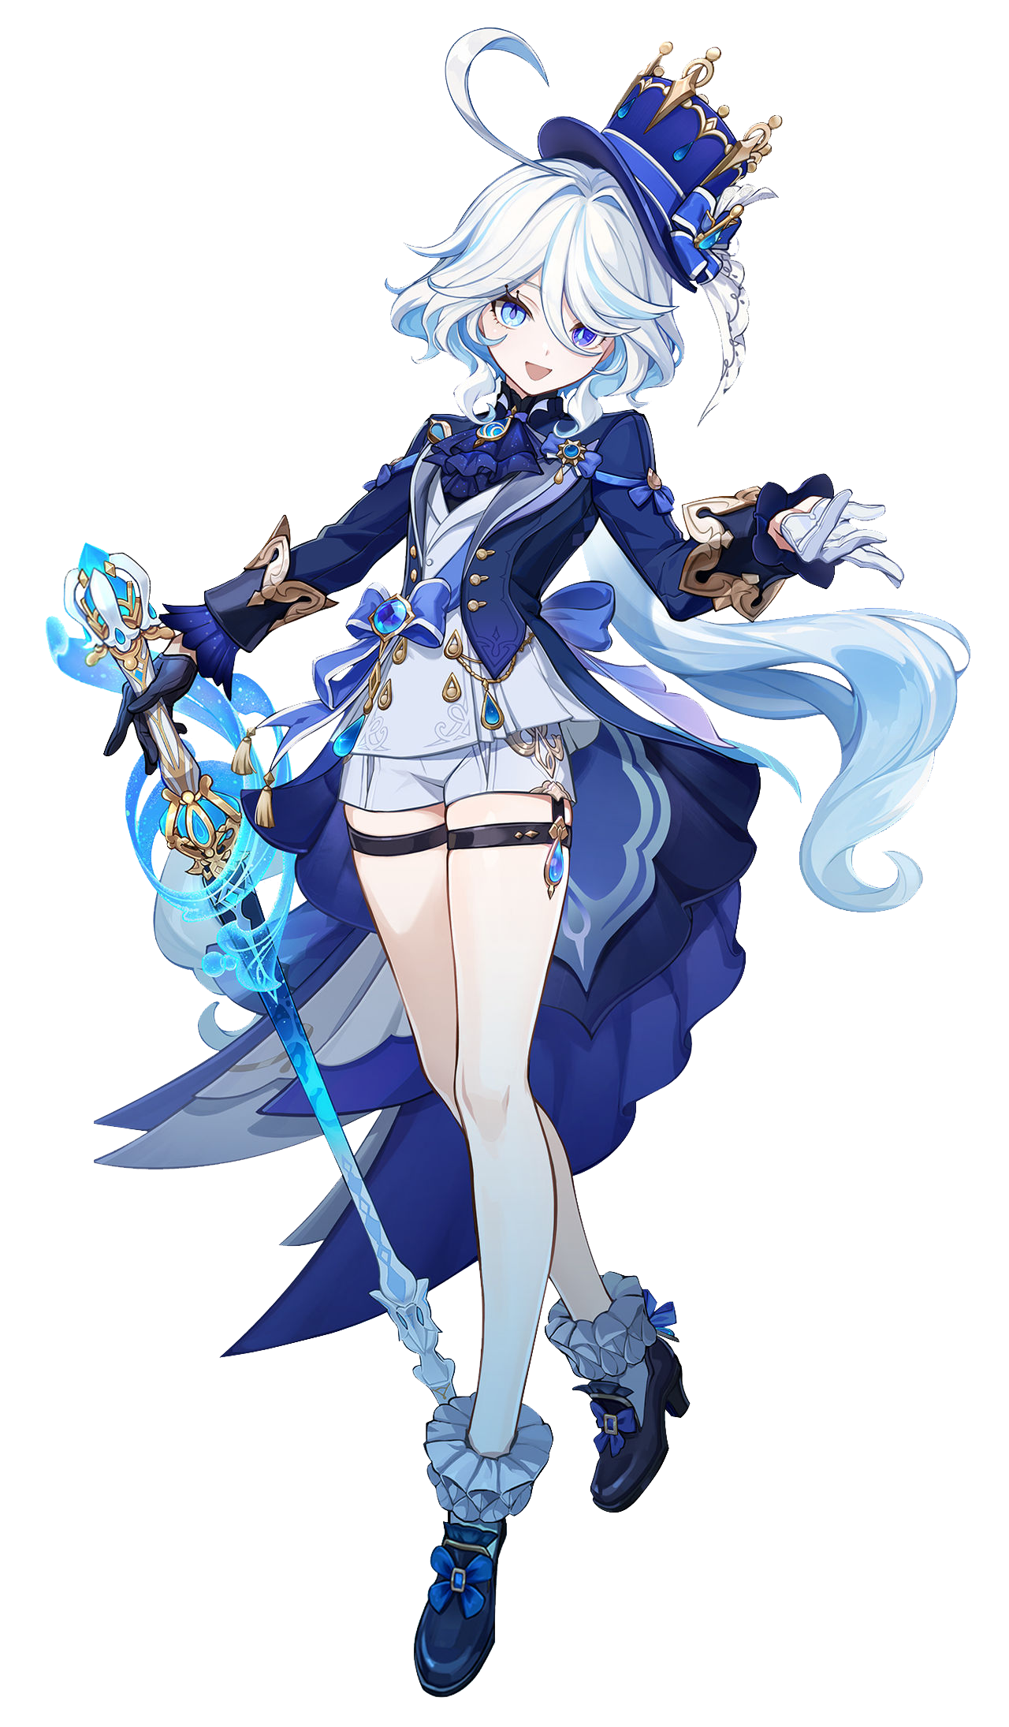
One of the roles that Furina played in Fontaine was a major one in the justice system. It was Neuvillette that stood in the forefront of every trial, and it was the Oratrice Mecanique d’Analyse Cardinale that made judgements. But Furina acted as the plaintiff, bringing the case against the individual who had committed the crime. She was essentially the prosecution, while the other side would play defense.

“I suppose I have time to review the case notes before anyone gets here then…” The woman had brought all of the relevant materials with her, of course. Files of important information and incriminating evidence. She flipped through them upon her chair high above where the audience would sit, overlooking the stage below. “April May… charged with… hm? Wait, this isn’t the case that’s being presented today, is it!?”

Rather… she hadn’t seen the information for this case before once in her life!? “If someone is playing a prank on me, then it isn’t a very funny one.” But when could someone have even swapped the papers? She’d checked them when she had taken them with her that morning and the details had been correct. Someone had somehow swapped them while she was carrying them? “Hmm…” She stood up abruptly with annoyance showing on her features. She had time, so she’d have to retrace her steps and look for clues.

But fate didn’t want to give her that chance.

“H-Huh!? What’s going on here!?” Was the world around her spinning? The sights of the Opera Epiclese’s interior bled together and brightened, and when the sights around her stabilized moments later? She wasn’t standing in her usual spot. She wasn’t even sure if she was standing in Fontaine. “Wh-Where am I!? Have I been kidnapped!?”

The best she could describe the space she was sitting in was a waiting room? There was a brown couch against one wall beside a plant, while on the opposing one there was a cabinet with a strange, black, square box upon it? It was a device she had never seen before. There was likewise a large, pink purse beside the couch. Unless the big, oak door nearby was locked then she wasn’t trapped. Had she really been kidnapped? Then… “Ah!? Where did those papers go!?” Her clothes had made the trip with her, but the papers she had been carrying…

Did they even matter at the moment? She had no idea where she was nor why! She could have been in danger! Or so she had thought, at least up until a strange voice echoed from somewhere. From a muffled intercom installed above the door in her room, not that she knew what that was. “The trial of ▮▮▮▮ ▮▮▮ will begin in ten minutes.”

“A trial? Is this a courthouse then?” Furina hadn’t quite caught the name that had been spoken; the broadcast had gotten fuzzy. Upon this realization something struck the woman. Did she really need to leave? She felt like she was supposed to remain in the room she was in? Within the defendant lobby. “B-But I’m not a defendant! I’m a plaintiff!” How could she even be on trial? She didn’t even know where she was! Was her existence in this place a crime? No! She hadn’t made out the name that had been spoken, but it hadn’t been her name. She was certain of that much! So what was the doubt that lingered within her? It was all too much. It felt like she would burst! And she did.

“Teehee!”

Furina’s gloved fingers covered her mouth just as quickly as the sound had escaped. A girlish giggle that had no place dancing from her lips, one that she hadn’t even intended on making. Nothing humorous had even occurred, so where had it come from!? The young woman’s mismatched blue eyes danced around, her cheeks burning red from the embarrassment she felt. And yet? She became hyperaware of something with those hands pressed to her lips. “Mmph?” It was a noise she made while wriggling those lips. It almost felt like they were pressing up against her hands more intensely than they had been?

“Whath ith… WAH!?” The Archon’s lips were interacting with each other strangely, bringing about a lisp from the unfamiliar sensation. They were… heavy? Bringing a single finger up to press into them, they were definitely swollen. “Ith thith an allergic reaction? I… don’t… know…” By slowing her words down she was able to avoid lisping, but that didn’t make matters any less alarming.

Come to think of it? Her gloves felt a little tight too. “I don’t understand…” She gingerly plucked one glove off and then the other, ultimately left to marvel at fingers that weren’t only slightly longer than she remembered, but also had nails that were manicured and painted pink. Pink did not go with the blues in her outfit at all! “It’s like my body is changing? How is this possible!?” She’d gotten a little too excited and her voice had cracked for just a moment. Or at the very least that was the excuse she was going with for now.

In actuality, bloated lips were only a small part of what had been happening when it came to Furina’s face. The skin of her facial features had tightened until it began to slightly shine for one, but that was hardly as shocking of a shift as the sight of her nose lengthening and widening or her brows thinning. But what was more shocking were her eyes.

Teardrop-shaped eyelashes thinned into narrow lines, and teardrop pupils both darkened and shrank into the expected dots. While the mismatched blues surrounding them within her irises? Both were overwhelmed by the speckles of a consistent brown until they were both the exact same color. Not that it really mattered. The shapes of those eyes narrowed until it was difficult to see their colors in the first place. All in all leaving her with a face that looked older, even if Furina wasn’t technically becoming older physically. It was just much more mature.

Furina pawed at her bangs without thinking. “Why are these bothering me?” Yet another voice crack came and went, but it was strange. How she sounded during that voice crack almost sounded like it suited her changed face better. That said? As if her prayers had been answered, the woman’s bangs began to part until her forehead was exposed in its entirety. Hair lengthened at the sides and shortened in the back, eventually straightening in the meantime, whites with blue highlights eventually overwhelmed with a cotton candy pink that was swept just over her shoulders on either side. It also knocked her hat off her head.

Of course, the pubes in her shorts also inherited this pink. While becoming nice and fuzzy to boot!

“That’s better!” She hadn’t even recognized that anything changed. It just seemed like her hair was no longer in the way and she liked it better this way. But that wasn’t too surprising. She didn’t look at all like Furina de Fontaine from the neck up now, and in fact she no longer sounded like her either. There was something vapid about the more mature hum that her voice possessed, like she should look older than she did.

A change had occurred subtly that wasn’t in service of that, however. Furina has actually shrunk slightly. It was only an inch – not notable at all upon dropping to 5’2”, but it was still worth noting even if it didn’t necessarily make her body seem more mature. The changes that would suggest as much weren’t exactly far behind though! The issue was that these weren’t changes that her outfit would really be able to accommodate.
As if to prove that point? The very first issue arrived in the form of a tightness in her shorts. Short as they were already it wasn’t so much a matter of her thighs as it was her hips. They had widened out of nowhere, prompting Furina to peer down with no shortage of confusion as the one button on those shorts held on for dear life. “Why’re they so tight? Must be my fault for putting on clothes that aren’t my size!” And yet she didn’t register it as an issue with her body. She registered it as an issue with her clothes.

Because she didn’t move to alleviate the discomfort in her shorts it eventually reached a boiling point or, well, a literal breaking point, and the sole button gave way under pressure. It popped right off. “Whee!” Furina found it a little funny. Despite her reaction it hadn’t been the hips alone that had prompted the button’s exit. Her once very compact ass had begun to swell and had quickly been filling the contents of her shorts.

Those shorts were made for only a small ass, though, and so it didn’t take long before the vertical seam between her cheeks split entirely down the center to reveal panties being wedged deep within the crack of this bubbled, heart-shaped rump. There was just so much to this year end that the excess was passed on to her thighs which were largely bare. However they were accessorized with two belts, and those belts dug into their meat until they eventually snapped themselves and fell to the ground. “Oh~!”

Was she enjoying this? That definitely appeared to be the case.

At least until a pressure beneath her layered jacket prompted the woman to paw at her chest. “Erm…” At least with her ass and thighs there had been a means of alleviating the tightness. Her coat was much too thick for anything to explode out of them regardless of how much mass existed within. So her breasts beginning to balloon was an issue that was immediately met with concern on the woman’s part. “H-How do I take this thingy off!?” She was trying to act cute about it, but her expression seemed rather… evil. The kind of face you might make if cornered.

The fact that she didn’t know how to take the coat off as breast meat continued to compile within its depths spoke to just how much her mind had changed. Furina could not recall how to take these clothes on or off and honestly? That frustrated her because she didn’t know why they were on her body in the first place. They were so ugly. Manicured fingers frantically searched around for a seam though, and just as it seemed like she might have her ribs crushed by her own tits?

She managed to find the fold and pull the jacket open, allowing perky F-cup tits to tear through the thin, white undershirt and breathe in the air of the waiting room. Furina let out a sigh of relief and even fondled them a moment, the sensitivity of erect and engorged nipples a little too distracting to ignore. But she eventually did let go once she looked down at herself and remembered what had gotten her into this mess in the first place!

Or at least what she perceived to be the cause, at least.

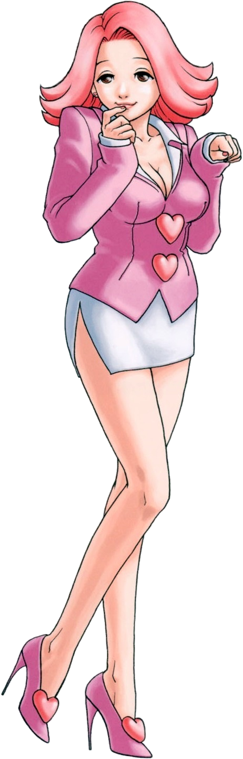
“Wh-What am I wearing!?” The first thing that the new defendant realized once she finally snapped out of it was her outfit… or at least what remained of it. With her body so voluptuous and supple, blue cloth was digging into whatever hadn’t exploded out of it all. It looked like she had been dressed in the clothes of a teenaged girl despite obviously being a sexy twenty three year old woman! “Blue isn’t even my color!”

Without any regard for whether or not there was a security camera in the defendant lobby (there was), she took a moment to disrobe what she could. “Grr…” Some of it had dug so deeply into her that she had to use all of her strength to pick it off, but eventually found herself strutting around the room completely nude – pink bush of pubes swaying while perky, large tits bounced with each step. Her plush, heart-shaped ass was pushed into the air as she leaned forward over her purse beside the couch and pulled out a change of clothes.

And a long-sleeved, pink jacket over a white dress shirt and slit, white pencil skirt soon covered the essentially. “Teehee! No underwear though! Oh well!” April May wasn’t the kind of woman who would worry about that. She saw her voluptuous body as a weapon, and if using that weapon meant lessoning her sentencing in the trial that she was presently about to step in for, well… she would definitely use it! She’d just need to make sure to cross her legs. As for footwear? She knew her heels were on the other side of the door.

April seemed to be oddly oblivious to her circumstances otherwise. She didn’t seem to recognize that she was a changed woman… literally. After peeling off the clothes that hadn’t fit her? Their existence hadn’t crossed her mind at all. So she wouldn’t question where they had come from or why she had even put them on in the first place. “This trial better not take too long~! I’m booked for a manicure in two hours~!” At least she was only on trial for aiding in a crime – given no choice by her boss. She’d probably get off lightly and that was fine with her! Life was short and she didn’t want to spend any of it behind bars!

In a strange twist of fate… wasn’t this good for her? Maybe not for the woman she had become, but for the Furina she had been. She was no longer trapped in a cycle of suffering. She had been freed… and become quite the free spirit in the process. And what would she be using that freedom for later that night?

Well, maybe a little sucking and fucking, as a treat.

