BEAST INVERSE
COMMISSION STORY
BY CHALDEACHANGE
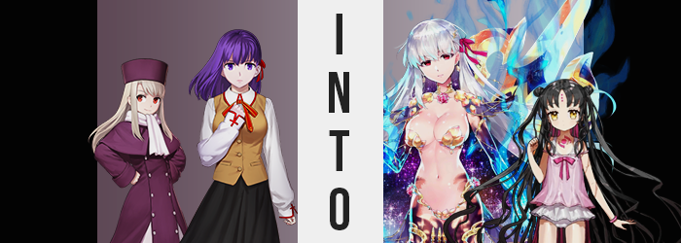

It had all started as a day just like any other.

But wasn’t that always the case on days where something exceptional would eventually come to happen? And really, something already had already done jus that. It was just that those staying at the Emiya household that day did not have any information about it. That a most peculiar fate had befallen Rin Tohsaka at the hands of a mysterious package just early that same day.

Of course, Shirou Emiya, the owner of the home, was perhaps the farthest from having any awareness of this. He hadn’t even been home that day whatsoever, instead helping with repairs up at the church after a legitimate gas leak had taken place early in the morning. Thankfully no one had been hurt or worse, but some of the building had been damaged by a fire that had come about as a result of it.

And so the only individuals at the homestead were Sakura Matou – Shirou’s steadfast kouhai and staunch caretaker – as well as Illyasviel von Einzbern – his (unknowingly) big sister despite her childlike size. “Wasn’t Rin supposed to be coming over for dinner too? I’m surprised she isn’t here already…” Sitting under the kotatsu in the Emiya’s living room, it was Illya who made this comment to Sakura, who was working in the kitchen to get dinner ready. “I’m boooored!”

The childish behavior prompted a well-meaning giggle from Sakura, who was cutting a head of lettuce. Thinking they’d try something a little more Western inspired for dinner, she was preparing hamburger steak and a salad to have with Illya and Rin. It was at times like these that she was reminded of just how much of a child Illya could be, though. “Well, if you need something to do, do you want to go out and check the mail, Illya-chan?” It should have come by this point in the day. Sakura was certain Rin would be there on time too.

Pushing herself up and responding with a “Fiiiiiine!”, the small, big sister practically skipped down the hall to the front door where she slid on sandals and left. She had to traverse the courtyard to reach the gate, and so of course she wasn’t going to do that in just socks! “Oh?”
Where she had been expecting to find some letters in the mailbox, there was actually a package at the gate. It wasn’t particularly large and was certainly small enough to move back into the main hall of the building, but what was curious about it was the label. It wasn’t addressed to Shirou himself but to ‘all residents’, and there was no return address whatsoever. “Well I live here, so that means it should be okay if I open it, right?”

Illya wasn’t exactly wrong, and despite the part of her that wondered if she should run it by Sakura first just in case, she hastily opened the box once she got into the hall – far enough away from the kitchen that Sakura wouldn’t even be able to hear just what it was that the girl was up to. Inside? Well…

“…Eh? Is this… golden underwear?” There were a number of golden ornaments contained within the package, but the one she had picked up first by its chain connectors looked expressly like a pair of golden panties done up in a flower petal shape. And certainly not underwear that would ever fit her. Not that it appeared comfortable at all. “Did… a pervert send these!? Or don’t tell me!?”

HAD SHIROU ORDERED THEM!?

Assuming the worst, Illya had never felt as disappointed toward her little brother as she was in that moment! But before she could fall down that hole and think of the best possible way to scold him, something strange happened. The metal, golden bikini bottom that she was holding suddenly glowed and disappeared, just as all of the decorations in the box soon did. “Huh?” That had definitely felt like some sort of magecraft had been activated.

She knew because it had resonated with her body. “Wait, was that— GRK!?” Illya’s heart had thumped really hard, and her body froze up temporarily, preventing her from finishing her sentence and forcing a fumble on what should have been a very natural response. At first she had thought to get help, but now? A voice deep down was telling her no help was needed.

That didn’t stop her from being scared and concerned though. She felt hot. Like very, very hot. Like a literal flame had been lit inside her own body, and while it was so unbearable that she almost wanted to scream out in agony, something smothered that impulse. It would be problematic if that woman in the other room heard me. Was it really a suggestion, though? It sounded more like a legitimate thought on Illya’s part, at least from how she perceived it.

In terms of perceiving things, however? Things had begun to transpire that the miniature eighteen year old didn’t really appear to notice, or at the very least she didn’t acknowledge them at first. For midst the heat there was a tingling sensation upon her face. She thought it was merely a side effect of the burning within as she clutched her chest, sweat seeping into her clothes.

But it wasn’t. There was a tangible, observable change that had struck the skin wherever it tingled. In some places? Maybe that observable change was a little more subtle than elsewhere. But the very shape of the girl’s face appeared to be undergoing a shift. Yet it wasn’t even towards something unfamiliar. It just wasn’t towards what she normally saw when she looked in the mirror.

Take Illyasviel’s eyes for example. While their crimson color, oddly, did not change at all? Well, in terms of shape those eyes were a mix of Japanese and European aesthetic normally, leaning more into the latter as the child of an Einzbern homunculus. Yet these was no doubt, quickly, that her blood was now purely Japanese. The shapes of her eyes narrowed, but they also seemed sharper, lashes longer, essentially creating the impression that she was older?

Of course, this impression was helped by additional changes to the girl’s facial structure. Her jaw clicked a moment with her face lengthening slightly as a cause, rounded and childish cheeks thinning in the process. But what didn’t narrow were her lips, which bloated several times thicker while her mouth came to house a tongue that was just a tad bit larger than it had been ever since she had stopped growing.

“It… burns…” The girl croaked, her voice deeper and notably more venomous. But there was also something familiar about it. Just as her face was still familiar. But the half-homunculus was so fixated on the discomfort that she took no notice of it. Or perhaps it was better to say that there was something akin to an itch in the back of her mind that kept her from thinking too hard about it.

Even as the tingling spread into her scalp – not quite altering that scalp itself, but what was growing out of it. Yet even then, was it all that dramatic? At first it didn’t seem that way. The snow white coloration of the girl’s hair was set slightly askew towards a silverier color, one with lilac undertones. Yet that hair simultaneously lengthened, spilling well down to the floor from her present standing height. And yet… That wasn’t even the strangest aspect of what would befall her hair, it just wasn’t time for the other effect to take root just yet.

The sounds that Illya made sounded dry, which made sense considering the burning feeling that she was enduring. Eyes half open, she hadn’t reacted specifically to any of the physical changes that had already befallen her, and that trend continued even as the rest of her small body began to adjust to better suit the face of a woman in her twenties. A woman that looked suspiciously like that of Sakura Matou, who was only a short ways away in the kitchen. And yet her body? It wasn’t ultimately rendered at a 1:1 ratio with Sakura’s. Her face already presented an age that was significantly older, after all.

With all of the discomfort that she felt, her teeth were grit beneath swollen lips and her posture was hunched over slightly as clothes became heavier and heavier with sweat. But the angle of the hunch grew more dramatic because, well, there was more to her body to hunch. Her spine and limbs had begun to lengthen in tandem with each other, height growing from a meager 4’3” to 5’6” over just a handful of seconds. This left the pink skirt she was wearing to rise well off her knees, and the shirt tucked into it became notably untucked so that her tummy was rendered completely exposed.

Showing off more of her skin, the fact that this wasn’t a simple ‘elongation of Illyasviel von Einzbern’ was fairly evident. After all, that exposed belly was widening to fit more comfortably into the shape of thighs that parted a handful of inches wider, in turn tearing the seams of the skirt that had been left seated upon them. “Ngh…!?” Sounding more than a little agitated by it, her white panties were uncomfortably lodged into the cheeks of her ass, too. Because those cheeks bubbled into incredibly full shapes, excess sculpting her thighs into bountiful new weight that gave her a very bottom-heavy appearance.

It burned, but there was something else. It felt a little pleasant? Arousing, even. So small her whole life, Illya had never felt anything like this before, but since her body was becoming increasingly adult? It was now a sensation she could clearly savor. Of course, this was also a side effect of the new nature that was swelling within her.

Though in terms of swelling, there was something much more obvious doing just that. A weight was accumulating beneath her button-up dress top, and since Illya was so flat under normal circumstances that she didn’t even wear a bra, its absence was clearly highlighted by the full, round shapes that eventually pushed the fabric of her already too-small shirt to the point that the top four buttons came undone, cleavage not only spilling out, but surpassing Sakura’s so that they were full, enticing E-cups.

“This feeling… I’m not… But I am…” The woman, and she was so clearly a woman and not a girl by this juncture, seemed to be torn mentally between something. The truth of the matter was that it was between her old identity and her new one, with a new personality and memories seating themselves – not entirely replacing the old, but utterly dominating them instead. And the more these memories multiplied? The hotter her body burned.

Literally.

Fingertips, longer and manicured now, began to burn with blue flames, as did her toes. This fire spread up her limbs, burning away and present cloth but likewise charring the skin the blue bled from. It didn’t take long for the entirety of her arms and legs to be burned a blackish purple, yet beneath the fire something else seemed to sparkle. Like the stars themselves were reflected on her limbs. And, so too, was the galaxy reflected on the underside of her mane of hair, now barely lifted off the floor now that she was taller.

“I see… I see…” Illya’s composure returned and she corrected her posture. The overwhelming heat subsided, or at least it no longer bothered her, but not before blue flames burned away all of her clothes. Not that this left her naked, no. The jewelry from inside the box made a reappearance, clinging to her body to cover the bare essentials, and only the bare essentials.

The woman now almost completely naked sans the golden ornaments that Illya had turned her nose up at just minutes prior (as well as a pink ribbon in her hair), she clicked her tongue at her present circumstances without even the slightest bit of care for how much of her body she was showing off. This body of hers was beautiful, was it not? And she was the God of Love. Why would she shy away from showing off that component of herself?

“Interesting…” For better or for worse, Kama fully grasped the weight of her current situation. Memories of her life as Illyasviel still persisted, but they had been tucked away in the crevices of her ego so that her new memories and personality remained dominant. She was corrupted and twisted now, but those corrupted and twisted feelings were keenly aimed at the same individual any woman with the face of Sakura Matou would be aimed. Shirou Emiya.

He was here, and she wanted him all to herself. There was nothing she wanted more, and yet there was one hurdle to this plan of hers in the kitchen connected to the very hallway she was now floating in. “Parvati… I will not let you have him!” Even though she was clearly referring to the regular old Sakura.

“Illya-chan has been a while getting the mail, I wonder if I should check on her?” Sakura wondered to herself, still oblivious to what had befallen both her friend, and her sister Rin. She had finally managed to prepare everything for dinner and had set it aside, but she had no one to serve it to? Taking off the cooking apron she was wearing and hanging it on a nearby rack, she had been on the cusp of venturing into the hall to find the missing girl in question.

Yet something prompted her to stop. A presence? A power? Regardless of its nature, something she couldn’t see was present in the kitchen with her. Because it was standing behind her and Sakura was no longer able to turn to meet its gaze. “I see… I suppose there’s only one way to remove you as my rival. If there’s nothing about you for him to find attractive, then… I’d like to see you get in my way then.” What was most shocking to Sakura of all was their voice. Because it sounded so much like her own.

But the presence finally disappeared, and Sakura was able to move once more. “Wh-What was that?” A fair question, but she was hardly afforded much of an opportunity to dwell on it. Because her body began to feel strange. Almost foreign, which was infinitely strange all on its own. Would it have been odd to describe it as ‘wet’? Even though her body’s surface was completely dry.

She was oblivious to how her purple bangs had parted in the center, revealing… One, two, three. Three hot pink dots that began to glow, running vertically down the center of her forehead. They appeared to be emitting a magic of some sort, one that seeped not only outward, but inward into Sakura’s body as well. It would, ultimately, have similar effects to the flames that had burned Illya from within. But the intended outcome was quite different than what had befallen the homunculus.

That was promptly made plain looking at her face and hair, two areas that were directly connected to the trio of glowing pink dots in the first place. Her shoulder length, purple hair already had its bangs parted, but the style of her hairdo changed further as locks lengthened and spread out behind her. It was almost eerie in how they did so, resembling long and stringy tentacles that fanned out in every direction. But more than that? This thinner hair darkened to a raven black color, stealing away the color that had been forced on her when she had been ‘introduced’ to the Crest Worms in the past.

“I feel… dizzy?” It really did feel like her head was swimming, but physically? There was a sudden and dramatic departure in terms of aesthetic from what made her Sakura Matou. On the one hand, she rapidly appeared younger. Her cheeks were rounder, brows smaller, eyes bigger and brighter (even inheriting an eerie, golden glow). On the other, she didn’t even look like a younger version of herself. The shape of her jaw, the narrow arch of her noise, the fullness of her forehead – it would have been beyond simple to mistake her for someone else.

And it wasn’t someone Sakura knew.

It became increasingly difficult for the teen to maintain her balance. “Wah!?” A childish voice jumped from thinned, rosy lips as she was forced to use the nearby counter to balance herself, but an equally childish giggle left her lips in an awkward fashion at the fact that she had managed to stop her fall. Something about her own thoughts was simpler now, more innocent? And yet that innocence was unknowingly tainted.

The cause of this imbalance was actually quite plain to anyone that might have been observing her. The school uniform that she was adorned with, as she wore almost every day, seemed uncannily ill fitted in some surprising areas. Such as? Well, around her chest was one. Sakura’s bosom was quite pronounced, certainly the largest among her peers. Yet it was the increasing absence of their heft that left the uniform to look disheveled. Her tits were losing their luster, so to speak, sizes diminishing and skin tightening around mounds that, ultimately, were little more than mosquito bites upon her chest.

Though as her top moved to accommodate the lack of breasts, her neckline briefly dipped to reveal that, just below her neck, a bright pink circle with matching lines around it was glowing just like the dots on her wide forehead.

“I… Who am I?” A seed of doubt was understandably planted. She clearly didn’t look like Sakura Matou, and the personality she was gaining, childish as it was, did not match her self-image as Sakura. Even her physical image departed more and more from that past self, with her ass and thighs subjected to the same theft that her breasts had been. Before long her hips were extremely thin, and her rear and legs had little to no meat to them. Like a child would.

Perplexed as she was, new memories and a new identity consuming her whole, she didn’t really bat much of an eyelash as she found the hand that she had used to stabilize herself on the counter lifting higher and higher, fingers becoming smaller and smaller. She was shrinking, and quite significantly so. Her skirt fell from her hips, panties going along with it – all while her top felt heavier and heavier, eventually resembling a dress as she fell to the four foot mark in height.

But she was so much smaller that even her top fell, sliding right across narrowed shoulders. This should have left her child-sized body completely bare, and yet evidently the transformation itself had shown some foresight. She wasn’t naked. A pink, one piece swimsuit was clinging properly to her smaller body underneath. The marking on her chest was completely visible now, but with hair now pulled up into tiny buns on the sides of her head? The light of all the pink markings on her body finally subsided.

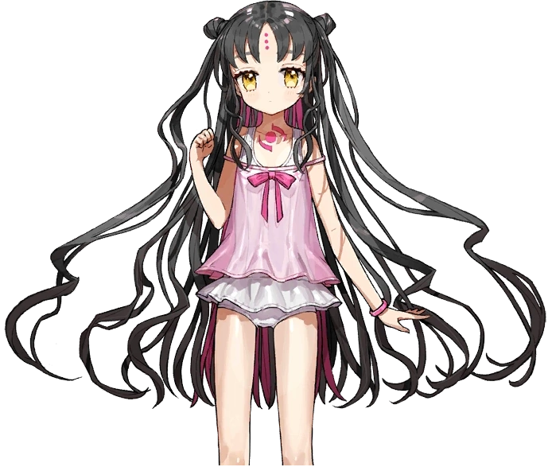
The child could not believe her own eyes. The tiny hands that she continued to stare at were just a small part of a smaller body, with all of Sakura’s blossoming appeal as a young woman gone just like that. But that was hardly as troubling as the memories that invasively mixed with her old ones. Memories that were vivid enough that she was able to immediately identify the culprit behind her current circumstances.

“Kama…” After all, they were technically two sides of the same Beast. While she had been turned into a child, Kiara Lily could still recognize a similar power to her own lingering in the air. “But if my circumstances are like this… Was she Illyasviel?” Kiara, too, could recognize that she had been Sakura still. Looking and acting as she now did, however? It was certainly unlikely that anyone would believe her if she claimed that was the case.

Which was surely part of Kama’s plans. Had she not wanted the child getting in her way? In the pursuit of love? Or simply more generally? If that was the case then she had clearly overlooked something. The presence of another Beast in the city that was much more powerful than the two of them. Likely another victim of the same phenomenon. And piecing things together? Likely Rin Tohsaka.

As much as she loathed her current predicament though? Kiara couldn’t help but unintentionally embrace the childlike purity that came with her form. More than get to the bottom of things? She wanted to play! Her idea of a game would certainly be much more twisted than anything any other girl her age would come up with, though. “Maybe living like this won’t be so bad, though! Maybe I can find someone suitable to adopt me?”

So that she could corrupt them, anyways.

