A Pale Dancer In The Dark

The isolated realm of Vein was a collection of ruined skyscrapers and desolate metropolitan centers from a bygone era, with thorns large enough to dwarf the region jutting out of the earth and unnatural topography that made navigating the network of disparate wrecks a treacherous affair, one would have to be insane to stay in such a place.

But when the rest of the world was in a similar if not much worse state complete with rabid monsters that shrugged off any attack thrown their way, Vein was beginning to look like a preferable alternative to the former. But that didn't mean it was without its own dangers besides the impossible landscape and fatal red mist surrounding the entirety of Veil itself, preventing anyone from going in or out.

While humans are very much alive within Vein, their lives are anything but well. Dwindling supplies meant a slow, agonizing death through dehydration and starvation, that is, if they weren't sucked dry of their blood by Revenants, a vampire-esque breed of revived humans that, unlike their rather ordinary counterparts, were nigh unkillable, with the only downside being that they could only live on the blood of man and Blood Beads produced by strange growths in Vein. Bearing superhuman strength, unnatural abilities and immense weaponry to work with, it'd be easy to mistake them for the apex predators in the limited ecosystem within Vein despite many believing otherwise. After all, as long as their heart which housed the parasite that gave them their powers remained intact, the world was their oyster, right?

Coming in many sizes while differing vastly in terms of appearance and strength, the Lost were arguably the top dogs in Vein's food chain. They represented a visual reminder of the fate that awaited every Revenant if they were to ever go too long without feeding. Physical superiority and abilities aside, they, unlike the Revenants, were truly immortal. No matter the method used to kill them, their bodies, fully assimilated and repurposed to become the parasite itself, would always return once their disparate particles had reformed elsewhere. It was why Revenants preferred to leave them just barely alive; pinned wherever they fell by staves, swords or whatever else was at hand, slumbering in states of dormancy rather than risk their return after death. A band aid solution for a growing problem…

…Because with every passing day, more Revenants joined the ranks of the Lost, and if things continued this way, it wouldn't be long till the last surviving bastions of Revenants and Humans were wiped out.

So while the lowly grunts and outlaws living beyond the fringes of the fractured government continued fighting tooth and claw to survive, certain groups would begin to make their move, all with varying motives, all focused on removing the figurative thorn in their sides before the wound got infected. But today's tale won't be focused on one of the more successful teams that had managed to brave the perils of Vein while facing down the Lost along the way. While the events soon to occur were indirectly caused by their actions, the unfortunate soul currently wandering through the ruins of an offshore oil rig buried leagues under the earth had no way of knowing until it was far too late to turn back.

The remarkable thing however was the fact that the man clad in a bulky protective jacket over thick protective overalls and muddy trousers wasn't a Revenant, but rather a plain old human being who, judging by the raggedy old beard peering out from under a gas mask slapped tight around a wrinkled face, was probably in his later years.

Seeing a live human wandering Vein on their lonesome was rare. If the Lost or natural hazards didn't get to them, then the Revenants would. While those taken in by the government led lives of relative safety in exchange for regular blood donations, those nabbed by the more ruthless anarchist groups going at it on their own were treated more like animals than people. Livestock to be reared and milked. And now when Blood Bead shortages were becoming a widespread problem, demand for human blood was at an all time high.

If this man had evaded capture, survived the Lost and the toxic miasma they produced and was skilled enough to scrounge for scraps, then he truly was in a league of his own, a living monument to mankind's drive to survive.

Unfortunately for him however, this run would be his last…for as quick thinking and resourceful as one could be. Contending against forces that were both incomprehensible and invisible to the naked eye was something that would leave a person hurt, changed even. And for the savvy scav, his fate would lean heavily towards the latter.

It had been a few days since he had begun tailing a curious group of Revenants wandering through the foggy, flooded bogs of the massive underground chamber that used to be a portion of the sea floor shoved all the way inland back before the Revenants and Lost became a problem. He had expected them to turn tail when things started to grow hot, as had he when a particularly relentless Lost had chased him to hell and back.

By the time he returned, the Revenants were gone, the place was notably quieter save for the crackle of lit torches to light the way and the salvage was all his for the taking.

Normally he would restrict himself to a bag full of supplies just in case he had to make a run for it, but from what he could tell, the entire place had been wiped clean of all those pesky Lost that usually hung around the richest sources of loot. It was all his to pick through and strip clean!

Mocking the Revenants for being blinder than bats for ignoring it all (and not because he was particularly envious of their youthful looks), the salvager begins his work; rushing as if there was no time left, stuffing his bags and pockets full of broken bits if machinery, scrap and even a medical supply box.

By the time he had hit the sunken oil rig proper, he was already lugging a sizable haul behind him, eager for more to be found in the somewhat intact rust bucket that dominated the earthen dome. They just didn't build them like they used to…

That was where the catch laid in scaling the immense structure so soon after the death of its sole occupant for many untold years now. This wasn't about taboo or intruding upon the privacy of the dead, because the person that had been treating this place as their home wasn't even a person at all.

It was a Lost, a particularly powerful one that had lain waste to many an experienced Revenant. Although the Revenant she once was had been lost to the ravages of time just like many of her new brethren, the twin tailed demon had been strong enough in mind to maintain some of her previous identity instead of ending up like many of the other deformed monstrosities lurking in the foggy basin below and elsewhere across Vein. While her memories had been lost upon her descent into madness, the monster's skill with her hefty sickle had remained intact, ending lives with it just as it had done before its wielder lost any semblance of her old self…except this time, anyone and anything caught in her sight was fair game.
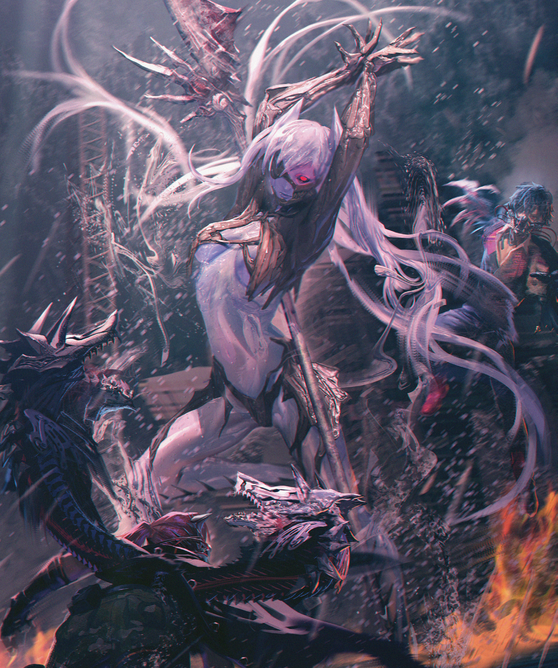
In fact, if one ignored the fact that she was taller than an outhouse, had hair that looked so wet they and slimy the strands congealed into goopy tendrils and a body clad entirely in deathly pale skin with long wavy legs that ended in twin stilettos sharpened into deadly points, she could very well pass for a human.

Known simply as the Invading Executioner by some of the more knowledgeable individuals with a vested interest in cataloging the many forms of Lost, the group of Revenants that had long since departed for greater ventures were the ones to deal the final blow against the femme fatale, leaving the Executioner to disintegrate into ash like particles upon her ‘death’, floating lazily around the damp arena before becoming too sparse to remain visible…except the greedy human wasn't aware of the fierce battle that had taken place there moments ago. Obliviously squatting over a pile of machinery to begin scrounging for more loot as the wayward cells of the Executioner begin to draw downward, centralizing around the peculiar entity they could sense intruding on their territory, prodding and poking before assimilating themselves into this acceptable vessel.

While the Lost had been a studied threat for years, there were still plenty of unknowns left to be discovered about their behavior and ecology. So when the man suddenly begins to bulk up in mass while slowly gaining height, no one could know what exactly was happening to the scavenger who likewise didn't seem to notice the predicament he was in as mottled brown skin slowly begins to lose all coloration starting from his gaunt cheeks which were filling in with firm yet solid layers of strange flesh, producing a slick fluid that moisturizes and spreads more of this curious change across the body of the unaware human.

Normally, only Revenants were at risk of becoming Lost, and while no human had ever been on record as having turned into either while alive, that wasn't to say there weren't such occurrences going unnoticed behind the scenes much like the one happening right now as the sound of raggedy boots tearing themselves apart go unnoticed by their owner who was still busy picking apart salvage, unaware of the subtle increase in elevation, his burly arms having been elongated into long curvy branches and just how plump his thighs had become with oily skin peeking through holes perforating the toughened material that comprised his rugged trousers, falling apart under their wearers' expanded girth.

By the time his baggy eyes ripple into wide sleek almonds atop inflating lips cured of cracks and colored a lucent blue at the strange sight of waxen dry skin on the back of his hands stripping themselves free of hair before leaking a clear substance over the rusted component in his hands, a hearty ass frees itself from dirty rags, flopping about for a second before firming up into perfect butt cheeks dripping the same fluid the rest of his changing body was excreting, leaving his flaccid pecker hanging exposed to the elements while a tight navel free of unshaved hair and scarring unveils itself from beneath the hem of a straining jacket looking heavily damp and about ready to burst like his trousers had before them.

But the man could not bring himself to feel fear or uncertainty. In a startling turn of events, the scavenger instead returns to his work, dropping the scrap in his hands before looking through the pile for other prizes, having to arch his curvier back and crane a slimming neck to get a better look considering he had risen to twice his original height with no signs of slowing down.

The thing that made the Lost simplistic and easy to deal with despite their massive strength was their repetitive nature and mindless approach to things, And with his body rapidly losing its humanity, his brain likewise was beginning to suffer from a severe case of dissociative identity disorder. Feeling disturbed at the sight of his changed body before shrugging it off as his own brain coaxes him back to calmness; this is always how you've looked like, idiot. And with his old life slowly being erased by the newly invigorated parasite working to convert its new host body, that was all he needed to know to continue working undisturbed, even as his trusty jacket finally gives in, splitting down the sides to reveal a lean supple torso lined with toned muscle and soft innards that were as curvy and tight as the rest of his body, adding to the pool around him as energized pores and alien flesh begins to coat the scavs smooth new skin in a thin layer of clear liquid that bore the texture and consistency of oil: thick, viscous and shiny.

With the infection reaching critical mass, the abilities of the Executioner begin to manifest in the once ordinary human as murky water begins to flow under the influence of the List's reawakening mind subverting the hapless human's, drawn in to razor sharp javelin legs that had hardened into a crystalline material instead of flesh, funneled in as if to fill the man's body akin to water being poured into an empty vase made of rough hewn glass. And the more fluids his body takes on, the feminine allure of his new body would begin its last steps towards its final form.

As dull gray skin begins to shine with a bioluminescent cyan glow, the scavenger's limp dick twitches with activity, springing to life between long tempting legs that twitch involuntarily against the sensation of water circulating through testes, gathering cum, teasing widening new passageways before spewing out of the tip, ejecting a mix of semen and water that slowly drains his manhood in size and definition as ballsacks deflate before smoothening into fat lips, framing a dripping wet slit that wastes no time in testing it's capabilities with quick spurts of vaginal juices from within the new hole popping into existence beneath a trembling clitoris letting out its last pathetic spurts of baby batter before settling into place inside it's cold blue blanket of flesh. A sputtering snatch where a proud pecker once stood, clean shaven and ready for use as a bony, metallic bronze growth formed from burning particles materializes over the feminized humans lower bits, hugging her pert ass while biting deep between her legs all while layering razor sharp edges one over the other in a form of serrated underwear that gave the appearance of organic lingerie, trailing down her shapely thighs before lining the bladed end of her calves with a notably sharper protrusion, lending more cutting power to the already sharp appendages.

By now, the human had to have realized something was wrong, but as mentioned at the start; it was far too late to do anything now. She should've felt something, anger, fear, sadness, hell, even pleasure judging by the way her wide set hips were thrusting wildly on instinct alongside her knees buckling occasionally as the rest of her slippery body continues to fill itself up with water while donning more of the bony bronze armor; arms and shoulders encased entirely with intricate lines and cracks along its length, petite digits lengthening into dexterous claws with an expert grip that felt itchy and uncomfortable without the cool handle of a sturdy weapon to busy themselves with. Not satisfied with just those skin tight additions however, the growths continue, surging up a shrunken neckline leading up to the emotionless face of a gorgeous young lady before forming a mockery of a half ruined gas mask, the spitting image of the young Revenant who had lost herself to her feral urges oh so long ago, letting out an eerie cackle of satisfaction in tune to her flat chest sagging into pert tits to fill in her empty top. They were lacking, true. But with a killer figure like hers and an innate flexibility to twist said body in any manner imaginable, small breasts were an equally small price to pay for such a feat.
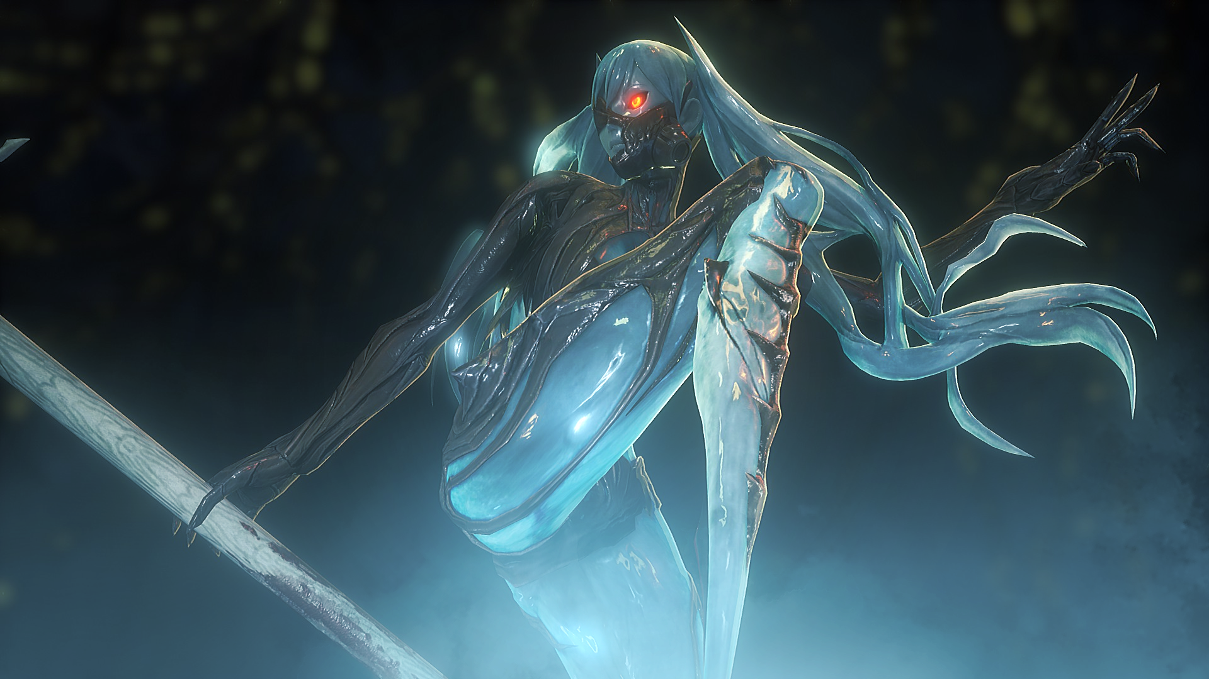
With her sclera darkening into abyssal black coals contrasted by fiery red irises burning strong, the human she had possessed to give rise to herself once more had truly been subverted in both body and mind, stomping a foot into the ground that sends both her naugthy bits jiggling and a mighty wave radiating from the explosive launch of something emerging beneath the pool, shooting up from behind in a pale blue the reborn Executioner easily intercepts, leaping high into the air before landing gracefully as withered gray hair finally blossoms forth into thick, gelatinous strands that seemed to mimic cutesy twintails, trailing around her like cruel claws as an eyepatch burns into existence beneath a neat fringe, completing the lewd, dominating ensemble of the Executioner; pale dancer of the abyss.

Scanning her home for intruders before realizing the people who had ended her not too long ago were no longer around, the Lost slowly begins to retreat back under the water, blending in seamlessly with the aquatic backdrop thanks in part to her slick blue body glistening with fluids acting as the perfect camouflage.

Any thoughts of salvage and hunting for supplies were long gone within the vapid brain of the newborn clone of the Executioner, plucked clean before being replaced by simple directives that bound her to this place, sentenced to dance and swim without end, bewitching any soul unfortunate enough to find themselves wandering into her domain, letting loose a ghostly serenade from between puckered lips before her head goes under alongside the wicked edge of her recreated sickle, letting her song bounce along the walls as newly spawned Lost begin to re-emerge alongside their unseen mistress, filling the watery grave with furious roars and demonic screeching once again.

And in the corner of the towering ruins of the rig, a scavenger's rucksack and bountiful haul of loot would go forgotten for the coming centuries ahead, surrounded by the tattered remains of clothing that many would only know of as the sad reminder of someone overstepping their boundaries and into a watery grave.

Not like they were too far off the mark anyway…

THE END

