PIXIE PANIC
DECEMBER 2021 REQUEST STORY
BY CHALDEACHANGE
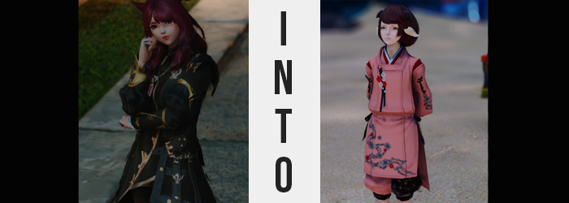

It had been a surprise to find herself drawn to Il Mheg, but not an unwelcome one.

You see, Silvia Kuroi’s nameday was on the horizon and she had met plenty of individuals over the course of her travels. Among them were members of the Pixie tribe in the First’s Il Mheg, and through their sharing of knowledge (and artifacts), the bonds the Miqo’te had forged there had become fairly pronounced. Pronounced enough, in fact, that a few of the pixies had sought her presence within their dreamland.

It was a realm with a multitude of gates that led to the dreams of others. Or, at least, other children. Lyhe Mheg, which was also known as the Garden of Dreams by mortal tongues, was such a fantastical realm. Adults could be brought within, but they could not partake in the pleasantries afforded by those dreams. “Uhh… This plan isn’t gonna work, is it?”

One of the three pixies that had guided the crimson-haired woman into Lyhe Mheg was the first to realize the err of their scheme. For Silvia’s birthday they had desired to bring her the most pleasant of dreams, and yet she was too old! How had they messed up such a plan!? Well… Pixies were mischievous, but they weren’t always the sharpest tools in the shed. Emphasis on that ‘mischievous’ adjective for later events, however.

“It’s fine. Lyhe Mheg is beautiful, so being invited in is present enough.” Silvia didn’t really mind. There was plenty she could study here that she couldn’t anywhere else. It was the thought that counted in the end, but her attempts to alleviate their concerns fell on deaf ears. The pixie trio had all huddled up in a floating circle and were murmuring to themselves. The woman thought it best to let them finish, and instead turned her back to them so that she could examine a nearby dream gate.

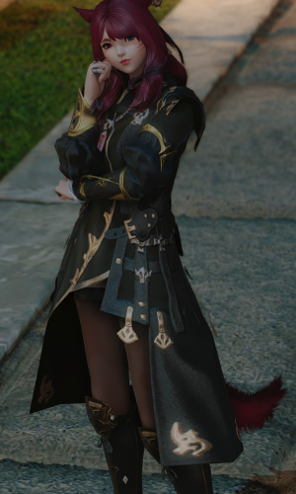
Which was something the three pixies took advantage of, because all at once Silvia felt six tiny hands upon her back, and all three pushed the Miqo’te through the gate she was standing in front of. “Hey!?” The gate disappeared behind her, and all of a sudden she was standing in the middle of a vacant, night street. A street in… “Wait, is this Kugane?” That didn’t make a lick of sense. The pixies on The First had no access to any of the locations on The Source.

“I suppose this could be a dream…” She had passed through a dream gate, but weren’t those supposed to be inaccessible? Was she inside someone’s dream? Looking behind her there was no gate, and there certainly weren’t any pixies. But the world around her seemed so real and lifelike. But of course it is, this is my home! “…? Hm?” That thought had hit her like a truck. She certainly wasn’t a Kugane native!

The street she was standing on seemed all too familiar, though. When I was younger, mother used to wait for me on that corner! But that memory wasn’t something that had happened in the past either. “The pixies! What did they do…?” Suspicion was immediately cast towards the fae folk that had placed her here in the first place. There could be no other culprit, could there? But to tamper with her memories without permission? Even for them, that was crossing a line.

If only it had been merely her memories, though.

While confused about the setting and the state of her psyche, Silv was in no position to notice nor contemplate a series of irregularities that began to seep into the fur, shapes, and in the case of her tail, bones of her Miqo’te features. For a time it almost seemed as if all of the color was being drained from the fur that decorated these places, ultimately rending them a ghostly white rather than the ruby red that she was known for. There was so much more going on than a change in fur color, however.

More specific to her tail, the skin beneath the whitened fur was growing tougher and bumpier until it almost didn’t look like skin at all. The pores necessary for hair to even grow closed, and the fur of her tail was left severed, spilling off in clump after clump. What this absence of hair ultimately revealed, however, was that her tail had become clad in hard looking, white scales. The entire shape of said appendage ultimately ended up distorted in the process, and by the time it was bald the base was much thicker than the tip. The end result was a reptilian tail.

The tail of a Raen tribe Au Ra.

This all occurred in tandem with her ears, which appeared to lengthen and coil around themselves – while the white-stained fur was pulled loose and fell against her shoulders just as the case had been with her tail. Silvia was in no danger of noticing these tufts though, for the evening breeze blew them off behind her. What remained of her hearing peripherals seemed to slowly crawl down the sides of her head, the flesh twisted into almost wing-shaped cones of thin, white keratin that were completely hollow, adjoined to tiny holes on the sides of her head that left her ability to hear intact. They were, undoubtedly, white horns. Two smaller ones even emerged from the top of her head, although strangely they were black instead of white.

“How do I get back to uh… that place again?” Strangely, she couldn’t recall the name of Lyhe Mheg or what lived there? She had just been with someone, hadn’t she? Pixies? The little creatures from fairy tale books?

Fingers scratched at the skin of her neck idly. It had been a little itchy for no reason, but before long that feeling went away. Which seemed to be for the best, seeing as it had all felt rather bumpy. Were Silvia in her right mind by this point in time, it was something that she naturally would have addressed. But she didn’t, and without any fanfare white scale plating had wrapped around her nape. But it wasn’t only there. Beneath her clothes it enraptured her hips, lower arms, and shins.

The dimly lit Kugane street became even more nostalgic from Silvia’s perspective. That park is where I play with my siblings! That is the stand where mother buys us Takoyaki! Thoughts and memories didn’t align with the Miqo’te’s history, but looking at her now? Was she even a Miqo’te? The whisker-like markings upon her face had faded, leaving said face free of any color or blemish.

But even then, that face was rearranged. Almost like the size of her skull had shortened, her features were pushed closer together vertically. And even then, everything seemed to collapse in on itself so that it was smaller. A tiny nose, rounder yet meagerer lips, tinier eyes; there certainly weren’t any signs of her traditional racial features any longer. On the other hand?

If Silva believed herself to be a Raen Au Ra, then perhaps that statement wasn’t really true.

And she did believe that, because that was a history that her memories now told.

The natural color of the woman’s irises shifted to a glistening emerald within narrowed lenses, and her hair? Lengths, slightly curled via a natural perm, withdrew to her shoulders at the cost of an inward curl that almost made said hairstyle look sort of like a dome. Mysteriously though, her hair’s color did not change. It remained the only thing constant between her two forms.

“No… These memories don’t make sense. After all, in them I’m…” Younger. Much younger. She wasn’t a child! “If I were a child, I wouldn’t know about… erm… uh?” What had she been about to talk about? Something only an adult would know? Like the kind of things they did in the bedroom? She couldn’t even recall those, but her cheeks still burned red, and she looked down at the pathway out of embarrassment at the prospect.

That said, wasn’t the pathway closer than it had been just moments ago? With the state of her psyche, it was difficult to make sense of what was correct and what wasn’t at this juncture. For what it was worth though, the pathway really was closer. Falling in line with the past her memories depicted, Silvia was, well, falling. Her feet were firmly planted on the ground still of course, but her point of view was plummeting.

Plenty was stolen from the woman in the moments that followed. Height was certainly one of those things, and its loss lead to her tunic becoming a burden against a regressing frame. “H-Hey! It’s hard to move!” Silvia tried her best to flail about within the heavy clothing, but she was more or less pinned down by its weight in the end – practically wading in boots that came up past her knees now in the process.

Her leggings unfurled and slid down stubbier legs, revealing that the feminine fat that blessed her with her adult figure was eroding. Her thighs already looked so thin, and without them nor her perky rear to keep them stable, panties ultimately fell to hang off the peaks of her boots as well. This went double for her chest, which emptied out until her bosom was seldom a bosom whatsoever – best likened to a pair of nubs that would someday flourish into something greater.

As she was now though, things like sex appeal were the farthest things from her priorities. “Acshually, where are these clothes from?” With an adorable voice of a higher pitch, one that now matched a youthfulness that had transformed everything from her face to the shortened length of her tail, she stumbled over even slightly long words as she tried to reason her clothing situation. They didn’t look like the kinds of clothes you would find in Kugane, and they were way too big for her!

“Oh! Huh? That’s weird…” At least her clothes had been a concern, but the next she looked down, she wasn’t dressed in the ones that had given her problems in the first place. She was instead swathed in a more traditional, pink ensemble befitting of a Kugane youth. In fact, she could remember the day her mother bought her this outfit! She had loved it so much! All of her little sisters were always jealous when she wore it!

There were no longer any doubts within her mind that she was a child. At eight years old, the young Mizuki knew nothing of the world beyond Kugane’s walls, despite longing to see them. In fact, she was on her way home from remedial classes that she was taking so that she might one day become an adventurer! …If only she held any recollection of the life she had led before becoming a Raen child. “Oh! But I should hurry home! I’m…” The girl yawned a huge yawn. “Very tired! I bet I’ll have pleasant dreams tonight!”

And she certainly would. Courtesy of the pixies.

