WRONG MUSOU
COMMISSION STORY
BY CHALDEACHANGE
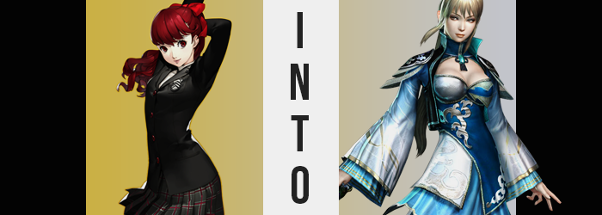

PERSONA 5 STRIKERS

A brand-new game in the Persona 5 series, aimed at providing a sequel while dipping the toes of the characters into a game following the musou, hundreds or enemies on screen, gameplay style that had a very potent following. But alas, because of how the timeline was split by the release of Persona 5 Royal, not every fan favorite character could be included. And their absence? It made some fans upset.

‘Why isn’t Kasumi in Strikers?’ The question was one that many pondered. She was one of the most popular characters within the Persona 5 universe at this point, so it was a heavy pill for much of the fanbase to swallow that she would have absolutely no presence. Many wished for it. ‘I wish that Kasumi could be in the musou game’. But they didn’t consider the possibility that this wish might actually come true.

But not in the way that they had intended.

Kasumi Yoshizawa had been visiting the library after class. She’d recently learned that the senpai she cared for dearly was a member of the Phantom Thieves, and she had likewise awakened her Persona, but as exciting as all of that was, she still had to attend to her studies.

She was more or less oblivious to what was going on in the real world, because under what circumstances would she consider herself to be fictional? The world she occupied, including her friends and herself, were all real as could be from her perspective. The teen didn’t know that there was another world that had created her, or that their dreams and desires for her might soon alter her fate.

But at the very least, she became aware that something was happening… for her Metaverse app suddenly twisted the world around her. “Huh!? Wait, what’s going on!?” She’d been sitting in a modern library, but now? Candle light the only thing illuminating her surroundings, she found herself sitting at a worn, wooden desk midst a large but crudely designed tent.

The tent itself had no floor, only dirt beneath her feet, and what counted as a bed was a lonely cot in the tent’s corner. It seemed to be quite dark outside, so was it nighttime? She sprung to her feet and looked around, quite thankful that she was still wearing the loafers of her uniform. “Is this really the Metaverse? It doesn’t feel…” Kasumi had only been there a handful of times, but every time she’d visited she had immediately felt her skin crawl from the atmosphere alone.

On the other hand, now? It was a little chilly, but it felt like she was still in the real world. Sparing a glance back at the desk she’d been sitting at, there appeared to be a number of papers scattered across the, and the language? “Chinese?” She only knew Japanese and some English, but she knew enough about the Chinese language to recognize it even if she couldn’t read it.

She couldn’t read it, yet the name at the top… “Wang Yuanji? Wasn’t that— Wait, I can read that!?” The name certainly sounded familiar, but since when could she discern it…? It wasn’t all of the text, either. Her inability to read it was still very present upon the rest of the scroll; it was simply the name that ended up translated. But Kasumi was fairly certain that she had read this name somewhere before. A historical text of some sort? Perhaps a game? Either way, it was one of those things that was going to bother her until she properly understood.

As the girl stood, still stunned by her circumstance, her phone’s screen had begun to glow within her skirt pocket. Rather, it had been glowing this entire time, having brought her here. “If this isn’t the Metaverse, then where is this?” The Chinese text, the dirt floor, the tent walls that surrounded her… even the air was much cleaner than she recalled, casting doubt on her even being outside of the city. Common sense would have suggested peeking out of the tent, but she didn’t get that far.

Something had caught her attention. Her bangs. “Huh!?” They appeared thinner somehow, but that wasn’t exactly what had caught her attention. In the beginning she thought it was merely a trick of the light, considering the tent’s innards were alight by the influence of torch and candle only, but… No. “Brown…?” Fingers had reached up to pull a little on the bangs hanging longest, and her mouth conveyed the realization she had been questioning. Her reddish-brown hair, at least as far as her bangs were concerned, had become a sandy brown that framed the sides of her face in bunches.

Slightly panicked by this realization, she then reached back to grab the ponytail she typically tied it all up in, only to realize that it suffered the same fate. In fact, she’d ultimately caught sight of the tail end of the shift, with some of the red fading out before her very eyes. By the touch of her fingers she could identify an additional change though. Her hair? It was thinner, oilier, as if it hadn’t been tended to properly recently… even though she had absolutely showered that morning. That ponytail seemed longer too, and straighter. The natural curl to her hair length had been entirely ironed out, and this showed in her bangs too which were straighter and more evenly distributed.

“This… it can’t be possible, right!?” Hair didn’t just change on its own, at least not without dye and time. It wasn’t something that could just shift before her very eyes without any type of warning, and yet Kasumi was forced to rub at her eyes for a moment, letting that hair go. They had become agitated, and by the time she pulled her hands away they had changed significantly in both color and shape.

They were thinner now and angled more upwards than they once had. It was subtle, but they certainly gave more of an impression of belonging to a Chinese woman than a Japanese girl. Paired with irises that were now of a softer chestnut tone, her cheekbones had likewise lifted, and her jawline narrowed. Were this not enough, Kasumi almost seemed to age, facially, in real time. Skin wore and tore, pores widening and her complexion becoming just a little rougher, albeit more beautiful, until it better resembled that of a woman in her twenties.

She’d felt her skin crawl in that time, and now her hands were papping her face in confusion. “Why does it feel so… Eek!? My voice is different!?” It was much deeper now, which ultimately made it far more suitable for the age her face reflected. On the other hand? The rest of her body hadn’t quite gotten that memo. Well, other than her skin, which had aged similarly to her face more or less.

It was funny how quickly these little mismatches could be corrected though.

The front of Kasumi’s shirt, quite suddenly, began to feel extremely restrictive. Enough that she squirmed, and her right hand was raised to press against her bosom in alarm. “Whoa! Why is this so… tight!?” Considering her hair, her face, and her voice? She had a surprisingly good idea as to the reason. But she also didn’t want to accept it because it was a bizarre thing to think. Was her chest growing?

It was. The pressure was due to her breasts pushing with such might against an ill-fit brassiere that their weight was being crushed against her chest. The front of her jacket looked almost comically pronounced for a moment, at least until Kasumi had the good sense to free the contents before any real harm could be done. Once she unhooked the jacket however, everything else just kind of spilled out on its own.

Given the space to do so, the front buttons of her white dress shirt popped off, giving her bra the necessary leeway to snap clean off in the back. “Oh!”, the young woman couldn’t help but cry as cream-colored flesh ultimately jiggled free, still bouncing as cup size after cup size found further application… until a firm pair of DD’s dangled there, pushing out the sides of her open shirt.

“These are… impossible?” Despite her alarm, as hands gently cradled the bolstered masses upon her chest, she spoke with a more mature calmness that didn’t necessarily match her personality – or, at least, what her personality should have been like. Kasumi had been overreacting this entire time, only to now take things calmly?

And there was certainly plenty of reason for her to have a more frantic point of view. Particularly as her ass swung back to bolster itself with excess weight just as her breasts had. Fat rippled and in turn the skin of her cheeks tightened, the back of her skirt inevitably flipped outward by the greater addition. It likewise tugged down her black tights… before a thickness that seized her thighs pulled them down even farther. The size of her cheeks forced her hips to widen several inches as well, making the fit of her lower wear even dicier.

It was true that her thighs were bloating, both with fat and muscle mass alike. In fact, her body was becoming much stronger in design just in general, not to the point where it was excessive, but all facets of her flesh rippled with the strength of one adjusted to the battlefield… and her body gained various scars that was just as suggestive of it. Not only that, while her nails lengthened and her fingers grew bonier, the nails themselves were chipped and dirty. She felt a little sticky, like she was covered in sweat – so much that her perfume did not completely disguise the scent.

But since when had she been wearing perfume?

“…!?” Wordlessly, it was the woman’s eyes that conveyed confusion as she placed a hand against the nearby table to stabilize her. She’d been knocked off balance suddenly, and for some reason she couldn’t seem to process the cause. But what she did realize was that the scroll she could not read earlier? She could discern the Chinese perfectly. How could she not? She was Chinese, correct? Wait. Didn’t that somehow feel wrong? “Hm…” Her memories felt disconnected, but she was fairly certain her past was one spent in China.

Regardless, the cause of her physical disorientation was caused by a small growth spurt. Four-ish inches were applied to her frame, seeing the woman’s bones stretch until her height better suited her presumed maturity… at the cost of her attire’s remaining fit. Kasumi’s tights now rested at her thighs, and the lower few buttons of her dress shirt, while still intact, her been lifted to reveal her navel. The sleeves of her jacket and shirt felt far too tight.

Kasumi should have been concerned by all of this, but as she lifted a leg to examine the cause as to why her shoes felt so tight (her feet had grown), her cellphone fell onto the dirt from her skirt pocket. “What on…? What is that?” Every modern, teenaged girl should have been able to identify a cellphone. The fact that she no longer could spoke entirely to her age. Not simply the fact that she was older, but the historical age her memories now reflected. Electricity? Guns? Cellphones?

She knew only of flames, blades, and carrier birds.

This was China’s Three Kingdoms era.

Despite the tightness of her clothes, the woman, confused about her current identity, reached down to pick up the phone. But nothing tightened or became disheveled. Instead, the cloth she was adorned in loosened and dyed to become a dress far more elegant and fitting (both literally and figurately) of a lady of her image.

Elegant robes of blue, white, and gold unfurled from what was once a high school girl’s black uniform. Cleavage left exposed, the tightness of the dress’ front was evident in how it squished her breasts according to the undeniable cleavage window in the front. The entire ensemble was just teeming with Chinese inspiration, from the big, flowing sleeves to the tall, embroidered boots. Even her bra and panties melted away, becoming little more than generic wraps meant to keep her most treasured parts obscured in slight from the elements.

“What does this mean for the Wei army?” While her clothing had completely transformed to properly match a woman of her name and background, Wang Yuanji stared perplexed at the small device that sat upon her desk. It was Kasumi’s cellphone, naturally, but any knowledge of the modern era the woman had once possessed had more or less been entirely extinguished.

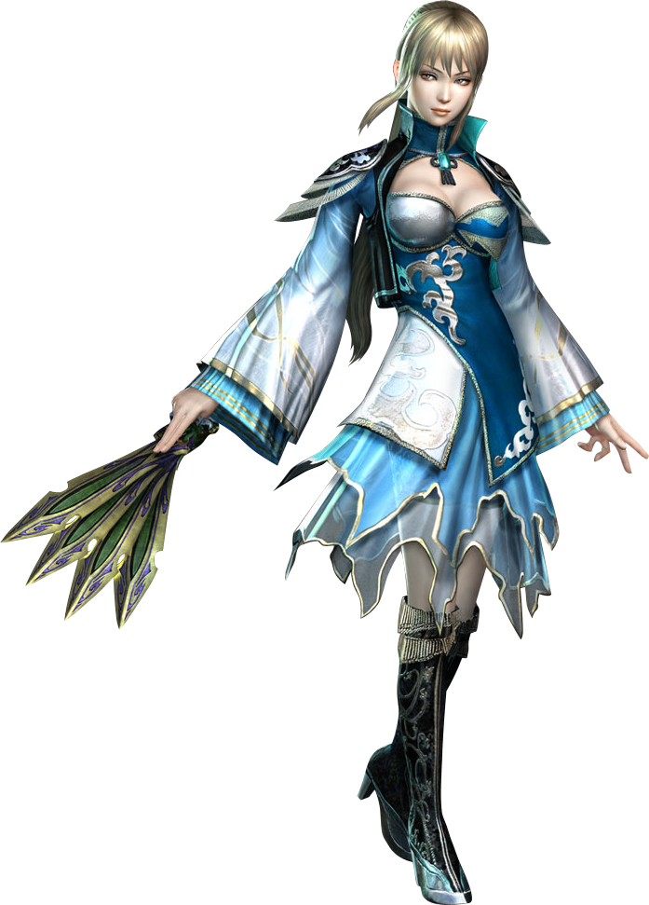
From her point of view now, this object, with its glowing panel, might be some kind of weapon. Or perhaps it was a treasure of some sort? Regardless, it was an important find – one that she might be best taking away from the allied camp she was currently staying in just in case the former ended up being true.

But why here? Why had this item appeared in her tent? The fact that this was how Yuanji perceived its appearance spoke a great deal to how her memories had been refitted to match both her body and her surroundings. She couldn’t recall who she’d used to be, or where she’d come from. Rather, instead she could only recall returning to her tent to turn in for the evening after a strategy meeting with Sima Zhao, finding the item upon her desk.

“This phone… Phone? What a strange word. Why did that come to mind?” Pondering its origin aloud, however, revealed that there were still lingering recollections. Fingers, as graceful as the throwing daggers she danced with in battle, traced the object’s shell with interest. She still didn’t know what that word meant, yet something in her core reassured her that it was not necessarily dangerous.

Yet, before her very eyes? The phone, and the Metaverse app that had brought her here on the wishes of her fans; it completely disappeared. “Oh!?” Wang Yuanji stood stunned, staring down at the spot on the desk the phone had been until just then. A single hand rose to her eyes and rubbed them gently, one by one. “Had I been staring at something?” Just as the device itself had disappeared, so too did the woman’s recollections of it. There was now not a single thing binding her to future Japan – she was now wholly a woman of China’s Three Kingdoms era.

Sighing, distraught with herself for being so perplexed by what was now seemingly nothing, a yawn was delivered elegantly into one hand before she turned her attention back to her cot. Piece by piece she shredded her dress until her body, beautiful as ever, was completely bare, and she slid beneath the cot’s single sheet naked. “The Sima clan will be holding the frontline during tomorrow’s battle, I’d best be well rested for what’s to come.”

She was the trusted caretaker of Sima Zhao after all, and his laziness was something she had to keep in mind when it came to the battlefield. Truly, she wished he weren’t so exhausting.

