*The Serpent’s Lair*

Far below the sun scorched expanse of nameless desert land that laid beyond the reach of most settled territories, a honeycombed network of endless tunnels and chambers ranging from the mundane to the ornate laid abandoned and derelict, sporting mesmerizing architecture and intricate machinery never before seen elsewhere in the world. Only accessible via surface level ruins that were all that remained of this long dead civilization aboveground, only a very small handful of people had ever got the chance to see if the rumors were true for themselves, rumors spread by those who who had seen it's hallowed halls, not as peaceful visitors but as unwanted intruders, recounting the perilous dangers that awaited within, threats that could not be reasoned with and a fate foretold to be worse than death should the demonic entities roaming its halls ever catch hold of an intruder.

For it was not war nor disease that wiped out this seemingly advanced civilization but a curse, one so potent, so ominous, that the caster could only be the gods themselves. For treacherous behavior or because their name had been slandered, no one knew for sure. What was known however, was that the inhabitants, the people of the once proud nation lived on to this very day. No longer human but something else entirely, as a redhead woman from one of the bordering nations up north would soon find out.

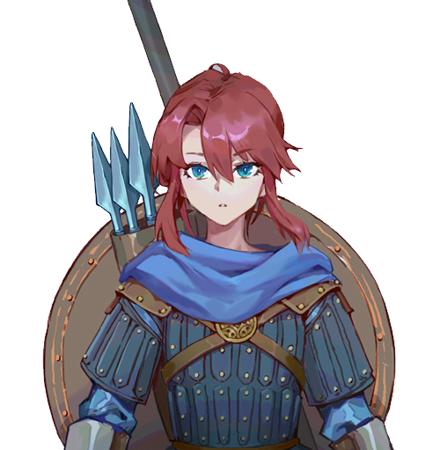

With a body of iron tempered in the bitter colds of her homeland, Enna was one of many nomadic warriors looking to make a name for themselves elsewhere, and until she did, returning to the village was impossible. She needed proof in the form of a trophy and a solid offering, so once she had heard tales of the labyrinthine underground ruins lined with untouched treasure and monsters never before seen, the bullheaded warrior would immediately make for the desert despite the warnings sent her way. It would be the greatest feat to bring home the bones of an unkillable beast, a hope that spurs her through a year's worth of travel when she would finally reach the beginnings of the arid desert far from the eyes of civilization. The stories claimed the beasts were invincible, Enna scoffed at them. In her mind, nothing was infallible, and by the day's end, she would have her trophy. So when she had found one of the many surface entrances that led underground, Enna didn't hesitate to leap down the dark pit after securing a length of rope to its side, unaware of the beast whose lair she was intruding upon.

Unsurprisingly, it didn't take long for her to be assaulted by its resident after making her descent; a large serpent with a seemingly endless body covered in raven scales and adorned in organic, curved metals of unknown make, especially prominent around the beginnings of a voluptuous female torso reminiscent of royalty from the accessories in her hair and ears. Wearing nothing like the shameless harlot Enna thought she was with eyes devoid of empathy, she had caught the intruder by surprise with a tail whip of a strength Enna's body had never felt before, sending the stunned northlander into the wall with a thunderous crack that bounces down the sandstone hall. In one stroke, the sword she had used to narrowly block the attack had been shattered along with the gauntleted arm that held the weapon, but she was still alive, and the warrior spirit within Enna forbade fear as rises to her feet, clinging on to the broken blade with the intent of facing honorable death, not a coward's retreat. Unaware that the arm she had assumed broken had been transformed by the liquid oozing from the serpents body; coated in an oily sheen of cocoa brown skin stripped of muscle and altered to become long and slender, tipped with painted hands not meant for the hilt of a sword but for something else entirely. The strike had not been meant to injure but rather, to afflict her with its transmogrifying venom…but it still hurt like hell.

Instead of another bone crushing whip of its tail, the shadowy serpent flies forward, coiling its serpentine form tightly around Enna before her shaken mind could react with the intent of constricting her into submission. And as its body tightens around the struggling woman, more of its ooze leaks through like a sponge, soaking through cracks in Enna's armor, drowning the drab leather and tempered iron before subsiding to reveal ornate gold in an eager bid to make contact with her flesh. And as it does, the change that had already consumed her sword arm spreads all over her body, creeping upward from the waist down in ebony veins that utterly devastates the warrior figure of the Northland woman, trading muscle for tender meat all while converting weathered skin into oil treated hide painted in colors far removed from her original heritage. By the time her meager bosom explodes into impossibly lewd teats that jiggles with her every breath, Enna was helpless to resist as her captor moves in for the final strike, connecting lips while forcing herself onto the surprised warrior with an overzealous hand already busy teasing the unchanged folds below, enthralled by the sensation of feeling the virgin Northlander's innards conform to her wants as Enna's vaginal walls clamp down on the serpent woman's jagged fingers, embracing it's corruptive touch while her rugged face begins to soften up quite literally, beginning with pillowy lips growing forth from dried, bloodied lips before losing her stern look as narrow eyes widen into beautiful pearls atop the gorgeous visage of an exotic consort, framed by a neatly trimmed fringe of an obsidian purple mane where frayed, flea bitten red once was.

With a muscular tail wrapped around frail arms and the rest of her highly sensitive form bound and enraptured by pleasure, there was no hope of escape for Enna as her back arches inward upon imbibing more of the noxious fluid sliding down her throat straight from her unwanted lover's serpentine tongue, altering vocal chords so her deep baritone was all but removed in place for a voice far soothing to the ears, and with a final prodding of the finger against her womb, Enna's genetic makeup had been completely rewritten. Instead of Northlander children, Enna's eternal body would now carry on the forgotten civilization's untainted legacy if she were to ever be impregnated.

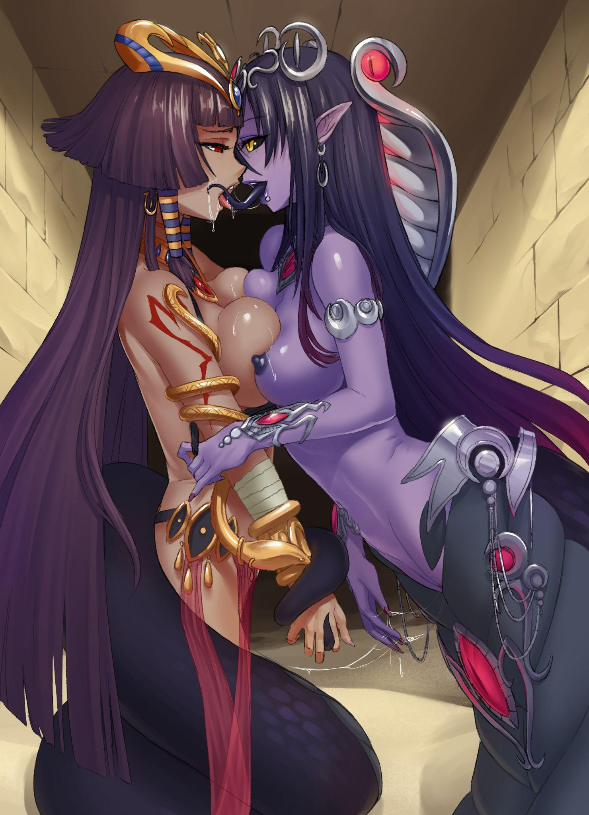

With dripping wet hands exiting loosened lips molded into one meant for repeated use and her befuddled mind lost in the bliss of orgasmic pleasure, the alien tongue spoken in the mature, husky voice of a foreign enchantress that was supposed to be Northlander slang shocks the former Enna, who could do nothing but choke back her words as the serpent parts from their kiss before placing a decorative crown atop her head, whispering words she could now understand all while her defeated gaze remains locked on her new reflection cast back at her in the monsters blackened eyes; a bodacious harlot stripped of her power and identity, no trace of the young warrior she once was in the voluptuous form that had overwritten it, a form her village would no doubt shun. She had failed her rite of passage. And even if she could escape, there would be no help for miles and miles around…

She had come to the underground seeking a prize, arrogant of the danger. And now here she laid, a prize for one of its comparatively kinder residents who only sought the company of another, driven by primal urges that could not be reasoned with as she whisks the humiliated warrior away deeper into her lair for some quality time together her pet would no doubt come to enjoy, for Enna was simply the latest to join the cursed ranks, and with a body built to receive and give pleasure, the following eternity would soon see what little resistance she had left break down against her mistress's voracious lust.

Until the next 'visitor' arrived, Abaso, a name graciously bestowed upon her rebirth from the black sludge, would be the serpent's staple pleasure servant. And instead of seeking rescue, Abaso would only scowl in disdain at the sight of another surface dweller, seeing them as potential rivals instead of hope to return to a place that no longer held any import within her heart thanks to the effects of the curse long having withered away any remnants of Enna cursing her decision to come here…

With hatred and contempt for her captor turned into undying loyalty towards her mistress, Abaso’s days of sword fighting in search of worth and trekking the globe were long forgotten and buried. Her solace, no matter how faux or forced upon her it was, had been found in the embrace of the serpent alongside her many identical sisters added to the fray over the many years as civilized lands encroached upon the previously isolated desert.

*THE END*