ELECTRO SHORTAGE
BIWEEKLY STORY #82
BY CHALDEACHANGE
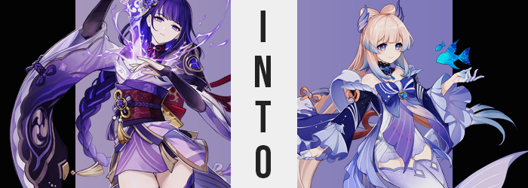

In the wake of the abolishment of the Vision Hunt Decree, it was imperative that relations be restored among the peoples of Inazuma. Between those that supported the efforts of the Raiden Shogun, those who were indifferent, and those that had formed a resistance against them, there were plenty of contradicting opinions that had led to a nation that was divided by more than mere ocean water.

With the looming crisis coming to its conclusion, it just made sense that the leaders of the opposing factions come to terms with one another, but thus far the capital had only sent Sara Kujou to speak with the Resistance – rather than the Raiden Shogun, who should have been the one doing so. But the Shogun had troubles of her own, things that absolutely could not be public knowledge.

Such as the fact that her body was artificial, and that within there were two souls. The original soul, Ei, and an artificial soul meant to do her bigging, the Raiden Shogun in question. The latter personality had been programmed by the former to follow certain commands, and with her mind changed, Ei had learned that these commands did not have a place in Inazuma’s future. Unfortunately it wasn’t a simple thing to just deprogram the Shogun.

But as calls for her direct appearance grew, Ei finally agreed to a meeting. It meant asking the Raiden Shogun personality to remain quiet so that she could keep control, because there was no way that it was in any position to negotiate with the Resistance that opposed everything she had been programmed to stand for. That could have led to an all-out civil war, and they had already come far too close to that happening.

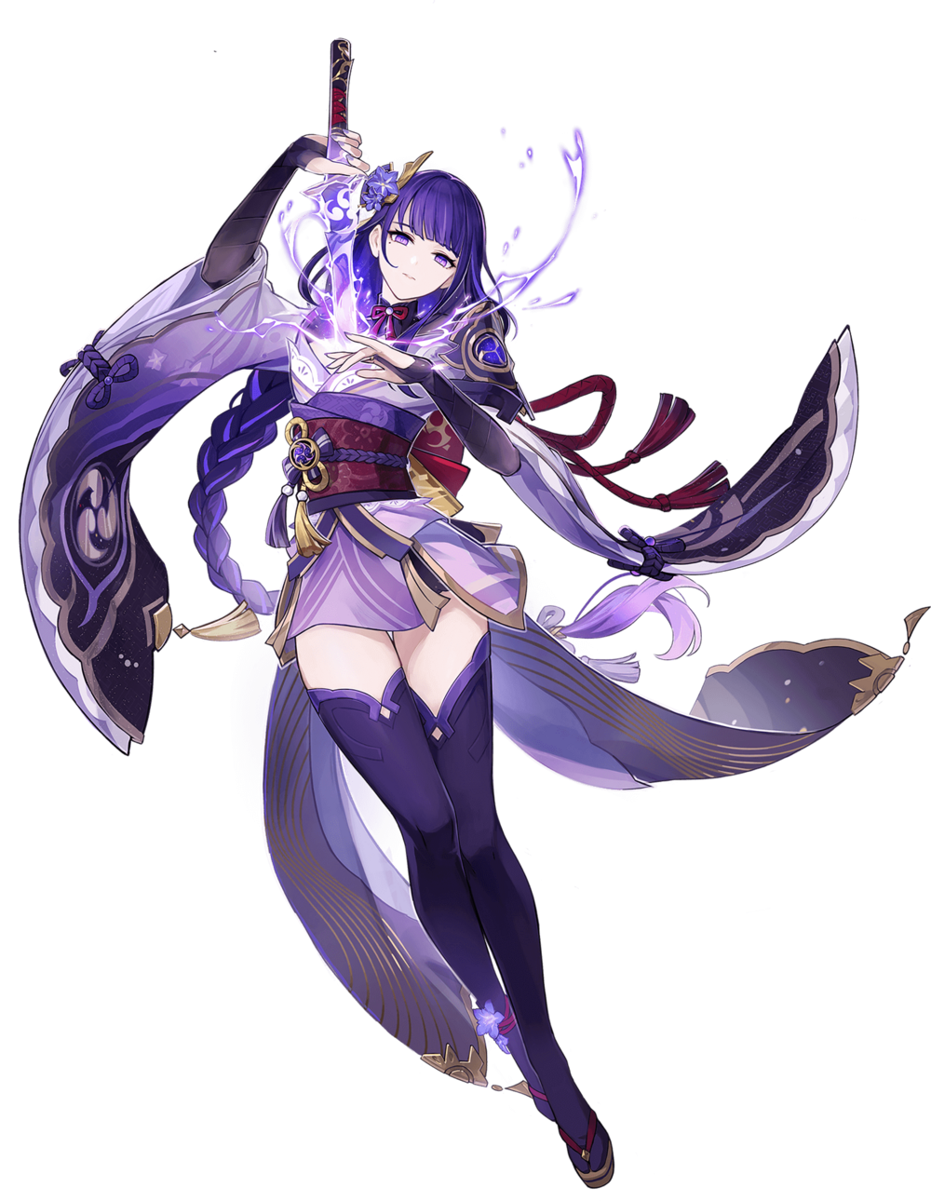
And so the venue had been set, upon a boat in between the capital and the Resistance’s stronghold. The negotiations would be had then and there, but there was a brief respite for dinner before these negotiations would begin in earnest. Because of her own complications Ei had opted to eat alone in her quarters, where a plate of cooked fish was ultimately brought to her.

It looked grilled to perfection, and despite her body being that of a puppet she had given herself the ability to eat. Food was a joy of hers (particularly when it came to sweets), and this fish looked so good that she was willing to make an exception and try it. As she understood, it should have been vetted for poison by Sara herself. There was no need to doubt its safety.

And so, sitting at the warm kotatsu she had been provided, the woman made quick work of her dish. “Mm! I suppose I should send my compliments to the shape. It’s been some 500 years since I last had cooked fish.” Perhaps there was a little bias because of that very long consumption gap, though.

While the meal had not been poisoned, however? That did not mean it hadn’t been tampered with. Not by the Resistance, but by Fatui agents seeking to overcomplicate the situation for their own gain. So, typical Fatui behavior.

With her plate polished off, Ei shuffled upon her knees to take a more relaxed sitting position. “I suppose all that’s left now is to wait for the conference?” It seemed like she was speaking to no one in particular, but the woman had actually posed this question to the second soul that was housed within her body, the Raiden Shogun. “Hm? That’s… strange.” But the woman didn’t receive a reply. Rather, it almost felt like she wasn’t there at all. Which was much more than strange. It was alarming.

Pondering if something was interfering with the artificial body that she inhabited, the woman paid little mind to her body’s actual physical condition. She was not observing her hair, for example, but then again who did when it was usually out of your field of vision? Nonetheless, a simple glance would have been enough to provoke more alarm than what she felt at only the Shogun’s absence.

Because the color of it all had begun to lighten, and not even with a consistent color. To be fair, the tips of Ei’s hair were a much lighter color than the darker full length, but even then the lighter purple presented there turned into a watery blue. The rest of it, however, took a very different color. A coral pink that looked as soft in color as it was to the touch, both complimenting and contrasting the blue at the tips in the back and on her bangs alike.

That said, even the style of this hairdo gradually shifted. Volume piled onto the long, braided ponytail that rested against the floor behind her, and that volume ultimately forced the full length of it to unravel entirely. Now freed, the full length of it spread out to the sides, suggesting it was normally tied up that way. Meanwhile, bangs became thicker and fluffier, layered hair framing the sides of her face like waves crashing against the shore.

“Why isn’t she responding? No mortal power should be able to interrupt our connection!” The issue wasn’t so much that her connection to the Shogun had been interrupted though, as much as it was that the Shogun personality had been removed from this vessel altogether.

With that connection removed, the woman’s eyes softened in both shape and color. A blue that still sported some violet undertones became the dominant color but were definitely bluer than purple. In terms of shape, they rounded to bring about a softer resting expression, something that Ei most certainly wasn’t known to possess. And from that point on? The woman’s very identity was slowly drained from her overall facial features.

Beginning with the beauty mark beneath her right eye, which smoothed out into skin as smooth and porcelain as the rest, Ei’s cheeks both softened and shortened, indicative of her skull’s shape shrinking ever so slightly. Nostril flared briefly, and the overall length of that nose’s bridge shrunk inward to giver a nose that was as cute as a button by contrast. And her lips? They settled into a natural pout and retained a pleasant glossy look, but they did become a little smaller.

Ei herself was at an impasse over what to do, and still hadn’t noticed much of anything other than the Shogun’s absence. “This could overcomplicate the… H-Huh? What’s wrong with my voice? Why is it so high?” Hearing herself speak, it seemed her voice had shrunk to better match the smaller look of her face. If she had ever met with the Sangonomiya priestess before she might have recognized it, but she hadn’t. After all…

When it came to face, voice, and hair? She resembled Kokomi Sangonomiya completely now.

In terms of when she had spoken, even her manner of speech wasn’t quite normal for Ei. It was just a touch more casual and had less of a serious edge – something that was much more characteristic of the priestess she was expected to meet very shortly. “My voice… Is it really wrong? No! It definitely is… Isn’t it?” Why did she not sound sure of it anymore? It was such an obvious change, and yet something deep down wanted her to believe that nothing had changed whatsoever.

If you were to examine the rest of the woman’s body at this juncture, it was clear that the transformation hadn’t been isolated to only her face. Ei always dressed in the same kimono, one that left her ample cleavage bare and the thickness of her thighs plentily apparent. Not because she wanted to show them off. It was just comfortable!

Nonetheless, that comfort was at risk because the body that it housed? Well, there was noticeably less of it. That ample bosom of hers was slowly emptying out, her sizable bust deflating like a pair of balloons that were having the air slowly released from them. While D-cups before, they only fell to the shallower side of Cs – but that was still a pretty dramatic change, all things considered. It was certainly enough to leave her kimono’s fold to hang a little lower.

And when it came to those exposed thighs? The very same ones she was resting on now beneath the cloth of the kotatsu. The end result saw Ei’s sitting height decline because all of the ample meat in her thighs and buns were fading out just as the meat of her tits had. They still remained respectably sized, but that was only because of something that was occurring concurrently.

“Eh!? Did the table get bigger?” Ei had noticed what that something was… kind of. The table hadn’t actually grown bigger, and instead it was the size of her own body that had changed. In the opposing direction, of course. The length of her limbs and torso were shortening, taking her from a respectable height down to roughly 5’3” while standing. This loss wasn’t without benefits, though. Because she was shorter, the weight that had been left in her breasts and thighs actually appeared much more pronounced by comparison.

And her ass? It hadn’t really declined in size all that much in the first place. It remained perky and thematically bubble-shaped. It had prevented her sitting height from dropping a little too much. “Did I… get smaller? Or was I always this height?” The woman’s eyes were strangely glazed over as she looked around the room, trying to decide if something was wrong. As soon as she looked down at herself again, something within decided that something most certainly was.

“Why am I…? What in the world am I wearing!?” Kokomi Sangonomiya cried out after standing, her small body absolutely no match for a kimono that fit her like a set of loose towels. The flowing robes she expected to see where nowhere to be found! “…Wait, no? These clothes are mine, aren’t they!? I’m the Raiden Shogun!”

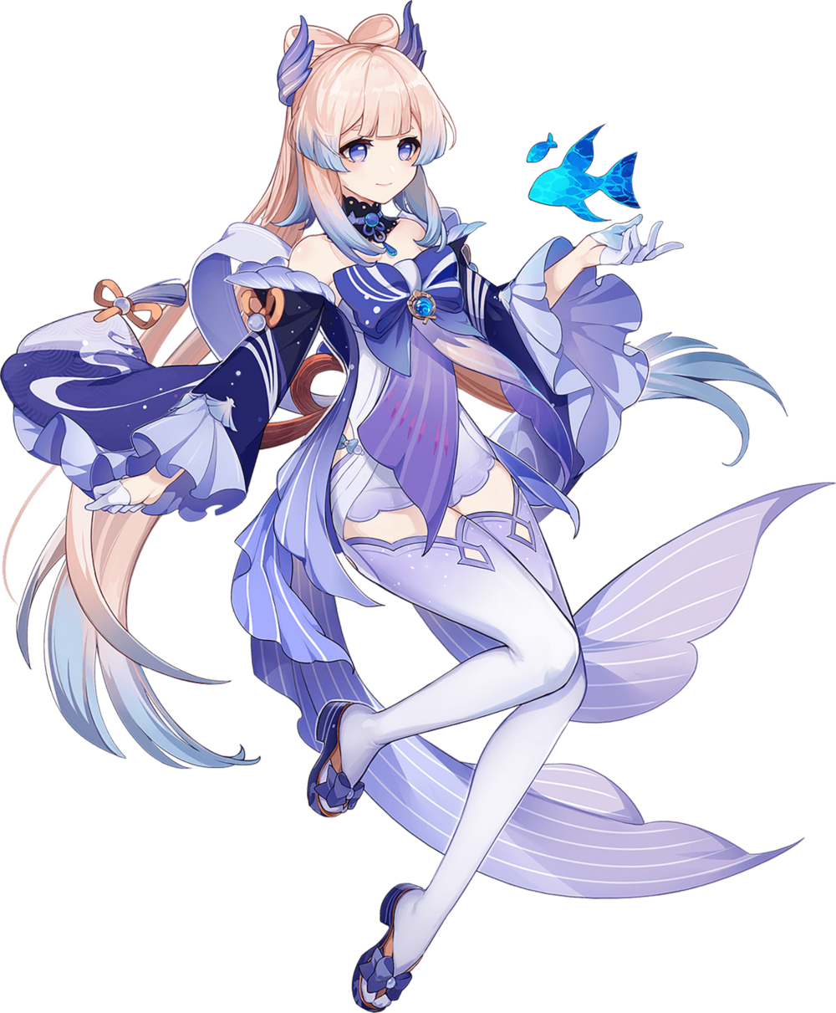
The tumultuous nature of her mentalscape had not been resolved, even with her physical transformation complete. Was she Kokomi Sangonomiya, leader of the Resistance, or was she Ei, the Raiden Shogun? Both felt plausible to her simultaneously, and yet that also absolutely could not be true. This rendered her incapable of deciding what to do.

Regardless of who she was, she absolutely needed a change of clothing first of all. If this had happened to her, then what of Sara who had tested the food? Was it a Resistance trap, or was the real Kokomi succumbing to a similar issue elsewhere on the ship? She was. Kokomi had become the Shogun but was grappling with having another self dormant within her as well. While Sara? She had become Kokomi’s general, Gorou, who had in turn became Sara.

…It would certainly be a chaotic negotiation session now.

