WHAT THE CARDS SAY
FIRST PERSON STORY
BY CHALDEACHANGE
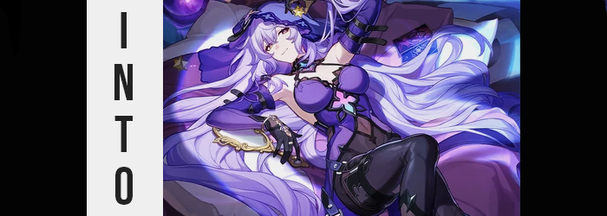

“Please… No more quizzes…”

It really felt like, as of late, the state of the internet was bringing me towards my wits end. Especially in the past year it felt like there had been an even bigger push for ads on the internet. Ads that took many forms, from banner ads to popups to even dropdown ads that were intentionally designed to make it difficult to close them. Being ignorant to just how dire the state of advertisements on the worldwide web had been fairly simple much of my life. Adblockers were a thing after all, and you could hide basically all of them without really needing to lift a finger.

And yet some sites were getting crafty. Putting aside the fact that Chrome-based browsers were planning on eliminating adblockers altogether in the near future (at the time of writing), some sites had opted to just block you from seeing their website altogether if you had an adblocker enabled. It was a practice that I could only imagine ever did any more harm than good to a site’s traffic, but that didn’t stop them from making an attempt. It was something I could usually skirt around. But in this case?

I had to disable my adblocker. I needed information on this one particular website that I couldn’t figure out any potential workaround for aside from paying for a subscription. And I would sooner saw off my own leg than unnecessarily give money to yet another subscription service that didn’t need a subscription model in this economy! But what made things incredibly annoying was the type of ads I was receiving while attempting to browse the site.

Quizzes. Short little quizzes that I couldn’t seem to close until I answered them since they took up my entire screen. “These things need to be illegal! Why are governments just letting these people do whatever they want with the internet!?” I might have been at wit’s end by this point, but even then could you really expect any government to do anything actual useful? No, but that probably wasn’t the point at the time.

I almost smashed my face against my keyboard by the time I got yet another full screen popup. But what stopped me from committing to the bit was the realization that it wasn’t the same kind of quiz ad that I had been seeing all of this time. Rather? It was an animated ad with what looked like tarot cards laying down on a table? “These look kind of familiar somehow… Wait, is this a Honkai Star Rail ad?”

Hoyoverse did have a tendency of advertising in some rather strange ways at times. And those card backs? They looked like the backs of the tarot cards used by Black Swan, a character from the Penacony arc. The only text on the ad read ‘PICK ONE’. I was exhausted by the constant popups, but I was also a big Honkai Star Rail fan. And so I did as I was told. I clicked on a card, and it flipped over, revealing the black silhouette of a swan.

A Black Swan if you would.

“So what was the—?” I had wondered what the ad’s purpose was. Was it to promote new characters? To get people to play? And yet before I could ask my question the ad flashed with light and me? I disappeared from not only my home, but from this plane of reality that we all occupied. Only to find myself standing in a purple void with the card I had chosen floating in front of me. “Huh?” For the second time in what could only have been thirty seconds, I was stunned by a flash of light – this time from the card. But in this case? When the light faded, my location hadn’t changed. I was still within the voice.

But my whole body felt wrong. It was actually difficult for me to even place a finger on how. Was I feeling warm? Tingly? Uncomfortable? Somehow all of these descriptors felt correct but wrong altogether. Everything just felt wrong. Like, from my perspective, my body wasn’t what it was supposed to be. “Oh my…” A reaction even left my lips that wasn’t even something I would have typically said. I was far too casual of a person to speak with such comforting calm.

“Wait, the card is gone. Just what is going on here!? Was this preordained? Preor— Why would I even ask that?” I shook my head, attempting to purge any strange thoughts from within. Those efforts were ultimately interrupted by an uncomfortable stomach gargle though. Was it uncomfortable because of how it felt? Not quite. It was more an issue of what the gargling was a product of and that was something I could both feel and see.

My attention had been drawn down to my stomach. I was an overweight guy, and my gut always protruded a fair amount, and yet? Why was my shirt now so loose around where a bulge should have been? “Did I lose weight…?” I felt stupid even suggesting that aloud, but pressing a hand into the cloth revealed that I wasn’t crazy. My finger pressed into a belly that was now only subtly plumper than a thin person’s gut would be, and I could feel it still shrinking until it wasn’t just trim in weight but subtle toned in terms of muscle.

And these losses had thinned my arms, legs, and face too.

“E-Eh?” My shirt hung down past my crotch now, which was fortunate because my pants were struggling to stay upright now that my legs and my ass were all without their excess weight now. I was more fortunate that my pants didn’t ultimately fall, but it was for reasons I hadn’t pieced together. I could feel those jeans digging a little too intensely into my hips, actually. Because my hips had swung a few inches wider. To the contrary? My shoulders were a little narrower now. “There’s no way I’m thin now…”

It felt like a dream come true, really. To lose all of that weight so quickly without any excess skin or stretch marks? “Wait, why can I picture what my beautiful tummy looks like?” I did have a point. I hadn’t lifted my shirt to see, so I shouldn’t have known what it did or didn’t have. But I just knew it. Like I had seen this new tummy of mine a million times. It’s just one small part of my gorgeous visage, after all. Perfection is apparent wherever you look upon my body!

These thoughts were dripping with confidence which in itself was strange because confidence was something I had always severely lacked, especially when it came to my appearance. But as the seconds tipped by within the void this only became truer – with a great deal of focus placed on my face as my Adam’s apple smoothed away into nothingness.

Every time I blinked my eyelashes crept a little longer around eyes that both widened in shape and rounded in size. My irises inherited a coloration that couldn’t possibly be considered ‘normal’, unless people tended to walk around with violet eyes that weren’t the product of colored contacts. Those eyes were both beautiful and effeminate, and once these traits were established in my gaze they spread to the rest of my face.

I pursed my lips. “Hm? They feel…? My voice sounds…?” On the cusp of commenting about the increased weight of my lips, for they had puffed up into nearly bee stung proportions, I was instead distracted by how soft, airy, and womanly my voice now sounded. And yet as foreign as it seemed? “This feels… right. If I’m becoming a woman, if I’m becoming her… Then wouldn’t that be a good thing?” My cheeks narrowed at the sides so that my jaw bore a more triangular shape, and my nose shrunk a touch until my face promoted an unrivaled beauty and elegance.

One complimented by equally beautiful locks of hair. My short, dark mane swept itself longer no sooner than my facial shift had completed. It all happened rather quickly, hair spilling over my ears and past my shoulders. It thickened as quickly as it lengthened, color lightening to a pale purple that was even softer in hue than my new eye color. This locks were just as soft and fluffy as they were long, creeping as far as the backs of my shins in a flowing but messy style that had an appeal all of its own. Even my bangs crossed between my eyes as if to hide my shrunken forehead.

I didn’t feel panicked by this juncture as much as I felt good. My personality was shifting along with my body, and additional memories made it clear to me just what my ultimate fate would be. I just couldn’t see any issues with this fate of mine. After all, she was extremely pretty and strong. I was extremely pretty and strong. And a pinching inward of my waistline began to set the stage for the dramatic changes that would seal the deal.

“Oh!” Or so I practically cooed as I felt a rather unorthodox tug between my legs. It was a change that was to be expected if I was to become a woman, and so my cock and balls really hadn’t stood a chance against the forces that were repurposing me into this new life as a deep pussy lined my womanly loins. “That was certainly a strange feeling.” I don’t think I could even describe it in a way that would do it justice. Although I couldn’t really linger on it for long, regardless.

Because now that my sex had shifted properly the speed of my physical changes escalated in key places – namely anywhere that you expected a woman to be… swollen. My ass and thighs were key players in this regard, with my previously widened hips evidently being a necessary boon to make this phase of my transformation more comfortable. To set the stage further though? I could see and feel my height diminishing. It didn’t really take me long at all to drop down from nearly the six foot mark to roughly 5’5”.

Skin was stretched tautly around thighs that burgeoned with an enticing thickness, so much so that even with my hips wider they rubbed up against each other between my legs. On the other hand? Cheeks filled the wide rump of my plus-sized jeans, eventually restoring their shapeliness in a bubbled heart shape that pulled them so tightly that the indentation of my ass crack could be seen through it. I reached a hand back to caress one of these cheeks. “These grew in nicely. As expected…”

No amount of cooing on my end could have prepared me for the sensation of the skin pulling around my chest, nor the rising of my nipples, however. With nowhere else to go those nips rubbing into my shirt, highlighting just how much more sensitive they were becoming to the point that I began to feel warm midst my loins. But I controlled myself. Where no weight had been present after my weight loss, it had gathered tenfold as tits jiggled into shape. Perfect, beautiful orbs that were heavier than average but not too heavy. They were just shy of G-cups, and admittedly I wouldn’t have wanted them any heavier.

I gave them a curious squeeze that made me shudder. “But this outfit just won’t do, I suppose. That said, it’s within my means to fix that myself now, isn’t it?” All it took was a mere snap of my fingers to force what I was wearing to glow. It tightened and changed in material and color, and in just a few seconds was reshaped into something I found more appropriate.

A purple veil with a belt hanging from it masked the peak of my long hair, while I was largely dressed in a purple bodysuit with black highlights and a purple halter top. You could literally see my toned navel through a diamond in the center, and I wasn’t really shy about exposing my abundant cleavage. Heeled boots fit my feet neatly, and long gloves fastened by belts warmed my arms.

“Oh dear, so the purpose was to transform me into Black Swan? That’s certainly quite the twist. And one I can’t find it in me to complain about.” Not only was I Black Swan entirely in appearance now but I felt rather at home in my new skin. Perhaps it was my new personality that brought me ease, or the memories that supplemented my new past easing me into things. Of course, the fact that I was now an extremely attractive woman made it easier to accept – feeding into a desire that I’d always had deep down.

Of course I was missing some answers as I stepped out from the void and into the streets of Penacony’s Golden Hour. “But who could have done this to me? And using what means? Don’t tell me it was the Garden of Recollections itself…” Could it have been my Aeon? All things considered Fuli likely benefited the most from recreating a Memokeeper. Had something happened to the original Black Swan? Or perhaps in this new reality I occupied, I simply hadn’t existed in the first place? I had much to mull over, but so little time to do so. “I suppose these are questions I should table for later. I have a Galaxy Ranger to meet before the Astral Express crew arrives.” My knowledge of what happened in the game was overlapping with my new memories in that regard.

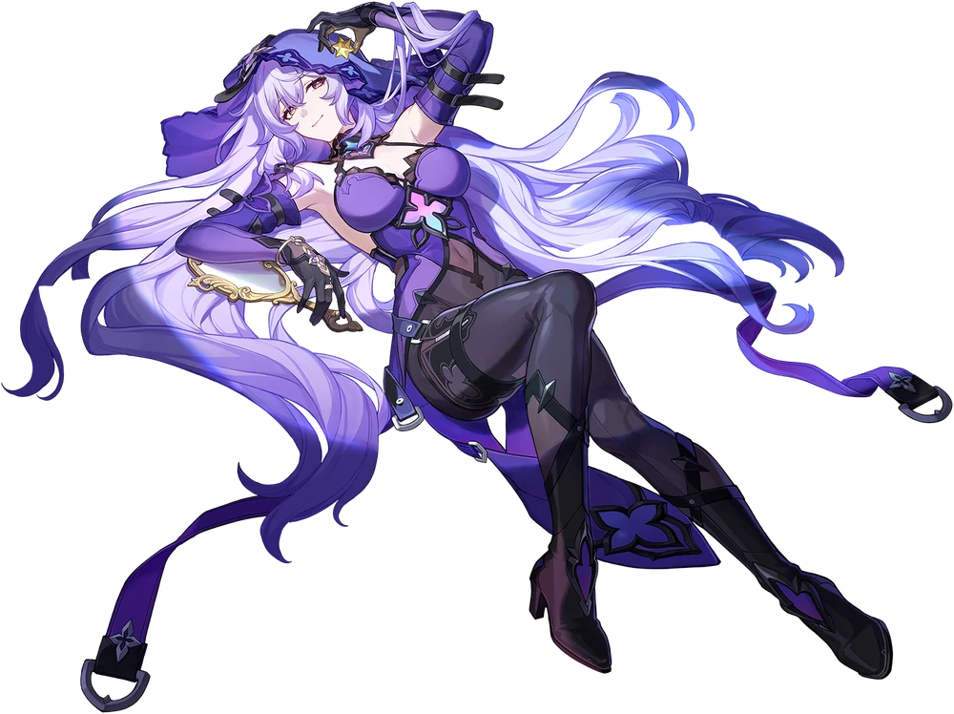

That dance would certainly be one that I wouldn’t forget. For various reasons.

