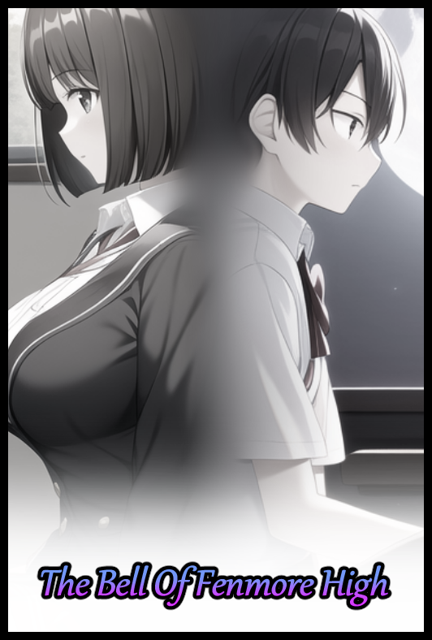

**“It’s freaking cold in here…damn it *Derrick*…when I win this I’m so getting back at you for this…”**

Sneaking in through the front gate was easy enough if one could climb or vault a two meter high wall. Evading lax security guards who had grown soft (quite literally in some cases) over years of tardy standards and no noteworthy incidents to rouse them to action was just as swell…but walking the darkened halls of a silent school alone was something else entirely.

Surreal…isolated…fear…those were but a few of the emotions ***Sean*** had to deal with as he sat deadly still in the chair he had occupied for the past five months as a second year student of ***Fenmore High***. A little known highschool in the district without much to its name that would make any parent eager to enroll their children. But what Fenmore High lacked in educational pedigree and renown, it more than made up for in the form of a ‘decorated’ history that would be sure to entice the younger mind than that of a more sensible adult who wouldn't find an interest in such things.

From the usual horror cliche of a vengeful spirit haunting the girl's bathroom to even more wacky tales like alien beings utilizing a chosen one to carry out experiments for them as a form of recompense, many stories and urban legends found their roots within the hallowed halls of Fenmore High. And in typical fashion, had inspired many to test the legends, to see for themselves if there was truth to be found in the fiction…and tonight, Sean was there to brave one of the school's many myths; a simple yet mysterious tale that told of a strange chime that could be heard upon the tolling of a bell that could only be heard by those who 'languish and loiter'...what that meant, no one really knew. But the main hubbub of the story revolved around the implication that those who heard the bell would soon be greeted by the ghosts of a yore, if the line 'be set upon by phantoms of those who remain' was enough of an indication.

A terrifying prospect to be sure, but on a dare and not willing to call it quits in fear of being made fun of. Sean had decided to see his plan of action through, and with only a few minutes left till the proposed end time of midnight on the clock, the nervous youth's nerves were gradually beginning to calm after hours of tense sitting in the middle of an empty classroom with all his senses on high alert, ears pricked, eyes furrowed and sharp. Seeing as how the requirements needed one to wait in suffering, the closest thing he could think of was to seat himself in the most boring place of Fenmore High…with just a slight smidge of fear from the possibility of hearing a chime ring out to summon the spirits of the damned…and with his friends waiting outside around the school to ensure he couldn't just wimp out without getting their 'seal of approval', Sean was in it for the long run. A run that would soon be over with yet another Fenmore myth put to rest.

But before the cocky student could think of a fitting revenge plan he could subject his friends to for winning the dare, an impossibly loud sound sends a shiver down Sean's spine as his mind tingles upon being touched by the immaterial waves of vibrating air running through him. It was the sound of a bell…but not just any bell, a real one, not the high pitched shrill of a digital tone played out over a modern day PA system or those clackers chimes…an actual, old school bell whose gong felt like it could shatter those who stood a few feet away from it. A glitch in the system wasn't possible, the power was out at this time of night…and as far as he could recall, Fenmore High didn't have the facilities to house such a thing…that is of course, what he *would* have thought if his mind hadn't been left scrambled by the auditory blast of supernatural sound.

Except it wasn't just his brain that had felt the effects of the phantom bells echoing gong, for a split millisecond after hearing it, Sean's posture would tense up for a moment before the world around him begins to accelerate, speeding through time as seconds burn into minutes before whole hours flew by at the snap of a finger, leaving the classroom lit by the distant lights of a dawning horizon while the cawing of noisy birds breaks the silence…but an instant time leap wasn't all that had occurred…



For within that same instance of accelerated time, Sean's figure had likewise suffered its own change; shrinking where he sat while a gaunt figure mellows out with supple indents and gentle curves to form a subtle hourglass figure that had yet to flower to full potential. Exposed once his clothes follow suit as the baggy material rapidly recedes and reforms, spreading out and splitting apart to form the straps needed for cotton panties to align themselves around broad hips once tortured silk consumes the bulge of the young man's pecker, shoving it back inside a wet opening that widens into existence between attractive legs stripped of muscle and hair while securing the bloating cheeks of a filled ass at the back. Finished off once an invisible hand gently prods at Sean's stiff back, molding it to form a permanent S shaped curve that brings focus to the ample butt and budding breasts of a young lady in her youth, a gender inversion made clear as the unseen sculptor morphs the unimpressionable face of an Average Joe into that of a keen eyed gal, framed by a curled bob cut head of brunette that jiggles into existence atop a petite neck supported by smooth, rounded shoulders and slender arms…a packaged wrapped up in porcelain smooth hide and the formation of what would become an exact replica of the Fenmore High's girls uniform. Complete with a matching set of underwear to protect the modesty of the newly formed Maiden sitting upright with a blank look on her face where Sean once was only a second ago.

**"H-Huh…are these…why am I a gi-"**

Before the beginnings of Sean's shrill cry of terror could reach its peak, a second gong drowns everything out once more, sending another spine chilling wave of disturbed air washing over the girl to finalize the fate she had landed herself in for attempting to test the waters, all on a dare…



Just like before, time speeds into a maddening blur. Zooming by dawn to the wee hours of the morning when the first members of faculty would begin to trickle in alongside other key staff and eventually, the many students zipping into the entrance of Fenmore High while Sean, or rather, the young girl he had become, hangs her head low once glassy eyes slowly slide shut once her mind gives in to the irresistible temptations of whatever had laid claim to the feminized student, listening to every 'word' it had to say to her in the subconscious realm in the form of a droning buzz, white noise that rewrites her very existence in the world down to genetics and memory as Sean ceases to be once her childhood memories of rough play are replaced by a pampered one where doll houses and books were all she knew. Applying an appropriately lady-like filter over everything the energetic lad she once was had experienced in his short time on Earth to form a timeline that would fit the plump girl taking shape in the seat as her body changes yet further. Gaining in mass and attractiveness in the eyes of the opposite sex once B cup breasts swell with milk and heft until they were heaving D's while a tight cunt between fattened legs fills slightly, gaining a 'well oiled' appearance as the hormonal experience of jerking off to playboy magazines and AV flicks becomes heated moments of innocent foreplay in bed, going from stroking to thrusting as the hand wrapped around an erect cock suddenly finds itself forcing a rubber rod into the soaking folds of her undulating pussy, flexing in need and torturous desire as the familiar face of a young man floats by just in time for the slamming of the door to snap ***Shina*** out of her hypnotic stupor, looking to the right just in time to catch sight of Mr Weynon, her class' homeroom teacher, stroll on in alongside all her other classmates already seated in their respective chairs…missing the sight of Shina’s skirt shortening itself to expose more of her milky thighs while the last pieces of white vanish from her outer shirt, completing the girl’s uniform hugging her gorgeous body to the point where the spherical curves of her hefty heifers were unintentionally put on show for the lecherous boys to leer at, some of which resonated with Shina as she nervously fidgets in her seat from all the stares being sent her way. Of course they were familiar, she had to bear with them almost everyday after all…why had she thought of them as friends? If anything, she found more comfort in the other girls than most of the rowdy boys. A fact Shina reaffirms herself with as she blocks out their piercing gazes while withdrawing her usual set of writing material and books in preparation for the lessons ahead, no longer caring for a forgotten dare that vanished in the wind alongside anything else pertaining to a second year student named Sean.



But Shina’s newfound disdain for the horny boys of her class and beyond saw only one exception. A certain childhood sweetheart who most definitely hadn’t been the same one to suggest the dare in the first place…but it wasn’t as if either one would care after all. The world had been reset, and as a result, the events of last night had turned out quite differently; with the busty brunette simply going to bed early as she usually would…except this time, she had finally mustered up the courage to send her ‘Darling Dearest’ a request to meet up tomorrow once school was over in the arts & crafts room, a safe spot for meetups between heated and would-be lovers…and the former was what Shina wholly intended for herself and Derrick to become once she had made her declaration of love known to him, putting to rest the conflicting train of thought telling her she had been doing something else the night before, vanishing the vestigial remnants of her former self without notice or worry, eagerly awaiting the final lesson of the day.

Unbeknownst to most, Fenmore High did indeed use to boast a tower from which a bell would be rung, a veritable artifact dating back all the way to the school’s founding. And according to witness accounts preserved only in the memory of the oldest who had walked the hallowed halls of Fenmore in a time long forgotten, the sound it made could speak to their hearts, coaxing desires to the forefront of one’s mind and bestowing within them the will to see their respective wishes through with their own two hands…until an incident had led to the removal of the bell tower many years after it had touched many folk, seeding within the school grounds a sentient will that had, over the course of generations, soaked and reveled in the many events that had taken place at Fenmore High, both good and bad. Stories and legends like the one that had been proven real on this day that would go unnoticed for many years to come…

THE END

*Image Sources*

Images generated by NovelAI