TIDDY OF TIME IV.
PAS DE BOOBIES
MARCH 2022 REQUEST STORY
BY CHALDEACHANGE
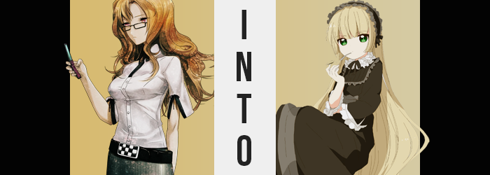

Being one of the members of the Future Gadget Laboratory that hardly had any involvement with the time machine whatsoever, it went without saying that Moeka Kiryu was a little more stumped about her present predicament than anyone who had awareness of it might have been, all things considered.

She had gone against her baser-most instinct when she had accepted the invitation to join in on the girls only party that was going on at the lab. Moeka was as socially reclusive as they came, electing to only communicate with her cellphone unless absolutely necessary. Which was a shame, in a sense. She was a beautiful young woman that, well, would most certainly scare off any suitors as they grappled with her seemingly serious and unfeeling disposition.

Even if that wasn’t the kind of woman that she was deep down, really.

That said, this disposition made it so that she was essentially useless when she was out of her element. She couldn’t really fathom why the other women wanted to spend time with her, at least when she would be essentially dead in terms of social ability. But the woman did owe them a favor, and so despite it all she had attended with the intention of leaving only a couple of hours in. That was the most her introverted persona would allow before she required a very long recharge.

Looking back, she could have saved herself from this situation had she simply not attended in the first place. She most definitely would not have been absorbed by that strange light, nor would she have awoken in a small but elaborate canopy bed within a building she did not recognize. More than panic about this change in location, however, Moeka was more concerned by something that was missing. Her phone! Where had her phone gone!?
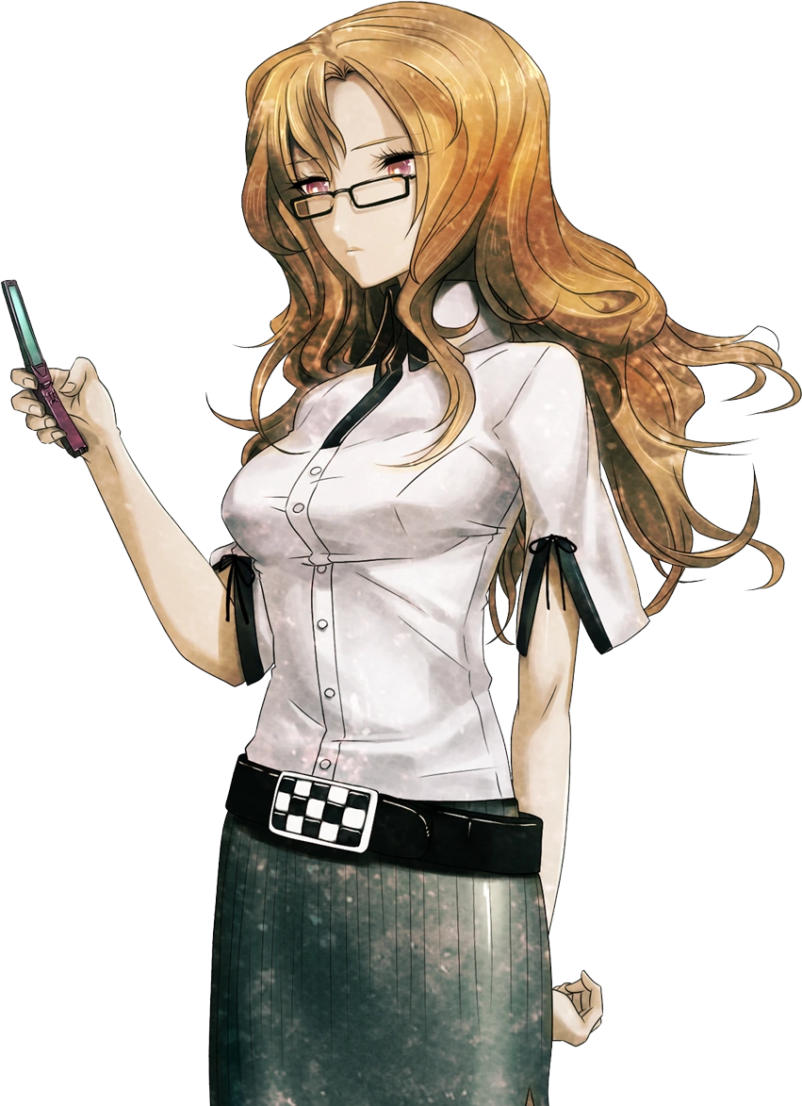
Being her key to communication, the young woman frantically check throughout her pockets in hopes that her cellular device was there and she hadn’t felt it. But her attention quickly turned to the satin sheets that she had been laying upon, and then under the bed as she began to function on the belief that her cell had fallen out and somehow slid underneath the sheets or the entire bed. Searching both of these areas yielded no results, much to her dismay.

The lack of a phone did not coax her into speaking, however. Instead she pushed up the glasses on the bridge of her nose and turned her attention back to the large, seemingly vacant space she occupied. The architecture there certainly didn’t appear to be Japanese in any capacity, instead inspiring thoughts of European design in her mind. Older European, to boot. Was there a place like this in Japan? There had to be, right? She couldn’t conceivably think she had been brought somewhere else so quickly.

And the evening sky still raged on past gigantic, open windows equipped with frillier curtains than one might expect. Truthfully she worried about the idea that she was trespassing and that if she alerted someone who might live there, that she would end up in trouble. But there really didn’t seem to be anyone else around. At least not on that floor. Things appeared to be lived in, however. Tea left in a set upon a small yet tall table, outfits that had been pulled from an ample closet that struck a chord with the gothic Lolita style…

Not that these outfits seemed fit for an adult. They were so small that they looked to better suit a child. A child couldn’t be living in this castle of a manor all by herself, could she? Moeka wondered, but didn’t once raise her voice to find out. Wouldn’t it be even more suspicious to be found in a child’s home uninvited? That was trouble that she didn’t much care to be involved with, certainly.

But she had yet to realize that she would be fulfilling that role herself, even if it wasn’t exactly the role of a ‘child’ like she had assumed lived there.

Moeka was already under the influence of this place and time, the young woman displaced from both temporal spaces beyond her notice. A modern Japanese woman did not belong there in any capacity, and so that the flow of time would continue on as it was meant to, changes needed to be made. Not to the world around her, but to the woman known as Moeka Kiryu herself. By the time the process was complete, she would not even realize she had been changed whatsoever. It would all just be normal. Just as it had been for all of her peers that had been cast about the tendrils of time. No world lines could possibly be allowed to stem because of the time machine’s unfortunate malfunction.

This assimilation, in fact, had already begun, but Moeka was left puzzled and confused by its effects. After all, they prompted her to remove her glasses – because the vision that had been enhanced by them had somehow grown blurry. “…?” Holding the steel frames between her hands, she was left beyond confused. With the glasses removed, the blurred vision had gone away. Which could only mean one thing, really. She didn’t need glasses anymore? How was that possible?

Left to deliberate this, the young woman was ignorant to the possibility – and fact – that there had been some manner of physical indication that something had, well, happened to her eyes. Which there most certainly was, and several strange adjustments had been left at that. The first was the matter of the colors of her irises. Almost a peach-like brown under normal circumstances, speckles of a teal green had seemingly burned in among them, and quickly overwhelmed the original color to replace it entirely.

Were that all, then her circumstances quite possibly could be likened to just wearing a pair of colored contacts (despite the fact that this color was truly legitimate), but that wasn’t really all. In fact, the shapes of her eyes overall were growing, with pinched corners rounding out and leaving those eyes larger and more naturally expressive. That said, they were not suggestive of the Japanese heritage she was expected to have. Nay, instead? They appeared to be undeniably Caucasian, most likely European.

Pourquoi can I see without my glasses? Still adverse to the idea of speaking aloud, internally Moeka was still fixated on the strange phenomenon that had happened with her glasses. But taking a peak at her thoughts at this juncture also revealed something else. They weren’t fully in her native language, and it seemed that French was slowly being mixed in beyond her ability to notice.

Although rationally? If you were to take a look at the young woman’s face then perhaps you might not see it as being that strange. Her now notably non-Asian eye design aside, it was something that seemed to rapidly be affecting her face as a whole. The shape of it all became quite rotund, and yet not in a way that seemed chubby or anything. Youthful appeared to be a much better descriptor, particularly as telling signs of adolescence seeped in with soft skin and lips that were thin without any real weight to them. It didn’t exactly make Moeka look like a child, not with her build as it was, but it certainly gave off an air of childishness.

And no longer was there even a pinch of Japanese design to her features.

While she had been wondering about her vision, the young woman soon found herself squinting at the glasses between her fingers. “Lunettes?” And finally breaking character, she spoke the word for ‘spectacles’ in French aloud to indicate her own confusion. She didn’t wear glasses, did she? And even if she did, she had never seen frames nor craftsmanship like these. They almost seemed like something out of another world, or another time. “Mais these are ma lunettes?” She could keenly remember them being hers, but when had she purchased them?

Plagued by uncertainty, the woman was just distracted enough to turn a blind eye to the fact that change had continued to sweep across her form. Now fixated on her hair, those light brown locks soon dangled down towards her waist after typically being cut just past the halfway point of her back. They actually fell much farther, all the way to her ankles, and if her height were to change? So would their length to retain that positioning.

Moeka had taken her eyes of her glasses for just a moment, and the next she knew? She had inserted the tip of one into her lips. Or that was what you might have expected, but in truth? The issue with her glasses was no more, and instead they had been transformed into an ornate, white pipe that she had begun to idly suckle upon. It felt stimulating, and that stimulation found her mind acting in a fashion that was unusually keen. It was like every detail in the room was now known to her, and every idea she had was explored down every possible route simultaneously.

These thought processes were not only abnormal, but she appeared to have forgotten about her earlier dilemma.

No sooner than she had began to draw on the pipe did a new color wash about her hair. Beginning in the roots, a gentle blonde whisked all of the way down to her tips, which curled ever so slightly despite straightening the look of it overall. When it came to her bangs, they rested just above her eyes and were drawn all the way across her forehead like curtains, while on the sides they softly framed her rounded face. The color could likewise be found in her brows and loins, but in either case there was not much there in terms of hair.

“I m’ennuie!” Whether it was her thoughts or her words, the maiden was now essentially speaking entirely in French. And so her speech from this point on will be translated into English from the get-go. But, as she had just expressed in one final mishmash of two languages, she felt bored. Restless. Her mind was working a mile a minute, but she had nothing to point that intellectual strength at.

For a brief moment, it almost seemed like she did. “Ah!?” Because the feeling of inertia had strangely taken hold, and for but a passing period she felt like she was falling despite still being rooted firmly on the floor of her mansion. But no sooner than it happened did she find that nothing was strange. Well, nothing strange other than the fit of her clothes. “When… did I put on this awful mess?”

What the girl had registered briefly was not the process of her falling, but of her stature diminishing with little regard for the Moeka in question. Whether it was her limbs, torso, or even her head – it had all collapsed, rendering her at a height that was much more suitable for a child. Even though she was chronologically in her teens at best. Ultimately, she had been rendered no taller than a meager 4’7”, and that had played havoc upon her outfit.

Her flat, green skirt had slid right off of hips that had narrowed for one, with panties dangling off of one side for dear life. Just as her height had been peeled away, so too had her more mature figure. There were no thighs or even much of an ass to speak of, it all appearing quite waifish by contrast to how she had appeared before. This was also true of her chest, which had emptied until her bosom was hardly more than a promise without much in the way of substance, and so her white blouse hung off of her miniature build like an oversized sweater.

“I have never seen clothing of this style before! Where could it have come from?” Tiny hands flailed about, and shrunken feet slid right out of her socks and footwear as the girl attempted to comprehend what had transpired to dress her in such a way. But the thought was quickly shoved from her mind, as the material that was strung about appeared to tighten and rebind into an entirely different ensemble entirely. A black, gothic Lolita dress with tiny heels, and the appropriate matching headpiece.

She had no qualms with this outfit.

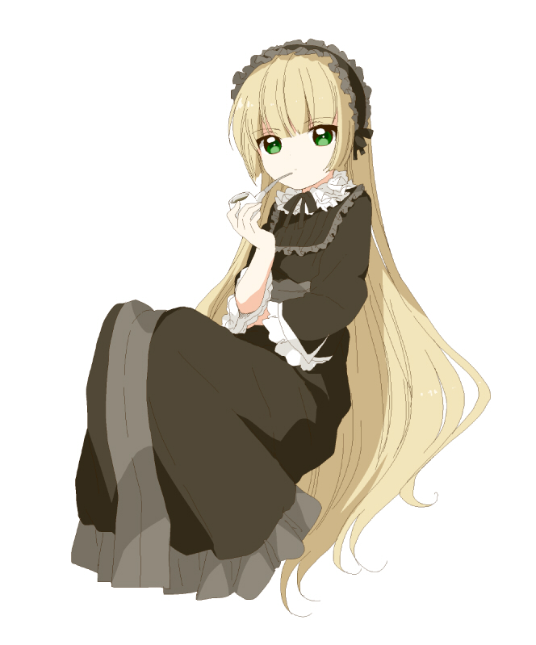
The bright emerald eyes of a girl who appeared to play the part of a child blinked, yet their glow did not sport the same immaturity that one might come to expect of a girl of her build. The truth of the matter was that she was in her teens. Only in the middle of her teenaged years, but a teenager, nonetheless. They waifish build of her body was from a deficiency… or could it perhaps be called a boon? Regardless of how you would describe it, something ran through her veins now that couldn’t quite be considered conventional.

It was the fault of that something that left her mind so active. She felt far more intelligent than a typical fifteen year old should have – and in fact she knew that she was far more intelligent than a typical fifteen year old. Because Victorique de Blois understood that she was exceptional. She was an expert at solving mysteries, she would have you know! But while she came off as cute and innocent through appearances alone, when it came to her demeanor…

“Hmph! Where is Kujo!? He told me he would stop by for tea, but he’s late!” New memories that had bled into her mind as her transformation had ensued were communicated with the same complicated personality that had taken root throughout it all. While Moeka was never one to speak without a purpose, Victorique, speaking French, was openly noisy. She did like to hear herself speak, but something deep down hoped that her words would summon her Japanese friend sooner.

It didn’t. He was simply running late! “Mon dieu… Today has been so boring.” Had it been? Perhaps from the perspective of one that didn’t realize she had been flung back in time to the early 1900s and had been turned into a young French lady it might have seemed that way, but not to an onlooker. From what she could recall, it had been a day of chores. Cleaning up the de Blois mansion – or at least the rooms of it she used – and having tea all alone. Such mundane activities did not stimulate her exceptional mind.

And she had come to rely on Kujo to entertain her. That said, their relationship had been becoming rather… close as of late. Victorique wasn’t quite sure what to make of what he had been forcing her to feel, but surely it was just an error of some kind, oui? He was the one light in a life that otherwise felt dreary, and then she constantly lived in fear that her existence would eventually bring about tragedy.

With a sigh, she draped herself over a chair before the table she enjoyed tea at, twiddling her thumbs rather absent-mindedly. Victorique hardly knew that her old self, Moeka, would never have desired the company of another like she did Kujo. It was a testament to just how different the two of them were in the end.

“…He had better hurry up.”

