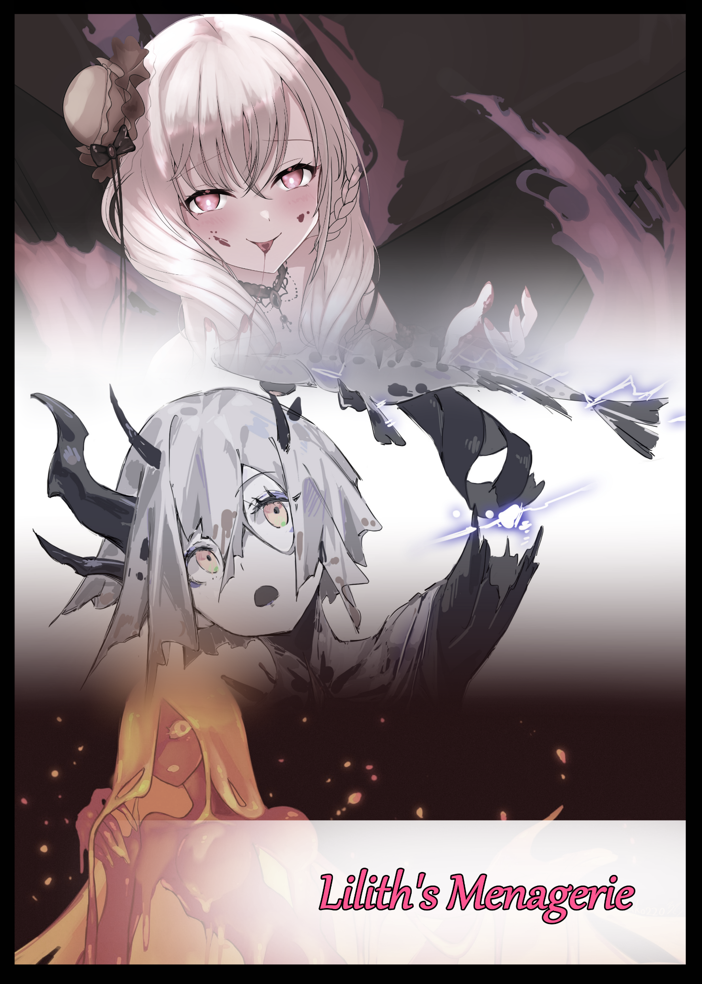
Glaring down from her vantage point on the second floor at the crowd milling below her with calculating red eyes. The mistress of the house strolls silently past more guests loitering around the banisters and guest rooms, all dressed in outfits depicting creatures from folklore and myth, ranging from simplistic horns to comical full body encompassing suits. To them, it was a small price to pay for an evening of fun to be had drinking and socializing amongst some of the most influential people in the neighborhood. But in her eyes, they were all juicy resources ripe for plundering, every single one; from young working adults to university sophomores, had unwittingly fallen into her trap.

It was so easy to lure one of those frat boys, bribing him with shallow gifts, enticing him with empty promises, and soon enough, he was hers to do with as she pleased.

With one of the college's most notable reps amongst the student body spreading word of a lavish party being held over at the wealthy district where the rich and glamorous lived, it didn't take long for a group to come forward. And when they heard the price of entry was to don one of the many provided costumes at the party venue as tribute to the Halloween season, that number soon exploded.

Now they were all here, milling about, enjoying the food and drink, none the wiser that for many of them, this would be their last time enjoying the taste of regular human food.

For the 'owner' of this house was inhuman, a being not of this earth. But she wasn't just some malicious entity from another realm looking to cause mischief, she was a Queen…a Demon Queen. And her name was Lilith.

Taking advantage of the human's custom of Halloween. Many demons like Lilith sought to consolidate power during the month where creatures of myth and legend were used as costumes and subjects of art, lending an air of innocence to the otherwise ferocious creatures they were based on.

For Lilith, her plan was simple; to gather, twist and corrupt as many human souls as she could, pumping them full of daemonic essence until they were demons themselves. The queen however, had gotten bored after her ninth batch of Succubi, she wanted more, sought new experiences, new genomes to vary the breeding stock with. And in all her time spent on Earth, she had only recently been alerted to a strange trend amongst the humans where artists proficient in the erotic arts fashioned amalgamations between human and animal akin to the sirens spoken of in sailor's stories, labelling them monster girls. To Lilith, it was a stroke of genius, realizing that, with a little bit of help from some of the Netherworld's most nefarious minds, she could make these dreams a reality.

After making her commission to the eggheads down under, they had returned to her with a sample product that initially left her disappointed. Some flimsy plastic outfit of sorts made in the likes of a well known monster girl that took heavily after the Hellhounds that guarded the castle gates above. Seeking to test it, she had invited the only pawn she had at the time after making sure he had sent out the invites for her gracious party.

Needless to say, the results were satisfactory, so much so that she ordered an entire dresser's worth of costumes based on different creatures recorded throughout all the known realms. Keeping their cheap look to aid in the false sense of security it provided to those doomed to wear it.

Now over half of those costumes were being worn by the humans that filled the halls of her temporary abode. Skin tight traps waiting to be sprung with but a simple command.

But Lilith considered herself a fair individual, both in terms of appearance and the way she presented herself to those who saw her; enemies, friends and victims alike. So tonight, she would give these humans a fair, fighting chance to up their already miniscule chances just a tad bit higher…one thing was for sure though, the pet Hellhound girl kneeling by her feet that morning would not be alone for long once the night was over and Lilith returned, bountiful harvest of subdued souls at her beck and call.

With the arrival of the witching hour and her guests thoroughly intoxicated, Lilith raises her hand high in the air before snapping her fingers, triggering an instantaneous cacophony of human voices in pain, groans, screams and cries of agony fill the halls as bodies keel over, vanishing under a tidal wave of living latex while others resist, managing to retain their physical self amidst the searing pain caused by the costumes beginning to fuse with their bare hide after eating through whatever clothes they wore as shiny rubber becomes sturdy scales, permeable amphibian hide, avian integument or buttery smooth skin while lifeless filling and protecting underlayers merge with flesh and blood, strengthening weak human meat, augmenting bones and altering genetic structures.

Very soon, the grating sounds of suffering give way to a sonorous melody of pleasure as pain is replaced by arousal, fueled by amped up libidos and overly sensitive skin flaring with nerves all connected to the transformed victims pleasure centers as the partygoers were finally given the reprieve to view their changed bodies, some with abject horror at the loss of their manhood and other miscellaneous bits while others took glee in the fact they had breasts the size of melons hanging off their chests. Although Lilith was sure those smiles would be knocked off their faces once they heard what she had planned for all of them.

Within seconds, the entire human population within the borders of the two story bungalow had been cut down to zero, replaced by a gathering of anthropomorphic characters that were all women of various sizes. No matter who they once were, everyone had been turned into monster girls based on whatever costume they had been wearing at the time, warping beefy jocks into impish goblin females and buxom Scylla broodmothers while pompous sorority members became a collection of buff Minotaurs and viscous Slimegirls that no longer bore any resemblance to their old appearances they so vainly cherished.

And in this assembly of inhuman women, all eyes were quick to turn toward the only one there who seemed to retain their humanity, smiling down at them all with a toothy smile before her human shell peels away to reveal the Demon Queen in her full splendor; clad in an elegant dress that matched the coloration of her ashen gray horns jutting out of her cranium in a half halo before surging straight up into wicked impalers, framing a phantom head of snow white hair that stands out from the moody vibe of her attire, scanning her soon to be royal retinue with analytical eyes before a warm smile breaks her firm lips, liking what she sees despite there being a few stragglers who had yet to succumb fully to their physical transformation. Kinks in the system she could simply send a report back to her hardworking demon scientists for analysis and fine-tuning. Pouring herself a glass of fine wine before turning to address her uneasy audience, issuing unto them a challenge, one where their very identities were at stake.

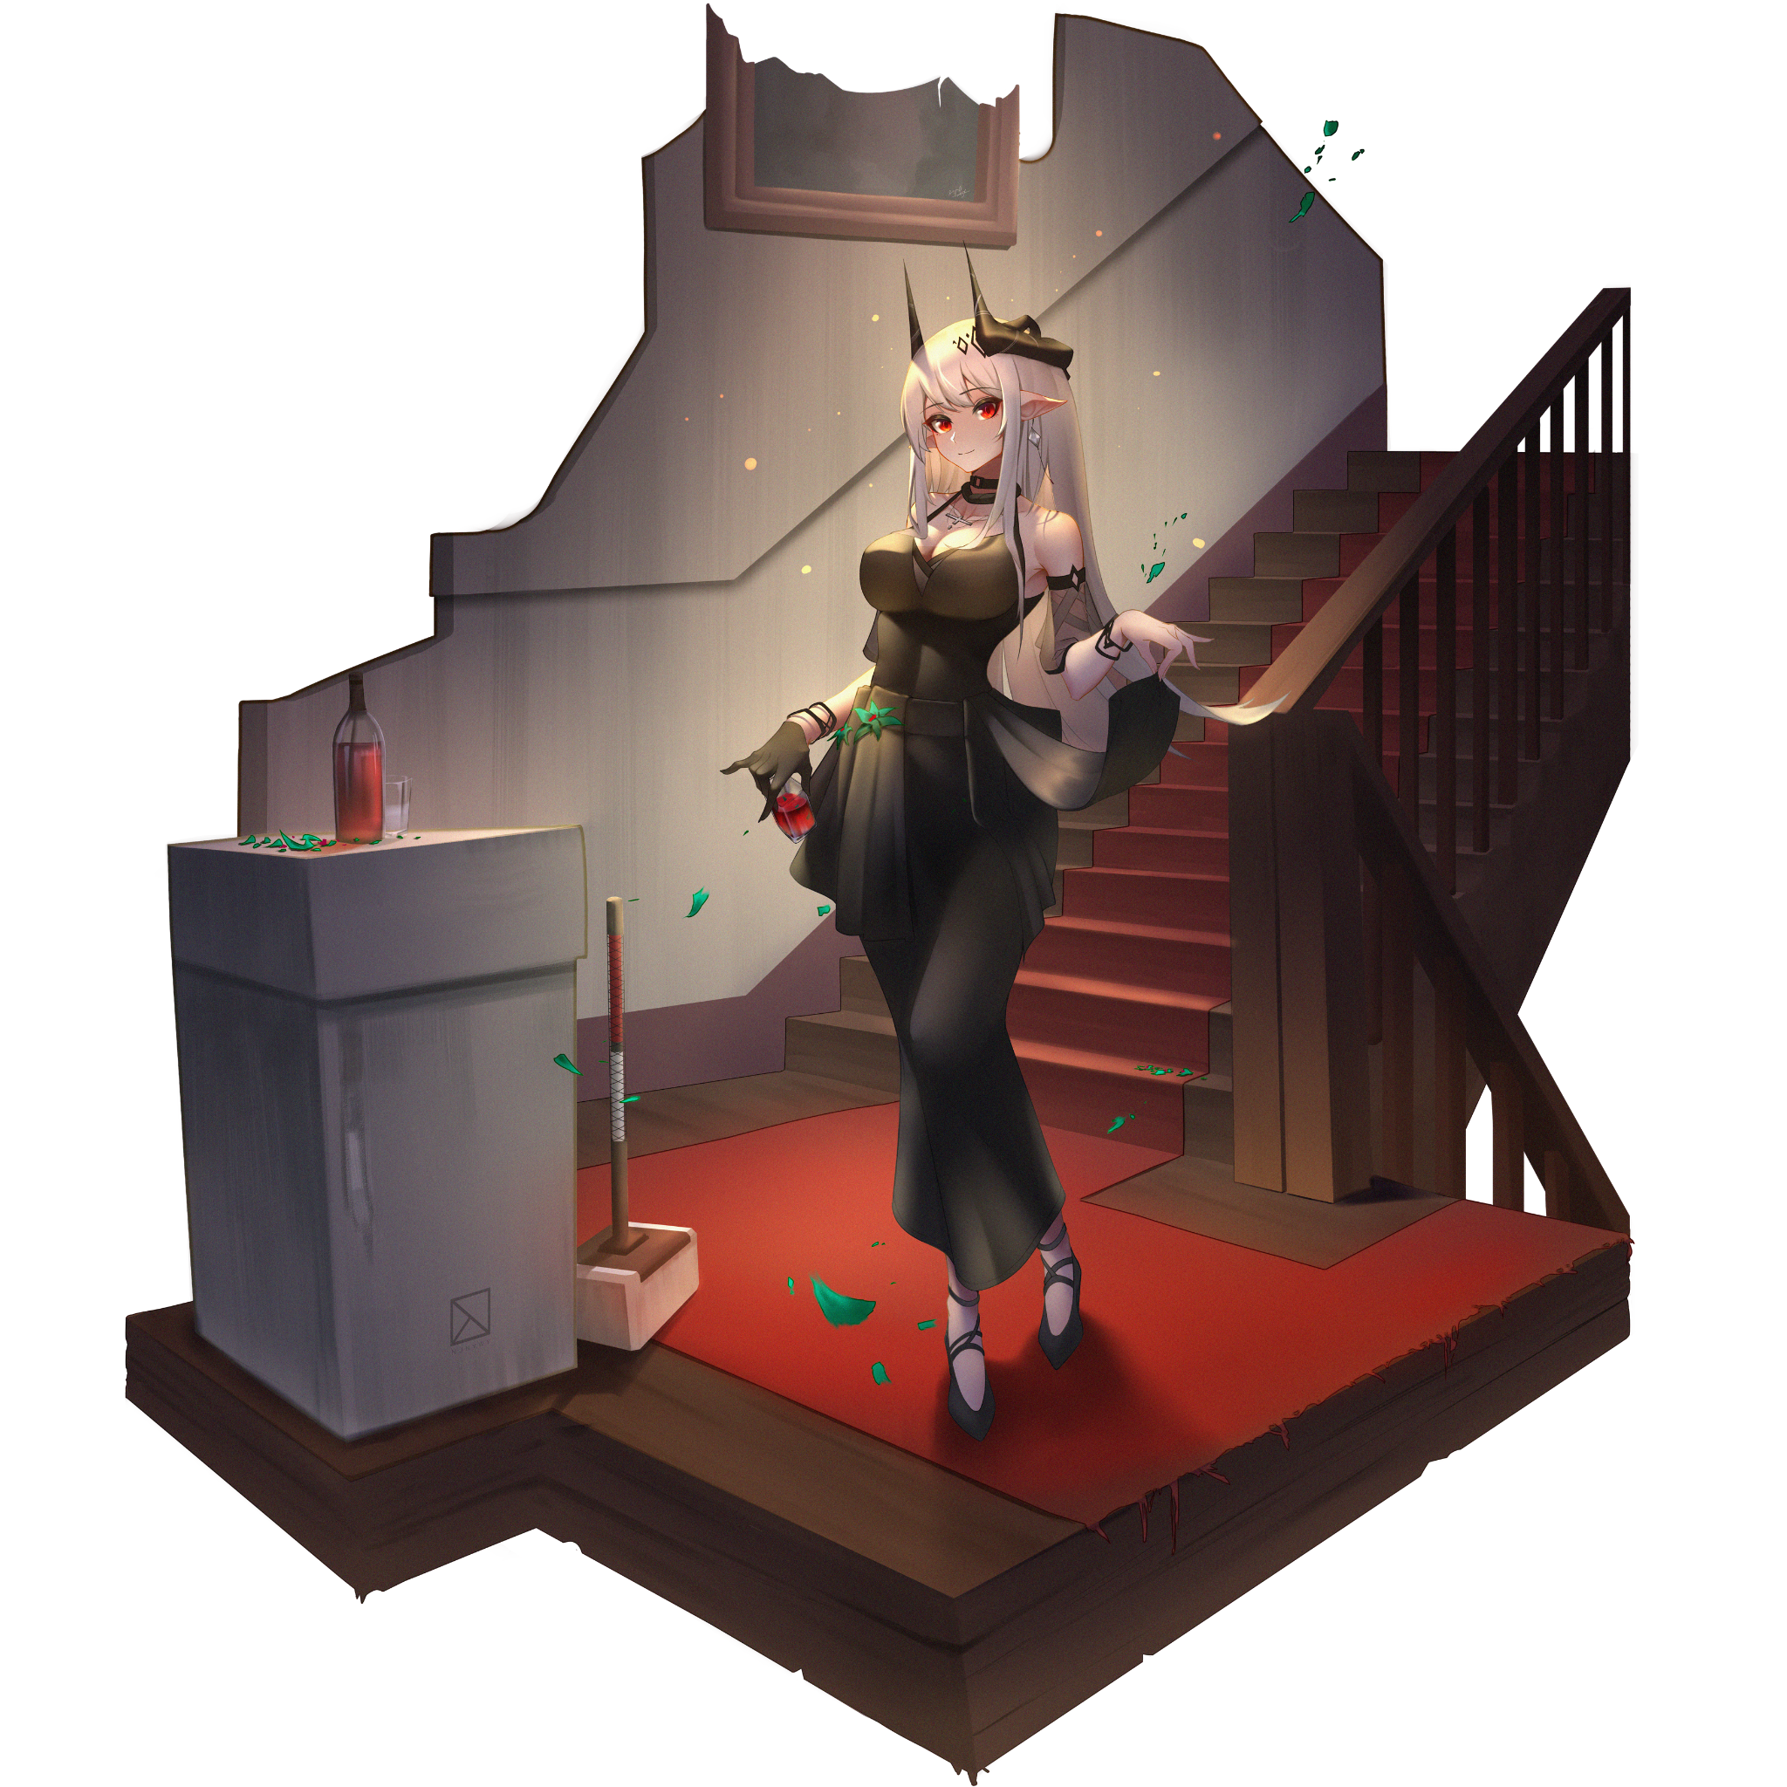

“O dearest subjects, I am delighted to see so many of you here on this most auspicious evening…however, I regretfully must inform you all that I am sorely needed elsewhere to tend to more important matters. Worry not however, for those who wish to come with me simply need give in to the sweet lullaby of subjugation all of you shall soon come to know…or feel free to struggle and resist. If by the time dawn breaks and those who want no part in this keep their sense of self…then they shall be free to go…until then my darlings~"

A snap of the finger and a thunderous boom followed by a blinding flash of light, and the Demon Queen had vanished, nowhere to be seen. Leaving scorched carpet and a bungalow full of confused monster girls who were at a loss for what to do as a steady uproar begins as they fall into chaos, bickering amongst each other with panic on everyone's mind once those who try to leave realize there was an invisible barrier keeping them locked inside with no hope of escape. Forgetting about the food and drink they so happily indulged themselves in earlier as they scrambled to find a way out while others broke down, unable to get over their drastic physical alterations.

Amidst the chaos, a silver haired vampire races toward the bungalow, trying to keep their cool despite the degrading situation with a plan in mind to get her her friends and wait out the night. But as they would soon find out however, no amount of planning could prepare them for what was about to happen next…

Safely back in the comforts of her throne, Lilith reclines into her chair with a satisfied sigh, watching the chaos unfold through an all seeing crystal display levitating before her. Although she did say she would be back at dawn, something told her she would have to return much sooner than promised considering how fast these humans were falling to their individual bodies, watching as the undead and inanimate women go first followed by the other, more resilient races who still had the benefits of flesh and blood bodies.

-

This night was simply the best; hanging out with Fiona, one of the most sought after girls from his university course while his buddies mingled amongst the bustling crowd of costumed party goers in the rich kids playground. Enjoying the food and drink, playing party games, the usual things rowdy youth like them enjoyed.

It had all been so fast, so sudden, that Malcolm barely had time to set his drink down when the first yell rang out before his skin started to burn and his muscles began to bunch up, forcing him to kneel just like all the other guests as their bodies were invaded by the outfits they wore.

For Malcolm, his was a simple outfit consisting of a set of ear extensions and detachable fangs connected to his canines, but for the others less fortunate enough to be wearing full body gear like the girl he'd just been talking to wearing a faux fur werewolf suit, he was greeted with the sight of her rolling around on the floor as synthetic fabric bonds with bare skin, dyeing her khaki tan hide a leathery black while thick tufts of fur emerge, covering her all over besides her palms, now sporting wicked claws formed from manicured nails and legs that painfully snap into a triple jointed formation, forcing an animalistic whine of pain from fanged jaws as her face lost its feminine innocence for fierce ire, serpentine tongue flicking in the air.

But his attention would soon be diverted back to himself when his neck suddenly became too heavy to lift, or rather, he no longer had the strength to do so, falling flat on a softer chest with an unusual pillowyness to it all while his jaws began to sting with an unbearable fire he could do nothing to quell, feeling invisible drills bore into his upper jaw while his ears began to pinch and elongate as cartilage becomes one with rubber.

With a feverish haze taking hold over mind and body, Malcolm's skin begins to shimmer, not because it was coated in a thin layer of cold sweat, but because it was becoming so; losing its lively pink hue for a deathly shade while calluses, scars and other such 'blemishes' fade away under pristine skin of a smoothness unheard of, far softer and pert than the girl in front of Malcolm before her skin had become leathery and layered, with hints of gentle softness present only in the pink pads beneath her paws and the multiple sets of mammaries hanging off her chest as the once petite girl finishes her transformation in a shaggy she wolf, collapsing onto her side with a thud and a feral whine, panting heavily with half lidded eyes struggling to remain open, furry tail flopping weakly behind her muscular rump. The exact opposite of what was happening to Malcolm as a sudden spine collapse forces a womanly scream out between soft lips painted a natural pink, sharpened canines glinting in the moonlight, pointed tongue spraying saliva into the air.

Within seconds, Malcolm's strong body, one honed from years of playing ball for all the schools he had attended crushes in on itself like a blocky caricature instantly being rounded out into a soft sphere with all edges lost through explosives in an instant. Leaving behind waifish limbs bereft of musculature, tipped with petite arms, gentle fingers and feet worthy of Cinderella's glass footwear. And in place of his abs, breasts would begin to nurture from their former A cup pudge, rubbing swollen pink nubs across the cooling blades of trimmed grass beneath, driving his mind mad in turn with lustful vigor as each attempt to crawl forward only fuels the fire. It was like every single nerve in his body had been amped up and rewired to his pleasure centers, feeding the scratch of stone against his knees, the chill of sweat beading across his skin and turning it all into some repulsive sensation that made Malcolm grit his fanged molars in a mix of denial and thrill, eyes struggling to remain focused as they dilate and burn a brilliant shade of crimson, pupils warping warping into feline slits.

But in this amped up state, Malcolm could literally picture every single detail from the ongoing transformation as it rounds out his toned core into a creamy tummy, widening his pelvis just a little further to make way for a steaming incubator, fattening his rear and most worryingly, the slithering sensation of his pecker moving with a life of its own, twitching as it begins to lose against the force pulling it back up between plump thighs into a pair of pert lips formed from what was once the wrinkled skin of his testicles, long since emptied and repurposed into new ovaries currently filling Malcolm with feel good chemicals and female hormones, all while he continues to flounder in place, clothes shifting to become skintight, composed of see through fabric strung together out of high quality silk bound by sturdy ropes that bite into the man’s tender skin and supple flesh, providing a clear outline of the former studs curvy hourglass figure while a lengthy loincloth drapes itself down over the man's vanishing member just as a fresh spray of useless semen hits the floor beneath the hunched over woman, accompanied by a long, drawn out moan vocalized in an otherworldy voice that blended the harsh grating of a man and the gentle high notes of a woman that could no longer be contained as slick chestnut brown hair loses its gel coating, cascading down rounded shoulders in a flurry of platinum locks that curl into braided ringlets near the bottom, hanging over decorated straps and a tight lace choker slung over a supple neck bereft of its Adam’s Apple, tuning Malcom’s baritone forever into the sing song voice of a seductress dripping with an airy wisp, panting while lying splayed out on the floor just like her former companion who had long since left in a panic, vanishing into the crowd of shifting bodies tripping all the while on her new legs, tail tucked between them. Leaving Malcom to her fate as the steady stream of spunk leaking from between her legs gives way to a strong jet of clear fluids, causing her to gasp sharply each time as her new reproductive system tests itself before giving the pleasure addled woman some much needed rest once her perfectly sculpted spine settles back into place over the grass.

By the time the loud procession of moans and groans had stopped and Malcolm finally recovered enough to examine her surroundings, everyone was gone, replaced by bodacious women that looked straight out of a porn artists rendition of a fairy tale picture book, there were Zombies with pronounced curves rubbing cold privates with concerned looks, Ghostly women who could only vocalize ethereal screams and wails despite them not wanting to, stone hide Gargoyle girls struggling to get a proper grip over their new wings. There were so many of them…but no men in sight.

And looking down at herself after falling back down over a cushioned, heart shaped behind, she realized why the party seemed dominated by women as she despaired to find out she hadn't been so lucky either. Her muscular form had been stripped away and replaced by one she wouldn't mind adoring if she still had her manhood. A walking wet dream clad in expensive clothes…that was what she had become.

Before Malcolm could explore herself further however, a woman's voice rings out across the night sky as if an invisible speaker was somewhere in the darkness above, broadcasting her eerie proclamation for all to see in a serene voice that, strangely enough, planted a seed of calm in her heart…

…That was when she realized she couldn't feel a heartbeat, palming a hand over her bosom, all Malcolm could feel was the ice cold bite of her pale skin and the slight pain she felt from unexpectedly sharp nails digging into them. Then she looked around her, at the monsters, remembering the people they once were and the costumes they had worn, and then it all made sense.

They had been transformed into monster women based on whatever outfits they had been wearing at the time. The girl she had been chatting up was wearing a werewolf suit while she had been wearing a simple set of ears and fangs, but even those innocuous bits had been enough to transform her into a stunning vampire gal dressed and ready for a ball. And as the voice trails off, Malcolm barely manages to hear the last bits of her ultimatum before an uproar began to stir around her as a stampede of hooves, paws and tails began. She had to find her friends, desperately trying to keep her cool as she called their names, hoping they were close by.

"Adam?! James! Where are you guys?!"

"M-Mal? I'm…over here…can't…feel my throat…"

And as a voice finally calls back to her in response, Malcolm speeds forward, stunning herself by how much distance she was covering with a simple step forward. Accidentally colliding with a rampaging centauress whose front hooves almost lash out at her, sidestepping just in time to come face to face with a curious girl bearing features of marine life across her gunmetal gray body covered in oily, pale webbing that stretches to her body's movement. Despite her petite frame and frazzled head of calcified flakes that resemble coral more than it did strands of actual mammalian hair, Malcolm could see traces of Andy that had survived the transformation in her doll-like visage. They had assumed his outfit to be based off of merfolk, but now that it had fused with her, Malcolm was startled by the brief bolts of azure energy coursing through Adam's matte smooth stone body, noticing her left arm was completely missing bone and flesh where it should have spilt out of the gaping hole in her elbow, looking more like ceramic tiles and shattered asphalt than it did torn skin.

"What's gonna…happen to us…I don’t wanna be…Mal…"

And down below, between long slender legs, she too had been deprived of her sausage, left with a notable gap, a plate of removable hide that sheltered the vulnerable snatch within, although she didn't seem to mind that much…a worrying sign. With no way out, Malcolm was at wits end on what to do besides hunkering down somewhere to wait this out, cursing herself for coming out here tonight.

"I-It'll be alright Adam…j-just hang in there alright, that voice said we've got till morning…just stay with me for a few hours more okay?"

"Hours…morning…"

What little emotion Adam had when responding to her cries was already vanishing in the way she displayed herself. Unlike Malcolm, who was struggling to keep herself composed in an alien body while exchanging ideas on what to do next with her friend, Adam's eyes had lost any sense of urgency, staring at her with half lidded disinterest while her sheepish voice soon begins to grow distant and soft, eventually grabbing her head with clawed hands, grunting in effort as if she was fighting a migraine. The lady had mentioned she would reverse the changes for those who managed to last the entire night without succumbing to their new identities…was this what she meant? But they'd barely gone five minutes into this whole mess and Adam was already succumbing to whatever mental attack was beginning to make the rounds as Malcolm turns to look around her, glimpsing signs of more people succumbing to their new instincts as undead began to slow and and dawdle around the place while Fiona laid on all fours, snacking noisily on a forgotten chicken laid out on the floor without a care in the world while others began making out with each other, cheeks flushed red as she watches a cyan feathered Harpy mount a red headed Centaur, bucking her hind legs in protest before the avian monstergirl, talons dug deep into her sides unsheathes a hidden 'blade' down under, plunging it into her conquest without hesitation with a gleeful look on her vapid face once the thrashing horse girl falls with a playful shriek of pure ecstasy, the fires of resistance in her lazy eyes instantly doused. Seeing such a fervent display of sex between women was beginning to stir something within Malcolm's chest, taking all her determination just to peel her eyes away without realizing she had been drooling, as a thin trail of saliva drops down her fangs and over her gorgeous chin, urging Adam to her feet with some difficulty thanks to how heavy she was.

Leading her friend inside the emptied out bungalow before things outside got worse, Malcolm sets the golem down on the couch, shattering it's legs under Adam's immense weight as she plants herself down without hesitation, completely dazed and out of it as her head seemed to swivel lazily on a pivot, shoulders drooping, back slouched forward. Eyes opening sporadically as if she was trying her best to stay awake.

Rapping knuckles against rock hard thighs, Malcolm tries her best to communicate with her friend, calling her name, waving her hands in front of her face. Nothing seemed to get through to her, until she noticed Adam seemed to be nodding her head in response to her quips, answering in what was probably the only way she could at this point probably because her body was as empty as it was lifeless…whatever was 'powering' Adam probably didn't follow human anatomy, which made Malcolm fear for her friends condition as she leans in as close as possible to make sure her words were properly heard;

"I'm going to search for James…he should be upstairs so you stay here…wait for us…okay?"

Another nod, but her eyes were shut this time, already leaning against the headrest with a creak of protest from the wood as Adam rests her full weight against the poor wood and leather construct. A sight that spurs Malcolm on her way, zooming by the scorch marks on the stairs, past vacant rooms and trashed hallways, all while yelling the name of her last remaining friend, razor sharp vision keeping track for the goober dressed in a neon orange mascot suit before coming to a stop in front of a closed door where a strong acrid stench hangs in the air with suffocating plumes of black smoke spreading further and further through the gaps of the closed bathroom door, accompanied by a strange sound that, amusingly enough, reminded her of a whoopee cushion being depressed underwater.

"J-James?! Where are you? Are you still in the toilet?!"

No reply, but there was a notable increase in tempo behind whatever was producing that bubbling sound…

Sighing with no other alternative at hand, Malcolm decides against using the door handle when there was steam visibly radiating off of it, raising her leg in preparation to deliver a strong blow aimed at the region where the lock was inserted, only to end up disintegrating the balsa wood entirely, wincing as a wave of nauseating heat washes over her, shattered mirror concealing the fact that she left no reflection in the scattered glass fragments around her feet, distracted by singed articles of clothing that implied a sexually explicit act had taken place here. She didn't even want to think about what it was like to suddenly have your body shift and change while pressed up against someone else's…

On the floor of the bathroom, she could see discarded boxers, lingerie and even a shirt. For a second, she almost thought she had the wrong person.

Until Malcolm remembered catching sight of James running off with another girl from his class also clad in a matching yellow suit, claiming he had a stomach ache that needed 'tending' to, sneaking off with a cheeky grin on his face.
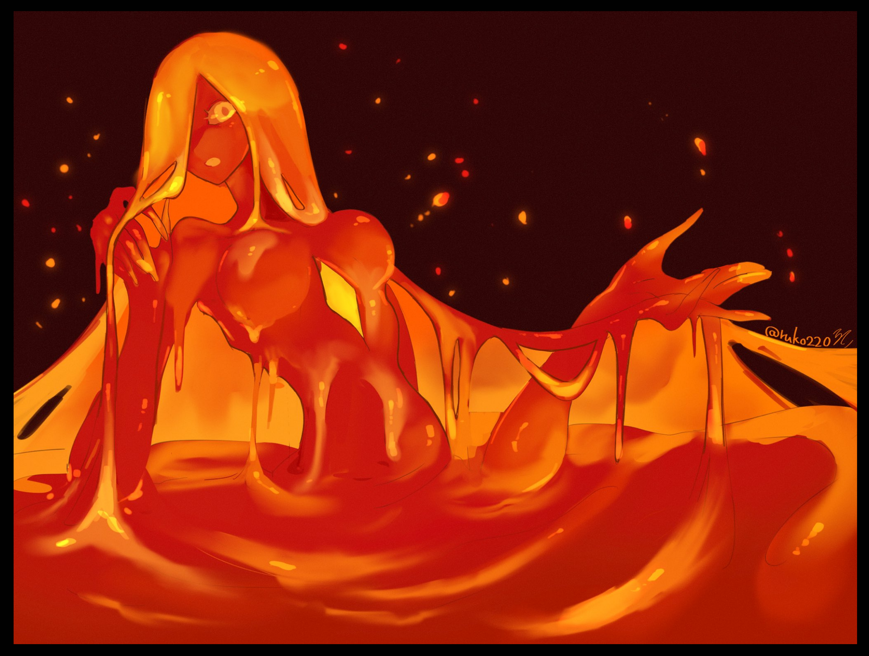
“Gr-elb mee….can’t…moveee…”

But looking back at the far wall of the burning room where a melting bathtub begins to overflow with magma, that same enthusiasm was lost on the face of the sultry maiden of fire that emerges from the depths of the scorching pool, jiggling orbs of lava sagging down a curvaceous torso, locking lidless eyes with Malcolm as she extends a soggy hand in a plea for help before catching sight of her thin, frail digits, gazing in wonderment while another, far larger but clearly feminine limb pulls itself free from below where a leg should've been. Too distracted by her own thin veil of mucus-like hair to care anymore, playing with the viscous material with child-like curiosity.

The mere sight of the amalgamation of limbs emerging from the lavagirl was more than enough to persuade Malcolm to back off, leaving James and her partner to their fate as she peels her eyes away from the sight of the second hand harshly giving the main body's right breast a firm squeeze, forcing a gurgled moan out of her while a mature face contorts in ecstasy, lolling neon orange tongue tasting the air as her trashing sends more lava across and out of the bathroom, starting a slow spreading fire that would consume the bungalow and everything in it by the time morning arrived. This was getting out of hand!

Retreating back downstairs to an eerily quiet lounge with her heart dampened, Malcolm would finally collapse to her knees halfway down the stairs, smacking her head against the steps before coming to a stop at the foot of it in a sudden fit of exhaustion. She felt cold now, extremely cold. After being exposed to the sweltering heat wave given off like an aura by James' new existence as a lava based Slimegirl, she had unknowingly lost a large amount of strength just to withstand it. And now that her reserves were empty, her new biology was free to feed on her weakened mind, implanting thoughts and urges she felt lethargic just thinking about.
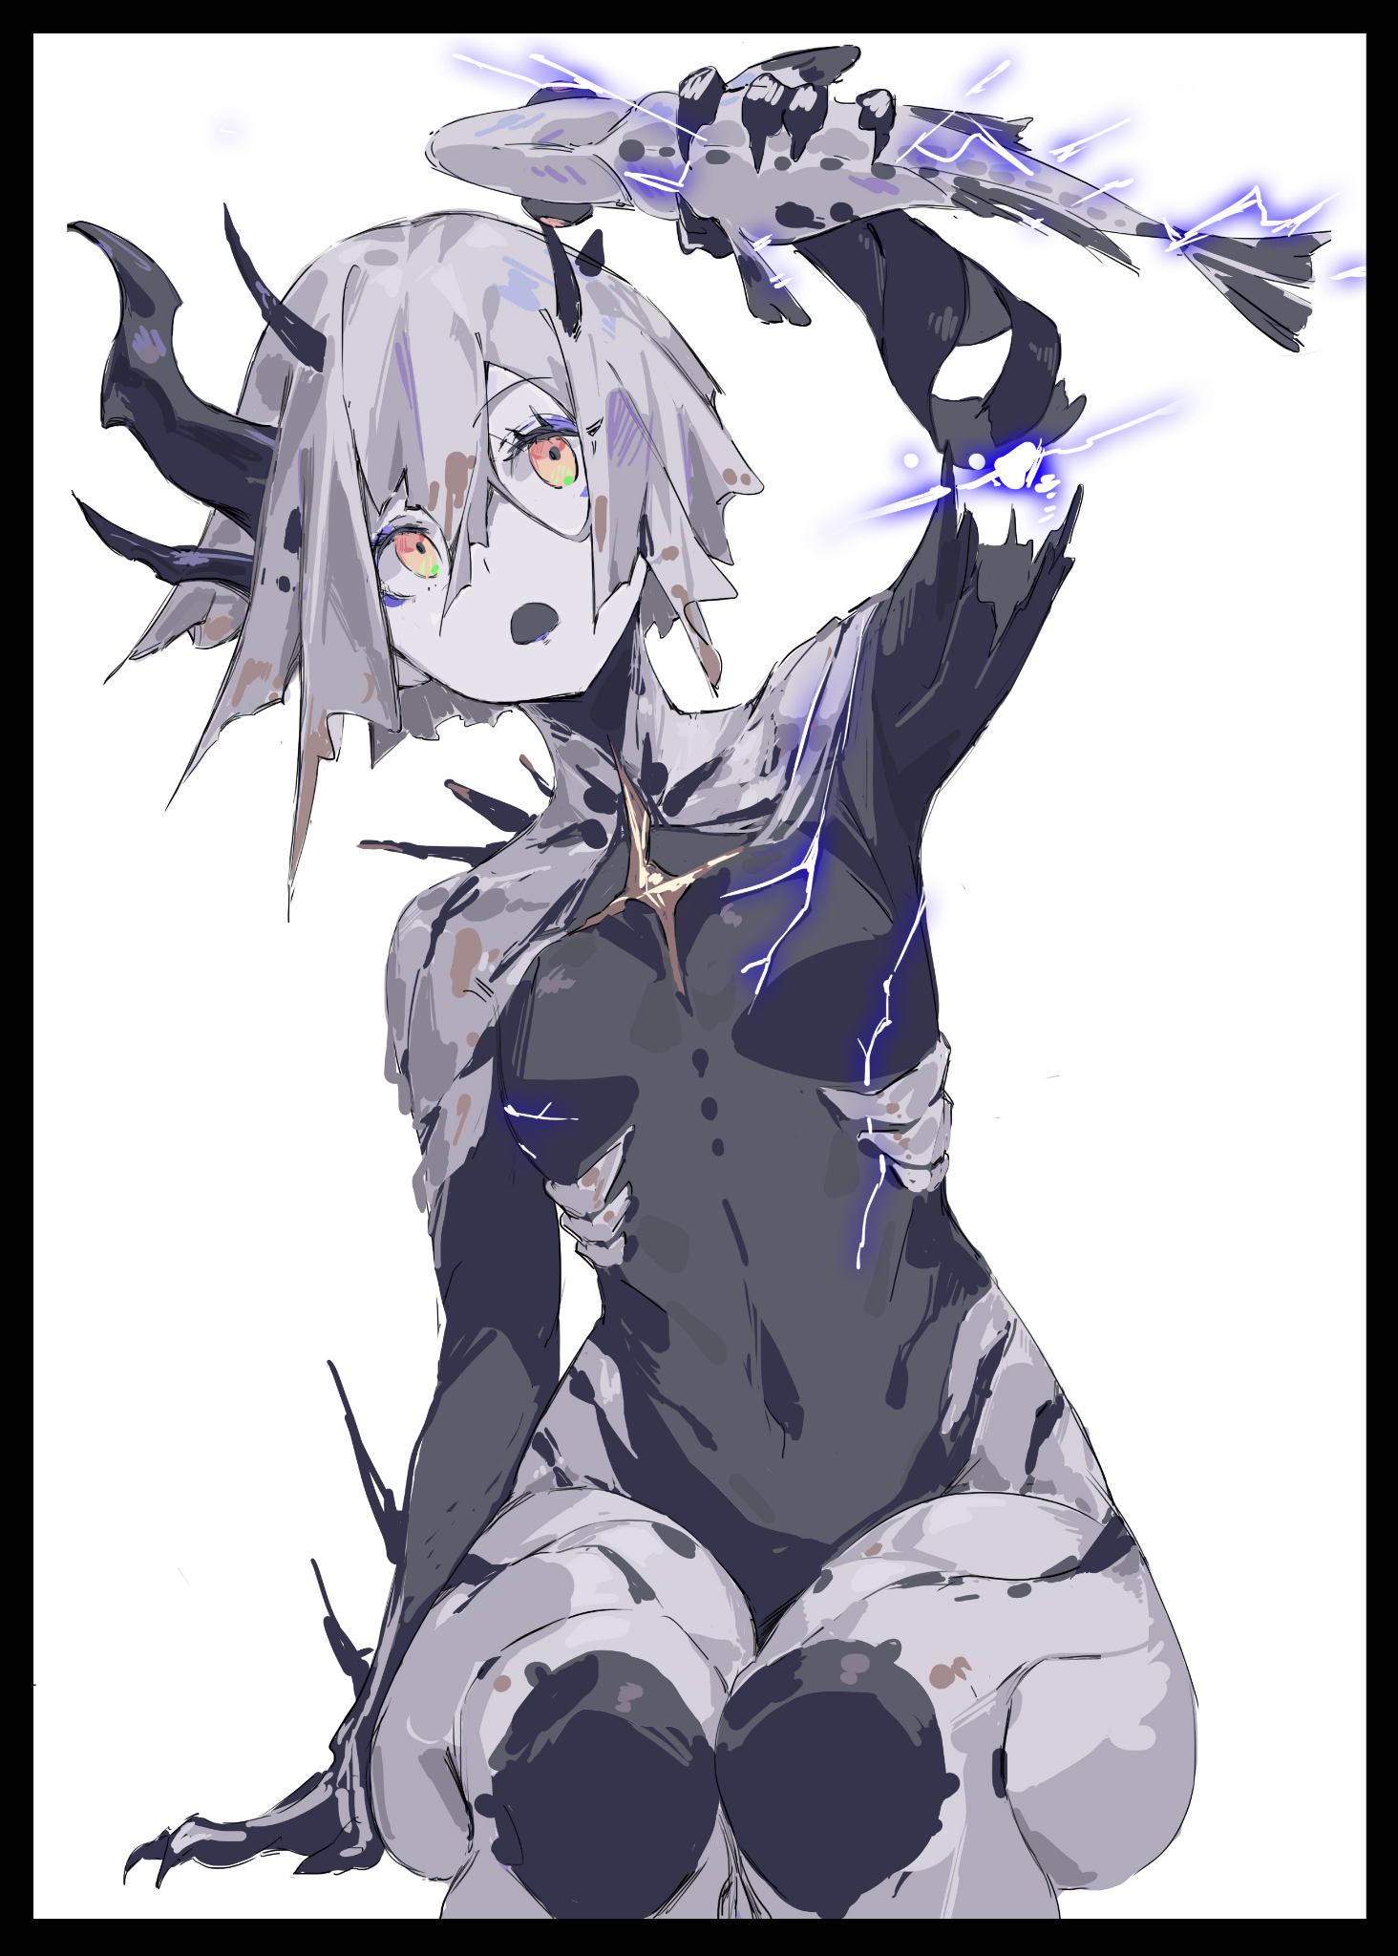
“Ahhh…”

Despite the disgust towards the imagery filling her head, she could not deny the sudden craving for it, and as her bloodshot eyes turn toward the shattered couch she had left Adam, Malcolm was horrified to see her friend seated atop the marble stand where a fish tank once stood, making childish vocalizations while clutching a white spotted koi in her hand, delivering controlled bursts of energy with painful ramifications for the animal, displaying no remorse as she continued to send electrifying bursts through the spasming fish. Her body too, had changed further since the last time she laid eyes on her friend; sporting an asymmetrical crown of thorns that jutted out the sides of her head while more of those drill like extensions jutted out of her spine and forearms like natural weapons for use in combat and self defense.

"Adam…stop that! You're hurting i-"

Malcolm could barely make it a few steps further before her face was doused in red, her vision clouded by fine mist, her nostrils flaring at the scent of metallic goodness that had her missing her mark by a mile as she sidesteps an oblivious Adam wiping her shell clean of fish guts and gore, tackling the spray of fish meat on the ground in a feral fit of blood rage, growling like a rabid dog before her body stiffens up, groaning as what little remained of her humanity makes a resurgence one last time in a bid to win out against the overwhelming hunger telling her to close her jaws over the raw fish meat currently held in her vice like grip, exhaling in distress with a needy vocalization filling the air, punching a hole straight through the floorboard as a coping act that catches Adam's attention for a brief moment before her spines quiver, sensing something amiss in the air that sends her walking out of the bungalow ruins right as an explosive release of flame bursts out into the hallway, accompanied by a reformed Slimegirl bearing the memories of neither of her component parts slipping off the banister in a living wave of lava, snaking her way outside to join the assembly going on while ignoring Malcolm as she continues her futile fight against the vampiric instinct urging her to feed. Clutching at her belly in pain, eyes turning gaunt as starvation begins to take its toll on the young vampiress.

“Oh my…what do we have here…a Vampire? Aren't you a sweet little thing?"

Too tired to even twist her neck to look at the owner of the oncoming shadow cast over her, Malcolm simply lays still before the towering young woman she barely remembered as the gracious host of the party-turned-nightmare, now sporting a flowing dress of her own and long ghostly white hair framed by wicked, ashen horns reflecting the moonlight against its pinprick edge while the raging house fire before her casts an unsettling aura in her eyes, dancing like lost souls in the pits of her lightless existence as she watches Malcolm with glee and interest.

"Such soft skin…oh~ and your hair is almost as perfect as mine! Such a plump body too! It'd be a shame to have you go to waste…don't you think so too? Wouldn't you like some fresh human blood? You look absolutely famished!"

Upon the mention of the word, Malcolm whines, wincing in pain as more images of soft, enticing necks flash by alongside more terrifying scenes of herself bathing in red, remembering the feel of warm life essence pouring down her throat, running off her skin and soaking her hair through despite never once relishing in such atrocities.

But the growing hunger within her screamed otherwise, demanding to be set free as it batters the mental restraints placed over it by the feeble human mind hosting it to see this woman's promise of blood fulfilled. And it was a fight Malcolm had no hope of winning against, even if she didn't know it yet.

Seeing no point in delaying the inevitable, Lilith smirks before holding out her hand over the cowering girl, summoning an orb of rippling scarlet that grows to the size of a football before letting a droplet fall, landing on the carpeted floor right in front of Malcolm's tear stained face.

And the moment her eyes, followed by her nostrils recognize the sight and scent of blood, Malcolm enters into a brief seizure before freezing up, arching her back while arms and legs splay out to both sides, grasping air and kicking up dust before dropping still with a soft sigh. Malcolm wasn't a spiritually attuned individual by any sense of the term. Which meant that besides knowing about the undead, vampiric aspects of her new body, she wasn't aware of anything else, too focused on gathering her friends to worry about herself after a sense of safety had set in all too soon alongside confidence and a smidge of cockiness after seeing everyone around her quickly succumb to whatever curse had trapped them in their costumes.

So when the hunger finally hit her, the human was ill prepared to face down the sensation of a starving vampire. Unlike humans whose bellies went on a gradual incline from mild discomfort to pain. Vampires did everything in their power to make sure they never ever went hungry. No matter the breed, once a bloodsucker was starved of food for long enough, they would be at their strongest, but we're oftentimes driven beyond help by the hellish pain they would be submerged in for the duration of what was known amongst their kind as Blood Rage. And Malcolm was well on her way towards entering that point of no return. Something her other self wanted desperately to avoid as if fought for control against the stubborn human it had been born inside of. An error it sought to correct.

And Lilith's timely intervention had been the key that allowed for it to turn the tides against Malcolm, drowning her soul in a torrential downpour of blood that represented it's dreadful strength, primeval knowledge, depthless depravity and an ironclad will to survive, something all creatures, both living and otherwise, held close to heart (or lack thereof).

But the vampire wanted more, and a human soul was a precious resource to simply snuff out. So incorporating bits and pieces of the human male within its grasp, the vampire begins imprinting itself over Malcolm, overwriting her image over his, turning him into her, taking his memories until that too, belonged to her, just like the rejuvenated body she now held complete control over as cupped hands deliver a constant flow of fresh blood from her Queen straight down her eager gullet with tantalizing bumps running down the length of her slim neck while excess runoff from her greedy slurping drips down onto her pale breasts, pooling in her cleavage, staining her dress, dribbling onto pillowy thighs before her eyes snap open in a magenta blaze, blasting the surroundings with a strong shockwave that temporarily kills the approaching fire.

Malcolm had lost for the final time in her life, awakening as a completely different person altogether. She felt livelier, more energetic, more euphoric than she ever had before. Frowning upon the humanity she had tried so hard to protect, giggling flirtatiously for even doing so as she sticks a middle finger soaked with more of that delicious red nectar into her mouth, slurping noisily with a vapid look of pure joy on her blood stained face, all while dark miasma begins to build around her, forming new additions in the form of a low hanging mantle that conceals most of her creamy back while a cute side hanging cap pops into existence atop her head, completing her getup just as she pulls her finger free with a playful tongue hanging in the air. Gazing with adoration and lust at the horned woman standing before her. Recognizing Lilith for who she was, fear and loathing replaced by love and devotion.
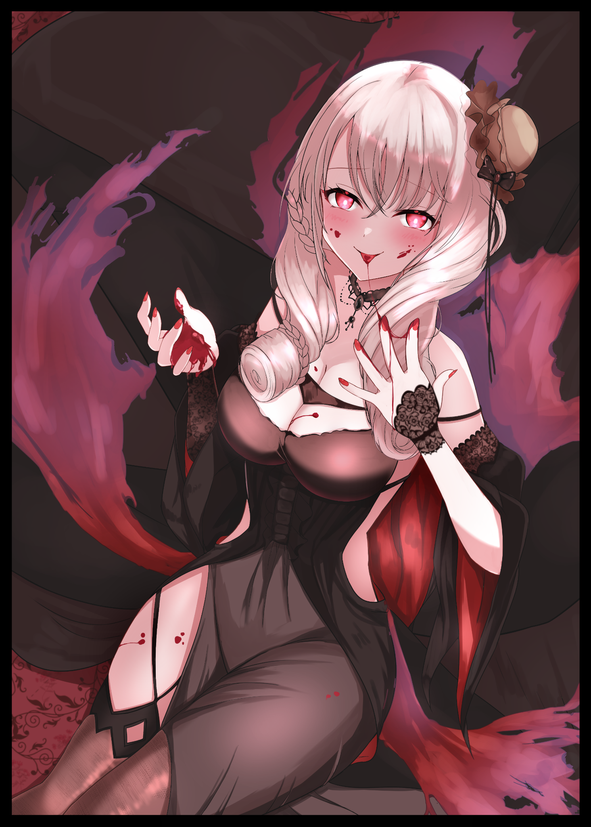
“Thank you for the food my Queen! Whatever you require of me, simply give the word, and I will gladly fulfill it~”

"Ufufu~ so eager to serve are we? Hmm…I might have something that could use your expertise my dear little bloodsucker~ Come, let us be off, I tire of the human realm."

"Of course my Queen~"

With the embers of the fire starting to pick up speed once more as the roof of the bungalow caves in on itself, the reborn vampire rises to her feet, eyes wholly fixated on Lilith as she shadows the Demon Queen, followed closely behind by Adam, James and the rest of the converted partygoers in an inhuman parade. Marching, slithering and hovering their way through a large portal leading back to the Netherworld until the entire estate empties out, with Fiona taking one final cautionary sniff in the air before following along her companions as the portal's magenta rim collapses. Leaving the fire to consume any evidence of the otherworldly invaders’ presence.

By the time the morning sun’s ray would grace the neighborhood however, the fire had unexpectedly spread further than anticipated, going unnoticed thanks to Lilith’s veil magic lasting far longer than expected. Diverting attention away from the sudden spike in missing persons cases while the media picked up on the massive fire spreading in the area, whisked away to serve in the Demon Queen’s menagerie…

THE END

