CRIMSONITE
COMMISSION STORY
BY CHALDEACHANGE
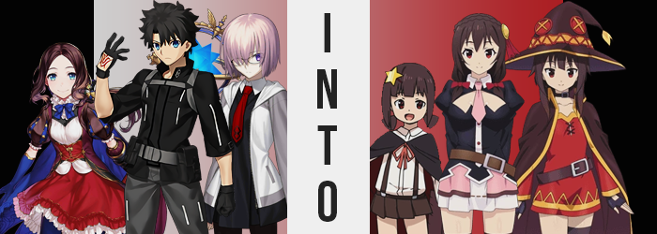

“Sometimes I wish da Vinci-chan wouldn’t unload strange inventions on us.”

Having been transferred to an unusual Singularity, the first thing the currently child-sized inventor had done with the infiltration squad was outfit them with her newest invention. A special, crimson gemstone necklace that was meant to take constant readings of their surroundings and send them back to the Shadow Border. If the tests were successful, it would ultimately aide with their inability to properly show those who remained in the base the full picture of what they were experiencing, something that was much needed.

Although between the necklace and the Singularity, something odd had been going on. Ritsuka had thought it strange himself, but not enough so to comment. After all, it was the summer variation of Jeanne Alter that had both found this Singularity and helped da Vinci-chan with her invention, and that fallen saint was hardly ever proactive in affairs that didn’t benefit her personally.

But what was done was done, and now the investigation squad had been split up. Ritsuka, Mashu, and da Vinci-chan herself had all been tasked with exploring a small village that was identified as the epicenter. No threats could be confirmed, which had made its existence an even bigger mystery. But it also meant that Ritsuka didn’t need to be babysat and could investigate at his own pace.

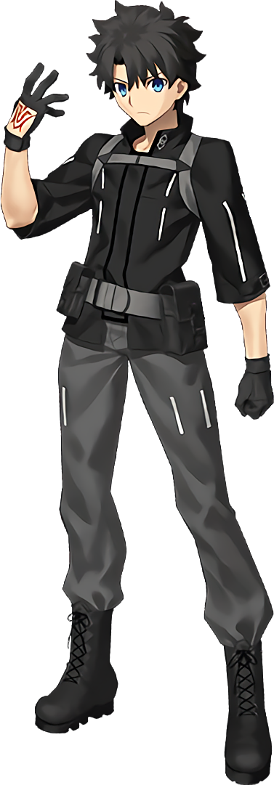
“This is a school, right? I assumed as much outside, but now that I’m inside it’s really obvious. It seems modern but, not so much.” Parts of the town seemed more modern than others, and for some reason all of the locals had red eyes, brown hair, and dressed in crimson. The school seemed to be a testament to the more modern aspect, but if it was a school then why was no one currently there? It was the middle of the day!

Taking in the hallway he was standing in fully, fingers absentmindedly reached to the crimson gem dangling around his neck so that he could make sure it was working properly. As da Vinci-chan explained it, as long as a warmth was emanating from the stone, it was most likely working properly.

“Uh… Wait, what!? Did I drop it!?” But not only was the gemstone not creating heat, it was just simply gone. He pulled the necklace portion from his neck just to make sure, but it was true! There was nothing there!

Because he’d completely missed it shattering and disappearing after shining brightly upon entering the school. Almost like it had been waiting for that very moment to activate.

It didn’t take very long for the boy to become enraptured by its power though. And not the power it had been created with in mind. While tests had shown the rocks would be perfect for the role that they’d been assigned, there was a much more nefarious reason for their existence at the end of the day. And in the beginning? This reason probably wasn’t as clear to Ritsuka as it certainly should have been.

What took place right out of the gate was a very clear (to everyone but him) change in color scheme to his primary features. Eyes were still desperately searching the floor for the crimson gemstone that was inexplicably missing, yet as they did so their bright blues ultimately ended up mischaracterized by a bright crimson – whereas the tone of his hair lightened several shades so that it was a dark brown.

The same color scheme that every local he’d bumped into seemed to have.

“Man, da Vinci-chan is going to kill me if I don’t find it!” The inventor was understandably sensitive about her devices getting broken or going missing without good cause, and it was fear of retribution that had him looking around even as his body continued to show signs of differentiating itself from its previous state. Going back to his hair for a brief moment, not only were the spikes flattening against his head but the length of it all appeared to be growing ever so much longer, spilling past his shoulders with far more volume than it should have possessed typically.

His brows furrowed with dismay, it was clear that they had not only lightened in color like the rest of his hair, but they’d thinned as well. And as if to trade off? The lashes upon his crimson eyes appeared to, ever so slightly, lengthen. “This isn’t good, this isn’t good, this isn’t gooood!” Anxiety continued to build over the missing stone in the interim, but the way Ritsuka was expressing that anxiety? It felt a little more unhinged and whinier than he’d typically make a point to do.

Convinced he must have dropped it on the floor somewhere, the boy fell down to his hands and knees. Had he paid attention to those hands, he might have noticed the fact that his fingers had become all the shorter, while fingernails had taken the opposing approach to jut out several inches past their normal length. Those hands had absolutely taken an effeminate look, but it wasn’t something isolated to his digits alone.

After his brows and lashes, Ritsuka’s facial features had found themselves to grow softer. Wider eyes, albeit still Japanese-looking by design, headlined a button nose and plumper lips. Once again, it wouldn’t be out of place to imply that he was looking more and more like a local of this town.

And when it came to his figure? Well, his clothes had grown a little looser while crawling about the floor. His muscles, ample for the boy’s figure, were becoming much less so. Almost like watching a rock turn into a pillow, those muscles softened and spread out to give him a leaner, squishier look. Still, there was some muscle to be had. From physical training of some sort, in all likelihood.

“Where is it? Where is iiiiiit!?” Hands pawed against the floorboards, no notice paid to how sweet and frantic his voice now sounded in the meantime while clothes grew even more illy fit. In this case though, it was hardly a matter of a loss of mass. In some ways it might have seemed that way, what with how his shoulders had slightly narrowed and his waistline had much more dramatically done so.

But there were gains to be had as well. Hips pulled a few inches wider while he crawled around, and that in turn stretched the waistband of his pants. Just below, things tightened further – thanks to the size of both his ass and thighs, strangely enough. A thickness had beset them that stretched the polyester of his garments to the point where they looked like they might burst, taut skin beneath pulled wide by thighs that surely possessed a subtle jiggle with each and every step. A barcode, for some reason, had appeared on his inner thigh.

And a bulbous ass grew to match, of course.

In the meantime, the front of his jacket tightened as weight found further home… in his chest this time. Nipples, erect as could be, cut against the underside of his clothes like diamonds while the teats beneath them surged forward with a contained bounce. The heft they sported peaked at D-cups, but considering several inches had pulled off Ritsuka’s height – unseen thanks to the fact that he was on hands and knees and already suffering clothing malfunction – they likely appeared a little larger than that.

“EEP!?” A sharp tug between her legs provoked her to leap back up onto her feet. What had just happened!? That had felt so strange! But the girl was none the wiser to the fact that her biological sex had just underwent a swipswap, with a pussy now nestled between her thighs. “Actually… Why was on the floor? Was I looking for something?”

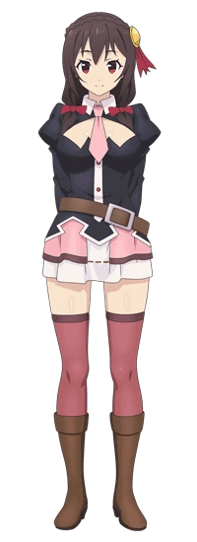
And didn’t her clothes feel a little loose? Well… not for long. Because they burned bright with a crimson light, and before long she was clad in a black, low-cut blouse and a pink miniskirt with darker pink thigh highs that pinched the meat of her thighs. Of course, her blouse had a cutout to show off the size of her breasts, and her hair was pulled over her shoulders with a pair of crimson ribbons.

Yunyun was… well, she was confused! She knew where she was, of course, but how she’d arrived there and why was a riddle she didn’t exactly have an answer for. This was definitely the school at the Crimson Demon Village, but she really had no reason to be there? After all, she’d finished studying there a long time ago. She was to be the next village chief after all…

But that wasn’t even the biggest issue!

“Wasn’t I in Axel? No… Do I belong here?” The question she asked herself had far more layers than she realized. Did she belong in the village? Of course she did? But deep down there was something calling out as if to say she was from another world. Her expression soured immediately. “N-No! I’m supposed to be the normal one in the village! I can’t be having thoughts like THOOOOOSE!”

Wholly ashamed of herself, she ran out the front door back to her home. But not before running into the door and slapping it painfully with her boobs. All in the day of your local Yunyun!

“I feel a little bad for trespassing, but I suppose I was invited in.” Elsewhere in the Crimson Demon Village, Mashu found herself in the bedroom of someone’s house. She’d been picked off the street by an older couple, obviously having picked her out for not at all resembling any of the other people that lived there. She’d been with da Vinci-chan as well, but both parents had led them to separate rooms for some reason? “Something about this feels a little off though? What did they mean by ‘You’ll fit in a little better shortly’? Is it normal hospitality here to bring guests into bedrooms?”

Mashu had plenty of valid reason to be suspicious, but unfortunately she was far too in the dark about the circumstances to make a call one way or the other. She hadn’t even taken notice of the crimson gem around her neck glowing and disappearing, or that side effects of its disappearance had begun to seep into her physical form.

Unlike Ritsuka though, her color palette wasn’t affected. At least not at first. Instead, the Demi-Servant scratched at her head a moment as she tried to process something. She wasn’t familiar with this room of course, but… “Is it bigger in here than I remember?” Not only did the few pieces of worn furniture look grander, but the ceiling seemed farther away, and the door looked more intimidating. It wasn’t dramatically so, but it was enough for her to notice.

“Almost like I… Wait!?” After dropping her hand from where she’d held it to her chin, there was another clue. Her fingers had been swallowed up by the sleeves of her hoodie, which meant… “Did I shrink!?” That was the most logical answer, wasn’t it? Felt not only in her sleeves, but in her dress’ overall fit, it was clear her body was not the size it had been when she had dressed herself that morning.

It was getting worst too, because the phenomenon didn’t affect her height alone. There was plenty of loss to go around without any sort of gain. For example: the loss of strength she suffered was far more severe than what her Master had endured, for while he’d been left with some muscle, Mashu’s body was ultimately emptied of any physical endurance whatsoever. Muscles waned entirely, and the teen felt briefly winded by their erasure. Her body just felt so much more inherently slovenly without the usual muscles to support it.

“Why do I feel so… Weak? Well, being weak isn’t a problem if you have EXPLOSION MAGIC! …Eh!?” What had she just blurted out so uncharacteristically!? Explosion magic? What the heck was that!? It was startling enough of a comment for her to take little notice as her body continued to empty, this time with focus on her more abundant, womanlier features.

The front of Mashu’s dress was flattening, her large breasts no longer had a place on her compressed frame. Smaller and smaller they shrank, with nipples suffering similar losses by dropping down a singular coin size. By the time all was said and done, the dress’ front was practically flat short of the bulges where her emptied bra was sitting.

In the meantime, her skirt appeared bigger simply because her hips had narrowed. Tights clung on, but with her thighs and ass emptying so that they were comparable to those of a girl in her early teens, there was certainly a bunchy looseness to them that couldn’t be denied. At least they kept her panties in place!

“Explosion magic…? I mean, it’s the best! You don’t even need any other magic! I’ve been working on it for so long, and I’ve come so far!” She couldn’t fathom where this enthusiasm had come from, but she was incapable of turning it off as well. Once confused by it, Mashu now properly recalled how to wield it. All of the training she’d done to perfect it hadn’t been for naught!

And as that enthusiasm built, her purple eyes began to glow crimson and her hair darkened to a much more mundane, messy brown. Facial features on the other hand? They had become much more youthful, with her eyes even taking a Japanese appeal even though she no longer knew what that name meant.

Much less remember her old name.

Clothes then took light, her oversized dress replaced by crimson witch attire with a black cape. Fingerless gloves decorated tiny fingers, and while her left leg was done up with a black thigh high, the left was purposefully done up in bandages. Doesn’t it look cool!?

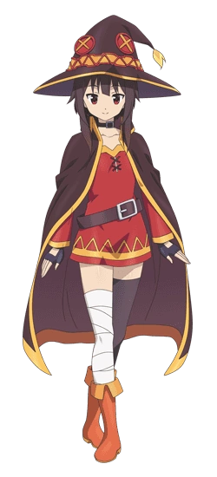
For how different her body was, there was a clear difference between Mashu’s transformation into this younger girl than Ritsuka’s transformation. While everything else had changed, her voice was completely the same. She was a little more outgoing with how she used it, but it undoubtedly carried the same melody. It was just as well, because Mashu as she might have once been.

She was Megumin now. “That’s better! Those other clothes were way too stuffy! Where’d they even come from!?” Puffing out her (lackluster) chest proudly, the Crimson Demon mage plucked a big hat from the back of her door and fastened it onto her head. “Actually, come to think of it… Why am I even home!? Didn’t I go back to Axel with Kazuma and the others after that last incident?” Not that she minded at all. This gave her a chance to catch up with her kid sister.

Who had conveniently just appeared in the room next door…

That room, when Mashu was still Mashu, had been occupied by da Vinci-chan. The young inventor had been just as taken aback as Mashu by the strange hospitality of the couple that had invited them in, but they’d earned da Vinci points by calling her adorable and just generally buttering her up. She didn’t have the foggiest that everything had been a setup, including the Crimsonite gemstones that Jeanne Alter had helped her create.

“Maybe I should check with Mashu? I’m kind of getting a bad feeling…” Out of the three of them, she was the only one to feel this way about the situation before it was too late. She was playing with the necklace around her neck at roughly the same time, which was why she immediately felt it.

The stone breaking and disappearing.

“What!? It shouldn’t be that flimsy!” No stone was! So it didn’t just break, something had triggered a reaction! “Wait, then that would mean… It would mean… Um?” A very complicated explanation had come to mind right out of the gate, but just as quickly? It disappeared. Forget the explanation itself, she couldn’t seem to recall any of the complex theories used to construct the gems in the first place! Her genius! It was waning!

“Why’s it so hard to think? Big words… like… compatar-abiliteeny!? What, is that even a word!? Um…” It wasn’t, but da Vinci could no longer really be sure. There might as well have been spirals swirling around in her eyes what with how confused she felt. To have her intellect endangered was to strike right at the heart of da Vinci’s pride. Unfortunately things didn’t exactly improve on that front, but for the da Vinci that enjoyed being called cute? Well, at least things looked brighter and brighter there.

At best, the Rider da Vinci-chan looked to typically be in her early teens. But there had been a prompt and dramatic challenge to that perceived age. “Ah!?” For she couldn’t help but allow a childish squeak to escape as something occurred to her. “I’m getting teenier!” All at once, it was like the size of her body had just called it quits. Her beautiful dress became little more than an over glorified blanked as her height fell to only a few feet tall, limbs and torso alike shortening as the physical regression took hold with just as much tenacity as her mental regression was.

On the brink of tears, the girl struggled to hold up her clothes so that she wasn’t bare. Leggings and gloves had already peeled off, and her panties had hit the floor. None of this was too surprising considering her frame. Not only was she depressingly short, but there wasn’t a single indicator remaining that she had touched upon puberty at all. Her chest had become completely flat, her hips were just as wide as her shoulders, and her legs were plump but only in a ‘she’s a kid, what did you expect?’ sort of way.

“Uh… What!? Why am I… I’m like a baby! So small… Um… Uh…?” da Vinci-chan was far too shaken to string together words more competent than that, but this was tragically in part because all of her genius was simply gone. Her IQ had fallen not only to be comparable to a small child, but one that grew up in a fantasy world to boot. She no longer held even a basic understanding of modern technology.

The girl also felt like she was forgetting something. She’d… lost something? Something important! But what? It was a question that plagued her as her eyes, having taken on a Japanese look, turned from blue to crimson and her brown locks both shortened and frayed. Their usual luster was lost, and her typically parted bangs came to dangle loosely across her forehead.

And then came the flash of light, one that disposed of her pretty but ill-fitting garments in exchange for something more plausible for a young child. A pleated, black skirt held up with suspenders over a white dress shirt, accessorized by a big, patchwork cloak handed down from her big sister that was tied with a pink ribbon. In her hair, which was now tied into a pair of cute pigtails, a single star ornament rested to the right side of her head.

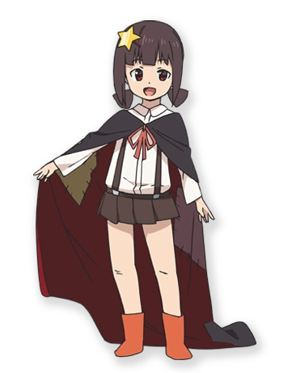
“Umm… What’s going on? Why’d I feel so scared!?” The six-year-old Komekko felt like she’d just woken from a nightmare. One where she’d been taller! But then she’d been drowning in really pretty clothes! It was hard to explain, but was it really a dream? She wasn’t allowed to sleep in this late, her parents forbade it. As much as she’d been curious briefly, she immediately found herself fixated on the sound of her door opening.

In walked her big sister! “Big sis! Why’re you here!? I thought you went back to, um… that place!” The name escaped her, but it was where big brother Kazuma was. Apparently he might eventually be her big brother! Not waiting for an answer whatsoever, she was quick to leap at Megumin, who was just as quick to catch her little sister and lift her up.

“I thought so too! But I’m here, so! Do you want to go annoy Yunyun? I bet she’s miserably hiding in her house right now, all by herself!”

So mean.

Back in Chaldea, Jeanne d’Arc Alter was laughing up a storm. “Ahahaha! You’re all idiots! Falling for such an obvious ploy!” The Crimsonite, the Singularity, it had all been a prank pulled by her and BB! The pair of them had just wanted free reign of Chaldea, and so they created a world based on a popular light novel and resolved to make Chaldea’s most prominent members a part of it. Those three were only the tip of the iceberg! And it had worked perfectly!

Though, as she laughed? The corrupted Jeanne wondered something. Had her breasts always been this massive? Had she always worn an eyepatch over her left eye? In the background, BB could be heard snickering.

“I’m so glad your plan worked, Arue-chan~!”

