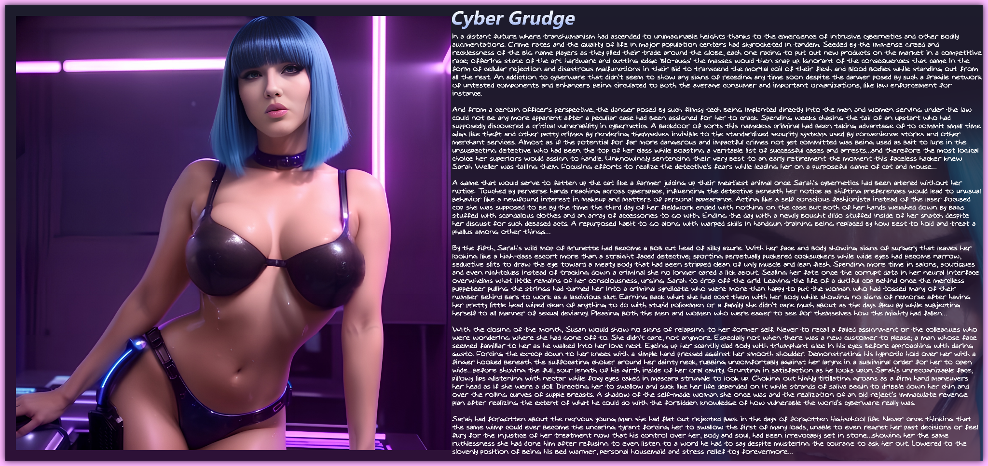

In a distant future where transhumanism had ascended to unimaginable heights thanks to the emergence of intrusive cybernetics and other bodily augmentations. Crime rates and the quality of life in major population centers had skyrocketed in tandem. Seeded by the immense greed and recklessness of the big name players as they plied their trade around the globe, each one racing to put out new products on the market in a competitive race; offering state of the art hardware and cutting edge 'bio-augs' the masses would then snap up. Ignorant of the consequences that came in the form of cellular rejection and disastrous malfunctions in their bid to transcend the mortal coil of their flesh and blood bodies while standing out from all the rest. An addiction to cyberware that didn't seem to show any signs of receding any time soon despite the danger posed by such a fragile network of untested components and enhancers being circulated to both the average consumer and important organizations, like law enforcement for instance.

And from a certain officer's perspective, the danger posed by such flimsy tech being implanted directly into the men and women serving under the law could not be any more apparent after a peculiar case had been assigned for her to crack. Spending weeks chasing the tail of an upstart who had supposedly discovered a critical vulnerability in cybernetics. A backdoor of sorts this nameless criminal had been taking advantage of to commit small time gigs like theft and other petty crimes by rendering themselves invisible to the standardized security systems used by convenience stores and other merchant services. Almost as if the potential for far more dangerous and impactful crimes not yet committed was being used as bait to lure in the unsuspecting detective who had been the top of her class while boasting a veritable list of successful cases and arrests…and therefore the most logical choice her superiors would assign to handle. Unknowingly sentencing their very best to an early retirement the moment this faceless hacker knew Sarah Weller was tailing them. Focusing efforts to realize the detective's fears while leading her on a purposeful game of cat and mouse…

A game that would serve to fatten up the cat like a farmer juicing up their meatiest animal once Sarah's cybernetics had been altered without her notice. Touched by perverse hands reaching across cyberspace, influencing the detective beneath her notice as shifting preferences would lead to unusual behavior like a newfound interest in makeup and matters of personal appearance. Acting like a self conscious fashionista instead of the laser focused cop she was supposed to be by the time the third day of her fieldwork ended with nothing on the case but both of her hands weighed down by bags stuffed with scandalous clothes and an array of accessories to go with. Ending the day with a newly bought dildo stuffed inside of her snatch despite her disgust for such debased acts. A repurposed habit to go along with warped skills in handgun training being replaced by how best to hold and treat a phallus among other things…

By the fifth, Sarah's wild mop of brunette had become a bob cut head of silky azure. With her face and body showing signs of surgery that leaves her looking like a high-class escort more than a straight faced detective; sporting perpetually puckered cocksuckers while wide eyes had become narrow, seductive slits to draw the eye toward a meaty body that had been stripped clean of ugly muscle and lean flesh. Spending more time in salons, boutiques and even nightclubs instead of tracking down a criminal she no longer cared a lick about. Sealing her fate once the corrupt data in her neural interface overwhelms what little remains of her consciousness, urging Sarah to drop off the grid. Leaving the life of a dutiful cop behind once the merciless puppeteer pulling the strings had turned her into a criminal syndicate who were more than happy to put the woman who had tossed many of their number behind bars to work as a lascivious slut. Earning back what she had cost them with her body while showing no signs of remorse after having her pretty little head wiped clean of anything to do with stupid policemen or a family she didn't care much about as the days flew by while subjecting herself to all manner of sexual deviancy. Pleasing both the men and women who were eager to see for themselves how the mighty had fallen…

With the closing of the month, Susan would show no signs of relapsing to her former self. Never to recall a failed assignment or the colleagues who were wondering where she had gone off to. She didn't care, not anymore. Especially not when there was a new customer to please; a man whose face seemed familiar to her as he walked into her love nest. Eyeing up her scantily clad body with triumphant glee in his eyes before approaching with daring gusto. Forcing the ex-cop down to her knees with a simple hand pressed against her smooth shoulder. Demonstrating his hypnotic hold over her with a finger hooked beneath the suffocating choker around her dainty neck, rubbing uncomfortably against her larynx in a subliminal order for her to open wide…before shoving the full, sour length of his girth inside of her oral cavity. Grunting in satisfaction as he looks upon Sarah's unrecognizable face; pillowy lips glistening with nectar while foxy eyes caked in mascara struggle to look up. Choking out highly titillating groans as a firm hand maneuvers her head as if she were a doll. Directing her to swallow and suck like her life depended on it while strands of saliva begin to dribble down her chin and over the rolling curves of supple breasts. A shadow of the self-made woman she once was and the realization of an old reject’s immaculate revenge plan after realizing the extent of what he could do with the forbidden knowledge of how vulnerable the world’s cyberware really was.

Sarah had forgotten about the nervous young man she had flat out rejected back in the days of forgotten highschool life. Never once thinking that the same wimp could ever become the uncaring tyrant forcing her to swallow the first of many loads, unable to even regret her past decisions or feel fury for the injustice of her treatment now that his control over her, body and soul, had been irrevocably set in stone…showing her the same ruthlessness she had done him after refusing to even listen to a word he had to say despite mustering the courage to ask her out. Lowered to the slovenly position of being his bed warmer, personal housemaid and stress relief toy forevermore…

THE END

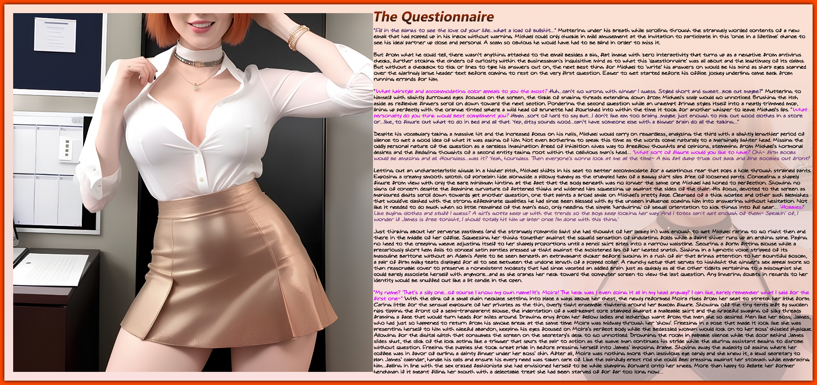

"Fill in the blanks to see the love of your life…what a load of bullshit…” Muttering under his breath while scrolling through the strangely worded contents of a new email that had popped up in his inbox without warning. Michael could only chuckle in mild amusement at the invitation to participate in this 'once in a lifetime' chance to see his ideal partner up close and personal. A scam so obvious he would have had to be blind in order to miss it.

But from what he could tell, there wasn't anything attached to the email besides a big, flat image with zero interactivity that turns up as a negative from antivirus checks, further stoking the cinders of curiosity within the businessman's inquisitive mind as to what this 'questionnaire' was all about and the legitimacy of its claims. But without a checkbox to tick or lines to type his answers out on, the next best thing for Michael to 'write' his answers on would be his mind as sharp eyes scanned over the glaringly large header text before coming to rest on the very first question. Eager to get started before his office jockey underling came back from running errands for him.

"What hairstyle and accommodating color appeals to you the most? Huh…can't go wrong with ginger I guess. Styled short and sweet…bob cut maybe?" Muttering to himself with slightly furrowed eyes focused on the screen, the tickle of snaking threads extending down from Michael's scalp would go unnoticed. Brushing the itch aside as reflexive fingers scroll on down toward the next section. Pondering the second question while an unkempt fringe styles itself into a neatly trimmed mop, lining up perfectly with the orange tinted sphere a wild head of brunette had flourished into within the time it took for another whisper to leave Michael's lips. "What personality do you think would best compliment you? Hmm…sort of hard to say but…I don't like em too brainy…maybe just enough to pick out good clothes in a store or…like, to figure out what to do in bed and all that. Yep, ditzy sounds good…can’t have someone else with a bigger brain do all the talking…"

Despite his vocabulary taking a massive hit and the increased focus on his nails, Michael would carry on regardless, analyzing the third with a slightly lengthier period of silence to get a good idea of what it was asking of him. Not even bothering to speak this time as the words come naturally to a marginally lighter head. Missing the oddly personal nature of the question as a careless imagination freed of inhibition gives way to freeflow thoughts and opinions, stemming from Michael's hormonal desires and the fledgling thoughts of a second entity taking root within the oblivious man’s head… 'What sort of figure would you like to have? Ohh~ firm boobs would be amazing and all. Hourglass…was it? Yeah, hourglass. Then everyone's gonna look at me all the time~ A big fat dump truck out back and fine boobies out front!’

Letting out an uncharacteristic giggle in a higher pitch, Michael shifts in his seat to better accommodate for a gelatinous rear that pops a hole through strained pants. Exposing a creamy smooth splotch of porcelain hide alongside a pillowy tummy as the crumpled hem of a baggy shirt slips free of loosened pants. Concealing a shapely figure from view with only the bare minimum hinting at the fact that the body beneath was no longer the same one Michael had honed to perfection. Showing no signs of concern despite the feminine curvature of fattened thighs and widened hips squeezing up against the sides of the chair. His focus, devoted to the screen as manicured digits scroll down towards yet another question, one that paints a broad smile on Michael's pretty face. Cleansed of a thick goatee and other such blemishes that would've clashed with the strong effeminate qualities he had since been blessed with by the unseen influence coaxing him into answering without hesitation. Not like it needed to do much when so little remained of the man's ego, only needing the simple 'hardwiring' of sexual orientation to kick things into full gear… 'Hobbies? Like buying clothes and stuff I guess? A girl's gotta keep up with the trends so the boys keep looking her way. And I totes can't get enough of them~ Speakin' of, I wonder if James is free tonight, I should totally hit him up later once I'm done with this thing.'

Just thinking about her perverse pastimes (and the strangely romantic light she had thought of her lackey in) was enough to get Michael raring to go right then and there in the middle of her office. Squeezing her thighs together against the squalid sensation of undulating folds while a faint shiver runs up an arching spine. Paying no heed to the creeping weave adjusting itself to her shapely proportions until a pencil skirt bites into a narrow waistline. Securing a form fitting blouse while a precariously short hem fails to conceal satin panties pressed up tight against the moistened lips of her heated snatch. Sighing in a hypnotic voice stripped of its masculine baritone without an Adam's Apple to be seen beneath an extravagant choker before sucking in a rush of air that brings attention to her bountiful bosom, a pair of firm milky teats displayed for all to see between the undone length of a popped collar. A raunchy getup that serves to highlight the ginger's sex appeal more so than reasonable cover to preserve a nonexistent modesty that had since vacated an addled brain just as quickly as all the other tidbits pertaining to a misogynist she could barely associate herself with anymore…and as she cranes her neck toward the computer screen to view the last question. Any lingering doubts in regards to her identity would be snuffed out like a lit candle in the open.

“My name? That’s a silly one…of course I know my own name! It’s Moira! The heck was I even doing it all in my head anyway? I can like, barely remember what I said for the first one~” With the clink of a small chain necklace settling into place a ways above her chest, the newly reformed Moira rises from her seat to stretch her lithe form. Caring little for the sensual exposure of her privates as the thin, overly tight ensemble tightens around her buxom figure. Showing off the tiny tents left by swollen nips tipping the front of a semi-transparent blouse, the indentation of a well-kempt core stamped against a malleable skirt and the graceful swaying of silky threads framing a face that would turn heads for miles around. Drawing envy from her fellow ladies and lecherous want from the men she so desired. Men like her boss; James, who had just so happened to return from his smoke break at the same time Moira was midway through her ‘show’. Freezing in a pose that made it look like she was presenting herself to him with gleeful abandon, keeping his eyes focused on Moira’s perfect body while the bedazzled woman would lock on to her boss’ chiseled physique. Allowing for the digital glitch that consumes the screen on the secretary’s desk to go unnoticed. Drowning the room in palpable silence while the door behind James slides shut, the click of the lock acting like a trigger that spurs the pair to action as the suave man continues his stride while the alluring assistant begins to disrobe without question. Freeing the puppies she took great pride in before pressing herself into James’ imposing frame. Shoving away the audacity of asking where her coffee was in favor of curling a dainty finger under her boss’ chin. After all, Moira was nothing more than lascivious eye candy and she knew it, a lewd secretary to plan James’ calendar, handle his calls and ensure his every need was taken care of. Like the painfully erect rod she could feel pressing against her stomach while embracing him…falling in line with the sex crazed fashionista she had envisioned herself to be while slumping forward onto her knees. More than happy to fellate her former henchman if it meant filling her mouth with a delectable treat she had been starved of for far too long now…

THE END

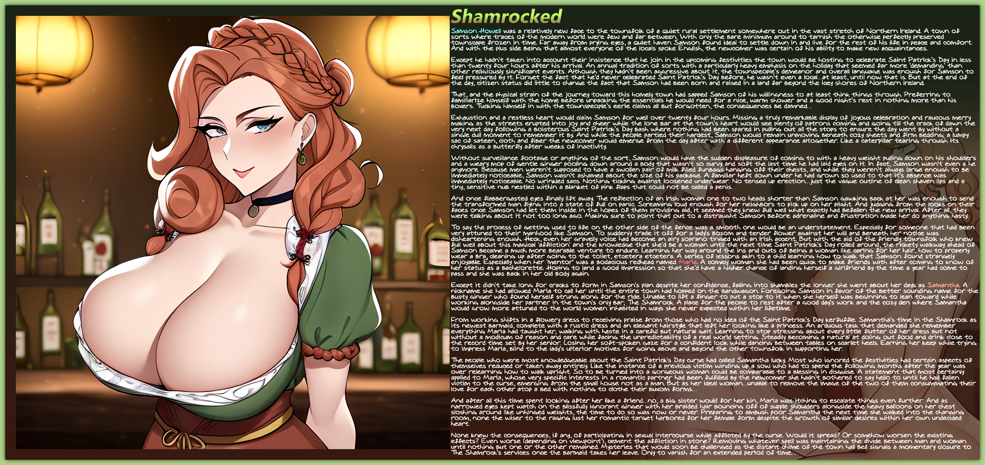

Samson Howell was a relatively new face to the townsfolk of a quiet rural settlement somewhere out in the vast stretch of Northern Ireland. A town of sorts where traces of the modern world were few and far between. With only the bare minimum around to tarnish the otherwise perfectly preserved townscape frozen in time. Far away from prying eyes, a quiet haven Samson found ideal to settle down in and live for the rest of his life in peace and comfort. And with the plus side being that almost everyone of the locals spoke English, the newcomer was certain of his ability to make new acquaintances.

Except he hadn't taken into account their insistence that he join in the upcoming festivities the town would be hosting to celebrate Saint Patrick’s Day in less than twenty four hours after his arrival. An annual tradition of sorts with a particularly heavy emphasis on the holiday that seemed far more ‘demanding’ than other religiously significant events. Although they hadn’t been aggressive about it, the townspeople’s demeanor and overall language was enough for Samson to feel pressured by it. Forget the fact that he’d never celebrated Saint Patrick’s Day before, he wasn’t even a local…at least, until now that is. But at the end of the day, citizen status did little to change the fact that Samson had been born and raised in a land far beyond the icey shores of Northern Ireland.

That, and the physical strain of the journey toward this homely town had sapped Samson of his willingness to at least think things through. Preferring to familiarize himself with the home before unpacking the essentials he would need for a nice, warm shower and a good night’s rest in nothing more than his boxers. Tucking himself in with the townspeople’s eerie claims all but forgotten, the consequences be damned…

Exhaustion and a restless heart would claim Samson for well over twenty four hours. Missing a truly remarkable display of joyous celebration and raucous merry making as the streets erupted into joy and cheer while the lone bar at the town’s heart would see plenty of patrons coming and going till the crack of dawn the very next day following a boisterous Saint Patrick’s Day bash where nothing had been spared in pulling out all the stops to ensure the day went by without a single dull moment to remember it by. And while the people partied their hardest, Samson would remain unmoving beneath cozy sheets and firm bedding; a lumpy sac of sateen, cloth and fiber the newcomer would emerge from the day after with a different appearance altogether. Like a caterpillar tearing through its chrysalis as a butterfly after weeks of inactivity.

Without surveillance footage or anything of the sort, Samson would have the sudden displeasure of coming to with a heavy weight pulling down on his shoulders and a weary mop of gentle ginger pooling down around a body that wasn't so curvy and soft the last time he had laid eyes on it. In fact, Samson wasn't even a he anymore. Because men weren't supposed to have a swollen pair of milk filled funbags hanging off their chests, and while they weren't always large enough to be immediately noticeable, Samson wasn't ashamed about the size of his package. A familiar heft down under he had grown so used to that it's absence was immediately noticeable. No wrinkled sacs. Nothing tickling against loosened underwear. No tensed up erection…just the vague outline of clean shaven lips and a tiny, sensitive nub nestled within a blanket of pink flaps that could not be called a penis.

And once flabbergasted eyes finally lift away. The reflection of an Irish woman one to two heads shorter than Samson gawking back at her was enough to send the transformed man flying into a state of full on panic. Screaming loud enough for her neighbors to pick up on her plight. And judging from the looks on their faces once Samson had let them inside in the hopes of them providing aid, it seemed they knew full well what exactly had befallen the new arrival. After all, they were talking about it not too long ago. Making sure to point that out to a distraught Samson before adrenaline and frustration made her do anything hasty.

To say the process of getting used to life on the other side of the fence was a smooth one would be an understatement. Especially for someone that had been very attuned to their manhood like Samson. To suddenly trade it off for a lady's bosom and tender flower against her will and beneath her notice was disheartening enough. Heck, even her gravelly voice had become an airy soprano tinged with an Irish accent. But with the aid of the friendly townsfolk who knew full well about this magical 'affliction' and the knowledge that she'd be a woman until the next time Saint Patrick's Day rolled around, the rickety walkway ahead of Samson became a much more bearable venture to endure. Learning her way around the ins and outs of being a woman like caring for her hair, how to properly wear a bra, cleaning up after going to the toilet, etcetera etcetera. A series of lessons akin to a child learning how to walk that Samson found strangely enjoyable. Especially when her 'mentor' was a bodacious redhead named Maria. A comely woman she had been quick to make friends with after coming to know of her status as a bachelorette. Hoping to land a good impression so that she'd have a higher chance of landing herself a girlfriend by the time a year had come to pass and she was back in her old body again.

Except it didn't take long for cracks to form in Samson's plan despite her confidence, falling into shambles the longer she went about her days as Samantha. A nickname she had allowed Maria to call her until the entire town had hopped on the bandwagon. Foregoing Samson in favor of the better sounding name for the busty ginger who found herself strung along for the ride. Unable to lift a finger to put a stop to it when she herself was beginning to lean toward while working alongside her partner in the town's only bar; The Shamrock. A place for the people to rest after a good day's work and the cozy den where Samantha would grow more attuned to the world women inhabited in ways she never expected within her lifetime.

From working shifts in a flowery dress to receiving praise from those who had no idea of the Saint Patrick's Day kerfuffle. Samantha's time in the Shamrock as its newest barmaid, complete with a rustic dress and an elegant hairstyle that left her looking like a princess. An arduous task that demanded she remember everything Maria had taught her; walking with haste in a careful but natural gait. Learning to stop stressing about every little flutter of her dress but not without a modicum of reason and care while facing the unpredictability of a real world setting. Steadily becoming a natural at doling out food and drink close to the record time set by her senior. Losing her soft-spoken gaze for a confident look while dancing between tables on scarlet heels. Earning her keep while trying to impress Maria, blind to the lady's ulterior motives for going above and beyond the other townsfolk in supporting her.

The people who were most knowledgeable about the Saint Patrick's Day curse had called Samantha lucky. Most who ignored the festivities had certain aspects of themselves reduced or taken away entirely. Like the instance of a previous victim winding up a sow who had to spend the following months after the year was over relearning how to walk upright. So to be turned into a gorgeous woman could be comparable to a blessing in disguise. A statement that most certainly applied to Maria, whose very specific interests in a romantic partner had been fulfilled by the newcomer she hadn’t bothered to say hello to until he had fallen victim to the curse, emerging from the small house not as a man. But as her ideal woman…unable to remove the image of the two of them consummating their love for each other atop a bed with nothing to clothe their buxom forms…

And after all this time spent looking after her like a friend…no, a big sister would for her kin, Maria was itching to escalate things even further. And as narrowed eyes kept watch on the blissfully ignorant ginger with her braided hair bouncing off of supple shoulders alongside the heavy balloons on her chest sloshing around like unhinged weights, the time to do so was now or never. Preparing to ambush poor Samantha the next time she walked into the changing room, none the wiser to the raging lust her romantic target harbored for her female form despite the growth of similar desires within her own undecided heart.

None knew the consequences, if any, of participating in sexual intercourse while afflicted by the curse. Would it spread? Or somehow worsen the existing effects? Even worse (depending on viewpoint), cement the affliction in stone? Removing whatever spell was maintaining the divide between man and woman until nothing but one or the other remained. Mysteries that would soon be challenged as the distant chime of the town hall bell signals a momentary closure to The Shamrock’s services once the barmaid takes her leave. Only to vanish for an extended period of time…

THE END

Images generated by Pornpen : https://pornpen.ai

