COMPANY DEMOTION
COMMISSION STORY
BY CHALDEACHANGE
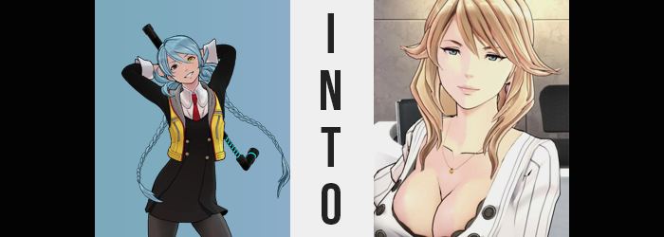

“This is stupid! Explain to me why we’re dealing with such a stupid case again?”

“Mizuki? May I suggest using a little more tact. Remember that if you shout, you’re likely to make others aware that you’re investigating.”

“Tch.” The life of Mizuki Date was an exciting one these days and so she didn’t really have any room to complain. She was a special agent. She was a Psyncer. Which also meant that she had a special, little prosthetic eyeball with a hyper advanced artificial intelligence inside it that made it easier for her to solve cases that would be far too difficult for others. In a way, that AI-ball gave her special powers. She was kind of like a superhero, wasn’t she? Stopping crime with secret abilities that no ordinary person possessed!

While she tended to let this sort of thing get to her head at times, she’d also been in enough near death experiences by this point that she had to admit that she wasn’t all that superhuman. Psyncing or not, superhuman strength or not, all it would take was one well placed bullet to end it all for her. But what was that about superhuman strength? If you asked Mizuki about it, she would usually just brush the question aside. Her body had always been like that, after all.

Even if she had only recently found out why. But that wasn’t all that relevant to this story.

Aiba, the artificial intelligence inside the eighteen year old’s left eyeball, sighed. “I understand, Mizuki. This is not the type of investigation you would like to be involved in. But as it is within your company, do you not feel some manner of moral responsibility to—?” The AI had prepared an entire speech to try and cheer the girl up, only for it to be interrupted quite rudely from the Psyncer.

“Nope! It’s just some stolen lunches. Why am I being asked to investigate this? I’m head honcho!” Mizuki could hear Aiba groan again, this time because the human had spat out details about their investigation again. “What? It’s not a big deal!” This was what had brought the two to the Lemniscate building that late afternoon. Lemniscate was a media office and talent agency and… it was being run by the eighteen year old whining about the work she had been given.

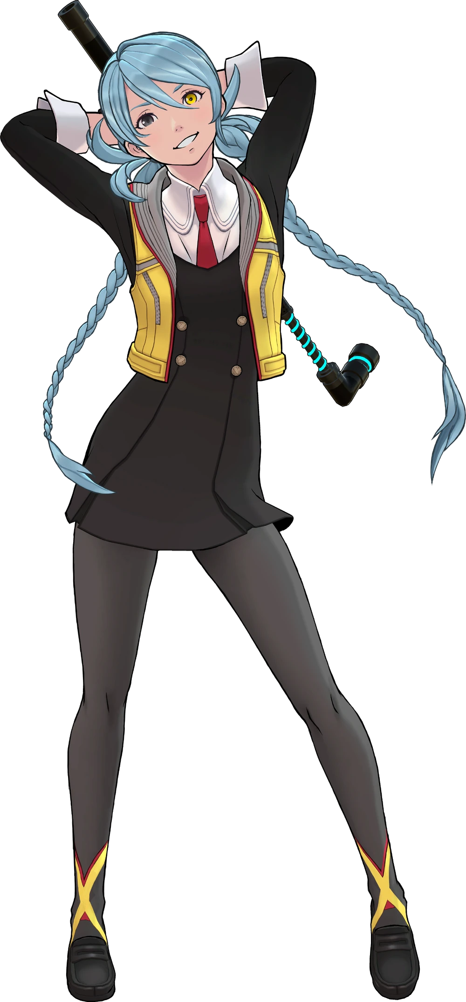
Not that Mizuki had ever wished to run Lemniscate nor the maid café, Sunfish Pocket. It was originally maintained by her father, but six years prior he had passed away under unfortunate circumstances that she didn’t like to recount. In the end those businesses were passed on to his next of kin, a child who was only twelve years old at the time. Since then, she had managed to give most of the responsibilities to others so that she could focus on her detective work, but…

The main office had been short staffed and one of the employees had asked Date to investigate a string of stolen lunches. It didn’t sound like the sort of job that he’d take up normally though. Not that it mattered when, in the end, he just pushed it off on Mizuki. “I swear if the staff member who requested this investigation is who I think it is, then…” Words muttered as the teenager stepped off the elevator and onto the main floor.

“Oh, like, that was me! Are you really here to investigate the missing food?” The timing couldn’t have been any worse. The receptionist behind the nearby desk had apparently overheard Mizuki’s groaning, and the reply she received made her groan even louder. Aiba was quick to send a comment to Mizuki inside her head alone.

So, it was the big tiddy receptionist after all… Typical Date… Not that I don’t understand where he’s coming from. They’re certainly… Wow.

Mizuki rolled her eyes. “Let’s just get this over with. Hold still a second, would ya?” She offered no further context about what she was doing. It was a trade secret! A Wink Psync. A usage of the AI-Ball that allowed her to briefly peer into the dreams and memories of whoever she pointed it at. And she wanted to look at what was going on in the head of the head of the Lemniscate secretary, Ritsuko Enshu. “Huh? Wait a sec, actually.”

Or that had been the plan, but upon trying to activate it something had gone wrong. There’d been some weird feedback and it hadn’t worked, prompting Mizuki to slip into a staff room attached to the lobby after waving the secretary away. “What happened there, Aiba? Do we need to get you looked at? …Aiba?”

What do you like, need? Mizuki sweetie? What’s wrong?

“…Huh? What the hell’s going on, Aiba? Why do you sound like that secretary?” Because Aiba was in her eye in that moment, Mizuki couldn’t actually perceive what had happened to her partner beyond the sound of her voice. But if she had been able to? She would have realized that Aiba’s visual form had changed to completely mirror Ritsuko’s.

Um… Nothing? I was just thinking? What if: we went and picked up a real cutie?

If the eighteen year old had been chewing food at the time then she probably would have spit it out at that moment. “Hah!? What are you talking about!? Is this just some kind of, like, prank!?” That sentence hung in the air for a moment before she followed up on it. “Ugh, you’ve even tricked me into saying it!” It was easy enough to assume as much, but that wasn’t quite it. The truth was far more terrifying in the end. Because in a way? Mizuki had been infected and Aiba, or at least what had become of Aiba, was the infection.

But it soooo isn’t a trick! Don’tcha just wanna kick back and relax like me?

The AI didn’t drop what the teen still believed to be an act, but it was additionally strange because, well… Those were Aiba’s comments, but they also resonated with her strangely. No, it seemed like those thoughts were somehow her own even though there was no way that was possible. At least not unless the egos of the two women were overlapping or, perhaps, blending. But Mizuki didn’t really consider that angle because, honestly? Why would she? “I don’t!”

Because she was understandably distracted by the bickering with Aiba, Mizuki wasn’t really paying all that much attention to her own body. Had she been? Well, realistically she would have just reacted sooner, but it allowed the side effects of her ‘infection’ to rear themselves early on without much in the way of pushback. This ignorance could only be sustained early on because the earliest signs were things that would have been difficult to notice without paying attention anyways.

Such as? Mizuki’s hair, for example. The light blue coloration of her body’s hair had always been a unique identifying feature of hers. There weren’t exactly a lot of people out there with that specific shade. Well, aside from one young woman who had the exact same shade. Yet the Psyncer’s own was losing its vibrancy, coloring fading to a pale blue for a moment before shifting away from the blue altogether until it was a sandy blonde.

To make matters even more concerning? Her braided twintails completely unfurled because the bands at the tips had slipped off courtesy of the length shortening. It crept up towards her shoulders where it eventually halted its regression, but there was a tradeoff for its shortened length. The hair that remained puffed out, becoming much fuller in shape with thick bangs swept to other side as the scent of an excessive amount of hairspray drifted off of it. Similarly? Pubic hairs that were now blonde had exploded into an unkempt bush within her underwear.

You just wanna pick up a real hottie and have a good fuck, right? We wanna do that!

“You totally don’t… We… I don’t want to do that!” Mizuki had never concerned herself with romance or physical pleasures, and yet after Aiba suggested them to her? Well, it became a little hard to focus. She kept thinking about things like being ridden or sucking cock? Her cheeks burned a little red. “Wh-What am I thinking about!? This is soooo not me!” At least it wasn’t her yet. But the pull was becoming harder and harder to resist.

Strangely? While she was imagining herself committing more inappropriate acts, the body she had been imagining herself doing them with hadn’t lined up with the body she possessed. Everything has seemed so much bigger, especially a chest she could imagine herself giving someone a titty job with. And that wasn’t unintentional. Her body just had to catch up to what she was imagining. Unfortunately, her clothing wasn’t exactly built for what that meant, however.

“Uh… What in the total hell!?” And thus, the ignorance on Mizuki’s part was abruptly shattered by something she absolutely could not ignore. She was growing, and quickly at that. Despite being in her late teens by this point in her life she was still on the short side. She hadn’t grown too much since her childhood and was just under the 5’ mark even after growing through her teens. But that was until her height shot up.

The girl’s Psyncer uniform absolutely was not designed to fit a size any greater than her already meager height. So as limbs lengthened, and her torso elongated? She immediately noticed just how tight everything was. “Ugh, this is sooooo not cool!” Her voice deepened as she tugged at cloth, tights being yanked down off her waist and the sleeves ripping off her coat thanks to shoulders broadening. In a similar fashion? The sides of her skirt were compromised by widening hips too. In the end? She had sprung up to 5’4” and had been given no choice but to kick off her footwear so that enlarged feet could be contained.

That’s right! Aren’t we becoming so smoking hot?

“We totally are!” Mizuki’s response to Aiba’s internal goading was immediate, and she reached her hand up to cover her lips in surprise. It hadn’t really caught her attention like it should have, but those hands… Not only were her fingers longer and her nails longer, but the fingers themselves appeared a little dried and cracked. Like the possessed the skin of a woman who was significantly older.

Which, peering at her face, made a whole lot of sense. Crow’s feet and vague bags under her eyes had appeared briefly only to be concealed by a strong-scented makeup that concealed them again seconds later. Thick lipstick adorned lips that bloated several times bigger, almost akin to the type of lips you would find on a pornstar. Whereas her eyes? Their colors darkened to a brown as mascara and eyeshadow masked their inconsistencies. But with her face just fuller and more mature overall? She definitely looked like a different person.

She looked like the receptionist. “But since I’m naturally so hot, there’s obvs nothing wrong here, right? Duh!” The woman, now looking like she might belong in her forties if not for her makeup, was finally at the stage where she was seeing her transformed body as ‘correct’. Aiba’s voice was becoming quieter too, but it was more like… their thoughts were overlapping much more strongly.

But while Mizuki certainly resembled the Leminscate receptionist now? She was still missing a pair of key features. Ones that absolutely could not be contained by her current outfit. Nonetheless, this didn’t stop them from trying. “Urk!?” The victim in question was immediately cued in thanks to the pressure and tension she felt around her chest. She was normally so flat that she didn’t wear a bra, but in this case that ended up being much more of a blessing than she could have foreseen.

Because what was once flat certainly wasn’t any longer. In a matter of seconds her A-cups had sprung up to C-cups and that alone was to make it obvious that her Psyncer uniform couldn’t contain them as it was. But she was afforded a sigh of relief as the slack loosened around her chest courtesy of her outfit itself shifting. Tights and undergarments stretched more conveniently around a plumper ass and thicker thighs that showed their age under scrutiny.

Mizuki was hoisted up as pink heels took shape, and that pink matched with the pencil skirt that was bound to her waist but hung down to the peaks of her thighs. Sleeves reattached themselves to a frilly, cream-colored blouse with an open collar, and as the neckline deepened further and further? Pink, orb-shaped flesh spilled out because her tits had only continued to grow. Nipples were engorged and had to be larger than her eyes, but of course her boobs themselves exploded well past any traditional size. They had to be H-cups by the time their cleavage was fully exposed, so perfectly shaped despite her age that they might have been the eight Wonder of the World.

Big tiddy indeed.

There were no longer two voices communicating back and forth within the woman’s mind as she stood in the staff room with a blank expression on her face. It almost looked like she had just been rebooted – even though there wasn’t much inside that brain to reboot in the first place. Both voices had overlapped and blended together, and so the end result? Well, Ritsuko Ensho had been reborn. “Like what even was I doing?”

The 42 year old bachelorette looked around with a skeptical glance. She couldn’t really recall the last five or so minutes for some reason? But she was definitely at work… Ritsuko did a little twirl, her ‘big tiddy’ jiggling about as she did so, still barely contained by her bra and blouse. “Oh! Am I on break? I must be on break, right?” Why else would she be in the staff room? It was where all of the staff took breaks, after all!

Even though the woman was in heels she still managed to tiptoe over to the full body mirror in the corner of the room not to fix herself up, but to check herself out. “I’ve got a hot date after work and I’m good to go! The nice thing about being able to dress like this at this gig is that it totally doubles as an easy date outfit too. Hehehe!” Although she really hoped that this hunk wouldn’t be too weirded out by the fact that she was a Reptilian. One of many conspiracy theories that this ditz of a woman unfortunately believed!

After cupping her tits to lift them and see them bounce with another giggle escaping lips caked with lipstick? “Time for a treat since I’ve been a good girl and I’m on break~!” She practically skipped over to the minifridge in the opposite corner of the break room and began to rummage around inside of it. What she settled on? It was definitely food labeled for someone else. All along? The food thief had been Ritsuko herself. She had been trying to look less suspicious by reporting it. And as she bit into a bit of the chocolate cake slice that wasn’t hers? She remembered something. “Wasn’t someone totally supposed to come and investigate that?”

They had. A new Mizuki and Aiba were in the lobby at that very moment. Confused about how they had ended up behind the secretary’s desk.

You can imagine why that had been the case?

