Applications of Integration – Formula Sheet:
Area under the Curve:  $$A=\sum_{i=1}^{n}{f(x_{i})}∆x ∆x=\frac{b-a}{n}$$  $$A=\int_{a}^{b}{f(x)}dx Interval→[a,b]$$ | Antiderivatives:  $$F^{'}\left(x\right)=f\left(x\right)$$  $$\int{f(x)}dx=F\left(x\right)+C$$
Summation Formulas:  $$\sum_{i = 1}^{n}{c=cn} \sum_{i = 1}^{n}{i=\frac{n(n+1)}{2}}$$  $$\sum_{i=1}^{n}{i^{2}}=\frac{n(n+1)(2n+1)}{6}$$  $$\sum_{i=1}^{n}{i^{3}}={\left[\frac{n(n+1)}{2}\right]}^{2}$$ | Rectilinear Motion:  $$v\left(t\right)=s^{'}\left(t\right)$$  $$a\left(t\right)=v'(t)$$  $$\int{v(t)}dt=s\left(t\right)+C$$  $$\int{a(t)}dt=v\left(t\right)+C$$
Summation Formulas:  $$\sum_{i=1}^{n}{i^{4}}=\frac{6n^{5}+15n^{4}+10n^{3}-n}{30}$$ | Definition of the Definite Integral:  $$\int_{a}^{b}{f(x)}dx=\lim_{n → ∞}{ \sum_{i = 1}^{n}{f(x_{i})}}∆x$$
Summation Formulas:  $$\sum_{i=1}^{n}{i^{5}}=\frac{{2n}^{6}+6n^{5}+5n^{4}-n^{2}}{12}$$ | Evaluating Definite Integrals:  $$\int_{a}^{b}{f(x)}dx=F\left(b\right)-F(a)$$
Area – Riemann Sums: (Left, Right, & Midpoint)  $$A_{L}= ∆x\left[{f(x}_{0}\right)+f\left(x_{1}\right)+f\left(x_{2}\right)+...{f(x}_{n-1})]$$  $$A_{M}=∆x\left[{f(x}_{0.5}\right)+{f(x}_{1.5})+{f(x}_{2.5})+{f(x}_{n-0.5})]$$  $$A_{R}=∆x\left[{f(x}_{1}\right)+{f(x}_{2})+{f(x}_{3})+...{f(x}_{n})]$$  $$∆x=\frac{b-a}{n}$$ | Properties of Definite Integrals:  $$\int_{a}^{b}{f(x)}dx=-\int_{b}^{a}{f(x)}dx$$  $$\int_{a}^{a}{f(x)}dx=0 \int_{a}^{b}{c}dx=c(b-a)$$  $$\int_{a}^{b}{f(x)}dx+\int_{b}^{c}{f(x)}dx=\int_{a}^{c}{f(x)}dx$$

Area – Trapezoidal Rule: (Approximate Integration)

$$T_{n}=\frac{∆x}{2}\left[{f(x}_{0}\right)+2{f(x}_{1})+2f{(x}_{2})+2f{(x}_{3})+...2{f(x}_{n-1})+{f(x}_{n})]$$

$$Area= \int_{a}^{b}{f(x)}dx≈T_{n} ∆x=\frac{b-a}{n} x_{i}=a+i∆x$$
Area – Simpson’s Rule: (Approximate Integration)

$$S_{n}=\frac{∆x}{3}\left[{f(x}_{0}\right)+4f{(x}_{1})+2f\left(x_{2}\right)+4f{(x}_{3})+...2{f(x}_{n-2})+4f\left(x_{n-1}\right)+f{(x}_{n})]$$

$$n→even ∆x=\frac{b-a}{n}$$
Error Bounds – Trapezoidal & Midpoint: $\left|f''(x)\right|≤K$  $$\left|E_{T}\right| ≤ \frac{K{\left(b-a\right)}^{3}}{{12n}^{2}} \left|E_{M}\right| ≤ \frac{K{(b-a)}^{3}}{{24n}^{2}}$$ | Error Bounds – Simpson’s Rule:  $$\left|E_{S}\right| ≤ \frac{K{\left(b-a\right)}^{5}}{{180n}^{4}} \left|f^{\left(4\right)}\left(x\right)\right|≤K on [a,b]$$
Integral of Even Functions:  $$f\left(-x\right)=f(x)$$  $$\int_{-a}^{a}{f(x)}dx=2\int_{0}^{a}{f(x)}dx$$  Integral of Odd Functions:  $$f\left(-x\right)=-f\left(x\right) \int_{-a}^{a}{f\left(x\right)}dx=0$$ | Fundamental Theorem of Calculus – Part 1:  $$g\left(x\right)=\int_{a}^{x}{f(t)}dt g^{'}\left(x\right)=f(x)$$  $$\frac{d}{dx}\int_{a}^{x}{f\left(t\right)}dt=f(x)$$  If f(x) is continuous on the interval [a, b], then g(x) is continuous on the closed interval [a, b] and differentiable on the open interval (a, b).
Natural Log defined as an integral:  $$\ln{(x)}=\int_{1}^{x}{ \frac{1}{t}} dt x>0$$ | Fundamental Theorem of Calculus – Part 2:  $$\int_{a}^{b}{f(x)}dx=F\left(b\right)-F(a)$$
U-Substitution:  $$\int{f[g\left(x\right)]∙g^{'}\left(x\right)}dx=\int{f(u)}du u=g(x)$$  $$\int_{a}^{b}{f[g\left(x\right)]}g^{'}\left(x\right)dx=\int_{g(a)}^{g(b)}{f(u)}du$$ | Net Change Theorem:  $$\int_{a}^{b}{F^{'}\left(x\right)}dx=F\left(b\right)-F(a)$$  $$\int_{a}^{b}{V'(t)}dt=V\left(b\right)-V(a)$$

Area Between Curves:  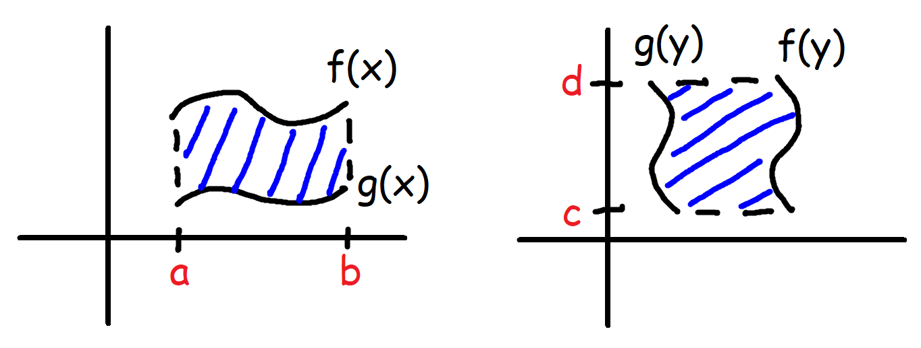 | Area Between Curves:  $$A=\int_{a}^{b}{\left[f\left(x\right)-g(x)\right]}dx (top-bottom)$$  $$A=\int_{c}^{d}{[f\left(y\right)-g\left(y\right)]}dy (right-left)$$
Disk Method:  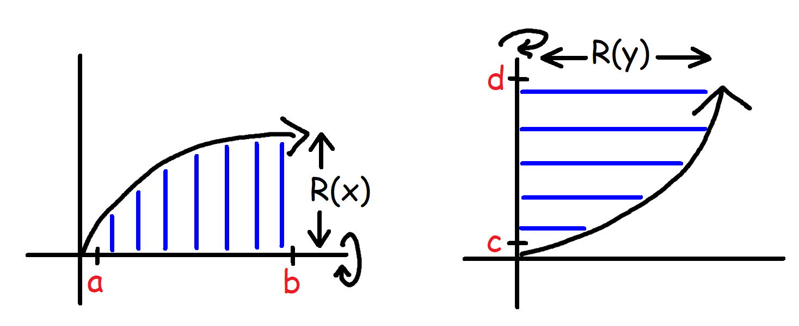 | Disk Method:  $$V=π\int_{a}^{b}{R^{2}(x)}dx$$  $$V=π\int_{c}^{d}{R^{2}(y)}dy$$
Washer Method:  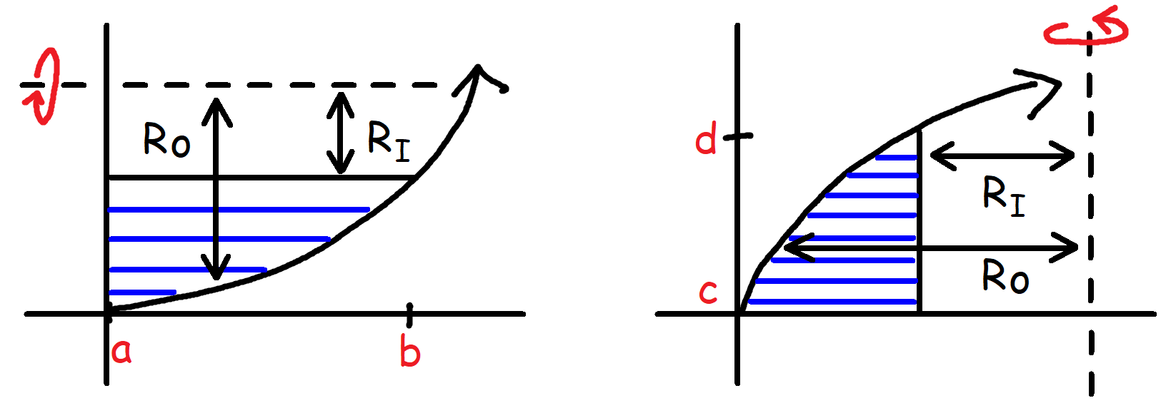 | Washer Method:  $$V=π\int_{a}^{b}{[{R_{o}}^{2}\left(x\right)-{R_{I}}^{2}(x)}] dx$$  $$V=π\int_{c}^{d}{[{R_{o}}^{2}\left(y\right)-{R_{I}}^{2}(y)}] dy$$
Shell Method:  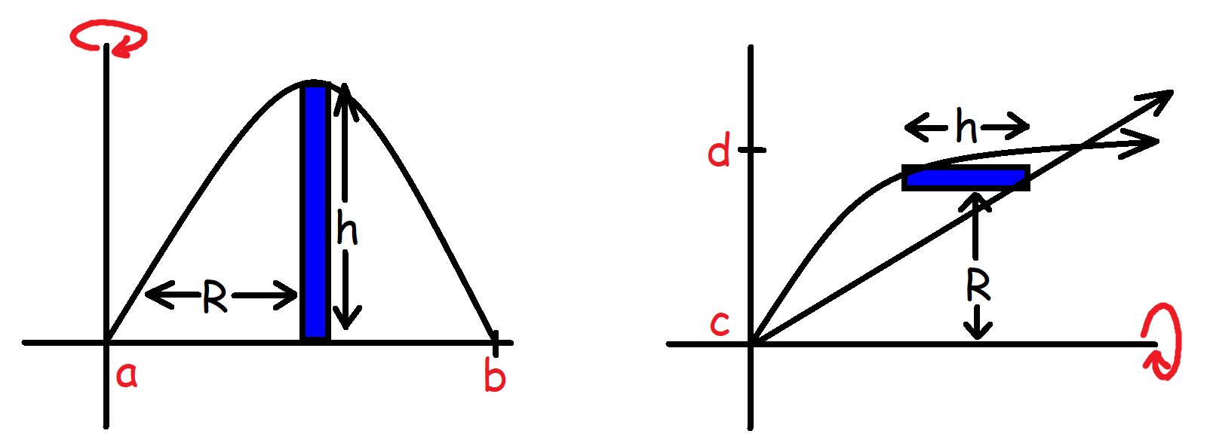 | Shell Method:  $$V=2π\int_{a}^{b}{R\left(x\right)}h\left(x\right) dx$$  $$V=2π\int_{c}^{d}{R\left(y\right)}h\left(y\right) dy$$
Improper Integrals:  $$\int_{a}^{∞}{f(x)}dx=\lim_{t → ∞}{\int_{a}^{t}{f(x)}}dx$$  $$\int_{-∞}^{b}{f(x)}dx=\lim_{t → -∞}{\int_{t}^{b}{f(x)}}dx$$ | Volume by Cross Sections:  $$V=\int_{a}^{b}{A(x)}dx cs⊥ x-axis$$  $$V=\int_{c}^{d}{A(y)}dy cs⊥ y-axis$$

Work done by a Force:  $$W=Fd W=\int_{a}^{b}{F(x)}dx$$  Note:  F(x) is a function of force with respect to position. | Arc Length:  $$L=\int_{a}^{b}{\sqrt{1+{\left[f'(x)\right]}^{2}}}dx L=\int_{a}^{b}{\sqrt{1+{\left(\frac{dy}{dx}\right)}^{2}}}dx$$  $$L=\int_{c}^{d}{\sqrt{1+{\left[g'(y)\right]}^{2}}}dy L=\int_{c}^{d}{\sqrt{1+{\left(\frac{dx}{dy}\right)}^{2}}}dy$$
Gravitational Force:  $$F=mg F=\frac{GM_{1}M_{2}}{R^{2}}$$  Restoring Force of Springs – Hooke’s Law:  $$F\left(x\right)=-kx$$ | Area of a Surface of Revolution:  $$S=2π\int_{a}^{b}{f(x)}\sqrt{1+{\left[f'(x)\right]}^{2}}dx$$  $$S=2π\int_{a}^{b}{y}\sqrt{1+{\left(\frac{dy}{dx}\right)}^{2}}dx$$
Work required to pump water out of a tank:  $$W=pg\int_{a}^{b}{V\left(x\right) D(x)} dx$$  Density of Water:  $$p_{H2O}=62.5 lbs/{ft}^{3}=1000 kg/m^{3}$$ | Area of a Surface of Revolution:  $$S=2π\int_{c}^{d}{g(y)}\sqrt{1+{\left[g'(y)\right]}^{2}} dy$$  $$S=2π\int_{c}^{d}{x}\sqrt{1+{\left(\frac{dx}{dy}\right)}^{2}}dy$$
Work done by an expanding gas:  $$W=\int_{V_{1}}^{V_{2}}{P dV}$$ | Average Value of a function:  $$f_{ave}=\frac{1}{b-a} \int_{a}^{b}{f(x)}dx$$
Mean Value Theorem for Integrals:  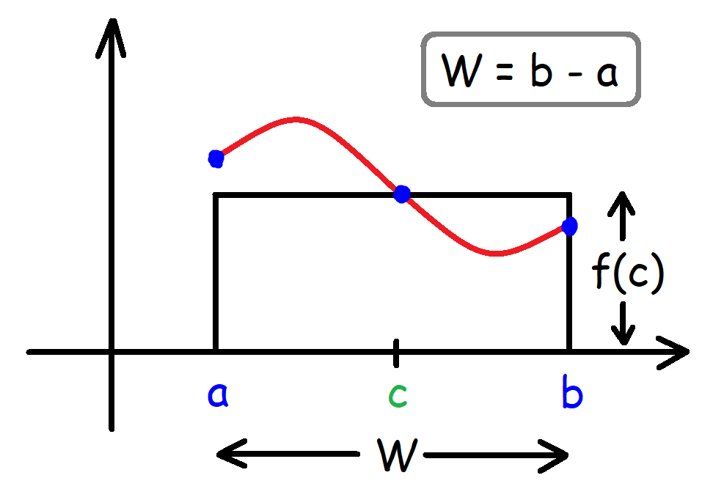 | Mean Value Theorem for Integrals:  $$\int_{a}^{b}{f(x)}dx=f(c)(b-a)$$  $$A_{curve}=A_{rectangle}$$  $$Width=b-a Height=f(c)$$  $$f\left(c\right)=f_{ave}$$

