Curled Up  A Vignette  By Maryanne Peters  When I retired, I decided that I was going to live a life of leisure. I had made plenty of money and I no longer had any dependents. I just wanted to curl up on the couch and relax.  It was just that my whole life I was driven, and I felt that so long as the driving force was still in me, I could never truly let go and lighten up.  The problem was that I was a man. The problem was between my legs. That simply had to go.  I had the money, and I also had a reasonable amount of hair. I needed an expert to rework my scalp and migrate a little beard hair further up – it is amazing what they can do. Now I am very happy with what I have. A large mop of blond hair to play with. | 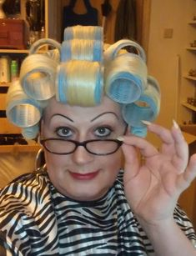

Of course I am not a natural blond, but blond hides the grey so much better, and white hair even better yet, and I just feel that as a woman, I ought to be blond. It reflects my character, I think. I like to have fun, and I want to look good. It has nothing to do with attracting somebody. If I look as good as I, can I just feel happy.

The truth is that I have always wanted to be a woman, and a pretty woman at that. But as my life marched on it seemed that I had lost the chance to transition and be desirable in a time of life that women look their best. But I was making money and being successful, and for that sacrifices need to be made. It was only when I saw that I had the chance to realize my life’s true ambition that I realized that a woman can be attractive and desirable at any age, if you have the money and you put in the effort.

Skin and hair are important for a transwoman. Of course the hormones help, and I also think that it helps that I am carrying a little too much weight. I look soft and womanly, and I am happy to look that way. Good legs help, but when you are shaped like I am, I recommended appropriate clothes and good posture. Combine that with proper hair care and a good skin regime, and maybe just a little bit of botox here and there? Be sure not to lose the ability to smile, especially if you enjoy life the way I do. At my age men prefer happy women – they are easy to please.

Yes, men. I was not sure it was going to work out that way, but it has. I now prefer men.

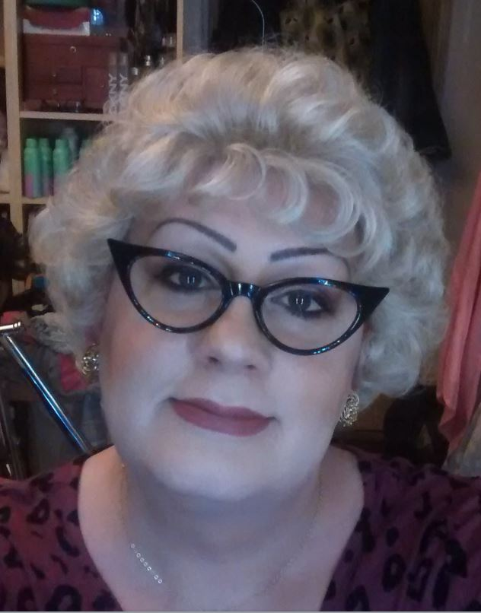 | But I like my own space too. There is nothing better than being curled up and curled up, on my sofa with my rollers in. I have Jasmine come around to my place to put in my roller set. She also keeps my brows plucked the way I like them, and she does my nails. I think that they look fabulous, and so delightfully impractical. I am a woman at last, and I rather prefer to do distinctly feminine things. I even don’t pull corks or change lightbulbs. I ask a man to do such things. I am happy to watch him and praise his strength and skill.  Oh yes, I receive gentlemen in every sense. When I am ready Jasmine brushes out my set I am happy to receive visitors.  I would have loved my hair to be longer had I transitioned young, but I think my hair looks right for my age. A style a little old-fashioned you might say, but appropriate.

Not the least because it remnds my gentlemen of their past, perhaps, and a time when men were men and women loved them for it. I am one of those women now. Not for me those young “metro-sexuals” who seem effeminate. I believe that men should be men, or in my case women, because that is what I really am.  All these men today who wear diamonds in their ears or even their noses! It gives my favorite gem a bad name. I go for pearls these days. Pearls are so feminine – don’t you think.  I were my spectacles for the same reason. I am short sighted but I could have surgery to fix it. But glasses in a distinctly feminine style can be such an important fashion accessory – don’t you think?  Anyway, that is the doorbell. I think it will be Walter tonight. He knows how to treat a lady. I will happily curl up in his arms tonight if things go to plan.  So bye for now! Please stay in touch.  The End | 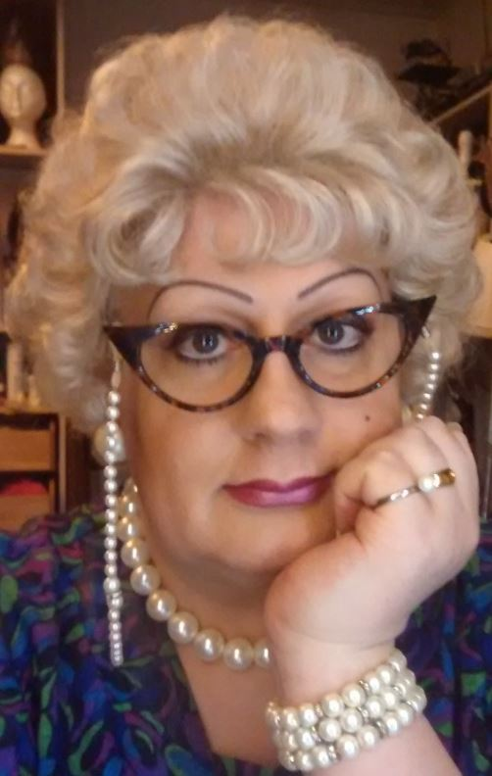
801
© Maryanne Peters 2023

