WASTED TALENTS
SEPTEMBER 2021 REQUEST STORY
BY CHALDEACHANGE
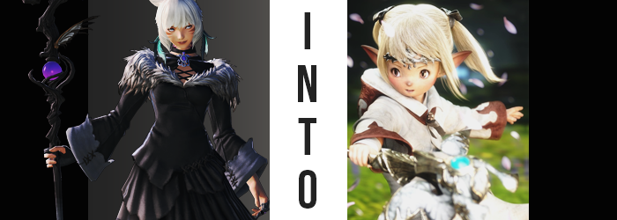

The town of Tomra was an interesting location in the First, Y’shtola Rhul couldn’t help but note. She had spent so much of her stay in the Rak’tika Greatwood that she hadn’t really taken in the culture of this world’s Lalafell. Well… no. That was incorrect. Every race had a different name on the First, and in the case of Lalafells they were simply referred to as ‘Dwarves’.

The homes of this Dwarven village were not meant to be lived in by regular people. With doorways big enough for only the smallest of people, it was clear that Tomra did not typically take the company of the other races. At the first mention of the only First Dwarf she knew though, she had an inkling as to why that was.

“Did you just bring up Lamitt? Clearly you ain’t know jack about anything ‘round here.” One drunken dwarf in particular had pushed back against the mention of Lamitt, even though Y’shtola merely had asked out of curiosity. A check, to see how renowned that name was. But she had been met with far more than animosity during her stay after the fact.

It wasn’t like she couldn’t understand their disdain for that name, but surely they did not understand Lamitt had tried to save them in the end? Whether she had become a Sin Eater or not, that did not erase her intentions. “But would you not think that her actions—?” The Miqo’te thought she might try to speak to the Dwarf’s sensibilities, only for another nearby to chant something or other. It certainly wasn’t an incantation Y’shtola had ever heard before, but before she could react?

The world instantly closed in around her.
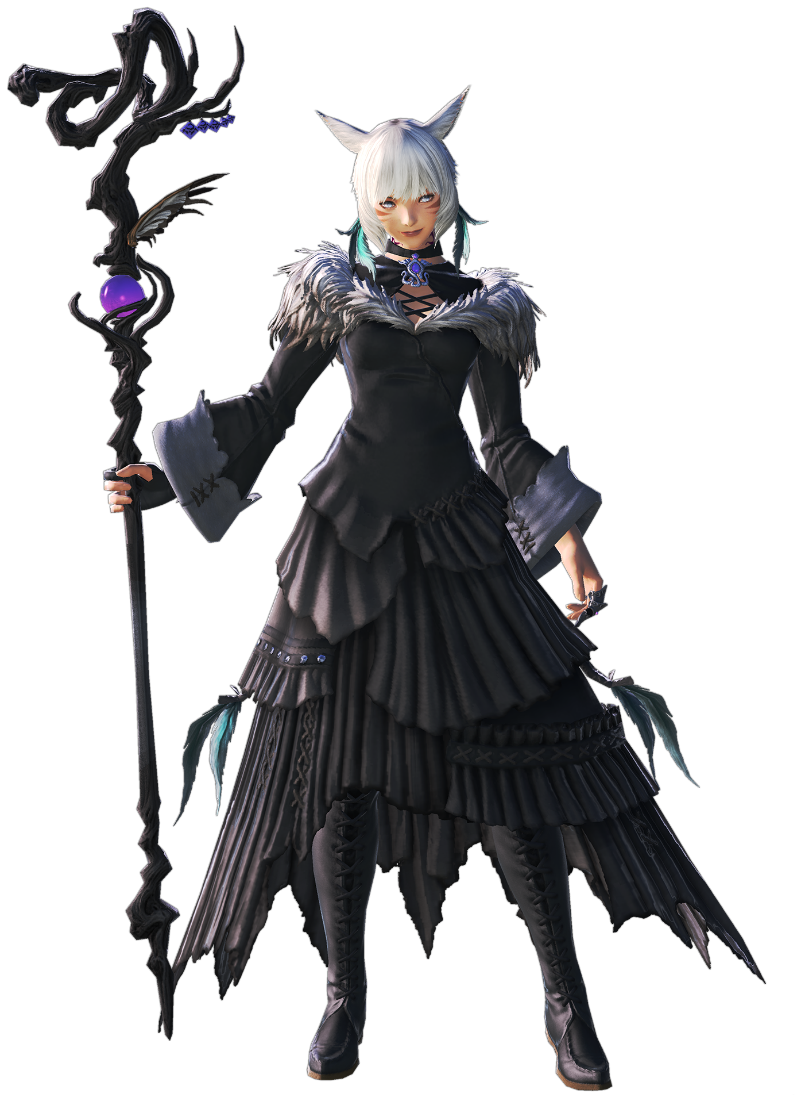
She had been forced into a laying position on the ground, cheek resting on dusty floor with her head pressed up against something. It was almost like she had been crammed into a box, and yet it certainly couldn’t be one. After all, even with her damaged vision she could tell she was positioned so that she was peering through a tiny window.

“Could this be…?” With her body curled up with no space to move, she couldn’t be one-hundred percent sure. And yet she felt certain enough. She had somehow been teleported into one of the tiny Dwarven structures that made up Tomra’s architecture. “How in the stars?” Some sort of magic, evidently. There was no way to cram an adult Miqo’te woman in through one of those tiny doorways, and yet even if she could explain where and how, she really had no means of understanding why.

Some of Tomra’s citizens really didn’t take kindly to Lamitt sympathizers. Many of them had lost loved ones to the Sin Eater she’d become, and a small cult of them? They had decided on a fitting punishment for these sympathizers. Giving them a taste of the life of the woman they defended.

Not that Y’shtola could possibly predict that such a fate awaited her.

“Regardless of how this happened, I suppose I’m in something of a bind here.” The Sorceress was hardly in the position to move, much less free herself from this situation. Her hands were pinned to her sides so she couldn’t move them to cast, and to begin with… Based on how even the slightest motion felt, Y’shtola was fairly certain she was no longer wearing any clothes, or at least it was all so tight that it created that impression.

The best she could hope to do was squirm, and in doing so she could both feel her nipples rub against the floor and her ass against the roof somewhere behind her. No, okay – her clothes were still there. It was just so hard to tell. Strangely she couldn’t feel her tail, but it was simple enough to chalk that up to a loss of circulation considering the circumstances. And yet, in truth, that wasn’t quite the case at all. The reason she could not sense anything from her tail was because it quite simply just did not exist any longer.

In the earliest moments, it had gone the way of the Ascians – that is to say that it had disappeared. Pulled back into her body through the tailbone it had grown from before her birth, one of her two key Miqo’te tells had completely dissipated. With the other piece not very far behind, it seemed.

Her feline ears were naturally impossible for the woman to see even under typical circumstances without a mirror, what with how they rested on the very top of her head. Cramped into this tiny house as she was, though? Well, no one could fault her for having even greater trouble. “Hm?” But the investigative mind could certainly tell that something was wrong; her hearing had dulled out for just a moment after all.

Her feline ears folded downward, forced into a flatter state than they already were while pinned against the ceiling. What came next wouldn’t be possible without the room to move, so being as perky as they normally were just wouldn’t do. Slowly they wriggled down the sides of the woman’s head, and as they did so the white fur that decorated them withdrew in a very subtle manner.

From that point on, it was just a matter of which race those ears would represent, because they certainly didn’t belong to any Miqo’te. Their cartilage fanned out to the sides, which essentially eliminated Hyurs and Roegadyn from the possibilities. As they were pulled longer, the tips clearly reached points – which narrowed the potential races down to two. The first were Elezens, but their pointed ears were usually thin. Not only were these ears thick, but they were stained with darker colors near the tips.

An easy Lalafell tell. Or Dwarves as they were called on the First.

Since her cheek was still resting on the floor, Y’shtola could now feel one of these ears pinned against it as well. “Surely I’m imagining things? There’s no way that…” That she could be becoming a Lalafell? No, that sounded entirely implausible, yet… I’m not a ‘Lalalfell’! What even is that? I was born a Dwarf! A voice from within sought to protest the Scion’s uncertainty.

In the meantime, the woman’s soft, white hair found itself compromised by a color that didn’t at all belong. It was hardly ridiculous in significance when it came to the scale of that change, but the sandy blonde that sought to bring some color to her mane was undeniably different than the color it was meant to be. What’s more, it grew longer and straighter so that it tickled the woman’s shoulders in the back, with stringier bangs swept to the left in the front.

“This is a curious phenomenon regardless. This voice inside of me feels so potent, it’s hard to resist…” Most would clearly be panicked in a situation like this, yet Y’shtola Rhul was the sort of individual that would find it fascinating. The only reason she could retain her calm though was that she sensed no hostility from that voice, even as it became stronger.

Without her knowing though, the woman had perhaps given too much freedom to this invasive force. Memories that she’d held dear to her were being swapped out beyond her notice, in fact. Beginning with those of her youth. Master Matoya? To which face did that name belong? She had been raised by a normal couple of Dwarves, as most had in Tomra.

“Ah! I can move!” The realization struck her as soon as the slightest bit of space was afforded, although Y’shtola herself didn’t immediately put two and two together to understand how. Another moment lingered before she caught on, and before she could even make a remark about it, there was then enough space for her to push herself up and roll onto her butt. “I’m shrinking now, is it?”

It would have been easy to assume the building had gotten bigger around her, but the Sorceress knew that was a far less plausible explanation than she, herself, shrinking in terms of options. After all, now that she could move her arms again, she was free to investigate areas of interest even while her butt slid inward as she continued to shrink proportionately in the room’s floor. The friction was certainly uncomfortable, and her dress was quick to become not only so big that it pooled around her, but before long she was practically swimming in it all – evidently, it was not shrinking alongside her.

Fingers played with the lengths of her ears once her entire torso fit expertly through the neckline of her outfit, and as they did she found that it was becoming increasingly difficult to do so. The cause? Withdrawing one hand before her eyes, she could see both her palms and the digits upon them swelling thicker.

It was a phenomenon that grew soon into her wrists and arms, rendering limbs consistently broad in a way that trended up her lower half as well. Tootsies were little more than tiny sausages against feet that were questionable in how they might support her strength while standing. They’d long pulled out of her boots, which laid a few feet away from her and looked hardly any bigger than she was since they’d once reached her thighs.

“But strange as it is, I feel like I’m in rather high spirits!” Y’shtola’s voice had taken a turn, both squeakier and full of an enthusiasm that was far more immature than she would typically express. She couldn’t keep her chubby fingers off herself, playing with her feet and running them across her legs.

Once her waistline thickened and her stomach bulge swelled to steal anything remotely like a figure from her torso though, it became clear to the woman that she looked bizarre. Like a very lanky Dwarf. She firmly groped her breasts a moment, and her expression looked relatively saddened as she felt and watched them fade away into mosquito bites that were a far cry from their usual size. It was like, from her point of view, she’d been gifted a normal pair of breasts only to have them taken away. That wasn’t true of course, because Y’shtola had possessed those breasts for a long time.

But now she didn’t feel that way.

In fact, while she could sense something had changed, she couldn’t quite recall ever having breasts like those.

Planting her small hands onto the dress that sat flat on the floor behind her, it took some effort to push herself up and onto her feet so that she could be fully free of her cloth prison. The roundness of her rear had collapsed, leaving her butt to appear as little more than an indentation down the center to indicate the subtlest of cheeks. The woman’s thighs were almost shaped like radishes after all, and that appeal only grew as her legs, well, did the opposite of growing. Y’shtola had already shrunk enough to stand within the tiny, Dwarven hut, but now her bodily proportions sought to make it so that she became even smaller – at least small enough to fit naturally through the door.

Thick arms and legs became even more so once the length of them practically halved, with each limb bearing more resemblance to a wide, stubby nub on the four corners of her body rather than the long limbs of literally any other race. This diminutive design affected her torso dramatically, and the roundness of her gut ultimately stood even more apparently once shoulders pinched in so that her chest was thin, and her body’s design grew wider the farther down you went towards her hips. This wasn’t to say that she was overweight – Lalafells and Dwarves just simply had wide designs without much in the way of sexual characteristic.

“This is… No, this is right, isn’t it?” Y’shtola’s mind was a mess. While looking down at herself, her potato-like body bare and visible without any discretion to speak of, there was a part of her that rejected things as ‘wrong’. Yet she had allowed the other voice so much room out of curiosity that any part of her that might have put up a fight was more or less caught up in the euphoria of it all.

That part within was enough to prompt herself to pull her cheek to make sure, although she did so in the process of said cheek changing. With her head collapsed in size, there was little room for the sleek design her face had possessed prior. Instead, each cheek was round and squishy, giving her a youthful glow despite still being in her twenties. Her nostrils had flared while her nose itself shrunk, instead looking like a dark-colored button above lips that lacked any real distinction, and her eyes? They were not only smaller and rounder, but were now colored a glossy brown.

Y’shtola’s vision had returned to normal, and she hadn’t even noticed. That was how far gone she was. Even if she’d still remembered that she could perceive things through aether, she no longer held recollection of the events that had led to that, nor how to do so. Instead there were memories of a simple life growing up in a discriminatory, Dwarven society.

Not to mention memories of fondness aimed at a certain individual.

And in a flash, the gigantic (by comparison to the woman) dress on the ground promptly lifted without the Dwarf’s feet to pin it down. It swirled around the room as if possessed a moment, leaving the Dwarf’s mouth agape with surprise before… it vanished. Where? She could not say. Yet she was now clad in an ensemble befitting of any healer worth their salt.
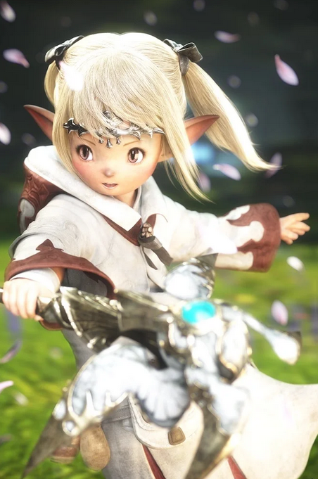
Staring out the window, her mind both half her own and half not, Lamitt’s brows furrowed as she came upon a realization. “What… year is it?” Dressed in the traditional raiments of a White Mage, she felt as if the world outside was not one she recognized. The buildings all looked newer, the town was less decrypt. It was the part of her mind that was still Y’shtola that found it odd though, because the other half of her mind?

She registered this as a year long past, the very day the young Lamitt had chosen to forsaken her Dwarven heritage to travel with Ardbert and his group. Even just thinking about Ardbert brought the tiny woman’s heart to flutter, and equally tiny fingers fell upon her chest to still her nerves. So handsome, so dashing, so kind… Despite the fact that Y’shtola had never once considered romance in her life, as Lamitt she really couldn’t stop thinking about that possibility.

As she lingered among her quarters, the Dwarven girl recalled she was on a time limit. It wouldn’t be long before her own people chased her out now, and while that was sad it was also a sacrifice she was willing to make for the sake of her own future. That was why she had abandoned her helmet. The more confident she became in this position, the quieter Y’shtola’s personality and memories grew. Much of her memory had been lost, but in terms of will? It had once been 50/50, but was now 90/10, leaning towards Lamitt.

“Okay, I should hurry!” After smacking her chubby cheeks to psyche herself up, the young lady waddled with haste over to a wooden rod propped up near the front entrance before hurrying out. There was a voice in the back of her head saying she might meet tragedy if she followed this path, and yet…

For him, she was willing to take that risk!

