FIZZLING BLASTS
COMMISSION STORY
BY CHALDEACHANGE
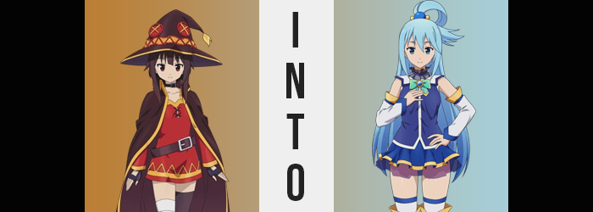

“I still don’t get why we’re having a party for a holiday only Kazuma seems to think exists.”

“Lighten up, Megumin! Why don’t you have a drink?”

“…I’m fourteen.” The Megumin in question replied in a perfect deadpan to the blue-haired goddess that was pestering her. Truthfully? She already wasn’t much of a holiday and party person. Unless she was given a chance to show off her favorite hobby – unleashing explosions – it was hard for the girl to show much enthusiasm. And when things were too hectic she was reminded of her time back home with the other Crimson Demons. Things didn’t need to be noisy all the time, did they?

Then there was the matter of what they were celebrating in the first place. Kazuma had seemingly gotten everyone in the town of Axel on board with Aqua’s help. Christmas. He claimed it was a holiday from his homeland but Megumin had been having a hard time keeping track of what it was supposed to be. At times he claimed it was a night for couples to be together (no doubt a ploy to get a girl to spend the evening in his company) and others he claimed the point was to give presents to your friends and loved ones (no doubt a ploy to get people to buy him things).

And if she didn’t already have enough proof that this was all made up? Sometimes he claimed that a jolly, fat, old man somehow crammed himself down chimneys to give gifts to kids. Just how gullible did he think people were? …TOO GULLIBLE! Why was she the only one not buying it? “Everyone’s too desperate for reasons to throw a party.”

Megumin’s bad attitude was really bringing the party down. Aqua didn’t say it out loud, but she wore a troubled expression while playing with a cup she had poured to try and get the teen to let loose a little bit. But there was a sleight of hand while she fiddled, not that Megumin was paying attention to notice in the first place. Some magical water was conjured and dropped into the red, plastic cup. Only a drop, but it would be enough for what she planned.

“Come on now, don’t be like that! Take a sip! It’s not alcoholic!” The goddess was much more forceful the second time. But Megumin didn’t really put up as much resistance as you might have expected… because secretly she’d wanted a chance to try the wine. People didn’t usually let her drink! But because she wasn’t all that honest with herself she had tried to play it off as being disinterested originally.

But if Aqua was going to be this pushy… “BLECH!?” The explosion mage had downed the entire glass in one motion. Eager as she had been to sample the beverage… she ultimately thought that it had tasted gross. “That flavor is so strong!” Like sour grapes? All wine was made with grapes, wasn’t it? She immediately felt a little nauseous and excused herself for a moment, leaving an Aqua who was beaming suspiciously behind.

“Heeheehee! Maybe now she’ll loosen up a little more! Like me!”

…Perhaps in a more literal sense than Aqua had intended though.

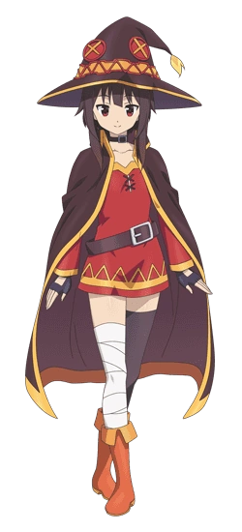
Megumin hadn’t gone to the bathroom or even her own bedroom in the wake of her onset illness though. “Huh? Wait! Why the heck am I in Aqua’s room?” Her bedroom in the mansion was a few doors down from Aqua’s, but she had never made that mistake before. She couldn’t even remember making a decision to go into any bedroom much less the wrong one. “Was it the wine? Does it normally hit that fast?” But she didn’t feel drunk or anything. In fact the nausea she had initially felt had more or less calmed down too.

If anything she felt a little tingly and dizzy. Okay, so maybe she was a little drunk. But off of a single cup?

“I need to leave… Maybe I’ll just go lay down?” And nap off whatever was going on with her. Before turning to leave she noticed a sexy Santa outfit laid out on Aqua’s bed. Apparently Kazuma had gotten someone to make it especially for Aqua so that he could laugh at her, and with its low neckline and very short skirt Megumin could see what might be funny about that. Of course Aqua hadn’t fallen for such an obvious attempt to turn her into a fanservice character. “Or I could try that on! HIC!”

H-Huh!? Why would I do that!?

It made no sense for her to try on a dress that was both skimpy and definitely wouldn’t fit her. And had she just hiccupped? Was that a side effect of the booze too? But she honestly hadn’t had all that much of it! Not that she had ever really been drunk before to know that, so she was just looking for excuses to justify the odd side effects. Not excluding the sensation that her face was feeling rather tingly. In her eyes that could have been a side effect of drinking, right?

But on the subject of her eyes specifically, their very state was relevant to why her face had been tingling in the first place. There was a mirror in Aqua’s room, a full length one at that. But it was tucked away in a corner and Megumin hadn’t necessarily realized she had a reason to look in it just yet. Had she though? The tingling’s source absolutely would have become obvious to her. Her eyes, after all, had not only changed in color from red to ocean blue, but they were bigger and wider to boot.

“A-A-ACHOO!?” There was a temporary squeak to her voice once she sneezed, but what had even prompted it so suddenly? Her nose had wriggled and her nostril had flared permanently, the shape and size of it all growing a bit. By the time she had exploded with her sneeze her lips had grown fuller to boot. In fact she didn’t look much… like Megumin? But that wasn’t to say her vaguely longer, thinner-cheeked face wasn’t familiar at all. It was another case of ‘she would have immediately understood if she looked in a mirror’.

With that in mind, perhaps it was fortunate that she was immediately given a good reason to seek out a mirror. Because the sight of her bangs dangling closer to her eyes had prompted the teen to raise a brow. As was the fact that it was… stretching down to her butt in the back? “HIC!? WHAT’S HAPPENING HERE!?” Wild as it was, it wasn’t even just the length that had taken her of guard. The color, too… Some strands were a familiar sky blue.

Megumin was understandably panicked by this point and her head was whipping around in search of that mirror. She finally saw it and ran over, but the short time that took was still enough for her whole head of hair, brows and all, to be dyed with that very same shade! She gripped the sides of the mirror and leaned in real close, sizing up what the mirror reflected. But her response to it? Well…

“AUUUUUUUUUUGH!?”

A very pained scream.

“I look like Aqua! No, wait… MY VOICE TOO!?” That shrill sound had hit her ear differently because it was coming from her own luscious lips, but that definitely sounded like Aqua’s voice. How? Why!? Even her reactions were becoming just as cartoonishly over the top as the goddess’ normally were! “Did she do something to my drink? I suppose with my powers as a goddess I… could… Huh?” Why did she feel like she knew Aqua’s powers so personally? If she wasn’t feeling even drunker (somehow) then perhaps she would have explored that query in a little more detail. Or maybe if her already sparse intellect wasn’t dropping even further.

As much as she probably would have appreciated a moment to stop, catch her breath, and try and figure out what was going on – maybe go and find Aqua and beat her up? – the transformation continued to escalate. It wasn’t content with merely leaving things in a state of ‘Aqua’s head on Megumin’s body’. It was in fact aiming to deliver her the full package whether she liked it or not. And as she had already demonstrated: she did not.

“W-W-Wait a second!” The tingling sensation that had washed over her face before could now be felt spreading across her entire body, which naturally unsettled the girl considering what she had already experienced. Her worst fears were almost immediately verified, not only because she could feel it, but because she could see it happening in the mirror too. But it was very much an uncanny feeling. The feeling of your body stretching in length, that is. “Whoa!?”

This phenomenon sent a ripple of imbalance through Megumin’s person, for her limbs were pulled longer as if they were mere putty in the hands of a god. Four or five inches were ultimately added to her height, which naturally lifted the base of her tunic up so that the short, black shorts she was wearing underneath it was exposed. Now she looked like a lanky Aqua with Megumin’s figure. A secret third existence somewhere in between these two identities.

“NO NO NO NO NO! Wait… Hahaha! Why would I be made about thiiiiish?” Was she beginning to slur her words now? It certainly sounded that way. But where was her shock and surprise? She had hated the idea of looking like Aqua before, but the more her transformation escalated the less troubled she felt by it. She was still bothered, but it didn’t feel like a big deal? After all she was taller now, not to mention— “Oh!”

There were other benefits.

Megumin tended to be envious of those with bigger busts than herself, so her body being pulled down and forward as her own chest erupted filled her with equal parts shock and awe. The growth of this bosom yanked up her tunic even further, D-cups with engorged nipples rubbing sensually up against the cloth. As if to catch them she grabbed the orbs with both her hands, rubbing them around a little. Which was okay since she was Aqua’s physical age of eighteen to nineteen now.

A pretty goofy smile spread across her lips. In part because the woman she was becoming was pretty goofy, and in part because she continued to feel more and more intoxicated. Having bigger boobs was pretty exciting to her too, though! That said, their growth wasn’t an isolated change in that more of her figure had undergone a similar expansion – notably her rear. Like it had exploded! …Though her passion for explosions had long since fizzled away.

The tight shorts that Megumin usually wore under her tunic had become significantly tighter, and really that was no surprise considering what was happening. The flesh of her cheeks was already poking up and out of the tops of the shorts, lipping over the waistline because her ass had become that much plumper like a peach. The sides of those shorts eventually tore not only in the back, but around the very short legs too. Because her thighs had thickened in a similar fashion and her hips had been given no choice but to widen a few inches to accommodate. Plush thighs didn’t even meet in the middle after her hips had expanded in the way that they had.

Strange noises came out of her mouth after squeezing her own ass. “Is this really all mine? Well I mean, obviously! I’m Aqua after all now, right? I can even remember things from her past!” Although for some reason she couldn’t remember anything before arriving in Axel for the first time. That didn’t really matter though, did it? Considering the way she was dressed now…

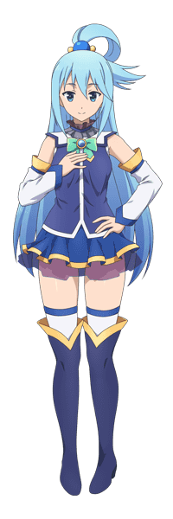
“I told Kazuma that I absolutely was never going to wear it, but…” With her breasts and ass forcing their way out of Megumin’s tunic and shorts, Aqua saw no choice but to put on the stupid, sexy Santa costume and began to wiggle out of the overbearing cloth she found herself in. Of course she wasn’t the real Aqua, and on some level she knew that. But her mind was like an identity stew.

Her new identity, that of the goddess Aqua, served as the base. It defined her appearance, personality, mannerisms, and much of her memories now. But there were little chunks in this hypothetical stew that represented her life as Megumin. Enough little pieces that allowed her to recognize who she had been and the fact that she had been transformed. The problem, then? Her new self didn’t really seem to care.

And it certainly didn’t help that she was very much intoxicated now.

“The real Aqua’sh gonna pay for thish…” It had reached the point where she was slurring her words as fingers were given no choice but to tear through the rest of her old outfit, tits spilling out with an enticing bounce and her ass cheeks and thighs giving mighty jiggles as they were eventually freed. The new Aqua stumbled about clumsily in her drunken stupor, finally pulling off the rest of her outfit so that she was completely nude before trying to put on the Santa costume.

Because she was so inebriated and mentally confused with her largely swapped identity, she didn’t even consider the fact that she could have just worn something else from the real Aqua’s wardrobe. Nor that she had forgotten something important as she wiggled into the tight and revealing dress. She had forgotten to put on underwear so bare cheeks and pussy were sticking out from the very short skirt, and if she moved the wrong way? A whole nipple would definitely pop out. Evidently Kazuma had designed it that way on purpose.

Fortunately she didn’t make it back to the party to have any issues of that nature. Because she collapsed on her bed, completely asleep in a matter of seconds.

“HUUUUUUUUH!?”

The next the Aqua formerly known as Megumin awoke, it was to the sound of her own voice – or at least the voice that her brain was recognizing as her own. “Mm? Keep it down, would ya?” It must have been an hour or two since she had transformed and fallen asleep, because she didn’t feel as drunk as she had before, leaning more into soberer territory. Her eyes were open a pinch, staring up at the real Aqua. Who was completely flabbergasted at the sight of her doppelganger after finding Megumin’s clothes littered about. “You did this to me anyways, right? I don’t know you were that into yourself, original me!”

“I-I didn’t mean to do this! It was just supposed to lighten you up a little!” So she had really turned Megumin into a copy of herself? Had she inadvertently done something amazing? Wait… Why was the sexily dressed copy of herself crawling across the bed at her? Grabbing her shoulders? Pulling her down? Kissing her!? “H-Hey!?”

“Don’t hey me! We both know you’re this much of a narcissist!”

