**PART 6**

**2 MONTHS LATER**

Kyle woke up slow, his body felt locked like his limbs wouldn’t even move. Softly he began stretching his arms and legs, aches and pains ran through all of his bones. He took a deep breath and suddenly began to gag! The flavor in his throat was terrible, sour, bitter, and dry! The coughs and gags turned to wheezing as he looked over to his nightside table, there was a glass of water he had not finished from the previous night. Kyle reached out, his arm shaking, trembling as he choked on the taste of feces deep in his throat.

His hand reached the glass and he gripped it tight, bringing his trembling hand back to his mouth with great effort! Even though the glass was only half full, water bounced back and forth, spilling over the sides from his tremors. Kyle cried as he started to drink, the sour bitter taste of shit got one thousand times worse for a moment until the second gulp washed down the flavor! He felt the contents of his stomach try to rise as he sat up and choked down the rest of the glass quickly!

Every morning got worse, the pain, the aching in his bones, the bitter flavor of shit in his throat. The worst part though was the headaches. It felt like a jackhammer going off in his head, sometimes it was so bad he could not even stand upright! Kyle knew what the cause of this all was, you didn’t need to be a rocket scientist to put this cause and effect together! All of the gas, the shit, the fumes from hundreds of women’s asses, it was eating away at his body, killing him, from the inside out. For the first time, he truly understood the pain Stanley was suffering, all of this would be worth it though. Kyle checked his phone and slowly laid back down in his bed. It was Friday. Today was the big day, the one he had been waiting for, working so hard to achieve. Kyle had a date with Alana.

His morning routine got longer each day as the pains increased at an abhorrent speed! He was now forced to be up at 5 am so he could get ready and be presentable for his first client of the morning. Mentally while brushing his teeth, Kyle mentally tried to remember his schedule for the day. Kacey, he thought to himself and suddenly began to choke and gag. Kyle bent over the sink and spit-up his toothpaste before dry heaving, he could already taste it, the fishy methane. Kacey was a regular client and since the day Kyle began, her gas had been burned into his throat! Just thinking of her brought flashbacks that could stop Kyle in his tracks.

He could see her big brown asshole in the back of his mind, winking, pulsating! Kyle shook his head, trying to get his brain of the thought but it was stuck! Her anus spread wide, rippling and vibrating as the warm gas hit him in the face, **FUCK** Kyle thought to himself, he could feel it! Kyle looked down to his feet and saw the heating had kicked on and warm air was blowing up from the vent on the floor. He let out another deep-throated gag before shoving the toothbrush into his mouth and aggressively brushing!

**KNOCK KNOCK KNOCK**

Kyle knocked on Kacey’s front door and waited patiently, his legs were shaking and he couldn’t stop them. Heavy footsteps could be heard approaching the door before it was ripped open, Kyle was greeted by her husband, he was always delightful and extremely polite!

**“YOUR FUCKING LATE!”** He practically spat while screaming.

“I’m sorry sir, I just had a late morning” Kyle apologized as he pushed his way by and began walking to his car with a briefcase in hand.

“Kacey and Ashely are in the back by the pool! She **BETTER** be in a good mood when I get home!” He got into his car and slammed the door before rolling down the window to scream one more time.

**“AND FOR GOD SAKES, TAKE CARE OF HER GOD DAMN GAS**! I swear, what the hell am I paying this asshole for!” He screamed and then mumbled to himself while rolling up the window, Kyle could hear it completely though.



Kyle slowly walked around the massive home while grumbling to himself from the treatment her husband dished him out, it was normal though. Did he say, Ashley? Kyle thought to himself, his question was answered when he walked around the corner to the backyard. Kacey was laying on a pool chair, stomach down, her massive ass up in the air behind her looking like a fucking mountain. Right next to her was another woman that could have been her twin, the two of them looked almost identical.

Kyle swallowed the lump of nerves in his throat and approached the two tanning ladies. Kacey perked her head up and smiled!

**“PERFECT, THE DOCTOR’S HERE!”** She called out. The other woman raised her head to look at Kyle who was blushing deeply, the clients had never brought friends, Kyle figured there was some sort of rule against it, he had never thought about it before now.

“Thank god! I can barely take it anymore!” the other blonde said very nonchalantly.

“Oh, this is my Sister, Daphney, you're gonna give her a check-up today as well!” Kacey said with a smile, not even bothering to ask.

“Uhmm, Kacey, I don’t think it’s appropriate to share your time slot with a friend? This is a medical inspection” Kyle explained as both women giggled and laughed…

“We’re family! It’s fine!” Kacey smiled!

**“PLUS**, she’s fucking paying you, what say do you have? Huh?” Daphney asked, she was much more aggressive than her sister. Kyle stood there not saying a word.

“Exactly, that’s what I thought” Daphney smiled and laid her head back down, her ass jiggled like a mountain of Jello as she laid down.

**BBBBBBFRRRRRRRRRRRRRRBBBFRRRRRRRRRPPPPTTTRRRRRRRRR**

A massive roar of ripping wet gas tore through the hot summer air forcing Kyle to take a step back in surprise! It was so loud that he could have easily heard it down the street! Kacey raised her ass into the air, grunting as her cheeks flexed, gas rushing out and filling the air! It ended with a deep wet sweaty splatter as she rested back down in a laying position. Dogs began barking all over the neighborhood in the distance, it was astounding!

“Oh my god! **THAT SMELL!”** Daphney gagged and held her nose turning her head the other way. She began choking just as it hit Kyle’s nose. He was used to Kacey’s boiled fish scented gas, the sickening odor she produced after indulging in sushi which he told her time and time again not to eat, but this was different, this was worse.

“You should give her a discount for not inhaling that one! gross!” Daphney said in a nasally voice while choking, Kacey was doing the same!



“Kacey!” Kyle tried speaking but had to stop and choke from how hot her gas was, it was like a mist in the air!

“I thought, I told you… before, Not to eat… anymore, sushi!” Kyle choked out between gasps.

“Oh my god! Did he just tell you what not to eat? Who the hell does this guy think he is?” Daphne asked in a spoiled tone as Kacey laughed.

“My old Doctor had to retire! This one is still learning the ropes!” Kacey laughed as she lifted her finger and beckoned Kyle closer. He could feel every muscle in his body fighting his mind, telling him not to move, he was like a zombie though, following her directions and drifting towards her.

Kyle stood behind Kacey as she reached down untying the straps of her thong and pulling the fabric from between her thick sweaty ass cheeks! The center of her bikini had a thick dark brown stain where her asshole had been! As Kyle saw it a shiver ran down his spine!

“Why don’t you get in there for a closer inspection? And I do expect a rebate of some kind for the last fart you just missed, totally unprofessional!” Kacey giggled and shook her ass back and forth, Kyle’s eyes were glued to it but he could hear Daphney laughing to his left.

Kyle slowly got to his knees, the odor was so thick around her ass, so dense he could barely catch a breath! Her cheeks jiggled a bit more as she looked back at him and smiled before resting her head in her arms. The smell of dying fish was so strong, it was like a fish market that had been left unmanned for years! Underneath the odor was a thick distinct smell of shit, so fresh that Kyle’s eyes watered. He reached for each ass cheek and tried spreading them, they were covered in so much sweat though, Kyle’s hands slipped right off causing him to fall face-first into her ass! Both women began laughing hysterically.

“Look at this beta bitch!” Daphney laughed as she pulled out her phone beginning to take a video. Kyle quickly pulled his face from her ass and gasped for air, he hadn’t even separated her cheeks and the odor was enough to knock him out cold.

“I think I feel a big one coming doc!” Kacey said with a tease in the back of her voice.

“If we even catch **A SINGLE WHIFF** of this fart! Then you’re gonna knock a hundred dollars off today’s bill! It’s **THE LEAST** you could do, for not doing your job properly!” Daphney exclaimed as she recorded him.

“Oh, here it comes’ Kacey said with a smile!

Kyle reached down, squeezing her hot thick sweat covered ass cheeks and spreading them wide! The inside of her asscrack was **DRENCHED** in sweat but he had no time to think about this. Her thick dark anus was winking, tightening, the outside was covered in a gooey serving of thick brown feces, it was a horrifying sight! Kyle threw his face down, wrapping his lips around the shit covered hole just milliseconds before the blast erupted from her insides.

**BBBBBBBFFPPPPPPPPBPBFFFBBBBBBBB**

**BBBBSSBBBBFRRTTBBBBBBBFFFFFFRR**

**RRRBBBFRRTTTTTTBBBFRRRRRRRRRRR**

**PPPSBBFBFBBBBFBFFFFRRTTTTFFFRRTTTBBFR**

The fart was easily one of the grossest things Kyle had experienced in all his time on this job! The initial blast was so powerful that it shot all the gooey shit from the rim of her anus off and into the back of his throat! He was assaulted with the bitter flavor of her fishy shit as the fart began rushing down his throat! He could feel the hot fishy gas filling his stomach, his lungs, any available space before exploding out of his nose making Daphney laugh hysterically. Kyle had to grip his fingers into the fat of each ass cheek to keep himself there, it was too terrible! Her anus began spitting out bits of wet shit, caking his tongue in cement-like shit as she moaned in relief! Kyle pulled himself away from her cheeks, his face popping from her ass just as the fart fizzled out and ended.

Kyle sprinted to the pool, dropping to his knees and dipping his head in, gagging and choking in the water! Behind him, he could hear Daphney and Kacey laughing hysterically. The flavor of raw fish in his throat was one of the worst flavors, he was terrified of coming to see Kacey and each week was worse than the last.

“Ugh, I can still smell that one!” Dapheny fanned her nose.

“Ugh, me too! **DOCTOR, I’M GONNA NEED ANOTHER REBATE!”** Kacey called out as both women laughed. Kyle was still choking on the pool water, he could not believe this was his life!

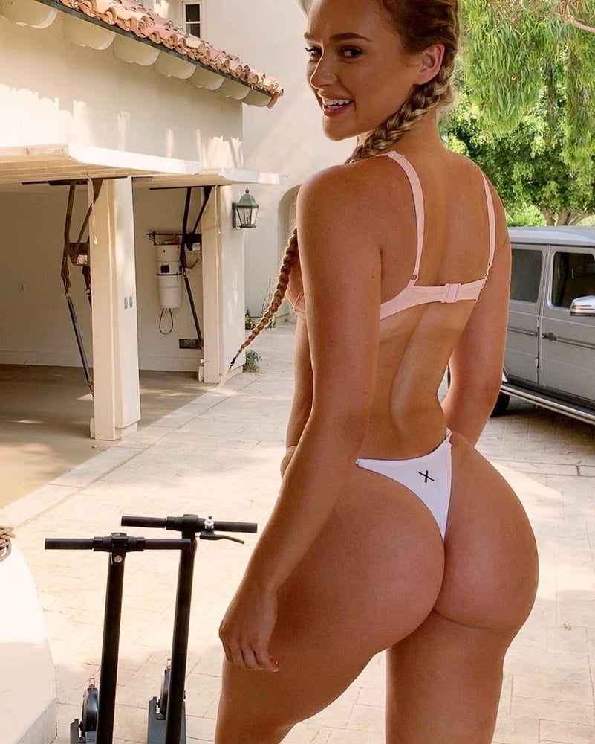

Kyle crawled back to Kacey’s pool chair, his head dripping with chlorinated water as he choked and gasped. Kacey was looking down on him and smiling, Kyle couldn’t help but feel like she was getting off on this, treating him so poorly.

“You missed another fart from my sister while you were drinking the precious pool water! And speaking of farts, I think I have one coming! Care to give me your diagnosis doctor?” Daphney asked in a very fake acted tone pretending to be naive. She leaned to the side with her big ass sticking out towards kyle while looking over her shoulder back at him.

“Here I’ll even do you a favor and help you out, since you're so terrible at your job, I can’t expect you to do anything properly!” she said while reaching back and pulling her thong strap aside.

Kyle crawled to her big sweaty ass, taking each cheek in one hand and spreading them wide, as they parted they made a slick squelching noise.

“Ugh, my ass is so swampy!” Daphney groaned!

“Eww gross!” Kacey giggled!

Kyle stayed on his knees, Daphneys cheeks parted as he stared at her winking anus! It was covered in small hairs that had been shaved recently leaving stubble behind. The inner area of her ass cheeks had thick yellow streaks of shit coming from the center of her anus, the smell was cheesy and very sour. Kyle’s eyes started to water as Dapheny looked down at him and shouted in frustration.

“Are you gonna wrap your lips around it, or just stare at it?” Daphney asked



With both women snickering and laughing, Kyle leaned in and slowly wrapped his lips around Daphney’s asshole. The rim was so sticky and the odor up close in her crack was incredibly wet and cheesy, it had a spoiled dairy like-smell that caused Kyle to gag in disgust. Suddenly Daphney’s asshole opened up wide, Kyle felt the rim of her ass force his mouth open slightly just before his mouth was filled with a thick mushy substance. Daphney began to laugh hysterically as she grabbed the back of Kyle’s head, holding him between her cheeks. He was in such shock that it took a moment for him to realize what she had ejected into his mouth. Just as he realized, her anus opened up again and blasted him, his mouth sprayed from all directions with brown diarrhea, coating his face and the pool deck beneath him in feces!

“**EWWWWWWW**” both women screamed in Unison as they got up and ran from the area to get away from the mess.

Kyle was on his hands and knees, his mouth wide open and dripping with wet feces filled with thick chunks of some sort. His face was coated, both eyes almost completely covered in Daphney’s shit! Kyle’s heart was racing, he felt like he was going to pass out, the flavor, my god, it was the worst, it was impossible to stop gagging! It was so bitter, so sour! He could taste the spoiled milk and started to dry heave. Quickly, Kyle began crawling towards the pool, desperate to clean his face and mouth only to hear Kacey’s voice scream at him.

**“DON’T YOU DARE PUT YOUR FACE IN MY POOL WATER! I SWEAR TO GOD I WILL SUE YOU FOR EVERYTHING YOU HAVE”** She screamed!

Kyle stopped barely a foot from the pool, through his shit covered eyes he could see the freshwater crashing into the side, his mouth was wide open, gasping and dripping with feces! Kyle began to cry, turning around and crawling, he had no idea where he was going, he couldn’t see a thing! Kacey and Daphney began screaming and laughing.

**“AHHHH HE’S COMING RIGHT FOR US!”** Daphney screamed as they ran to the house, Kyle could hear the back door sliding closed. Seconds later it opened again and Kacey walked towards him, he could see the outline of her body through his shit covered eyes.

“Here! Clean yourself up and get out of here! You're disgusting!” she said with a disappointed tone before disappearing into her home. Kyle blindly reached forward, patting the ground until he found what she had left him. It was a small square hand towel, barely big enough to wipe his face! Kyle desperately wiped his eyes clean and then began choking as he rubbed the cloth against his tongue over and over! Her shit was like sticky glue, it just wouldn’t come off!

Kyle ran to his car in the front and got his emergency bag from the back trunk, changing his shirt, and grabbing a bottle of water to pour over his head right there in the driveway! He was coated in shit! Even after changing his shirt, and pouring multiple bottles of water on his head, he was still covered! It was in his ears, inside of his nose, And the smell, my god, it was from hell! He had no idea what Kacey’s sister had eaten that morning, but it turned to pure bile and poison inside of her!

Kyle checked his phone, he was already late for his next appointment with a woman named Jenna, the client was blowing up his phone, he had 15 missed calls and 23 unread texts! Out of everyone he saw on a regular basis, she made him the most nervous! Jenna is a Jewish stay-at-home mom, she is **INCREDIBLY DEMANDING**, and worst of all, she is a friend of a friend of a friend, floating around in the same friend group as Kyle. He recognized her the moment he showed up for his first appointment. She was so distracted by her stomach pains though that she failed to recognize him. Each time he visited her in the back of his mind he feared she would figure it out, let everyone know what he was doing for a job.

“Jenna, I’m so sorry! I got” Kyle tried explaining into his cellphone.

**“WHAT AM I PAYING YOU FOR! WHEN I EXPECT YOU TO BE HERE FOR 11, YOU NEED TO BE HERE FOR 11! I HAVE BEEN SITTING HERE, FARTING MY ASS OFF! I HAD LASAGNA LAST NIGHT BECAUSE I EXPECTED YOU HERE!”** Jenna screamed in anger, Kyle could hear a massive airy fart ripping in the background of the phone.

“I know Jenna, I’m going to be right over, I just have to run home and shower first!” Kyle tried explaining…

**“WHAT!!! ARE YOU FUCKING KIDDING ME!** I can’t believe this!” she said to herself while hanging up in a fit of anger.

Kyle hung up and jumped in his car, speeding out of Kacey’s driveway and back towards his apartment. While looking at the GPS he could see it was going to be twenty minutes to his home, and then thirty minutes to Jenna’s, plus at least ten minutes to shower and ten more to dry off and get changed, Jenna was going to be furious!

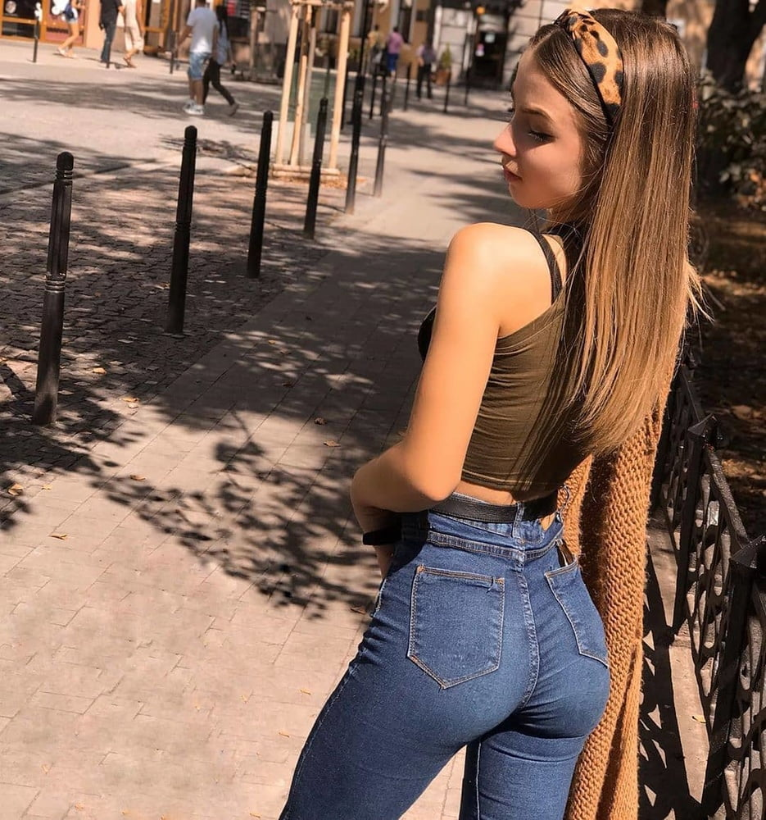

The entire time Kyle was showering, His phone was ringing off the hook, he knew it was Jenna! She was incredibly beautiful with a mouthwatering tight ass, but her attitude was absolutely vile, Jenna was truly the worst person Kyle knew. He felt bad for her husband, he had never met the guy though, he was always at work by the time Kyle arrived.

It’s surprising Kyle did not get a ticket, he was speeding the entire way to Jenna’s house, all while his phone continued to ring and beep with text messages! When he pulled up in her driveway, Jenna was outside, pacing back and forth while looking at her phone with frustration.

Kyle jumped out of the car and began running over to her!

“Jenna, I am so sorry! I got held up with” She instantly cut him off and raised her finger in the air!

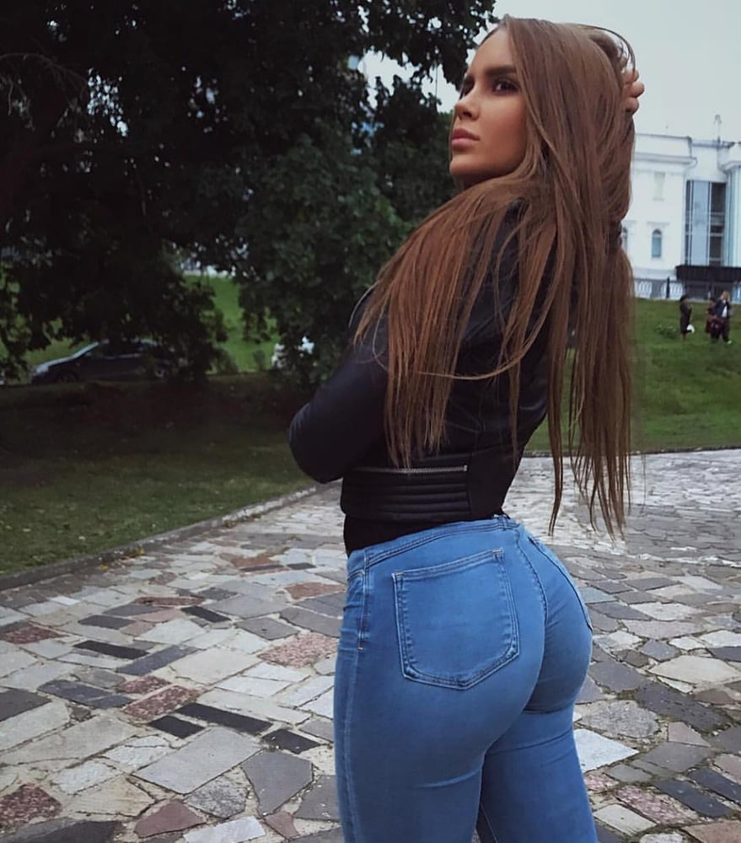

“**YOU,** are **SO LATE!”** she said with clenched teeth and one hand over her stomach.

“I know! I am so sorry!” Kyle apologized as she cut him off again.

“You have **ONE JOB**, be on time, and smell my fucking gas! Is that so hard? Are the farts rotting your brain? Huh?” Jenna asked, Kyle knew the question was not rhetorical and began blushing as he hung his head.

“No Jenna, The farts are not rotting my brain, I am just… having a bad day” Kyle explained.

“And you think that’s my problem? When you make an appointment with me, you be **ON TIME**, I have a friend here now and you forced me to stand outside in the front yard! I don’t want them smelling my gas! Do you even know how humiliating that is!” Jenna scolded him

“I’m so sorry! I will make it up to you!” Kyle said softly, trying to diffuse things.

“You can make things up to me right now! Come out back, and you're gonna kneel behind me and **SUCK** my gas while I chat and spend time with my girlfriend! That’s how you can make things up to me!” Jenna explained while somehow looking down on him even though he was taller than her.

“Jenna! I can come back tomorrow! It’s not a pro…” Kyle explained as she cut him off again

**“ON YOUR KNEES! NOW!”** she screamed as he dropped to his knees on the driveway.

Kyle could feel his knees burning on the asphalt from how hard he had dropped. Jenna turned her back to him leaving her big fat bubbly denim-clad ass inches from his face! The jeans were made of leggings material so they dug deep into the crack between her fat cheeks. She bent over slightly, pushing out her ass and making it even rounder as Kyle watched, he knew what she expected. He leaned in, letting his nose enter the deep crack.

**BBBBBFRRsppp**

**Pppprttt**

**Sppppprttttttttt**

“Ah fuck, that one warmed up my jeans!” Jenna laughed as Kyle began choking profusely.

Even through the denim, Kyle’s nose was assaulted with the burning smell of shit! Her fart reeked like broccoli and cabbage, practically burning a third hole into his nose with how hot it was! The fart was airy at first but ended with a wet splatter causing Kyle to fall back on his ass! Jenna laughed and fanned behind her ass with one hand as Kyle’s eyes watered.

“See! That’s why I can't do it around my friend!” now hurry, I don’t wanna keep her waiting!” Jenna explained as she began walking around her house to the backyard. Kyle followed her as she looked back and stopped.

“On your hands and knees,” Jenna smiled…

“Jenna, I don't think that’s” she cut him off again.

**“ON YOUR HANDS AND KNEES!**” she shouted in anger while pointing to the ground. Kyle slowly got on all fours as she smiled.

“Good, I expect you to behave today, I still want a full hour of your time, just kneel behind me as my friend and I chat, and don”t let any gas reach our noses! Understand!” she explained once more!

Kyle was blushing a deep shade of red, he had never been so dehumanized by someone, besides Daphney using his mouth as a literal toilet! Kyle looked up in front of him, admiring Jenna’s fat ass! Her cheeks were wriggling back and forth in the tight jeans, it was kind of attractive for a moment. Suddenly she stopped, quickly bending over and sticking her ass out! The center of her ass crack nearly hit Kyle’s nose as she grunted and released the monster brewing inside her.

**SPPPRPppdppPPppprppttt**

**Pspprpptprprprpptprprptptt**

“Whew, they just keep getting wetter and wetter! If you were not so late we could have gotten to the bottom of this issue, but now you’re just going to be a gas receptacle! That’s your punishment!” Jenna explained without looking back at him and while fanning her tight little ass again. She was just rubbing salt on his wounds, getting some more humiliation in, Kyle knew it and tried to ignore her.

“Hey! I am so sorry for the wait!” Jenna said in a friendly tone as she reached the backyard.

“My stomach has been acting up all sorts of horrible ways today, but don’t worry! The doctor is here so we can finally talk in peace!” Jenna laughed as her friend began to giggle.

“It’s about time! I was starting to get impatient!” The friend replied, Kyle, recognized the voice!

Kyle looked up and past Jenna’s ass to her friend who was sitting with her back turned at a square-shaped picnic table. Her ass was so big and fat, wrapped in a pair of tight almost see-through leggings! Kyle could see the thong underneath tucked between her fat cheeks and disappearing as it ran down. She began to turn and look back as Kyle froze, it was like time was moving in slow motion! Quickly he ducked his head, hiding his face and keeping behind Jenna, just as Alanna turned to face him.



“So this is the famous fart doctor?” Alanna asked with a laugh as Kyle kept his head down and crawled behind Jenna, his heart was beating a million miles per minute! Jenna took a seat across from Alanna while sticking out her ass in an animated fashion for Kyle to smell. He had managed to get behind her without Alanna seeing his face, but there was no way he could last the entire hour!

“So tell me more about this date you’re going on tonight!!” Jenna began to gossip as Kyle grabbed her jeans and pulled them roughly down over her very fat and jiggly little bum. Jenna laughed in shock as Kyle thrust his face into her sweat-damp ass crack hiding between her cheeks!

“Whew! He’s eager today!” Jenna laughed as Kyle tried not to choke on the smell of her asshole! Her anus was rubbery and winking on his nose, gripping the end and pinching him. Her entire crack reeked like rotten broccoli and stale green vegetables! It was like a compost bin after a hot summer day!

“How much do you pay for this?” Alanna asked with a giggle…

“I don’t know, Robert pays for it!” Jenna laughed.

“He doesn’t mind another man’s face being so close, to your uhmmm privates?” Alanna asked curiously.

“Haha well, a few weeks after our wedding night, I finally convinced him to let me sit on his face, it’s my favorite! The feeling of a man’s nose pressed firmly to your asshole! Mmm, it’s just on another level of enjoyment! Robert couldn’t stand the smell though, I have always had a pretty active digestive system, so he did some research and then he found Stanley, he just retired though, now I have Kyle here to sniff up all my dirty gas!” Jenna laughed and wiggled her ass with Kyle’s face tucked in her cheeks, he was blushing and wanted to scream!

“Kyle!? Haha, that’s the name of the guy I’m going on a date with!” Alanna laughed

“Oh my god! Can you imagine! Dating this guy! His face must reek by the end of the day!” Jenna joked as both of them laughed!

**BBBBFRRTSPPPPRsppprpttttttttttt**

As Jenna was laughing, a hot wet fart shot out into his nose! It was so sharp and powerful that he could feel the wet bits of shit hitting the back of his throat all the way through his nostrils! Kyle wanted to pull his face from her ass, to take a breath of fresh air, but Alanna couldn’t see him! This was fucking terrible! Kyle began to choke and gasp, keeping his face between her sweaty swampy ass cheeks and inhaling the gas!

“Wow, he loves your farts! What’s your secret!?” Alanna asked with a giggle!

“Tons of veggies!” Jenna laughed

Jenna grunted and tightened up her body while sitting up straight! Kyle could feel her asshole pushing on his nose before sucking the tip deep inside! There was a wet gurgle coming from her rectum as she started to push. Kyle closed his eyes, knowing it would be terrible!

**BBBBBBBFRRTTTTTTTTTTTT**

**SPPPRTT**

**Spppprptttttttt**

**Sppprtttttrbbfrttpppsprpt**

The first blast from her fart was so powerful that it shot Kyle’s face from her asshole, knocking him back as he choked and gagged1 the rotten green flavor of broccoli was stained to the back of his throat making each breath pure torture! Alanna leaned over to see him and Kyle quickly thrust his face back into Jenna’s cheeks! She was still mid-fart and it began to splatter, leaking wet diarrhea that Kyle smeared into his face! He cried with his head in her ass, her shit dripping down his face! Jenna began to laugh as she leaned forward and stuck her butt back out for him.

“You should book an appointment with him, it’s really empowering!” Jenna smiled as Kyle’s eyes went wide…

“Oh my gosh, no, I could never afford that!” Alanna laughed…

“Well, if this date with this doctor friend of yours goes well, maybe he can fund the expense! Unless he wants to take the blasts to the face! But from my experience, he won’t!” Jenna laughed.

**“HEY**! Why don’t you try out the doctor right here? I paid for the time, I don’t mind!” Jenna offered as Kyle began to panic! It felt like his heart was going to explode out of his chest! He began to hyperventilate, huffing in and out and inhaling the vegetable scented odor of shit between Jenna’s cheeks! He was huffing her shit so fast that his head began spinning, he was going to pass out!

“Haha hmmm, I don’t know, you just splattered his face!” Alanna laughed a bit hesitantly.

“He can go clean up!” Jenna pulled her ass forward and looked back as Kyle dropped down and hung his head, practically laying flat on the ground to avoid Alanna’s sight.

**“GO INSIDE NOW! CLEAN AND DISINFECT YOUR FACE! AND YOU BETTER BE BACK BEFORE I HAVE ANOTHER FART READY!”** Jenna yelled dominantly trying to impress Alanna.

Kyle turned his head all the way to the right and began crawling while looking away from Alanna, as he was at the back door to the house he could hear her speaking with Jenna.

“Are you always so mean to him? That’s so cruel!” she said with empathy!

The kitchen door led to the backyard so Kyle used the sink to wash his face with soap and water! Some brown came off of his nose making him gag In disgust. The job was bad enough but having some strange woman’s shit on your nose or worse, filling your mouth, was not part of the description. After he finished cleaning up, he debated just running, leaving, Jenna would be pissed but there was no way he was going to let Alanna see him like this. He was just about to leave when turned and stopped, frozen in fear.

“Kyle?” Alanna asked as she stood in the entrance to the backyard with a confused look on her face…

“What are you doing in Jenna’s… oh my god!” Alanna gasped with both hands over her mouth!

“Alanna!!! Please!!! I can explain!!!” Kyle stammered as dropped to his knees! He had been used and abused by so many women that he had started to become naturally submissive without even realizing it. He crawled to her feet on all fours and leaned his head down with his forehead to the floor in front of her feet!

“I failed my exams! I needed the money! This guy, he was a friend of my Professors! He offered me this job! One thing led to another! I’m so sorry! I’ll quit! I’ll stop! I only did this for the money and to impress you! Please! I’ll do anything! I’m so sorry!” Kyle cried on his hands and knees! He lifted his head from the floor and moved forward, about to kiss the top of Alanna’s barefoot as she jumped back and kicked his head **HARD!**

“Eww! Don’t let your lips touch me!” She said with disgust while looking down on him, Kyle was on his side holding his head and crying on the floor.

“What do you mean, you did this for me? We were never even a couple! What are you talking about?” Alanna asked in confusion…

“I… I.. I wanted to impress you!” Kyle explained!

Alanna stared in confusion for a moment before beginning to laugh hysterically!

“And you thought, **THIS?** Would impress me? Sniffing shit from women’s asses!?” Alanna asked rhetorically!

“I get paid a lot of money!” Kyle explained

“I don’t care **HOW MUCH MONEY YOU MAKE! I WOULD NEVER LET YOUR LIPS TOUCH ME! Ugh! GROSS!”** Alanna shivered and brushed off her sides in disgust!

“I can’t believe I almost went on a date with you! **WERE YOU GOING TO TELL ME THIS? HUH? BEFORE YOU TRIED KISSING ME?”** Alanna asked with anger.

“I… I…” Kyle stammered and blushed on the floor…

“That’s what I thought!”

Alanna turned around and squatted in front of Kyle, her big fat ass stretching out to an outrageous degree in her tight almost see through leggings.

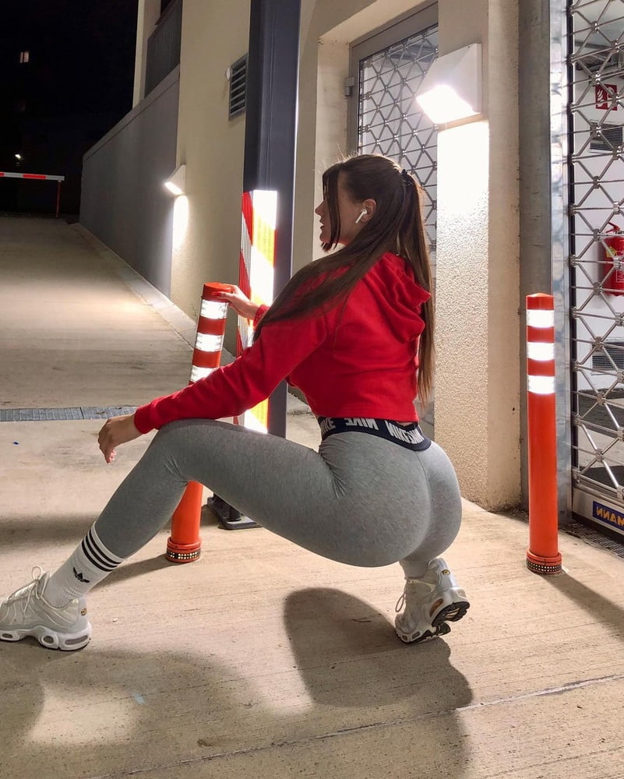

“What are you doing???” Kyle asked with tears running down his cheeks, her big ass was right in his face.

“Using you for the only thing you're good for! Sniffing gas!” Alanna spat at him as a ripping fart left her asshole.

**BBBBBBBBFRRTTTTTTTTTTTTTTTTTTTTTTTTTTTTTTTTTTT**

“What’s going on in here?” Jenna asked as she stood at the back door with a smile on her face!

Kyle began to gasp! Out of all the farts he had smelled over the past two months, even after having Daphney shit in his mouth, nothing had been as bad as this! Alanna’s gas was like fire blowing past his face! Kyle had to close his eyes as he opened his mouth to choke only letting more gas enter his body! It felt like fire in his throat as Alanna pushed back, her ass smearing into his face as Jenna laughed!

“I told you, it’s fun right?” Jenna asked!

“This is the guy I was **SUPPOSED TO GO OUT WITH!”** Alanna said while standing back up and fanning behind her ass!

**“NO WAY! YOU’RE KIDDING ME!”** Jenna laughed! There was a slight pause as they watched Kyle choke on the kitchen floor.

“Are you… still going to?” Jenna asked curiously…

**“FUCK NO! ARE YOU KIDDING ME?!”** Alanna shouted!

“Geez! I was just asking! No need to bite my head off!” Jenna giggled and walked over to Kyle kicking his midsection!

**“MY HOURS NOT OVER LOSER! COME ON!”** She laughed and walked back out to the table. Kyle looked up to see Alanna looking down at him, she had lost all respect for him. She puckered up her lips and spit on the floor by his face. Kyle looked down at the glob of saliva.

“Clean that up and meet me outside!” Alanna turned, Kyle watched as her fat ass wiggled back and forth heading for the backyard.

**1 MONTH LATER**

“Yea! I just finished my run, god it’s hot out today, I’m sweating buckets! Oh my god! Jenna, he’s amazing! He is a neurosurgeon! The date was incredible! I don’t think I have ever been so in love with a man! I know… right?” Alanna spoke into her cellphone as she walked down the sidewalk, sweat dripping down her body!

“He’s bringing me out again tonight, yea! To that fancy Italian place downtown!” Alanna giggled!

“He loves spoiling me! I can’t wait to see what gift he brings tonight! I swear I’m so lucky!” Alanna smiled!

‘Haha, yeah, I’m about to use him right now! You were right! It is empowering! Okay! Call me tonight! Alright! See ya, hun!” Alanna hung up her cellphone and looked back to Kyle who was out of breath running behind her.

“Isn’t this a great deal? I help you keep in shape, make sure your body is strong and in return, you take care of my gas for free! Speaking of which, I think I feel one coming!” Alanna smiled.

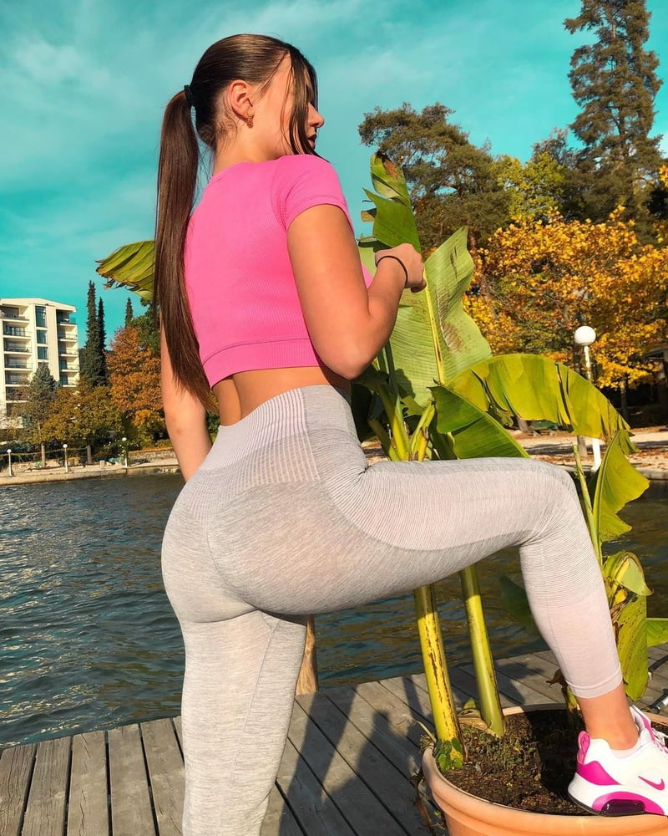

**THE END**