FATE / REINCARNATED
CH4: POOR CAREER CHOICES
BY CHALDEACHANGE
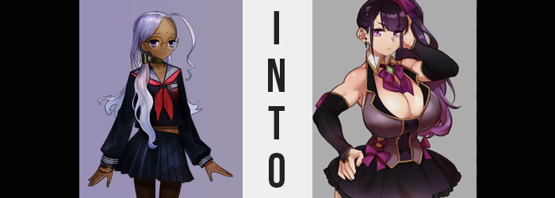

It took quite a lot to surprise Rani VIII.

This was, in large part, because she didn’t have much of an emotional range to begin with. She was an artificial existence, a homunculus, and one that didn’t really express how she felt much in her day to day. Something that took her off guard would just become an obstacle to be dealt with, not something that an emotional response was required to help cope with.

That was why, despite suddenly having been displaced into an unfamiliar location, the young woman of Indian descent did not even bat an eyelash. She had been in the process of being assigned the Servant that would be her partner during the Moon Cell Holy Grail War when an error of some nature had suddenly occurred – or at least that was the best way she could possibly explain the situation.

“This situation is… unusual.” Even vocally in her deadpan voice, she wasn’t really sure how to describe this phenomenon. The room she was in was uncanny in how unlikely it would have normally been for her to have stepped foot in one, because it appeared to be the sort of changing room that important people used. Like singers and other performers. Based on the big mirror, make-up desk, and the many dresses hanging in the back, this certainly seemed to be the case.

She certainly wasn’t supposed to be there. But what was stranger was that how it almost felt as if she were right where she belonged. That contradiction wreaked havoc in her mind, which was typically so reasonable in how it carried out its thought processes. To begin with, how had receiving a Servant turned into this very unusual predicament?

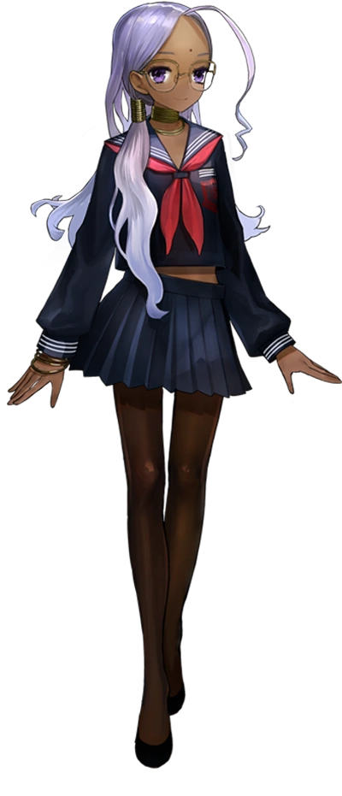
The door to leave was right there, though. All she had to do was walk out of it and seek answers, but something stopped her short of doing it. The very same feeling that rationalized that she was not somewhere she shouldn’t be, not that she could really understand the context behind that feeling. In fact, it didn’t really matter how keen her intellect was at the end of the day. Just as everyone else who had been caught up in this unusual summoning ritual had been, she wouldn’t quite be able to place her finger on what was happening.

She would simply succumb.

“I need to… Do I need to leave?” These thoughts were like two sides of the same coin, and Rani could not figure out which version of her wants were correct. Did she stay here for whatever reason? Or did she escape to seek answers? She didn’t even quite understand why this dilemma existed in the first place. But it wouldn’t be a dilemma for much longer.

Rani herself had not taken notice of it, because she couldn’t take notice of it, but her body had begun to grow awash with change. Change that seemed to be set on compromising the specifications that had been put aside for her as a homunculus. After all, she had been designed to look and act a certain way, and it was both of these areas where her creator’s goals would be undone.

For example? Just looking at her skin, it was extremely clear that there was something amiss. After all, small pale spots had begun to emerge against her dark, Indian complexion. While their numbers amounted to few in the beginning, over time they both grew and multiplied, merging together until her skin color was consistently this paler tone – complete with dark pink nipples. Even her bindi dot was eviscerated by this change in complexion, but that wasn’t even the full extent of the change that plagued her face.

Now, Rani VIII knew plenty of Japanese people. Among those that would participate in the Moon Cell Holy Grail War, there were plenty of them. But she hadn’t anticipated that she, too, would become Japanese herself. Yet that was clearly what her transformation was trending towards, for the corners of her eyes narrowed until they were almond shaped overall. Facial features grew softer, with rounder cheeks and lips that almost appeared flatter for a moment – at least until something else saw them protrude with a new thickness.

That ‘something else’ was quite clear in its nature. That is to say that Rani appeared to be older than her body had designed to appear. Rather than a girl that leaned into the younger side of things, maturity had settled in a face that was now both a different race and belonging to a woman in her early twenties if anything. What’s more, the purple of her eyes eventually lit up into a bright pink that was, surprisingly, wholly natural.

Rani felt unsteady. For someone who was usually emotionless, she was beginning to feel something. It wasn’t a positive feeling, but she couldn’t place her finger on it yet either. She shook her head and removed her glasses, finding that she somehow didn’t need to wear them anymore. But she also didn’t question it in the slightest, dropping frames on the ground beside her like they were utterly inconsequential.

In the meantime? The strands of her hair darkened to a rich maroon, while the waves of her natural hairstyle became just the slightest bit straighter. It didn’t lengthen at all in the back, but in the front? Her bangs thickened and found themselves swept to the left, somewhat disguising just how big and fluffy her eyebrows had become.

Racially and facially it seemed that her transformation had been completed. So that really left her figure, which was not at all suited for the role that this world had in store for her. And so, to begin with? Rani grew. Vertically, anyways. Her height increased a few inches, taking a uniform that already showed off a bit of her tummy and then revealed even more of it as the uniform was hoisted up. This growth also yanked her tights down slightly off her hips to boot.

With more of her belly exposed, it made it easier to see that her body had begun to broaden as well. Shoulders and hips alike pulled wider, which in turn left her uniform to feel even tighter than before. But at the same time? Her belly grew wider as well, rippling slightly with muscle while a bit of fat also kept it looking softer. At least in terms of the muscle she had grown, it was more widespread than just her belly. It rippled through her arms and legs, revealing that she had become a woman that cared a great deal about working out.

Well, I need to keep fit if I’m going to be on stage.

It was a strange thought, but she didn’t even question it since it just felt so natural. Just as natural as the weight that was taking her figure, which was once so slender, and repurposing it into something that was incredibly pronounced and almost impossibly lewd, just on the merit of sizing alone.

Take her lower half, for example? Her hips had already pulled wide, but they were given no choice but to grow wider still, tearing the side of her skirt from a combination of their width and the mass that had caused her hips’ extension in the first place. That is to say: her ass and thighs had grown ridiculously more pronounced, with the thighs alone each growing thicker than her own waistline. Of course, her ass bloated to better suit it, and it was all bare thanks to her skirt lifting up and her panties flossing between her cheeks uncomfortably.

She had the lower body of a woman out of the dreams of the world’s horniest man, and this wasn’t even isolated to everything below her waist. Because her chest? Well… There was no denying that it was subjected to the very same fantasy. There was nothing that was even gradual about it: her flat bosom exploded, blowing out the front of her uniform and becoming tits so large that each one was almost twice the side of her head. It was no wonder that she was so muscular – she had to be if she was carrying around a figure like that!

“I hate my body…” She had been quiet all this time, but suddenly and uncharacteristically murmured distaste for a figure that she saw as something she’d always had, or at least had for longer than thirty seconds. Thinking about how well-endowed she was just reminded her of the cons of her job, and how things had taken a turn for the worst because of it. And what was that job, exactly?

It became clear once she closed her eyes and opened them again, because doing so saw her outfit change. Into a maroon dress with open cleavage and fingerless gloves, hair tied off into a side ponytail. It was the garb of an idol, one custom made to fit such a bombastic figure. The figure that she now seemed to hate with all of her being.

“Ugh, I’m right where I need to be, but as per usual I’m having all these doubts…” The Japanese woman, twenty-one years of age, shook her head from side to side as she felt her skin grow clammy with anxiety. Ranka Saehara had wanted nothing more to be an idol all her life. Singing and dancing on stage just looked so fun, and the attention idols received from their fans just seemed like the best. She had worked hard to become one. All of the dancing and singing lessons, all of the auditions… and she had finally made it.

But the idol life wasn’t what she had hoped it would be. As she had grown up, her body had developed into one that was exceptionally lewd. Her breasts were far bigger than those of most women in general, much less those her own age, and the same could be said of her lower half. Throw in how she was quite clearly muscular in the best way, and well…

The fans she had were only really fans because they were horny. No one cared about her singing or dancing, they just cared about her appearance. She was constantly receiving incredibly gross messages from her ‘fans’, but they all just wanted to fuck her!

What was worse, the fact that so many had turned her into this idol that was known for how sexy she was meant that most normal idol enjoyers wanted nothing to do with supporting her. Her engagement was low, and her fan count was significantly lower than normal – which meant even getting work was harder than it should have been. She had lived her dream and become an idol.

And for what?

She didn’t have answers, but she did have a show to do. In front of how many fans? She didn’t know. And Ranka almost hoped there weren’t a lot. Because that would just mean there were even more creeps out there for her to deal with. “Maybe I should just quit after this…?”

