Hamelin High

Harold knew he’d screwed up big time the moment he awoke feeling nauseous with his eyes feeling watery after being open for so long, finding himself petrified on a couch with the familiar scene of the principal’s office coming into focus around him, his belongings ranging from notebooks to a government-issued tablet were strewn on the table before him letting him know the jig was up.

A government agent sent to spy on the seemingly innocuous all-girls school of Hamelin High after a strange string of tales involving some form of grooming being used to keep the student body ‘prim and proper’, Harold had spent months building up trust amongst the faculty and students, wondering if he’d been sent out here on a bogus claim after engaging with the wide cast of ordinary people that worked and studied here. If there truly was something wrong, he wasn’t seeing it.

‘Maybe it’s just paranoid parents or jealous officials from the nearby schools…might need a refresher course after this mess…haven't held a gun in so long…’


He’d been just about ready to call off the investigation when he stumbled across something strange in the nurse’s office after a long afternoon spent marking test papers and keying in scores, hearing the familiar voice of the school nurse speaking to someone in a commanding tone he’d never heard her use before as her patients angry voice falls silent, peering in through a gap in the door to find her ‘conversing’ with one of the girls from the new intake he remembered causing a ruckus just last week. Sitting lifelessly still with a blank look on her face, dull eyes reflecting a pink glow coming from the phone in the nurse’s hand.

And while he might’ve felt relieved at the time to know he wasn’t going to be in charge of her class, what he saw through those doors was beginning to turn his thoughts around as the nurse began to mutter, with each word out her mouth causing the student before her to metamorphose into someone else entirely; short hair flowing out into a long mane of gaudy pink silk, a glaring expression mellowing out into a vapid smile, flat chest bubbling like goo until a hefty bosom sags forth, tenting the girls poor blouse as she continues to change until an entirely new person altogether had taken her place. Giggling like a ditzy highschool girl as she begins to move in her chair, popping a button in her shirt as her larger bosom heaves with the momentum, threatening to snap the weakening cloth until the nurse mutters inaudibly, unravelling the former tomboy’s clothes into shiny strands of silk before it all snaps back over her now voluptuous figure, leaving a tantalizing window for her cleavage that in all honesty, matched what a girl like her would pull off to get all the men staring her wat.

“Like, thanks for that Miss Tanya! I feel so much better now~ This’ll totes help me with my studies!”

Transfixed and mesmerized by the girl’s metamorphosis as the vapid ditz she had turned into broke into casual conversation with the nurse as if nothing was wrong, Harold had barely heard the approach of a stranger from behind until it was too late, blacking out the instant he spun around in an effort to get out of the way. Leading to his current predicament.

But try as he might, his body refused to obey, unable to move even the muscles on his face, staring blankly at the figure of Selene, the principal of Hamelin High, as she stepped into view, a familiar pink glow from the phone in her hands aimed right at him. And while there was an expressionless gaze on the man’s rugged features, Harold’s mind roiled in panic and anger, struggling to break free from whatever had taken hold of his body .‘The hell did she do…can’t even move my fingers…’

"It's such a pity to do this Mr Harold, but to think you were a dog for the stooges on high…it’s too high a risk to leave you be. I assure you that you’ll be well cared for here at Hamelin High.” With her declaration made, Selene thumbs the screen of her phone, intensifying the hypnotic pink glow as Harold feels his body stiffen up with a cold tingle creeping up his spine.

Watching her lips begin to move, Harold could feel what had befallen the unfortunate girl from earlier as he experiences it firsthand, feeling his skin prickle with heat as years of muscle earned from gruelling military training and self maintenance ebbs away, a chiselled physique rounding out into one filled with plentiful curves and dips in all the right places. Unable to do anything but wait as he feels his girthy arms melt down into feminine branches, a solid pair of legs fattening up into plump curvy pillars, squirming against the alien sensation of his proud manhood worming itself up through a widening cavity between his legs with his rear doing the opposite, pushing outward into a bubbly set of cheeks. By this point, Harold had lost all semblance of his former self, teetering off the edge with how comical his head looked on a body that was clearly not his, or rather her own anymore. But that wasn’t going to last.

Try as she might to stave off the building pressure she could feel crawling up her smooth neck, her will would inevitably give way as the changes snaked upward, reshaping bone and feminizing her facial features, radiant cheeks tickled by the lengthy strands of brunette hair streaking past down her face and back before tying itself back up into a long ponytail, masking the grizzled man’s face for a moment before lifting away to reveal the carefully crafted visage of an oriental woman with slant eyes, rosey yellow tinted skin that now matched that of her body with gloss coated lips that were so soft and plump they formed a natural pucker. With the physical transformation complete, a soft girly sigh escapes the former Harold as her alluring body slumps down the couch in ill-fitting clothes.

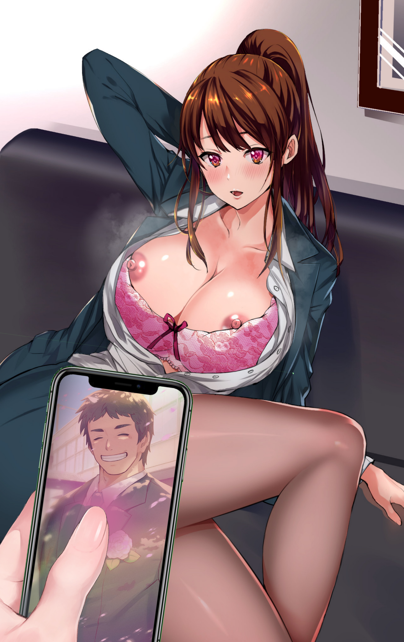
“Just one more edit, and you’ll be good to go Hifumi~” Harold’s mind was on fire, raging as with her body taken away bit by bit while being powerless to stop it, swearing vengeance as she stared at Selene through dull pink eyes. But another tingle, this time right in her head, signalled last set of changes as her old set of clothes dematerialized, exposing her nubile young body before reforming into new form fitting attire; complete with a tight pencil skirt wrapped around sizeable hips below a white undershirt as a pink bra slithers beneath, clasping around modest B-cups with a matching pink thong riding up her ass, sending a pleasurable sting through Harold’s mind as it rubs up against her moistening snatch. Making it much harder to resist the mental corrections settling into place as a silky pair of stockings worms their way up her legs from heel covered feet.

‘Shit…C-Can’t think straight…need to focus…focus…on what exactly…’ With cracks all around her dwindling psyche, Harold soon begins to relax, forgetting why she had been so angry at the principal in the first place as her golden brown eyes fill with life, slowly moving her aching limbs and sensitive body as she rights herself upward before a loud shredding sound catches both women’s attention, a pair of eyes gazing in surprise at Hifumi’s milky tits with fat pink nipples erect in the cool office air after having torn clean through her blazer and undershirt, popping buttons and pushing aside her tight fitting bra in their struggle to be free, feeling heat rush to her cheeks at how good it all felt with the fight to resist slowing to a crawl. ‘Weren't they B-cups before…no wait, that’s wrong…my boobs have always been big…’

“Oops…might’ve made them a little too big on accident, the mind can be such a fickle thing to work with~”

But Hifumi cared little to pick up on what the principal had said as she rubs wearily at the nape of her stiff neck, moving around in her body with a strange sense of deja vu mixing with foreign isolation. ‘But…isn’t this my body? Why do I feel so…I can’t remember…’

As her gaze rose from her pert tits to the principal still standing over her with her phone raised at her, some part of Harold that hadn’t yet faded away into the recesses of Hifumi’s mind took control. Realizing just how far gone she was the moment she realized she couldn’t get angry towards the woman that had reduced her to this sorry state…or at least, that was what she was assuming had been done to her for she didn’t know what was wrong in the first place. In her mind, she had always been a girl, born and raised between an American father and his stunning wife he had met while on a business trip to Japan.

An entire history of living outback in a comfy suburban town with rowdy kids to play with? Gone. Studying hard to get into Harvard? No sign of that ever happening. Signing on with the military after he graduated to get some spice in life? Nope.

Harold’s career as a government agent with an extensive history of military training and experience had already been forgotten, what remained now was just a terrified fragment of the man she once was valiantly doing his best to resist even though the fight was already as good as lost. With an incomplete Hifumi tagging along for the ride with all the gaps in her memory making it hard to say no.

“Y-You…Miss Selene? You did something to me…right? I feel…wrong!” Hearing that seemed to surprise the principal, a quizzical look on her face as she fiddles with something on her phone before sighing. Gazing down at her with a mixed expression of approval and disdain as she snarled in a hostile voice that was in stark contrast to her previous gentle tone.

“If you want to keep resisting, then we’ll do things your way you stubborn dolt. I had hoped to keep your retinue of skills intact but since you’re so insistent; we’ll have to give you the full treatment…”

Pressing her thumb down on the phone screen once more, Hifumi cries out in a choked scream, toppling forward as an overwhelming heat fills her entire being, trembling and moaning as she feels her entire body ripple like jelly under the invisible hands of the sculptor now pressing down hard on her like she was putty for an artist to mold as they saw fit.

The last thing she could see was black strands of hair beginning to frame her vision as her body continued to grow smaller, rapidly losing in height and mass with the exception of her bosom that only seemed to inflate as hands kneaded the buoyant melons gently into a more firm, youthful bust filled with sweet nectar.

The tired figure could barely make out the principal’s muffled words before her vision blacks out entirely, with her mind slipping slowly away until neither Harold nor Hifumi remained within the void of an empty vessel…

A FEW WEEKS LATER

It was another calm day over the wind blessed canvas of a quiet town, upon which sat the prestigious all-girls school; Hamelin High, famous for its robust education complete with collaborations between popular universities and courses that basically guaranteed a multitude of choices between career paths for its students.

One such person was Hasumi Takeda, a foreign student from Japan that had moved here with her mother just to attend the famous school. Already making a name for herself with her dedication to learning along with her striking appearance; combining a well endowed figure for a girl her age with the fierce visage of a handsome prince framed by neatly trimmed raven black hair tied back into a flowing ponytail. It had made her the talk of the student body with her limited knowledge of English sparing her the embarrassment of hearing the girls fawn over her while jokingly getting each other to ask her out on dates.

It didn’t help that she also signed on with the Kendo club, making more and more girls swing by the gymnasium just to watch her practice.

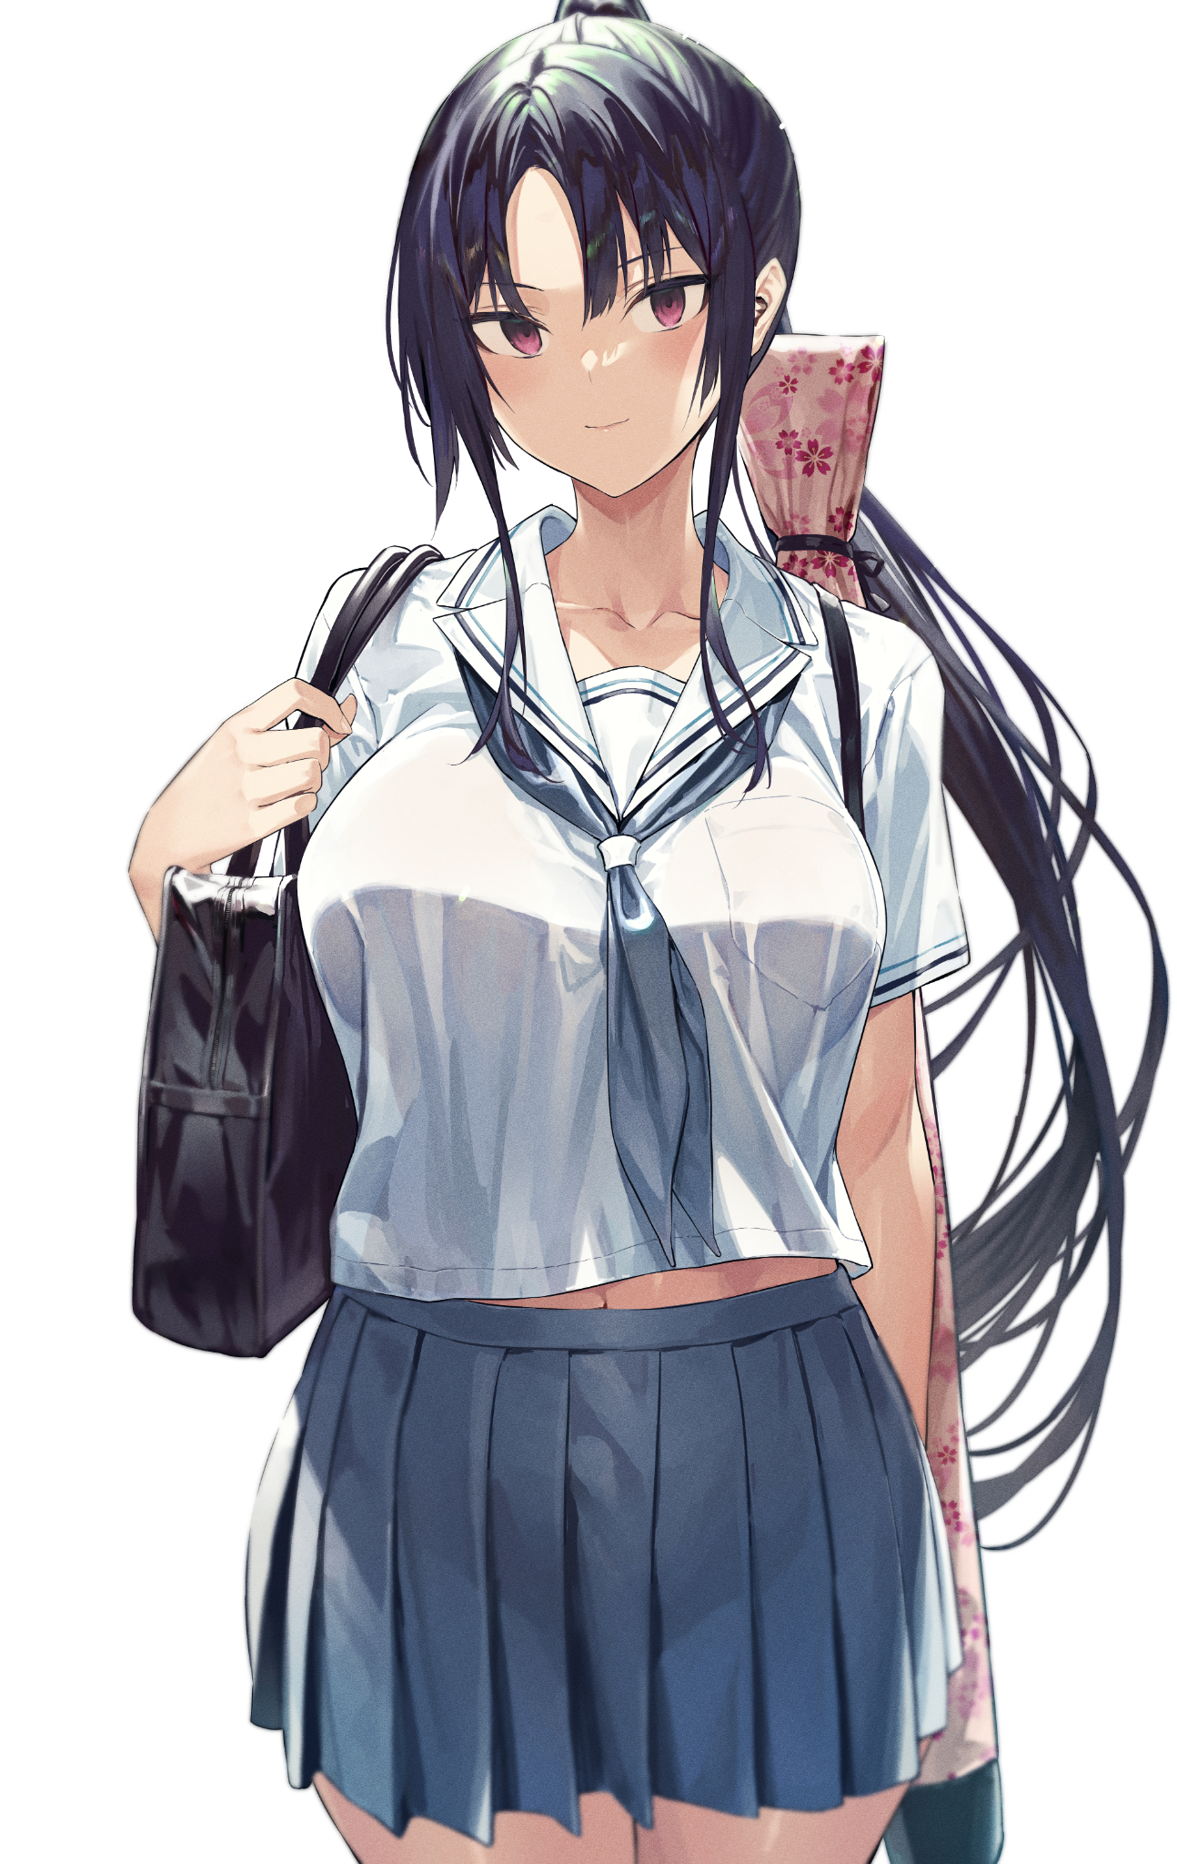
But not everything was sunshine and roses for the young Japanese girl, spending sleepless nights waking with a terrible chill and covered in sweat after going through an indecipherable series of events in her mind before it all ended with her being suffocated in a black mass that felt as if it was going to snuff her out of existence. All while an ominous violet light shone down from above the pitch black void in her mind.

And when it seemed like she couldn’t take it anymore, Hasumi had been referred to the school’s nurse one day after school, with her teacher telling her that everything would be fine as she led her down to the nurse’s office before leaving her alone. Shutting the door behind a nervous Hasumi as she bows her head in greeting. “Hello, I'm here for…P-Principal? Why are you-”

Before a pink glow shines brightly against the stupefied girl’s face, her voice cutting short as she falls silent with the light in her eyes fading away, a vapid smile on her face as she stands still in the room before Selene and the nurse, who was already walking slowly around her frozen patient, holding her phone up like a scanner while reading through the various popups on her screen with a stern gaze..

“So? Can you fix her?”

Sighing dismissively, the nurse turns her attention back over to her employer with an unamused look, clearly disappointed in her. “Sure I can, you’re lucky these things have warnings built in to monitor the students…poor girl’s head was about to blow with all these recursive loops she’s been going through every night…no thanks to you, what got you so riled up to do this anyway?”

Selene clicks her tongue in annoyance at the question, raising a hand up in dismissal as she struts out of the room seemingly satisfied with the simple assessment that her latest creation and blunder was salvageable. “Just get her healed and make sure she doesn’t get any more fits from her old self, seeing her do it once was maddening enough, but now she goes and does it again…”

The nurse had stopped listening to the principal's angry tirade past the first sentence as she continued on her way, muttering angrily under her breath as she left the place, giving the nurse some much needed breathing room and peace to think as she worked on repairing Hasumi’s damaged psyche, removing the corrupted bit of code on her screen that represented the stubborn remnants of whoever had been used to give her life and form. Shutting off the application as she watched the pink glow in Hasumi’s lustrous eyes dissipate as she seemed to return to reality, blinking a few times in confusion as she slowly scanned the room like she was searching for something.

Until her eyes hit the clock, widening in panic at the realization that it was already past 2pm.

“M-Miss Vanessa? I’m sorry for the trouble…thank you again for helping me with my insomnia. I’ve got to go!”

Sprinting down the corridor as fast as her athletic legs could carry her, Vannessa sighs as she watches Hasumi fly down the hall before turning on her heels and leaping down the entire flight of stairs with the excited whooping of the other students filling the air. Clearly not as enthused as her students were, her mind heavy on more pressing matters of morality and judgement. Shaking her head as she returns to her office, shutting the door as she thumbs at her phone, flipping over towards the secret of Hamelin High’s success. Watching with a furrowed brow as the red cross over Hasumi Takeda’s name flickers away, returning to a normal green tab alongside her fellow students…

‘For the greater good of education huh…god, I need a vacation…’

THE END

