OTHER PRIMALS
COMMISSION STORY
BY CHALDEACHANGE
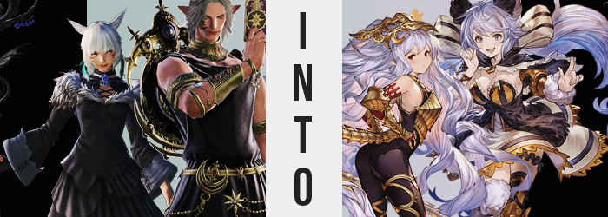

It had been nary a few weeks since they had returned from their adventure within the First, and yet the Scions of the Seventh Dawn had already had new issues flung into their laps. Not that they weren’t at all expecting this to happen. With all of the problems that plagued the Source, it was inevitable that they would not be given very much time to enjoy a well-deserved reprieve. But there would be no moaning nor whining on their part… Okay, perhaps on Alisaie’s part.

But the two we would follow on this day certainly were not the types. Both Y’shtola Rhul and Urianger Augurelt were among the most mature members of the Scions, their level heads crucial to their shared thirst for knowledge. Whether it was Miqo’te seeking to unravel the world’s secrets, or the Elezen attempting to use what he learned to innovate, one could easily say that these two made up the core intellectual force of the peace-keeping group.

They were only one team of several, mind you. The phenomenon that had summoned their resources was one that spanned Eorzea, and so they had all broken themselves up into teams in order to investigate. There was the matter of the strange towers that had sprung up across the globe, of course, but this issue seemed to be unrelated – albeit just as widespread.

“What do you think, Urianger? Their composition does not seem to be of a stone I have ever set my gaze upon.” Y’shtola remarked after closely examining the cause in question. It was a crystal, one as big as several Elezen stacked upon each other, surely. But it bore not similarities to crystals she had seen before, and with her unique optical abilities that was even clearer. Supplementing her vision with an aether-based technique, she could see its true nature. If she were to best describe it? “It almost seems to be like something not of this star.”

Acknowledging the Miqo’te’s assessment, the Elezen man paced around the floating gem. It had simply appeared in the center of this forest, and all of the wildlife around it? It had twisted, changed, resembling life of the likes that had never been seen in this world. “Mine assessments are of similar outcomes. Thee would be correct in assuming that this hails from another star, but with the knowledge that we have, mine deductions run no farther than that.”

Seeing no harm in doing so, and in fact seeing it as a necessity for gathering data, the strange-speaking man reached out to place a hand on the crystal’s side. Y’shtola had already informed him that there would be no harm in doing so, as it did not seem to be radiating whatever energy had altered their surroundings prior to their arrival on the scene. But a flash of light as his fingers stroked the gem’s side proved one thing.

She had been wrong.

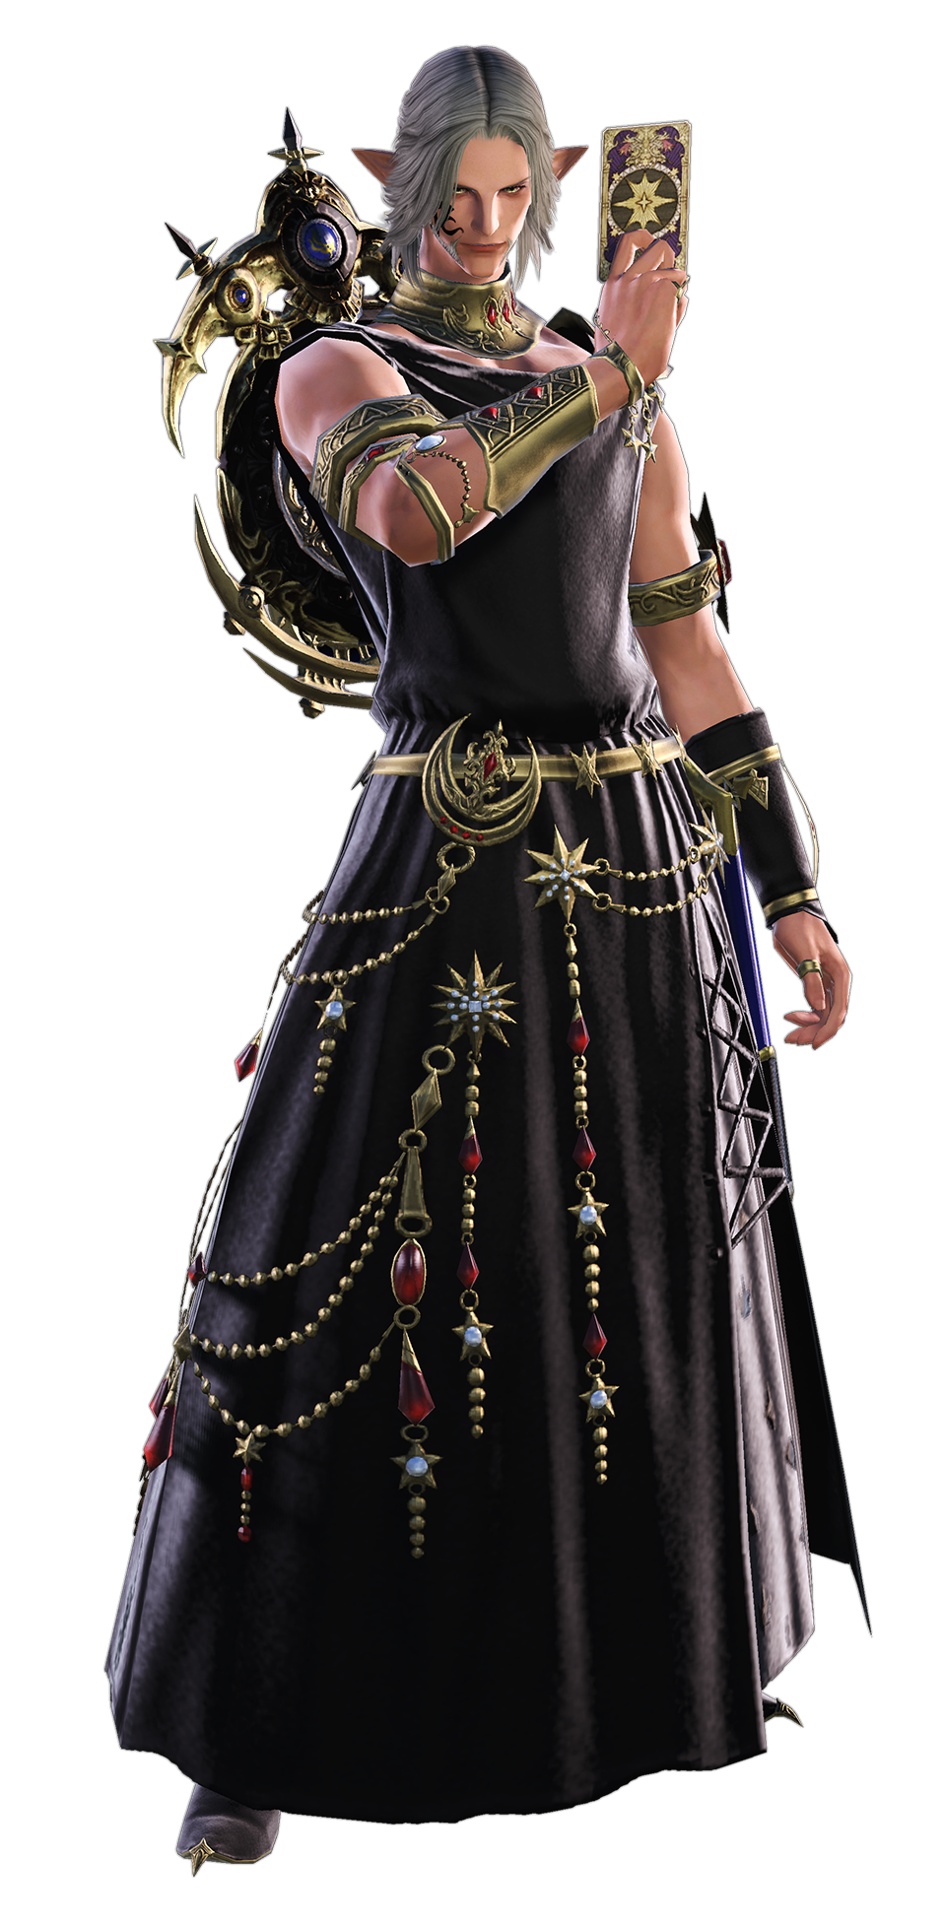
“What?” Shock was conveyed with a raspy voice once the light cleared from the man’s vision. He found himself standing – if that was the right word for whatever this was – in the middle of what seemed to be a rainbow-colored realm. Questions about the placement of his feet came about because he wasn’t standing on anything he could visibly see, almost as if there was a floor of glass beneath him. “Was Y’shtola’s assessment incorrect? If so, this is quite the predicament.”

Urianger took a step, and like before his foot settled on something. That meant that there was something resembling a floor beneath him, and yet he couldn’t fathom that walking on would lead him to an escape route. Perhaps he would have to leave his hopes in that the woman outside would find a means of retrieving him? But something within him almost made him wary about remaining overexposed within this place. After all, if the effects it had enforced on the wildlife outside were any indication? This crystal contained a power that could reweave the very essence of life.

And he had not yet noticed a crimson light that was gathering around him.

Still perplexed by his surroundings, there wasn’t really much of a thought paid to self-reflection – and such a thought would surely have allowed the Elezen man to realize what was occurring before it was too late. Would that have meant he would have been able to prevent it? No, but it was certainly something that would have been nice to know. Probably.

And there were already plenty of signs that something was in the works worth noticing, to boot. His pointed Elezen ears, for example? Pores meant to distribute hair atop his head were moved and regrown while those ears crept up towards the peak of his head – but that wasn’t even all. They grew bigger in the process, triangles somewhat turning so that their interiors were pointed out to the sides. Something about this all appeared miraculously unsettling when it had begun, but the peaks of those ears eventually curved some, and a soft, brown fur then erupted across them. Until they looked like the ears of a furred mammal.

Certainly not a Miqo’te’s or Viera’s, mind you. They looked like a comfortable middle ground between the two.

“’Tis truly a spectacle, but there must be a means of escape?” The ears atop his head twitched, and yet Urianger did not pay them any attention. This, while the dark gray hairs around these changed ears began to lighten to a mix of blue, purple, and silver, taking on a softer, fluffier quality that only grew as the hair, well, grew. Not only in length but in volume as it all tumbled down his back, gathering just past the man’s thighs while these locks curled somewhat naturally. Not even his bangs were spared, as they now covered his fairly noticeable forehead gap and were waved to the side in their length. All in all, this hair looked quite cute.

But was cuteness the name of the game? Yes. Indubitably. One needn’t look any farther than Urianger’s face to see that, as eyes lit up with the exact same color that was sported by his hair. Lashes grew longer, and the eyes themselves became bigger and comparatively much more feminine. But that was true of his entire face, really. Rounder cheeks, plumper lips, a smaller nose… Even the tattoo on the right side of his face was erased once his face came to resemble that of a female Miqo’te more than anything. But the skin below that marking? It was much lighter than his usual tan.

Not that this was an issue for long. Rather than this lighter, pinker skin tone evening out to match the man’s natural tan, the reverse ended up true and the rest of her skin lightened to match the marking. This transpired no sooner than the man himself began to find it difficult to concentrate. “Is this place tuckering me out?” With a voice that sounded as sweet as his face, he rubbed at his eyes while whatever he’d been thinking of fell right out of his head.

In fact, it was becoming much more difficult to think of anything that would set him apart as an intellectual.

Rubbing at his eyes, it robbed the man of his ability to truly notice what had begun to occur regarding his stature. Elezen were a naturally tall people that towered over six feet, but he was falling dramatically to 5’4”. His robe would naturally pool on the floor around his feet, and said feet also slid out of his sandals because his feet had collapsed as well. They were almost dainty… just as dainty as his fingers.

Or her fingers? “Nn!?” The crystal’s effect had forced ignorance upon her, and yet her body could not ignore a change as dramatic as her cock and balls being yanked inside of her so that a silver-haired pussy was shaped in its place. What occurred from this point on happened quickly, for her hips swung wider to accommodate what was growing around them.

Namely a peach-shaped bottom and thighs that were thick and feminine to match. The back of her robes, drooping so low, were inadvertently lifted as the cheeks of her rear rose. It didn’t take them long to become full and firm, presenting her with a wistful rump that was only really second to… her tits.

“I feel really bouncy all of a sudden!” Urianger was referring to her personality, but what was physically bouncing was her chest. The neckline of her Astrologian robe hung pretty low now that she was so short, but that blank space was quickly filled with overflowing cleavage as a flat chest burgeoned forth into a pair of E-cup breasts that were just as bouncy as her personality.

She blinked, and in that half-a-second moment of time, her robes had completely been replaced by a dress of white, black, and orange – cleavage still exposed, with golden armor pieces on her left arm and leg. It was a cute outfit that highlighted her charms, from fluffy boots to the white ribbon that now held her long hair into two twin tails.

“Wow~! It’s really pretty in here, but it feels kind of opp… oppress… oprah… STIFLING in here!” The violet-haired maiden, while bouncing with what seemed to be a boundless energy, struggled to find the word that she felt would best describe the aura of this crystal’s innards. While she could recall being drawn into it for some reason, Satyr couldn’t quite place a finger on when that had happened. Like everything from before than moment had become a little blurrier? Not that the past ten minutes or so sat anymore vividly in her mind.

There was no hesitation as she ran across the invisible floor, her sizable bosom heaving as she did so. The woman differed so much from her old self. Childish, energetic… There was plenty to be said of her level of intellect too, because while it wouldn’t be fair to call her an idiot, she wasn’t exactly the best educated individual in the world, either.

But just how well educated could a Primal Beast be expected to be?

No sooner than Urianger had disappeared did Y’shtola find herself in a very similar predicament. She had urgently rushed to the spot of his disappearance and, in testing the waters, had accidentally touched the rainbow crystal before being drawn into the very same interior landscape. It was so vast, however, that despite still existing within the same space, the two of them could not see nor hear each other.

“’Tis an unsettling development to be sure. The flow of aether within is…” Was it even aether that flowed here? She could perceive an energy, and yet it almost seemed to be distorted somehow. Had she any hopes of it leading her to an exit, or at least Urianger himself, those hopes had been dashed. If anything it seemed to be gathering around her. “Does it seek to remake me like it did the wildlife nearby?” That would certainly be an uncomfortable development, but Y’shtola was not one to show fear in the face of the inevitable.

Even as she began to glow an earthly brown.

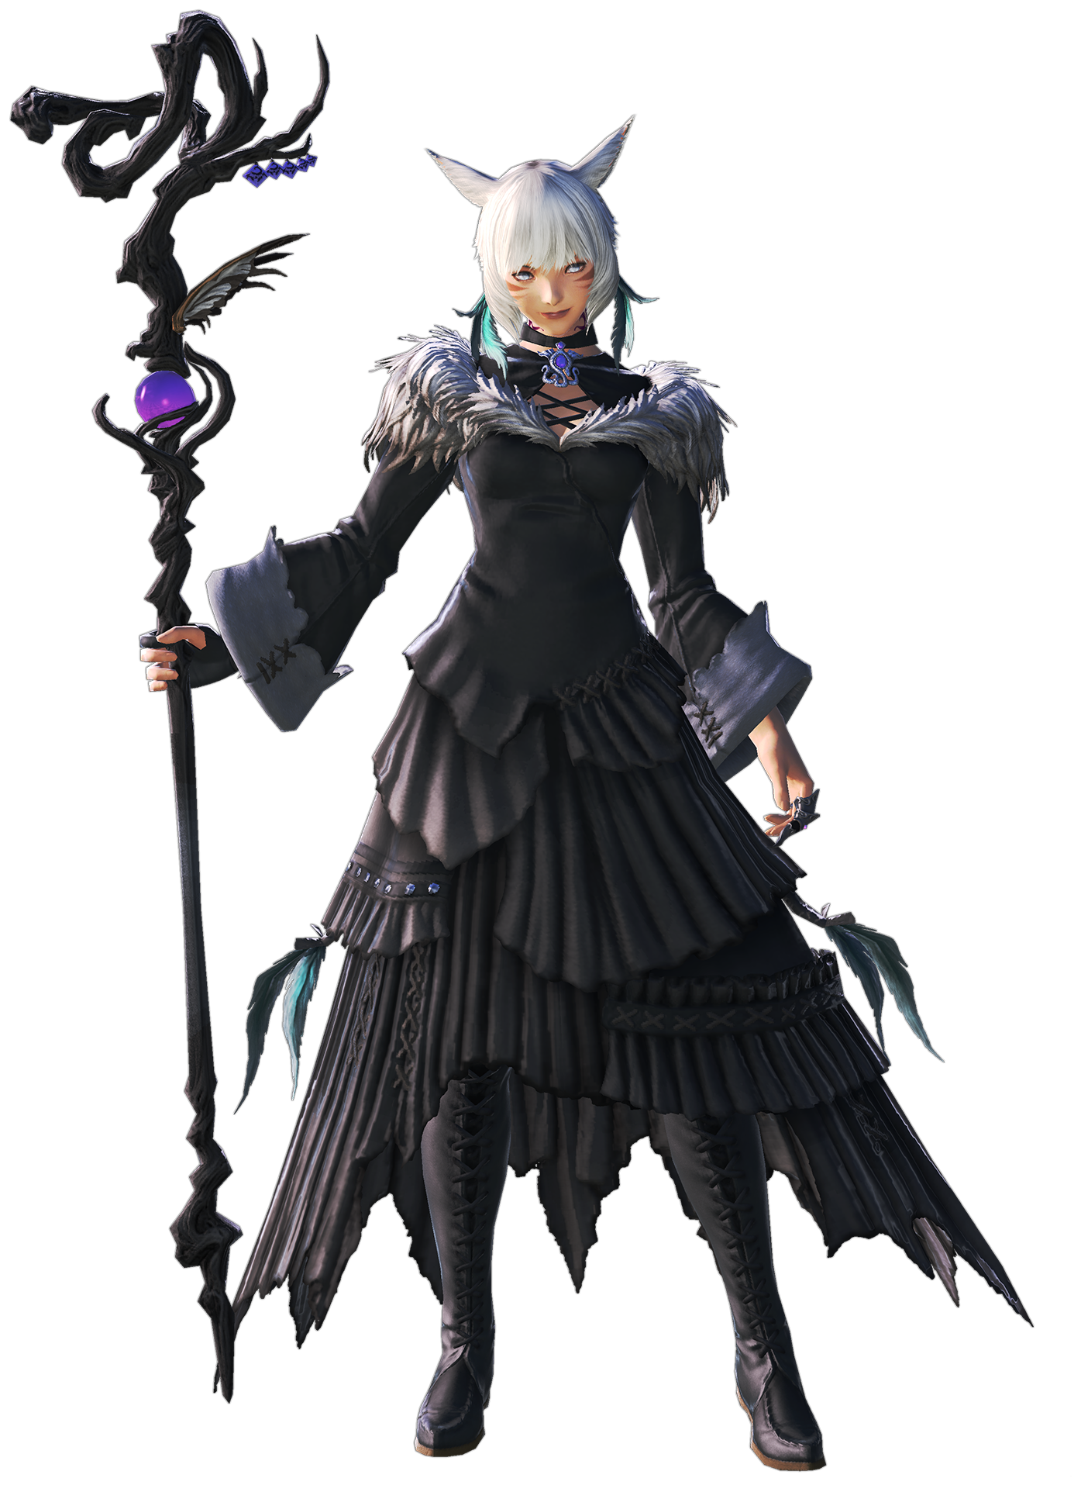
“Hm?” Unlike with Urianger, Y’shtola was not so lucky to be served the most minor of her alterations in the beginning. Suffering the crystal’s influence, her height suddenly dropped – and it most certainly wasn’t an affliction that would go unnoticed by a mind that had yet to properly be influenced by the greater power that swirled around her. “Am I getting smaller?”

Just as she hadn’t panicked when she had been abducted into this realm in the first place, the Miqo’te did not show alarm even as her limbs regressed and her point of view diminished. She knew full well that in situations such as these, overreacting could only worsen the circumstances. Not that this was actually the case here. Her emotions would amount to nothing in the end.

Despite her best attempt at repressing those emotions though, be the time she slid beneath the five foot mark she was already finding it more difficult to keep a lid on them. Why did she feel so… agitated? Inconvenienced? She hardly ever let feelings like these get the best of her.

“Hmph.” Incapable of repressing this defiance any longer, when her height finally bottomed at 4’5” she crossed arms beneath her chest. A chest that was, unsurprisingly, much smaller as well. Her bust had regressed along with her height, so much so that she was practically flat by this juncture. Did that mean she had been entirely robbed of her mature physique? Not entirely. While her face did seem to have something of a more youthful glow, she was still technically an adult, physically.

A very, very short adult.

And that was communicated nowhere as clearly as it was her rear end. Her hips had initially collapsed along with the rest of her body, but they seemed to fill out once again so that they were significantly more pronounced for a maiden of her size. Of course, Y’shtola’s dress was hanging off of her like a blanket by this point, so you couldn’t really see that.

At the very least, while her undergarments had been on the verge of falling off, that didn’t seem to be the case any longer. The widened hips had helped, but the real saviors here were the cheeks of her bum. It rapidly became the defining indicator of her adulthood, with her rump ballooning with pleasant vigor that left cheeks looking as full and comfortable as a gel-padded mouse pad. Rest your wrist on those, mind you, and you would just be asking to receive a slap.

“This isn’t… I’m not…?” So much was wrong with this situation, but with a squeakier voice Y’shtola effectively demonstrated the problem she was having. What was clearly an issue before wasn’t really seen as one any longer. Her height? What was wrong with that? The real problem was her clothing… wasn’t it?

The color of the woman’s hair began to change, turning from a pure silver with a lighter shade that also carried tones of purple. These locks were quick to elongated, taking her short hair style and reshaping it into one that spilled all of the way down to her ankles. The lengths were just as wild as snakes, wriggling about while curled at the tips.

Strangely enough though, the color change did not affect the fur on her ears or tail. Well… The latter case was easily explainable, seeing as it no longer existed, but her ears? The fur that set upon them was actually thinning, disappearing to reveal the cartilage while the ears’ positioning slid down to the sides of her head. Shrinking a little, they retained their points… but ultimately better resembled short Elezen ears more than anything.

Y’shtola’s eyes began to glow red, and as they did? The dark markings upon her face faded, as did the tattoo upon her neck, to reveal a lighter skin color beneath them. As had been the case with Urianger, this revelation predated an overall shift in her body’s natural melanin level. It didn’t take long for all of her skin to meet this pale pink, a color that made apparent that she was passively blushing to herself all the while.

Why did she feel so embarrassed? “These clothes…” She didn’t like them. They were tacky and were falling off of her. One wrong step and it felt like she would be left standing there naked. The body of a proud Primal Beast was not one to be seen in such a state! And thus, it would not! For a single blink saw that tacky dress disposed of, and in its place? An ensemble that was much more up to her standards.

Gold ran rampant across the outfit. Whether it was the chest piece, the gauntlets, the armored boots, or the snake tail that stretched from behind, there was no shortage of sparkling wealth clad upon her. There was even an elaborate headpiece that resembled the face of a wyrm atop her head. But beneath it all? There was a black, sleeveless body sock. It hugged her torso strictly, and in its strictness the abundance of her ass was beyond apparent. Black nylon gripped her so tightly that they practically weaved all of the way into the depths of her butt crack. And yet she wasn’t cameltoeing the front at all, nor could you make out the imprints of her silver pubes.

With the brown light that had surrounded her dimming, the new Primal Beast, Medusa, gave a shake of her head with hands planted firmly on her hips. “Tch.” Casting her eyes over her shoulders, she gave an involuntary twitch of her sizable booty with the motions – drawn to the sensation of another Primal Beast present. “Satyr is here too, is she? Not that I care…” Even though she did care, and was just dismissing that fact for no reason whatsoever.

The pair of them had been transformed into what were known as Primal Beasts in a distant land, with Satyr representing fire and the smaller Medusa representing the element of earth. The crystal, and in fact all of these rainbow crystals, had sought to spread their influence after arriving from a distant planet – and that meant implanting deities of their own not unlike the Primals of this world.

“HEY!?” To those ends, the small snake girl let out a cry as what felt like suction suddenly pulled upon her, and after ejecting her through what she could only think to assume was a portal. “…Soft.” She had landed on something that was very comfortable. It took her a second to realize that her chin was resting between a very sizable pair of tits. Satyr’s tits. While Medusa’s butt was up in the air.

“Oh, hey Medusa!”

“GET OFF OF ME!”

“BUT YOU’RE THE ONE ON ME!”

