BOUNDARY - SERVITUDE
COMMISSION STORY
BY CHALDEACHANGE


“Auau… Exploring this mansion normally was already hard, but now?” Hanyu, once Reimu Hakurei, lamented her decision to visit the Scarlet Devil Mansion that night – not that she’d had any choice in the matter. She had already sought out a magician with hopes that this curse set upon her by some sort of difficulty with Yukari’s portals could be undone, and in the process she had unintentionally bore witness to her best friend being turned into a Chinese woman, and what she assumed was a case of Alice Margatroid being turned into a doll.

This meant that short of finding Yukari herself, something that was difficult on a good day much less if she was sick, there were dwindling options from whom she could request assistance. Even now she didn’t really want to rely on this woman, but afforded little other choice Patchouli Knowledge was her best bet… if Patchouli could even see her.

Things already weren’t looking good on that front. She had snuck past Hong Meiling as if it was nothing, and where Sakuya Izayoi would typically meet her upon entry, she received no such greeting on this occasion. “Does this mean that people really can’t see me like this? Auauuuuu! That’s a big problem!” The girl hung her head low with disappointment. How would she get Patchouli to notice her!?

But the lack of a greeting wasn’t actually because of a presence that had essentially been erased. In truth, the effects of Yukari’s sneeze-inspired portals? They were much more widespread than the poor Hanyu even realized.

Rewinding about twenty minutes, Remilia Scarlet had been going about her evening as usual. Being a vampire, she had a preference for getting up when the sun finally set and was typically active throughout the night. This meant that, essentially, it was morning by her standards. She had heard nothing of any incidents transpiring in Gensokyo and she certain wasn’t the cause of any… this time. She was merely anticipating having a quiet day of self-care. With a little help from her maid Sakuya, of course.

“I suppose a spot of tea would be a good way to start the day. Sakuya should be bringing it any moment now.” Such was their routine, at least. Most nights began the same – barring any unexpected visitations that Sakuya had to deal with. It always put her maid in a sour mood when Patchouli reported the Kirisame woman stealing from her around this time. Just how good was Meiling as a guard by this juncture?

Now dressed, Remilia had been intent on opening her door a crack so that her maid knew she was ready to receive her tea, only for an unsavory irregularity to spoil her mood.

ACHOO!

A loud sneeze accompanied a portal that not only opened up beneath the vampire’s winged form, but also pulled her inside. Yukari to be sure, but surely the Gap Youkai knew better than to summon the vampire without warning? “…Oh.” Or so she’d briefly wondered, but the portal spat her out back in her own bedroom. What had been the purpose of that? Surely such a powerful youkai could not be so off-put by the common cold? How humorous if so!

What this put into motion, on the other hand, was not something that could be seen as very humorous in retrospect.

It began with a wave of fatigue that struck Remilia as if from nowhere, provoking her into casting a glance towards the bed she had only just recently stirred from. “No, what am I thinking? I only just woke for the day.” But she didn’t feel like that, not at all. Instead it felt like she had gotten up very earlier in the morning and had been awake since. Even her body was aching as if she had been running around the whole day rather than, you know, sleeping? These were all feelings a vampire of her renown wouldn’t typically feel either way.

Which, naturally, cast doubt upon her lineage. Examining traits relevant to her status as a vampire did indicate plenty. Take the girl’s pointed ears, for one. While concealed rather proficiently by her mop-styled blue locks, their tips were actually rounding into circular shapes much more commonly found in humans. Such was the fate of her small but potent vampiric fangs to boot, and before long they were little more than a regular girl’s canines.

Perhaps in a change that was much larger in scale, Remilia’s bat wings began to fold in, and in a way that looked quite uncomfortable. But the vampire herself hardly paid any mind to it, which more or less fell in line with most of the transformations at the hands of Yukari’s portals by this juncture. Rather it was like a great weight had been lifted off her shoulders once they disappeared back inside her body, leaving not even a single trace of their existence upon her back.

“When did it get so late?” Late? Was that the right word for it? The maiden felt puzzled by this assessment somehow, even though the sun had set. She cast a glance to the moon outside her window, although in doing so the moon’s light came to be reflected upon eyes that were not their typical crimson. Instead there was a much more human turquoise housed within her irises, the color better displayed by eyes that appeared just a smidge wider than they had initially.

It almost seemed like the light of the full moon was dyeing her hair to boot, but that was just a false lead. The color of Remi’s icy locks was changing, but it was still through the efforts of the rampant Yukari’s power. What emerged was a strawberry pink in the place of the pastel blue, colors weaving to almost appear as if two colors of cotton candy had been swirled together. Even so, it didn’t take long for the pink to become the much more dominant of the two and overwhelm even the last remaining strand. It all seemed to blend in rather well with her pink outfit though.

As if to try and sort out the aching of her muscles, Remilia did a big stretch. Which seemed to work, albeit just a little too literally. Because the girl’s skirt hem parted from the base of her pink top, revealing more and more of her stomach as she reached towards the ceiling. A ceiling that, by all definitions, was growing closer and closer to her head. Not because the ceiling was falling, but because her head was being raised.

Because the girl was growing taller – significantly so. At best her body was typically likened to that of a child, and yet as she swelled higher and higher, her height actually became more akin to that of a young woman. She passed the five-foot mark in what felt like no time whatsoever, and ultimately stopped at 5’3”. This left her much bigger than her outfit was crafted to allow, with lengthened limbs jutting far out from her sleeves and skirt – widened shoulders tearing in slight as she lowered her hands once more.

“I-I feel like I was doing something important…” Her voice now older and softer, Remilia was evidently still unaware of what plagued her. Rather she was becoming increasingly confused about her situation. Was she supposed to be doing something? What was it? Did it have something to do with her clothes feeling so darn tight? And why had she stuttered just then? She was always so confident! …Right?

To be fair, the situation with her outfit was getting worse thanks to several factors. The first being the size of her chest, quickly filled a pink top that was already barely covering her upper half. It was lucky that Remilia didn’t wear a bra with how small her breasts normally were, as they promptly rose to C-cups that took up all of the space within pink cloth. The woman herself merely scratched at them a moment, wondering more about her outfit than the size of her rack itself.

Behind her, once short hair cascaded down in a much straighter fashion than what was the norm from her. It appeared to be well-combed, and her bangs lengthened at the sides to perfectly frame her face. That said, her face wasn’t quite what it had once been either. With her growth spurt it was only natural that Remilia would come to look a little more mature – and as expected the impression her facial structure gave off was that of a young woman around twenty – the primary concern was its shape. Her smile was wider with plumper lips, her skull was taller, and all in all she just did not look like Remilia.

But a completely different woman altogether.

Mind you, this was reflected just as much in her personality and mannerisms as it was her appearance. Even as her hips widened and her butt became full, her posture had passively changed so that both hands rested on her lap. “Service? Oh, was I about to s-serve someone something?” The human’s memories also grew clearer, and her background and role spoke nothing of vampirism or possessing any great powers. But who was she serving? What was she serving them?

These questions were quickly granted answers in tandem with a change of outfits, because the ill-fitted pink ensemble transformed into a largely black maid’s ensemble with a skirt that fanned out far to the sides, fingerless gloves, black steel boots, leggings, and your usual white maid frills.

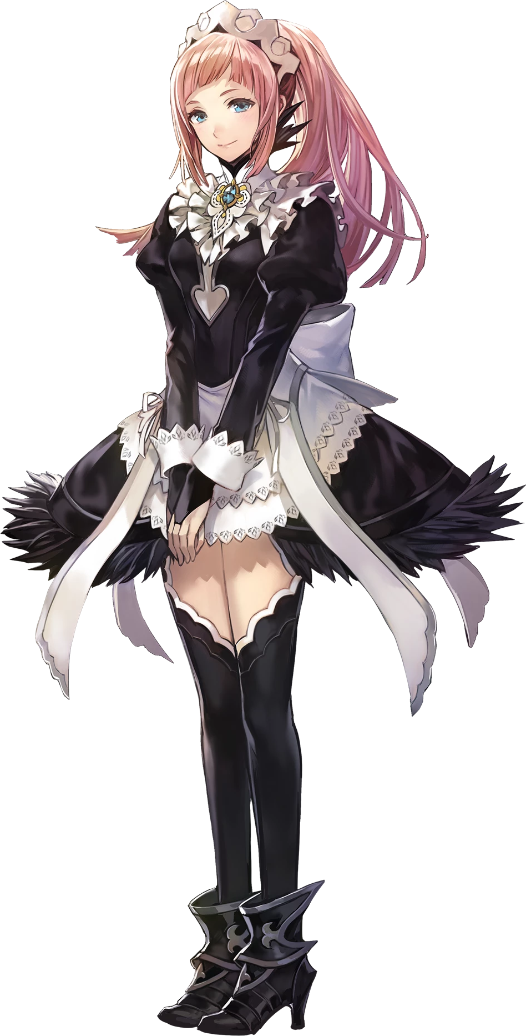
“H-Huh!? Why am I in mistress’ room!? Without tea!?” The human maid practically tripped over her own two feet upon the realization that she had acted out of sorts for some reason. Her routine at this time of day should have been to bring the girl she served her evening tea. Early to bed and early to rise, there was a fairly strict sense of how things were supposed to go in this manor, and Felicia was often the cause of various hiccups even though their master was so forgiving.

It was due to her twin sister, who did more work in the basement, that things ran so smoothly! Of course, this was only accomplishable because Flandre had been transformed into Felicia’s twin, Flora. She was simply unaccounted for as of this moment. Nonetheless, knowing her sister wasn’t around didn’t do much for her anxiety. “WAAA! I’m so sorryyyyyy!”

Who was she even apologizing to? No one was there!

Around roughly the same time, Sakuya had been in the manor’s kitchen preparing Remilia’s tea. She liked it at a very specific temperature and brewed a very specific way, so it was only natural that she be the one to see to it every night. In fact, everything was now prepared to be wheeled up to the vampire’s room upon a cart, everything set out atop it. “I know she won’t complain, but I am running a few seconds behind.” Tragic, but she’d had to shoo a mouse out of the kitchen when she had first entered.

Just as she had been set to deliver the drink, though…

ACHOO!
She was slam-dunked through a gap portal faster than you could, well, sneeze, only to land on her own two feet directly where she had started. “Yukari? How unusual for her to feel under the weather… This is the first time I’ve experienced a phenomenon like that.” Sakuya had passed through portals at Yukari’s behest in the past, but that felt vaguely… strange.

In fact, the typically composed maid soon found herself wobbling to and fro despite being firmly planted on the ground. “Uhm?” She couldn’t really muster anymore shock than that, mostly because the effects of the portal were inhibiting her ability to address it. But the cause of her imbalance? It was a fairly serious one.

Sakuya’s height was dropping – and rapidly so. The fit of her maid uniform almost felt like it was enclosing upon her, swallowing her arms and legs almost whole, leaving only her ankles and wrists exposed when all was said and done. It wasn’t merely a vertical loss either, for shoulders and hips had both narrowed so that the arms of the dress appeared to be dangling off to one side. If the outfit hadn’t been a whole piece, she might have been going without lower wear by this juncture.

“Wait… Is something not strange here?” She felt as if something obvious was amiss, but she also couldn’t figure out just what that amiss thing was. You’d think practically swimming in your own clothes would be a pretty strong tell though, especially with cuffs spilling off your wrists and naturally stepping out of shoes that could no longer hold shrunken tootsies.

Unfortunately for the maid, more was lost than any woman would have been comfortable with… bringing to the table the question of ‘was she even a woman at all anymore?’. Because the front of her dress had emptied, breasts slipping away until they were little more than subtle swells upon her chest as if to represent a potential to, one day, grow greater. With her hips already narrowed, thighs and ass behaved similarly. The collapsed until they were better suited for a girl on the cusp of puberty.

And so, looking now at her face, was Sakuya still a woman? No. She was a child. Perhaps not the youngest of them, but comparable to her old age she had suffered quite the drop. Youthened features were indicative of a maiden that had just recently crossed into her teens, which explained the signs of life her figure demonstrated. Yet despite it? “This is troublesome. What am I forgetting here?” For one so young and speaking with such a high pitch, there was a great deal of maturity in how she spoke.

Sakuya’s face, steeled by confusion, was not done even after becoming younger, however. Her eyes narrowed, albeit not because she was squinting at anything. Rather their shapes were becoming naturally tighter, taking on an even more Eastern look than they’d held before. Hues of emerald likewise danced among her irises, and on the whole her complexion took on a much fairer and delicate aesthetic. The kind of appeal that might provoke others into protecting her. Which was off-putting for both her old personality and her new one.

“How could I forget something that must have been important?”, she huffed as crimson markings spread across her face. A singular dot between her eyes, with streaks beneath her eyes that all seemed to be intentionally placed. They gave off the impression of a young lady in an important post, and that sense of important was bleeding into her personality. But there was something else as well, an underlying self-doubt that brought up reluctance like water drawn from a well. Had she actually forgotten something? Why was she not as pressed about her outfit?

The girl’s hair both lengthened and smoothed out, her naturally perm dismissed in favor of an absolute straightness that lingered instead. With it came darkness in the form of black strands that mingled with her silver. As if they were reproducing, the color spread from one strand to the next until the hair that fell most of the way down her shrunken back was completed dyed in raven hues.

She rolled her arms, and in doing so was momentarily surprised to feel the weight of her outfit now alleviated. Clothes had glowed gold briefly and reformed, robbing her of her maid uniform and exchanging it for a short, sleeveless pink dress with a white cape and detached sleeves. A translucent ribbon ran behind her from one wrist to the next, both bound to golden bracelets with big bells dangling beneath them. With her hair styled up into two big circles, a small golden tiara also rested upon her head.

“Um…” Sakuya’s head cleared some, but she with memories ‘returning’ it still took her a moment to piece things together again. Exposed thighs bounced just a little as she tapped her open-toed feet, shrouded in purple sandals attached to vibrant, pink boots, but with time she finally became confident in her situation. It just wasn’t the same situation that had been reality before Yukari had sneezed.


“Hm? Why am I down at the kitchen? It’s usually Felicia that prepares my tea, not myself…” The young mistress of this manor, Rayfa Padma Khura’in, looked around with puzzlement upon her young but stern expression. Perhaps it was strange for a human, served by humans, to have made Gensokyo their home – but her family had come to this land many generations ago, before the barrier was even erected.

At least that was what she recalled.

With her parents long passed, the fourteen-year-old had been given little choice but to wear the family name alone. Considering her spiritual powers on the other hand, she wasn’t all that out of place within this world. She presented herself as stubborn and prideful to the people of Gensokyo, but in truth? She was but a girl of her age deep down, often discouraged by her own inadequacies in face of the lofty expectations forced upon her.

“M-M-MISTRESS! I’M SO SORRY! I DON’T KNOW WHY I—HUH!? WHY ARE YOU IN HERE!? DID YOU HAVE TO MAKE YOUR OWN TEA!? OH NOOOOOO— AH!?” Lacking in answers, Rayfa was even more confused when her maid, Felicia burst through the kitchen doors, spouting of a series of questions while affording her little time to answer them. Felicia was quick to trip and eat the floor, spurning concern from the little master.

“Are you alright, Felicia? I don’t know either. Did someone swap our places with magic? I can’t fathom why though.” With a sigh, she crouched down beside the older woman and offered a hand up. Regardless of the cause, so long as it didn’t happen again they could carry on as usual, no?

Which brings us to the present, when Hanyu finally reached the doors to the manor’s library…

