LEISURE ISLAND IV.
COMMISSION STORY
BY CHALDEACHANGE
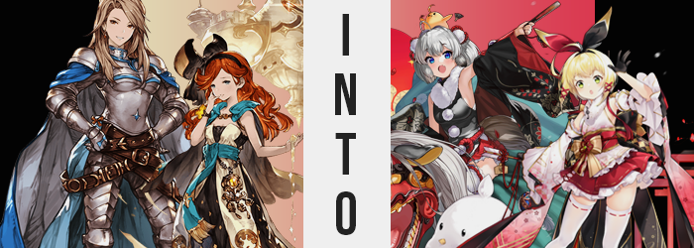

“The isle of Voluptas is amazing!”

Katalina watched Sara travel across the snow-covered path with a smile upon her face. As the other crew members of the Grandcypher had, the two had been given permission to explore Voluptas at their leisure and engage in whatever activities they desired. It was meant to be a vacation after all, even if Lyria had left them with an ominous possibility when they had first flown in. Katalina had expressed a desire to investigate those claims, but at Gran’s behest she had been given a different task.

“It is quite amazing, isn’t it? To think you could have beaches and a snowy mountain in such close proximity to one another.” Sara had wanted to go up to the snowy northern section of the island resort, but most of the crew members were interested in going somewhere warm instead. He didn’t feel comfortable sending a maiden of Sara’s age all that way alone and had asked Katalina if she could accompany her.

Obviously, she had, and it wasn’t like the knight had any complaints about it. There was an intriguing festival of sorts ongoing that reminded her of the yearly festivals surrounding the Divine Generals. Similar clothing was worn by those passing by, with various stalls selling snacks, toys, and even running games for children to take part in. Sara wasn’t especially interested in those, though.

As the two passed by one stall that was set up outside of a set of changing stalls, they were stopped by a woman dressed in one of those colorful outfits. “Hello! Would you two be interested in trying on some of the festival clothing? You may have seen similar styles before, but the island they’re based in have a rather unique spin on the style!”

“…I knew it. This doesn’t fit my body at all.” In the end Katalina hadn’t been able to say no to the stall clerk’s offer at all. She had been escorted to one of the changing rooms and given a set of clothes that, at the time, she had said would not fit her. But the clerk had responded with so much certainty that they would. Almost a little too much certainty considering how things had panned out in the end. “Perhaps she gave me the clothes she meant to give to Sara?” But even then, they probably would have been slightly too big for the child?

The end result was, well, something. The adult woman was dress in clothes that were barely holding onto her body. A black, sleeveless top with a fur wrap that concealed its raised neckline, with white poms arranged down the center was what contained her torso. It wasn’t even closed all the way in the front because it couldn’t accommodate the sizes of her torso and breasts, and her tummy was completely bare.

She was also wearing a red miniskirt that might as well have been a microskirt with how it rode up, and a decorative silver-furred tail was affixed to the back. But at least she was still wearing her own underwear. There were likewise white leggings that presumably were meant to reach her thighs, but they didn’t even reach her knees and were way too tight around her feet. The raised, wooden sandals were also too small, and her feet were resting off of them. “Are these stalls soundproof? Hello!? These clothes definitely aren’t my size!” But there was no response. Was it actually soundproofed?

The walls were, but the door wasn’t. So, while Sara couldn’t have heard her? The clerk outside definitely should have been able to.

“Well, I can’t leave like… this…?” Katalina had come to the natural conclusion that she would just have to change back into her normal clothes and leave while hoping that Sara had been given better luck with the clothing she had been offered. The child was much more excited about it, after all, so if anything, she wanted to hope she was having a good time. It was just that when she went to pull off the sleeveless top? She found that it wasn’t fitting as tightly as it had when she had first put it on. “Hm? Did the cloth stretch from someone too big wearing it?”

The knight really didn’t want to have to pay for any damages when it wasn’t her fault, but upon examination she found that it hadn’t really been stretched in any capacity. So why was it that the clothing article fit better all of a sudden? If she hadn’t seen it continue to happen with her own two eyes, then she probably would never have believed it. “W-Wait a second!” Her sizable bosom (or sizable to her, anyways) didn’t seem to be as sizable as she remembered it.

Rather, it was actively becoming smaller before her very eyes. “Am I seeing things? Perhaps I need to sleep more…?” But even seeing it wasn’t really enough at first. She had to reach her fingers up to gently poke at her own mounds through the open gap that had been allowed by how large her breasts had initially been. Those fingers pressed into her breasts until they reached her ribcage, and she definitely didn’t need to push as hard as she usually did. “My… My breasts are smaller…”

B-cups, maybe? Without thinking about why she had felt compelled to do so, she pulled the top the rest of the way across her chest to properly hide away the exposed skin. It now fit? Not vertically still, of course, but her chest was no longer so big that she couldn’t bind the top properly. “How did this happen? Magic? Or…?” For a brief moment, Katalina remembered what Lyria had been said about a Primal. But she immediately forgot. Her head felt so groggy.

What had been happening with the woman’s breasts had actually captured most of her attention. It hadn’t even occurred to her that it wasn’t the only part of her body that had become more compact over the course of those few moments. The way her lower gait had been structured before, the red skirt she had put on had initially felt like it was going to explode off her hips at any moment.

That feeling was slowly alleviated as her hips pulled inward towards each other – something that probably would have pushed her thighs and ass to pop as they were compressed alongside them. But this didn’t happen. All of that weight around her hips softened away first, part of the uncanny trend of Katalina’s muscular body being robbed of all of its strength. But from there? The excess drained away so that she was proportionately lean in her upper legs and didn’t really have much of a butt to speak of. At least this meant that the skirt now fit properly horizontally!

“Should I complain!? Orrrr….? Eh? My voice? Why do I sound like this!?” The knight raised an eyebrow at the sound of her voice. Her pitch was higher than she remembered, and she had a lot more pep to it. But was it really all that wrong? Like it was definitely wrong, but it somehow felt right too! A crashing wave of bright blue crashed against her originally brown irises as she contemplated this, permanently changing their colors.

And they weren’t even the only part of her head that experienced an abrupt, relatively unnoticed coloration shift. The tips of her brown mane lightened and shone with a silver that spread down to her roots. It seemed to alter the quality of her hair too, becoming fluffier – but also shortening so that it only reached her chin. There were tufts of silver on either side of her cheeks that were a little darker than the rest. Was that really hair or were they… animal ears? It remained relatively unclear.

It didn’t even occur to her to check, really. For a brief moment she had even forgotten that anything was wrong in the first place, at least until— “EHHHH!?” Katalina took a tumble, or at least she thought she had taken a tumble. The inside of the changing room just suddenly felt significantly larger all of a sudden, but in actuality it wasn’t a matter of the room getting bigger. She had become smaller, with her limbs and torso crunching down until she was around 5’ tall rather than 5’7”. It had been a significant drop. Not even her hands and feet were spared, with the later eventually pulling in against the sandals enough so that they didn’t lip over the end. They fit perfectly.

If there was any good fortune to this change, it was certainly that it allowed the clothing she was wearing to now fit perfectly. The top had slid down to cover her bellybutton, the skirt now reached at least the tops of her thinned thighs (and her own underwear had now shrunk to match her smaller gait), and even the leggings could be pulled up past her knees with a little “Hup!” from the girl. Because she most certainly did not resemble the woman in her twenties that she had prior. Her face was smaller, cuter, and rounder. She didn’t look a lick like Katalina.

More like a girl in her early to mid-teens, perhaps?

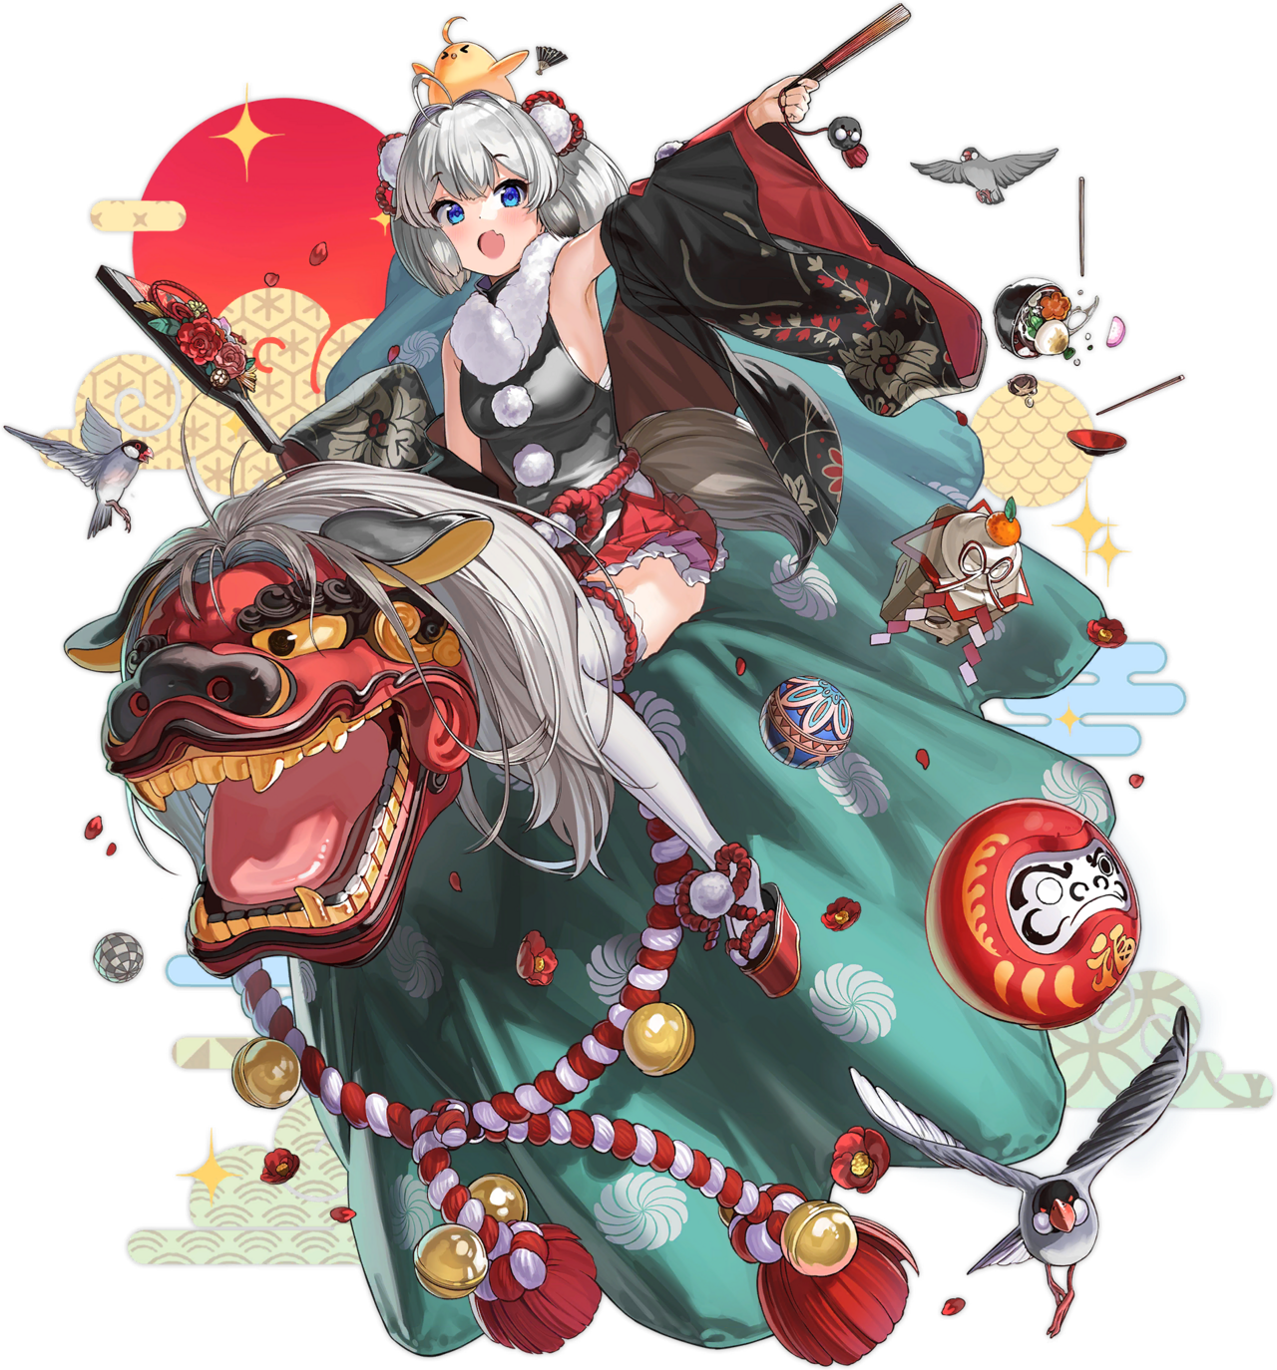
The stall clerk’s promise hadn’t been false in the end. The traditional Japanese clothing that she had been given did fit her, but some adjustments had simply been necessary beforehand. That was what Z28 was now realizing. “Eh!? But I’m like… a different person now? Even though I guess I do fit in the clothes…” As had been the case with the others who had been transformed by Voluptas’ Primal, the teenaged girl hadn’t forgotten her origins. It was more like another life had been laid on top of her old one like a blanket and she believed both to be real.

But the blanket felt more compelling, and with time, it would become heavier.

Z28 ultimately shrugged it off. “I guess it doesn’t matter, right? I’m here to have some fun with, uh…?” What was the name of that redheaded girl she had come with again? She could remember her face, but the name just wasn’t there. Probably because she was in the stall beside her trying on clothes of her own. “I’m sure I’ll remember when I see her again!” She may have been younger now, but she still felt responsible for what happened to that girl.

Ignorant to what was going on in the stall beside her, Sara realized she was having a very different issue from Katalina’s. While the older woman’s outfit had been much too small for her, Sara’s? It was a little bit too big. “Maybe I should ask for different clothes…?” It had been a sound idea, but there was one problem. The door didn’t seem to open even after undoing the lock. “…Oh…” Was she trapped? Was the door broken? It wasn’t in her nature to assume that the clerk had intentionally trapped her within… even though that was what had happened.

The nine year old couldn’t leave dressed as she was, in loose white thigh highs and oversized zouri. The white kimono with a pink and red gradient didn’t fit, nor did the matching detached sleeves that showed off a unique floral pattern. Not even the obi could be pulled tightly enough around her torso. “These clothes are really beautiful, but…” They definitely didn’t fit her.

She wished that they did, however.

While struggling to make the thigh highs actually reach her thighs without falling down, though? It almost seemed like her wish had been granted for a moment. “…Eh?” Sara had her fingers under the upper hems of the white thigh highs and had momentarily assumed it was a futile endeavor. They reached too high on her legs for one, but her thighs also weren’t wide enough for them to rest against her flesh properly. There was a gap! But that was exactly where her surprise came from.

…Because the flesh of her thighs was now touching her fingers, and then seconds later began to push against them until her fingers got caught and she had to pull them out. Rather than slide back down her legs again? That white cloth and its crimson hem remained tightly bound to her thighs. “D-Did my thighs just get thicker!?” Even if they had, it didn’t change that her legs were still too short. The leggings were bunched up around her knees. For now, anyways.

“Eep!?” The squeak that jumped from the girl’s lips next sounded a little off. Like it was still high pitched, but it wasn’t the same pitch that Sara usually communicated with. She shot up straight as she made the noise, and only because of her chest. The kimono top had been loose around that area because Sara didn’t have much of a bust to speak of, and even at that moment she really didn’t have that much of one. But her chest had definitely grown a little bit. Maybe up to A-cups from borderline nothing? They fit properly in the top now at least.

But the girl didn’t understand why that was. She didn’t know about Lyria’s concerns to be able to even draw that line in the first place. …Not that she would have remembered for long anyways. “I-Is my wish getting granted?” The change to her voice from before was seemingly a permanent change as she wondered what miracle might have helped her with the cute clothing that she wanted to wear. She didn’t really feel distraught about it even though it was a little uncanny.

Maybe Sara would have felt differently if she’d noticed earlier that whatever was happening to her, it wasn’t merely affecting her body in a way that would allow the clothing to fit her. Had that been the case then there wouldn’t have been any real reason for, say, the girl’s hair to shorten nor lighten. The bright red that many knew her for was sapped away until it was a dull blonde instead, and it really only reached her chin instead of tumbling down past her shoulder blades.

“Woah! Wait a moment! This feels weird!” Something in her subconscious had provoked her to throw her hands out to her sides, almost like her sense of balance had been impeded. This was true in a sense, because all at once her body had decided to spring upwards. The bunched up section of her thigh highs around her knees were pulled tighter, while feet grew both in the sock segments and the zouri on her feet. The detached sleeves that had hung down to her wrists before soon only reached her forearms, while gloves no longer felt like they were on the cusp of slipping off any longer.

Sara had been a girl of only 4’5” before. Now? She had grown up to 4’10” instead. Still not an average height for a young lady by any means, but those extra five inches made it so that she was a lot closer than she had ever been before. This height jump seemingly came with an additional benefit too: about three years of additional age, in fact. She looked like she was twelve or so, which meant that she would have become roughly three years older during the process.

She hummed to herself for a moment. “I guess it doesn’t feel that weird. Actually, it feels pretty normal!” Eyes shone with an emerald green that hadn’t been present moments prior, almost as if to indicate visually that this wasn’t the same girl she had been before her transformation had begun. Her face told a similar store. Even though she was older now, her face seemed to be rounder in shape. She more or less looked like a different person altogether, as had been the case with Katalina.

It wasn’t really her wish that had transformed the nine year old Sara into Southampton, the twelve or thirteen year old that now stood in her place. “Hehehe! Everything fits perfectly now!” Despite being aware of her transformation just as Z28 had been, the little knight didn’t really seem to care all that much about it. She just seemed to be thankful that the cute clothes were no longer falling off of her body!

Did it really matter all that much who she had been so long as she enjoyed who she was now? It really didn’t, right? And so, she skipped out of the changing room without sparing a thought for the clothes that she left behind, the only remaining trace of her past life, so that she could meet up with Z28! “I wonder how many festival games we’ll get to play before we get too sleepy! A girl’s night sounds pretty fun!” She didn’t get to attend those all too often! Or at least Sara hadn’t.

Memories of Southampton’s life spoke to the numerous times she had actually done so there, namely because she came from a place that was practically solely occupied by women.

But of course, Katalina and Sara’s existence hadn’t been wiped entirely from the island. Sooner or later the clerk, who was actually the Primal in disguise, would trick the original Z28 and Southampton into trying their clothes on instead. Then there would be no discrepancy, right? But the Primal couldn’t help but lament the state of things. Just how many people were on that ship that had a hunch about the island’s unnatural state?

“No matter. I’ll deal with them all with time…”

How many more could have even been suspicious about the island? Perhaps it was finally time that she targeted the presumed source of those ‘rumors’? And then it would only be a matter of cleaning up any stragglers. The Primal smirked to herself while pretending to check her stock of costumes. “Where would that girl of blue be at this very moment, I wonder?”

