PHANTOM THIEVES OF STELLARON
COMMISSION STORY
BY CHALDEACHANGE
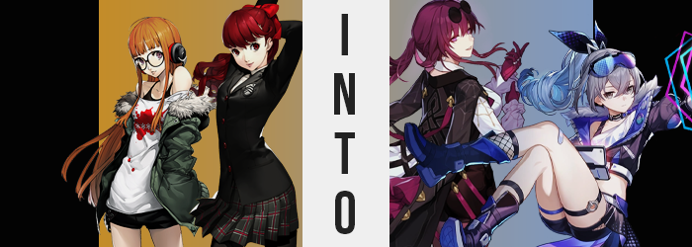

“Oh gacha! Why art thou such a cruel mistress!?”

“I don’t really understand what just happened… Isn’t this a little like gambling?”

An exchange between two similarly aged teenaged girls could have been overheard in the attic of Leblance that functioned both as Joker’s bedroom and the base of the Phantom Thieves. Maybe both of those things could be considered past tense though? It had been a few weeks since Joker had returned home after the incident with Maruki had been cleared up, and it felt like a hole had been left in the hearts of those that remained.

Sumire Yoshizawa was a little sad about it but she also understood that this was how things had to be. She was still able to talk to her senpai over the phone and through text and instant messaging after all! They’d meet again! He said he was going to come back often on trips to visit! On the other hand, she had noticed that another member of their group had been a little harder hit by his absence.

It wasn’t really that surprising. Joker had essentially become Futaba Sakura’s rock in her efforts to open herself up to the outside world again. She was still thankfully trying and it didn’t seem like any progress had been lost on that front, but it was clear she had been lonely. That was why Sumire had suggested that the two of them hang out in the Leblanc attic that Sunday afternoon.

Their senpai had asked that his friends keep it nice and clean for when he inevitably returned to visit and since it had been a few weeks it felt like the perfect time to engage in a light dusting and sweeping. A task that they had managed to accomplish in all of twenty minutes before Futaba had plonked down on his bed and began to tap her phone. Sumire, being curious, had sat down beside her and peered in.

It looked like she was playing a video game? One of those anime styled ones she always saw advertised on trains and billboards across the city. Futaba had rolled in one of those… gacha thingies? And she hadn’t gotten what she had wanted, evidently. “You don’t understand Sumire! I want Silver Wolf so bad! She’s just like me for real! I was smitten with her when I saw her in the prologue, not to mention how cool and sexy Kafka was!”

Sumire blinked a few times, utterly shocked by the things that had just been said to her. She had needed a moment to process them, actually. “O-Oh, I see… Well I’m sure you can get her if you try!” Short of giving her the money to help roll the character (that was how it worked right?) she couldn’t really offer more than her encouragement.

It wasn’t like she give her the character!

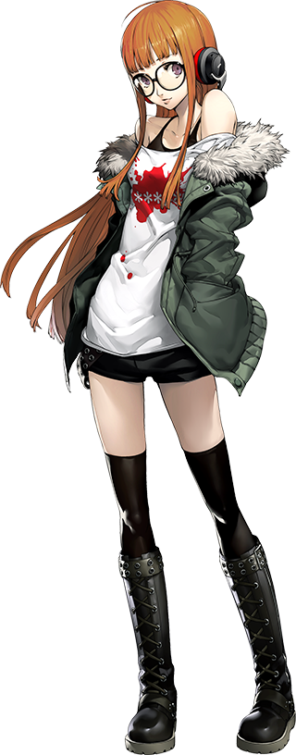
“HUH!? IS THAT OUTER SPACE!?” Honestly? Futaba didn’t have the foggiest idea about what had just happened. She had been playing one of her new favorite games, Honkai: Star Rail, with Sumire at her side. And then there had been like… a bright light? The next thing she knew she was standing in the midst of a sea of stars – sort of. She was standing on what she could only assume was the bridge of a spaceship? With a view of the stars beyond the thick glass in front.

She was understandably excited. This was just like in her game! “Wait… This isn’t the Metaverse, is it? I thought we were done with all that!?” But her phone wasn’t with her? Had she dropped it? Without it there was no way to check if the Metaverse App was active, but at the same time she was just in her regular clothing? “Persona!” And calling for her Persona didn’t seem to do anything?

“Okay so what other options are there? Did Sumire bonk me on the head really hard?” No, that seemed pretty unlikely. They had become the best of friends as of late and Sumire wasn’t really the type to resort to violence, much less for no reason. So something else had brought her here. That or she was dreaming.

Considering all of the buttons and levers on the futuristic spaceship bridge, combatting her desire to press and pull things might as well have been just as much of a concern on Futaba’s part as it was attempting to figure out where she was and how she had ended up there. “Well, it’s not like I don’t know what they… do?” That wasn’t right, was it? Why did she suddenly believe she knew what everything on the bridge of her ship did? No, didn’t it make sense that she would if it was her ship?

Something was wrong. The teen’s memories weren’t lining up properly, almost like there was a factual tug-o-war occurring within. But what was happening mentally was merely the tip of the iceberg – she just hadn’t realized it yet, if she even would at all. A glance at the teen’s eyes was indicative of that, because not only were her pupils absent, but a soft pink glow sat midst the dark purple which had likewise darkened considerable. This gave her eyes a spooky and inhuman feel to them.

Mind you the outskirts of her irises weren’t the sole place that this dark, reddish purple had emerged. The fringe of Futaba’s hair had darkened towards this very same color, and from there it bled all of the way down to her roots like an infection taking seed. Curiously, her tailbone length locks appeared to regress in length once the dye job had been done, and ultimately it only reached down to her armpits.

“Hehehe… Something’s wrong… with me…” The fact that she had unintentionally giggled before uttering those words was a fairly notable indicator that this was the case. Her mind was perhaps changing more quickly than her body, and the changes to her flesh and blood had even ratcheted up their efforts to try and keep up. And speaking of ‘up’, that was a term relevant to what was happening to the girl’s body now.

The phrase ‘growing up’ was very relevant but in two very different ways simultaneously. One of these ways was much more obvious than the other initially, as her limbs soon lengthened along with her torso. “Oh!?” Futaba was growing taller and her clothing became more restrictive in kind. Her tight shorts were rendered tighter and her shirt and tank top were lifted up to show her belly. Leggings usually sat at her thighs, but ultimately slid beneath her knees whereas her boots became more cramped from enlarged feet.

“Well this is certainly uncomfortable.” Futaba cooed in a deeper, huskier voice, shedding the unzipped jacket from her shoulders with longer fingers. It was clear as to what the other use of ‘growing up’ was just looking at her face. She didn’t look an iota like a teenaged girl any longer, with her facial features more mature but simultaneously unlike herself. Full and swollen lips and a longer, slanted nose was nestled between eyes that had narrowed and gained lengthier lashes. She was hauntingly beautiful, but now looking like a young adult she didn’t look much like Futaba.

The woman purred, her eyes traveling down to meet her outfit once more. “And it certainly isn’t getting anymore comfortable. Should I just tear this off before it’s too late?” No additional changes had occurred but it was like she understood what was about to happen. Was it some kind of precognitive ability? You might understandably come to that conclusion, but she was still able to acknowledge that she was transforming.

She’d simply put two and two together.

And just as she had anticipated the clothing that she was wearing became even more restrictive. The clasp of Futaba’s bra snapped clean behind her. It had already been imperiled by a torso that had broadened as she had grown older, but it had finally been pushed over capacity as the size of her breasts surged with additional mass. Her bra had been digging into tits that had swollen well past their containers, and once that strap snapped they pulled the rest of her tank top and shirt around them so that they only covered her F-cup tits (and even then you could see her underboob).

“Mmn!” The woman sounded a moan that was just a touch too dramatic. But she had wanted it to sound that way. The more dramatic the better – her motivations had fallen along these lines. But she didn’t make any sounds to indicate she was uncomfortable, not even as the button of her shorts flew off. Futaba’s hips has swung several inches wider while both her ass and her thighs were thickening with an astounding girth. Each thigh was as thick as her waist and her ass was impeccably shaped. Unfortunately this was far too much for her shorts, which eventually tore at the sides and peeled off along with her small panties.

Her pussy and a bush of purplish red pubes were exposed for all of five seconds before they were covered up one more. A white dress shirt, black shorts that actually fit her, purple tights, heeled boots, leather gloves, a jacket thrown over her shoulder, rounded shades atop her head… and way too many belts. This all composed a costume that should have been familiar to her.

Because she had become a character from the game she had just been playing.

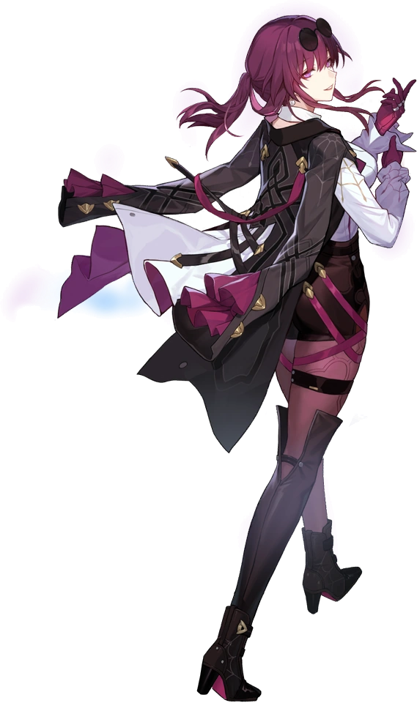
“Hmm… Is something different? I suppose that couldn’t be the case, could it?” While Kafka had seemed so aware throughout her transformation, she now seemingly couldn’t recall any of it. She didn’t recognize that anything was even wrong in the end. Perhaps there was some underlying doubt about the nature of her very existence in the moment, mind you, but that doubt was overshadowed by her unyielding faith in destiny and the future that Elio had spelled out for her.

Her future as a Stellaron Hunter and the wish that could only be granted by following his orders.

Still, the woman made a greater than usual effort to stretch her limbs. “Why does everything feel so tight? You’d think I’d been inside for years while hardly moving a muscle.” Kafka legitimately didn’t understand how on the money she had been with that comment. Once she felt limber enough, she turned back to the door of the spaceship that led out into the personal chambers. “I wonder if she’s up. We have a job to do soon.”

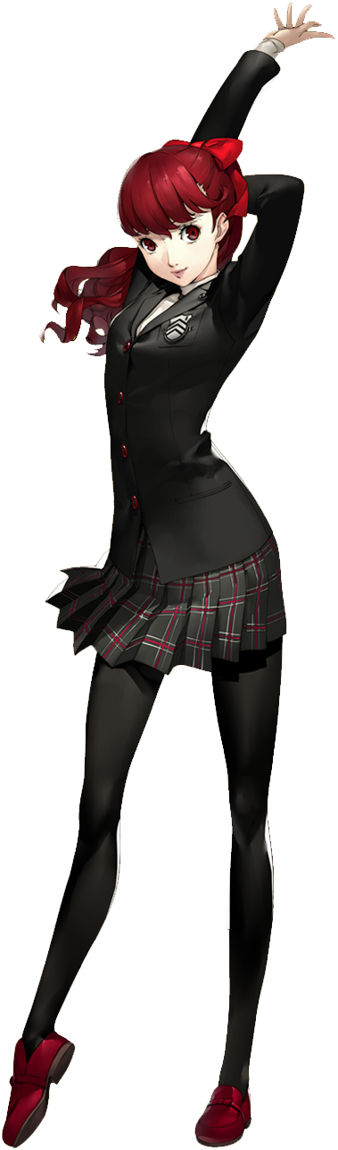
Rather than the excitement Futaba had felt, Sumire was overwhelmed with dread after she found herself in entirely different surroundings. Surroundings that seemed as if they had come directly out of a sci-fi movie. “My phone isn’t here? So is this the Metaverse or not?” Was Futaba here as well? They had been in the same room when they had been flashbanged… but from her perspective it had seemed like the light’s source had been Futaba’s phone.

The very moment Sumire had internally expressed that desire to help her out.

She hadn’t drawn the line between those two things though. Instead? The teen wasn’t sure how to proceed. She was in a very cramped and messy cabin? There was a lot of futuristic technology scattered about, but also a lot of snacks and worn clothing. This might not have been too surprising all on its own, but the view through a small window nearby? It revealed a starry sky and a space station. “Doesn’t this feel a lot like the game she was playing…?”

Not that Sumire had enough knowledge to answer her own question. She was always so busy with dance practice and her studies that she didn’t have a lot of time to play video games. But in that moment? Man, how EZ would it be to make time to play right now? It almost felt like she had a craving. One that could be satisfied because there were a number of controllers strewn about her room.

She shook her head. “H-Huh? That was rather strange as hell!” She was so shocked that her dainty hands were quick to cover her mouth. The girl had meant to say that first part but not what she had uttered at the end! Where had that even come from!? It had been much too casual considering the uptight way she tended to speak. Sumire did withdraw her hands a moment later, but in doing so she noticed something else. “…Huh? My nails?”

The teen always kept her fingernails an inch past her fingertips but they looked… frayed? She’d had a habit of chewing them when she was a child and they appeared very similar to back in those days. But there was also a dark blue paint spread across them, obviously chipped from the damage that had affected them. “That’s not right… but it’s a real pain to keep ‘em clean.” Thinking to how she typed on a keyboard so quickly, or how intense her gaming sessions could be, she—

“What are these memories!?”

They weren’t hers! Even insisting that prompted a shadow of doubt deep down though. Could she really be… a gamer? Sumire shook her head as if to say, ‘perish the thought’, and yet the weight and sway of her ponytail felt a touch off. The reason for that was very visibly obvious: the loose hair behind the ribbon was longer even though it didn’t look that way. The whole ponytail had spiraled into a drill shape. A blue drill, for its length had lost its red. Not even the crimson directly atop her head was spared, for it had lightened to a silver with bangs fluffier and criss-crossing each other.

Sumire looked around the small cabin. The most time she spent inside the more familiar it seemed. Although even the eyes she observed it through eventually differed, with brownish red irises dyed silver and lashes thinner. The shapes of these eyes rounded, no longer easily identifiable as the eyes of a Japanese teen – and that spread into the rest of her face with thinned lips, a smaller nose, and significantly narrowed cheeks.

“These memories… Well, seems like I’ve been living a pretty good life?” Now that she had managed to piece some of them together she was becoming quite fond of this new self of hers. Living however she wanted, no dead twin sister, free time to do whatever she wanted? Plus there were new skills associated with this knowledge. She wasn’t especially computer savvy before but now she could hack something extremely complicated very easily. Plus gaming? Wasn’t gaming the best? She knew she was really good at that too.

The girl felt more accepting of her fate, so she didn’t react much as her height dropped a couple of inches so that her uniform was loose. The bra she was wearing felt even more so because her breasts had diminished down to A-cups, yet traversing below her tummy found that nothing else would shrink but instead grow.

A quiet groan of discomfort was made with this newer, higher voice of hers with her ire directed down to the area in question. Her black tights and underwear felt like they were riding up her butt which was, in fact, true. Her cheeks had almost doubled in size, and that pushed her hips wider in kind. Tights slid down in slight only to get caught around her rear, with the excess material left by her shorter stature soon getting hitched around thighs that doubled in their girth. She was very plush beneath the belt, something that her new personality was well aware of.

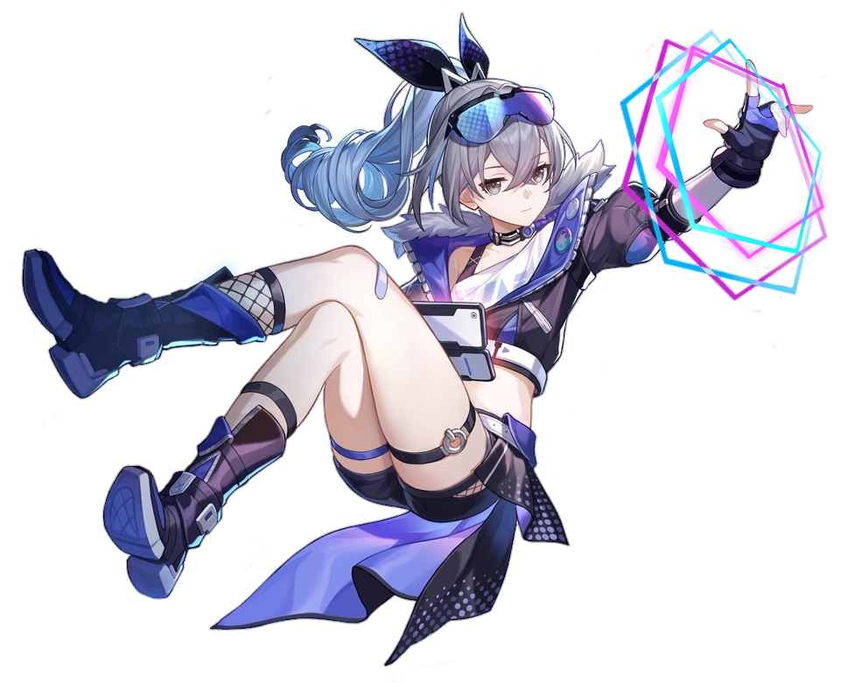
“What? Nothing wrong with a girl with a nice ass. Gamer girls with big butts are in style, right? GG for me.” Or so she said as if to address things, breaking the fourth wall in a way that felt in-character for her personality. The discomfort of her clothes was short lived because as was the case with Kafka her clothing was replaced in a jiffy. A black tank top that was cropped above her belly was beneath a black jacket with an open, blue collar. She had short, leather shorts with her legs fully on display, boots that matches her jacket with fishnet socks reaching up her shins. The girl also had fingerless gloves, leather bands around her thighs that highlighted their thickness, a pair of blue shades, and a black and blue bow to hold her drill ponytail where the red ribbon had once been.

“Oooooh, I get it. So this is just because I wanted her to ‘have a Silver Wolf’, huh?” Which felt like a funny thing for the Silver Wolf to say in a monotone, checking her own body over while wearing a very blank expression. She had the memories of the girl she had become just as Kafka had her own, but there was a difference between the fates of the two girls. Silver Wolf could clearly remember being Sumire still. This should probably have invoked some sort of concern or desire to address it at least, but ultimately? She just shrugged at the thought. “Who cares?”

She knew Kafka was Futaba too, but did it matter? She ‘had a Silver Wolf’ like this. That was what she had wanted, right?

The way she saw it this was a way cooler life. Plus she could play games all she wanted when she wasn’t doing Stellaron Hunter things. She could appreciate Futaba’s love for them as well as her love for hacking – she excelled in both of these areas now after all! “How much time do we have before the next mission?” She peered at a holographic clock on the wall and allowed herself to collapse in her bed with little energy before grabbing a game controller.

“Enough time.” A holographic screen appeared on the far wall the moment she made contact with the controller. It looked like she was going into her St*am account to play a very, very old game? “I have some time to do a new Persona 5 Royal run. Might be fun to do with this… new context I have.”

