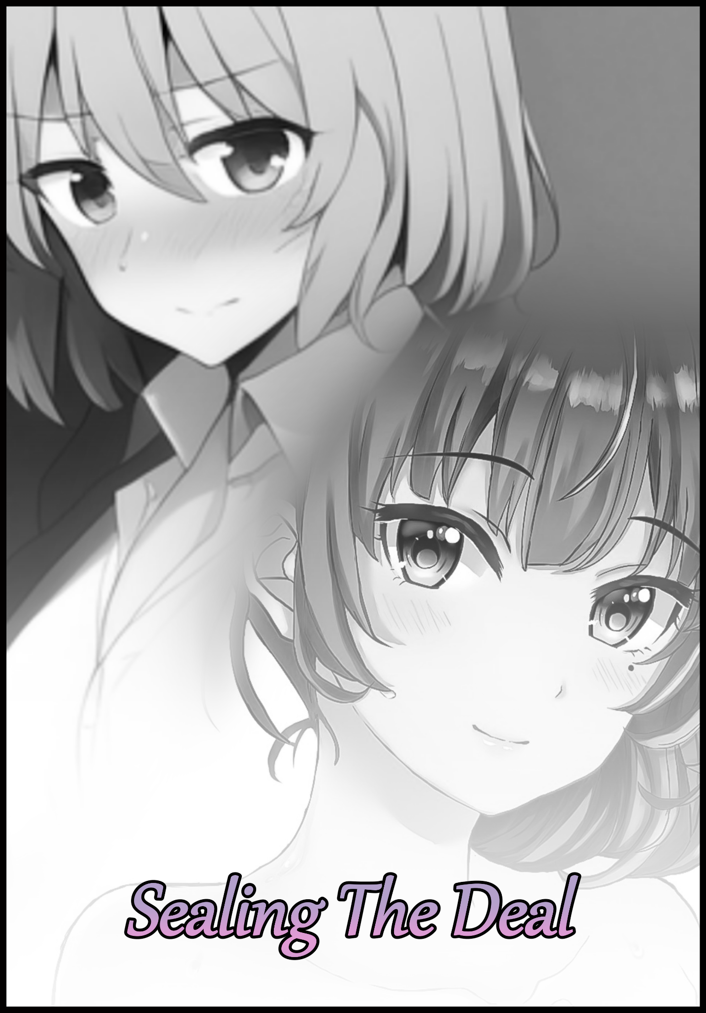

A couple of years had gone by since fledgling couple James and Sarah had been subject to a strange, inexplicable phenomenon that had left their relationship stronger than ever before by the time of it’s closure, with a particularly lasting effect on the former in particular. A brief event that had barely lasted for more than a day before coming to an abrupt end unbeknownst to either of them, not when blissful slumber had claimed their awareness of it. Leaving everything as they remembered it to be the next time they opened their eyes.

Before then, their status as husband and wife seemed to matter little, not when James, the self-anointed bread earner of the family, had begun aggressively pursuing his career in an effort to keep them cozy and fed far into the future. But in so doing, had begun to neglect the very reason he was pursuing such a course of action in the first place. Spending less and less time with Sarah and more on ensuring his colleagues and bosses were tended to, doing more for a sterile workplace than he had ever done his own home and wife…and even though she understood his drive, silent frustration stemming from harbored feelings of being abandoned and left to the sidelines would eat away at her pained heart. Doing whatever she could, whenever she could, to keep their flame alight.

Even then, her efforts to keep their romance going would be hampered by James’ work-addled mind, only ever able to think about when to schedule the next board meeting or whatever other matters were plaguing the business while he was supposed to be spending time off with his wife. Resulting in stagnant dates or even minor scuffles here and there, either between themselves or random members of the public unfortunate enough to catch James’ ire. And with a temper fueled by the weighty coals of stress, the number of interruptions to Sarah’s attempts had been innumerable. Leaving her at wits end about what to do, helpless to avert what she feared her husband would do to himself more than her if he were to ever take up hooch and lose all sense of reason…

So when that little incident of theirs had occurred, it was like a dream come true. A resolution that appeared to rewound the tattered ends on both sides of the strained thread keeping James and Sarah together. Leaving the latter satisfied and hopeful for the future they would have together now that her husband seemed to see reason shortly after awakening to a morning sun that had never felt better.

But while Sarah had moved on without a second thought, James was stuck. Anchored by lingering feelings whose roots could be traced back to that unbelievable evening and the raunchy events that filled the tail end of it. All because of how surreal and impossible the whole experience was; of living a fraction of a day as a member of the opposite sex. One that had understandably left an indelible mark on James’ psyche. Not in a serious enough capacity, but rather, a longing to go back and experience it all over again. An urge he had been close to letting go off until the next time his temper would inadvertently flare after assuming it to be a one-time thing that would never happen again. An assumption that would soon be proven wrong after a few months had come to pass since then.

True, he hadn’t taken what had been made known to him on that night for granted. But not even the most understanding of men were free from the temptation to give in to anger and let loose with an angry muttering or a slam of the fist against whatever solid surface was open for abuse. And after many years spent slaving away as a corporate slave whose drive for a promotion was being taken advantage of, James would find these old habits incredibly hard to shake off. Giving in to anger after being told he was ‘the only man for the job’. A kinder way of saying he’d been forced to fill in for a colleague’s absence with no prior warning alongside the not-so subtle tip of a knife jabbing against his sides after his efforts to please the company had slowed dramatically with the realization he had much more important matters to tend to, like his beloved…and when the idea of seeing Sarah’s mood go down if he were to tell her he couldn’t make it for their weekend date while the colleague he was filling in for got to walk away scott-free to enjoy their own plans, the frustration from such injustice had been too much to contain. Leading James to vent in the toilet where his wife wouldn’t be able to hear.

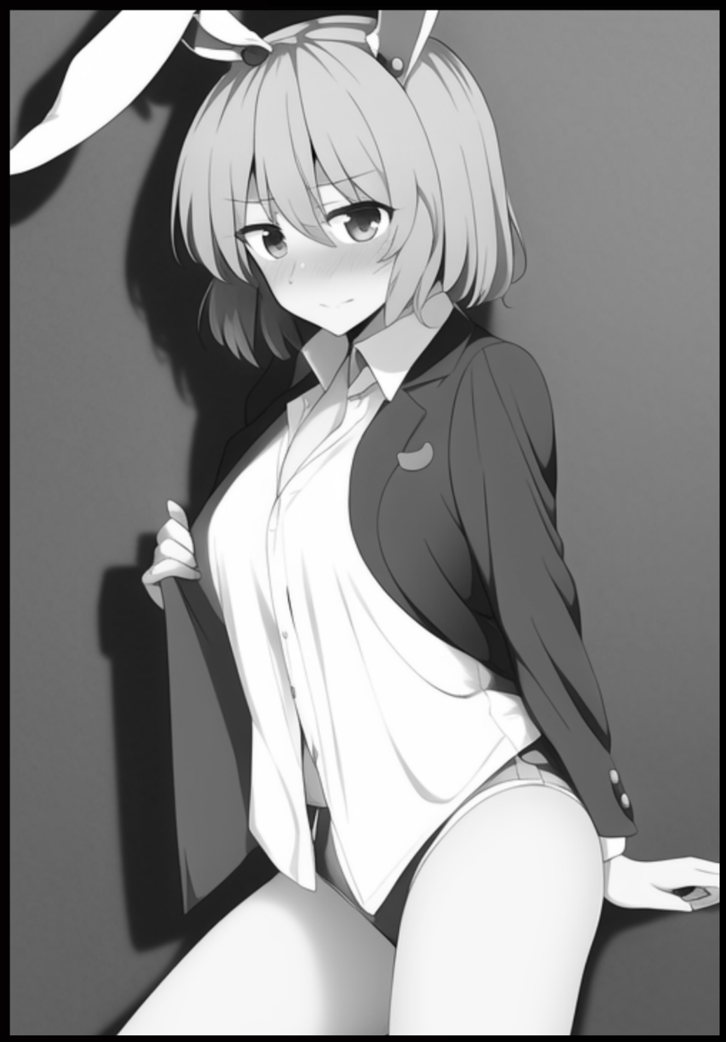
And the moment his anger had been expressed both visibly and audibly, the same tingling wave of energy that had washed over him in the Chinese restaurant that night returns. Manifesting as the same gust of wind that wasted no time in changing the surprised man caught in its epicenter, leaving the clothes untouched while intangible hands worked on the flesh beneath. Doing away with lean muscle and salaryman’s flab, scouring coarse skin with a firm sweep that strips it of curly strands and discolored splotches working in tandem with a subtle softening of pale hide to bestow James with the luscious coat of skin Sarah’s hands had come to know very well. Blushing from how sensual the experience felt as pecs bloated into breasts while the region between perfectly sculpted thighs grew nice and tight…

By the time baggy pants had fallen away down the length of perfectly sculpted legs lined with perfect heft into a crumpled heap by boots that no longer fit, the James’ transformation into his female self had been complete. Leaving Jenny (a name affectionately coined by Sarah) alone and confused in the men’s toilet, looking at herself with dumbfounded eyes before turning her attention to the immediate surroundings, panic written clearly over a shifty posture and the spastic twitching of a fully functional set of rabbit’s ears sticking out tall over her head in place of the human ones that had temporarily made their exit from existence, matching up nicely with the adorable little fluffball that had since pushed free out the back of Jenny’s form-fitting underwear. Lagomorphic oddities that would make the purple haired bunny girl stick right out like a sore thumb. Gaping at her reflection in the mirror while a flabbergasted mind struggles to think of what she’d done wrong to garner the return of whatever unseen force had changed her in the distant past.

Thankfully for her however, she had been in the safety of her home. Struggling to find it in herself to walk out the closed door and show herself to a pleasantly surprised Sarah when her usual straightforward self had been temporarily replaced with Jenny's soft spoken cowardice. An detriment that seemed to work off of her base as its complete opposite, quelling the anger that had given rise to her transformation in the first place by ensuring she would neither have the will or capability to carry on harboring such animosity. Not when her very being had been stripped of all its strength alongside the confidence to make her opinions known…which also made her an incredibly easy target for Sarah to play around with.

Being a stickler for the adorable, it had taken Sarah all her will to prevent from glomping Jenny the first time she had laid eyes on her back in that restaurant and the short car ride home following the discovery of her husband’s sudden metamorphosis from grumpy man to demure bunny girl. And now, after quite a stretch of time since then, the excitement of seeing her rabbit eared 'wife' reveal herself from down the hallway again had been enough to break the metaphorical dam that was Sarah's self-control, snatching the feminized man with ease now that her strength had been temporarily locked away. Allowing not a single chance for Jenny to slip in a word of protest or explanation for her circumstances as an eager Sarah ferries her straight to the bedroom, whereupon she would find a brief moment to quell her insatiable wife's thirst for her female self with a half-stuttered reminder of more important things to take care of, like her inexplicable transformation after all this time. Only to be greeted with a smile and a dismissive statement... "C'mon~ We have all the time in the world to look into that don't we? Now be a good girl and let me do my thing, I never thought I'd see you like this again Jenny!"

Forced to acquiesce to her wife's demands now that she was in the submissive end of the stick, it would take a couple more hours till Jenny was finally able to have a proper discussion with Susan in regards to her situation…after being subject to those dexterous hands of hers, unfazed by the body of man or woman as they ran the length of her half clothed figure with careful precision, knowing just where to press, pull and pinch to get the best reactions out of her just like she did back when their quiet love life hadn't always been this 'exciting'. But as much as it shamed her to say it, there truly was nothing else like experiencing the mind melting bliss of a woman’s climax months after going without. Forget the lack of a rod to jerk when the entire process looked and felt so different. No radiating warmth building up somewhere deep inside of a cramping groin as testicles readied themselves to fire off a load, no strain from a non-existent phallus stiffening to full mast. Just a subtle twitch and a spasm from tender vulva and the moistened folds they guarded before a urethral opening beneath a tingling clitoris taken care of by a gentle thumb funnels a liberal squirt of transparent juices, shot out in an arching spray by powerful pelvic muscles working hand-in-hand with vaginal tissue squeezing tight around Sarah’s fingers as they apply pressure against her inner walls to fuel her partner’s orgasm. Pressing hard enough for Jenny to feel the faint tickle of manicured nails digging in somewhere beneath her cushy tummy…an instantaneous series of events accompanied by a gratuitous showing of her own generous bosom as they bounce madly to the tune of Jenny’s spasming figure, crying out just like she had done not too long ago. Reminded of how different she had become despite more or less retaining her original sense of self, basking in the afterglow of it all with her head on her wife’s lap and a hand running through her silken bob cut. Staring down at her with a beaming expression that bore no signs of the lethargy she had displayed upon coming home from work a few hours ago.

“Nice to see you’ve still got that singing voice of yours Jenny~ Now then…I think now’s a good time we move on to more pressing matters, hm?”

Explaining it all from start to finish with Sarah listening intently despite treating her like a little sister to be doted on, it didn’t take long for the wizened woman to piece things together after hearing about the events leading up to Jenny’s surprise ‘visit’. Smiling softly after being told she had been conflicted about even going into work that day despite the mandatory order, a definitive showing that things had indeed changed between them and that the words her husband had said to her following the renewal in their relationship hadn’t just been empty promises spoken for the sake of appeasing her. “Hmhm~ How sweet of you dear…but you said you were feeling angry right? Isn’t that what happened last time too? Is your temper really that bad?” With nothing else to go off of besides James’ anger being the trigger behind Jenny’s emergence, the two would pass the rest of the evening showering off the traces of their lascivious tussle in the sheets, easily fitting into the confines of the cubicle thanks to Jenny’s reduced stature in comparison to James’ bulk…giving her a whole new level of insight then as to how girlfriends functioned when left to their own devices if Sarah was a good enough representative; sneaking in playful jostles and snide remarks while she helped her wash her hair while marveling at her more fantastical features and how they connected to her body, finding new spots to play with in the process if she ever got the chance to. And once the two were done and ready for bed in a new change of clothes, the night would pass relatively fast after the initial adrenaline rush had passed them by. Giving way for the stresses of work and the rigors of lovemaking to take the couple on a swift path to relaxing rest. Awakening to a weekend morning with James restored to his former self at the crack of dawn. Left with nothing more than the memories of the previous night and the faint sensations of his feminine self as proof of the events that had transpired.

And sure enough, that would not be the last time Jenny the demure bunny would show herself. ‘Appearing’ whenever James’ temper would flare up, followed shortly after by a sensual transformation into his fairer, soft spoken self. Almost like a mimicry of a certain green-skinned comic book superhero…except instead of turning into a nigh invulnerable tank on two legs, Jenny was nothing short of being a downgrade in every single factor. A slender build with just the right amount of curves not to look skeletal and a personality softer than cotton. Hardly what one would consider hero material.

But the most concerning of these relapse events were the increasingly shortening spans of time between them. From a few months to only a few weeks, James was starting to develop an attraction to his opposite; a desire to live more as Jenny and less like himself. But with his pre-existing status in the world as a man and the lagomorphic attributes his other self bore, ‘living’ it in the open was out of the question. Restricting them to moments of privacy or whenever he was at home before subverting his place in the world for Jenny to walk about for the rest of the day. And with all the material he had in mind, it wasn’t too hard to call upon the spiteful material needed to get himself riled up and ready to morph into his quiet, girly self. Something Sarah would soon pick up on after the initial welcome of Jenny’s repeat appearances had given way to skepticism and concern after a myriad trysts and encounters with her husband’s soft side in the years that followed. Noting how his ‘usual’ self was starting to be affected by Jenny’s mannerisms and traits, almost as if fragments of the latter were bleeding over little by little with each sequential transformation; a pollen addicted bee, quite literally consumed by its desires…

It wasn’t as if she disliked one or the other. James was Jenny and vice versa, whether or not they had a stiff sausage or an easily lubricated snatch, a brash face or a quiet one. It didn’t change the fact that behind it all was the person she had fallen in love with. Instead, what really had her attention was the reasoning behind it all; why James was suddenly so gung-ho with ‘letting loose’ like this, even if he played it off everytime she asked as the stress from work eating away at him. It didn’t make sense when everything had been going fine so far, the two of them were spending good time together and his workplace’s ironclad grip on his life had been weathered into a weak grasp. What was there to be mad about? If anything, he should’ve been having the time of his life right about now… ‘He can't actually be starting to like this would he? Would James really do this all on purpose?’ It frustrated her a smidge when the matter at hand she had no proper understanding of was one that could bring potential harm to her husband if left unchecked.

With suspicions stirring and assumptions taking root, Sarah’s reaction to her husband’s eventual confession to his growing would be rather mild to say the least when pre-existing notions and a greater understanding of their situation were there to help ease her in to the knowledge that James had found himself desiring to live the rest of his life as a bona fide female with nothing to hide…but Sarah’s consent was the least of their problems, because even if she said yes…the current limitations were just too erratic, uncontrollable and most definitely not suitable for a normal life by any definition; a limited time per day to be Jenny…a seemingly spastic ‘cooldown’ period of sorts…and then there were the rabbit ears and tail, she’d draw eyes wherever she went, and if anyone were to figure out those weren’t just accessories, the unwanted attention that would cause was unthinkable, with repercussions extending to Sarah as well. Something that left James conflicted on what to do despite his new wants.

Fortunately for the troubled man, his wife hadn’t been twiddling her thumbs about the whole situation. Because with a little bit of poking around memory lane, she had been able to ascertain a certain link to James’ ‘anger management’ problems; the Chinese restaurant they’d visited on a troubled dinner date gone right; the place where Jenny had first come to be…

“Y’know dear? Now that I think of it…we’ve never gone back there since then…maybe they would know a thing or two about this whole situation? Hmm…and you might even be able to apologize for saying those nasty things~”

With no other solution in mind, the couple would prepare for a swift return to the place where it all began. Expecting to find great difficulty in convincing the staff and management that they had something important to discuss with them involving matters with a gender changing curse of sorts, only to be met at the counter with a knowing look from the server who seemed to pick up on what James and Sarah were talking about the moment their conversation entered into the part where the awkward man mentioned berating a helpless waitress despite it being her first time working there. And once she had managed to get another of her colleagues to bring them in, the two would soon be ushered up into the second floor where the very same wizened elder who had apologized on her employee’s behalf in the not so distant past resided, showing no signs of animosity about her demeanor as she welcomed them into her office. Beady eyes lingering over James in particular as the two seat themselves before her with bated breath and nervous tension in stiffened shoulders, uncertain of what to expect but with renewed hope building in their hearts that they had found a reliable hand to guide them along James’ unique case. Spilling the beans after a shaky introduction and a moment of hesitation from the hesitant man before he was ready to make known his greatest desire yet; "I know I didn't make a good impression the last time I was here, and I don't know if it's why you let us in to see you but…please, if there is a way, could you…make this curse last forever?” A hearty laugh would be had from their host upon hearing of James’ request, settling back down with a short and simple introduction that told the couple all they would need to know about her before getting down to the reason for her visitor's presence in her office that evening. Doing more than just unveiling the secrets behind the mysterious force that had taken hold of James’ life so strongly. Telling of an old tale that spoke of the magic’s ties and the significance it had to the establishment’s history, of a power that would latch on to those who did wrong in its presence, intent on punishing them for their misdeeds.

The punishments, according to the lady, seemed to vary across a wide stretch of accounts that could very well have been poppycock spun from hysteria and a need for a good old laugh amongst old patrons who had one too many drinks. But a singular thread they all shared was the constant inclusion of the rabbit, a similarity exhibited in Jenny’s appearance. But the specifics paled in comparison to what the wizened elder had to say to the awestruck couple listening intently to her tale regarding their inquiry about making the effects of the curse permanent without the detrimental side effects of said curse lingering to bother them moving forward;

“You desire to make what should be punishment irrevocable without the parts that make it so…a funny request you have there young man…but be warned, such a request will require an equal level of payment so to speak, and I'm afraid it won't be you who'll be paying the divines what's owed to them in exchange for granting your wish…I must admit, I've never seen the likes of you before. Most want nothing more than to rid themselves of what they can only see as a malediction. But to ask it be made permanent? You're most definitely a first in that regard…why do I help, you ask? Because I see that look on your face; of one who sees the error in their ways. Did you know? The nice lady who brought you in from the reception, the very same woman you let loose on when you first came through those doors. She’s not the type to harbor animosity, but even the slightest of apologies would do dividends don’t you agree? Whatever the two of you decide next, I can only hope brings you the happiness you desire…"

Shortly after their meeting, the pair would quickly leave for the destination indicated on the slip of paper passed to them by the restaurant manager before their departure, but not before doing a quick stop at the counter to utter a swift but sincere apology to the receptionist who had evidently done well for herself. Cementing a modicum of mutual understanding and resolution before they had to go lest they hog the queue any longer, waving the kind woman goodbye before getting into the cab they had booked beforehand. A ride that would mostly go by in uneventful silence, interrupted on occasion by uncertain glances shared between James and Surah but with not a single word exchanged. Lasting all the way up till their arrival at a secluded hot springs resort quite a distance away from the hustle and bustle of the city's heart they lived in that seemed to be close for the night, a fact the lone attendant manning the front door looked about ready to enforce before catching sight of the slip they had been told to hand to whoever might be there to obstruct passage. Allowing entry to the couple as the lone man leads them down a streamlined series of corridors leading to an unexpected portion of the building they'd never thought to see or partake in tonight as it all rushes back to them in the here and now; standing silently before two shuttered doors leading into the two changing rooms for men and women. Except the two were standing on opposite sides meant for the other with furrowed brows, concern written clearly on the faces of both husband and wife as they took a moment to gather themselves before proceeding with whatever it was they were there to do.

“We don’t have to do this, you know? What she said…it’s seriously asking too much from you don’t you think? We could-”

“I said we're going to go through with this and that’s final. I told you didn’t I? You aren’t alone in anything you do dear…and besides, we’ve been led this far on a good lead I doubt we’ll find anywhere else…and you can’t get to be the only one to have all the fun~ It’s not as if me doing the same will be any different!”

Sighing as he turns to face his wife, James crosses the short distance between them to hold her in his arms, knowing full well it’d be the last time he would ever be able to do so in such a manner; looking down at her from his towering height with a tender look to reciprocate Sarah’s loving gaze, savoring the moment encased in a tender warmth borne from their bodies pressed softly together in marital union. Sure, this sensation wouldn’t strictly be lost to them, but the dynamic would soon be irrevocably changed and flipped onto its head once they went through those doors. An outcome he’d never thought to reach in the first place…and yet, here they were; standing at a metaphorical crossroad that would see their lives changed…for good or bad, James couldn’t say. But a simple step back, and he knew things would most likely turn out well in the end. For how couldn’t they? He’d been blessed with a great companion who did her damndest to see their relationship remain just as strong as it was back when love’s first threads were sown between them, and a part of him couldn’t help but imagine what the two of them would look like once they had hopped the fence…without a ladder of any sort to make a return trip as they share one last kiss before splitting off and heading down into their respective changing rooms. Opening the doors to unveil chambers shrouded in obfuscating mist, moving with a life of its own but never extending past the boundaries of the room despite the doors being opened. A daunting sight that takes only a few seconds for either party to overcome as the pair take one harmonious step before vanishing into the clouds. Allowing for the doors to slide shut behind them once their passage was all but confirmed.
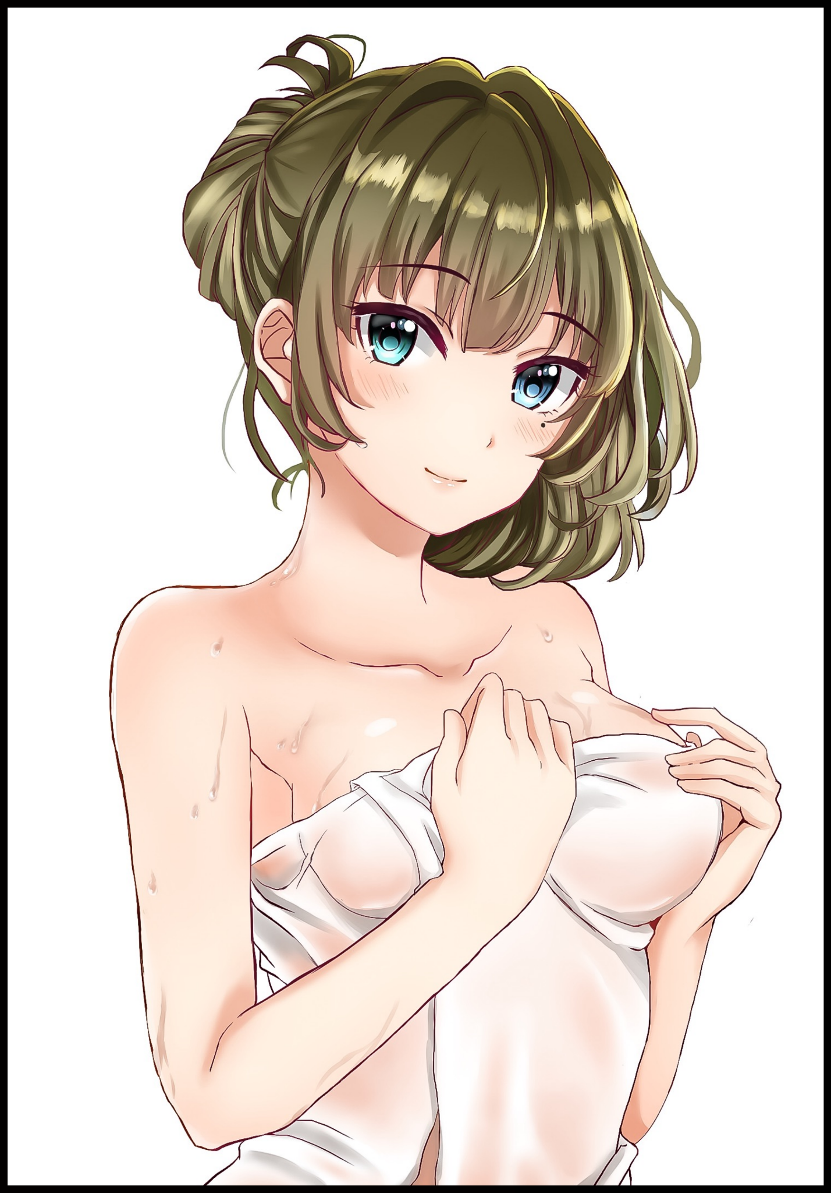
And in the same moment those sliding wooden shutters locked tight, both James and Susan would be set upon by an unseen force working its influence through the mist itself. Relieving the couple of clothes that melts away, dissipating in fine mist that leaves the two in the nude, naked as the day they were born with a passing sense of trepidation in uncertain hearts once the two of them begin to change, seeing a drastic loss in height for James while Susan’s modest stature shoots up and away. All while the hardened tone of freshly grown muscle begins to press up against hide that had all but lost it’s womanly texture in a trade that sees James’ coarse skin taking on a sensual, glistening hue as his own manliness recedes at a rapid pace, just like he’d seen many times now whenever Jenny came out to play…

But for Sarah, all this was most definitely a new experience for the startled woman. Imbuing a smidge of loss in her racing heart at the sight of her bosom receding back into a chest that been stretched and solidified to fit the rest of a gaunt figure that had lost almost all of it’s sensual curvature with only the faintest shadow of it remaining in bony hips framing a toned core lined with the imprints of impossibly thick abdominals in an apparent display of equivalent exchange; swapping out a matronly tummy ripe for a head to rest upon for the serious gains of an athletic bodybuilder that looked like it had taken months of hard work at the local gym to procure in stark contrast to James’ gaining belly as a result of pursuing his career so hard back when their relationship had been on the brink of collapse. Softening and spreading said flab until it looked like the belly of an up and coming gravure model. Stamped down the center with a cute little belly button. Hurried little breaths coaxing tits of her own to balloon and jiggle to life where Sarah’s had faded. Tingling in the humid air as the inevitable arousal gleaned from the morphing of the flesh sets in, causing vibrant nipples to swell to hardened erection while a secondary signal arrives to late down under, only managing to make Jenny’s newly shrouded clit twitch as a dribble of cum oozes out of her urethra before trailing down the length of glistening thighs that were neither too plump or firm, bouncing with the slightest of steps with waifish feet tipped with dainty little toes worthy to don a princess’ bejeweled heels.
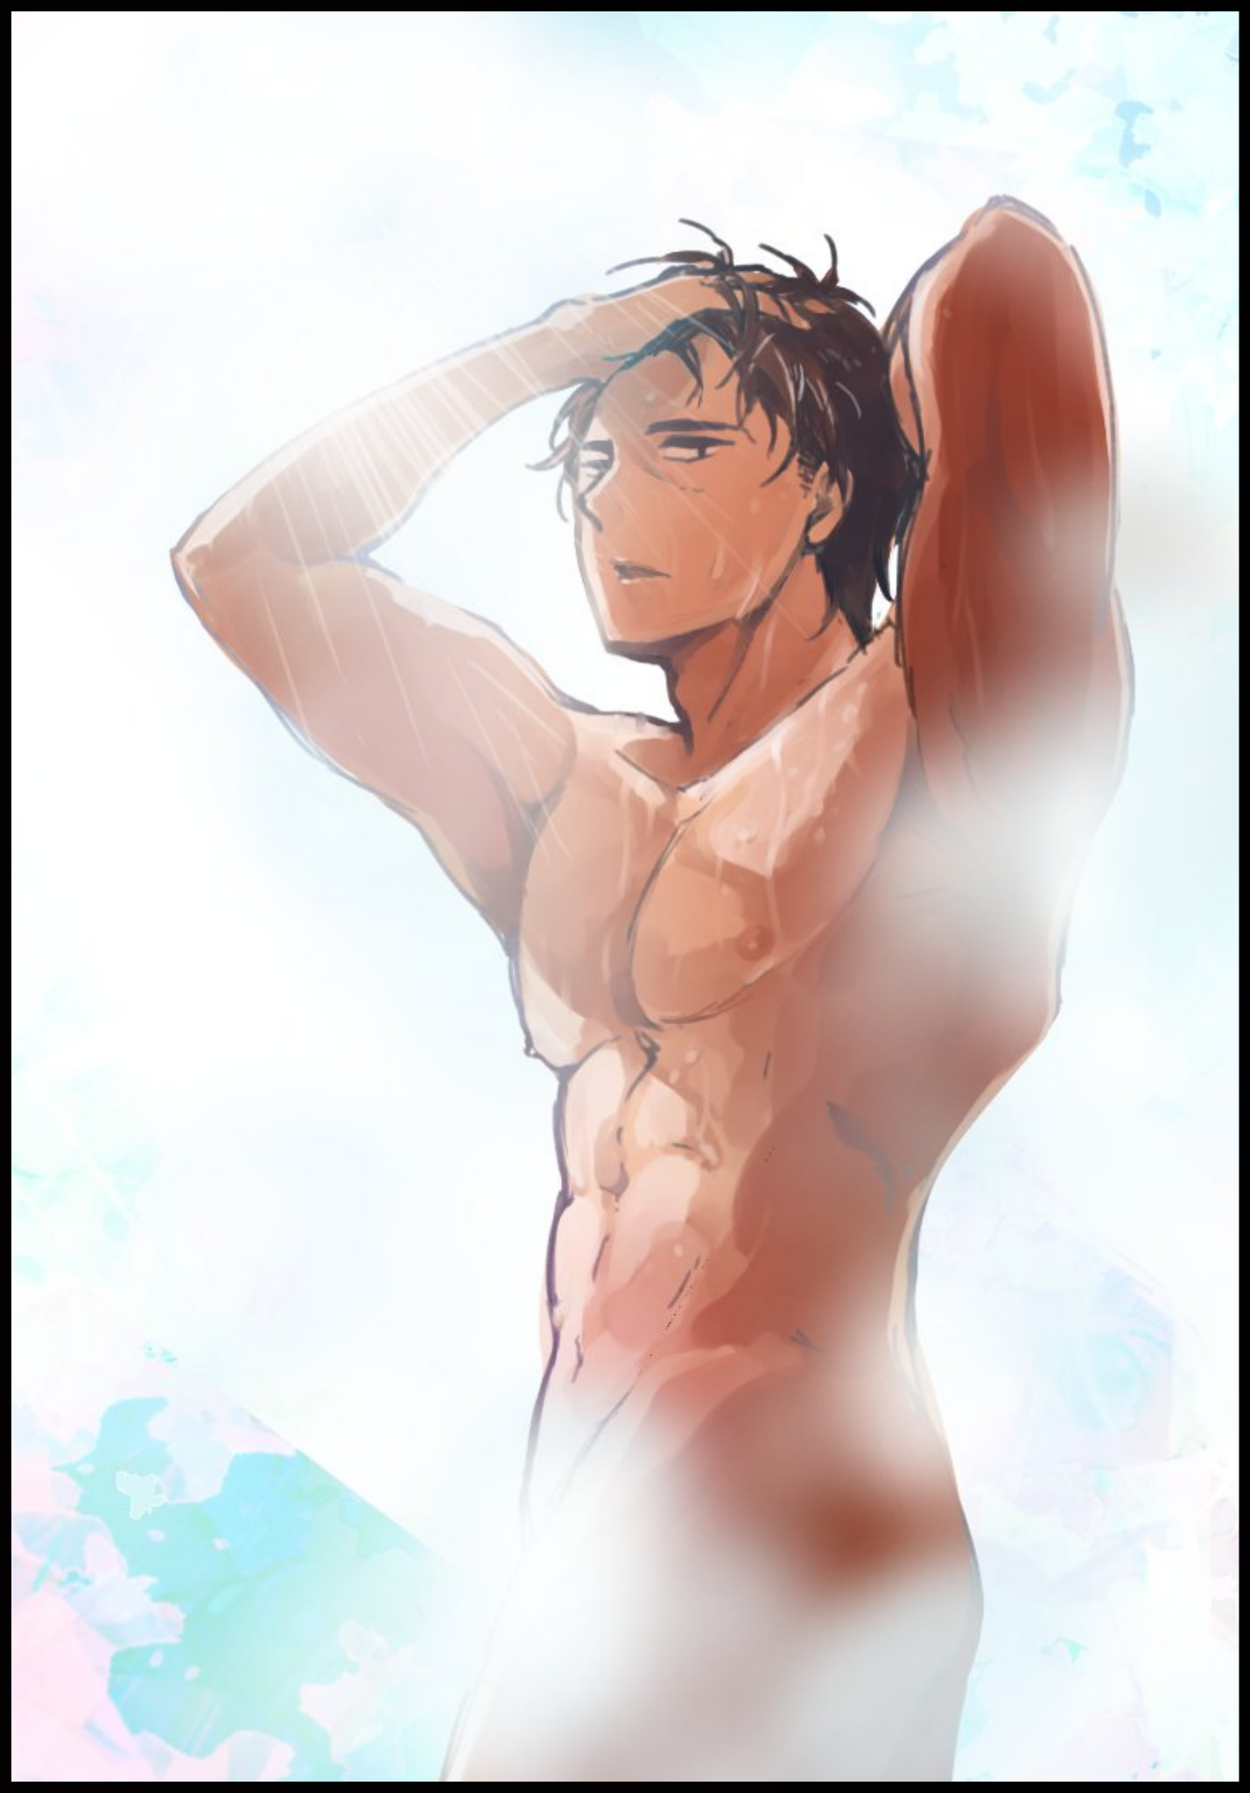
Sarah on the other hand, would find himself being forced to take a seat on the benches lining the walls when his voluminous butt had compacted in on itself alongside a shrinkage of hair, leaving a blocky behind while the front begins to burn with the coals of arousal fueled by the emergence of androgens in a body that could no longer be classified as ‘feminine’ in any shape or form, especially after the gash between burly pillars had receded after an especially large and veiny phallus had wormed it’s way out, flopping down to tickle the inner portions of sturdy thighs as all remnants of a woman’s vulva finishes taking their newly ordained positions as wrinkled sacs, housing shifted ovaries that were now in charge of producing the piping hot batter his former husband had permanently lost the ability to produce in turn, oblivious to Jenny’s sensual gasps and adorable cries while a deep baritone forms heavy gasps and grunts that conveyed Sarah’s newfound handsomeness without a need for anyone to lay eyes upon his chiseled visage. A fitting combination to go with the herculean form he had been blessed with in a similar fashion to Jenny who, while not as well endowed or demure as her former lagomorphic appearance, retained the same, overall flavor. Looking like a natural progression from her male self in comparison to the almost child-like appearance the purple haired Jenny sported as silken threads of shaded green wind themselves into a curly bun secured by a tiny string weaved together out of thin air, just like the faint cloth that shrouds itself over the transformed couple. Finding success as soaked fabric secures itself over Jenny’s generous bosom and bountiful hips while Sarah would remain none the wiser to the towel that had simply slid off her muscular body and onto the floor as he rises to take a look at himself in one of the many full-body mirrors lining the changing room wall, unable to help the crimson blush that paints itself beneath steely eyes at the sight of the absolute package he was rocking in contrast to the delight Jenny felt while doing twirls before her reflection, relishing in how light and free she felt without the burden of awkward embarrassment that kept it all toned down and suppressed. No odd features that would force her to seclude herself from society at risk of being found out…true freedom that feld like a heavy weight had been lifted off her shoulders. Excitedly racing toward the opposite end of the room with haste in her step, eager to show herself to Sarah, who she had temporarily forgotten no longer looked the same as she did before stepping foot into the men’s changing room.

James’ wish had required the fulfillment of another enchantment separate from the one that had already cast its hold over him, a stronger one to overwrite the old so to speak. But the prerequisites of said enchantment were incredibly stringent and demanding to those involved in it’s invocation; that a couple bonded with the strings of true love were to set foot inside the opposing gender’s changing rooms to start a sequence of events that would end in the irrevocable flip of the couple’s dynamic…an old, forgotten urban legend that had come in useful to rid James of his rage-induced affliction while fulfilling his desire to live life from here on out as a full fledged woman, mindful of all it entailed as an impatient Jenny pulls open the closed doors leading to the other side of the hot spring, only to come across a naked stud she couldn’t believe was her wife. Getting a better look at his stunning physique while he ogled hers in return once the magical mist begins to clear up, swallowing a lump of saliva that had gotten stuck in her throat at the sight of majestic muscle and the generous package sticking up right as the horny man, unable to control his urges, shifts in a failed attempt to mask the rousing feeling of want he was getting at the sight of Jenny’s voluptuous figure, dripping wet and wrapped up tight in semi-transparent cloth that only makes the tease that much more effective. Oblivious to the way in which Jenny’s vulva spasms just beneath the hem of her towel, crossing her knees as a steam ridden exhale precedes a maddened kick from her womb, snapping out of her lustful stupor once Sarah clears his throat, speaking in a suave voice to match his imposing presence in the room… “J-Jenny? Is that you?”

“H-Huh? Yeah…it’s me…and you’re…really Sarah huh? What the hell…you’re even more j-jacked than I ever was…”

“Yeah…I guess I am huh? Makes sense since I’m always the one to set things straight around the house yeah? But Sarah wouldn’t fit right…not anymore…how’s Sam sound like to you?”

“It’s a good name…Sam…yeah, it’s nice, short and sweet…but d-dear? Thank you again…for all of this…”

“Don’t mention it Jenny…it wasn’t all too bad honestly. I’m built like a horse…and I don’t feel my shoulders aching anymore…but there’s something I just don’t…get…how do you ‘guys’ like…y’know?”

“Something you don't…ah…”

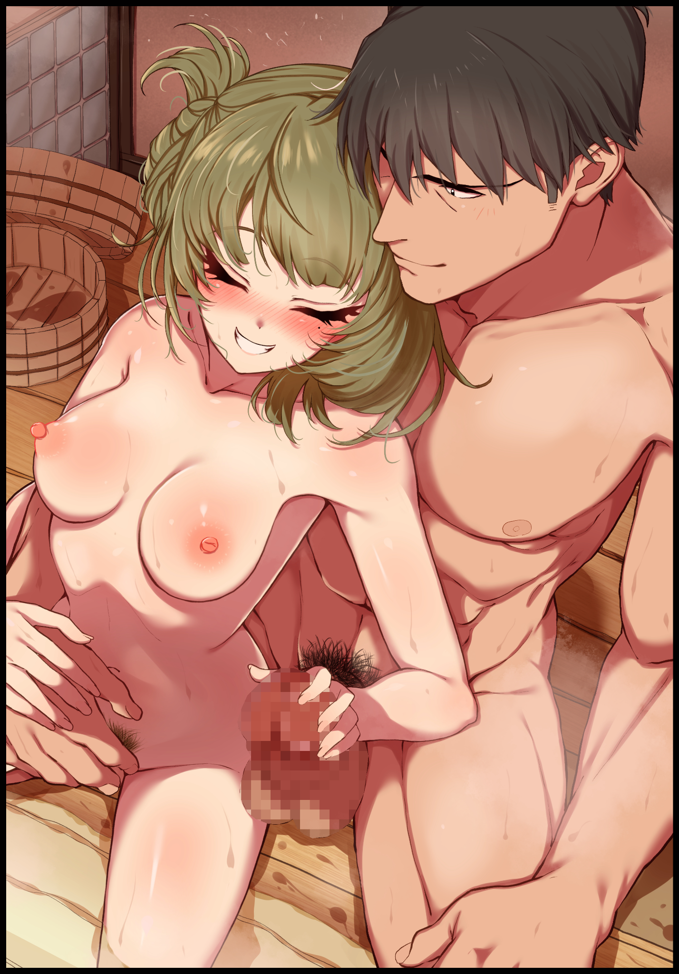
Falling silent after following the newly branded Sam’s awkward gaze down toward the throbbing girth sticking up high like a flag pole, Jenny feels herself overcome by another wave of arousing warmth, making it harder for her to properly process her thoughts as a clenched hand comes to rest upon her bosom, willing herself to take shaky steps forward, bypassing the veiny thing until she stands right next to her husband, leading him toward the nearby benches with a gentle hand over his shoulder until the two were seated side by side, displaying the remarkable difference between them as Jenny cranes her neck upward, diverting her gaze from her man’s painfully erect cock to look Sam in the eye, as if in silent questioning as to whether or not he found this to be an acceptable approach. Getting her answer in the form of a firm hand curling around her waist to caress her tender tummy before going lower, tracing the faint line of silky pubes crowning her vagina as itchy fingers play with moistened folds and hypersensitive nerves, clearly enjoying the way Jenny arches her spine and recoils in euphoric bliss, turning her wavering expression into a sensual look of arousal as pretty lashes close while a hearty giggle escapes soft spoken lips. Jerking her body with enough force to bring a bounce to immaculate breasts while her own hands move to repay the favor, relishing in the sheer size of Sam’s pecker through the sense of touch alone, unable to help herself as she grunts in exertion. Letting loose all over her husband’s fingers with a fresh spurt of pussy juice to coat his hands with while steamy precum tickles her digits in return. Sharing in the moment together despite how sudden and fast this all must’ve been for her dearest Sam, already close to having his first male orgasm despite having spent less than ten minutes in his new body.

“Heh…looks like you’re still an easy squirt even without the bunny ears~”

“Says the man who lets loose with a lil’ tickle from a lady’s fingers~ Admit it, I hit the right spot didn’t I?”

“That’s basically cheating but…so do I technically…should we…y’know?”

“Seal the deal? Why not?” Leaping up from her diminutive perch before Sam could say or do otherwise, Jenny lands a soft kiss straight onto his lips. Landing back onto her cushioned rear with a bounce and a mischievous cackle, adoring the look of surprise on her husband’s face before the hand nestled over groin tightens, bringing some level of seriousness back to the room as he leans closer, taking in the feminine scent wafting off of Jenny’s pristine locks until he was right up close to her face. Close enough to hear her earnest confession in full; “Sam…I love you…”

No words needed to be said in response as the altered couple move in close to cement their respective feelings for one another in this private den of theirs they had full reign over until the next breaking of dawn. Plenty of time to familiarize themselves once their romantic coupling soon becomes a hot and heated tryst in the steamy depths of a sequestered hot spring. Uttering a mental note of thanks to the old manager and everyone else that had made this outcome possible in the first place before their minds became just as devoted as their bodies already were toward the act of gentle procreation between a bonded pair such as themselves…
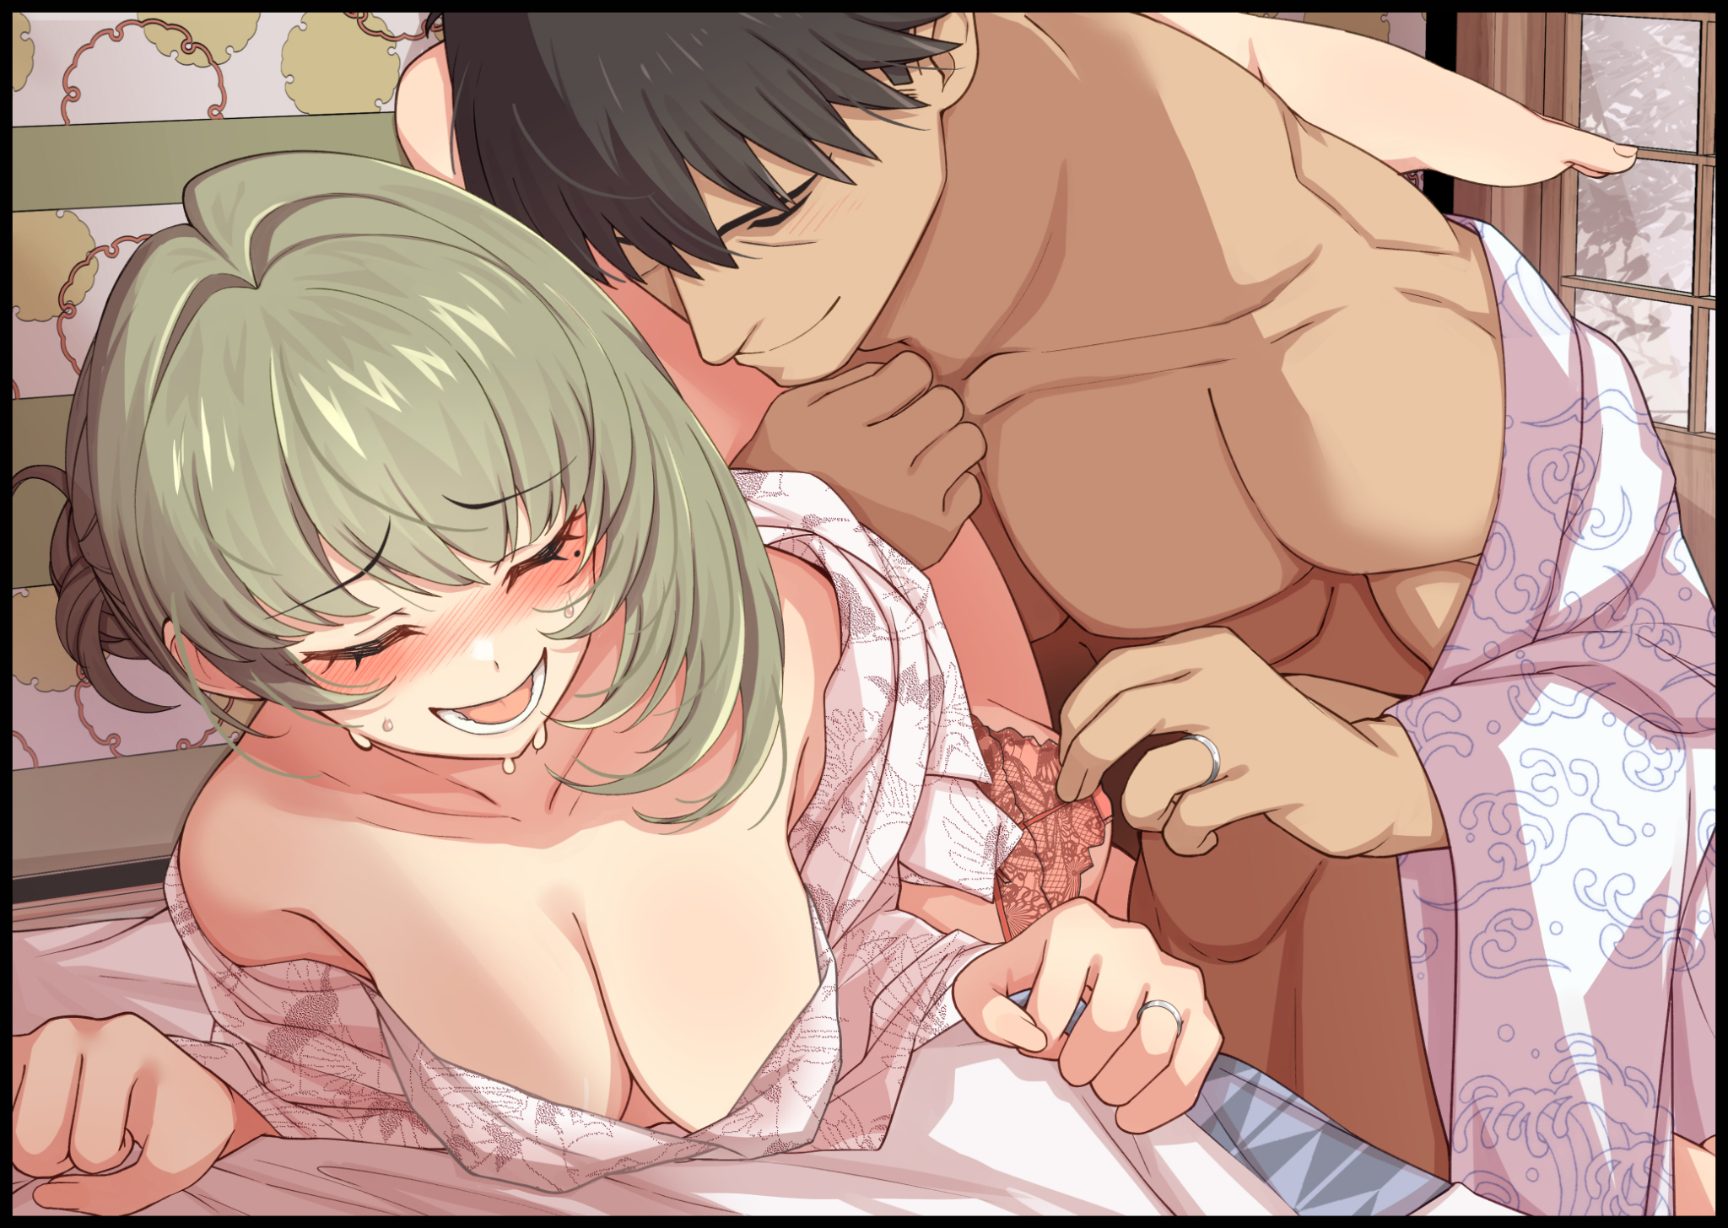
None would ever remember James and Sarah for who they once were thanks to the thorough effects of the enchantment whose magic had long since left their altered forms the moment their adjustments were finished. Leaving them as if they’d always been born into the world as Jenny and Sam respectively once they left the confines of the changing rooms with new garments to clothe themselves with. Gleaming rings representative of their bond slid tight around fourth digits as they made their way towards the more proper confines of the guest rooms provided for their overnight stay to get properly acquainted with each other.

And once all was said and done, neither Jenny nor Sam would ever look back on their lives going forward. Content and all the more eager for what laid ahead down the shared road they would walk hand in hand till the inevitable end did them part…

THE END

Image 1 generated with NovelAI : https://novelai.net/image

Image 2 by Kyoshincats : https://www.pixiv.net/en/users/28383482

Image 3 by Hamu : https://www.pixiv.net/en/users/18756125

Image 4 & 5 by Morino Shoutaro : https://www.pixiv.net/en/users/15144761

