SHUT-IN FUTURE
COMMISSION STORY
BY CHALDEACHANGE
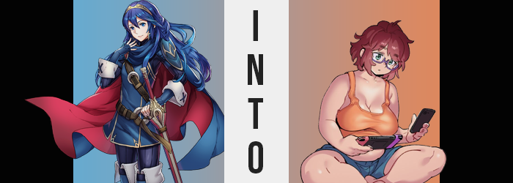

It was a very important day for Lucina of Ylisse.

A whole lifetime of pain and suffering had reached its culmination. The princess had been raised in turmoil and chaos and had lost her family in the process thanks to the efforts of the Fell Dragon, Grima. But she wasn’t even alone in that aspect. There were plenty of kids her age in similar predicaments, with parents who had been killed far too young. There was no hope left for this timeline, and nothing could undo this damage that had already been done.

But that didn’t mean that there wasn’t hope. “If I cannot save this timeline, then…” Well, another possibility had presented itself thanks to the Divine Dragon and the great power of Naga. There was no means through which she could save her timeline, but it wasn’t impossible to create a new one where the tragic events that had befallen her own didn’t come to pass. One where her parents, and the parents of her friends, could all live happily ever after.

And yet there was no guarantee that this plan of hers would work. It involved being sent back in time and making sure that the future did not come to pass herself. Grima had to be stopped before its power became too great. And for that reason, Lucina was glad that she had allies. Close friends that would be traveling to the past with her, all born into similar circumstances. If all went according to plan… if they could prevent those key moment that led to this future, then they could succeed.

To those ends, Lucina went ahead of the others. They needed someone on the ground a little earlier than others so that they could intervene effectively. Lucina had even settled on a disguise so that she wouldn’t draw any attention from her parents in the past. And with the process for traveling to the past enacted…

She began this journey.

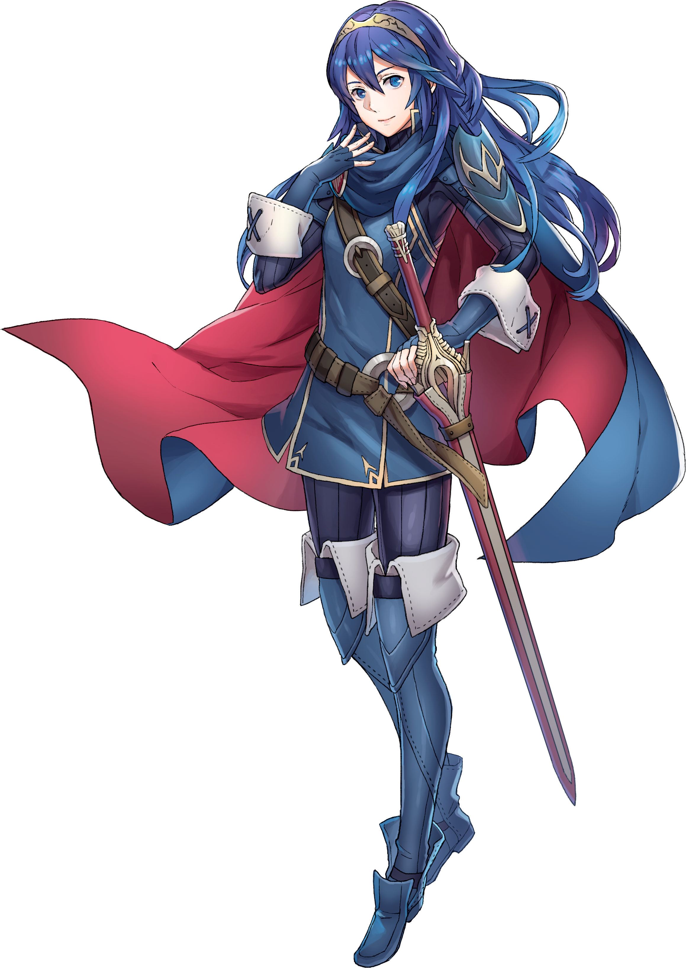
“Erm… Did something go awry with the Divine Dragon’s powers?” The very moment that the Ylissean princess from the future opened her eyes she could easily recognize that her surroundings were incorrect. It was a dimly lit space, and on its head that alone wasn’t really enough for her to conclude that something had gone wrong. What made it clearer was what that dim light revealed. That is to say that nothing it did reveal was familiar.

Even the source of light itself was foreign to Lucina. Rather than radiate from the sun or from a flame like she would typically expect; that light instead glowed from a flat, rectangular surface atop a small table with a chair with wheels on it? “For what reason would something other than a cart or carriage require wheels?” In any case, she couldn’t imagine why a chair would need them?

“This clearly isn’t the past. But then…?” Was it the future? In a sense that was the correct conclusion… sort of. It was a future, but not of her world. The things she was seeing around the room were technological advances made in a world without magic. In our world. Really, the only things she could identify were the bed, dresser, and desk. But these things had far more different designs than she was accustomed to seeing.

She took a step and almost immediately tripped over something on the carpeted floor. “How do they make the floor so soft? Is it entirely covered with a rug?” Rugs did exist in her era, but they could only cover a limited area and were quite costly. Only the well off could afford them, so she couldn’t imagine how much it would cost to affix one to the entire floor of a room. Though on the subject of what she had almost tripped on in the first place?

Lucina knelt down and picked them up curiously and with some sanitary caution, holding them with only two fingers. “Are these… undergarments?” Of course, the world she came from didn’t have anything as fancy as the orange lace that she was holding. She couldn’t imagine wearing something so thin and fancy. Undergarments didn’t hold any aesthetic purpose in the world she hailed from. But they were also quite large. Likely to fit a wider woman than herself.

After holding them for a moment, the princess was beheld by a sudden moment of embarrassment and dropped them back onto the floor where they probably didn’t belong. Was that embarrassment secondhand? Feeling embarrassed from holding another person’s undergarments was certainly a common feeling, wasn’t it? And in a sense that was why she had felt a little bit flustered. But in another? It felt a little more personal. I wish my underwear didn’t have to be so large…? Like she had subconsciously acknowledged the underwear as her own.

She put it out of sight and out of side for a moment, only then noticing something odd on the far wall. “Is that… the Falchion?” No, it looked too fake. What was it made out of? It was dark in the room but even she could tell how flimsy it was. That was, of course, because it was a cheaply made replica. Merchandise. Not a blade to be swung as a weapon at all. Her fingers reached down to grasp the blade at her hip to compared the two, but her fingers didn’t grab anything. The blade was gone? “…Huh?”

Not that it mattered. Before long, she wouldn’t really be in the right condition to swing a blade in the first place.

Lucina stared down at the spot on her hip where her blade should have been with clear confusion. “Where did it go? Did I drop it somewhere in here?” The reality of the situation was that the Falchion was on the wall as the earliest victim of what was about to become of her. And there were signs of that already creeping in on her. Because the princess? She found herself squinting.

“Why is my vision so blurry?” Squinting just barely sharpened her view, and the blurriness certainly didn’t help her at all considering the room was already so dimly lit. She rubbed at her eyes and opened them again with hope that this would clear away her issue, but the world felt even harder to process after the fact. But there was a more concerning affair that she didn’t even have the chance to visually process because of its location.

When her eyes had opened after rubbing them? Their blues were now a pale green, and the brand in her left eye? It was gone. Although, there was certainly something off about their shapes too? The corners of her gaze pinched in so that the young woman’s eyelids didn’t open as wide as easily, likewise giving them a narrowed shape that betrayed her Ylissean lineage. They were more reminiscent of the eyes of a person from Chon’sin back in Valm, but in the place she now found herself? Those people would be referred to as Japanese.

“I need to find my megane…” A flaring of the girl’s nostrils in turn delivered a far more nasally quality to the sound of her voice, and even then? She was left bewildered by what she had just said. “My… what?” She may have been the one to ask the question, but her thoughts were also what delivered to her an answer. An accessory to help me see. Oh! Megane! She had known what glasses were, but as languages shifted in her mind she hadn’t drawn the equation between them and ‘megane’ immediately. But those words weren’t being thought in the language she had been speaking before. In fact, ‘megane’ was a word in that language. Again, in Japanese. And she had begun to speak it as fluently as she was thinking in it.

She was guided instinctually through the barely lit room to the bedside table, where upon it a pair of purple-framed glasses were located. “How do I know what…? Oh! That’s actually better!” After putting them on, her vision was entirely corrected much to her surprise. But why had her vision worsened? Or was it that her vision had always been that bad? The princess was no longer capable of properly recalling for certain.

With those mental changes taking root, was it possible that might have been affecting her physically? Not really, although it certainly did seem like it as her lips swelled and her face rounded a touch. She hardly looked the same age, and she looked at least ten years older just on the merit of perceived maturity. There was, however, something very odd about her eyebrows, which not only became as fuzzy as a pair of caterpillars, but likewise inherited a dark auburn color that clashed with the rest of her body’s hair. Briefly.

But not for very long. Lucina was busy adjusting to her changes in perception and, perhaps more concerningly, changes to her memories. Far too busy to spare a thought for the very vague sensation of her hair’s long and lustrous length regressing. Nonetheless, it unwound until it only met her chin as that same auburn coloration sought to destroy its original blue. But not everything was about loss, for what she lost in length she regained in volume. The remaining hair thickened and curled, taking on a messier look that was a little greasy. Like it was overdue for a wash.

The first sign that the cleanliness of this woman she was becoming wasn’t quite up to snuff.

“Ugh… Why do I feel so tired all of a sudden?” Her fatigue wasn’t the sleepy kind, but it was the exhausted kind. That toned body of hers just felt heavier than she could vaguely remember, with each movement more laborious than it had been seconds before. Visually? Considering her outfit covered her from head to toe, initially it was difficult to tell that her muscles had diminished. But a related escalation of this intention brought far more visible signs. “I feel kinda bloated.” She looked ‘kinda’ bloated.

Lucina’s tummy rumbled to accompany the bloating, but the sight of her tummy was actually way more attention grabbing. The tunic top that she was wearing was being forced forward by her own body at the base as her gut both widened and protruded, rolls of weight creating stretch marks around pulled skin as her belly lifted the tunic up until you could see the base of her belly sticking out. “Hmm…” She rubbed at her belly with fingers that not only had swelled into grubbier forms themselves, but the scent of snack foods was ever apparent on them – mixed with bathroom soap for some reason.

But did she not notice her weight gain? It hadn’t even been limited to her stomach. Her upper arms and legs had inherited it in a similar intensity, now thick and flabby and barely contained by what she was wearing. Each clumsy step she took on enlarged feet that had been robbed of their callouses saw her body jiggle, and that even included the cheeks of her big ass that were trying to escape out the back of her tights.

Rubbing turned to scratching. Her skin had begun to take an odd glow. Dried sweat, indicating that it had probably been some days since she had last bathed… and she was definitely beginning to smell like that was a concern. By the next stumbled step? Bare feet touched the carpet below her. Her lower body’s attire had been changed into only a pair of blue pajama shorts, while an orange tank top replaced everything above the belt. This top was unwashed like the shorts, but it also wasn’t long enough to hide her protruding, chubby belly as she scratched, but…

Its fit only worsened thanks to her breasts. They’d grown a few cup sizes larger thanks to her changed physique, but the power changing her sought to alter them further. Within this new top they ballooned, easily doubling and maybe even tripling their original weight so that a pair of soft cantaloupes sagged down against her belly thanks to their understandable interaction with gravity.

She may have been overweight, but there was denying she had amazing tits to go along with that weight.
“E-E-EH!? What is that doing in my shorts’ pocket!?” No longer baffled by what was going on, the chubby woman became acutely aware of a strange weight pulling down her tight shorts from the side – incidentally on the very same side of her body where she had kept her Falchion in her past life. But in this life? She had no need for a real sword. Only a brand new tool befitting of the age. And so Riri Tachibana stumbled a moment, but eventually managed to pull the glowing Nintendo Switch from her shorts’ pocket.

Funnily enough, her Nintendo account was named ‘Ruukina’, as in Japanese for ‘Lucina’ from the hit game, Fire Emblem: Awakening.

Thick fingers struggled to turn the gaming device around in her hand as her big butt fell into the comfort of her bed. “Oh, I brought it with me to the bathroom, right? I see! I was in the middle of this map!” Had she washed her hands after using the bathroom? Yes, she’d done that much at least! She may have been what Japanese society considered to be the bottom of the barrel in terms of usefulness,

Riri allowed her back to fall so that she was laying on the bed, hoisting her glowing Switch into the air above her as she controlled her units in Fire Emblem: Engage. This thirty year old woman was a NEET and hardly ever went aside, but more than anything? She was self-described as the ‘#1 Fire Emblem Fan in Japan’, but more than that? She was also the ‘#1 Lucina Fan in Japan’. Plenty of other game fans knew of her on message boards, always defending her precious princess’ honor from the online haters.

That explained the prop Falchion on her wall, at least.

“That’s right, Emblem Lucina! Get their butts!” So, it really wasn’t much of a surprise that in her Engage playthrough, she had paired her absolute favorite character with the main protagonist, Alear, and had been plowing through the stages ever since. Every time she got to use Lucina’s special technique and the princess appeared on screen, she became absolutely giddy. Just as giddy as whenever she replayed Awakening on her old 3DS, which was like, say, every other month or so? There was little point in denying that Riri was a huge superfan.

Which really was ironic when you remembered that she had been Lucina when she had stepped foot in her room ten minutes prior. Lucina did not belong in this world as a real person, and fate itself had wielded its power to correct that by assimilating her into it. With this new life of hers, Lucina would live on in spirit. But only because she was the strongest Lucina fan not only in Japan, but on all of the Earth!

But what would happen to her old friends that were sent to the ‘past’ using the same means?

