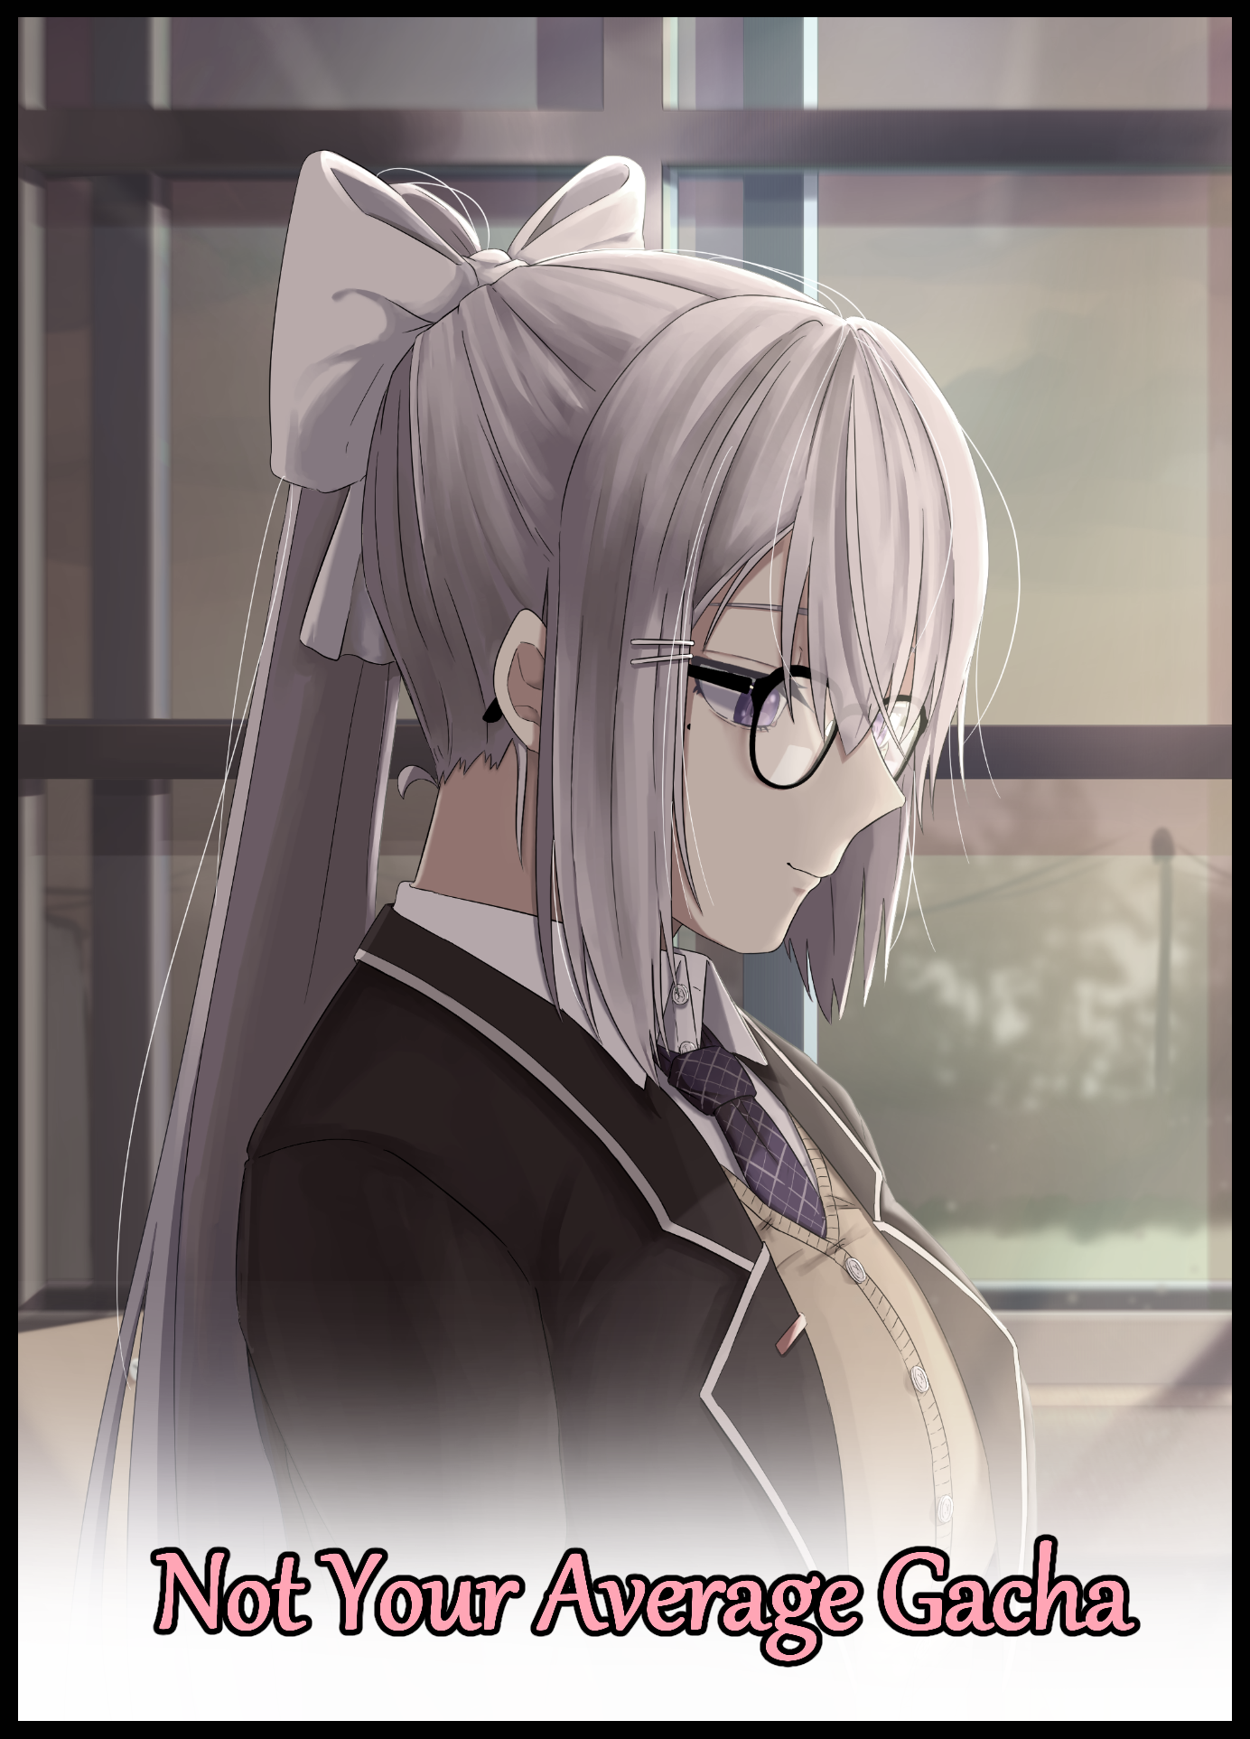

Scrolling through the Internet on a boring Sunday afternoon in a posh apartment flat off the coastline where only the rich and famous could hope to live in, a weathered man who didn't seem to be enjoying himself sat hunched over in his chair, resting an elbow on the table to provide support for his heavy head, resting at an angle that gave him a lazy posture akin to someone who woke up on the wrong side of bed.

But the man wasn't angry and neither was he feeling particularly devastated. His smartwatch business was booming and there had been no downers to bog his mood in the past few months. In fact, everything was peachy in his life.

And that was precisely the conundrum he faced, one that had him losing steam with each passing day. Feeling lethargy creeping up on him, losing focus at random points of the day, needing reminders on what he needed to do lest he forget and what was arguably the worst detractor of them all; a lack of joy and excitement in his everyday life.

Where he once had an eagerness to attend social gatherings that were basically contests where flaunting one's wealth and fame was to be expected, he now found them unappealing, preferring to spend most of his time at home when he wasn't busy with work. And while a successful entrepreneur like himself might find it prudent to buy into expensive goods and collectors items, that urge died out the moment he'd filled his first shelf with antiques and other miscellaneous bits and bobbles.

Within the span of a few years to get to where he currently stood on a small fortune he could call his own. The man had burned himself to a standstill. He still had the drive to run his business well as a good CEO should, but beyond that…what else was there?

Up here, the world was cold and distant. He didn't feel like a part of society. While he saw ordinary folk going out their daily lives with some struggling to make ends meet, they saw him as just another rich sod who couldn't understand a fraction of what life was like for them. And that was a half-truth, he had been born into a middle class family after all.

And to get to where he was took grueling work, making connections, ensuring they had a familiarity with the field they intended to profit in, unwavering dedication and maybe just a smidge of luck. And once that had paid off, they would be well on their way to becoming another of the rich snobs they despised…if their businesses didn't collapse within a month of course, he'd seen it happen one too many times. He used to fear the same happening to him, cherishing his hard earned riches like a dragon would their golden horde.

But now he didn't, or rather, couldn't quite care much if it was all taken from him. Life had come to a standstill. Without challenge, there was no excitement. Without change, it had turned into a stagnant pool he desperately wanted out of. And although he wouldn't willingly bankrupt himself he sorely wanted something to happen, anything, just to feel the 'spice' life was supposedly full of once more.

Games wouldn't do the trick, neither did television. Traveling the globe didn't ring a bell with him, and he had every intent on remaining a bachelor after he was certain he had grown past the age suitable for a love life. No one had need for a miserable 'old man' like himself after all. And he certainly wasn't eager to get himself a trophy wife or a skank, leeches in human form.

And it all served to frustrate Gibson even further as he scrolls through another webpage offering life advice, stopping once he realized it was just more of the same copy paste drivel he'd read elsewhere a dozen times over. Driving home the feeling of repetition he couldn't quite break away from as he groans in disbelief, pushing away from the desk in frustration, eyes turned skyward at the dull ceiling above.

Unbeknownst to the troubled businessman, greater powers beyond his imagination with highly relatable goals to the human were listening in on his grievances, plotting and scheming up a way to grant Gibson his wish for something to break the cycle of normalcy. And with a tiny peek through the net offered by the desktop terminal, the intangible being knew just what Gibson would need as it's manipulation goes unnoticed by the man, manifesting as a rapid series of flickers, glitches and screen tears that last for only a handful of seconds before fading, replacing the hack guru's website for a popup enticing the viewer with a chance to win 'life changing prizes' with an emphasis on the last few words rendered in bold and colored in gaudy, neon pink and purple.

In other words, it was a digital gashapon with nondescript prizes and an equally suspicious design that made it look like clickbait that would intrude upon someone browsing an explicit webpage, offering Gibson a choice as to whether or not he would want to risk the unknown or simply quit out of there and go his merry way once he recovers from his annoyance enough to turn his gaze back to the computer with a look of confusion on his face.

"What the hell is this…'Reset - Begin Again At The Peak of Everyone's Lives'…Five Rolls, Five Chances to Make a Change…huh…"

He had heard of a similar system before. Originating in Japan before being adapted for the modern age, Gacha was a staple in many free to play mobile games, even extending its roots into paid, high production releases. Behind all the fluff however, all Gibson knew was that the system was basically digital gambling for a chance at winning digital goods…how this was any different from all the others was a mystery.

But no matter how he looked at it, the thing was obviously a scam. At best, it would open a pop up or something asking for his credit card number. At worst, he would have his personal desktop locked up by some virus. An easy fix considering he'd been smart enough to rig up a VM to protect the underlying software if he was ever unlucky enough to suffer a virus.

On the other hand, something inside Gibson, presumably the cinders of childish curiosity he had thought long extinguished, urged him to click on the button that said ROLL in full caps like a lure, catching his weary eyes as they flicker between the button and the flavor text, wondering what this thing was even supposed to be. Muttering the words under his breath and the meaning behind them.

Reset…at the peak of everyone's youth…that would have to mean…childhood maybe? Highschool? A point in time where one didn't need to worry about anything besides school…tests…and petty squabbles between friends…Gibson had to agree with that statement as his mind drifts back to old memories muddying himself in the fields with his rowdy friends, the mischief of pulling pranks on the girls, the sting of heartbreak at never being able to confess to his dream girl before graduation. So many memories from a time long ago resurfaced to spur the hand that held the mouse, moving it over toward the big blue button begging for him to push it.

"Ahh hell…what do I have to lose anyway…"

Depressing the mouse with a determined finger, an admittedly excited and intrigued Gibson leans in to read the popup that appears after a lengthy loading time, noting every single word so as to not be misled;

[By agreeing, you will be given five rolls. If you are dissatisfied with a scenario, simply say you would like to forfeit through the use of the phrase 'Reroll' and the next roll will trigger. Be warned, the fourth will be your last scenario.]

That last word sent a chill down Gibson's spine but he had chalked it up to simple confusion. It was probably just telling him he wouldn't have a chance to say no to whatever 'scenario' he would end up winning by the fourth and final roll…probably…

With his consent given through another press of a button, the screen freezes for a moment before the circular hoop of a loading symbol appears…then nothing, forcing a sigh of disappointment from Gibson once the screen of his computer goes dark.

"Hahh…usual virus…got my hopes up too high for…a…second…woah."

Before Gibson could finish speaking, a nauseating wave creeps over his mind, dulling his senses in the form of blurring vision, muffled hearing and a worrying numbness that leaves him with an alien sense of weightlessness that makes it incredibly hard to focus. Gibson could still see the faint silhouette of his desktop alongside the sudden glow of the screen returning to life, but he couldn't do anything to resist the strange ailment that had suddenly overtaken him. Attempting to move made his limbs move in strange ways, and when he couldn't feel anything, trying to walk would be a dangerous affair made worse by the fact that his vision seemed to worsen, losing all sense of his surroundings once shapes began to blend into soft edged blobs and ever changing color. Even his attempts to speak were hindered by an unknown blockage in his throat that made it nearly impossible to speak.

If only he could see what was happening to his body, then maybe Gibson would realize what made it so hard to talk and walk, failing to notice he was no longer sitting in his room anymore.

And in the now vacant flat he has lived in for nearly two decades now, every single item that wasn't nailed down or a part of the original architecture begins to blip out of existence. All the furnishings and items Gibson had bought with his hard earned money were deleted without care; the curios on display, his workstation, the wine collection stashed away at the top of the pantry. Everything that could've pointed to Gibson's ownership over the place was removed in the blink of an eye shortly after the former tenant had vanished without a trace.

Where he was now was a place no human was meant to traverse, a place for higher beings to relax in, a playground for them to play in. And Gibson was being adjusted according to the first roll in the game he had unknowingly agreed to participate in, tailor made to fulfill his desire for excitement in his life…and what better way to do so than to give him an entirely new one altogether?

Worn out sinew realigned themselves, a rigid skeletal system conforms to new designs while flesh softens and regains youthful vigor. Accompanied by the unwinding fabrics of designer clothes taking on a cheaper make as they sew themselves into a smaller form fit for the younger, more slender body shape Gibson was being blessed with. Except no man, no matter their age, would ever wish to be caught wearing girls underwear unless they chose to, especially not ones like the lace panties decorated with floral embroidery slapping itself around Gibson's widening hips jutting out the side of a blooming figure midway through its growth into an eye catching hourglass, doing away with the bulge between milky thighs as they gradually conform to a flat, gentle slope once his wrinkled member recedes into smooth lips; the entrance to a young lady's untouched flower.

And a little further up top where a hairy chest was supposed to be, twin gelatinous mounds covered in creamy smooth skin stripped of moles, scabs and follicles jutted outward, sagging just a little to highlight their perkiness with bright pink nipples barely hidden behind the supportive cups of a cotton bra measuring somewhere in the B's.

With the formation of a pleated skirt and a comfortable blouse to provide the newly feminized Gibson with some measure of decency. Stable outlines and plain colors begin to coalesce around the interdimensional void she had unwittingly consigned herself to, forming familiar shapes like a desk, chestnut colored walls and even a wardrobe stacked from top to bottom with dresses and clothes befitting a girl well into her senior highschool year. Much like the intoxicated beauty laid out by invisible hands over on the warm velvety sheets of a small bed, fluttering lashes struggling to stay open on a face that was no longer reminiscent of the bearded American man that had given her shape, overtaken completely by that of a person originating from the Eastern corners of the globe, framed by meticulously, smooth hair painted a natural shade of platinum blonde that pours down all around her back.

"Ughh…where am…m-my voice sounds so…strange…young! No way! Did it really work?!"

As energy soon begins to flow through revitalized limbs cured of aching in the joints that were signs of the onset of aging. Gibson pushes off the bed beneath her in a giddy fit of excitement, still unaware of her warped gender until dainty hands paw at the hem of her skirt, freezing in place at the sight of two curvy legs jutting out beneath them, cutting her jovial exclamations short with the overjoyed look on her face slowly turning to uncertainty, disbelief, and then eventually concern. Laughing in a shaky manner while rubbing at her eyes as if hoping the sight of a woman's legs would vanish if she did so.
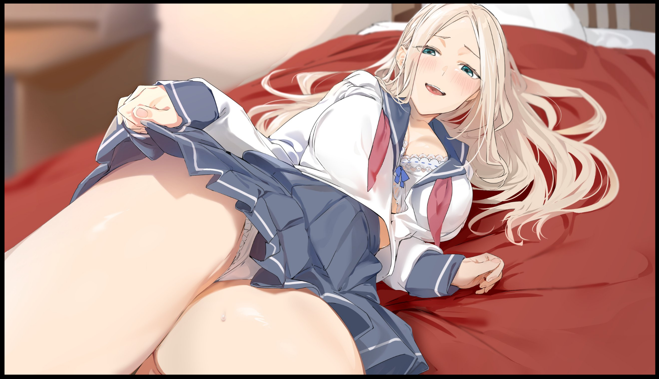
But still they remained, and it didn't take long for all that optimism and excitement on Gibson's face to vanish once a shrill scream of terror exits her mouth, scrabbling like a madwoman until her back slams up against the headrest in an effort to ride herself of the alien legs. Only serving to cement that fear once her scramble only served to raise more awareness regarding the rest of her body; locks of hair in her eyes, her chest being way too jiggly and a noticeable lack of sturdy musculature. She remembered being an ace player on the football team, not sorting books in a library!

"H-How am I a girl?! Did that meddlesome advert lie to me?!"

Fear and surprise quickly turns to anger, a worrying sign pointing to a sudden shift in personality within Gibson's calm and collected mind. With the reversal in age and the inversion in gender, minute changes were still busy racking Gibson's internals, pumping her body full of hormones and chemicals that would inevitably cause a permanent change that had yet to manifest itself in the bodacious student Gibson had become. Clicking her tongue in annoyance with a slender arm held up against her bosom in an overtly feminine manner to calm herself.

Before she could think to do something that could help pinpoint what exactly was happening, a muffled shout from somewhere beyond the mahogany door causes Gibson to jitter in fright, turning sharply toward the sound of rapidly approaching footfalls heralding the arrival of what sounded like an older woman.

"Tsumire? Is everything alright? I heard you screaming from downstairs!"

'Tsumire?! Who is…is that who I got turned into? This is terrible…what do I…of course! The other rolls!'

Remembering what the disclaimer message had told her about the 'Reroll' system, Gibson disregards everything else in order to focus, shutting her eyes with a final prayer to no deific figure in particular before shouting with all her might.

"This isn't what I want! Reroll!"

Speaking the words forces the vision obscuring veil from earlier to fold over Gibson once more, washing the homely scenery around her away before immediately transitioning toward a far more spacious, yet cluttered interior complete with a dining table and a full set of chairs enough for a family, replacing the bed she'd been lying on with a wooden chair that fits her shifting body perfectly, losing lustrous blonde for matte raven blue alongside a change in hairstyle from a loose mane to a high strung ponytail accompanied by a floral accessory. Meanwhile, her voluptuous figure takes on a 'portly' quality, gaining supple layers of fat in her belly and legs while her chest balloons with mass that detracts slightly from their heft in exchange for size and sensitivity, perking erect nipples from the bare blouse brushing against it with the absence of her underwear…

By the time snow white stockings slap tight around marshmallow thighs that jiggle with the slightest vibration, Gibson had metamorphosed into another girl, one with an air of innocence about her to serve as a distraction for something far more salacious, rousing from the dizziness with naive eyes wincing against the bright light shining down from above.

"Mmm…where…oh my, the porridge…falling asleep while cooking, silly me!"

Bouncing quite literally off the chair she'd been sleeping on Gibson sprints across the polished wooden floor toward the kitchen with her ponytail trailing behind, turning down the heat before scooping a ladle out of the cabinet in one practiced motion, picking out seasoning and spices from the pantry before adding in a generous amount that transforms the already meaty snell of the brew into an enticing one that had the chef humming with excitement…before realizing how easily she had slipped into the role of whoever she had turned into this time without realizing it, dropping the ladle with a loud clang that masks the sound of a bedroom door opening somewhere behind an alarmed Gibson.

"If I'm already slipping on the second…what am I supposed to do by the time the fourth one ends?"

"Fourth? You were keeping count?"
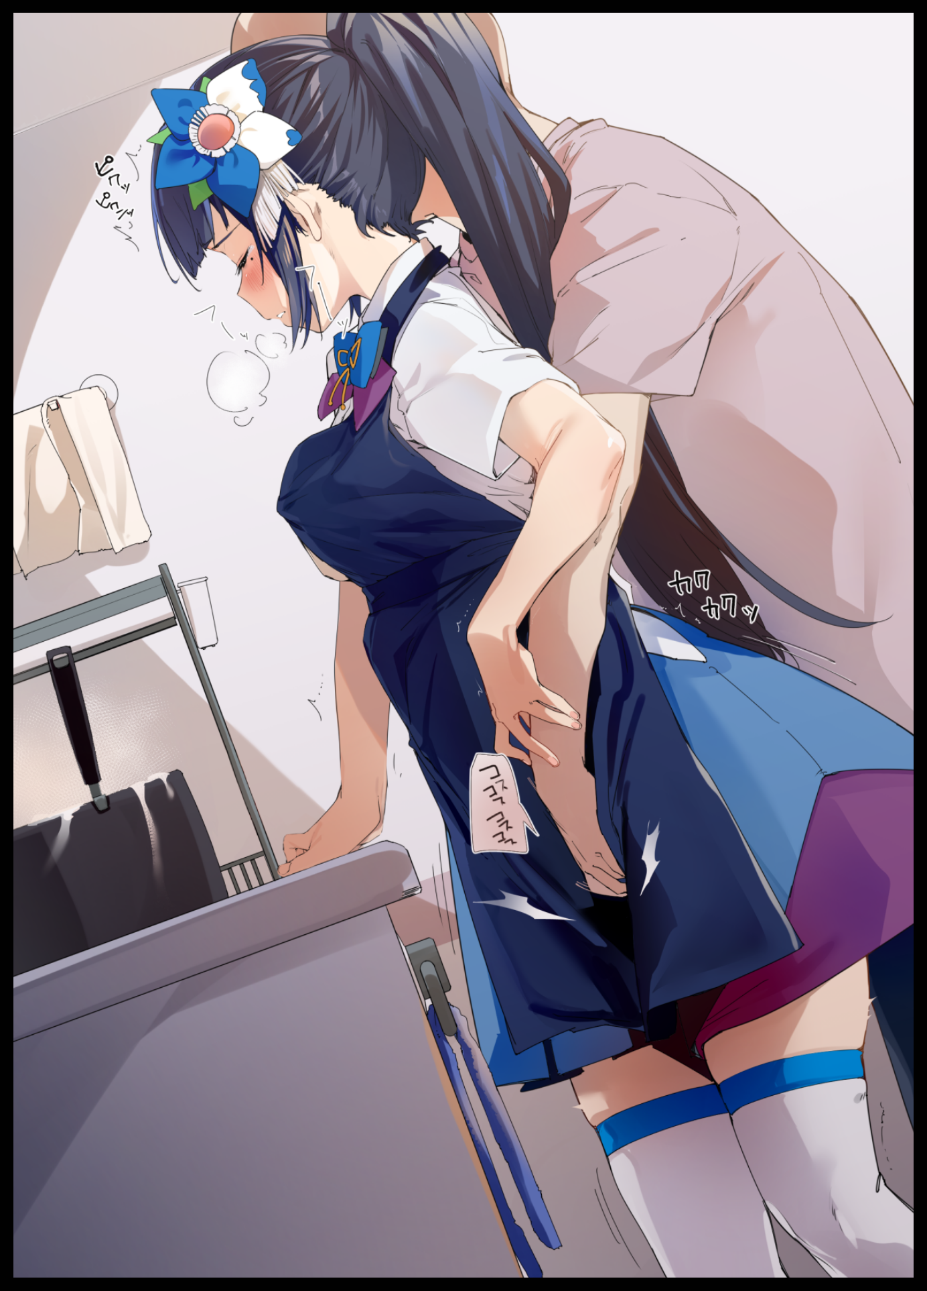
Before Gibson could react to the cool voice wafting in from behind her, two hands and a large muscular frame her body was more than familiar with creeps around from the side and back, flanking her in a position that prevents Gibson from moving away before things start to get intimate, stifling the girl's protests once the stranger whose voice and touch rouses familial pangs of warmth in her heart begins to grope and caress her body, slipping a hand down her collar to give her left breast a good squeeze while his other simply creeps lower, pressing down hard on her apron to trace the contours of her tummy, hips and thighs before jabbing the outline of a pudgy cameltoe, releasing a generous spray of vaginal fluids that thoroughly soaks the apron and underlying skirt clean through. Only then would Gibson realize why she wasn't wearing a bra or panties while she crumbles upon the wave of orgasmic bliss washing over her highly sensitive body from her boyfriend's expert touch; easy access.

"As juicy as always Saori…want me to keep going?"

"Yes! K-Keep going!"

She hadn't meant to say those words, but any hope for correcting herself was demolished when she felt Daniel, whose name she could only wonder how she knew of, press his advantage with her consent, forcing sweet sighs and throaty moans out of her, abandoning the food to focus on the pleasure she was receiving as her knees begin to quake, feeling the tickle of her juices against her inner thighs as it continues to spray forth from her hyperactive pussy, stretching her urethra everytime Daniel's probing fingers flick at her clitoris to release another splurt that hits the floor with a wet splat. Further pushing Gibson further and further into taking up the mantle of Daniel's girlfriend.

Even when she still had her pecker, Gibson was never one to indulge in such 'sinful' delights. So experiencing the pleasures of the fairer sex without warning and in a body with a sensitivity so high even the air exhaled by Daniel as he breathed made her want to shoot another load onto the floor was simply mind blowing, leaving Gibson vulnerable to the encroaching memories of the girl she had become, taking on her childhood as her own while detached emotions of love for the man whose touch made her melt into a puddle became all too real. So much so that she was beginning to forget what made her so worried in the first place once her original set of memories and personality began to crack under the emotional duress of it all.

She couldn’t let it happen, whatever this was. She had no intention of letting it win, gritting her teeth despite the salacious sounds she had yet to make, bracing herself against the countertop with a trembling, sweat soaked hand before forcing the words out of her mouth, sporting the slightest hint of an accent when she had been speaking fluent English like a red blooded American just a few minutes ago.

"Need…"

"Need? What do you want babe?"

"...to…R-Reroll!"

Once again, the world dissolves around Gibson, giving the girl temporary reprieve once the fingers assaulting her snatch vanish alongside the hand kneading her breast, falling onto the floor with a sigh of relief that honestly, came way too early considering the twisted situation she had gotten herself into. Because right as her knees hit the non existent floor and her thighs mesh with her calves, a burning sensation within her belly forces the girl's eyes wide open before letting loose a startled scream dripping with sensual aftertones.

Looking down wrought no results, only the sight of her pudgy form beneath a disintegrating skirt and apron beginning to slim down and change once again, conforming to the body she had been born with in this third life of hers. It was supposed to be a foreign sensation, not meant to be known to her. But it was there, Gibson could feel it as her breathing quickens, trembling arms trying desperately to lift herself off the floor, trying without success to free herself of the straddling position she had been forced into, all while the sensation of a phantom dick messes with her mind, gasping, moaning and grunting in her delirium wrought by her fight against the invisible force keeping her pinned.

Until a sudden pang of what could only be described as some form of pain in Gibson's heart brings her fight to a crashing halt, wincing against the overwhelming emotional baggage she couldn't understand a lick of, only that it made her want to curl up into a ball and fade away as she hunches over, wracked by emotional and physical stress while her snatch transforms into one that had seen a modicum of use as undulating folds of dull pink flesh flaps and flexes around a throbbing sausage that steadily manifests itself from thin air alongside the broad frame of a muscular young man, putting himself together to the tune of Gibson's third body finalizing itself in the form of a blushing tomboy. Trading a fluffy head of hair for a spiky, boyish cut much like the one she used to sport back in her actual highschool days running track and field…or at least, that was what she remembered it to be. It was hard to recall…

If one were to disregard her petite breasts and sputtering loins, it would've been easy to mistake Gibson's current appearance for an effeminate young man. Especially in the lowlight conditions of a gymnasium storage room, the perfect place for a young couple to run off to for some steamy time together.
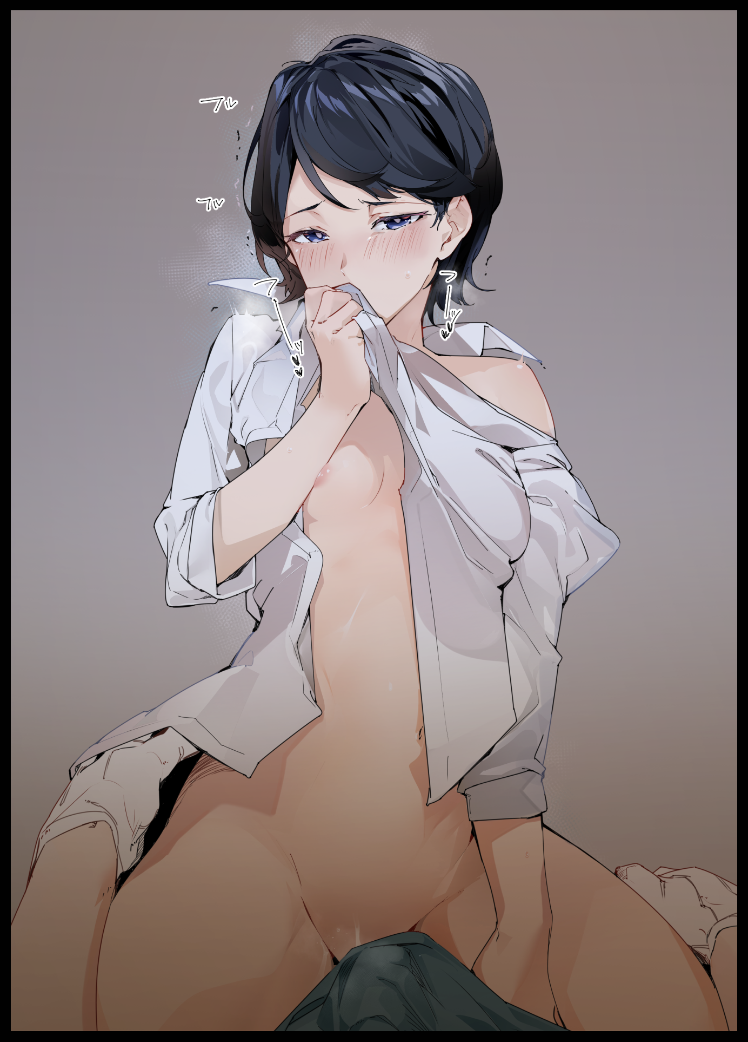
With an apparent escalating trend ramping up the eroticism and severity of the changes on every 'roll', Gibson was immediately made aware of the identities of both herself and the man she was currently having sex with, squealing in shame and embarrassment she could not fight back against as the personality alterations became stronger. Kicking off her waking moment as Izumi; the school's most handsome girl, with a literal bang, turning into her right at the same time she had decided to shag her boyfriend right after training was over. Despite her cool headed nature and the fact that she had more girls confessing to her than the boys who preferred their women a little more well endowed and feminine than she was, whenever Sam held her down like he did now while making love, Izumi became a totally different person altogether. Enough for the weary man gently pumping into her from below to raise a hand in concern, gracing his girl's sweat soaked chin.

"Am I going too hard? Need me to slow down?"

"N-No need…I'm fine…P-Please Sam, continue…today's my s-safe day so-mngh! it's alright to come inside me…"

There would be no second voice protesting the brazen consent for her partner to empty his load inside of her. Instead, Izumi had already begun to overtake what little remained of Gibson. Everytime she raised herself before coming down hard in an effort to drive Sam's cock deeper into her was like a relentless sucker punch delivered to the fading passenger at the back of her mind. It had been a transition so fluid, so unnoticeable, that the accumulated fear Gibson felt from what was going to happen on the final roll to how easily she had slipped into her new alter ego permeated Izumi's heart. Influencing her to some degree in an effort to carry out her former self's last ditch effort to try and resolve this.

"Reroll…"

Instead of another perverted scenario however, Gibson would find himself returned to normal in his study, sucking in a breath of air while patting himself down like mad, sturdy chest rising and falling to the tune of his lungs going into overdrive from the sudden surge of adrenaline shooting through him after being flung from body to body at a pace that had him reeling from the aftermath of it all.

Patting down his pants, and he could once again, feel the pecker he'd been born with tangled up with the sensation of having a mottled flower between legs that were definitely more pleasing to look at than his tubby, weed covered pillars. The same applied for the invisible weights tugging hard on his shoulders and the pinprick chill of amazingly soft hair constantly brushing against the nape of his neck. It felt like he was suffering a severe case of phantom sensation from the body parts he no longer possessed, mildly relieved yet feeling a strange longing to return to what must've been an incredibly lucid dream for him to experience life on the other side of the fence through three different vessels of increasing eroticism and romance…a strange combination if there ever was one.

But as he laid back into his chair after that mind bending experience, the weathered man couldn't help but feel a longing to see his last roll through, even though he recognized what that would've meant for his psyche, especially after viewing things through Izumi's eyes, whose name he could still remember alongside her buddy Sam. It was as if he'd forgotten himself, completely becoming her during those final, heated moments in coitus with another…

"The Peak of Everyone's Lives…I guess that does make sense…in some way…"

A sudden beep from the desktop in front of Gibson draws his attention, dashing any hope that it had been a dream once he reads the message displayed on the screen;

[You did click on it anyway right? Effective marketing! It was probably the only way to get you to accept…sorry bud, you're still in the Dreamscape…four rolls remember?]

Normally, the sight of a message that took up his entire desktop screen that looked like an impossible reply to what he had absent-minded remark

"You…whatever you are…you did all that? Made me dream I was living the life of some imaginary highschoolers?"

A moment of silence passes before another beep pips across the expanse of Gibson's spacious room, suspense only serving to tighten the metaphorical knot around his neck as he leans forward to read the new message.

[It'd take too long to explain, but in short; the place you're in right now isn't actually your home. It's the tiny little bit of your subconscious that's still…well…you; what's left after the previous three rolls did quite a number on your psyche. We just bought you out here cuz things seemed to be getting a little hectic back there…this is supposed to be a reward after all…won't be much if you aren't aware of the benefits before the end.]

"Subconscious…god this is so much to take in…s-so if I'm in my own brain…what's happened to my body? And what's all this about a reward?"

[Do you wish to know what's in store for you in your last roll? It'd ruin the surprise if you can't wait, just say the word and we can send you off immediately…or we can keep chatting…]

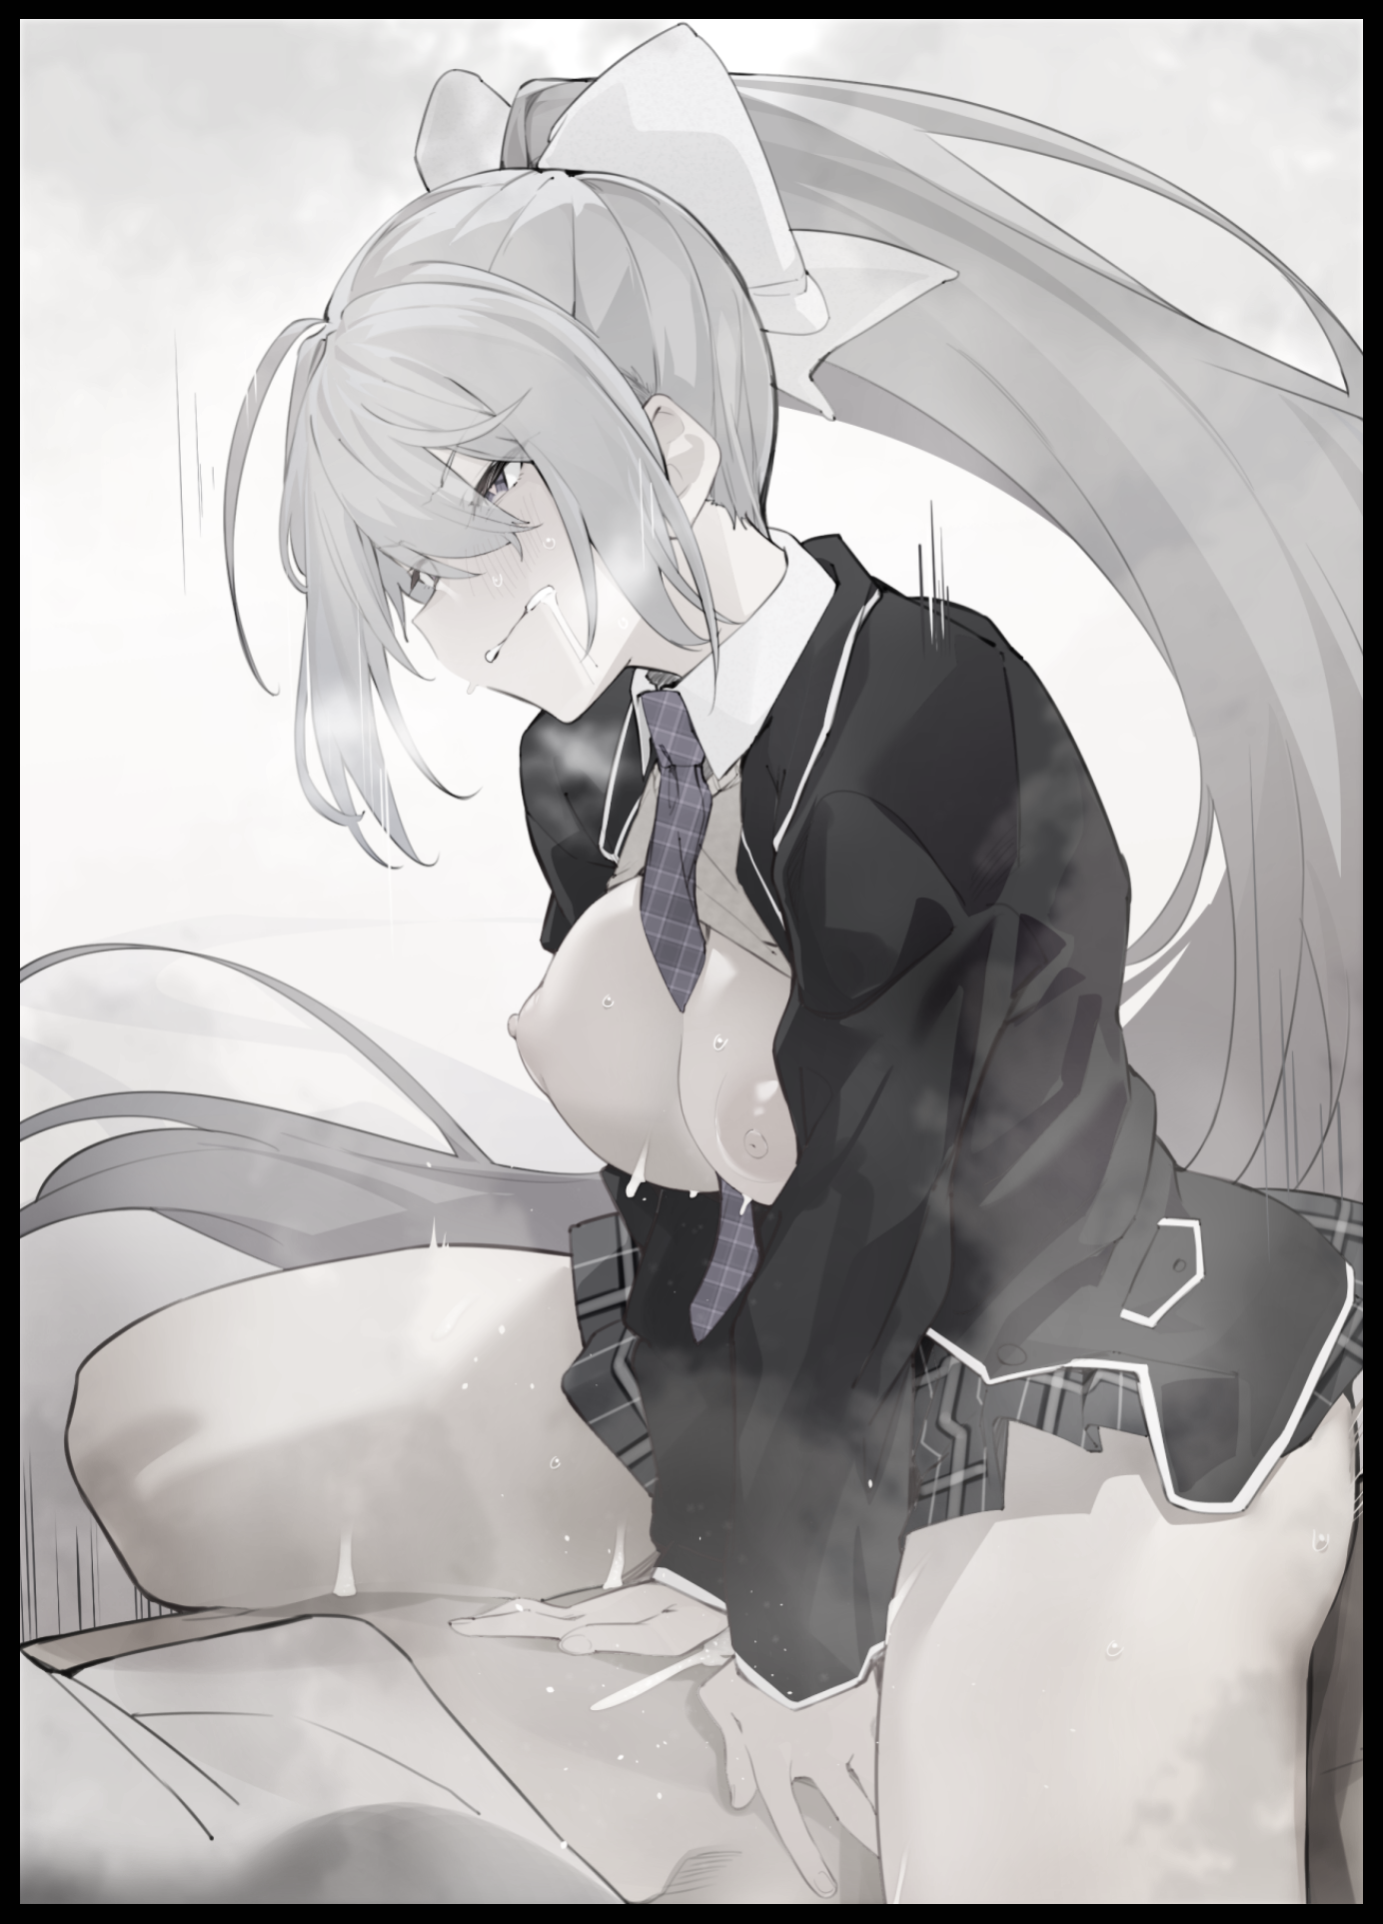
The response came quicker this time, leaving Gibson the ball to ponder with before tossing it back over to the unseen entity he now found himself conversing with quite readily, because he didn't have to take a look around to realize this being spoke the truth. The windows were pure white instead of the usual scenic view over the coastline and sun speckled horizon. Add to that the ambient lighting being too…'flat'...and it made the place look as if it was being rendered by the mind of someone who was beginning to forget it entirely…his mind.

"Maybe…just a glimpse?"

A burst of static, and Gibson’s computer screen changes from plain white to a low shot view of what looked like a couple in the midst of…at this point, he wasn’t even surprised anymore. Only feeling a tinge of regret, no doubt lingering emotions left over from Izumi not being able to finish her own fun time considering how this new girl, presumably his final roll and permanent vessel when this was over, was enjoying the company of another man in the same cowgirl straddling position he had endured not too long ago as Izumi, finding himself rubbing a hand over his rock hard stomach upon the reminder of that raunchy memory.

“Is it just me, or does every single option involve sex?"

[Glad you took it nicely…and please, it's just a spur of the moment thing. What you do afterwards Kaede, that's up to you…though you won't remember a lick of what we spoke of, can't have a human with intact memories going about in a timeline rewritten after all~]

"Yeah, yeah…some higher being rule or something…so…once this all goes through and I'm gone ..what'll happen to everyone else in my old life?"

[Oh it's already been done. Everyone related to you has already forgotten your existence. Your business, your savings, even your family…it was all gone the moment you gave your consent on the agreement check…but…as I recall, you were dissatisfied with the way your life was headed…am I right?]

"Yeah…but still…losing everything…"

[...in exchange for a new start. You might be back at square one, sure…but who's to say it won't be different? Or fun even? Think about it…if you can…you've noticed already haven't you? Are you…mad? You can't really blame us right? You had the choice after all .3.]

Gibson didn't need to think about what the entity meant when he realized he couldn't rouse any memories of the past. The faces of his mother and father were there, but we're of distinct Japanese descent instead…of whatever race his old self hailed from. And instead of a non-existent smartwatch business, a bubbly life at some highschool was all he could recall. All from the eyes of the silver haired Kaede; a Japanese girl born in America simply trying to do her best studying in a land far removed from her native country.

And as strange as it was, he couldn't seem to muster any anger or remorse over the deception…because in a way, the entity was right; he could've simply hit the big red X to close the advert…but he had decided to chance it and go ahead with the obviously suspicious offer.

"Devilish aren't you?"

[What can we say? The world of business is a cutthroat one after all…besides…it's a good deal don't you think? Plus, you did sort of help test out the system as our honorary first customer!]

"Speaking of…why are you even doing this anyway?"

[Trade secret…now…are you ready? Nothing else you wanna remember before you go?]

"Ready as I'll ever be…doubt I'll need much else, said so yourself didn't you? I can't remember anymore…can't even see myself anymore…"

Looking down after speaking the last words in a sonorous alto dripping with a heavy accent far more noticeable than her previous selves combined that sounded far different than his old, gravelly voice. Gibson turns his gaze from the monitor down over his…or rather her body; glimpsing the sight of bountiful breasts jutting out beneath a warm cotton blouse and undershirt alongside the familiar tickle of a skirt brushing against exposed thighs, flexing dainty digits tipped with manicured nails in her face while twirling a stray lock of platinum between her fingers in whimsical fashion. She'd already been changed so much to the point that the absence of her dick and the weight of her bosom didn't even surprise her any longer. Sitting with knees bent at an angle so as to keep her privates private.

[Come now, it ain’t all bad, you’re still you even if you might not look it…now, hold still, this’ll only take a moment…thanks for being a chum.]

"It's been fun…"

[Likewise, enjoy yourself now you hear?]
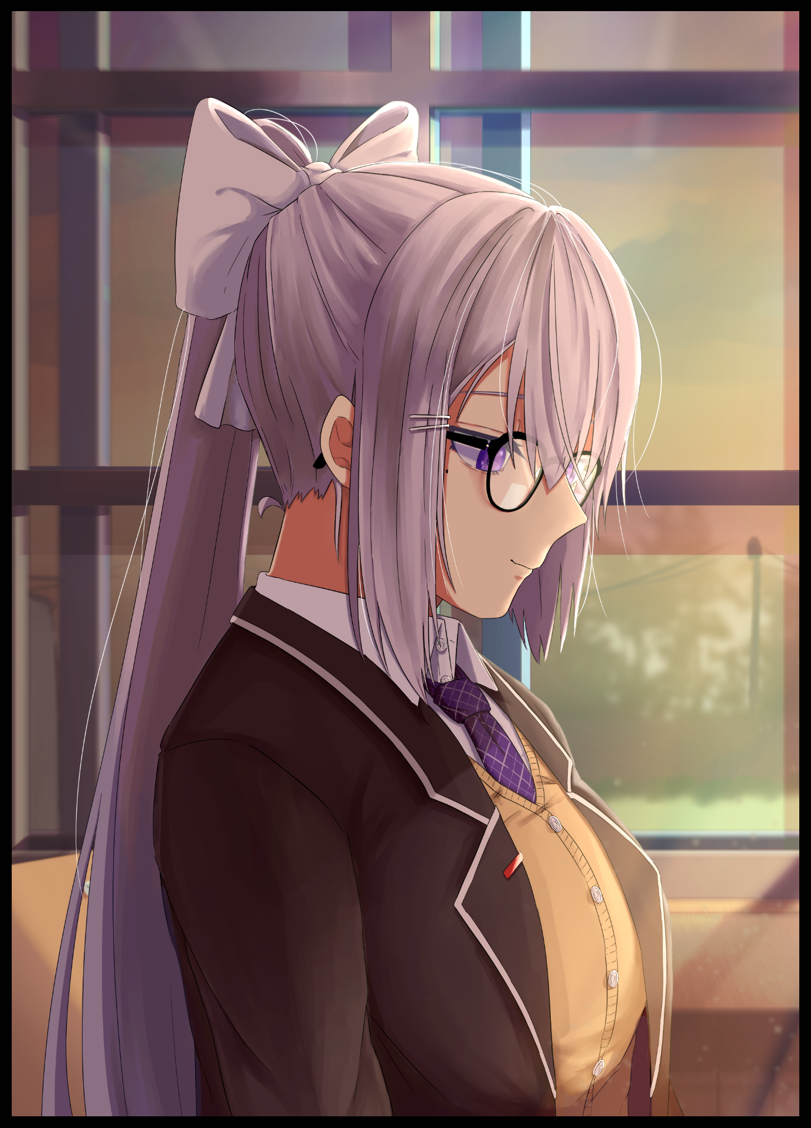
A void of white washes over the surroundings before engulfing Kaede, nullifying her senses for a moment as a tingly wave hijacks her brain, affording sudden clarity, silence…before she would come to with a start, awakening in an empty classroom while blinking away a tear at the corner of her eyes. Dazedly scanning her surroundings with a slow swivel of her neck to find herself completely alone as she adjusts the spectacles hanging lopsided off the crook of her button nose, rising quickly to a prim, seating position before anyone could catch sight of her looking sloppy.

Recent memory told her she had blanked out after something…good…had happened to her. But she just couldn't recall what it was exactly, only that the warm, bubbly euphoria from that short trek through memory lane remained like butterflies in her tummy, leaving her unable to wipe the wry smile that had plastered itself over her face even as she yawned while doing quick stretches, gentle eyes glancing outside the window to take in the sight of the afternoon sun slipping over the distant rooftops before the sound of a sliding door opening behind her causes her to snap back to reality, twisting sharply in her seat toward the source, causing her slim lips to crease into a full blown smile of affection for the unsuspecting young man walking in dressed in a baggy jacket and trousers wearing a goofy grin on his face. The sight of which triggers an influx of memory that begins to urge the quiet girl towards more salacious thoughts, especially after realizing what that 'happy' feeling inside of her was.

"Finally awake Kae? You ready to go home now?"

"Sure thing Fred…but…before we go…"

Rising off her chair with a slick string of something connected to the base of her skirt and the wooden seat that snaps once she begins to move, Kaede wasn't quite satisfied with what had transpired between her and Fred earlier. Sure, she had let him mark her so thoroughly she lost consciousness. But for some reason, the memory of it seemed displaced, as if she hadn't really been there to experience it for herself. And while she could see the satisfaction literally glowing from her boyfriend's face, she didn't feel the same…and that needed some correcting before they got to go home, enticing him with subtle body language and enchanting flutters of the eye that had him allow wrapped up in her fingers by the time she made it before him, pressing her warm bosom against Fred's chest in an act of familial love that had him stunned…even more so when she began to guide his hand downward, brushing last the hem of her skirt before brazenly rubbing his hand against her sopping wet panties, soaked in a mix of their juices from their first romp together.

And from how his number two immediately sprang up like a flag pole at full mast, Kaede knew she didn’t need to ask if he was ready for round two…letting him hoist her up like a princess back over to the seat they had done the deed at to commemorate three months together as a couple.

Right before Fred could take the lead however, Kaede arches her flexible back, thrusting forward while locking her legs in a vice grip around her boyfriend to keep him in place while she plants a kiss on his lips. Making her feel blessed to have been born a girl, even moreso to have found a man like Fred who’d been so supportive of her despite her distant nature and foreign status.

“Fred…I love you…”

“Love you too Kae…”

Watching the couple begin to make out once again in the privacy of an empty school, the entity leaves for another venture with a smile on its non-existent face, wishing the changeling luck on her new life going forward…

THE END

