Try Lesbianism
A Short Story
By Maryanne Peters

What man would be happy to hear his wife declare that she was a lesbian? That she was a lesbian and did not find him sexually attractive? That she never had?

I mean, such a husband would think: Is it something I did that turned you away from men? Or, if you have always felt this way, what does that say about me? Am I less of a man? When we make love, do you think of me as female to get off?

What man would be happy to hear his wife declare that she was a lesbian? Me, as it turns out.

Not straight away. Maybe I had all of those thoughts I mentioned, but then I realized that we might be able to stay together. If this affair with this young woman was just that, and if our homelife and family meant anything, we might stay together, if I was a woman.

“Are you telling me that you are transgender?” Simone gaped at me.

“I am saying that I am not so slavishly attached to my masculinity that I will let that come between us,” I told her. “I cannot think of anything more important to me than you and our daughters, and if you cannot change then I am prepared to.”

Masculinity. What is that? I had male friends, but I had always put my family first. Was I interested in male pursuits? I followed sport, sure, but so do women. I played golf and tennis, but so do women. I worked in an office where half the workforce were women, and we even had one transwoman in the property management section.

Was I proud of my male body? I was healthy and that counted for a lot, but I was not involved in body image. Everyman is attached to their genitals – right? Maybe my attitude to them changed once I had learned that they were so unattractive to my wife. I remember thinking that a penis was useful for pissing out of without dropping your pants. If you are not making love to the woman you want, it seemed to me that This was all it was good for. What real man thinks like that?

Besides, my masculinity was that I was a man in a house of women. With my wife and both our daughters well into high school, and none of them having men around, I was the lone man.

“It would be nice to have a lesbian relationship with you,” said Simone. “But you would just be pretending for the sake of our marriage.”

“I am talking about change, not pretence,” I responded. “But even if it was pretending, we would be together. How could that be bad.”

“As a transwoman, you would be a woman. A deformed one, but a woman. I think I could have a relationship with that kind of woman. But you are not that.”

“As I said, I am prepared to change,” I said to her. “Given all our years together you owe me the chance to at least try.”

If she was reluctant but only just willing, I was enthusiastic. I was ready to adopt a totally feminine persona and to woo my wife all over again, as a woman. I thought that I knew what a woman was, but I soon discovered that my wife was right: I was not that. I needed to study and truly change.

Getting closer to my daughters helped. Their mother had come out, and I told them that I was coming out as well, as transgendered. I thought that it was a lie at the time. I only intended to become as much of a woman as I needed to be, to keep Simone. I told them that because I was to become a woman, their parents could stay together. They seemed doubtful, but kids want their parents to stay as a couple.

I told the girls that they could help. I needed to start from scratch with this whole woman thing, and they were closer to the start. I immersed myself in their magazines, websites, messaging, and all things girly. I don’t think that any normal father could ever be closer to his daughters. They loved the new me that was developing. If only their mother could be brought around.

To me it seemed that the external appearance of a woman was the key. That was what attracted lesbians to other women. I started to grow the hair on my head and get rid of all other hair. But that is not it. Some lesbians are attracted to butch women, because they are women. It is not always about appearance and behavior – it is something deeper.

Hormones were a better way to get there. The effects of hormones on the body are well established, but they also affect the mind to some extent. Simone said that she found that change in me pleasing. That and the fact that I had to surrender any overtly masculine behaviour.

It was not as if I was at all macho. I was a quiet person and a homebody. At work they barely noticed that I was changing, although I had cleared it with HR and there had been some announcements. I think that some of the people I worked with just said: “Gary who?” If people don’t know you, why would they care?

I just started by wearing different pants and shoes – neutral I guess, and more colorful tops that were not so neutral. I started washing my hair daily and brushing it for volume. Then I had my ears pierced and wore a little lipstick and mascara. Nobody at work noticed, or if they did, they did not care. It really made me feel less important somehow. Or was that the feeling women have?

I was not up to wearing dresses at work, but I tried some on at home. Simone seemed pleased, but I wondered if she was somehow just pleased that I was trying. Somehow it seemed that she was still not attracted to me the way I wanted.

“Am I trying too hard to be feminine? You like feminine women – right?” It seemed to me that I was going all the way, for nothing.

She wanted to give something back, so she suggested sex. Lesbian sex. I was very keen. It seemed to me that this could be the beginning of something positive, but my penis was functioning poorly. I guessed that this was a consequence of the hormone doses and was before I discovered that Viagra could fix the problem.

“That kind of sex is not necessary,” she said. “Lesbian sex is about exploring one another’s bodies. When they are the same bodies they react in the same way. We’ll tuck away your male bits because they are non-responsive, we’ll shave down and caress one another, as lesbians do.”

I really enjoyed it, and I thought that we were getting somewhere, especially when she started playing with the little breast buds that had formed on my chest. It was a new kind of love making, but I still longed to be inside her.

But when I discovered how I could get erections she told me that I would have to take just as I gave.

“Lesbianism is about equality. The better word is reciprocity. If you enter me, then I enter you.” You don’t have to be a genius to know what she was talking about. For the first time in this whole exercise, including happily swallowing anti-androgens and estrogen, I started to baulk. There is something about losing anal virginity that really worried me.

I had never asked her to submit to anal sex. I had no idea what it was about, but I decided that I would need to research it. It turns out that is easy. In fact, the act itself is not hard, at least after the first one or two entries. But I think that I had reason to be worried as I had been. There is something about receiving that is distinctly un-male. I think that it may have broken down the last barrier.

I started wearing dresses to work, and shoes with a heel, and more makeup, and drop earrings. My hair was getting longer, and I was styling it – even experimenting with wearing it up.

I told everybody that I wanted to be called Emily. It seemed like a very feminine name. I was a feminine kind of woman. A lesbian, but a feminine one.

People at work started to notice me. I had ceased to be invisible. I thought that I was becoming attractive. Women would compliment me on my clothes and presentation, and men would stare at me. It was general knowledge that I was a transwoman, but people would say: “I can’t remember what you looked like before, Emily”. That did not matter to me. In fact, it was a positive. Before, I had barely existed. Now, even if I was not attractive, I was noticed.

When Tom was transferred from the West Coast to become my immediate boss, he was told who I was. He tried to be relaxed about it, but I knew that he was staring at me. I am not sure how it is with other transwomen, but I sort of liked it. He might be wondering what was lurking under my skirts, but I was not leaving him in much doubt about what was in my bra – by now two fulsome boobs. I might have even been guilty of flirting a bit.

Sometimes I think that transwomen are treated differently. In the age of “me too” could a cis-gendered woman be told by Tom: “You look great today, Emily”. It would be sexual molestation. Tom knew that I would enjoy the complement. What transwoman would not?

Was I pushing the wrong buttons? Sometimes I wondered whether other women in the office could truly accept me as female because of the way I sought approval. Could I ever really claim “me too”.

“I don’t believe in workplace relationships, so this is not a date or anything, but I have to go to a presentation so I wonder if you might accompany me?” That was what Tom said. “Me too” be damned.

“You should know that I am in a stable lesbian relationship.” That was my reply. It was not no.

But the truth is that I was not in a stable lesbian relationship. Sure, we had intimate moments, and occasional reciprocal sex, but I felt that things were still not right between us. It seemed to me, and others including our daughters, that there was hardly a scintilla of maleness in me, but Simone could still see it.

“Ok,” I told Tom. “What should I wear.”

“It is black tie for me, so evening wear I guess,” he said. “Do you have anything? It is for work, so if you need a rental outfit and a hairdo, the office will pay.”

I have to say I was excited. If there was one thing that I learnt from my daughters, it was that being a girl starts with princess fantasies. It did for them anyway. As a part of my transition adjustment I had tried to dream those thoughts, as if I were a girl child, with some success. This would be one of those moments. The princess gets taken to the ball, with the fairy godmother and the prince all rolled into one.

Simone was annoyed by the idea. I hoped that this might spark something positive in her, but it might have been more envy than jealousy. That seemed incongruous. As a genetic woman she had chosen to exhibit her lesbianism with increasingly severe clothing choices, in total contrast to me, freshly a woman, seeking femininity. That was what Tom wanted that evening.

I picked up the dress on the way home. It was cream with pearls on the bodice. I would have been ridiculously expensive, but I was only hiring it for the night as Tom had arranged. It was supplied with a corset because the cut was very narrow at the waist. I had never worn such a thing before, but I loved the shape that it gave me.

I had to buy some heels to match, even though they would be concealed by the long hem. Later Tom was to pay for those as well. Then I went to the salon for the full makeover. It would be my true Cinderella moment.

“You have good bone structure,” said the beautician. “You should wear your hair back off your face, and it must be a little longer, and blonde.”

“Do you think so?” I thought that my blue eyes were my best feature as a woman, and were set off by my darker hair. I generally wore it hanging down because I thought the shape of my face was too angular and masculine.

“Put yourself in our hands,” she said.

So, I did. I laid back while they colored my hair, added extensions, plucked my eyebrows and painted my nails. Then they set to work on my face – shading to show the nose and the cheekbones, dark around the eyes, and a dark red color to the lips. My hair was back combed for height on top, pinned at the side, and just a few curls on the fake ends dangling down my back.

I saw myself and I was mesmerized. I was hoping for striking. I was surprised by sheer beauty.
I hurried home to show Simone, but as I walked into the room and gave her a twirl, the look on her face was one of horror.  “What have you done to yourself?” That was what she said. I was just confused. Surely this would prove to her that I was no longer a man in any way? Surely now she would see that I had become what she said she wanted - a woman to be her partner?  My daughters were the complete opposite. They were thrilled that I had been transformed into a princess and could not wait to help to squeeze me into the gown.  “You need a bag,” they said. I had lipstick and mascara for touching up, and of course I would need scent and a tissue or two. They found a little pearl purse in the dress up box – something from my grandmother as I recall. For the first time I wondered if the pearls were real. Even if not, the little bag worked perfectly with the dress.  “You really are a princess, Daddy,” they said.  “I think you should call me Emmy,” I said. “I really don’t look like a daddy, do I?”  I practised my entry walk and some dance moves with my daughters, to their unrestrained delight, until the limousine arrived to pick me up. If it had been a pumpkin coach I would not have been surprised. | 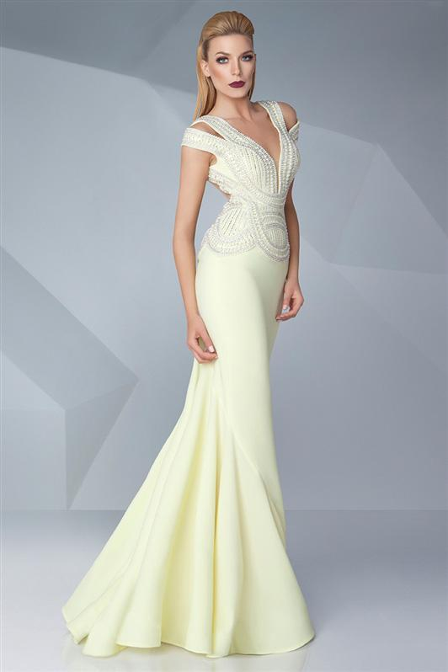

“You look fantastic,” said Tom. He held one hand as I held the hem of my dress with the other, slipping out of the car with some effort.

“You are the boss,” I observed. “And here I am. Ready to serve.”

“Tonight, you are my escort, not my employee.”

Did he see something in me that made him choose me to be that? Why would he pick the trans-girl when he could have taken Gillian from Accounts, or Marcia from personnel? I was determined to return his trust in me and be intelligent and charming. As for feminine, how could I not be, dressed like that?

I was walking on air, which always seems graceful. Even my voice seemed to have gone up a few octaves. My big clumsy hands seemed suddenly elegant, as I held my champagne flute in one hand, absent-mindedly caressing it with the other.

I had been prepared to confirm to anybody who had asked: “Yes, indeed, I am a male to female transsexual” which was something I claimed to be sometimes, but it never came up. It seemed to me that nobody had me picked as anything other than a woman, and a perfect one at that.

I could have been a princess that night. I did not want it to end.

But the time came. Tom said that He could arrange a taxi for me to go straight home, or one from his apartment should I wish to join him for a nightcap.

“That sounds dangerously close to a workplace entanglement,” I said. “But tonight, I feel invincible.”

What did I think was going to happen. I knew how I looked. I knew he had been staring at my cleavage all night along with half on the other men in the room. The other half were probably staring att my butt in that cream gown.

We were barely inside the door before we were kissing passionately. Despite the effort to get into the gown it fell to the floor the moment that his fingers were finished with the zip.

“I am not complete down below,” I said. “But I can take you in my back pussy.” The words just came out in a breathless gush, but somehow did not sound at all slutty.

“Thank God,” he said. “I cannot control myself.”

I am glad now that Simone insisted on reciprocity. It meant that after all those nights receiving plastic, the first time that I received a rod of flesh, I fully appreciated how much better that is. Not only flesh, but with hot syrup to fill my insides. Oh my God!

I did try lesbianism, but I prefer Tom.

The End

© Maryanne Peters 2020

